Living with Polycystic Ovary Syndrome (PCOS): An Information Booklet for Service Users and Healthcare Professionals in the UK

Executive Summary
Polycystic Ovary Syndrome (PCOS) is a multifaceted, lifelong endocrine-metabolic disorder with an estimated prevalence of 5 to 20 percent in all women of reproductive age around the world with reported prevalence steadily increasing throughout the United Kingdom, ranging between 1 to 3.5 percent at various points in the timeframe since the start of the 21st century. This evidence based information booklet gives an overview of PCOS to UK service users and health care practitioners and discusses its definition, burden, aetiology and the multidimensional physical, psychological, social and family effects of the condition. It provides evidence-based NHS treatments along pharmacological, lifestyle, fertility, and mental health pathways based on NICE guidance (March and September 2025) and the 2023 International Evidence-based PCOS Guideline. PCOS is critically applied to the theoretical frameworks, such as the NHS House of Care and WHO Innovative Care for Chronic Conditions models, and the policy analysis of national policy, such as the Renewed Women’s Health Strategy for England (April 2026), and local delivery of the policy, such as Women’s Health Hubs. The booklet ends by giving recommendations on encouraging person-centered, culturally sensitive, multidisciplinary and lifelong care among women with PCOS.
Table of Contents
Executive Summary 2
1. Introduction 5
1.1 Purpose and scope of the booklet 5
1.2 Target audience and rationale for topic selection 5
2. Understanding PCOS: Definition, Burden and Aetiology 5
2.1 Definition and clinical features (Rotterdam criteria) 6
2.2 Global prevalence and burden 6
2.3 UK prevalence and burden (NHS data, 2025–2026) 7
2.4 Risk factors and aetiology 8
2.4.1 Genetic and hormonal factors 8
2.4.2 Lifestyle and metabolic factors 9
2.4.3 Ethnicity and sociodemographic considerations 9
3. Impact of PCOS and Evidence-Based NHS Treatments 10
3.1 Physical impact on the individual 10
3.2 Psychological impact on the individual 10
3.3 Social impact on the individual 11
3.4 Wider implications for families and carers 12
3.5 Evidence-based NHS treatments 12
3.5.1 Pharmacological management 12
3.5.2 Lifestyle and behavioural interventions 12
3.5.3 Fertility and specialist services 13
3.5.4 Mental health support pathways 13
4. Theoretical Perspectives and Models for Improved Outcomes 13
4.1 UK model: NHS House of Care framework 14
4.2 International model: WHO Innovative Care for Chronic Conditions (ICCC) framework 15
4.3 Critical comparison and application to PCOS care 15
5. Local and National Policy Agendas 15
5.1 National agendas 16
5.1.1 NHS Long Term Plan and Women's Health Strategy for England 16
5.1.2 NICE guidance relevant to PCOS 17
5.2 Local agendas 17
5.3 Critical examination of policy implementation gaps 17
6. Recommendations for Person-Centred Care 18
6.1 Person-centred and culturally sensitive approaches 18
6.2 Self-management support strategies 18
6.3 Multidisciplinary and lifelong care considerations 18
6.4 Note on end-of-life care relevance 19
7. Conclusion 19
Reference List 21

1. Introduction

1.1 Purpose and scope of the booklet
This booklet is an evidence-based summary of Polycystic Ovary Syndrome (PCOS) which is a complex endocrine and metabolic long term condition that occurs in women of reproductive age. It discusses the definition, burden, aetiology, physical, psychological and social impact, NHS treatment pathways, theoretical care models, UK policy agendas, and person-centred recommendations to facilitate holistic, lifelong management.

1.2 Target audience and rationale for topic selection
The targeted audience of the booklet is service users and healthcare professionals in the UK. PCOS has to be given priority as the prevalence of the disease among UK primary care has increased to 3.5% by 2020 in comparison with 1.02% in 2004, and the prevalence rates in other countries are no less than 10-13% which has been under-diagnosed (Berni, Morgan and Rees, 2025).

2. Understanding PCOS: Definition, Burden and Aetiology

2.1 Definition and clinical features (Rotterdam criteria)
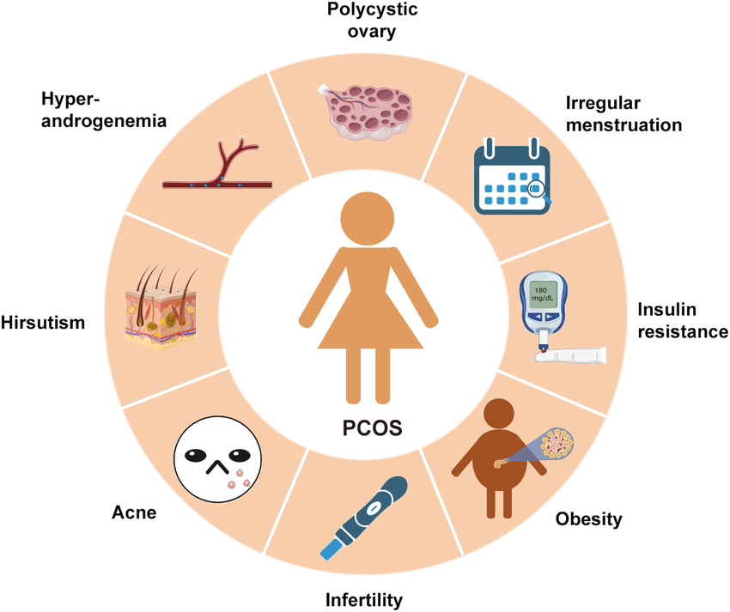
Figure 1: The symptoms of PCOS
(Source: Zhang et al., 2025)
Polycystic Ovary Syndrome (PCOS) is a heterogeneous endocrine-metabolic reproductive-aged female chronic disorder. Diagnosis is based on the Rotterdam criteria, with at least two out of three characteristics: oligo- or anovulation, clinical or biochemical hyperandrogenism (acne, hirsutism, elevated testosterone) and the appearance of polycystic ovarian morphology on ultrasound (Singh et al., 2023). Typical clinical manifestations are abnormal menstruation cycle, infertility, weight gain, insulin resistance, alopecia, and acanthosis nigricans, and chronic cardiometabolic and psychological consequences (Zhang et al., 2025).

2.2 Global prevalence and burden
PCOS is a condition that is estimated to occur in 5-20% of women of reproductive age worldwide, depending on the diagnosis criteria. The current analyses of the Global Burden of Disease (GBD) 2021, updated in 2025, report an age-standardised prevalence rate of about 3,365 per 100,000 women of childbearing age worldwide, and an increase in prevalence of 29.66% and disability-adjusted life years (DALYs) of 28.37 between 1990 and 2021. Projections released in 2025 using Bayesian techniques predict the further increase of the PCOS burden until the years 2035 and 2050 due to obesity, urbanisation, and better detection (World Health Organization, 2025).

2.3 UK prevalence and burden (NHS data, 2025–2026)
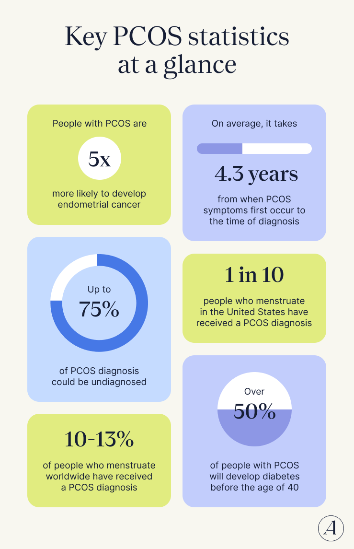
Figure 2: PCOS summary Statistics
(Source: Myers, 2026)
The incidence of UK primary care has risen sharply, to 3.48 per cent in 2020, with circa 369,505 cases of primary care diagnosed. As per the report of the All-Party Parliamentary Group on PCOS (2025) the UK prevalence rates (34%), are reported to be far lower than those of the rest of the international community (10%-13%), proving under-diagnosed at a very high level. The impact on NHS resources is significant: average yearly health care expenditure per PCOS patient amounts to 1,546 vs. 940 per patient in controls, and women with PCOS attend more healthcare services on average than those in the controls: 10.72 health contacts/year in PCOS cases versus 7.11 health contacts/year in controls (Myers, 2026).

2.4 Risk factors and aetiology
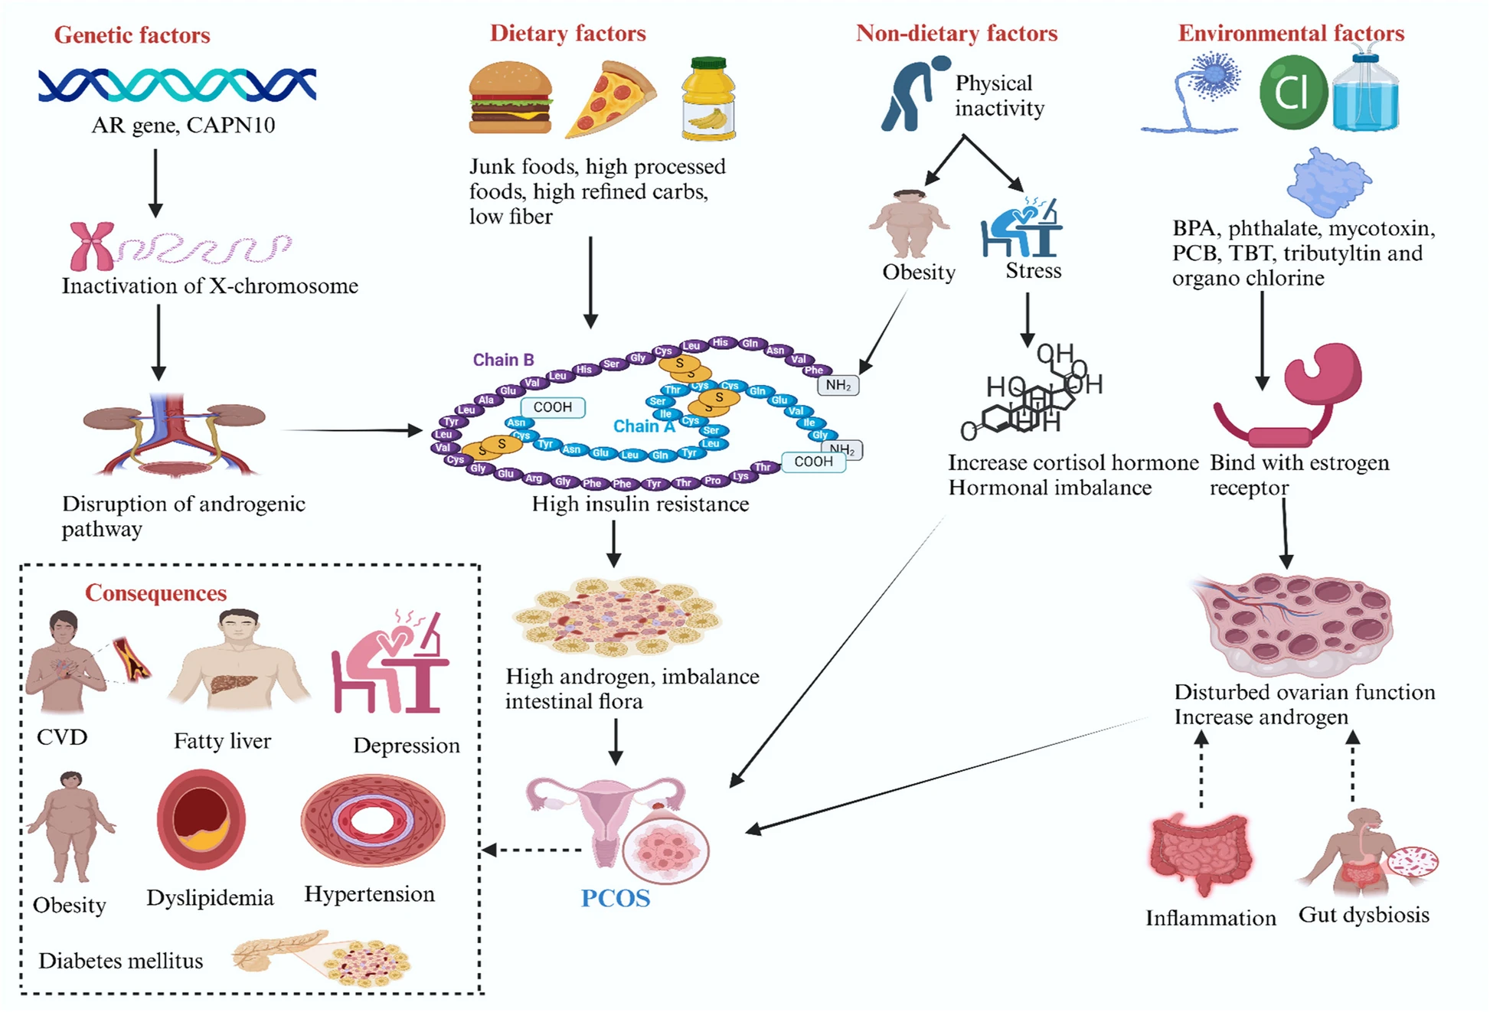
Figure 3: Polycystic ovarian syndrome a risk factor
(Source: Naeem et al., 2025)

2.4.1 Genetic and hormonal factors
PCOS has a high familial clustering whereby first-degree relatives are at high risk. Pathophysiology focuses on hyperandrogenism, dysregulated gonadotropin secretion (increased LH:FSH ratio), and insulin resistance, and genome-wide association studies have found loci that are associated with follicular development and steroidogenesis (Harada, 2022).

2.4.2 Lifestyle and metabolic factors
Poor diet, chronic low-grade inflammation, and obesity increase insulin resistance exacerbating the reproductive and metabolic characteristics. About 40-80% percent of women with PCOS are obese or overweight, which hastens the onset of type 2 diabetes, dyslipidaemia and cardiovascular disease (European Society of Endocrinology, 2026).

2.4.3 Ethnicity and sociodemographic considerations
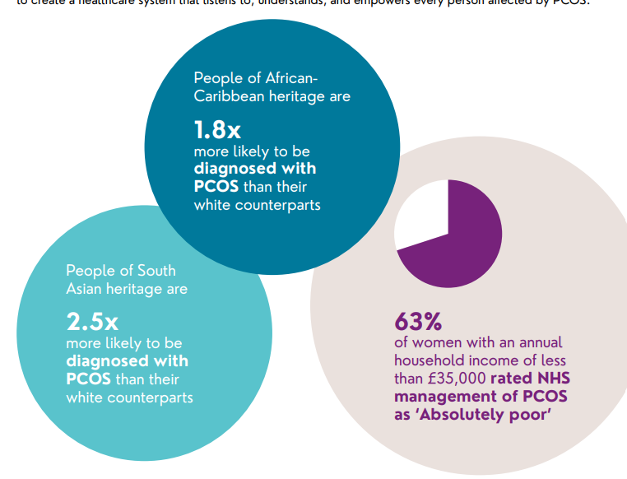
Figure 4: Ethnicity as a factor
(Source: All-Party Parliamentary Group, 2025)
A study indicates alarming ethnic differences. Asian women are more likely to experience it with a ratio of incidence that stands at 2.5x in comparison with White females. In women, especially in less-developed regions, especially in those between 20 and 24 years of age, the incidence is also high and that is a combination of biological disposition, deprivation and lack of equitable access to diagnoses (Naidu et al., 2026).

3. Impact of PCOS and Evidence-Based NHS Treatments

3.1 Physical impact on the individual
PCOS has extensive lifelong physical impacts. Reproductive characteristics encompass menstrual irregularity, anovulation as well as subfertility, where PCOS is recognised by the Naeem et al. (2025) as the leading cause of anovulation in the world. Hyperandrogenic changes like hirsutism, persistent acne and androgenic alopecia lead to apparent body alteration and suffering. Women are at a high risk of type 2 diabetes, non-alcoholic fatty liver disease, hypertension, dyslipidaemia, sleep apnoea and endometrial hyperplasia, which is metabolic. PCOS is confirmed as a significantly increased risk of type 2 diabetes and cardiovascular events in the long term in women with PCOS than in matched controls, where weight gain is a mediating factor in both comorbidities (Shruthi et al., 2025).

3.2 Psychological impact on the individual
The mental impact is immense. A 2025 systematic review and meta-analysis Atinga et al. (2025), found a pooled prevalence of depression (51%) and anxiety (45%) in women of reproductive age with PCOS with the highest rates in women aged 20–25. Women with PCOS are presumed to be three to eight times more probable to be depressed and anxious than their counterparts without the disease, and are additionally at high risk of eating disorders, obsessive-compulsive disorder, body image dissatisfaction and sleep disturbance.
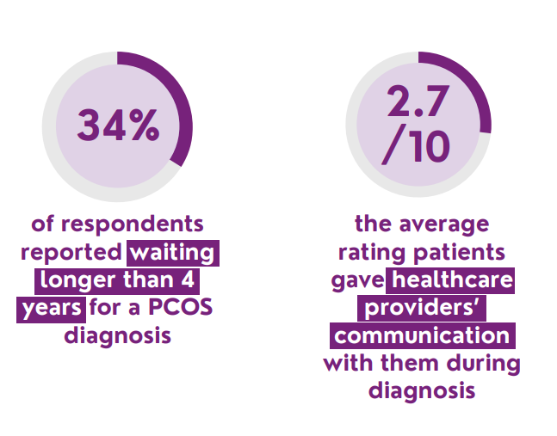
Figure 5: Late Diagnosis of PCOS
(Source: All-Party Parliamentary Group, 2025)
According to the All-Party Parliamentary Group on PCOS (2025), the delay in making a diagnosis, dismissive consultations, and the lack of knowledge of clinicians play a significant role in the development of psychological distress.

3.3 Social impact on the individual
Social impacts have been less quality of life, presenteeism at work, strain in relationships and stigma, relating to observable symptoms of hirsutism, acne and weight gain. Women often complain of leaving social and intimate interactions, decreased levels of education, and financial expenses associated with cosmetic, skin and weight control products (Magalhães, Barbosa and Borges, 2022). Shame, isolation, and intergenerational pressure may be increased due to cultural sensitivities to fertility issues, especially among South Asian and minority ethnic groups in the UK.

3.4 Wider implications for families and carers
The family and partners suffer emotional, financial and caregiving stress especially in fertility expeditions, miscarriage and pregnancy complications like gestational diabetes and pre-eclampsia. The psychological burden of subfertility and assisted reproduction can be shared between the partners. Informal carers, mainly mothers and sisters of affected women, tend to support their affected women emotionally, go with them to appointments and support them in changing their lifestyle, which can disturb employment, family dynamics and intergenerational health expectations.

3.5 Evidence-based NHS treatments

3.5.1 Pharmacological management
Combined oral contraceptives have been approved as the initial interventions in menstrual control and androgen-induced symptoms by the NICE Clinical Knowledge Summary (March 2025). Metformin is commonly used off-label to treat insulin resistance and weight-related, especially in women with a BMI 25 kg/m2 and above. Anti-androgins like spironolactone and cyproterone acetate as well as topical eflornithine in facial hirsutism and acne treatments are all still on routine access via the NHS dermatology and gynaecology routes, based on the multi-system manifestation of this syndrome (Cooper and Patel, 2024).

3.5.2 Lifestyle and behavioural interventions
The foundation of management is the lifestyle change and it has been identified as first-line in the 2023 International Evidence-Based PCOS Guideline and the congruent NHS pathways. Locally commissioned Tier 2 and Tier 3 NHS weight-management services, structured exercise programmes, dietetic input, and behaviour change interventions have been demonstrated to make a significant difference, even in terms of whether body weight has reduced by 5–10%, as it results in an imperceptibly better ovulatory function, insulin sensitivity, and mood (Teede et al., 2023). The prevention-centered change in the 10 Year Health Plan, which is coupled with renewed NHS Health Check guidelines, supports routine prevention of cardiometabolic screening of PCOS women since early adulthood.

3.5.3 Fertility and specialist services
In the draft NICE Fertility Guideline (September 2025), clomifene citrate, letrozole and metformin or a combination of any of these is still maintained as a first-line choice of ovulation induction. Laparoscopic ovarian drilling and gonadotrophins are part of the second-line interventions, with in vitro fertilisation used in cases of clomifene resistance or left refractory cases with access via NHS commissioned pathways through Integrated Care Board (ICB) commissioning policies (NICE, 2026). IVF eligibility by postcode is still a fact in 2025-2026, and the refreshed Women's Health Strategy has pledged to reduce racism in this regard.

3.5.4 Mental health support pathways
NHS Talking Therapies NICE-approved cognitive behavioural therapy and counselling offered to mild-to-moderate depression and anxiety with stepped up service to specialist Community Mental Health Teams should the need arise. The activity level is also high: in the month of April 2025 alone, 133,908 new referrals were documented and 89.6% of all new referrals to the treatment commencing in July 2025 accessed services within six weeks, which is more than the national six-week average (NHS North East London, 2025). The recovery of approximately 48% of referrals which start at clinical caseness is reliable. Perinatal mental health Services provide support to women during pregnancy; new Women's Health Hubs are increasingly offering psychological services as well as endocrine and gynaecological services, complemented by third-sector support, such as Verity PCOS UK (Daniel et al., 2024).

4. Theoretical Perspectives and Models for Improved Outcomes

4.1 UK model: NHS House of Care framework
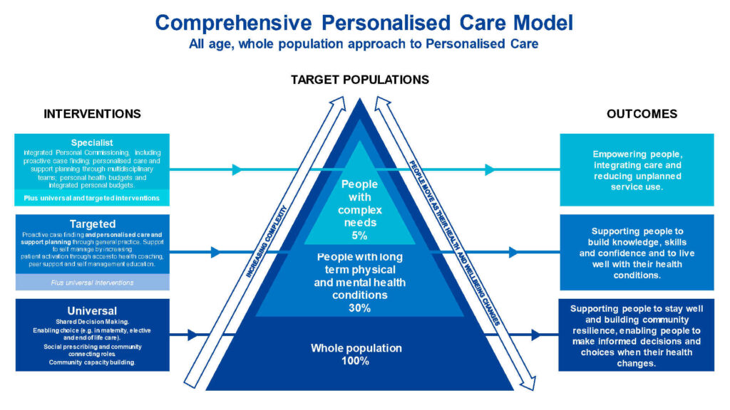
Figure 6: NHS House of Care framework
(Source: Coalition for Personalised Care, 2025)
The NHS House of Care framework provides a system-wide, structured system of managing long-term conditions in England, which is based on personalised care and support planning. It has a conceptual house that is based on four interdependent elements which include engaged, informed individuals and carers (one wall), health and care professionals who are dedicated to partnership working (the opposite wall), commissioning that supports proactive and integrated care (the foundation) and organisational and clinical processes that facilitate care planning (the roof) (Coalition for Personalised Care, 2025). The key element of the model is the care and support planning conversation which makes the individual an expert about his or her life. Its application to PCOS helps to manage shared decision-making in menstrual, metabolic, fertility, dermatological, and psychological fields, substituting fragmented appointments with goal-setting collaboratively and relationship continuity (NHS, 2023).

4.2 International model: WHO Innovative Care for Chronic Conditions (ICCC) framework
The World Health Organization Innovative Care Framework (ICCC) re-conceptualizes care of long-term conditions at three levels of interaction. On the macro level, supportive policy environments are created to create funding, legislation, workforce planning, and intersectoral partnerships. Meso level healthcare organisations and community partners collaborate to facilitate services, capacity-building and continuum. At the micro level, the framework fosters an effective triad of informed, motivated patients and families, prepared and proactive healthcare teams and engaged community partners. In the case of PCOS, ICCC provides a valuable perspective to effectively align the global guideline introduction, NHS commissioning, and local community resources, especially when considering the under-served populations, the care of which does not always occur within the clinic walls (Teede et al., 2024).

4.3 Critical comparison and application to PCOS care
The two frameworks are also similar in that they have a person-centred ethos, and acknowledge that chronic conditions require long-term, multidimensional support as opposed to disease-specific, episodic intervention. As per Coulter et al. (2016), The House of Care is, however, operationally inbuilt in the NHS commissioning and primary care and thus is especially viable in routine PCOS reviews, lifestyle support and metabolic surveillance. ICCC, in turn, is more comprehensive, focusing on policy alignment on the upstream level, community mobilisation, and equity, particularly considering the ethnic and socioeconomic differences in the diagnosis and outcomes of PCOS, which have been well documented. Kharkwal (2025) states that the most important drawback of both frameworks is that they are generic in nature: both of them do not specifically consider the gendered, fertility-related, and stigmatized aspects of PCOS. A composite application, a blend of ICCC macro-level equity lens and micro-level care planning developed by the House of Care, is the most consistent platform that can be used to achieve better PCOS outcomes in the UK setting.

5. Local and National Policy Agendas

5.1 National agendas

5.1.1 NHS Long Term Plan and Women's Health Strategy for England
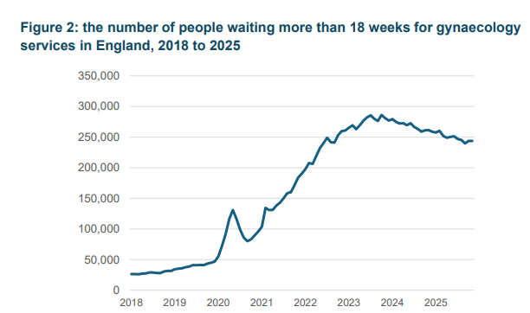
Figure 7: The number of people waiting more than 18 weeks for gynaecology
services in England, 2018 to 2025
(Source: Department of Health and Social Care, 2026)
The NHS Long Term Plan and its follow-up, the 10 Year Health Plan, introduce three systemic changes applicable to the PCOS care: hospital-to-community, analogue-to-digital, treatment-to-prevention. PCOS is a prioritised gynaecological condition as identified in Women's Health Strategy for England (2022) and on 23 October 2025 the Government announced its renewal with the publication of the Renewed Women's Health Strategy for England in April 2026 establishing longer-term commitments (Department of Health and Social Care, 2026). The broader economic argument is also important: the health outcomes of women are estimated to cost the UK economy up to £11 billion a year. Statutory Relationships, Sex and Health Education (RSHE) guidance was revised in July 2025 to incorporate menstrual health, and PCOS, with early awareness being embedded (Uberoi, Stiebahl and Burnett, 2025).

5.1.2 NICE guidance relevant to PCOS
Directly supporting the PCOS management are the Clinical Knowledge Summary on PCOS (March 2025), the draft NICE Fertility Guideline (September 2025) which addresses ovulation induction and IVF, and NICE guidance on type 2 diabetes prevention, obesity, cardiovascular risk and depression in adults (Arshad et al., 2025). Together they allow a multi-pathway, comorbidity-sensitive response, but none of the NICE guidelines to date has consolidated lifelong PCOS management.

5.2 Local agendas
Integrated Care Systems (ICS) and Women's Health Hubs
ICBs are turning national strategy into local delivery, accompanied by an investment of up to £25 million in England between 20232025 to increase Women’s Health Hubs, which represent a 595,000 investment per ICB (GOV.UK, 2026). Hubs are used to co-locate menstrual, contraceptive, menopause, prolapse and reproductive services, PCOS being increasingly included. An example of this is the Tower hamlets Women health hub which reports that referrals to the secondary-care gynaecology were reduced by 60% and local gynaecology waiting lists reduced by 30% in months following the launch of the program (RCOG, 2026). An example of continued rollout is the opening of the first clinics of the Waltham Forest Hub by Barts Health NHS Trust in April 2025.

5.3 Critical examination of policy implementation gaps
There are still considerable gaps in implementation. England had 586,013 incomplete gynaecology pathways as of December 2024 with 44.6 per cent of patients waiting more than 18 weeks and 18,859 waiting longer than 52 weeks. In July 2025, NHS England data indicated that Asian or Asian British origin patients and those in the most deprived communities are disproportionately at risk of waiting longer, further worsening inequalities in PCOS (Uberoi, Stiebahl and Burnett, 2025). The new Jess Rule, which obliges GPs to think again when they have had three undiagnosed consultations, can possibly decrease diagnostic delay, but it needs sound monitoring.

6. Recommendations for Person-Centred Care

6.1 Person-centred and culturally sensitive approaches
PCOS care must be co-created with the person, basing itself on her values and life stage, fertility-sharing objectives, and cultural background. Higher PCOS incidence and longer waits and disparities in diagnoses especially affect South Asian and Black women, and NHS England statistics in July of 2025 validated that Asian or Asian British patients are disproportionately likely to wait over 18 weeks to be treated, compared to any other group (Xu et al., 2025). Interpreter access, culturally sensitive communication, trauma sensitive consultations, body-image sensitive language, and interpreter access must thus be integrated into practice and not considered as optional.

6.2 Self-management support strategies
Planned self-management education instills confidence in setting of goals, monitoring of symptoms, and lifestyle change, assisted by Women's Health Hubs and NHS Talking Therapies and the reliable third-sector providers including Verity PCOS UK. Digital acceptance is now quite massive: since December 2025, there are over 39 million registered users of the NHS App, and 62.3 million logins in November 2025 alone, offering a valid platform to introduce symptom trackers, GP record access, and prescription management. Long-term maintenance of behaviour change can be achieved via motivational interviewing, peer-support networks and health coaching (NHS England, 2025).

6.3 Multidisciplinary and lifelong care considerations
Due to the cross-reproductive, metabolic, dermatological, and psychological areas of PCOS, multidisciplinary working is critical. The input should be coordinated by clear local pathways, mutual digital records, and named care coordinators promoting the contribution of general practice teams, gynaecology teams, endocrinology teams, dietetics teams, dermatology teams, fertility services teams, and mental health teams (Joshi et al., 2023). The screening cardiometabolic, mental health, fertility planning, and menopause transition should be expressly addressed in the yearly review templates with continuity of relationship prioritised throughout adolescence, reproductive years and beyond. This lifelong and neighbourhood based model is stressed by the change in the 10 Year Health Plan of the switch of hospital care to community care (Nappi et al., 2022).

6.4 Note on end-of-life care relevance
The end-of-life care does not generally concern the PCOS per se since the syndrome is not life-limiting. But palliative principles, advance care planning and holistic comfort-based care are still applicable in case women develop life restrictive complications like advanced type 2 diabetes, cardiovascular disease or endometrial cancer (Wilkin, Fang and Sixsmith, 2024). In these cases, assimilation with palliative care services is expected to comply with the laid-down frameworks of NHS end-of-life care guidelines where there should be dignity, control of symptoms and support to the family.

7. Conclusion
PCOS is a multifaceted, chronic disease which has significant physical, psychological, social and economic consequences to women in the UK and worldwide. The time lag in diagnosing, ethnic disparities, discontinuous care, and enduring gynaecological waiting lines highlight the dire necessity of coordinated change. A robust basis is provided by the NHS House of Care/WHO ICCC models, along with the revised Women's Health Strategy, NICE guidelines, and women-focused Women's Health Hubs, which are locally embedded. To achieve better results, it is imperative to invest in the long term, integrate the care with cultural responsiveness and person-centred care, apply multidisciplinary integration, and include the voices of women in both policy and practice as meaningful.

Reference List
All-Party Parliamentary Group (2025). Breaking the Cycle: Addressing Systemic Failures in PCOS Diagnosis and Management A Report by the All-Party Parliamentary Group on Polycystic Ovary Syndrome (PCOS). [online] Available at: https://static1.squarespace.com/static/681cadfb3719d664b7337819/t/68bea7c79232014fbfaaf5b9/1757325255835/APPG+PCOS+REPORT.pdf.
Arshad, A., Armeni, E., Broughton, S., Ali, A., Blendis, E., Gleeson, H., Robinson, L. and Kempegowda, P. (2025). Polycystic ovary syndrome: pragmatic management across levels of care. Gynecological Endocrinology, 41(1). doi:https://doi.org/10.1080/09513590.2025.2574874.
Atinga, A., Bashiru, H.A., Solomon, A.O., Oghide, O., Adufe, I., Aduroja, P.E., Afolabi, A.O., Bakare, A.A., Olabisi, O.I., Mshelia, P.P., Ononuju, A.H., Nwafor, A.V., Olusa, A.S., Okeke, O.P., Akinsolu, F.T., Abodunrin, O.R. and Sobande, O.O. (2025). Depression and anxiety among women with polycystic ovarian syndrome in low- and middle-income countries: a systematic review and meta-analysis. Frontiers in Global Women’s Health, 6. doi:https://doi.org/10.3389/fgwh.2025.1688913.
Berni, T.R., Morgan, C.L. and D Aled Rees (2025). Rising incidence, health resource utilization and costs of Polycystic Ovary Syndrome in the United Kingdom. The Journal of Clinical Endocrinology & Metabolism, 110(5). doi:https://doi.org/10.1210/clinem/dgae518.
Coalition for Personalised Care. (2025). The NHS Comprehensive Model of Personalised Care - Coalition for Personalised Care. [online] Available at: https://www.coalitionforpersonalisedcare.org/the-nhs-comprehensive-model-of-personalised-care/.
Cooper, D.B. and Patel, P. (2024). Oral contraceptive pills. [online] PubMed. Available at: https://www.ncbi.nlm.nih.gov/books/NBK430882/.
Coulter, A., Kramer, G., Warren, T. and Salisbury, C. (2016). Building the House of Care for People with long-term conditions: the Foundation of the House of Care Framework. British Journal of General Practice, [online] 66(645), pp.288–290. doi:https://doi.org/10.3399/bjgp16x684745.
Daniel, K., Bousfield, J., Hocking, L., Jackson, L. and Taylor, B. (2024). Introduction. [online] Nih.gov. Available at: https://www.ncbi.nlm.nih.gov/books/NBK607333/.
Department of Health and Social Care (2026). The Renewed Women’s Health Strategy for England. [online] Available at: https://assets.publishing.service.gov.uk/media/69df5d7261d2e8e9b9e42d2e/renewed-womens-health-strategy-for-england-web-accessible.pdf.
European Society of Endocrinology (2026). Heart disease risk increases in women with polycystic ovary syndrome. [online] News-Medical. Available at: https://www.news-medical.net/news/20260510/Heart-disease-risk-increases-in-women-with-polycystic-ovary-syndrome.aspx
GOV.UK. (2026). £25 million for women’s health hub expansion. [online] Available at: https://www.gov.uk/government/news/25-million-for-womens-health-hub-expansion.
Harada, M. (2022). Pathophysiology of polycystic ovary syndrome revisited: Current understanding and perspectives regarding future research. Reproductive Medicine and Biology, [online] 21(1). doi:https://doi.org/10.1002/rmb2.12487.
Joshi, B., Patil, A., Vaidya, R., Begum, S., Chauhan, S., Mukherjee, S. and Kokate, P. (2023). An integrated multidisciplinary model of care for addressing comorbidities beyond reproductive health among women with polycystic ovary syndrome in India. Indian Journal of Medical Research, 0(0), p.0. doi:https://doi.org/10.4103/ijmr.ijmr_2497_19.
Kharkwal, D. (2025). The Invisible Burden: A Qualitative Exploration of PCOS/PCOD’s Psychosocial and Educational Consequences in Indian College Students. INTERNATIONAL JOURNAL OF MULTIDISCIPLINARY RESEARCH AND ANALYSIS, 08(04). doi:https://doi.org/10.47191/ijmra/v8-i04-49.
Magalhães, S., Barbosa, J. and Borges, E. (2022). The relationship between presenteeism, quality of life and social support in higher education professionals: A cross-sectional path analysis. PLOS ONE, 17(4), p.e0267514. doi:https://doi.org/10.1371/journal.pone.0267514.
Myers, A. (2026). PCOS statistics: What the numbers really mean. [online] Allarahealth.com. Available at: https://www.allarahealth.com/blog/pcos-statistics-facts.
Naeem, I., Zehra, A., Rehman, F., Hussain, A., Hussain, A., Hussain, N., Waseem, M., Alqahtani, R.M., Shamlan, G., Ahmed, I.A.M., Manzoor, M.F. and Abdullahi, M.A. (2025). Polycystic ovarian syndrome a risk factor for non-communicable diseases: insights into recent research and prevention approaches. Journal of Ovarian Research, 18(1). doi:https://doi.org/10.1186/s13048-025-01741-z.
Naidu, A.S., Lo, J.C., Darbinian, J.A. and Greenspan, L.C. (2026). US Adolescents of Asian Ethnicity Have Higher Risk of Polycystic Ovary Syndrome. Hormone Research in Paediatrics, pp.1–5. doi:https://doi.org/10.1159/000552156.
Nappi, R.E., Chedraui, P., Lambrinoudaki, I. and Simoncini, T. (2022). Menopause: a cardiometabolic transition. The Lancet. Diabetes & Endocrinology, [online] 10(6), pp.442–456. doi:https://doi.org/10.1016/S2213-8587(22)00076-6.
NHS (2023). House of Care. [online] www.whittington.nhs.uk. Available at: https://www.whittington.nhs.uk/default.asp?c=31000.
NHS England (2025). NHS England» Record numbers using NHS App to manage health. [online] England.nhs.uk. Available at: https://www.england.nhs.uk/2025/12/record-numbers-using-nhs-app-to-manage-health/.
NHS North East London. (2025). Mental health - talking therapies - NHS North East London. [online] Available at: https://northeastlondon.icb.nhs.uk/service/mental-health-talking-therapies/.
NICE (2026). Overview | Fertility problems: assessment and treatment | Guidance | NICE. [online] Nice.org.uk. Available at: https://www.nice.org.uk/guidance/ng257.
RCOG (2026). As gynaecology waiting lists rise, a North London women’s health hub shows the way forward | RCOG. [online] RCOG. Available at: https://www.rcog.org.uk/news/as-gynaecology-waiting-lists-rise-a-north-london-women-s-health-hub-shows-the-way-forward/.
Shruthi, S., Lakshmi, G., T S, M. and Washington, J.K. (2025). Evaluating the Role of Urinary Amylase in Diagnosing Acute Pancreatitis: A Systematic Review and Meta-Analysis. Cureus. doi:https://doi.org/10.7759/cureus.98869.
Singh, S., Pal, N., Shubham, S., Sarma, D.K., Verma, V., Marotta, F. and Kumar, M. (2023). Polycystic Ovary Syndrome: Etiology, Current Management, and Future Therapeutics. Journal of Clinical Medicine, [online] 12(4), p.1454. doi:https://doi.org/10.3390/jcm12041454.
Teede, H.J., Gibson, M., Laven, J., Dokras, A., Moran, L.J., Piltonin, T., Costello, M., Mousa, A., Joham, A.E., Tay, C.T., Arlt, W., Azziz, R., Balen, A., Bedson, L., Berry, L., Boivin, J., Boyle, J., Brennan, L., Brown, W. and Burgert, T. (2024). International PCOS guideline clinical research priorities roadmap: a co-designed approach aligned with end-user priorities in a neglected women’s health condition. eClinicalMedicine, 78, p.102927. doi:https://doi.org/10.1016/j.eclinm.2024.102927.
Teede, H.J., Tay, C.T., Laven, J.J.E., Dokras, A., Moran, L.J., Piltonen, T.T., Costello, M.F., Boivin, J., Redman, L.M., Boyle, J.A., Norman, R.J., Mousa, A. and Joham, A.E. (2023). Recommendations From the 2023 International Evidence-based Guideline for the Assessment and Management of Polycystic Ovary Syndrome. The Journal of Clinical Endocrinology and Metabolism, [online] 108(10), pp.2447–2469. doi:https://doi.org/10.1210/clinem/dgad463.
Uberoi, E., Stiebahl, S. and Burnett, H. (2025). Women’s health. [online] Available at: https://researchbriefings.files.parliament.uk/documents/CDP-2025-0038/CDP-2025-0038.pdf.
Wilkin, K., Fang, M.L. and Sixsmith, J. (2024). Implementing Advance Care Planning in Palliative and End of Life care: a Scoping Review of Community Nursing Perspectives. BMC Geriatrics (Online), [online] 24(1). doi:https://doi.org/10.1186/s12877-024-04888-4.
World Health Organization (2025). Polycystic ovary syndrome. [online] World Health Organization. Available at: https://www.who.int/news-room/fact-sheets/detail/polycystic-ovary-syndrome.
Xu, R., Li, X., Sang, L., Su, L., Song, L., Ren, Y. and Su, J. (2025). Global Burden and Future Trends of Polycystic Ovary Syndrome: Insights from the GBD 2021 Study. International Journal of Women s Health, Volume 17, pp.3707–3720. doi:https://doi.org/10.2147/ijwh.s556627.
Zhang, Q., Yang, Z., Ou, X., Zhang, M., Qin, X. and Wu, G. (2025). The role of immunity in insulin resistance in patients with polycystic ovary syndrome. Frontiers in Endocrinology, 15. doi:https://doi.org/10.3389/fendo.2024.1464561.

