

Leadership and management, theory and practice

Student: Ana Baicu, 2012401
Lecturer: Mushfiqur Rahman
Module cod: LCBB6003

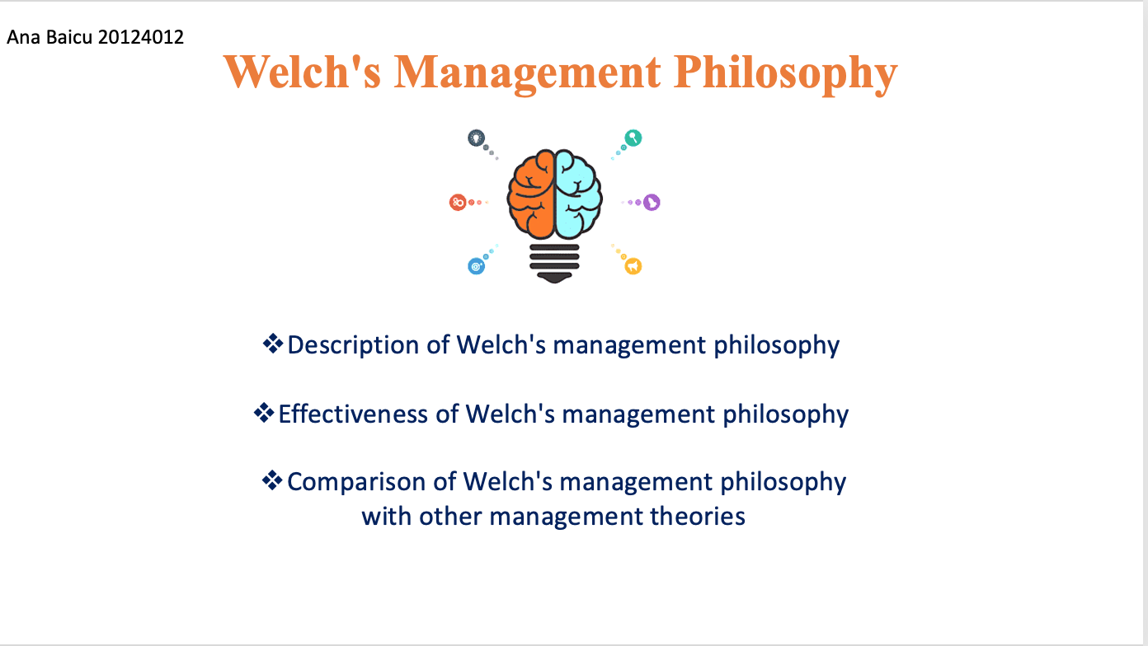

Welch's Management Philosophy
The foundation of Welch's management approach was "boundaryless" companies. He always allowed his managers the freedom to make choices and take charge of their companies because he believed in the benefits of decentralisation (Ulrich, & Lake, 2018). Welch also put in place a strict performance management system intended to find and advance the finest employees. He thought that by placing the appropriate people in the right roles, GE could accomplish its objectives. To promote cooperation and creativity, Welch's strategy also involves tearing down organisational barriers between business divisions and flattening the structure.
Welch's management style was effective, as seen by GE's substantial expansion and achievement during his leadership. Under his direction, GE's market value increased by more than 4,000%, and he turned the business into one of the most valuable in the world. Welch's focus on talent development and performance management helped ensure that the appropriate individuals worked in the proper positions. His strategy of decentralisation and dismantling silos promoted cooperation and creativity.
However, some of Welch's management practices, such as the "Rank and Yank" system, have been criticized for being too harsh and demotivating to employees (Jones, & George, 2020). This system produced a culture of fear and competition within the company, which could have adversely affected employee morale and creativity.
Welch's management philosophy can be compared to other management theories, such as transformational leadership and the balanced scorecard approach. Transformational leadership emphasizes the importance of inspiring and motivating employees to achieve their full potential. Welch's leadership style can be seen as transformational in his ability to inspire and push his employees to achieve more (Delaney, 2018). The balanced scorecard approach measures and manages performance across multiple dimensions, including financial, customer, internal processes, learning, and growth. Welch's emphasis on performance management and talent development aligns with the balanced scorecard approach, focusing on measuring and improving performance.

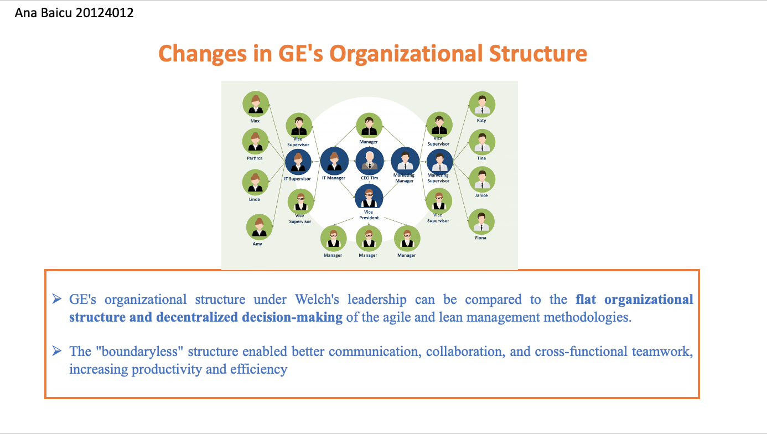

Welch oversaw the implementation of significant organisational reforms at GE. The elimination of silos between business divisions and the flattening of the hierarchical structure were two of the biggest improvements. Welch thought that bureaucracy and traditional hierarchical institutions hampered creativity and innovation (Latham, 2017). To stimulate cooperation, communication, and cross-functional teamwork, he put into place a "boundaryless" organisational structure. Welch also allowed his managers the freedom to run their company independently and make their judgments.
The changes in GE's organizational structure under Welch's leadership were influential in fostering a culture of innovation and promoting creativity within the company. The "boundaryless" structure enabled better communication, collaboration, and cross-functional teamwork, increasing productivity and efficiency. The decentralization of decision-making and autonomy given to managers helped create a sense of ownership and accountability, leading to better performance and results.
GE's organizational structure under Welch's leadership can be compared to the flat organizational structure and decentralized decision-making of the agilee and lean management methodologies (Edmonson, 2019). These methodologies empower employees and foster collaboration and innovation to achieve the organization's goals. However, GE's organizational structure also had some similarities with the traditional bureaucratic structure, such as focusing on hierarchy and top-down decision-making. Overall, GE's "boundaryless" structure effectively promoted innovation and creativity within the company.

References
Welch, J., & Byrne, J. A. (2021). Jack: Straight from the gut. Business Plus.
Goldsmith, M., & Carter, L. (2017). Best practices in leadership development and organization change: How the best companies ensure meaningful change and sustainable leadership. John Wiley & Sons.
Jones, G. R., & George, J. M. (2020). Essentials of contemporary management. McGraw-Hill.
Delaney, J. T. (2018). Strategic human resource management. Oxford University Press.
Edmonson, A. (2019). Psychological safety and learning behavior in work teams. Administrative science quarterly, 44(2), 350-383.
Collins, J. (2015). Good to great: Why some companies make the leap and others do not. HarperCollins.
Quinn, R. E. (2018). Beyond rational management: Mastering the paradoxes and competing demands of high performance. Jossey-Bass.
Galbraith, J. R. (2016). Designing complex organizations. Addison-Wesley.
Hamel, G., & Prahalad, C. K. (2014). Competing for the future. Harvard Business Press.
Barney, J. (2021). Firm resources and sustained competitive advantage. Journal of Management, 17(1), 99-120.
Noe, R. A., Hollenbeck, J. R., Gerhart, B., & Wright, P. M. (2017). Human resource management: Gaining a competitive advantage. McGraw-Hill Education.
Latham, G. P. (2017). Work motivation: History, theory, research, and practice. Sage Publications.
Ulrich, D., & Lake, D. G. (2018). Organizational capability: Competing from the inside out. Wiley.
Finkelstein, S., Hambrick, D. C., & Cannella Jr, A. A. (2019). Strategic leadership: Theory and research on executives, top management teams, and boards. Oxford University Press.

