ASSIGNMENT 2 MARKETING MANAGEMENT

SUBMITTED TO
“UNIVERSITY OF WALES TRINITY SAINT DAVID”

NAME: SUDARSHAN SUNIL ALANDE

STUDENT ID: 2220282

COURSE: MBA- GENERAL MANAGEMENT

LECTURER: PROF. TUSHARA BALENDRAN

COURSE MODULE: MARKETING MANAGEMET

CODE: LCMB7001

TABLE OF CONTENT
Sr. No. | Title/ Content | Page No.
1 | Introduction  - Background  - Aim of the Study  - Mission  - Vision | 3
2 | Communication  - Definition  - Shannon-Weaver’s Communication Model  - Components of Communication Model | 6
3 | Integrated Marketing Communication (IMC) | 8
4 | Tumi- New Promotional Strategies  - Online  - Offline | 8
5 | Branding and Brand Equity | 10
6 | Keller’s Brand Equity Model  - Advantages  - Disadvantages | 10
7 | Customer Journey  - Definition  - Stages of Customer Journey | 15
8 | Customer Touchpoints  - Definition  - Customer Journey Touchpoints | 17
9 | Customer Persona | 19
10 | Customer Journey Map | 21
11 | Strengths and Weaknesses of Customer Journey Map | 22
12 | Total Engagement Model | 23
13 | Recommendations | 25
14 | Conclusion | 26
15 | References | 27

INTRODUCTION

Since 1975, TUMI has optimized excellent business, travel, and lifestyle necessities with enhanced, intelligent design in order to simplify, enhance, and enrich consumers' lives on the road. The American-designed premium brand is available in the United States, France, England, and the capital city of Tokyo as well as the world's major specialty, department, and travel retailers in over 75 countries.
In this report, analysis of Tumi strategies including new and current promotional strategies, different models analyzing company positioning and critical analysis, its advantages and disadvantages has been discussed. Along with Customer Journey map, its touchpoints and improvement has been discussed followed by conclusion and recommendation.
The brand is recognized across the globe as the leading maker of luggage and accessories for individuals whose lifestyles involve world-class business, performing luxury, and, of course, travel. Tumi has been producing high-quality, useful fundamentals to enhance the different aspects of the jet-setter lifestyle since 1975. TUMI has been broadening its view of the globe-trotting man since that first stitch, now embracing perfumes in its collection of top luxury items.
Tumi is committed to quality and innovation. Their designs are as useful as they are beautiful, made with quality and sustainable materials and with an eye towards intuitive utility and modern technology integration.
Everything they make is built to move and engineered to last. They are constantly moving forward—evolving and responding to client requirements in order to pursue their hobbies and navigate the globe with flair and convenience.
(Source- https://www.fashionabc.org/wiki/tumi/)

(Image Source: https://go.kotisdesign.com/brands/tumi/)

Background
Following over three decades of offering top-notch goods to wealthy, seasoned travelers who traverse the world frequently, Tumi has emerged as the global leader in luxury travel, business, women's bags, and personal accessories. The secret to Tumi's success is its unwavering commitment to its basic values of outstanding design, superior functionality, and technical innovation.

TUMI was founded by Charlie Clifford, an American entrepreneur and former Peace Corps member who imports leather bags from South America. The firm was named after a Peruvian deity that its creator got to know while serving in the American Peace Corps in South America and was founded in 1975. The pioneering development of soft, black-on-black ballistic nylon travel bags by Tumi throughout the 1980s propelled the business to its current position as a market leader. Sales five-folded in the 1990s as people all around the world came to favor Tumi's distinctive fusion of cutting-edge design with unrivalled performance.
Tumi now has more than 27 patents for its groundbreaking technical and design work. Tumi's position as the top innovator in the field of travel and personal accessories will be safe for years to come with the current release of the cutting edge T3 Collection and the impending debut of the Generation 4 luggage and Signature series.
(Image Source: https://www.inc.com/magazine/20110501/how-i-did-it-charlie-clifford-tumi-luggage.html)
Tumi is aware that every one of its clients has distinct demands and that they require a range of items to suit their own travel preferences. Tumi consistently releases exceptional new product lines that embody the brand's core values of performance, organization, and contemporary design. Gift wrapping, card insertion, and drop shipping are just a few of the value-added services provided by the Tumi Special Markets Division, led by Michael Landry. (Anonymous, Incentive, New York, 2005)

Aim of the Study
The primary goal and purpose of this research are to identify the unique marketing methods of Tumi, a global consumer Premium or Luxury Travel and Lifestyle Company in terms of financial aspects and user numbers. For years, the organization has worked in the sector of travel and lifestyle gear, creating a better experience for consumers with its ability to invent new and update items. Understanding these types of strategies is the study's aim component. The Study will assist in understanding the trades, patterns, and innovations taken care of by Tumi in order to demonstrate its perfect marketing skills and strategies for raising brand awareness in addition to handling and assessing customer experiences across a range of communication channels in order to guarantee current and future stakeholders' expectations are met.
Mission
According to Tumi UK Brand Profile, the mission statement is to provide beautifully optimized solutions that help people move freely, whereas others only shows you where to go, Tumi actually takes customer to places.
Vision
The company's aim is that they are devoted to acquiring responsibly and minimizing the environmental effect of their products. Tumi takes focused action in ways that can have a significant influence on the environment, creating long-lasting and repairable goods while expanding the usage of recycled, renewable, and creative materials. Brand is committed to leaving the world a better place than they found it, and their initiatives in Diversity and Inclusion, Sustainability, and Philanthropy are some of the steps they're doing to achieve this goal. (Fashion ABC) (Tumi.com)

TUMI designs that are robust, practical, and visually appealing by incorporating the best and strongest materials to add luxury and make a product that is durable and not break down with everyday wear and tear. TUMI has taken the globe by storm, with coverage in periodicals such as 'Women's Health,' 'GQ UK,' 'New Yorker,' 'LA Times,' 'Forbes Korea,' and 'Boomerang Business Week,' to mention a few. TUMI prides pride in the things they call 'TUMI Solutions,' which are mostly the methods of production and design that go into their travel line; how they can overcome the stresses of travel and make it easier for the user. Among the solutions are the following:
- TUMI T-Pass
- The TUMI Tracer
- TUMI ID Lock
- TUMI Add-a-Bag Strap
They also have a 30-step trial procedure before finalizing the product, which includes crucial features such as product quality and selecting the correct materials, aesthetics, and function.
COMMUNICATION

Communication can be defined as a transmission of information or sharing a meaning;
or according to British Dictionary, Communication can be defined as the act or an instance of communicating; the imparting or exchange of information, ideas, or feelings.(British Dictionary)
From a marketing point of view, the promotion function allows information to flow between the manufacturer and the target audience (end consumers, intermediaries, stake holders, employees, financial institutions like banks, and all the elements which form the target market).
Understanding the components of the communication process and the flow of information is critical for a marketer.

Communication Model (Shannon and Weaver)
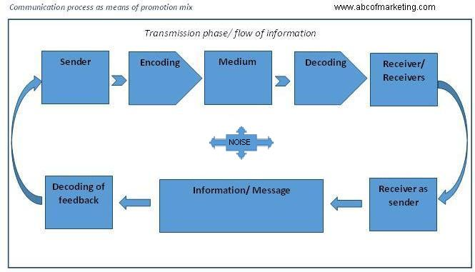
(Image Source: ABC of Marketing)
Shannon, an American mathematician, electronic engineer, and Weaver, an American physicist, collaborated in 1948 to publish "A Mathematical Theory of Communication," commonly known as the "Shannon-Weaver model of communication," in the "Bell System Technical Journal."
This paradigm was developed expressly to facilitate effective communication among sender and recipient. The model considers data source, transmitter, noise, channel, message, receiver, channel, information destination, encode and decode.

Components of Communication process:
- The individual or organization who originates a message is known as the sender or communicator.
- The individual or organization to whom a communication is addressed is referred to as the receiver or interpreter.
- The communication (verbal and/or nonverbal content) must be encoded by the transmitter and decoded by the recipient as it travels across the channel.
- The channel through which communication is delivered and received is referred to as the medium.
- Noise is defined as any interference with or distortion of the sender's message. Noise obstructs effective communication.
- Feedback is a reaction from the receiver indicating whether or not a message was received correctly.(ABC Marketing)
Sender: The model begins with the information source, often known as the sender. This is the person in charge of communicating the information. The message, the receiver, and the route by which the data will be delivered are all chosen by the sender. The use of body language, writing, spoken word, or music can all be used to express a message. An excellent example is a radio newsreader. The newsreader will choose the message to convey before the show begins.
Encoding: The encoder is often referred to as the transmitter. This is the person or piece of equipment in charge of turning a message to a signal that may be transmitted from its sender to the destination. The concept was first created to illustrate how electromagnetic radiation and binary digits are used to interact in computers and telephones. By turning the notion to be transmitted into written or spoken words, a person might act as the encoder. A station of radio is an example of a transmission device since it turns voice to radio waves, which are then broadcast through radio.
Medium: The medium or device which transmits information from the point of origin to the decoder and receiver is referred to as this. In a landline phone, for example, wires are used as the channel.
Noise: Noise refers to the disturbances that occur while a transmission travels from source to receiver. It can be physical, such as when a nearby kid screams while someone is on the phone. It can also be psychological, such as when a mental distraction from a former experience happens.
Decoding: The decoder is the reception point where a signal is turned into a decipherable message. Equipment, software, machines, and persons are all examples of decoders. It is the inverse of encoding.
Receiver: A receiver is also referred to as the destination. This is the final step in the communication process. After considering the noise, a person receives the message delivered to them. As an example, consider receiving a text message on one's phone.
Feedback: Feedback is a reaction sent by a receiver to a sender. A text message reply is an example.
(Source- Garret Dickinson, 2022)

Integrated Marketing Communication
IMC is the process of combining marketing communication aspects such as public relations, social media, consumer analytics, business development principles, and advertising to create a brand identity that is consistent across many media channels.
IMC helps public and private organizations and enterprises to create a compelling and seamless customer experience for a product and/or service, as well as optimize an organization's image and stakeholder relationships. Workers with an integrated marketing communications background may work in industries that include marketing on social media, online media, journalism, market research and consultancy, publicity, non-profit and government, entertainment, television and radio, and other related disciplines. (Master’s in communication, 2022)

New Promotional Strategies
Tumi holds a great position in luxury fashion market, still there are opportunities for the brand to grow further by adding new promotional strategies.
Luxury and Fashion retailers are all on providing an exclusive, aspirational, and unforgettable experience. Yet, luxury brand marketing entails more than just developing a visually appealing website or utilizing celebrity endorsements or influencer marketing.
Online:
- Tumi must understand what the consumer wants from a company and how digital may help them get there in order to compete in the increasingly competitive premium industry and attract new customers.(Neil Patel, 2023)
- Tumi may try to launch some of their signature products only on their website by using Price Skimming method from Ansoff matrix but provide some discount on it. This may help to grow sale of Omni channel website.
- Even if business have a physical business, a robust email marketing strategy is crucial. Obtaining as many e-mail addresses that are available from customers, prospective customers, Tumi event attendees, and so on. Following the launch, the team may send an e-mail to all of those people alerting them that they can now buy at the business online. Consider sending an email with a promotion or a referral discount to encourage clients to share the website with people they know. Email is still one of the most effective marketing tools in the ecommerce arsenal, so keep collecting email addresses on the site.
- Utilizing Google AdWords for search engine marketing allows brand to bid on keywords in order to appear first in search engine results pages. Obtaining the desired "top spot" is what search engine optimization is all about keeping in mind that Google AdWords will still appear first.
- Establish cross-promotional partnerships with other brands. Finding a firm that has a similar target demographic but a distinct product. As a consequence, each business partner is able to access an entirely new and relevant audience. Depending on the time of year, a co-branded gift guide may be a fantastic endeavor. Tumi might also run down-funnel promotions, such as giving a discount on one product in return for buying another.
- Tumi can get a wonderful opportunity to encourage their ideal client's decision with inspirational images or by linking essential components of Tumi products with unique or unconventional lifestyle choices.
Offline:
- Tumi can embrace celebrity endorsements in its advertising approach for its products. As brand ambassadors, famous actors and celebrities might be affiliated with the brand. They can actually participate in high-profile brand promotions. Tumi can also actively sponsor in big sporting events like Olympics and racing.
- Tumi may emphasize their brand's emotional appeal, stressing the sentiments of luxury and decadence that it provokes. This can be a very powerful technique to connect with people on an emotional level and build brand loyalty. It can be especially effective when targeting premium travelers and gain more attention than competitors like Rimova, Samsonite.
- Most of the competitive brands provides lifetime warranty on most of their products which Tumi also used to follow until acquired by Samsonite. Providing lifetime warranty again can be helpful to rebuild the trust within loyal customers.
Apart from online and offline promotional strategies, Tumi can have promotional strategies for not only customers but also suppliers and distributors. Tumi offers 50% off on all the products to its employees as employee discount. Also, if any Tumi employee refers to their friends or family members a Tumi product, they offer 15% additional off on their purchase. Likewise Tumi can also offer some amount discount to its suppliers and distributors to gain more business.
Branding
Branding refers to the act of building a distinct identity for a firm in the eyes of its target audience and consumers is referred to as branding. Branding, at its most basic, comprises of a company's logo, visual design, goal, and tone of voice. (Source- shopify.com)

Brand Equity
Brand equity is defined as the value premium generated by a corporation when a product with a distinctive name is compared to a generic alternative. Companies may increase brand equity for their goods by making them memorable and unique, easily recognizable, and better in quality and reliability.
Source- https://www.investopedia.com/terms/b/brandequity.asp

Keller’s Brand Equity Model
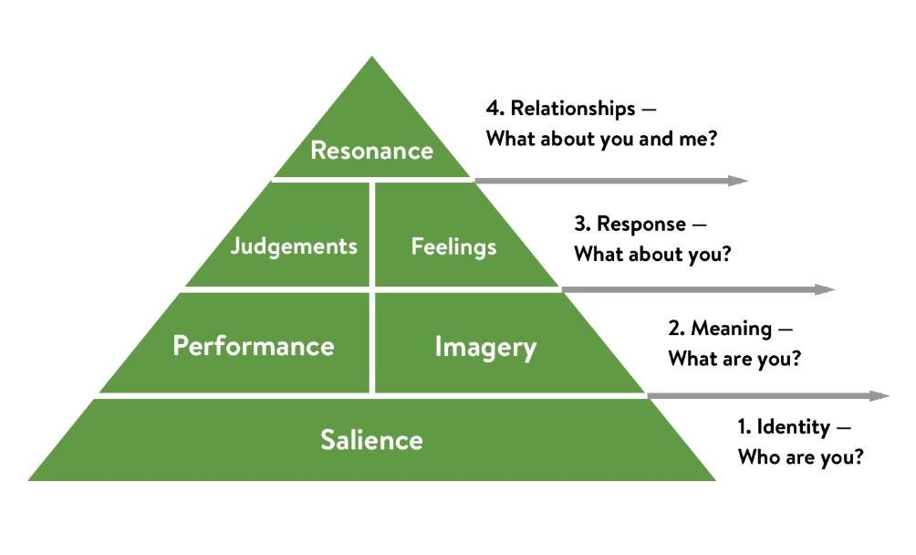
(Source- Medium.com, Keller’s Brand Equity Model)

Kevin Lane Keller established Keller's Brand Equity Model (also known as the Customer-Based Brand Equity (CBBE) Model) in his widely used textbook, "Strategic Brand Management." (Source- Medium.com)
The Brand Equity Model is built on the basic premise that in order to build a successful brand, it must influence how people feel and think about their product. Every brand must develop acceptable brand experiences so that customers have particular, positive ideas, feelings, beliefs, attitudes, and perceptions about it.
Customers that have high brand equity will buy more from that brand, advocate it to others, are more loyal, and are less likely to switch to a competitor.
- Brand Identity (Salience)
The brand equity pyramid is built on salience, which represents how aware people are of a brand's presence in general. This is a key initial step in creating consumer brand equity; if individuals lack information about the brand, they won't be able to form an opinion about it. This section carries the weight of the entire pyramid.
This level, without a doubt, is about more than just assuring that people recognise the brand; it must be the proper recognition. In this first instance, it is vital to offer individuals with a clear, consistent, and accurate depiction of the brand's identity, since they will have little chance of progressing up the pyramid if they do not.
Tumi, as a brand has its own image and unique symbol. Luxury shoppers can easily identify the brand by its logo. (Hitesh Bhasin, 2009)
- Brand Meaning (Performance and Imagery)
The goal of this stage is to establish a brand meaning for the consumer. Consumers must grasp what the brand represents and what it stands for.
'Performance' and 'Imagery' are the major building pieces at this stage. To accomplish this, the branding goal is to generate points of parity and differentiation. Simply using images is not enough; the brand must also deliver on its promises in order to develop resonance with the customer.
Brand Imagery- refers to a brand's intangible qualities. It primarily addresses how a company intends to meet a consumer's social and psychological demands. It is made up of sub-components such as:
User profiles- describe the types of people and organizations who use the brand. It entails the division of demographic and psychographic data.
Purchase and usage context - refers to when and where the brand is purchased, where it is acquired, and if it is utilized on a regular, infrequent, formal, or informal basis, among other things.
Brands, like people, have personalities and ideals. Keller discusses various dimensions of brand personality, including sincerity, energy, competence, sophistication, and roughness.
History, heritage, and experience - mostly discusses the brand's history and heritage over the years, as well as the impact it has on consumer views.
Tumi does carry a history of their classic collection and Ballistic Nylon. Tumi is evolving with sustainability and charity as they product products with recyclable material.
Also since 2016, Tumi has collaborated with Waves For Water to make an impact on water crises. They are supporting communities across more than 10 countries around the globe to provide pure water for more than 5 million people.
Brand Performance - This relates to the brand's tangible aspects. It is primarily concerned with the brand's ability to meet functional needs. The 'product' itself and how it delivers are the most crucial components of brand equity. (Keaton Hawker, 2019)
Keller identified the following brand performance sub-components:
Primary and secondary features - refers to the satisfaction of the product's basic advantages, which is its primary characteristic, and the provision of auxiliary benefits as a secondary feature. When you enter in the store, the ambience and fashion consultants or sales persons presents the brand image and can judge the performance on basis on that before even availing the service.
Service efficiency, efficacy, and empathy - service effectiveness refers to the level of customer satisfaction following service provision, efficiency refers to responsiveness in terms of time, speed, and so on, and empathy represents customer care and trust in the brand.
Style and design are the most visible and reflect the aesthetic components of the brand. The appearance, feel, smell, texture, form, size, and color all play a role in the consumer decision-making process.
One of the most essential components of performance is price. Consumers' views and expectations of a product are generally formed based on the price it commands in the market. In the long run, a good price plan can help you build brand equity.
- Brand Response (Judgements and Feelings)
When a customer purchases a product, they have opinions about the brand and the purchase. If the consumer's expectations are satisfied, he is overjoyed and has positive thoughts about the brand. If the product outperforms expectations, it generates a lot of talk and may convert the customer into a brand advocate. Customers get "Feelings" as a result of such wonderful encounters.
However, if the experience is unfavorable, the customer is left with negative thoughts about the brand, which is referred to as "Judgements." According to the approach, a brand with more feelings than judgements helps from creating brand equity. As a result, brand response is greater on the Brand equity hierarchy.(Hitesh Bhasin, 2009)
Tumi always send a feedback message or email to get the feedback for the improvement also to be connected with the customer to make customer loyalty.
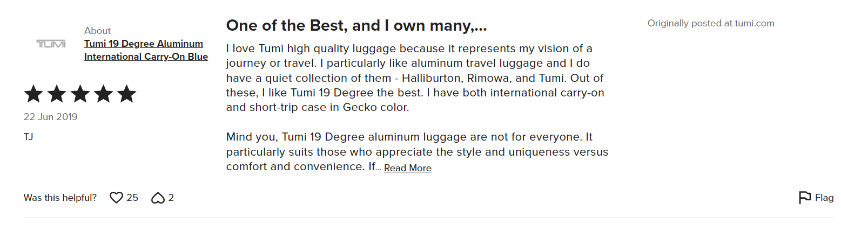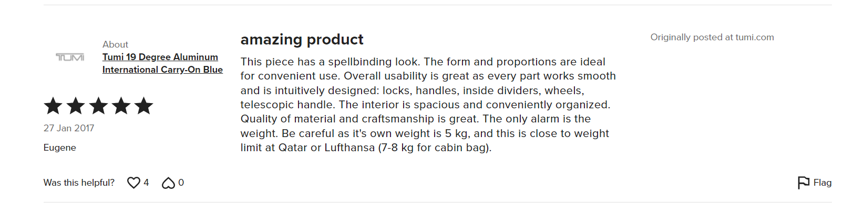
(Source: Tumi.com)

- Brand Relationship (Resonance)
Brand resonance is how a customer identifies with a brand. This is the strong, long-term relationship that the brand hopes to build with each and every consumer acquired along the road. The goal is for the brand to connect so powerfully with consumers that they do not just return, but also become brand ambassadors.
Loyalty programs, client involvement via the internet and social media platforms, and the development of emotional ties are all excellent strategies for increasing resonance. Tumi does not really have loyalty cards or membership programs all over the globes as such, but they do believe in maintaining relationship with the customer on store level where in customers are contacted by the respective stores where they have been making the purchase from. Brand representatives get in touch with the customers to get the feedback and make a note of it.

Advantages of Keller’s Brand Equity Model
- The brand equity concept is investigated in order to ascertain how marketing communications might develop passionate, active loyalty bonds and affect brand equity. Keller (2009)
- The reason strongest brand in the CBBE model succeeds in each of the six brand building blocks, allowing companies to succeed. Keller (2001)
- Brands that can establish client resonance and affection get a plethora of benefits, including larger price increases and more effective marketing operations.
- As a brand's committed customers and supporters grow, so does the quantity of organic social media posts about the company, product, or service. Customers can utilize their personal social media profiles to express their positive brand experiences on a variety of digital channels, which helps to improve brand awareness. As their consumers begin to promote their brand for free, many businesses perceive a rise in engagement and a decrease in advertising costs.

Disadvantages of Keller’s Brand Equity Model
- Brand must devote a significant amount of time and effort in branding because it necessitates effort, and making attempts necessitates time through various promotional strategies, just as advertising necessitates time and work.
- Kuhn et al. (2008) observed that emotions did not play a role in the context of industrial marketing and suggested that resonance be adjusted to be more relevant.
- The role of corporate representatives in building brand equity is also emphasized, underlining the need of include this human aspect in a between businesses brand equity model.

Customer Journey
Definition:
A customer journey is the series of encounters an individual has with the brand, product, and/or service. It encompasses both direct interactions, such as contacting customer service, and indirect interactions, such as learning about a brand during an event.
The customer journey can be thought of as a map of the various encounters that each consumer has with your brand and marketing touchpoints. Every customer journey is unique, and the path each individual travels through your website, customer service team, and several other brand channels allows marketers to tailor their marketing plan to each customer.

Stages of Customer Journey:
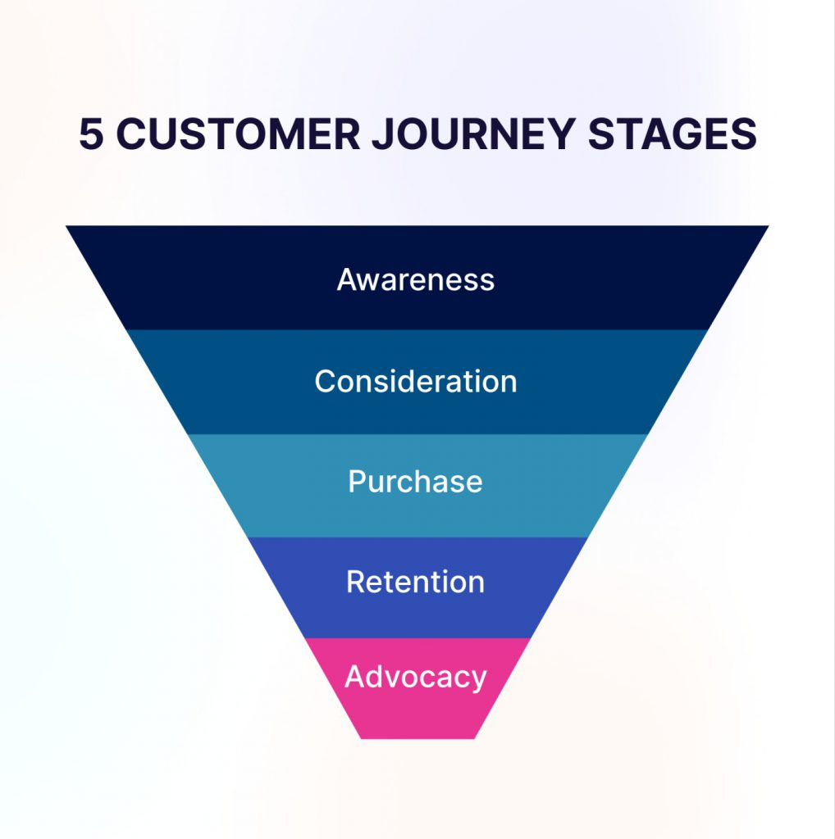
(Source- https://www.revechat.com/blog/customer-journey-stages/)
- Awareness
A customer journey refers to the series of interactions a person has with a brand, product, and/or service. It includes both direct contacts like calling customer service and indirect interactions like learning about a brand at an event.
The customer journey may be viewed as a map of each consumer's experiences with the brand and promotional touchpoints. Every customer journey is distinct, and the path each person takes through the brand website, customer support team, and a variety of other brand channels enables marketers to adapt their marketing strategy to each consumer. (Parveen Singh, 2022)

- Consideration
During the consideration phase, customers compare one organization's proposals to those of its competitors. Blog content, success stories, email nurturing campaigns, and webinar or event registrations may all help organisations keep their audiences engaged.
When customer service representatives communicate with consumers, they may emphasize certain features of their goods and services so that customers understand their value. Prospects can become involved with brands in which they are already interested at this point.
Finally, if marketing departments can address key issues raised by prospects, they may help move those customers to the next step of the customer journey. Marketing teams must adjust their content style and vocabulary from high-level and instructional to a more thorough approach at this period. (Griffin LaFleur, 2022)

- Purchase
This is often referred to as the evaluating stage. The consumer has made their choice, evaluated the benefits and drawbacks of many brands, and is now ready to purchase. At this point, it is advantageous to be as transparent and honest about pricing as possible. Extra expenses on the website are the most common reason for cart abandonment (think hidden shipping costs or additional taxes).
Other significant factors that can boost cart abandonment include requiring an account for purchase and a lengthy checkout process. Often, optimizing the checkout experience for customers simply means simplifying it. How much information does a company truly require from a customer to facilitate a purchase? (CIM.co.uk)

- Retention
Following the sale, the following two steps of the client journey take place. Salespeople typically make sales, enrol clients, and then wait for renewal or a cross-selling opportunity before dealing with them again. Successful businesses, on the other hand, continue to market to and connect with customers, boosting the likelihood of increased customer lifetime value through repeat business.
During the retention phase, organisations may create a loyalty programme or a knowledge base FAQ, as well as regularly convey corporate or product developments to customers. Companies might also provide periodic product training sessions or extra promotions during the client lifecycle. Regular communication may lead to increased customer participation, as well as improved customer understanding and value.
- Advocacy
Even greater than reselling to current customers, ask them to inform others about their positive experience with the brand. Advocacy may take numerous forms, from posting online reviews to personally educating friends and family about the company.
A brand advocate strategy may also include a number of methods. Encourage referrals by offering one-of-a-kind affiliate connections that qualify both the giver and the recipient to future price reductions or entry into a prize draw. Post social media shout outs and share user-generated content to communicate with potential consumers.

Customer Touchpoints

What is Customer Touchpoint?
Any direct or indirect experience a customer has with a brand is considered a customer touchpoint. Customer touchpoints can occur before, during, or after the purchase of a brand's product or service and can occur both within and outside of a brand's control.
Customers' interactions with brands can be indirect, such as reading reviews, or direct, such as shopping in a retailer's store. Every customer touchpoint along the customer journey has the power to change perceptions and brand loyalty.
(Source-https://www.techtarget.com/searchcustomerexperience/definition/customer-touch-point)

Customer Journey Touchpoints:

- Pre-purchase
How did the customer find you? These are the first points of contact for customers before they visit the store in person or online.
Online advertisements: Begin by ensuring that all online advertising links connect to information that is directly related to the adverts. If the advertisement includes a link to a page that details or shows the sale items in detail, make sure the link takes customers there.
While Tumi want clients to explore their website, this is not the moment to direct them to a sign-up form or the main page. Improving the customer experience by creating a landing page with appropriate content.
Social Media: Brand like TUMI does not really need to be on every social media network, however the brand should have a presence on the channels that customers use. Keeping the websites active by posting interesting and relevant material. Always respond to consumer comments, as this is why they are on social media in the first place, and begin developing relationships with potential customers. Tumi makes sure that they always put new arrivals and offers and promotions on social media.
Referrals: Referral program for existing customers provide incentives for both the referrer and the new consumer. This makes both parties satisfied and enhances the likelihood of future purchases and referrals. Currently Tumi does not have any referral programs.
Websites: When potential customers visit a brand's website, they should be able to swiftly and easily access the information they seek. The navigation should be straightforward and intuitive. Product pages should provide clear photographs and explanations of the brand's goods. If the product or service is difficult to define, consider including videos. Remember that if website visitors cannot discover the information they seek, they will go elsewhere. A feedback survey can be used to learn how people feel about the brand's website.

- Purchase
During purchase, it is easy to find out what did the customers do at the point of sale (POS)? Was the experience sufficient for them?
Customer feedback: A Power Reviews study found that 97% of consumers evaluate product reviews before making a purchasing decision. Remember that the customers are looking for these reviews, so brand must include them in the social media postings, site pages, and marketing materials. Tumi always believes in feedback that’s why after every purchase of Tumi products, customer receives a text message and email for the feedback upon the service and the product.
POS (Point of Sale): At the point of sale (POS), a sales representative or a web page will offer all necessary information, especially the requirements that the product will satisfy. This is the last point of interaction before making a transaction. At point of sales, Tumi has its unique store design which all Tumi stores in the globe follows. They have a Series of collections put on every wall and changed every two weeks. Tumi has its own Standard Operating Procedures in terms of Visual Merchandising.

- Post-purchase
Touchpoints persist even after a sale has been completed. Brands should never overlook these critical times in the consumer journey.
Survey feedback: This is the chance to learn more about the customer experience. What was the difficult part? What was simple? Use a customer service feedback survey to determine where training or upgrades are needed.
Email: Use the opportunity to upsell or cross-sell the products if the customer has signed up to receive emails about new offers and products.
Community Management: Continue to monitor the social media channels. When people comment and share the posts, make sure brand community manager responds and keeps the conversation going.

Customer Persona
Shreyas Dhuri
Background:  - Head of Finance  - Living in Warsaw  - From Mumbai  - Working with City Bank, Warsaw |  | Education & Skills:  - MBA  - Hospitality  - English: Proficient  - Finance
Demographics:  - Age- 25-30 years  - Annual Income: £55,000 - £70,000  - Ethnicity: Indian  - Social Media Usage: Highly Active | Hobbies:  - Traveling  - Swimming  - Reading | Marital Status:  - Unmarried
Source: Author of this Report

TUMI Customer Journey Map:
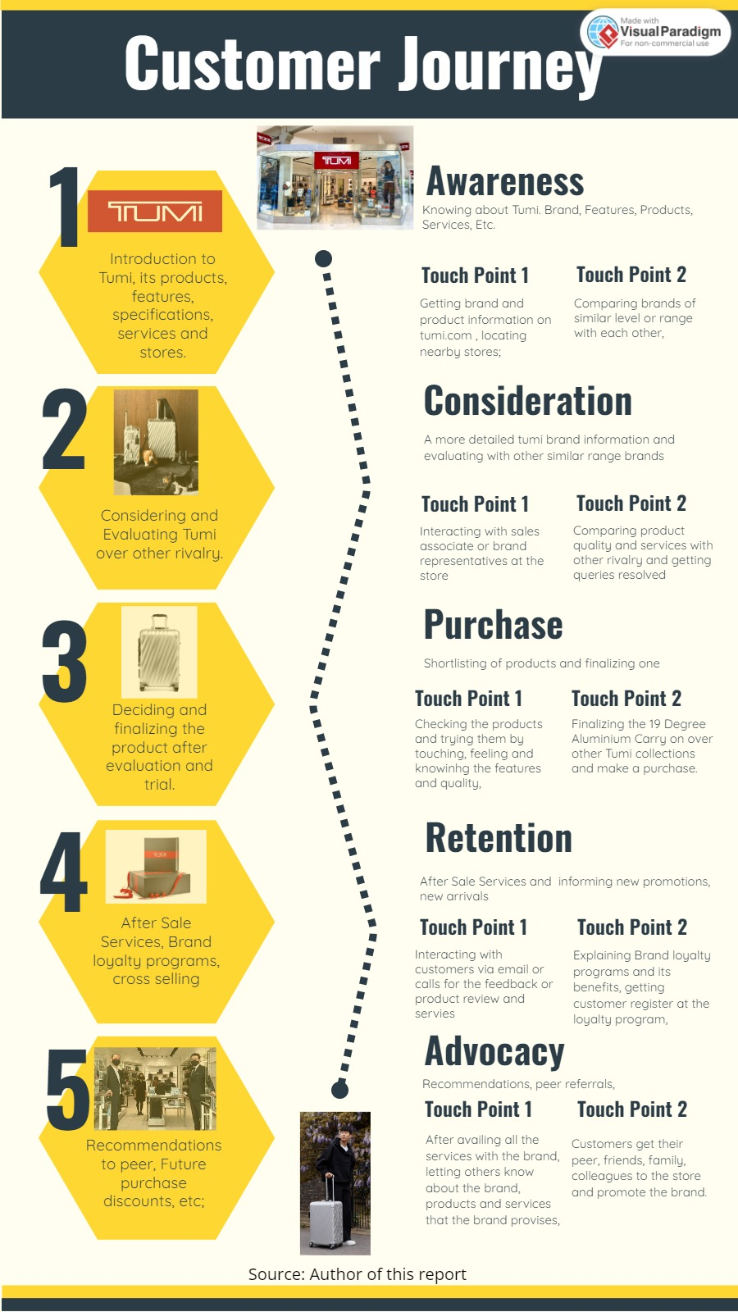
Customer Journey Map (Source: Author of this report)

Strengths and Weaknesses of Customer Journey Map
Strengths of Customer Journey Map:
- Tumi has its own Omni Channel website via which consumers or explorers can simply check Tumi products, Services that they provide and background information.
- Tumi has held and built good relationship with its customers and resulting, Tumi consumers are peer referrals as they inform their colleagues, friends, relatives and help brand to promote the brand.
- Tumi also focuses on consumer behavior as they progress through the sales funnel. They does consider journey to accurately predict what the clients require at each stage of the process and aim to give those answers.
- Every season when Tumi introduces new collection or products, Tumi has their own social media influencers whom they offer free products for the promotions and it really helps the brand to reach out to more audience.
- Customer journey planning can assist the team to anticipate client demands, allowing them to respond to consumer requests more quickly.

Weaknesses of Customer Journey Map:
- It is nearly impossible to establish actionable insights to improve service experiences for customers if the brand like Tumi do not define the customer who has gone through the journey or recognize their requirements and desires.
- Because the map is built on formal contacts rather than actual customer activity, Tumi miss out on opportunities to use the benefits of customers' trust.
- Customers have a variety of contact channels to select from, including both online and traditional methods. When all communication channels are included in the map, it becomes complex, but a map based on a single communication channel seems like a basic flow diagram.
- Most of the times, Tumi make the mistake of employing communication channels where their customers desire to be rather than channels where their customers actually are.
- In general, customer journey maps treat all consumers the same, rather than being developed particularly around the Appropriate Experience for each logical client segment.

Total Engagement Model
A Total Engagement model is one that is devoted to a single brand and aggressively promotes the brand's products and services to others.

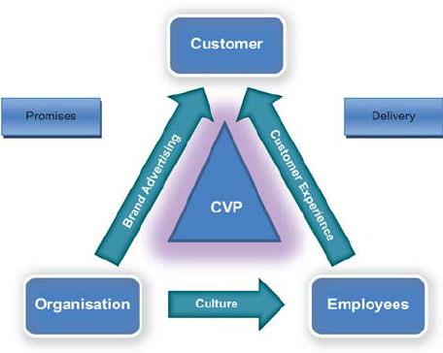
Total Engagement Model (Source-Research gate)
The first is the brand itself, which should explain the value that the brand offer consistently. The second factor to consider is the culture of the business, which is a crucial enabler in delivering a differentiated value offer and designed customer experience through motivated workers.
An engaged employee is one who understands its objectives and direction and is genuinely invested in its success. They are more productive, more committed to peaceful conflict resolution, and more loyal to their firm in general. If the organization's goal is to achieve long-term growth, then must establish a purposeful and collaborative link between engaged staff and engaged customers. (Frank Alpert, 2010, p.200)
Not only Tumi logo or name, but the brand is the whole total of what Tumi stands for. The value proposition must be an important aspect of any brand.
Culture is defined and relates to the internal components of an organization such as its aims, values, and internal practices. This should be designed to create an environment in which employees can offer your value proposition and planned customer experience on a regular basis.
A Customer Value Proposition (CVP) is a projected value commitment made by a firm to its customers in order to boost customer engagement. Adding value is accomplished by placing the (potential) client / target audience at the heart of the business. The things and/or services do not show this added value in and of itself, but their use creates a Customer Value Proposition.
Tumi customer experience is the combination of physical and emotional factors that customers encounter while interacting with the brand - in other words, what the actually provides. The customer value proposition is the value that the brand provide to its consumers. In other words, this is why buyers should choose you over your competitors.

Recommendations

- Tumi's usage of a professional agency implies that they may leverage their extensive technological knowledge to add new touchpoints to their site that rivals may not have, such as live chat with customer care assistants.
- Tumi may be extending its operations and developing new areas of service. This will necessitate the development of new touchpoints in order to reach a new consumer. Even if companies are not developing new service packages, they may still come up with innovative methods to connect with clients. Perhaps creating new touchpoints on social media that are not often utilized will assist to attract more clients and win revenue.
- Tumi may also start creating holdings on highways and have more celebrity ambassadors for the marketing and new promotions.
- Tumi may organize a loyalty program wherein there would be some referral discounts for their new as well as existing customers.
- At Stores or Point of sales, Tumi employees rarely informs customer about Tumi social media profiles such as Instagram, Facebook or Twitter, having customers connected on social media can help brand to reach out to all the users about new promotions and new arrivals.
- Tumi can start providing more customization services apart from Monogramming, such as variety of colors and attachments for their classic products, etc.

Conclusion

Tumi, a luxury or premium lifestyle brand trying to create a strong brand image in the market. Tumi can get successful with their objectives, brand values and IMC strategies during every season. The following findings were made after a thorough examination of Tumi's organisation, operations, and market positioning. Tumi's marketing activities are currently focused on its travel, business, and leisure goods. To enhance sales, they may expand this to include their whole apparel inventory, not just jackets. Tumi must retain its leadership position in unique Tumi tracer technology since uniqueness is the company's primary marketing strategy.
The company's money should be used more wisely. Because there is no longer a clear boundary between Travel and Leisure, this might be accomplished by expanding their efforts to include such and other places. The use of the Internet to engage with clients has emerged as one of the most important aspects of the Tumi brand. To do this, they might also revamp their website to make it more consumer-friendly. The website currently takes far too long to load, and the plain design tells nothing about the products. The critical analysis of Tumi products, services and marketing strategies helps the organization to rethink and re-implement the strategies to get stronger and stronger. Evaluating customer journey and implementing new strategies and touchpoints are better for service improvement. By making sure of innovative strategies and raising awareness of the brand can fulfil the expectations of customers, employees and future stakeholders.

REFERENCES:

ABC of Marketing, Communication Model, Retrieved on 24th March 2023, https://www.abcofmarketing.com/explain-communication-model-process-relative-promotion-mix-organisation/

Adam Ramshaw, Genroe, The Benefits and Disadvantages of Customer journey Mapping, Retrieved on 7th April, 2023, https://www.genroe.com/blog/benefits-and-disadvantages-of-customer-journey-mapping/15321

Ava Remy, Brand Equity, Advantages and Disadvantages of Keller’s Brand Equity Model, 2013, Retrieved on 6th April, 2023, https://avaremy.wordpress.com/2013/11/09/brand-equity/

Big Commerce, Promote your online store, Retrieved on 1st April, 2023, https://www.bigcommerce.com/articles/offline-to-online/promote-online-store/st

British Dictionary, Defination of communication, Retrieved on 24th March 2023, https://www.dictionary.com/browse/communication#:~:text=British%20Dictionary%20definitions%20for%20communication,message%2C%20letter%2C%20or%20telephone%20call

Business Administration Theories, 2022, retrieved on 05th April, 2023, StudyMumbai.com, https://www.batheories.com/kellers-brand-equity-model/?utm_content=cmp-true

Chris Roberts, Keerthana Venkatesh, Total Engagement Model, Engaged Strategy, 2017, retrieved on 09th April, 2023, https://www.engagedstrategy.com.au/engaged-marketings-proprietary-business-model-becomes-part-of-an-academic-book/total-engagement-model/

Christopher Roberts, Frank Alpert and Carissa Roberts, Strategic Drivers of Customer and Employee Applications, 2016, Retrieved on 9th April, 2023.

Communication Theory, Shannon and Weaver Model of Communication, Retrieved on 25th March, 2023, https://www.communicationtheory.org/shannon-and-weaver-model-of-communication/

Fashion ABC, Retrieved on 23rd March 2023, https://www.fashionabc.org/wiki/tumi/
Frank Alpert, Total Engagement Model, Research Gate, 2010, Retrieved on 9yth April, 2023, https://www.researchgate.net/figure/The-total-engagement-model_fig2_49513186

Garrett Dickinson, Shannon and Weaver communication model, 2022, Retrieved on 25th March, 2023, https://study.com/learn/lesson/shannon-weaver-model-communication-theory-parts-transmission-model.html

Griffin LaFleur, Swing Education, Tech Target, 5 Customer journey phases for business to understand, 2022, retrieved on 56th April, 2023, https://www.techtarget.com/searchcustomerexperience/tip/5-customer-journey-phases-for-businesses-to-understand

Hitesh Bhasin, Keller’s Brand Equity Model, Marketing 91, 2019, retrieved on 6th April, 2023, https://www.marketing91.com/kellers-brand-equity-model/

How to identify your customer touchpoints, Survey Monkey, Retrieved on 7th April, 2023, https://www.surveymonkey.com/mp/identify-customer-touchpoints/#:~:text=Touchpoint%20definition%3A%20A%20touchpoint%20is,they%20purchase%20something%20from%20you.

Indeed editorial Team, Benefits of Customer Journey Map, 4th February 2023, Retrieved on 7th April 2023, https://www.indeed.com/career-advice/career-development/journey-mapping-benefits

Insight for professionals, Understanding the 5 stages of customer journey, 2022, Retrieved on 6th April, 2023, https://www.insightsforprofessionals.com/marketing/customer-experience/understanding-customer-journey-stages

Keaton Hawker, 2019, Keller’s Brand Equity Model, Retrieved on 05th April, 2023, https://medium.com/@keatonhawker/kellers-brand-equity-model-what-it-is-how-to-use-it-84e42d562299

Keller, K.L., Keller’s Brand Equity Model, Retrieved on 05th April, 2023, https://www.mindtools.com/ajnlcxe/kellers-brand-equity-model

Lincoln Murphy, Customer Centric Growth, Sixteen Ventures, 2017, Retrieved on 07th April, 2023, https://sixteenventures.com/customer-journey-maps
Louis Vuitton Advertising Strategies, January 8, 2022, Retrieved on 1st April, 2023, https://blog.avada.io/resources/louis-vuitton-advertising.html

Masters in communication, 2022, Retrived on 28th March 2023, https://www.mastersincommunications.com/faqs/what-is-integrated-marketing-communications

Neil Patel, The best luxury marketing strategies, Retrieved on 1st april, 2023, https://neilpatel.com/blog/luxury-marketing/

Papirfly, 2019, Retrieved on 05th April, 2023, https://www.papirfly.com/blog/retail-marketing/customer-brand-equity-and-understanding-kellers-brand-equity-model/

Prachi Juneja, Shannon and Weaver Model of Communication, Management Study Guide, Retrieved on 25th March 2023, https://www.managementstudyguide.com/shannon-and-weaver-model-of-communication.htm

Praveen Singh, Customer Journey Stages, Revechat, 2022, Retrieved on 6th April, 2023, https://www.revechat.com/blog/customer-journey-stages/

Shivani Chaturvedi, Smartkarrot, Customer Success, 2021, Retrieved on 7th April, 2023, https://www.smartkarrot.com/resources/blog/customer-journey-mapping-mistakes/#:~:text=The%20biggest%20problem%20with%20this,always%20built%20on%20formal%20interaction.

Shopify, Branding, 202, Retrieved on 2nd April 2023, https://www.shopify.com/blog/what-is-branding#:~:text=Branding%20is%20the%20process%20of,mission%2C%20and%20tone%20of%20voice.

Superbrands, Retrieved on 22nd March 2023, https://www.brandsearch.superbrands.com/download/1197/usa-volume-11/80543/usa-volume-11-tumi.pdf

Suze and Paul, Luxury Columnist, Retrieved on 01st April 2023, https://luxurycolumnist.com/luxury-marketing-strategy/
The Chartered Institute of Marketing, Five Stages of customer buing journey, 2022, Retrieved on 6th April, 2023, https://www.cim.co.uk/content-hub/blog/five-stages-of-your-customers-buying-journey/

Tristan Harris, Thrive Agency, Customer Journey Map, 2022, Retrieved on 7th April, 2023, https://www.hotjar.com/customer-journey-map/benefits/

Tumi Brand Profile, Tumi.uk, https://uk.tumi.com/on/demandware.static/-/Library-Sites-tumi-content-library/default/dw14ea922f/download/pdf/B2B_TUMI_BrandProfile.pdf

Tumi, Brand Logo, https://go.kotisdesign.com/brands/tumi/

Wang, Wei and Yu, 2008, Global brand equity model combining customer‐based with product‐market outcome approaches. Journal of Product & Brand Management, Retrieved on 5th April, 2023.

Wheels Luxury Gifts, https://www.wheelersluxurygifts.com/brands/tumi

