
Module: Introduction to Web and Database Concepts

Module code: ACCA4023

Assignment Title: Design and Implementation of a Relational Database System

Student Name: Muhamad-Sobaan-Shaja-Ud Din

Student ID: 2436564

Table of Contents
1.Introduction 3
2.Scenario Analysis 4
3.Entity and Attribute Analysis 5
4.ERD and Relationships 6
Entity Relationship Diagram 6
Relationships Between Entities 6
Importance of Relationships 7
5.Database Structure and Implementation 7
Database Tables 8
Customer and Vehicle Tables 8
Booking and Payment Tables 8
6.Normalisation to 3NF 9
First Normal Form 9
Second Normal Form 9
Third Normal Form 9
7.Sample Data 10
Introduction 10
Customer and Vehicle Data 10
Booking and Payment Data 10
Purpose of Sample Data 11
8. Query Development 11
Introduction 11
Booking Query 12
Parking Availability Query 12
Revenue Query 12
Query Results 12
9. Validation and Testing 13
Introduction 13
Data Validation 13
Relationship Testing 14
Query Testing 14
Test Results 14
Reflection and Future Improvements 14
Reflection 14
Future Improvements 14
Conclusion 15
10. References 15

1.Introduction

AutoPark Management System is a parking services company that operates within the city, and it is responsible for running different parking facilities. At the moment, the company uses manual data inputting to enter important data, such as information on vehicles entry and exit, availability of parking slots, details about the customers, booking, and payments. The use of manual data inputting system may cause some problems related to possible errors in entering information, its duplication, loss of information and inability to see which parking slots are available. ObjectiveThe objective of this project is to create and develop an efficient centralised database system that will make use of Microsoft Access. The suggested database will be a convenient platform for storing and organising the information about parking sites, parking slots, clients, cars, reservations and payments.This database system will facilitate the work of the parking service by providing users with the opportunity to register clients' and cars' details, check the availability of parking slots, manage reservations and register payments. Besides, the queries and reports will allow managers to get the valuable information about the occupancy rate of parking places and other operations performed at various parking sites. The report below describes the process of analysis, design, and implementation of the proposed AutoPark Management System database. The report identifies the key entities, attributes, and relationships needed by the database, and illustrates the ERD of the database. Additionally, the structure of the database is described, and the way the database has been normalized to Third Normal Form (3NF) is shown. Moreover, the report discusses the sample data, the queries run, validations and testing that have been carried out.


2.Scenario Analysis
AutoPark Management System necessitates the use of an organised database for proper management of the day-to-day activities at several parking locations within the city. The manual approach of maintaining the information may lead to errors, duplicate entries and issues in tracking of the spaces and payments. Thus, the designed database must organise the information and make relationships between different pieces of information.The entities identified based on the given scenario are Parking Site, Parking Slot, Customer, Vehicle, Booking and Payment. All these entities are the vital components of the parking management system and contain attributes that store particular information.Parking Site is an entity that represents each parking place managed by the AutoPark.
Since the company runs many places, each parking site must be stored separately. The attributes of this entity are SiteID, SiteName, Address, City, Postcode and TotalCapacity. SiteID is a primary key since it is unique to every site within the database. Parking Slot is an entity that defines the different slots within the site. The attributes include SlotID, SiteID, SlotNumber, and SlotStatus. SlotID is the primary key and SiteID is the foreign key and establishes a relationship from each parking slot to the parking site in which it occurs. A parking site contains several parking slots, but each parking slot can only be found within one parking site, creating a one-to-many relationship between the Parking Site and Parking Slot entities.The Customer entity holds data about the customers using the AutoPark system.
The attributes include CustomerID, FirstName, LastName, PhoneNumber, and EmailAddress. CustomerID is the primary key for this entity. By defining the customers as an entity, there is reduced duplication since the same information is not duplicated every time they book a space. The Entity Vehicle stores the details regarding the vehicles owned by the customers.
The attributes include VehicleID, CustomerID, RegistrationNumber, VehicleMake, VehicleModel, and VehicleColour. The attribute VehicleID serves as the primary key, while CustomerID serves as the foreign key to link each vehicle with their respective owner. A single customer can own multiple vehicles, but each vehicle belongs to a single customer. Thus, the relationship between Customer and Vehicle is one-to-many.The Booking entity contains the details of reservation and parking. This is an important entity as it links the customer, vehicle, and parking slot. The attributes include BookingID, CustomerID, VehicleID, SlotID, BookingDate, StartDateTime, EndDateTime, and BookingStatus. The primary key is BookingID, while the foreign keys are CustomerID, VehicleID, and SlotID. The relationships enable the database to determine the customer who made the booking, vehicle that is being booked, and the parking slot that is booked.

More than one Booking may be created by a customer at various points in time, and also more than one vehicle may participate in more than one Booking. Likewise, a Parking Slot may be booked more than once. However, the application should not allow two vehicles to book the same Parking Slot at the same time. This example highlights the significance of relations and constraints in a database.
The Payment entity holds financial information about bookings. The attributes of this entity are PaymentID, BookingID, PaymentDate, Amount, PaymentMethod and PaymentStatus. The PaymentID is the primary key whereas BookingID is the foreign key which associates the Payment to its respective Booking. Separating the financial information from booking information makes things organized.
Relationships among the listed entities will constitute the basic part of the AutoPark Management System. One parking area will hold many parking spots. One client will have many cars and will make many bookings. One car will participate in many bookings while one parking spot will be used in many bookings as well. One booking includes one client, one car, and one parking spot. Payments will be linked to the corresponding booking.
Use of the primary and foreign keys will guarantee the uniqueness and proper linking of all the records. The suggested structure of entities will serve as a good starting point for designing the Entity-Relationship Diagram and building the Microsoft Access database. Splitting of information into separate entities will assist in the process of data normalisation.

3.Entity and Attribute Analysis
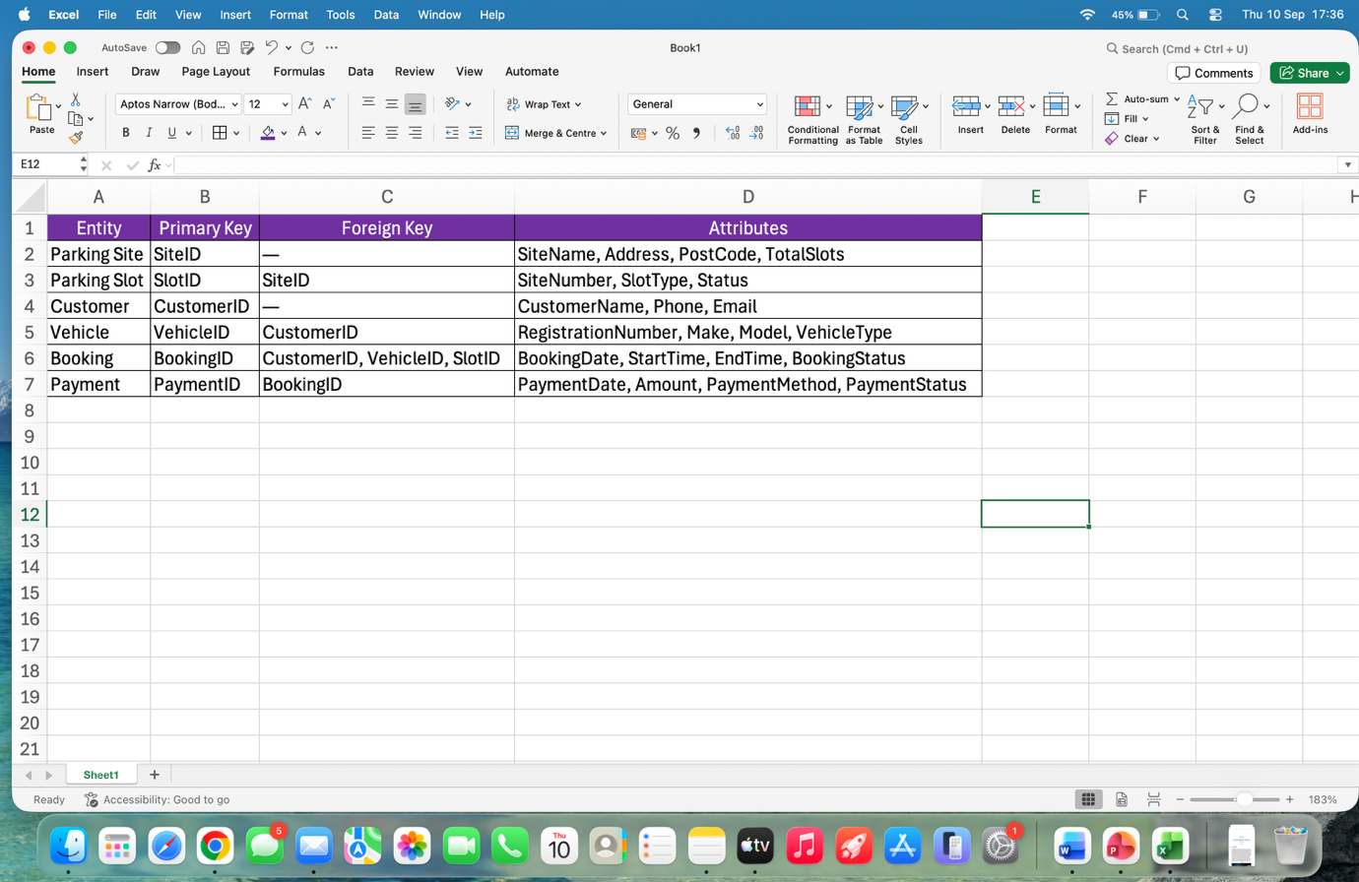
Figure 1: Entity and Attribute Analysis of the AutoPark Management System.

4.ERD and Relationships

Entity Relationship Diagram
The ERD for the AutoPark Management System describes the structure of the database and the relationship between the various entities. The entities that have been incorporated into the system include ParkingSite, ParkingSlot, Customer, Vehicle, Booking and Payment. All entities have their own primary key to uniquely identify records in the database. Foreign keys are used to show relationships between the tables.
The ParkingSite table holds details of each parking site while the ParkingSlot holds details of each parking slot within each parking site. The Customer and Vehicle tables are separate from each other since a single customer can have several vehicles. The Booking table links customers, vehicles and parking slots and holds details such as entry and exit times and booking status.
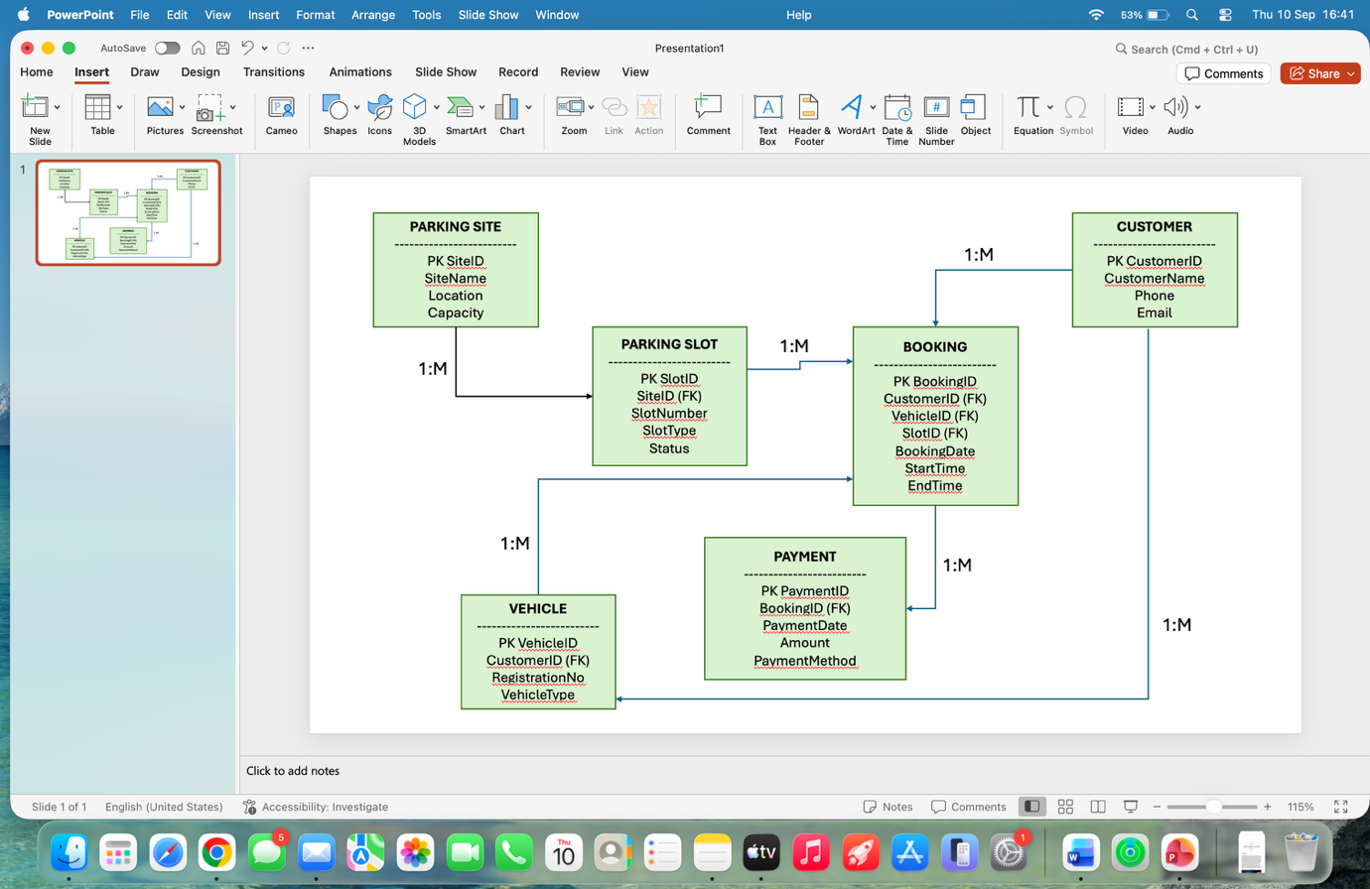
Figure 2: Entity Relationship Diagram (ERD) for the AutoPark Management System.

Relationships Between Entities
There is a one-to-many relationship (1:M) between ParkingSite and ParkingSlot since there can be several parking slots in one parking site, but not vice versa.
A similar one-to-many relationship (1:M) exists between Customer and Vehicle, since a customer can have several vehicles, and each vehicle can have only one customer who is assigned via CustomerID foreign key.
The Customer and Booking relationship is one-to-many since a customer can have several bookings in the system. It works similarly for the Vehicle and Booking relationship.
There is also a one-to-many relationship between ParkingSlot and Booking since one parking slot can be used by several bookings. The Booking and Payment relationship associates each payment with a booking.

Importance of Relationships
These relations enable efficient storage of data without having duplicates. The primary key and the foreign key help to make relations between different records. It also acts as a guide to designing the database in Microsoft Access and enables easy extraction of data such as bookings, availability of parking, and payments.

5.Database Structure and Implementation
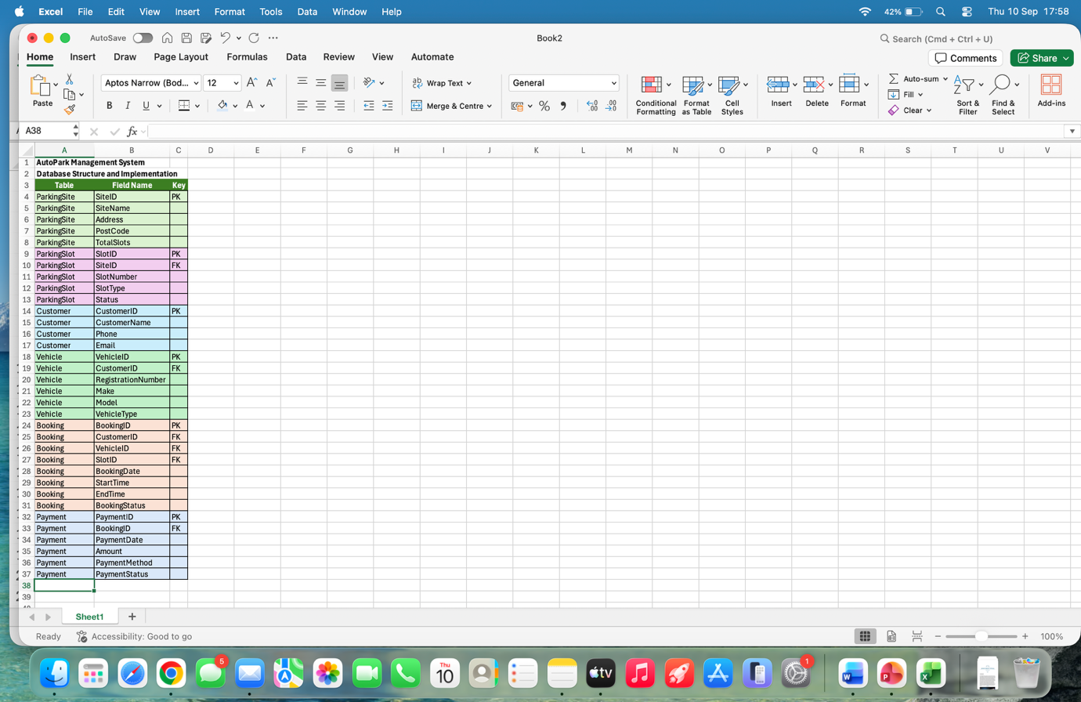
Figure 3: Database tables and field structure for the AutoPark Management System.

Database Tables
AutoPark Management System was developed using Microsoft Access software. The database was segregated into six main tables, namely, ParkingSite, ParkingSlot, Customer, Vehicle, Booking, and Payment. Every table maintains data of particular nature that is necessary for the parking business.
ParkingSite table holds details regarding parking site. This table consists of fields like SiteID, SiteName, Address, PostCode, and TotalSlots. SiteID was chosen as the primary key since it is unique for every site.
ParkingSlot table keeps details regarding individual parking slots. The fields maintained in this table include SlotID, SiteID, SlotNumber, SlotType, and Status. SlotID is primary key, whereas SiteID is foreign key linking each parking slot to the parking site.

Customer and Vehicle Tables
The Customer Table holds all the information about the customers, including CustomerID, FirstName, LastName, Phone, and Email. CustomerID is considered the primary key. The Vehicle table holds information about the vehicles such as VehicleID, CustomerID, RegistrationNumber, Make, Model, and VehicleType. CustomerID acts as a foreign key.

Booking and Payment Tables
The Booking table stores parking bookings through BookingID, CustomerID, VehicleID, SlotID, EntryDateTime, ExitDateTime and BookingStatus. The Payment table stores information about payments using PaymentID, BookingID, PaymentDate, Amount, PaymentMethod and PaymentStatus.
Primary key and foreign key constraints have been employed to ensure the relationships between tables and data integrity. Data types have also been used appropriately to minimize errors during data entry.

6.Normalisation to 3NF

First Normal Form
Database Normalization was used to develop the AutoPark Management System. The first step is the First Normal Form (1NF), where all the fields in the database should have atomic values. Information in the suggested database is broken down into smaller fields, rather than putting multiple values in one field. For instance, the first name, last name, phone number and email of the customer are put in separate fields of the Customer table. Likewise, the vehicles are kept as individual entries, instead of putting multiple vehicles in one customer entry. Every table in the database also has a Primary Key, which is unique for every entry.

Second Normal Form
The next stage in normalization is Second Normal Form (2NF). It guarantees that the database is in 1NF and attributes rely on the whole primary key in their table. The information about the customer in the Autopark database depends on the Customer ID, information about the vehicle depends on the Vehicle ID, while booking information depends on the Booking ID. This way, the information will be kept in the right table, without any repetition in other tables.

Third Normal Form
The third step to achieving normalization is the Third Normal Form (3NF), where transitive dependency is taken care of. In this particular database, customer information is contained in the Customer table only, whereas the Vehicle information is contained in the Vehicle table. Parking site information is contained in the Parking Site table, and the Slot Information is contained in the Parking Slot table. Bookings information is contained in the Booking table, and Payments information in the Payment table.

7.Sample Data
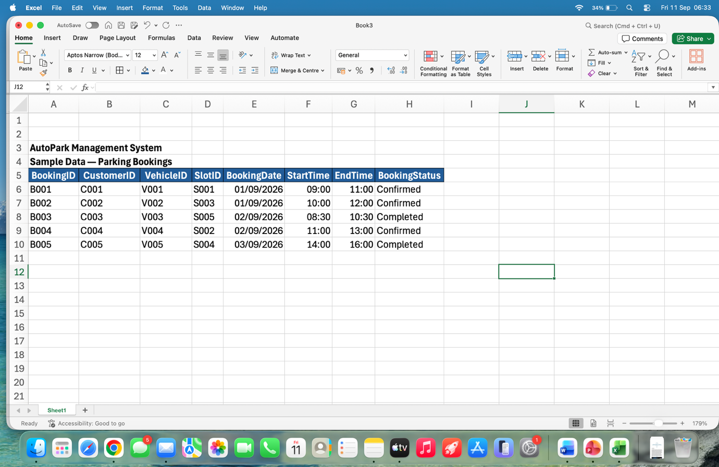
Figure 4: Sample booking data for the AutoPark Management System.

Introduction
Example data was inserted into the AutoPark Management System in order to show how the database will work when using real data. The data consists of typical customers, vehicles, parking places, parking spots, booking and payment records. Five records minimum were created in each of the necessary tables so that the database can be checked using various queries.

Customer and Vehicle Data
Example data for customer entries is contained in the Customer table where each customer has been assigned a unique CustomerID. Data for the vehicles owned by each customer was then inputted into the system with reference to the CustomerID number.

Booking and Payment Data
Booking records were created using different customers, vehicles and parking slots. Each booking includes entry and exit information and a booking status. Payment records were then added and connected to the relevant bookings using BookingID. Different payment amounts and payment methods were included to provide realistic data for testing revenue and booking queries.

Purpose of Sample Data
The data sample makes it possible for the database to undergo tests in real-world scenarios. It can be used to test whether the relationships are working well and whether queries can extract information on bookings, available parking slots, customers, and payments.

8. Query Development
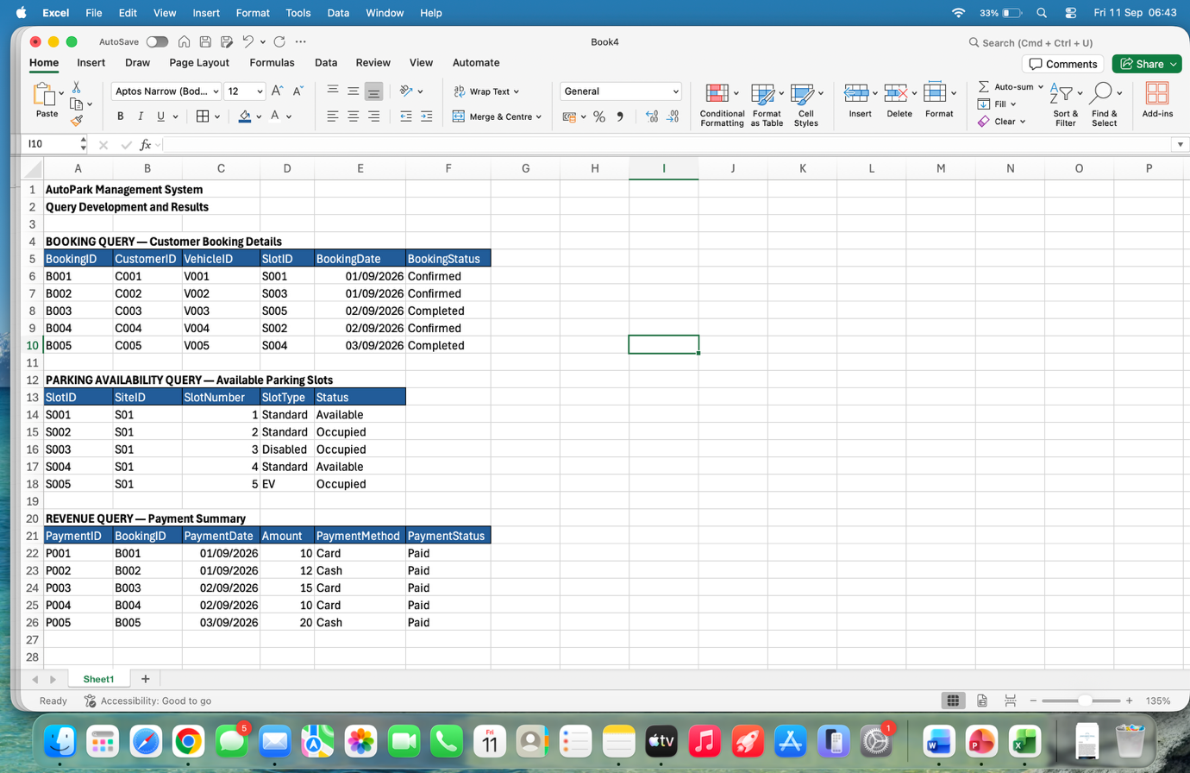
Figure 5: Query results for bookings, parking availability and revenue.

Introduction
Microsoft Access was used to create some queries that can help extract useful information from the AutoPark Management System. Queries provide the ability for the company to search through the information stored in the database tables, thus making the process of monitoring parking activities and extracting information much easier.

Booking Query
The Booking Query can be utilized in order to get information on bookings and past bookings. Information can be taken from tables including the Customer, Vehicle, Booking and Parking Slot. Details that can be retrieved include customer name, vehicle registration number, parking slot, entry time, exit time and booking status. This will help the staff know who is booked and which parking slots are in use.

Parking Availability Query
The parking availability search will be able to help in determining parking lots depending on the status of the lot. The query will be able to filter out only those records that are available. This helps in easily locating the available parking lots.

Revenue Query
A revenue inquiry can be constructed using the Payment table to calculate the total amount of revenue earned through parking booking payments. The SUM function can be applied on the Amount column to calculate the total revenue. The payment data can also be categorized based on the payment mode and date for financial analysis purposes.

Query Results
The queries were then checked on the sample data inputted to the database. It was found out that information could be accessed from more than one table at once and the database could be used for the operations of AutoPark Management System.

9. Validation and Testing
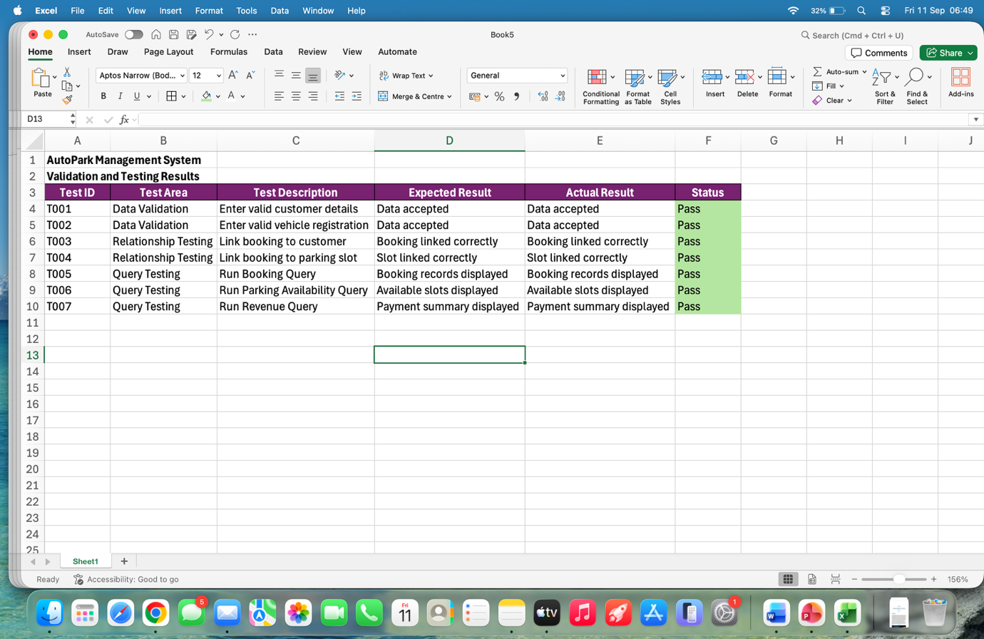
Figure 6: Validation and testing results for the AutoPark Management System.

Introduction
The validation and testing of the system have been done to confirm the accuracy of the functioning of the AutoPark Management System, and the correct entry of the data into the database. The process of testing is crucial since it helps in identifying the errors in data entry, data relationships, queries and the working of the database.

Data Validation
The validation rule was adopted in order to minimize errors in the database entry. The appropriate data type was specified for all the fields in order to ensure correct storage of the information. For instance, the telephone number and the e-mail addresses were stored as text, whereas payment was stored as currency/numeric data type. The use of primary key was used to avoid duplicate identification numbers.

Relationship Testing
Relationships among the various tables were tested to make sure that the foreign keys were appropriately linked with the respective data. For instance, a vehicle was linked to the appropriate customer using the CustomerID, while a booking was linked to the particular customer, vehicle, and parking space.

Query Testing
Testing of the queries was done using the sample data. The booking query was tested to verify that it displayed the right booking details. Parking availability query was tested to determine the available slots, and the revenue query was tested to make sure that payments were done correctly.

Test Results
This procedure was carried out to show that the database would effectively store, relate and retrieve data. Errors would be detected and fixed through this process before use of the system.

Reflection and Future Improvements

Reflection
The creation of the AutoPark Management System offered the chance of putting into practice knowledge about databases in a practical context. This process entailed analysis of the parking situation, determination of the necessary entities and attributes, making connections between the tables, normalising and creating the database using Microsoft Access. One of the biggest hurdles was making sure that the tables were properly linked using the primary and foreign keys. Testing the database and queries ensured that the data could be inputted and retrieved.

Future Improvements
Future improvements to the database may include creating an interface that is easy for both staff and clients to use. This can include creating forms to aid in entering the data into the database and minimize mistakes. Also, reports can be generated to show the information on the occupancy of the parking space, client bookings, and income earned. Automation of the process of booking and paying can also be included among the improvements.

Conclusion
This section is intended to summarize the key results of the AutoPark Management System. Firstly, introduce the fact that the database was created in the application Microsoft Access and served the purposes of the parking management case.
Secondly, elaborate on the design of the database based on the key entities, such as ParkingSite, ParkingSlot, Customer, Vehicle, Booking and Payment. Explain how the Entity Relationship Diagram (ERD) helped in building relations between those entities and how primary keys and foreign keys were used to keep the relationship among tables.
Thirdly, indicate that the database was normalized up to Third Normal Form (3NF). Mention how this fact helped in reducing duplicated data in the database.
Fourthly, describe the sample data, queries, validation and testing conducted in the process of implementing the system. Mention how this proved the capability of the system to perform important functions for the parking management, like maintaining customers, their vehicles, bookings, parking slots availability and payments.
Lastly, provide suggestions on further improvement of the system, including convenient forms, automated reports, enhanced booking and multiple sites features.

10. References
Microsoft, “Guide to table relationships,” Microsoft Support.
Microsoft, “Create, edit or delete a relationship,” Microsoft Support.
Microsoft, “Learn the structure of an Access database,” Microsoft Support.
IBM, “What Is Database Normalization?” IBM Think.

