Programme: MSc Public Health and Social Care in Practice
Module: Social Epidemiology and Public Health Development
Module Code: LCHS7000
Lecturer Name: Itse Olaoye
Student Name: Patel Vidhi
Student ID: 2523554

Assessment: Part 1
Title: Disability and Health Inequality Among People with Disabilities in the UK

Table of Contents
TASK 1 3
1.1 Introduction 3
1.2 Contextual Background and Underlying Factors 3
1.2.1 Health Inequalities of Disease and Illness 3
1.2.2 National Response to Reduce Health Inequalities 6
1.2.3 Organisations that Support People with Disabilities 7
1.3 Conclusion 8
TASK 2 10
2.1 Introduction 10
2.2 Main Body 11
2.2.1 Public Health Measures using the 3 P's (Prevention, Protection and Promotion) 11
2.2.2 Key Determinants and Risk Factors 13
2.2.3 Epidemiological Studies and Health Needs Assessment 14
2.2.4 Public Health Monitoring and Surveillance Systems 14
2.2.5 Short and Long-Term Impact on Public Health 15
2.2.6 Health Intervention Programme 16
2.2.7 Evaluation of the Proposed Intervention 16
2.2.8 The Epidemiological Approach: Strengths and Weaknesses 17
2.3 Conclusion 17
References 18

TASK 1

1.1 Introduction
A person with a disability is someone who has a long-term physical, sensory, intellectual or mental impairment that affects their everyday activities and ability to participate in society. In the UK, in 2025, almost one-quarter of the working-age population were considered disabled - the equivalent of 10.4 million people (Mentalhealth.org.uk, 2025). Health inequalities disproportionately affect the disabled as they are more likely to experience barriers to accessing health care, employment, education, housing and social participation. Smythe et al., (2026) note that disabled people have worse health outcomes, a lower life expectancy and are at greater risk of preventable disease because of discrimination and lack of access to services. These include inequalities in physical and mental health and social disadvantage.

1.2 Contextual Background and Underlying Factors

1.2.1 Health Inequalities of Disease and Illness
1. More Mental Illness
Individuals with disability have higher chances of experiencing depression, anxiety and other associated emotional distress compared to individuals without disability. Mentalhealth.org.uk (2026) indicates that physically ill people are more than twice as likely to have common mental health conditions (32.9% versus 12.6%). Mental health is further impacted by isolation, stigma, poverty and unemployment. This study conducted by Umucu et al., (2025) found out that increased psychological distress was associated with work and social isolation. Interventions comprise access to counselling, inclusive mental health services, and community support.
2. Higher Prevalence of Chronic Illness
People with disability have more chronic diseases, such as diabetes, obesity, heart diseases and respiratory diseases. GOV.UK (2025) In 2024/25 the working-age population (16 to 64 years) in the UK stood at 41.9 million; this represents a rise of 1.3 million (3.3%) from the figure recorded for 2013/14. Lack of mobility, lack of access to health promotion initiatives, and late diagnosis contribute to this. Smythe et al., (2026) report that lack of access to preventive care results in delayed diagnosis. Screening and disability-sensitive health services are key to this.
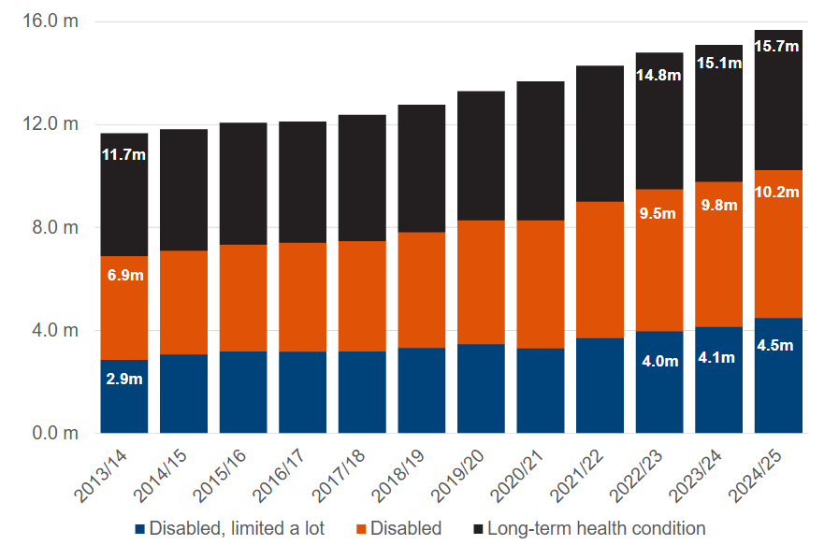
Figure 1: Number of People with a Long-term Health Condition (Disabled)
(Source: GOV.UK, 2025)
3. Greater Risk of Death and Infection
The disabled people have increased incidences of early mortality and preventable infections due to inappropriate housing and access to health care. Obed-Arthur et al., (2026) discovered that poverty, inadequate housing, and inability to access health care increase the risks of bacterial infections and avoidable hospitalizations. They can worsen the situation because of the delay in the diagnosis. This increases the rate of death as compared to the rest of the population. This difference can be reduced through improved measures to prevent infections, equal access to health care and frequent health check-ups (Scope, 2026).
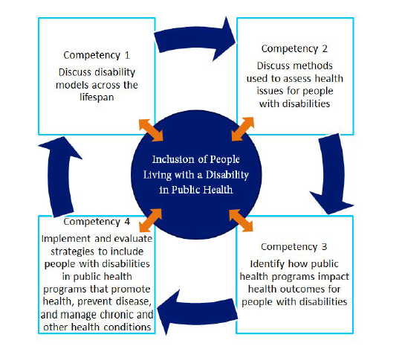
Figure 2: People Living with Disability
(Source: Disabilityinpublichealth.org, 2026)
Social Inequalities
1. Poverty and Unemployment: Employment and economic insecurity cause the level of poverty among disabled people to be higher. The UK disability rate of employment stood at 52.8% (non-disabled: 82.5) - a disability employment gap of 29.7 percentage points. According to Jrf.org.uk (2026) notes that 28% of disabled individuals are living in poverty with a corresponding 33 percent working age disabled adults. Poverty can hardly allow one to afford healthy food, transport and health services. This can be addressed by enhancing disability benefits, job supports and workplace accommodations (UK Government, 2025).
2. Social Isolation and Loneliness: The lack of engagement in education, employment and social opportunities, mobility and discrimination make many people with disabilities feel lonely. Havercamp et al., (2025) report that social exclusion causes depression, anxiety and ill health. Disability can restrict the availability of community spaces and networks to the disabled due to mobility impairments. Isolation destroys self esteem. It can be enhanced by inclusion, peer support services, and open spaces to increase the quality of life and build relationships (Mencap, 2026).
3. Accessibility and Housing: The poor housing and unreachable built environment have an unfair effect on people with disabilities. Limited mobility due to inaccessible bathrooms, ramps, and public transport threaten health. Barrington et al., (2026) found the inaccessibility of services to be detrimental especially to intellectually disabled individuals and the inability to access health care. Poor housing may increase chronic illnesses and expose one to infection. It must invest in available housing, transport and social infrastructure..

1.2.2 National Response to Reduce Health Inequalities
Disability-Inclusive Health Systems: An important national response is the development of disability-inclusive health systems. According to Kuper et al., (2024), the transformation of health services is necessary to offer equitable access by training staff, communicating and creating a readily available infrastructure. This augments prevention, treatment and detection. Accessible health systems avoid preventable disease, and facilitate longer-term health among individuals with disability.
Financial Support and Employment Policies: Another national intervention is through the provision of financial support through the Personal Independence Payment (PIP) and through employment support through the Access to Work program. These are the UK government measures that help people with a disability to meet the extra expenses and workplace adaptations. According to Jrf.org.uk (2026), such policies encourage independence and reduce poverty. These policies facilitate easier working and alleviate financial burdens, which help in lessening other health disparities.
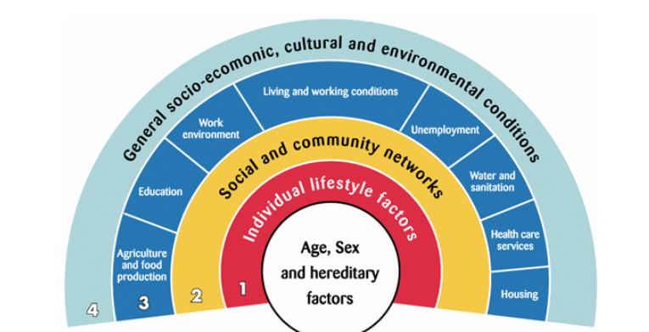
Figure 3: Determinants of Health
(Source: Health knowledge, 2026)

1.2.3 Organisations that Support People with Disabilities
Scope Charity
- Scope is a major disability charity in the UK. Scope is meant to be the means of ensuring disability equality by addressing the discrimination and enhancing the health, work, education and housing opportunities.
- Scope provides services such as benefits advice, employment services, independent living and family services. It also advocates to create awareness about disability discrimination and social injustice.
- The goal of Scope is to have a fair society where the disabled enjoy equal rights and opportunities. The organisation also undertakes research and policy reform advocacy to increase long-term outcomes. By raising awareness and advocating policies, Scope promotes acceptance and inclusion in the UK (Mentalhealth.org.uk, 2026).

Mencap charity
- Mencap is a charity that supports people with learning disabilities and their family members. It supports them in accessing medical services, education and employment (Mencap, 2026).
- Mencap runs campaigns to promote awareness of health inequalities of people with learning disabilities, for example shorter life span and life quality.
- Mencap provides a range of services such as supported living, advocacy, community support services etc. It is set to help people with learning disabilities live independently and have access to health services with equality, to take active role in community and to live a life full of achievement.

1.3 Conclusion
The disabled people in the UK have health disparities caused by medical and social factors. Poverty, loneliness and poor housing add to increased rates of mental illness, chronic disease and death. In the UK, there is some data on inequality in employment, poverty and chronic illness. Such differences can be attributed to discrimination, inaccessibility to healthcare and social support. These problems are tackled by the government programs like disability-friendly financial assistance programs and health care.

Assessment: Part 2
Title: Epidemiological Analysis of Hypertension as a Major Public Health Problem in the London Boroughs, (Newham)

TASK 2

2.1 Introduction
Hypertension, as the leading non-communicable disease is the leading public health problem in the UK, and it is a particular problem in deprived communities such as the London Borough of Newham. Hypertension is the consistent elevated of blood pressure 140/90mmHg and is also referred to as the "silent killer" as it does not present with symptoms. It is a risk factor for cerebrovascular accident, myocardial infarction, and renal failure. On average, the World Health Organization estimates over 1.3 billion individuals globally (16% of the world population) to live with a disability and they experience worse health and live shorter lives than their non-disabled counterparts (World health organisation, 2025). In 2025, 10.4 million individuals (almost one in every four working age adults) in the UK were categorized as having a disability of hypertension and 16.8 million individuals were estimated to be living with a disability in 2023/24. (UK Government, 2025). Disability related health inequality leads to poverty, social exclusion, mental health and chronic disease with long term effects, which are huge to both individuals and health systems in London boroughs (Newham) (Wellnewham.org.uk, 2026).
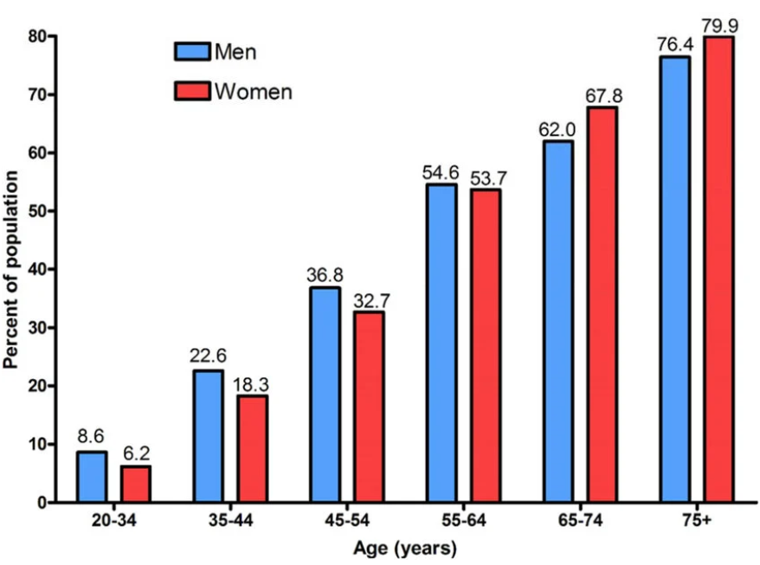
Figure 1: Hypertension among Man and Women
(Source: Buford, 2016)

2.2 Main Body

2.2.1 Public Health Measures using the 3 P's (Prevention, Protection and Promotion)
Prevention: Prevention strategies seek to prevent avoidable hypertension and promote early diagnosis in the UK's at-risk populations. Hypertension is known as the "silent killer" as people can be unaware of the condition until they develop complications. High blood pressure affects 32% of adults in the UK, and many of these are unaware. Hypertension can be prevented through blood pressure checks, NHS Health Checks, salt reduction, healthy diets, exercise, quitting smoking and maintaining a healthy weight (NHS England, 2015). The need for accessible health services and screening programs to increase diagnosis.
Protection: Protection is expected to reduce social and economic determinants of hypertension. Many factors such as poverty, poor housing, stress, unhealthy diets, and inadequate access to health care cause hypertension. Poor diets and lack of physical activity are reasons why hypertension is more common in the poverty-stricken regions. One of the major public health issues is poverty, which influences access to healthy living and health care (Joseph Rowntree Foundation, 2026). Vulnerable communities are safeguarded by policies in the UK that include free NHS blood pressure monitoring, drug support and help in managing chronic conditions.
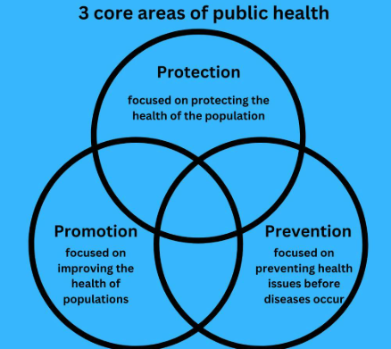
Figure 2: 3 Core are of Public Health
(Source: Thephmillennial, 2026)
Promotion: The goal of promotion is to sensitize people about high blood pressure and healthy lifestyles in order to reduce the risk of heart diseases in the future. High blood pressure may not be noticed until the disease develops its signs and symptoms. Promotions of health promotion by NHS England and British Heart Foundation encourage healthier diet, physical activity, alcohol consumption and health examination (NHS England, 2025). Workplace health and community education is considered a part of health promotion. Health education through enhancing inclusion and reducing the barriers to people with disabilities who are also likely to be at risk of developing hypertension..

2.2.2 Key Determinants and Risk Factors
Key Determinants and Risk Factors | Explanation
Poor Diet | High salt intake, unhealthy fats, and low fruit and vegetable consumption increase the risk of high blood pressure and heart disease (Watso et al., 2023).
Obesity | Excess body weight puts extra pressure on the heart and blood vessels.
Physical Inactivity | Physical inactivity undermines the health of the heart and leads to obesity, stress, and blood pressure (Huang et al., 2024).
Stress and Poverty | Financial stress, poor housing, and deprivation increase long-term stress levels
Smoking and Alcohol | Smoking damages blood vessels, while excessive alcohol intake increases blood pressure

The major determinants of the inequalities in the health of hypertension people are poverty, unemployment, inability to access healthcare, poor housing and social exclusion. According to the Joseph Rowntree Foundation (2026), 28% of individuals with disabilities in the London boroughs (Newham) are living in poverty, and 33% of working age individuals with disabilities. Access to fresh food, transport and health care is limited by poverty. According to the UK Government (2025) statistics, people with disabilities have a lower employment rate of 52.8% than the 82.5% of those who are not disabled. This also adds to economic struggle and mental illness. According to Mental Health Foundation (2025), 32.9% of individuals with health conditions have common mental health problems as opposed to 12.6% who do not have health conditions.

2.2.3 Epidemiological Studies and Health Needs Assessment
Needs Assessment | Explanation
Higher Disease Rates | Around 32% of adults in the UK have hypertension, and high blood pressure causes approximately 50% of heart attacks and strokes. This shows hypertension is a major public health concern (Digital NHS UK, 2026).
Healthcare Barriers | Nearly 5 million adults in England are estimated to have undiagnosed high blood pressure because many people miss regular GP checks and screenings.
High-Risk Groups | The most in danger of developing hypertension and associated complications are adults over 65 years, obese individuals, smokers, diabetic individuals and those who live in deprived regions.
Newham Data Use | NHS Health Check data, GP records, hospital admissions, and local deprivation statistics are used to identify high-risk groups and improve early intervention planning (Tanner et al., 2022).

The identification of the most important groups of people with hypertension can be conducted with the help of epidemiological research. Disability is linked with high incidences of chronic disease, mental health issues and early mortality. The access to health care, especially preventive care and specialist medical care is immensely hindered in individuals with intellectual disabilities (Barrington et al., 2026). Disability, poverty, and hospital admission and primary care access can be analysed to identify high-risk populations in Newham, UK borough, and assess health needs. Public Health England (2015) follows these trends with the help of disability health profiles. The most at risk population that should be given urgent attention is older people with disabilities, people with learning disabilities, and low-income households with disabilities (Obed-Arthur et al., 2026).

2.2.4 Public Health Monitoring and Surveillance Systems
Surveillance plays a key role in tracking hypertension and addressing health disparities in the UK. NHS England (2025) reports that 32% of adults in the UK have high blood pressure and nearly 5 million adults in England are thought to have undiagnosed hypertension. The British Heart Foundation (2025) estimates high blood pressure is responsible for around 50% of heart disease and stroke, and is a major cause of death. The Office for National Statistics (2025) tracks age, deprivation and geographical variations in hypertension through national surveys. Public Health England (2025) monitors hospitalisations, heart disease deaths and chronic disease using the Fingertips Public Health Profiles. According to, NHS England (2025), February had a total of 2,081,878 attendances at A&E departments in England. The daily average attendances rose to 74,353, a 3.9% increase on the daily average of the previous month, and a 0.1% decrease from the same month last year.
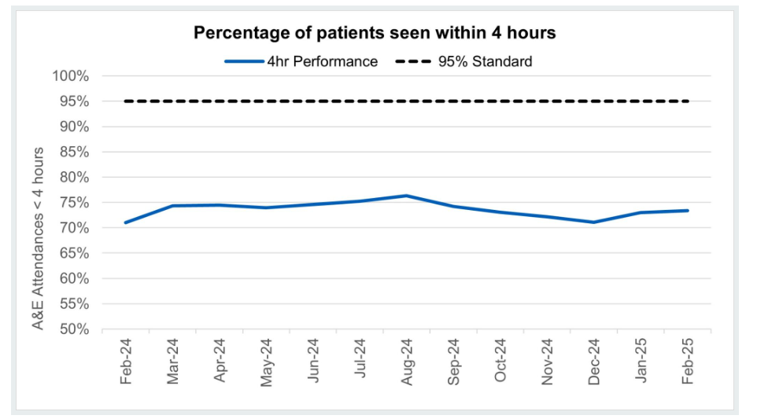
Figure 3: Percentage of Hypertension patient
(Source: NHS England, 2025)

2.2.5 Short and Long-Term Impact on Public Health
Hypertension has many short- and long-term health consequences. Short-term impacts include undiagnosed or poorly treated high blood pressure, resulting in more GP consultations and hospitalisations (Havercamp et al., 2025). And some may not be aware they have it. Over time, high blood pressure is a major risk factor for stroke, heart disease, kidney disease and death. The British Heart Foundation (2015) estimates that high blood pressure causes 50% of heart attacks and strokes in the UK. It also leads to higher NHS healthcare costs and lost productivity from chronic disease. In disadvantaged areas like Newham, the effects are greater due to differences in lifestyle, income and health care.

2.2.6 Health Intervention Programme
The proposed Newham Hypertension Prevention and Management Programme should prioritise early detection and behaviour change. This includes free NHS Health Checks for people aged 40-74 and community screening for undiagnosed hypertension. Education initiatives should encourage low-salt diets, exercise and healthy eating. Regular GP follow-up and medication compliance are crucial to reduce blood pressure and complications. Community outreach in high-risk and disadvantaged areas can boost participation. Such measures support NHS England (2025) policies to combat cardiovascular disease and enhance health.

2.2.7 Evaluation of the Proposed Intervention
Data can be used to assess the success of the Hypertension Prevention and Management Programme. Hypertension is common in the UK, with 32% of adults having high blood pressure, and it is estimated that almost 5 million adults in England suffer from undiagnosed hypertension. Raised blood pressure is responsible for 50% of heart attacks and strokes (British heart foundation, 2015). A programme would have lower stroke and heart disease hospitalisations, better blood pressure control and more people attending NHS Health Checks.
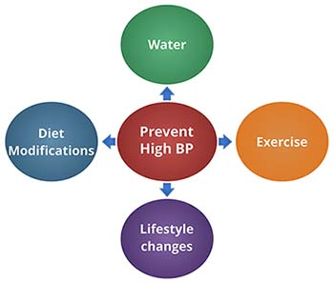
Figure 4: Hypertension Prevention
(Source: Watso et al., 2023)

2.2.8 The Epidemiological Approach: Strengths and Weaknesses
The epidemiological method is advantageous since it involves the use of statistical data to identify disparities, risk factors and at-risk groups. It guides the policy and resource allocation that is evidence-based. It is a strong source of inequalities in disability-related inequalities as well as informing interventions design, as stated by Barrington et al., (2026). However, it has its drawbacks. There is under-reporting of hypertension and not all surveillance data covers hidden barriers such as stigma and discrimination.

2.3 Conclusion
High blood pressure is a significant public health issue in the UK and especially in poor areas such as the London Borough of Newham. It is a common condition, there is failure to detect it and it is associated with deprivation; evidence indicates that hypertension is the major risk factor for cardiovascular disease, cerebrovascular accident and mortality. The UK official statistics show disparities, including reduced workforce participation and multiple health conditions as compared to the general population. Disability inclusive health services, social security and community intervention programs are health promotion strategies essential in ameliorating these disparities. Identification of high risk groups and intervention is supported by surveillance and epidemiological studies.

References
Barrington, M., Fisher, K.R., Harris-Roxas, B., Spooner, C., Trollor, J.N. and Weise, J. (2026) ‘Access to healthcare for people with intellectual disability: a scoping review’, Scandinavian Journal of Public Health, 54(2), pp. 173–188.
British Heart Foundation (2025) High Blood Pressure Statistics. Available at: https://www.bhf.org.uk/informationsupport/risk-factors/high-blood-pressure (Accessed: 27 April 2026).
Buford, T.W. (2016) ‘Hypertension and aging’, Ageing Research Reviews, 26, pp. 96–111.
Digital NHS UK (2026) Adult health with hypertension. Available at: https://digital.nhs.uk/data-and-information/publications/statistical/health-survey-for-england/2021-part-2/adult-health-hypertension (Accessed: 28 April 2026).
Disabilityinpublichealth.org (2026) Public health. Available at: https://disabilityinpublichealth.org/conclusion/ (Accessed: 29 April 2026).
Folorunsho, S. (2025) ‘The role of social determinants of health in shaping racial and disability disparities among older adults in the United States’, Journal of Aging & Social Policy, pp. 1–17.
Havercamp, S.M., Krahn, G.L., Murray, A.J., Akobirshoev, I., Bellamy, C.D., Bonardi, A., Breslin, M.L., Brown, L.X.Z., Costa, M., Dembo, R.S. and Ellsworth, D. (2025) ‘A call to action to include disability in intersectional health equity research and policy’, The Lancet Regional Health – Americas, 49.
Health Knowledge (2026) Inequalities in health. Available at: https://www.healthknowledge.org.uk/public-health-textbook/medical-sociology-policy-economics/4c-equality-equity-policy/inequalities-distribution (Accessed: 28 April 2026).
Huang, Z., Li, X., Liu, X., Xu, Y., Feng, H. and Ren, L. (2024) ‘Exercise blood pressure, cardiorespiratory fitness, fatness and cardiovascular risk in children and adolescents’, Frontiers in Public Health, 12, p. 1298612.
Joseph Rowntree Foundation (2026) UK Poverty Statistics: Disability. Available at: https://www.jrf.org.uk/uk-poverty-statistics/disability (Accessed: 27 April 2026).
Kuper, H., Gatta, D.R., Rotenberg, S., Banks, L.M., Smythe, T. and Heydt, P. (2024) ‘Building disability-inclusive health systems’, The Lancet Public Health, 9(5), pp. e316–e325.
Mencap (2026) Mencap marks 70 years: launch of new online community providing peer-to-peer support for parents. Available at: https://www.mencap.org.uk/press-release/mencap-marks-70-years-launch-new-online-community-providing-peer-peer-support-parents (Accessed: 27 April 2026).
Mental Health Foundation (2025) Mental health statistics. Available at: https://www.mentalhealth.org.uk/explore-mental-health/statistics (Accessed: 29 April 2026).
Mental Health Foundation (2026) People with physical health conditions: statistics. Available at: https://www.mentalhealth.org.uk/explore-mental-health/statistics/people-physical-health-conditions-statistics (Accessed: 28 April 2026).
NHS England (2025) Health Inequalities Improvement Programme. Available at: https://www.england.nhs.uk/about/equality/equality-hub/health-inequalities/ (Accessed: 27 April 2026).
Obed-Arthur, N., Casale, E., Harvey, E.J., DeBrun, C., Finistrella, V., Gilham, E. and Ashiru-Oredope, D. (2026) ‘Assessing the association between elements of health inequalities and the risk of bacterial infection in high-income countries: a systematic scoping review’, Access Microbiology, pp. 000956-v2.
Office for National Statistics (2025) Outcomes for disabled people in the UK. Available at: https://www.ons.gov.uk/peoplepopulationandcommunity/healthandsocialcare/disability (Accessed: 28 April 2026).
Public Health England (2025) Disability and Public Health Profiles. Available at: https://fingertips.phe.org.uk (Accessed: 28 April 2026).
Scope (2026) Home | Disability charity Scope UK. Available at: https://www.scope.org.uk (Accessed: 29 April 2026).
Smythe, T., Rotenberg, S., Moyo-Chilufya, M., Wilbur, J. and Kuper, H. (2026) ‘Health inequalities among people with disabilities: an umbrella review and evidence synthesis’, EClinicalMedicine, 91.
Tanner, L., Kenny, R.P.W., Still, M., Ling, J., Pearson, F., Thompson, K. and Bhardwaj-Gosling, R. (2022) ‘NHS Health Check programme: a rapid review update’, BMJ Open, 12(2), p. e052832.
Thephmillennial (2026) What is public health? Available at: https://thephmillennial.com/what-is-public-health/ (Accessed: 28 April 2026).
UK Government (2025) The employment of disabled people 2025. Available at: https://www.gov.uk/government/statistics/the-employment-of-disabled-people-2025 (Accessed: 27 April 2026).
Umucu, E., Vernon, A.A., Pan, D., Qin, S., Solis, G., Campa, R. and Lee, B. (2025) ‘Health inequities among persons with disabilities: a global scoping review’, Frontiers in Public Health, 13, p. 1538519.
Watso, J.C., Fancher, I.S., Gomez, D.H., Hutchison, Z.J., Gutiérrez, O.M. and Robinson, A.T. (2023) ‘The damaging duo: obesity and excess dietary salt contribute to hypertension and cardiovascular disease’, Obesity Reviews, 24(8), p. e13589.
Well Newham (2026) Blood pressure advice. Available at: https://www.wellnewham.org.uk/advice/blood-pressure (Accessed: 29 April 2026).
World Health Organization (2025) Disability and health. Available at: https://www.who.int/news-room/fact-sheets/detail/disability-and-health (Accessed: 29 April 2026).

