MBA Marketing
Management: Yogesh Sain (2221521)

‘to maximize

customer satisfaction, companies have long

emphasized touchpoints. But doing so can divert

attention from the more important issue: the

customer’s end-to-end journey" (Neher et al.,

March 2016).

From touchpoints to journeys: seeing the world as customers do

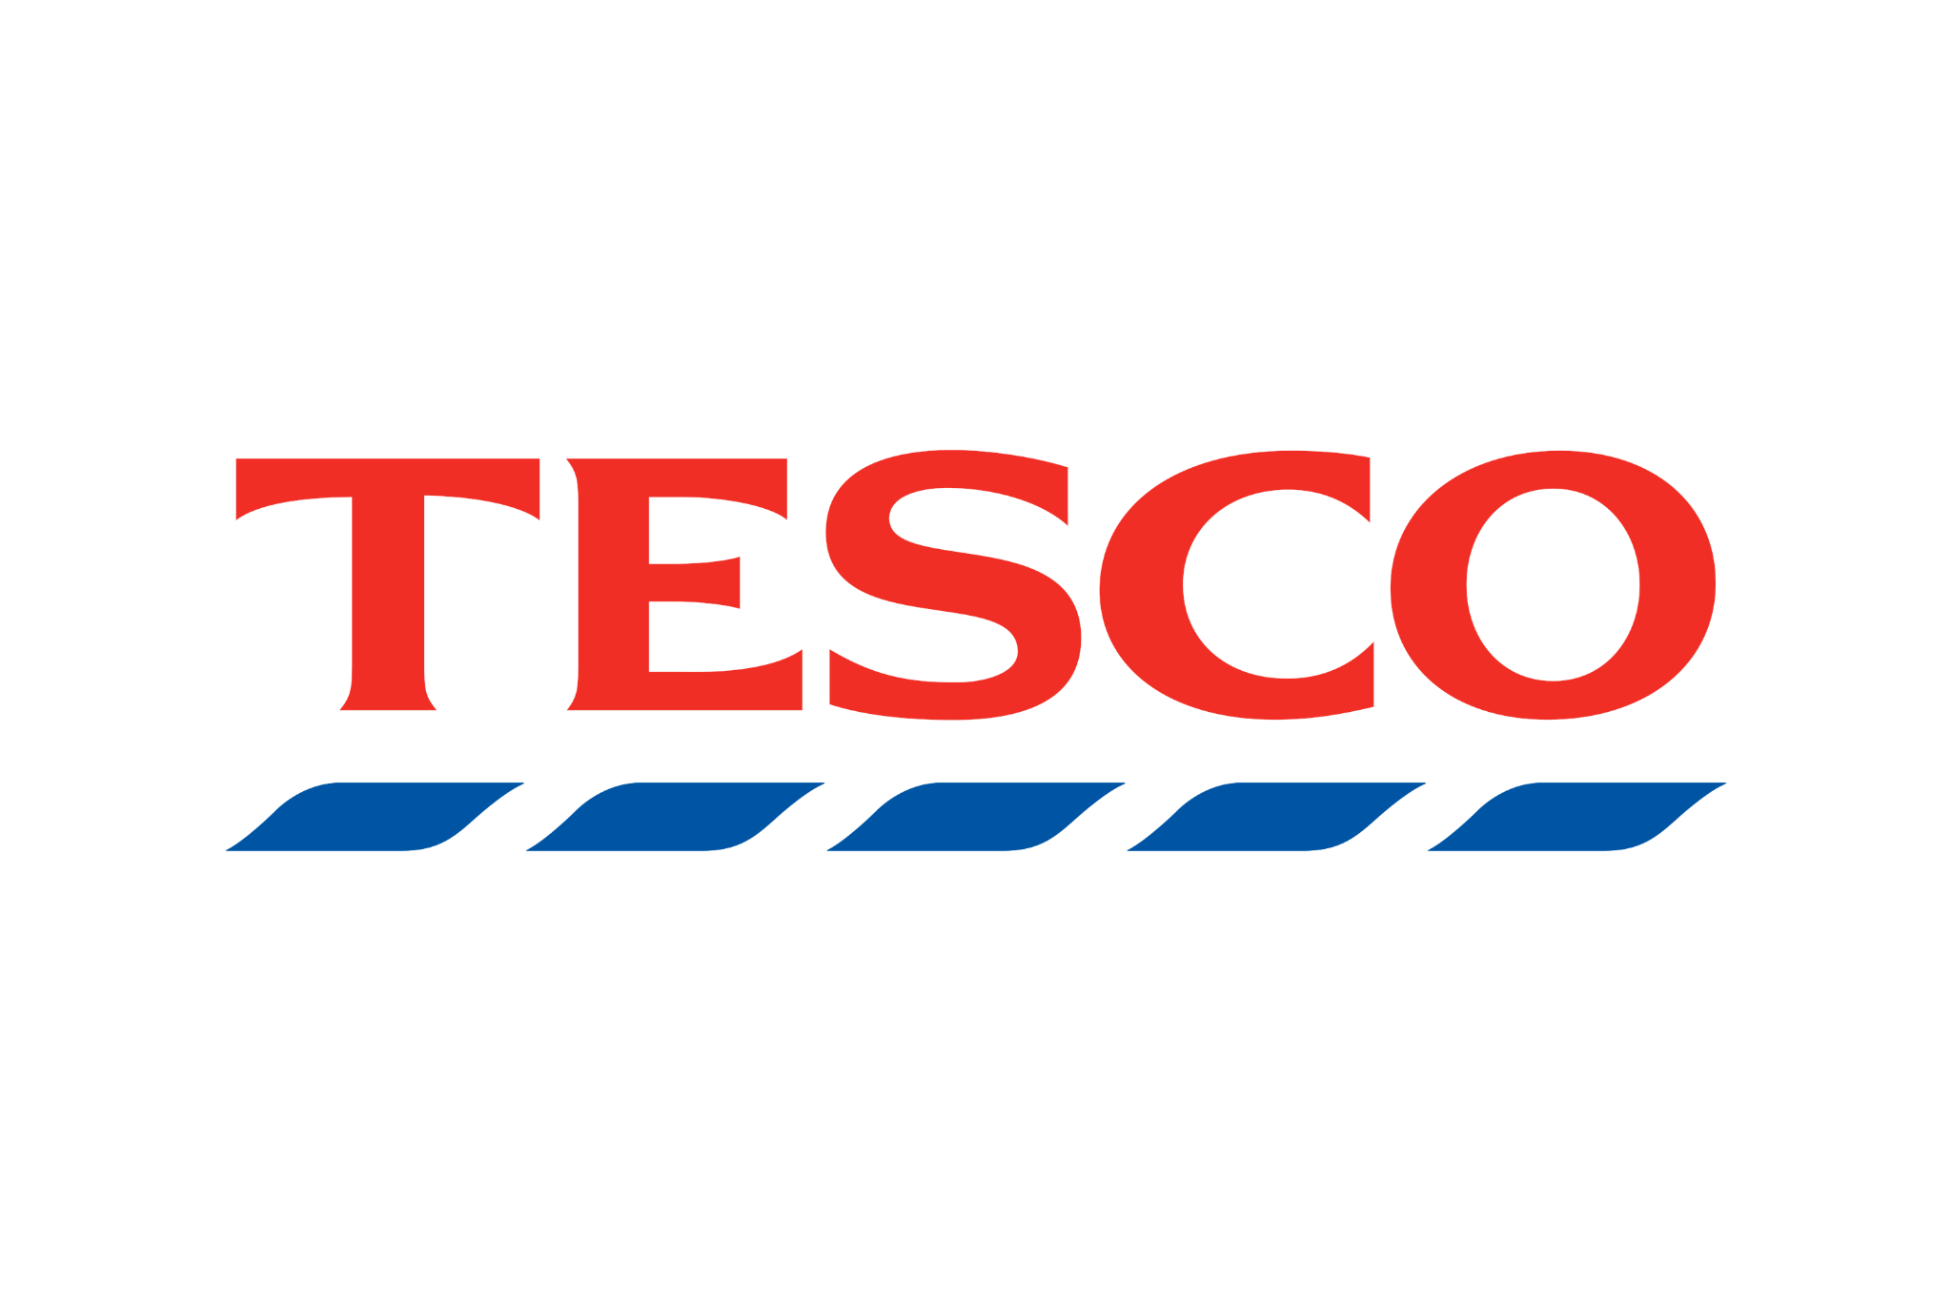

Introduction
One of the top ten food retailers in the UK is Tesco plc, one of the largest in the nation. Tesco was the third-largest global retailer by revenue when it announced being the first UK company to reach $2 billion in profits at the beginning of 2005 (Tesco Annual Review, 2005). industry over gest There are millions of people employed nationwide in the manufacturing and retail sectors of the retail grocery sector, which has long been the largest industry in the UK. P was a retail employee (Datamonitor, 2003).

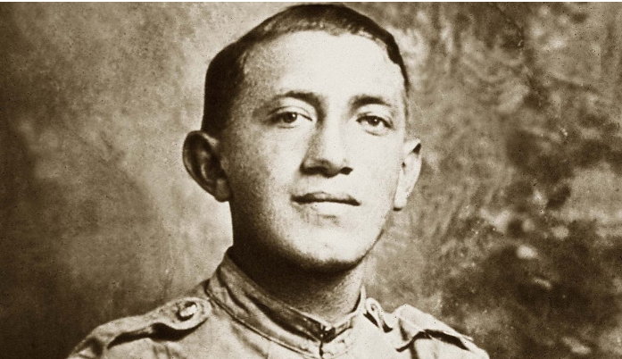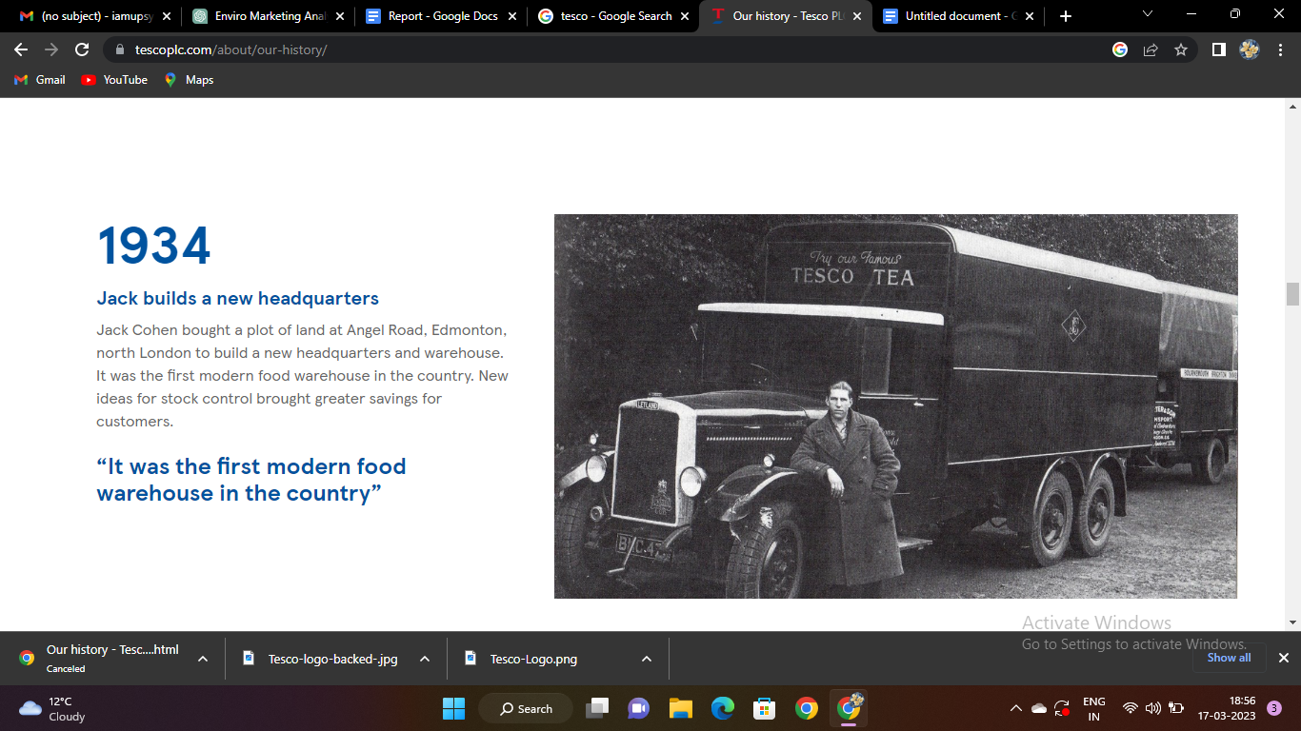

The initials of the company's founder, Jack Cohen, and a tea supplier, T.E. Stockwell, were combined to form the name TESCO. As soon as Jack Cohen started running a booth and selling extra food
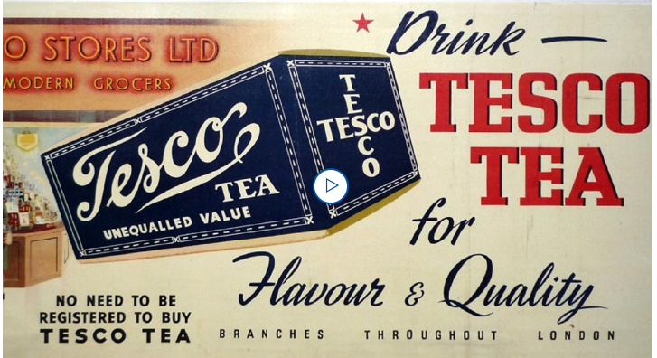
In 1919, he established Tesco in London's East End. In 1924, Jack Cohen created the new label TESCO by combining the first two letters of his last name (CO) with the first three letters of the supplier's name (TES). With more than 326,000 employees and 2,318 stores, Tesco is one of the biggest food retailers in the world.

Tesco Plc operates companies under the names Tesco Extra, Superstore, Metro, and Express in the UK. The first Tesco store opened in Burnt Oak, Edgware, and Middlesex in 1929, and Tesco was listed on the London Stock Exchange as Tesco Stores Holdings Ltd.

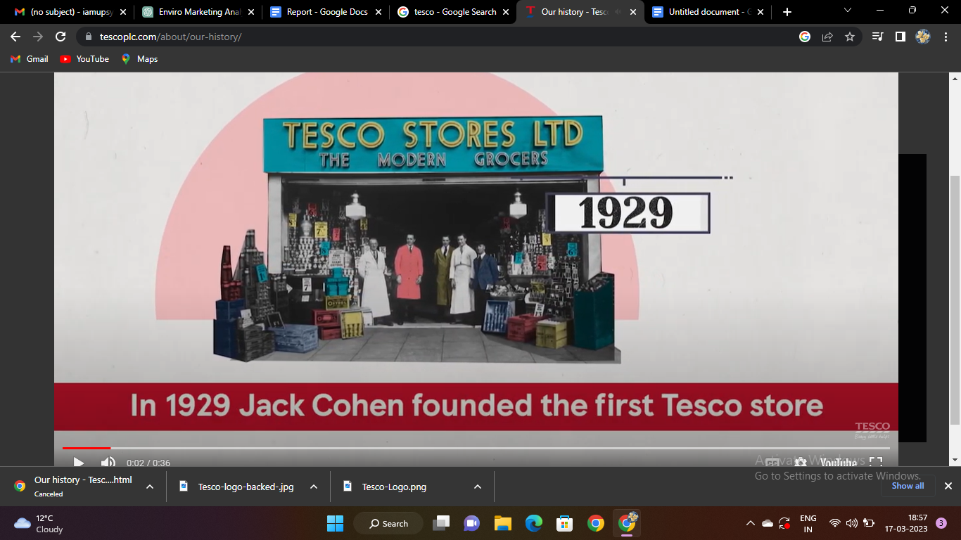
Commerce in 1947. Tesco own-label goods, which come in three levels: values, normal, and finest, account for 50% of sales. Because many of its stores have gas stations in addition to their convenience stores and other retailing services from Tesco, like Tesco personal finance, the company is growing into one of Britain's largest independent retailers of gasoline. Tesco plc is skilled in more than just selling food and drink; examples include clothing. many other things, including electronics, phone service, music downloads, auto insurance, and the sale and rental of DVDs and CDs.

The mission and vision statements of Tesco are examined.
Tesco's motto is "We make what matters better, together." It is abundantly clear from the declaration that everyone helps the business succeed. It promotes a culture where everyone can realize their potential and adds to the ongoing success of this business. The following are its key components:

enhancing health. Tesco's reputation is based on its unwavering commitment to its customers' health, which is exemplified by this component, both domestically and internationally. Because it carries farm-fresh foods and goes above and beyond to keep all of its outlets at the highest level of hygienic standards, this supermarket may currently be the best in the area.
outstanding quality. Tesco, which has been offering its customers excellent value for close to a century, reaffirms its unwavering dedication to providing them with better service each and every time. In order to empower its customers to make even better decisions, the company gives them access to a wider range of products than just a limited selection.
improving lives. Tesco offers much more than just personal shopping. The business is conscious of the positive effects that even the smallest act of kindness can have on the lives of those in need. Tesco has been interacting with neighbors and coworkers in a variety of ways through its Little Helps Program. In actuality, this strategy is supported by three pillars: people, places, and products.
DESCRIPTION OF THE VISION
Tesco's mission is to "be the most highly valued business by: the customers we serve, the communities we operate in, our loyal and dedicated staff, and of course, our shareholders." The declaration makes it clear that measuring the company's achievement of its vision and the satisfaction of all stakeholders is an essential component of the procedure. These are the key parts of the statement:
most well-known companies. This section serves as an example of how effectively Tesco's ideal future state is captured by the vision statement. The business's ongoing dedication to developing cutting-edge strategies to satisfy every player's needs and win their loyalty is demonstrated by the fact that it strives to be highly regarded. Tesco has already made a lot of progress in this direction, according to its annual reports.
to all. To ensure that its brand is well-liked by everyone, Tesco has shaped itself so that it can serve all customers, including those who shop online. The business is proud to serve its UK customers by employing more than 450 000 people from 11 different countries. Every customer receives the services they require without being overlooked thanks to the large team.
the fundamental ideas
"Customer-focused, considerate of everyone, and minimal assistance makes a difference."
Tesco's guiding principles have come to characterize the business for more than a century. Tesco is a trustworthy brand due to its strong internal culture, which results from how highly it values its customers.

Tesco makes it clear that its customers are the most crucial component of its operations. Because of this, its culture favors offering them the most cutting-edge and useful shopping environment. This organization has policies in place to support the development and motivation of its employees in order to ensure effectiveness and cooperation among all parties. Tesco upholds its reputation by supporting the various forms of social and economic development among the customers it serves.

Communication Definition
The act of communicating involves passing along thoughts, concepts, or messages to another person, group, or organization via a range of media and channels. To be understood, a message must first be encoded by the sender, transmitted over a channel, and then received, decoded, and understood by the recipient.

A communication model is a condensed illustration of the communication process that explains how messages are transmitted and received. The Shannon-Weaver model, which incorporates the following components, is the most widely used communication model.

The person or thing that starts the communication process is known as the "sender."
The process of transforming a message into a format that can be communicated across a channel is known as "encoding."
The channel is the means of communication, such as spoken communication, email, phone, or social media.
Noise: any disturbance or obstruction that could reduce the message's accuracy and clarity while it is being transmitted.
Receiver: The one or thing that receives and decodes the message
Understanding and giving meaning to a message is the process of decoding.
Feedback completes the communication loop when the recipient responds to or reacts to the message.

Integrated Marketing Communication (IMC) Definition
IMC, or integrated marketing communications, is a strategic approach that aims to integrate and harmonize all the various communication tools and channels used by a business or brand to market its goods or services. IMC entails combining various communication strategies, including public relations, personal selling, direct marketing, and advertising, into a seamless and cohesive message that is delivered to the target audience. In order to maximize the efficiency of the business's communication efforts, IMC's main goal is to create a consistent brand image and message across all communication channels.

The promotion mix outlines the manner in which marketers carry out their marketing initiatives by fusing various marketing communication strategies. It takes knowledge and experience to effectively use various marketing communication techniques. Each technique has its own advantages and challenges. It should come as no surprise that marketing communication strategies change throughout time as new tools and capacities for communication become available to marketers and the target audience.

Why is integrated marketing communication important?
Today, every company uses a range of channels to reach out to their target audience. Numerous digital channels have been added to the traditional forms of communication like TV, radio, newspapers, outdoor ads, and mailboxes. As a result, it can be challenging to keep track of all the media options available to reach potential customers.

In order to achieve their marketing goals, businesses must now focus on multiple marketing platforms at once. An omnichannel marketing strategy is required to ensure that all channels work together seamlessly. In this case, IMC (Integrated Marketing Communications) is crucial.
IMC is crucial for four key reasons: it ensures consistency throughout the entire customer journey, supports brand development, enables effective use of the right channel mix, and increases the effectiveness of those channels through collaboration.

Promotional strategies Tesco can use to raise awareness of its brand
Tesco can use a variety of promotional techniques to expand its current traditional promotional campaigns and increase brand awareness. Here are some inventive marketing techniques it might employ:

1. Influencer marketing: To raise brand awareness, target new demographics, and establish credibility with new customers on social media, Tesco can launch an influencer marketing campaign with relevant social media personalities.

2. Gamification: Competitions or games that use Tesco's brand and product offerings as prizes can be made for customers using mobile-based applications. People may become engaged and enthusiastic as a result, focusing their attention on new offerings or promotions.

3. Social media competitions: Holding different social media competitions can increase awareness and engagement. For instance, Tesco could host photo competitions where participants submit images of themselves using Tesco goods, and the best entry receives a prize.

4. Cross-promotion with other brands: Tesco can work with other brands on promotions, co-branding, or joint marketing campaigns. Examples include running in-store promotions with partner brands or co-creating content for mutual engagement.

5. Community Initiatives: Tesco might support neighborhood improvement initiatives by working with neighborhood councils, schools, and community organizations. Within the communities they serve, this may spark interest and promote social responsibility and awareness.

6. Augmented reality: Tesco could give customers a virtual reality experience, with immersive experiences showing the entire customer journey when using Tesco's goods or services, from the point of decision to the point of purchase.

7. Loyalty Rewards Program: Tesco could offer club card holders new incentives and rewards, giving them a stronger incentive to choose Tesco over rivals in the market.
8. Online advertisements: Tesco can use targeted online advertising to reach customers by posting their sponsored advertisements on various websites, including social media platforms, apps, or other relevant online communities.

9. Interactive Customer Service Experience: Tesco could make the online shoppers' experience with customer service more interactive by using chatbots or even live video chat. This can enhance the shopping experience by giving customers personalized recommendations, responding to their inquiries quickly, and so on.

10. Cause-Related Marketing: Tesco could help charitable causes by giving a portion of their profits to nonprofits or charities. The purpose of cause-related marketing is to increase awareness of Tesco's brand and build consumer trust while also raising money for pressing social issues.

11. Marketing personalization: Tesco could use information from its customer loyalty program and other data sources to personalize its marketing communications, ensuring that customers are given the appropriate product information and promotions. This could be done by using past purchase and search data or other insights like geographic location, age range or interests to provide personalized promotions.

12. Campaigns to create customized, client-driven QR codes may be run by Tesco. promotion that is entertaining and engaging and directs target customers to Tesco's website, social media accounts, or other branded content.

13. In-store shopper marketing initiatives: Tesco could develop a themed shopping environment to support their brand and draw in customers with simple-to-find displays, inventive in-store promotions, or covert shopper initiatives.

Tesco will be able to increase brand awareness among consumers, drive growth and revenue, cultivate a more devoted customer base, and strengthen its position in the market by implementing these cutting-edge promotional techniques.

Definition of Branding and Brand Equity
A company's efforts to create a distinctive identity and reputation for its goods or services are referred to as "branding." The process of coming up with an instantly recognizable name, symbol, design, or other feature that identifies a company's goods or services and sets them apart from those of rivals It includes all aspects of a company that a customer might notice, such as the logo, packaging, marketing, user experience, customer support, and overarching messaging. Customers should feel valued and trusted when choosing a company's products or services over those offered by competitors. This is the aim of branding.

On the other hand, brand equity describes the immaterial value that a brand brings to a company's goods or services. It is the value that a brand name adds to a good or service that transcends its useful qualities. Brand equity factors in things like brand fidelity, awareness, associations with perceived quality, and other favorable traits that influence consumer behavior and preference for a brand. Strong brand equity helps a company differentiate itself from its competitors, allowing it to command higher prices, retain customers, and secure new business opportunities.

Aaker’s Brand Equity model : TESCO

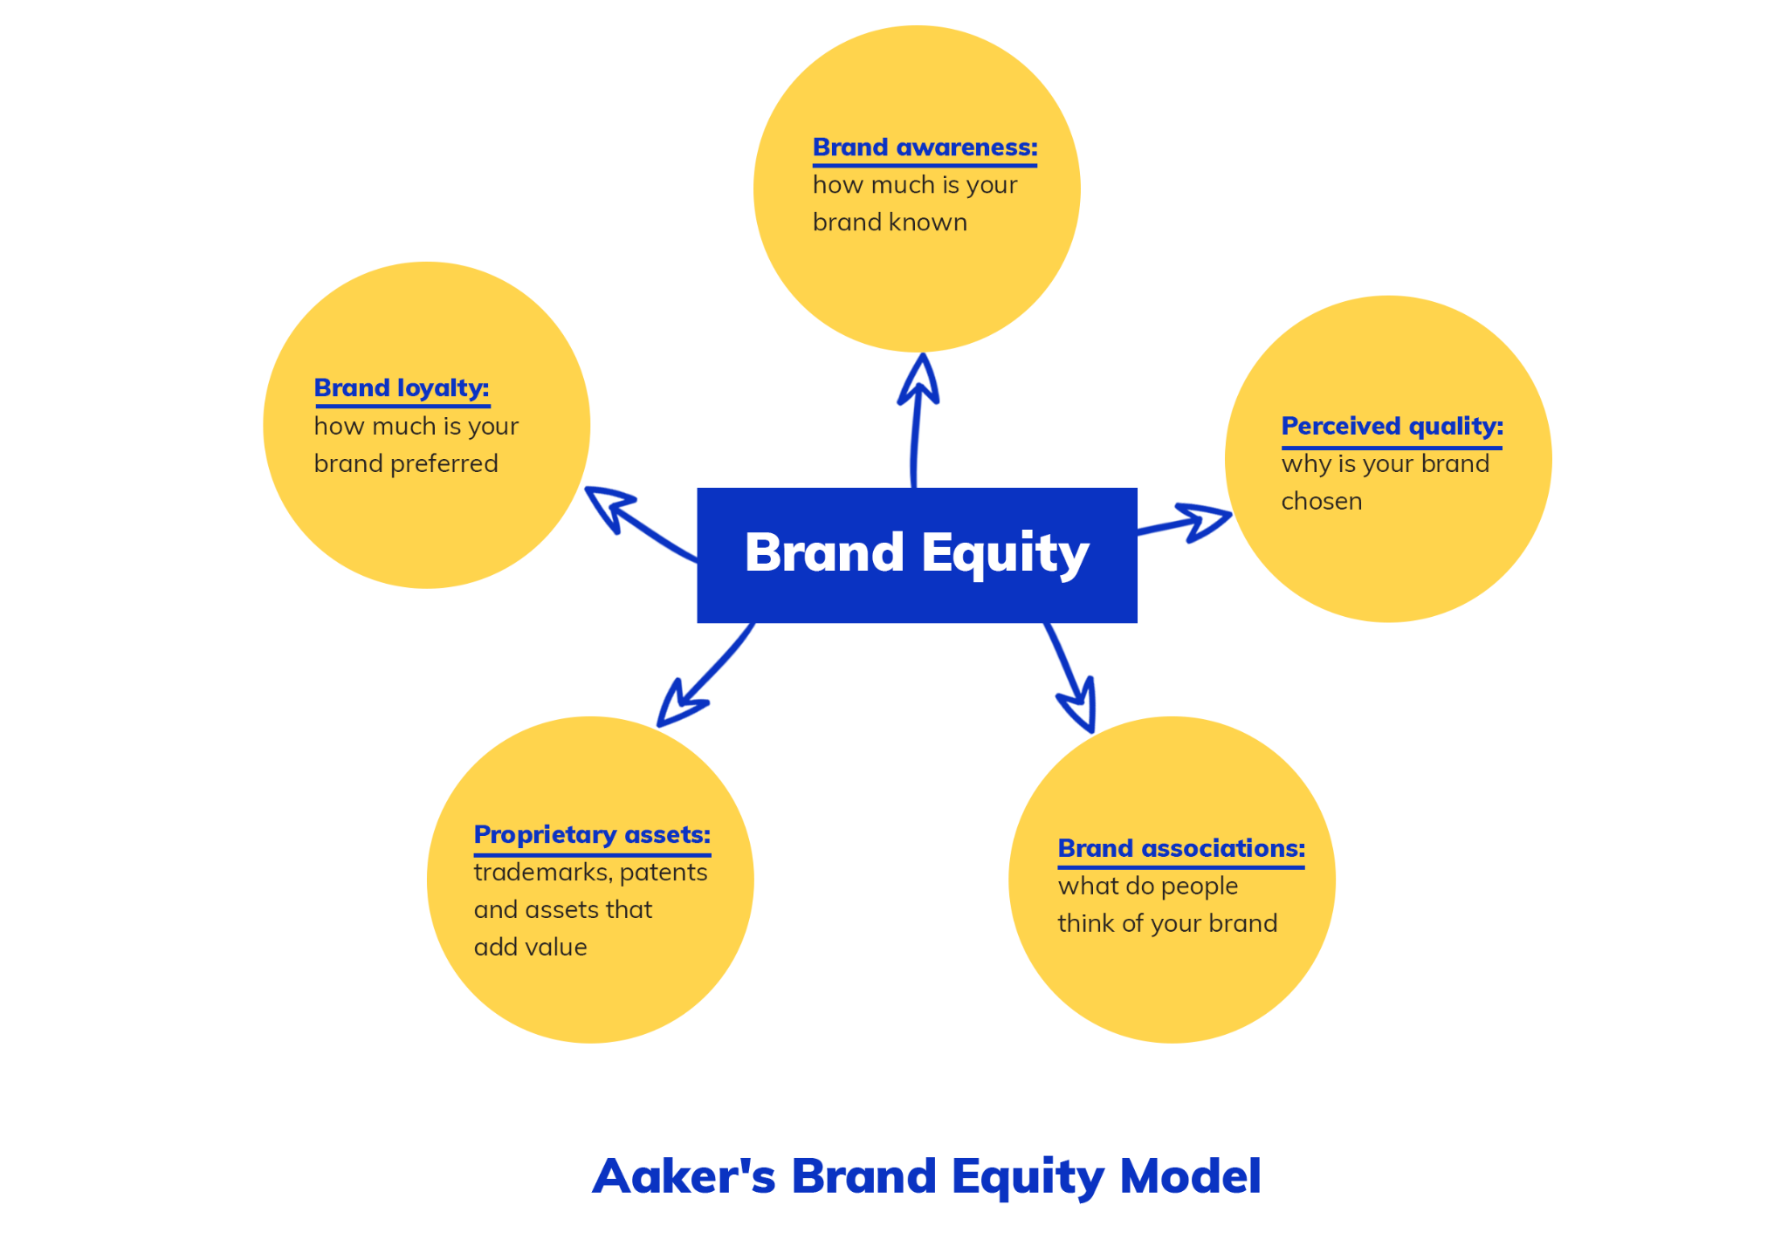
Brand associations, perceived quality, brand loyalty, brand awareness, and other exclusive brand assets are the five elements that make up Aaker's Brand Equity model. By concentrating on these elements, Tesco, one of the biggest retailers in the UK, has built solid brand equity over the years.

Brand loyalty: Tesco's quality, reasonable prices, and extensive product selection have helped it build a loyal customer base. Additionally, Tesco provides personalized deals and loyalty reward programs to entice customers to keep shopping there.

Brand recognition: Tesco is a well-known brand in the UK, and a successful advertising and marketing strategy has aided in raising consumer awareness of the company. To reach a larger audience, Tesco also employs a variety of communication channels, including social media, newspapers, television, and billboards.

Perceived Quality: Tesco is renowned for providing its customers with high-quality goods and services. To raise the quality of its products, the company has made investments in product quality improvement and implemented sustainable supply chain practices.

Brand association: Tesco's brand is associated with a variety of groups and communities, which makes it more appealing to the target market. For example, Collaborations works with charities and regional farmers to support the community, and these initiatives have a positive effect on the company's reputation. Shopping is convenient for consumers. To improve the comfort and convenience of its customers' shopping, Tesco has introduced self-checkout systems, online shopping, and mobile apps.

The Aaker Brand Equity model has the benefits of being practical, simple to understand, and offering a thorough analysis of a company's brand equity. The model aids businesses in identifying what needs to be improved in order to boost brand equity. Additionally, the model aids businesses in determining the advantages and disadvantages of their brand equity in comparison to rivals.

The Aaker Brand Equity model has some drawbacks, including the fact that there are many variables to take into account and that measuring brand equity precisely can be difficult.
A model component can also be ambiguous, making it challenging to assess how well each one works.

As a result of concentrating on the five elements of the Aaker Brand Equity model, Tesco has developed strong brand equity. The business has invested in providing high-quality goods and services while also growing its customer base and brand awareness. Tesco has also invested in innovation and technology and built up strong brand associations. Tesco's strong brand reputation is explained by the Aaker Brand Equity model, which also provides advice.

TESCO CUSTOMER JOURNEY
→→→→→→→→→→→→→→→→→→→→→→→→→→→→→→→→→→→→→→→
AWARENESS | RESEARCH | CONSIDERATION | PURCHASE | DELIVERY/  COLLECTION | POST PURCHASE | LOYALTY

The various customer journey stages for Tesco are depicted in the following straightforward diagram, along with some of the touchpoints that customers might use at each stage:

Tesco Customer Journey Diagram
The various touch points or interactions a customer has with British multinational grocery retailer Tesco are referred to as the "Tesco customer journey." An overview of the typical customer journey is provided below:

- Customers learn about Tesco through a variety of channels, such as TV commercials, online advertisements, word-of-mouth recommendations, or in-store promotions.

- Customer researches Tesco's offerings, including its product selection, costs, special offers, and delivery choices. They could accomplish this by going to the Tesco website, perusing customer testimonials, or going to a physical store.

- Taking into account: The consumer chooses whether or not to shop at Tesco based on their personal preferences and research. They could contrast Tesco's selection with those of other merchants and consider elements like price, convenience, and quality.

- Purchase: Whether in-person or online, the customer makes a purchase from Tesco. They can either visit a physical store to shop in person or order groceries for delivery home using the Tesco website or mobile app.

- Delivery/Pickup: When a customer places an online grocery order, they have the option of having the items delivered to their home or picking them up from a designated pickup location. Tesco provides a number of delivery options, such as same-day, next-day, and Click+Collect.

- Post-purchase: Tesco may contact the customer to follow up on the sale and solicit feedback or make tailored recommendations based on the buyer's past purchases. The client can post a review or discuss their encounter on social media.

- Tesco's Clubcard loyalty program, which gives customers points for every purchase made, aims to increase customer loyalty. These points can be exchanged for deals, coupons, or other benefits.

The overall goal of the Tesco customer journey is to offer a convenient and personalized shopping experience, both online and in-store, while fostering customer loyalty through rewards and incentives.

This diagram shows the different touchpoints that customers may use to interact with Tesco throughout their customer journey, such as the Tesco website, physical stores, mobile apps, customer service, and more. Tesco can enhance the general customer journey, boost customer loyalty, and boost customer satisfaction by offering a seamless and positive experience at each touchpoint.

A framework called the Total Engagement Model emphasizes the significance of involving workers in all facets of business operations. It entails encouraging an atmosphere of open dialogue and cooperation, rewarding and praising staff members, and including them in decision-making procedures. This model can have a number of effects on the success of Tesco, one of the biggest retail businesses in the UK.

To start, Tesco can use this model to encourage an open culture of communication with its staff. Tesco can develop a more inspired and motivated workforce by giving them the chance to express their ideas. Additionally, it can inspire workers to take responsibility for their work, which will result in a workforce that is more dedicated and productive. Additionally, Tesco can use this model to recognize and honor staff members for their contributions, which will foster a sense of community and job satisfaction.

Tesco's operations could benefit from incorporating the Total Engagement Model in order to foster a culture that values employee engagement. By encouraging a supportive and positive work environment, Tesco can improve its business outcomes, leading to higher customer satisfaction and increased profits. This model can help Tesco stay competitive in the retail industry by promoting its skilled and engaged workforce.

In conclusion, Tesco can improve operations and raise employee engagement by using the Total Engagement Model as a helpful framework. Tesco can develop a more inspired and motivated workforce that will produce better business results by encouraging an environment of open communication, rewarding and recognizing employees, and including them in decision-making processes. With the aid of this model, Tesco can be successful by appreciating the significance of employee satisfaction and inclusion.

Payne, A., Storbacka, K., & Frow, P. (2017). Managing the co-creation of value. Journal of the Academy of Marketing Science, 45(3), 489- 504. doi: 10.1007/s11747-016-0488-3
Yani-De-Soriano, M., Foxall, G. R., & Dacko, S. G. (2013). Retail innovation and customer experience: A case study of Tesco. Journal of Retailing and Consumer Services, 20(2), 189-197. doi: 10.1016/j.jretconser.2012.11.004
Kapln, R. S., & Norton, D. P. (2001). The strategy-focused organization. Harvard Business Review, 79(10), 76-85.
O'Cass, A., & Grace, D. (2003). To brand or not to brand? A theoretical and empirical question. Journal of Product and Brand Management, 12(2), 106-117. doi: 10.1108/10610420310469194
Tesco PLC. (2021). Our business. Retrieved from https://www.tescoplc.com/about-us/our-business/
Tesco PLC. (2021). Our strategy. Retrieved from https://www.tescoplc.com/about-us/our-strategy/
Christensen, C. M. (1997). The innovator's dilemma: When new technologies cause great firms to fail. Harvard Business Review Press.
Kotler, P., & Keller, K. L. (2016). Marketing management (15th ed.). Pearson.
Slater, S. F., & Narver, J. C. (1995). Market orientation and the learning organization. Journal of Marketing, 59(3), 63-74. doi: 10.1177/002224299505900304
Tesco PLC. (2021). Our brands. Retrieved from https://www.tescoplc.com/about-us/our-brands/
Wilson, R. M. S., & Gilligan, C. (2012). Strategic marketing management (3rd ed.). Routledge.
Christensen, C. M. (1997). The innovator's dilemma: When new technologies cause great firms to fail. Harvard Business Review Press.
Kotler, P., & Keller, K. L. (2016). Marketing management (15th ed.). Pearson.
Slater, S. F., & Narver, J. C. (1995). Market orientation and the learning organization. Journal of Marketing, 59(3), 63-74. doi: 10.1177/002224299505900304
Tesco PLC. (2021). Our brands. Retrieved from https://www.tescoplc.com/about-us/our-brands/
Grönroos, C. (2006). Adopting a service logic for marketing. Marketing Theory, 6(3), 317-333. doi: 10.1177/1470593106066796
Gupta, S., Lehmann, D. R., & Stuart, J. A. (2004). Valuing customers. Journal of Marketing Research, 41(1), 7-18. doi: 10.1509/jmkr.41.1.7.25084
Tesco PLC. (2021). Tesco and Society. Retrieved from https://www.tescoplc.com/sustainability/tesco-and-society/
Vargo, S. L., & Lusch, R. F. (2004). Evolving to a new dominant logic for marketing. Journal of Marketing, 68(1), 1-17. doi: 10.1509/jmkg.68.1.1.24036
Zeithaml, V. A., Bitner, M. J., & Gremler, D. D. (2006). Services marketing: Integrating customer focus across the firm (4th ed.). McGraw-Hill.

