

MENTAL DISORDERS AND PSYCHOPATHOLOGY
BMH6006
ASSESSMENT 2

Submission deadline : 1st September 2023; 2pm (UK time).
- General Anxiety Disorder
- Schizophrenia
- Autism

Lecturer name : Bianca Sanfilippo
Student name : Yuliana Abadzhieva
Student ID : 1818406

Table of Contents

1.Introduction………………………………………………………………………………….3
2.General Anxiety Disorder (GAD)………………………………………………………….4
3.Schizophrenia……………………………………………………………………………….7
4.Autism……………………………………………………………………………………….12
5.Conclusion………………………………………………………………………………….17
6.Reference list……………………………………………………………………………….19

Introduction

The International Classification of Diseases, 10th Revision ICD-10 (WHO,2010) is essential for categorising and comprehending a wide range of illnesses in the field of mental and behavioural disorders. This report explores conditions that impact cognition, emotion, and behaviour and offers a framework for understanding the complexities of mental health. In the paperwork is discuss the three essential disorders: Autism, Schizophrenia, and Generalised anxiety disorder. Each disorder has unique traits, difficulties, and effects on those affected and society. The classification, diagnosis, and comprehension of mental and behavioural diseases are greatly aided by ICD-10 Chapter 5. The ICD-10 supports developing research, guiding therapeutic practises, and raising awareness of these disorders by offering a standardised framework. This classification system underlines the need to appreciate the difficulties people with mental disorders encounter. It emphasises the necessity for all-encompassing strategies to assist their well-being and inclusion into society.

- General Anxiety Disorder

A mental health disease known as generalised anxiety disorder (GAD) is characterised by excessive and ongoing worry or anxiety over various commonplace circumstances and events. This uncontrollable, excessive concern can lead to severe distress and interfere with normal functioning. GAD goes beyond the typical worries and strains of daily living, and the anxiety is not always related to a particular occasion or circumstance. (Clark, 2022).
- One of the main characteristics of Generalized Anxiety Disorder (GAD) is excessive worry. People with GAD often experience intense anxiety that is not proportionate to the actual situation. They anticipate the worst outcomes and find it difficult to stop or control their worry. (Shevlin et al., 2022).
- GAD is a chronic condition with symptoms lasting at least six months. The level of anxiety can remain constant over time and may fluctuate in intensity. GAD can also cause physical symptoms such as restlessness, muscle tension, fatigue, irritability, difficulty concentrating, sleep disturbances, and psychological distress.(Gordon,K.,et al.,2023).
- It is common for GAD to occur alongside other mental health conditions, including depression and other anxiety disorders. It is crucial to understand that the diagnosis of GAD is typically made by a qualified mental health professional who relies on clinical assessment and criteria outlined in diagnostic manuals like the DSM-5. Treatment for GAD may involve psychotherapy, medication, or a combination of both, depending on the severity of symptoms and individual preferences (EI Baon ,C.,et. al.,2023).
General Anxiety Disorder is a classification in the International Classification of Diseases, 10th Revision (ICD-10), including Generalized Anxiety Disorder (GAD). GAD is identified explicitly by the F40-F48 code range and is categorized as F41.1. This group of disorders encompasses various conditions associated with stress and anxiety (Siddiqui,I.,et.al.,2023).

- People suffering General Anxiety Disorder in the UK
Anyone who exhibits signs of physiological arousal, such as restlessness, sleeplessness, muscle tension, and chronic, excessive worry unrelated to specific situations, might be suspected of having generalised anxiety disorder (GAD). (NICE, 2023).

Understanding symptoms, medical history, physical exams, laboratory testing, and occasionally imaging studies in-depth is necessary for a medical diagnosis.ICD-10 codes can aid healthcare practitioners in accurately recording and communicating diagnoses, but the diagnosis process necessitates a thorough assessment of the patient's health. It is best to get medical attention from a healthcare expert if you have symptoms or concerns so they can help you with the diagnostic process and suggest the proper tests or treatments. (Lontos,D.,et al.,2023).

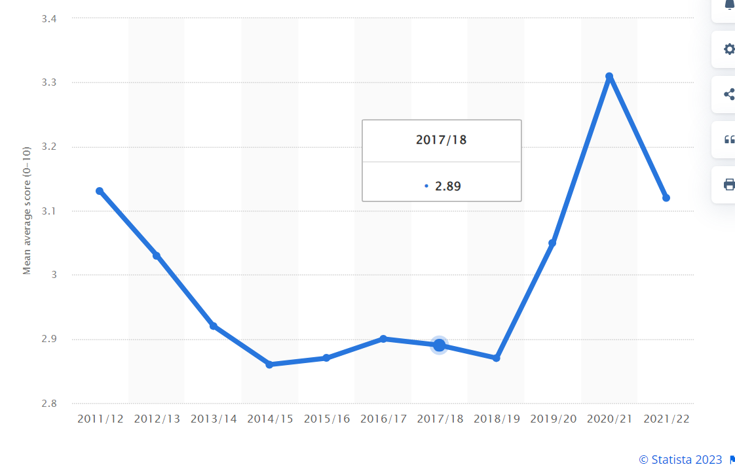
source:https://www.statista.com/statistics/1166036/anxiety-in-the-uk/.

- Current treatments (GAD).

If you are experiencing mental or physical health issues, cognitive behavioural therapy (CBT) could be a helpful solution. This therapy focuses on altering your thoughts and behaviours to manage your concerns better. CBT is often used to treat anxiety and depression, but it can also be beneficial for addressing other issues. (NHS, 2022b).
Cognitive Behavioural Therapy (CBT) is a form of therapy that recognizes the interconnectedness of thoughts, emotions, physical sensations, and behaviours. Negative thoughts and feelings can create negative patterns that are challenging to overcome. CBT aims to break down these significant issues into minor, manageable problems to help you deal with them more effectively. For individuals with Generalized Anxiety Disorder (GAD), CBT can provide tools to transform negative patterns and improve mental health. Unlike other forms of therapy, CBT focuses on present issues instead of past experiences and aims to find practical ways to boost your mood each day (NHS, 2022).

- Measurements of rehabilitation
The criteria, concept, factorial, and procedural validity of a 7-item anxiety scale (GAD-7) were high. The optimum cut point for sensitivity (89%) and specificity (82%) was found. All six Medical Outcomes Study Short-Form General Health Survey measures and disability days showed a high correlation between increasing scores on the scale and numerous functional impairment domains. Despite the frequent co-occurrence of GAD and depressive symptoms, factor analysis proved they were two separate dimensions. Additionally, functional impairment and disability were impacted differently yet independently by GAD and depression symptoms. The self-report and interviewer-administered versions of the scale have satisfactory agreement (Rl et al., 2006).

Recommendations for improvements (GAD)
Of course, the following general suggestions will help in managing and treating Generalised Anxiety Disorder (GAD):
- Increased Awareness and Education: Promote awareness campaigns to educate the public about GAD signs, symptoms, and treatments. This can reduce stigma and encourage early intervention and support-seeking.
- Enhanced Screening and Early Intervention: Implement regular screenings for anxiety disorders in primary care to detect individuals with GAD early. Early intervention improves treatment outcomes (GOV.UK, 2019).
- Integrated Care Approach: Foster collaboration among mental health professionals, primary care physicians, and other healthcare providers to ensure coordinated care for individuals with GAD, addressing mental and physical health needs (NICE, 2020).

Principles of care of people with (GAD).
- Holistic Assessment: Conduct a thorough mental health assessment, considering symptoms, medical history, social context, and coexisting conditions. This assessment will guide personalized treatment planning (Anxiety UK, 2019).
- Collaborative Decision-Making: Individuals should be involved in decision-making regarding their care, including treatment options, goals, and preferences. This shared decision-making process empowers individuals and enhances their treatment adherence (NICE, 2020a).

Schizophrenia
Various cognitive, emotional, and behavioural abnormalities characterise a severe and persistent mental illness called Schizophrenia. It impacts a person's thinking, perception, emotions, and capacity for daily living. Hallucinations, delusions, disorganised thinking, and speech decreased emotional expressiveness, and impaired social functioning are all possible symptoms of schizophrenia (National Institute of Mental Health, 2018).
Let us start with the prevalence of schizophrenia. It has been estimated that between 0.3% and 0.9% of the world's population has schizophrenia or a psychotic disorder2, and 1% of people will have schizophrenia at some point (Mind, 2020).
According to estimates, there are roughly 15 cases of schizophrenia per 100,000 persons.4According to a systematic analysis of numerous studies, schizophrenia is predicted to affect between seven and forty-three persons out of every 100,000 (World Health Organization, 2022).
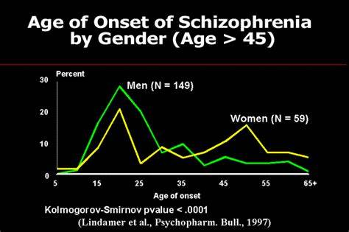
https://th.bing.com/th/id/OIP.izJQviwm2RuqwbW4x0CvxQAAAA?pid=ImgDet&rs=1
Classification

F20-F29: Schizophrenia, schizotypal and delusional disorders
F20: Schizophrenia
F20.0: Paranoid schizophrenia: Individuals with schizophrenia often experience strong delusions and auditory hallucinations centred around a single theme, which may involve persecution or grandiosity.
F20.1: Hebephrenic schizophrenia: Characterized by disorganized thinking, emotional instability, and inappropriate or flattened affect.
F20.2: Catatonic schizophrenia: This encompasses a variety of motor disorders, ranging from immobility to extreme motor hyperactivity.
F20.3: Undifferentiated schizophrenia: If the symptoms shown by the patient do not match any subtype.
F20.4: post-schizophrenic depression: This term refers to the symptoms of depression that occur once the active phase of schizophrenia has ended.
F20.5: Residual schizophrenia: Refers to the continuing presence of mild symptoms following a previous episode.
F20.6: Simple schizophrenia: Characterized by a gradual and progressive decline in functioning without prominent psychotic symptoms.
F20.8: Other schizophrenia: Used for cases not fitting the specific subtypes listed.
F20.9: Schizophrenia, unspecified: This term is used in cases with insufficient data for a precise diagnosis.
It is important to note that schizophrenia can be classified into different subtypes based on the most prevalent symptoms and features. However, it is essential to understand that the ICD-10 classification system primarily codes and categorises diseases for statistical and billing purposes. For clinical assessment and diagnosis, healthcare professionals rely on a combination of clinical judgment, interviews, and diagnostic manual criteria (National Institute of Mental Health, 2018b).

Causes (Aetiology).

Genetics: Having a family history of schizophrenia is a significant risk factor. If an individual has a parent or sibling with schizophrenia, they are at a higher risk of developing the disorder. Multiple genes are believed to be involved, and interactions between genetic factors can influence susceptibility (https://www.facebook.com/nhswebsite, 2021).
Neurochemical Imbalances: Dysfunction in neurotransmitter systems, particularly dopamine and glutamate, has been implicated in the development of schizophrenia. Abnormalities in the transmission of these neurotransmitters can impact cognitive and emotional processes (Mind, 2020b).
Neurodevelopmental Factors: Disruptions in brain development during pregnancy or early childhood may contribute to the onset of schizophrenia. Factors such as prenatal exposure to infections, malnutrition, or stress can influence brain structure and function (Mayo Clinic, 2020a).
Environmental Factors: Various environmental factors have been associated with an increased risk of developing schizophrenia. These include exposure to infections, prenatal or early life stress, and childhood trauma (Leask, 2004).
Brain Structure and Function: Structural brain abnormalities, such as enlarged ventricles and decreased grey matter volume, have been observed in individuals with schizophrenia. Disrupted neural connectivity and abnormal neural circuitry may contribute to cognitive and perceptual disturbances (NHS, 2019).

Signs/Symptoms/Diagnosis
- Individuals with Schizophrenia experience not only positive symptoms but also negative symptoms. These symptoms involve a decrease or loss of normal functioning, including a lack of motivation, reduced expression of emotions, social withdrawal, and difficulty experiencing pleasure. These symptoms often lead to difficulty maintaining relationships, pursuing education or employment, and engaging in daily activities ((NHS, 2021).
- Schizophrenia must be ruled out along with other mental illnesses, and its symptoms must not be brought on by substance misuse, medication, or a physical ailment. Making a schizophrenia diagnosis may involve the following:
A physical examination may be conducted to detect any related complications and eliminate other possible causes of symptoms. Various tests, including drug and alcohol screening and medical tests to rule out diseases with similar symptoms, may be performed. Additionally, the doctor may order imaging tests like MRI or CT scan. A psychiatric evaluation will also be conducted, wherein a mental health professional or doctor will assess the person's mental condition by observing their appearance and behaviour, asking about thoughts, emotions, substance use, and the possibility of violence or suicide (Mayo Clinic, 2020a).

Treatments

Medication, psychotherapy, and psychosocial therapies are frequently used to treat schizophrenia.
Medication: The mainstay of schizophrenia treatment is antipsychotic medication. They function by lessening the intensity of symptoms like delusions, hallucinations, and disordered thinking.
Psychotherapy: In the management of schizophrenia, psychotherapy is crucial, or cognitive-behavioural therapy, is one strategy that is frequently utilised.
Psychosocial interventions: It is essential to provide psychosocial interventions for people with schizophrenia to help them perform better overall and live better lives.
Self-help and Peer Support: For people with schizophrenia, self-help groups and peer support initiatives can be very helpful (NHS, 2022c).
The treatment for schizophrenia is still lacking. However, the symptoms and episodes can be managed with the appropriate care and medicine. One in ten patients may experience a complete recovery, and one in five may see a considerable reduction in their symptoms. A diagnosis of schizophrenia will be managed as a chronic illness by 50% of those who receive one. NICE advises that clozapine be tried if several of these medications are not functioning, and the patient's condition is not improving (NICE, 2023).

Measurements of Rehabilitation

Schizophrenia is a complex condition to quantify. Because of this, in this instance, just the standard of care and treatment are evaluated. How well are the schizophrenia-related complications controlled?
Medications and treatment are used in combination to address this illness.
The NHS (2022) states that CMHTs are responsible for treating schizophrenia.
The goal of (CMHTs) is to provide daily care for persons who have this mental illness.
Social workers, community mental health nurses with specialised training in mental health disorders, occupational therapists, chemists, counsellors and psychotherapists, psychologists, and psychiatric doctors are some of the professionals who can be accessed through CMHT (NHS England, 2022).
Advice and the Caring Principal (NICE)
The recommendation addresses the diagnosis and treatment of schizophrenia and psychosis in adults. It is to achieve earlier diagnosis, quicker treatment, and sustained healing. Another suggestion is to look for comorbid health issues. The help these people can receive from their relatives and those providing for them is equally vital (National Institute for Health and Care Excellence, 2014b).

Recommendations for treating schizophrenia.
For schizophrenia, use Progressive Muscle Relaxation (PMR)
This kind of physical activity benefits the body. It aids in the body's reduction of stress and anxiety. To help the mussels relax, gently tighten them. A review of 5 papers from 2019 and 200 participants in studies looking at the effects of progressive muscle relaxation on people's health. The conclusion was that therapy relieves anxiety, enhances well-being, and improves social functioning. The study, however, only looked at the number of sessions. Thus, it needs to be clarified how many are needed to be effective (NHS, 2022d).

Autism

A complex and varied neurodevelopmental disease known as Autism, sometimes known as autism spectrum disorder (ASD), is characterised by various difficulties in social communication, repetitive behaviours, and constrained interests. People with Autism frequently display disparities in their perceptions of and interactions with their environment.
The word "spectrum" in autism spectrum disorder emphasises the vast range of symptoms and skills that autistic people can have. Some may experience minor issues that enable them to live reasonably independent lives. In contrast, others may experience more severe challenges that influence their daily functioning and require varied support (Wikipedia Contributors, 2019).
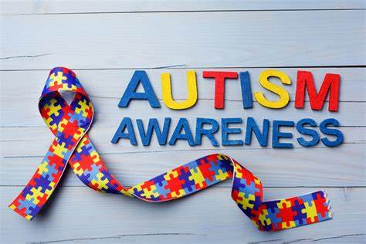

- Autism is categorised under F84.0, "F80-F89 Disorders of Psychological Development." (ICD, 2010) - information on the prevalence of autistic children worldwide and in the UK. One in 100 children may have autism, but it does not indicate that the other one in your family will necessarily have it as well. Twenty children have a 5% chance of developing the same illness as their siblings. That means 19 out of 20 people, or 75%, will be free of autistic symptoms (NHS, 2022e).

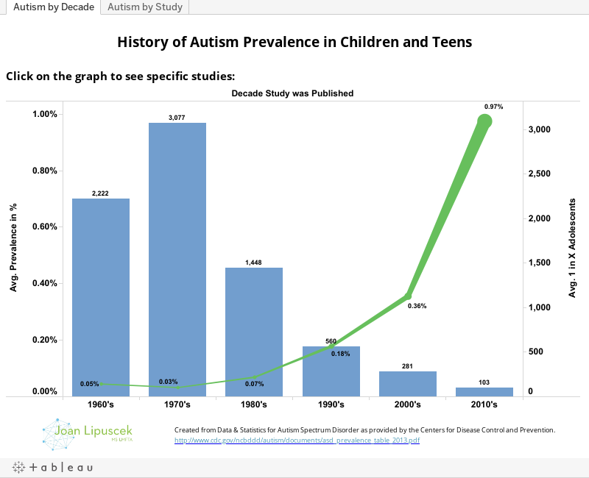
https://public.tableau.com/static/images/Au/AutismSpectrumDisorderPrevalence/AutismbyDecade/1_rss.png

Causes(Aetiology)

Although the precise causes of autism are not entirely understood, it is thought that a complex combination of genetic, environmental, and neurological variables is the primary cause of the disorder. While there is no single known cause of autism, several essential factors have been identified that may have a bearing on the emergence of autism spectrum disorder (ASD):
- Genetic factors significantly influence autism development. Given that autism frequently runs in families, there is compelling evidence of a genetic susceptibility. The likelihood of autism has been linked to specific genes and genetic abnormalities. Though no single "autism gene" has been discovered, several genes likely play a role in the disorder (National Autistic Society, 2022).
- Studies have investigated the immune system's function in autism. Autism has been linked to immune system dysregulation, particularly inflammation, which has been suggested as a potential cause that may affect brain development.
- The immune system's function in autism has been the subject of specific studies. It has been suggested that immune system dysregulation, mainly when it involves inflammation, may impact brain growth, and play a role in the emergence of autism (Kidshealth.org, 2018).

Signs/Symptoms
The most significant signs of autism include difficulty understanding what other people are thinking or feeling; extreme anxiety when outside; difficulty making friends; rudeness or lack of interest in others; inability to understand sarcasm or phrases; and having a set daily routine and becoming extremely anxious if it changes. A shift in the daily routine might bring on anxiety (Hirota and King, 2023).
Impaired Social Communication:
Some individuals face difficulties with verbal and nonverbal communication, including struggles with gestures, facial expressions, and tone of voice. Additionally, they may experience challenges in understanding and utilizing social cues such as eye contact, body language, and appropriate personal space. These individuals may also experience difficulties initiating and maintaining conversations and comprehending figurative language and humour (Baio et al., 2018).
Restricted and Repetitive Behaviours:
Some common behaviours associated with autism include repetitive movements like hand-flapping or rocking and repetitive speech. Individuals with autism may also develop intense interests in specific topics, often at the expense of other activities. They may insist on sameness and routine, becoming upset by changes in their surroundings or routines (Christensen et al., 2019).

Diagnosis

Although the syndrome may exclude a diagnosis of attention-deficit/hyperactivity disorder (ADHD), recent studies have found significant symptom overlap and comorbidity rates between ADHD and autism spectrum disorders (ASD). This presents an opportunity for more detailed research into the distinctions and similarities between these two disorders. This report discusses the latest data on comorbidity rates, symptom overlap, and standard and disorder-specific risk factors, such as recent proteomic studies. Additionally, the review compares neuropsychological findings in areas such as attention, reward processing, and social cognition, which show both overlapping and specific impairments for each disorder. The paperwork also reports on selective brain imaging findings and summarizes therapeutic options while discussing new approaches. Finally, the review concludes with a prospectus on open questions for future research and clinical practice (Taurines et al., 2012).

Current treatments
Applied Behaviour Analysis (ABA) is a therapy that teaches and reinforces positive behaviours while decreasing challenging ones. It is frequently utilized for children and can be customized to meet their unique requirements. Early Intensive Behavioural Intervention (EIBI) is a more intensive form of ABA therapy frequently suggested for children under the age of five diagnosed with autism (Miyauchi and Voineagu, 2023).
Speech Therapy: Speech-language pathologists help people with autism gain better speech, language comprehension, and nonverbal communication abilities.
Social Skills Training: This kind of therapy teaches and practises social skills such as eye contact, taking turns in conversations, and interpreting social cues for people with autism.
Medications: Specific autistic symptoms, including hyperactivity, aggression, anxiety, or depression, may be treated with medication. Antipsychotics, antidepressants, and stimulants are typical drugs. However, medication is often only used as a last resort and is closely monitored due to potential adverse effects (Vorstman et al., 2017).

Measurements of Rehabilitation

- Vineland Adaptive Behaviour Scales: This diagnostic instrument assesses various adaptive behaviours in people with autism, such as communication, self-care, socialisation, and motor abilities.
- The Childhood Autism Rating Scale (CARS) measures the severity of autism and is used to diagnose cases. It assigns scores to several autism-related behaviours and traits.
- A standardised observational evaluation called the Autism Diagnostic Observation Schedule (ADOS) is used to identify and assess social and communication behaviours in people thought to have autism.
- Language and Communication Assessments:
- The Communication and Symbolic Behaviour Scales (CSBS) measure the development of symbolic behaviour and communication in early autistic children.
- The Peabody Picture Vocabulary Test (PPVT) assesses receptive vocabulary abilities, which is crucial for observing a child's language development.
- Assessments of Social Skills and Interaction:
- The Social Responsiveness Scale (SRS) measures the social deficits and problematic behaviours related to autism spectrum disorders.(Watling and Hauer, 2015).

Recommendation for treating Autism.

Early Intervention: For children with autism, early intervention is essential. If you suspect autism, get evaluated and diagnosed as soon as possible. Early interventions like Applied Behaviour Analysis (ABA) and speech therapy can be successful when initiated during preschool.
Work with your child's school to create an Individualised Education Plan (IEP) that details specific educational objectives and modifications to meet your child's requirements.
Alternative and Complementary Therapies: Some families consider complementary therapies, including music therapy, dietary changes, and sensory integration. Before attempting these therapies, it is crucial to speak with a healthcare practitioner because they can have varying degrees of effectiveness (www.nice.org.uk, 2012).

Conclusion
Finally, the International Classification of Diseases, 10th Revision (ICD-10) is a thorough and widely used system for identifying and classifying various medical illnesses and disorders. It is a crucial tool for managing health-related data, tracking illness patterns, and efficiently allocating resources for healthcare professionals, researchers, politicians, and public health officials. ICD-10 offers a well-organized framework for classifying illnesses in various areas, including public, mental, and physical health. Its vast array of codes allows a wide range of medical disorders to be accurately documented, aiding proper diagnosis, treatment, and billing procedures.

Reference list
Anxiety UK (2019). Anxiety UK - National charity helping people with Anxiety. [online] Anxiety UK. Available at: https://www.anxietyuk.org.uk/ [Accessed 30 Aug. 2023].
Baio, J., Wiggins, L., Christensen, D.L., Maenner, M.J., Daniels, J., Warren, Z., Kurzius-Spencer, M., Zahorodny, W., Robinson Rosenberg, C., White, T., Durkin, M.S., Imm, P., Nikolaou, L., Yeargin-Allsopp, M., Lee, L.-C., Harrington, R., Lopez, M., Fitzgerald, R.T., Hewitt, A. and Pettygrove, S. (2018). Prevalence of Autism Spectrum Disorder Among Children Aged 8 Years — Autism and Developmental Disabilities Monitoring Network, 11 Sites, United States, 2014. MMWR. Surveillance Summaries, [online] 67(6), pp.1–23. doi:https://doi.org/10.15585/mmwr.ss6706a1.
Christensen, D.L., Maenner, M.J., Bilder, D., Constantino, J.N., Daniels, J., Durkin, M.S., Fitzgerald, R.T., Kurzius-Spencer, M., Pettygrove, S.D., Robinson, C., Shenouda, J., White, T., Zahorodny, W., Pazol, K. and Dietz, P. (2019). Prevalence and Characteristics of Autism Spectrum Disorder Among Children Aged 4 Years — Early Autism and Developmental Disabilities Monitoring Network, Seven Sites, United States, 2010, 2012, and 2014. MMWR. Surveillance Summaries, [online] 68(2), pp.1–19. doi:https://doi.org/10.15585/mmwr.ss6802a1.
Clark, D. (2022). Anxiety in the UK 2020. [online] Statista. Available at: https://www.statista.com/statistics/1166036/anxiety-in-the-uk/ [Accessed 30 Aug. 2023].
El Baou, C., Desai, R., Cooper, C., Marchant, N.L., Pilling, S., Richards, M., Saunders, R., Buckman, J.E., Aguirre, E., John, A. and Stott, J., 2023. Psychological therapies for depression and cardiovascular risk: evidence from national healthcare records in England. European Heart Journal, 44(18), pp.1650-1662.
GOV.UK (2019). National Institute for Health and Care Excellence. [online] GOV.UK. Available at: https://www.gov.uk/government/organisations/national-institute-for-clinical-excellence [Accessed 30 Aug. 2023].
Gordon, K., Warne, N., Heron, J., von Gontard, A. and Joinson, C., 2023. Continence problems and mental health in adolescents from a UK cohort. European Urology.
Harley TherapyTM Blog. (2017). What is the ICD-10? And How Does It Relate to Mental Health Issues? [online] Available at: https://www.harleytherapy.co.uk/counselling/what-is-the-icd-10.htm#:~:text=In%20the%20United%20Kingdom%20the%20ICD-10%20%28the%20latest [Accessed 30 Aug. 2023].
Hirota, T. and King, B.H. (2023). Autism Spectrum Disorder: A Review. JAMA, [online] 329(2), pp.157–168. doi:https://doi.org/10.1001/jama.2022.23661.
https://www.facebook.com/nhswebsite (2021). Causes - Schizophrenia. [online] nhs.uk. Available at: https://www.nhs.uk/mental-health/conditions/schizophrenia/causes/#Genetics [Accessed 31 Aug. 2023].
Kidshealth.org. (2018). Autism Spectrum Disorder (for Kids) - KidsHealth. [online] Available at: https://kidshealth.org/en/kids/autism.html [Accessed 31 Aug. 2023].
Leask, S.J. (2004). Environmental influences in schizophrenia: the known and the unknown. Advances in Psychiatric Treatment, [online] 10(5), pp.323–330. doi:https://doi.org/10.1192/apt.10.5.323.
Lantos, D., Moreno-Agostino, D., Harris, L.T., Ploubidis, G., Haselden, L. and Fitzsimons, E., 2023. The performance of long vs. short questionnaire-based measures of depression, anxiety, and psychological distress among UK adults: A comparison of the patient health questionnaires, generalized anxiety disorder scales, malaise inventory, and Kessler scales. Journal of Affective Disorders.
Leask, S.J. (2004). Environmental influences in schizophrenia: the known and the unknown. Advances in Psychiatric Treatment, [online] 10(5), pp.323–330. doi:https://doi.org/10.1192/apt.10.5.323.
Mayo Clinic (2020a). Schizophrenia - Diagnosis and Treatment - Mayo Clinic. [online] Mayoclinic.org. Available at: https://www.mayoclinic.org/diseases-conditions/schizophrenia/diagnosis-treatment/drc-20354449 [Accessed 31 Aug. 2023].
Mental Health UK (2019). Symptoms of schizophrenia - Mental Health UK. [online] Mental Health UK. Available at: https://mentalhealth-uk.org/help-and-information/conditions/schizophrenia/symptoms/ [Accessed 31 Aug. 2023].
Mind (2020a). About schizophrenia | Mind, the mental health charity - help for mental health problems. [online] Mind.org.uk. Available at: https://www.mind.org.uk/information-support/types-of-mental-health-problems/schizophrenia/about-schizophrenia/ [Accessed 30 Aug. 2023].
Miyauchi, S. and Voineagu, I. (2023). Autism susceptibility genes and the transcriptional landscape of the human brain. International Review of Neurobiology, [online] 113, pp.303–318. doi:https://doi.org/10.1016/B978-0-12-418700-9.00010-1.

National Autistic Society (2022). the causes of autism. [online] www.autism.org.uk. Available at: https://www.autism.org.uk/advice-and-guidance/what-is-autism/the-causes-of-autism [Accessed 31 Aug. 2023].
National Institute for Health and Care Excellence (2014a). Overview | Psychosis and schizophrenia in adults: prevention and management | Guidance | NICE. [online] Nice.org.uk. Available at: https://www.nice.org.uk/guidance/cg178 [Accessed 31 Aug. 2023].
National Institute of Mental Health (2018a). Schizophrenia. [online] www.nimh.nih.gov. Available at: https://www.nimh.nih.gov/health/statistics/schizophrenia [Accessed 30 Aug. 2023].
National Institute of Mental Health (2018b). Schizophrenia. [online] www.nimh.nih.gov. Available at: https://www.nimh.nih.gov/health/statistics/schizophrenia [Accessed 31 Aug. 2023].
National Institute of Mental Health (2018b). Schizophrenia. [online] www.nimh.nih.gov. Available at: https://www.nimh.nih.gov/health/statistics/schizophrenia [Accessed 31 Aug. 2023].
NHS (2018). Overview - Generalised Anxiety Disorder in Adults. [online] nhs.uk. Available at: https://www.nhs.uk/mental-health/conditions/generalised-anxiety-disorder/overview/ [Accessed 30 Aug. 2023].
NHS (2019). Causes - Schizophrenia. [online] nhs.uk. Available at: https://www.nhs.uk/mental-health/conditions/schizophrenia/causes/ [Accessed 31 Aug. 2023].
NHS (2021). Diagnosis - Schizophrenia. [online] nhs.uk. Available at: https://www.nhs.uk/mental-health/conditions/schizophrenia/diagnosis/ [Accessed 31 Aug. 2023].
NHS (2022a). Cognitive Behavioural Therapy (CBT). [online] NHS. Available at: https://www.nhs.uk/mental-health/talking-therapies-medicine-treatments/talking-therapies-and-counselling/cognitive-behavioural-therapy-cbt/overview/ [Accessed 30 Aug. 2023].
NHS (2022b). Cognitive Behavioural Therapy (CBT). [online] NHS. Available at: https://www.nhs.uk/mental-health/talking-therapies-medicine-treatments/talking-therapies-and-counselling/cognitive-behavioural-therapy-cbt/overview/ [Accessed 30 Aug. 2023].
NHS (2022c). Treatment - Schizophrenia. [online] NHS. Available at: https://www.nhs.uk/mental-health/conditions/schizophrenia/treatment/ [Accessed 31 Aug. 2023].
NHS (2022e). What Is autism? [online] NHS. Available at: https://www.nhs.uk/conditions/autism/what-is-autism/ [Accessed 31 Aug. 2023].
NICE (2020a). Overview | Generalised anxiety disorder and panic disorder in adults: management | Guidance | NICE. [online] Nice.org.uk. Available at: https://www.nice.org.uk/guidance/cg113 [Accessed 30 Aug. 2023].
NICE. (2023). CKS is only available in the UK. [online] Available at: https://cks.nice.org.uk/topics/generalized-anxiety-disorder/diagnosis/diagnosis/ [Accessed 30 Aug. 2023].
Rl, S., K, K., Jb, W. and B, L. (2006). A Brief Measure for Assessing Generalized Anxiety Disorder: The GAD-7. [online] Archives of internal medicine. Available at: https://pubmed.ncbi.nlm.nih.gov/16717171/ [Accessed 30 Aug. 2023].
Shevlin, M., Butter, S., McBride, O., Murphy, J., Gibson-Miller, J., Hartman, T.K., Levita, L., Mason, L., Martinez, A.P., McKay, R., Stocks, T.V., Bennett, K.M., Hyland, P., Vallieres, F., Valiente, C., Vazquez, C., Contreras, A., Peinado, V., Trucharte, A. and Bertamini, M. (2022). Measurement invariance of the Patient Health Questionnaire (PHQ-9) and Generalized Anxiety Disorder scale (GAD-7) across four European countries during the COVID-19 pandemic. BMC Psychiatry, 22(1). doi:https://doi.org/10.1186/s12888-022-03787-5.
Siddiqui, I., Gupta, J., Collett, G., McIntosh, I., Komodromos, C., Godec, T., Ng, S., Maniero, C., Antoniou, S., Khan, R. and Kapil, V., 2023. Perceived workplace support and mental health, well-being, and burnout among health care professionals during the COVID-19 pandemic: a cohort analysis. Canadian Medical Association Open Access Journal, 11(1), pp.E191-E200.
Taurines, R., Schwenck, C., Westerwald, E., Sachse, M., Siniatchkin, M. and Freitag, C. (2012). ADHD and autism: differential diagnosis or overlapping traits? A selective review. ADHD Attention Deficit and Hyperactivity Disorders, 4(3), pp.115–139. doi:https://doi.org/10.1007/s12402-012-0086-2.
Vorstman, J.A.S., Parr, J.R., Moreno-De-Luca, D., Anney, R.J.L., Nurnberger Jr, J.I. and Hallmayer, J.F. (2017). Autism genetics: opportunities and challenges for clinical translation. Nature Reviews Genetics, [online] 18(6), pp.362–376. doi:https://doi.org/10.1038/nrg.2017.4.
Vorstman, J.A.S., Parr, J.R., Moreno-De-Luca, D., Anney, R.J.L., Nurnberger Jr, J.I. and Hallmayer, J.F. (2017). Autism genetics: opportunities and challenges for clinical translation. Nature Reviews Genetics, [online] 18(6), pp.362–376. doi:https://doi.org/10.1038/nrg.2017.4.
Watling, R. and Hauer, S. (2015). Effectiveness of Ayres Sensory Integration®and Sensory-Based Interventions for People with Autism Spectrum Disorder: A Systematic Review. American Journal of Occupational Therapy, 69(5), p.6905180030p1. doi:https://doi.org/10.5014/ajot.2015.018051.
World Health Organization (2022). Schizophrenia. [online] Who.int. Available at: https://www.who.int/news-room/fact-sheets/detail/schizophrenia [Accessed 30 Aug. 2023].
www.nice.org.uk. (2012). Recommendations | autism spectrum disorder in adults: diagnosis and management | Guidance | NICE. [online] Available at: https://www.nice.org.uk/guidance/cg142/chapter/Recommendations [Accessed 1 Sep. 2023].

