Benchmarking exercise HMS Heron stores department

Select an organisation with which you are familiar and conduct a benchmarking exercise on a process you agree with the management of the organisation.
Your submission should be in the form of a report with a target word count of no more than 4,000 words

Benchmarking exercise on Fastest Supply Lead time by a company or organisation in the UK
Benchmarking is a comparison of performance within a supply chain. The level of achievement is evaluated and strived to obtain.
Typical start point for an organisation to start a Benchmarking review could be “How good is the quality of service”. This can be further investigated by asking a more in depth question “How good is it compared to the market leader?

Example: Best supply time organisation
To achieve this the benchmark to become the best and fastest needs realizing. What is the fastest lead supply time overall out of all UK organisations achieve? Whole supply chains can be benchmarked and accessed using this principle.

Quote: Know your enemy and know yourself and in a thousand battles never be in peril
Sun Tzu

Absolute Standards – ISO, BSI etc
Fig 1 Below is a table which shows how ISO standards are made, and below that are the different types of standards.

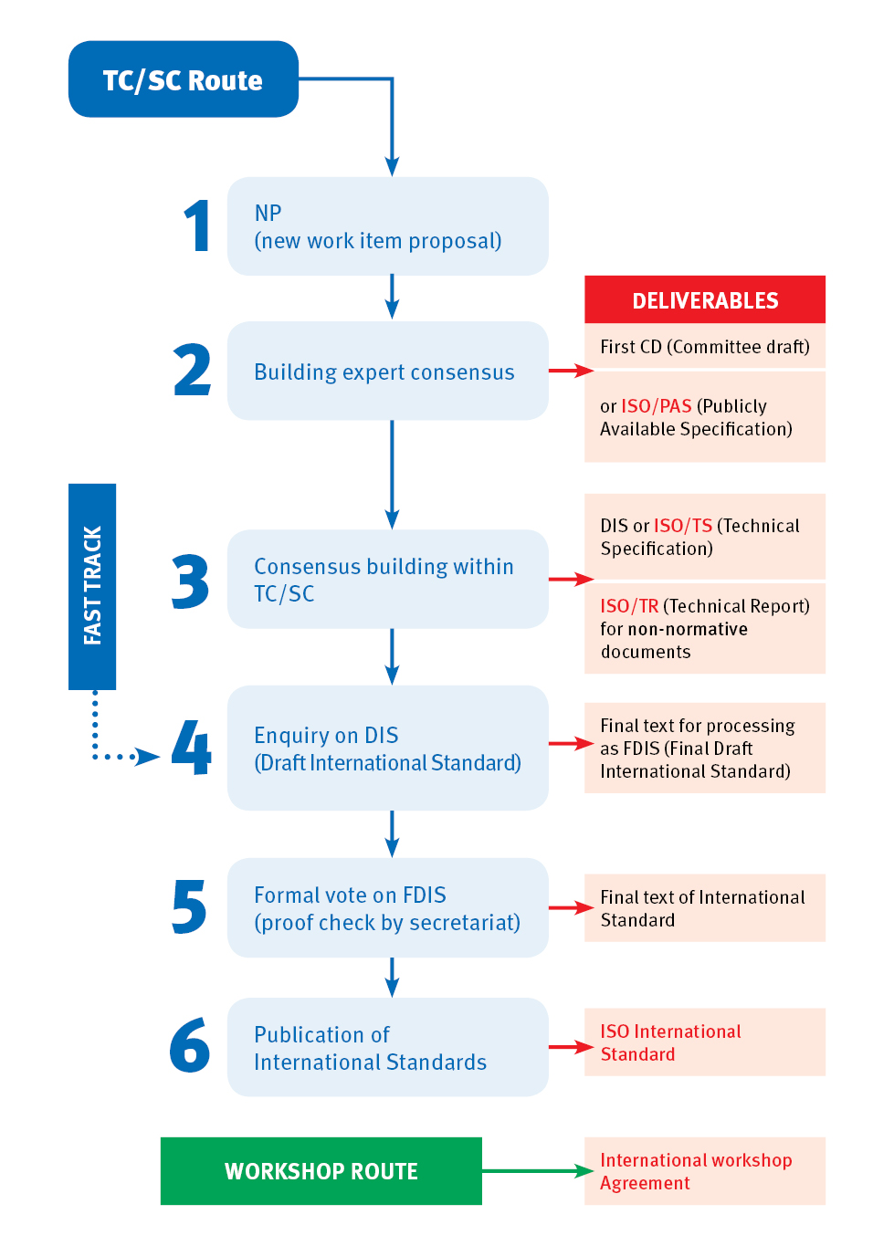
Fig 2
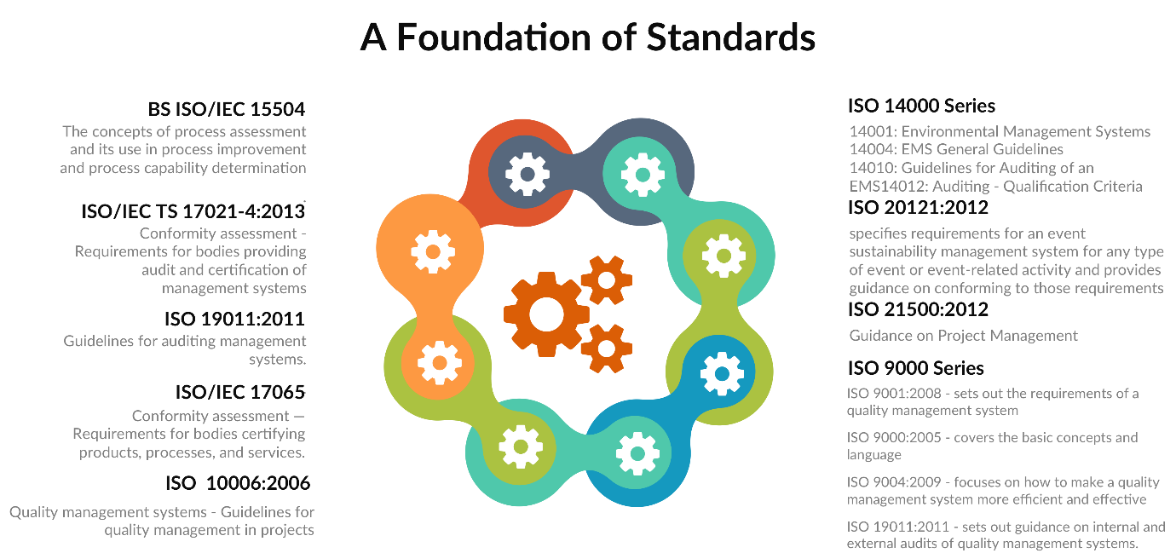

Target performance – setting tough goals

Key Performance Indicators (KPI) are developed to meet the specific needs of an organisation. Used correctly they will help the supply chain achieve improved business performance. Business opportunity areas will need to be defined and the right areas need focusing on and moving forward developing them. Comparison is required between the Royal Navy supply chain organisation cost and service trade off and other similar organisations and business. This supply chain KPI compared to the fastest, average and worst performers within the same industry. Translate supply chain costs from currency value to a % of sales or purchase. Realise the specific areas that are of need of improvement or streamlining. Review operation planning process and access impact on the supply chain overall performance.

Historical standards – do better than yesterday

Reference: 2006DIN04-070

a. The new matrix will retain separate codes for Operational and non-Operational demands.

b. SPS 06 expresses all Supply Chain Pipeline Times (SCPT) in calendar days.

c. Existing codes 1,2,3, (operational) 5,9 and 13(non-operational) will be used as now. SPC 4 and 16 will
be used to allow users to submit demands with an RDD beyond 7 days in UK/NEW (separate SCPT
tables will be available for other theatres).

(1) SPC 1 and 5 will be for urgent demands with a target of 24 hours for satisfaction within UK/
NWE.

(2) SPC 2 and 9 will be for priority demands with a target of between 48 hours and 6 days for
satisfaction within UK/NWE.1

(3) SPC 3 and 13 will be for routine demands with a target of 7 days for satisfaction within UK/
NWE1.

(4) SPC 4 and 16 will be used for demands with a Required Delivery Date (RDD) beyond 7 days
within UK/NWE largely, but not exclusively, by the maritime environment.
d. Specialist SPC 75 will be retained for air automated restocking only and SPC 99 for Maritime very long
lead time demands.
e. A new matrix giving details for each SPC will be published as a part of the new pamphlet.
f. There will some changes to the labels used to identify the SPC.

Direct competitors



DHL JETLINE | Emergency next flight out: delivery within the shortest possible time
DHL SPRINTLINE | Emergency dedicated vehicle: delivery within the shortest possible time

Time Definite
Service | Delivery Commitment
DHL EXPRESS 9:00 | Time-critical: delivery on the next possible day by 9:00 a.m.
DHL EXPRESS 10:30 | Time-critical: delivery on the next possible day by 10:30 a.m.
DHL EXPRESS 12:00 | Time-critical: delivery on the next possible day by 12:00 noon
DHL EXPRESS WORLDWIDE | Time-sensitive: delivery by end of next possible day
DHL EXPRESS EASY | Time-sensitive: available at DHL Service Points

Day Definite
Service | Delivery Commitment
DHL ECONOMY SELECT | Less urgent: delivery within certain number of days
DHL GLOBALMAIL | International non-sorted, non-franked business correspondence


DestinationsTrackingSignature on delivery Online delivery confirmation Delivery aims to Europe Delivery aims to

Rest of World Signed Over 60 countries - Europe 3–5 working days rest of the world 5-7 working days

BuyInternational TrackedOver 50 countries - Europe 3–5 working days rest of the world 5-7 working days

BuyInternational SignedOver 155 countries - Europe 3–5 working days rest of the world 5-7 working days

BuyInternational StandardWorldwide - Europe 3–5 working days rest of the world 5-7 working days

BuyInternational EconomyWorldwide – Europe 10-15 days’ rest of the world 6-12 weeks

Same sector but not competitors

Estimated days of supply:
The estimated number of days that your current inventory supply will last based on the projected demand for your product

How does Amazon generate restock recommendations?
Inventory management recommendations and related estimates (for example, estimated days of supply) are based on a variety of factors, which may include your sales history, seasonality and the product's historical selling prices and sales volume. The relevance of these recommendations can be improved when you enter additional details regarding your business, which may include the lead time that your supplier requires for new purchase orders, Reorder frequency and minimum order quantities.
The Restock Inventory tool is intended to provide you with information to help manage your inventory levels but use of this tool is not a substitute for your own judgement about demand for your products. Many factors may influence the actual demand for your products, including price fluctuations, consumer demand shifts and changes in competing offers for those products. Recommendations are not a guarantee of future results, and sellers remain responsible for determining their prices and inventory levels.
Identify the process to benchmark and the measures of performance

The process for developing a performance measurement and benchmarking system

- What is being benchmarked?
- Defines the measures
- Data collection methods
- Collection of data

Consistency is essential for good benchmarking and to ensure this it is necessary to agree a definition of the key performance measures. A standard reporting format needs to be circulating throughout the organisation. Data collection is achieved by individuals at the project level and they are to be empowered and guided to do this by the hierarchy. Honest reporting is essential, and this must be strived for while keeping integrity. A high code of ethics must be in place and an internal worker might be likely to achieve this than an outside contractor. This must be determined being continuing with the process.

Benchmarking data can’t be used for individual performance reviews, but the project director’s use of the benchmarking process should be accessed. To make benchmarking most accurate the Earned Value Management System (EVMS) is to be used. All benchmarking systems need yearly evaluation to make basic definitions of measures. Which are understood that data is accurate and consistent.

Form a Benchmarking team

When forming a benchmarking team, it’s important to research internal and external data. Access what is being benchmarked and compare finding’s to other organisations. Think about which data collection methods need to be used and what is the best practice overall. Evolve and implement an action plan. When accessing data identify the performance gaps. To produce a successful benchmarking study that matches up to organisational strategy and find the right targets the benchmarking team must be right. It can mean the difference between success and failure.

Communication within the team is a key success or failure trigger and it’s vital that all the team can communicate to a high level. This must translate well between the benchmarking study coordinator and the executive board who are responsible for most project approvals and go ahead. The benchmarking team usually consists of between three and seven members that are diverse enough to bring together the variety of skills and capabilities required. The time given depends on the number of hours worked by the team.

Michael J. Spendolini (Principal of MJS Associates, Laguna Beach, CA)
Abstract:
There is nothing that can wreck a well‐intentioned benchmarking plan faster than selecting the wrong people for the team. Take the company that chose staff members who didn't have enough credibility within the organization to sell their benchmarking team's recommendations to senior management. The team did an excellent job, but without the clout to get their recommendations approved, their efforts failed.
Before putting into place the final benchmarking team members the manager needs to name the program coordinator. The program coordinator on occasions can be named as two people sharing the role but that depends on the team size. Different people may occupy multiple roles within the team when the requirement is in place.
Within a benchmarking team there are Program coordinator, data analyst, data collector and process owner. A benchmarking leader must have expert knowledge (subject matter expert) in the area were the benchmarking study is conducted. The coordinator should have excellent communication and leadership qualities. Daily tasks and terms of reference need to clearly defined. The leader role needs to be respected by all members of the team and the leader is responsible for the entire team. Resources need to be available for managing the budget, meeting’s and solving any issues while constantly monitoring the whole benchmarking process.
Key benchmarking personnel must have the right implementation for the research plan. This will include collecting and compiling data from various sources. Along with the executive board and project coordinator, other important personnel include process owners, data collectors, data analysts, benchmarking project support staff and facilitators. The process owner needs good communication skills and the ability to solve complex problems. The process owner must identify certain problems within the processes and is responsible for mapping the process.
Data collectors, analysts need to have good business process knowledge and data analysis capabilities. They need to be able to make questionnaires and develop ways of retrieving data statistically and in the form of graphs. The benchmarking project support staff must assist the benchmarking team in graphic design, information technology, legal queries, policy, search services and training.
Facilitators need to be independent and remain objective showing no interests except for the facilitation of the team. They need to hold responsibility for making sure the project objectives are carried out successfully and helping the team to solve any problems they may come across. The main goal of benchmarking is to align the process to market reality, customer focus and improving the process. The Benchmarking team selected must be best suited to reach this goal to satisfy it’s brief.

Identify benchmarking partners

It is essential to select the right benchmarking partners and learning from the best organisations. The process required in the selection phase can be a complicated one which needs the required time and all resources delivered as and when needed. The benchmarking process in very structured that contains many organised steps which need to be adhered to always. A key focus is to access how the organisation can obtain a valuable learning experience and add the best findings into the organisation’s processes. Before starting this explore these four questions:

- What to benchmark?
- Who to benchmark?
- How to upgrade the performance of the process?
- How does other organisations upgrade their performance of the process they use?
Selection of a benchmarking partner can best be selected by using the Analytical Hierarchy Process (AHP Principle). Benchmarking partners can be divided into four main categories from low to high hierarchy, they are:

- Equivalent or lower than current performance level
- Improved performance
- Best practices
- Best in class

Best practices mean excellence within products, services or processes performance. Best class means excellent performance within a certain field in a specific industry. Multiple attribute decision making follows a simple plan made up of clarification of problem, identify objectives and measurement of effectiveness. Before identifying the best benchmarking partners first make a list of benchmarking partners for an initial co-operative benchmarking. Some of these potential partners will eventually be eliminated from the list for various reasons. These reasons could include lack of interest or not willing to share the organisations information.

In the selection process, specialists have developed different approaches:

Alternatives to alternative scorecard
A score card matrix is used and rated from 0.00 to 10.00. The best alternative for each attribute is highlighted with a colour representing this and this method is best employed in the initial phase for narrowing the candidate list down.

Ranking the alternatives
Potential partners can be compared in pairs against each other’s attributes and decide overall which is better.

Polar graphs
This is the most popular method used by benchmarking experts and it’s based on graphical representation. This visual representation makes decision making easier and simpler to recognise results outcome.

Collect and analyse appropriate data

4 P’s
- Product / service
- Price
- Place
- Promotion

Productivity is an output per resource, these resources are:
- Labour hours
- Money
- Raw materials
- Energy costs
- ETC

Three categories to consider within a Benchmarking project are comparability, compliance and change. Make strong change management plans and ensure compliance. Benchmark what is comparable. Make reports using results and database.

Fig 3

Formulate a plan to match or exceed the benchmark
Fig 4
SCOR Model

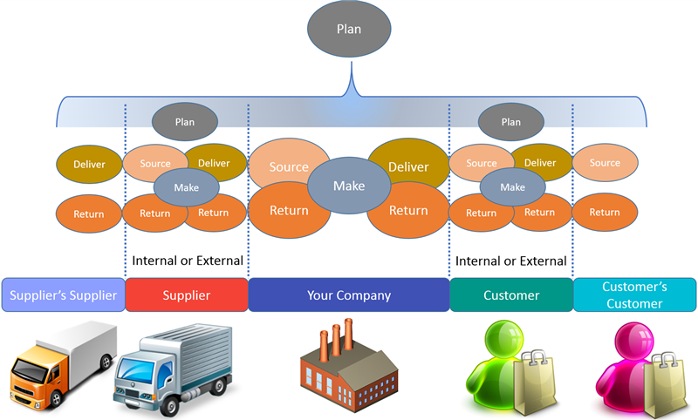

Quote:

Supply Chain Operations Reference (SCOR) is the process reference model used across industries as a supply chain management diagnostic tool.

https://searcherp.techtarget.com/definition/Supply-Chain-Operations-Reference-SCOR

Supply Chain Operations Reference (SCOR) is very useful because it defines a structured way of capturing data. Which then can be stored in a database to better inform the organisation of what is happening currently and what might happen statistically in the future supply chain operations. The SCOR model is based on three pillars, which are process modelling, performance measurement and best practice pillars. It’s the performance measurement pillar that is used for benchmarking which is like an order of Key Performance Indicators. Accurate data is key to success with SCOR. Key focus areas within SCOR are costs, assets, agility, responsiveness and reliability. A Process Improvement Report (PIR) is useful to compare how the supply chain is performing against market leaders from a service or cost point of view.

External verses Internal benchmarking

Benchmarking can be internal or external, when internally organisations benchmark against their own projects. External benchmarking is were external organisations look at projects from other organisations. External benchmarks are thought to have the greater advantage, however internal benchmarking is the starting point for quantity process examining. Trends can be identified by looking at data over a period. External benchmarks compare against competitors and help understand of what is meant by “good” performance.

Reference Page

https://searcherp.techtarget.com/definition/Supply-Chain-Operations-Reference-SCOR

https://www.performancemagazine.org/benchmark-with-the-best-selecting-the-right-ben...

Office of Energy Efficiency & Renewable Energy (2013), Designing a benchmarking plan
Knowledge for Health (2014), Benchmarking team member duties, APQC Report 2010
Successful Workplace (2013), Building Your Benchmarking Team
2006DIN04-070

Hmmm. Not quite got a grip of this. The exercise is for you to
Select an organisation with which you are familiar and conduct a benchmarking exercise on a process you agree with the management of the organisation.

Familiar means the MOD – you know next to nothing about the organisations you have mentioned and, in particular, you have no evidence about how well they meet the KPI. That data are essential to this process and you can only get data such as these from organisations you are familiar with. Compare and contrast the pipeline failure rates for two MOD supply chain units (not organisations - (too big) but your own unit and another similar unit whether it is RN, Army or RAF. Identify something like Dues In or whatever you call that in the Navy, or some other easily obtained set of data that will allow you to compare performance. Or you could do something that is a bit more ambitious – compare the speed the customers are served in your unit cookhouse compared to the customer café in your local supermarket. But avoid trying to produce something that is too big and unwieldly with no chance of comparing similar data – not target but what they actually did. I VERY much doubt that Amazon will tell you of all of their failures….!
And DO NOT cut and paste your way through an assignment. Please.

