Student name:Moawia Edris Adam Haron
Student ID:2336780
Module name: Introduction to Physiology
Module code: BMHP5023
Lecturer name:shaila Hussain
Assessment: Component 1
Table of Contents
1. Introduction 1
2. Structure of the respiratory system 2
3. Gas exchange in lungs 3
4. Recording and tracking respiratory functions 5
5. Recommendations 6
6. Conclusion 7
References 8

1. Introduction
Asthma is a common disease all over the world. In the UK, around 7.2 million people have asthma (Gajjar, Rough and Burnett, 2025). In 2020, around 1261 deaths occurred because of asthma in England. Asthma is a chronic disease in which the airways in the lungs become inflamed and narrow (Zambon, 2022). The inflammation and narrowing can cause the muscles surrounding the airways to constrict, leading to chest tightness, coughing, wheezing, and shortness of breath. These indications can range from minor to severe and may be activated by various factors. Risk factors for Asthma are many (Zambon, 2022). For instance, genetic and familial factors, such as being born prematurely or having a low birth weight, are risk factors for children. In addition, family history, like hay fever, eczema, can increase the risk of Asthma. Moreover, allergies and atopy, like dust mites, pollen, mould, animal dander and cockroach allergens can enhance the risk of Asthma. Lifestyle and health conditions are also risk factors for Asthma.
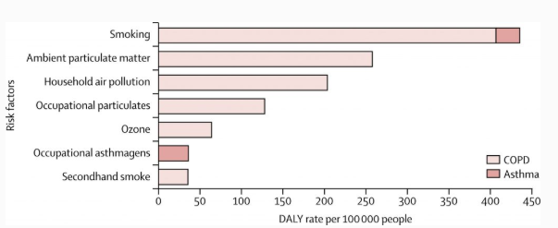
Figure 1: Risk factors of Asthma.
Source: (Majeed, 2019).
The graph shows that smoking is a risk factor for Asthma. It shows that around 400 people are facing the risk of Asthma because of smoking. On the other hand, it illustrates that household pollution, occupational particulates, like chemicals and dust, can enhance the risk of Asthma among around 200 and 150 people (Majeed, 2019). Moreover, it also shows that ambient particulate matter, ozone, secondhand smoke, and occupational asthmagens are risk factors for Asthma. Moreover, obesity and viral respiratory infections can enhance the risk of Asthma.
The aim of the report is to evaluate various factors related to Asthma and the human respiratory system. It will show the structure of the respiratory system and gas exchange in the lungs. The importance of recording and tracking respiratory functions for individuals with Asthma will be shown in this report. Besides, recommendations will also be shown with a conclusion.

2. Structure of the respiratory system
Mechanical respiration is the physical process connecting the physical movement of air into and out of the lungs, which is known as breathing (Yamaguchi, 2020). The process of mechanical respiration includes inhalation and exhalation.
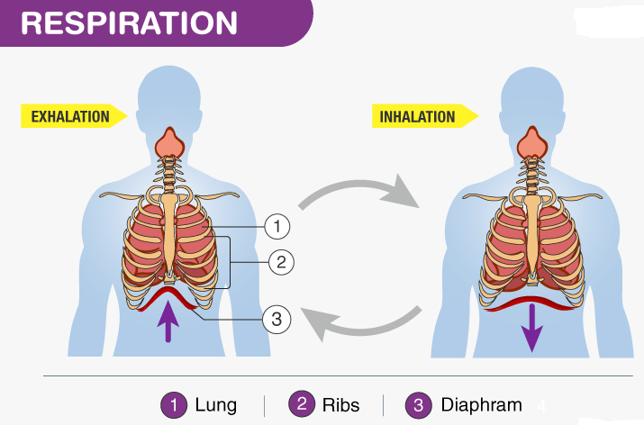
Figure 2: The process of mechanical respiration.
Source: (BYJU'S, 2020).
The diagram shows that during exhalation, the diaphragm becomes narrow, and during inhalation, it becomes wider (BYJU'S, 2020). The full process will be explained in the section below:
Inhalation (Inspiration)
Inhalation is an active process that brings air into the lungs (Singh and Malarvili, 2023). Muscle Contraction involves in diaphragm, a dome-shaped muscle positioned under the lungs. During inhalation, the diaphragm contracts and compresses, affecting the descending aorta. Concurrently, the peripheral intercostal muscles between the ribs contract, elevating the rib cage up and outward. Volume and Pressure Changes involve these muscle contractions, intensification the capacity of the thoracic hollow (Majeed, 2019). According to Boyle's Law, as volume increases, pressure declines. The pressure inside the lungs, which is known as intrapulmonary pressure, is reduced below the atmospheric pressure outside the body. Airflow involves this pressure variance, which generates an incline, producing air to rush into the lungs through the nose or mouth (Israel, Gibson and Chung, 2019). It goes down the windpipe and into the bronchial tube and air sac, until the pressure inside the lungs equalises with the atmospheric pressure.
Exhalation (Expiration)
Exhalation is naturally an inactive process that transfers air out of the lungs (Gajjar, Rough and Burnett, 2025). It includes muscle relaxation, volume and pressure changes and airflow. Muscle relaxation is the process of managing the external intercostal muscles (Feary, Cullinan and Suojalehto, 2020). For example, the diaphragm and the external intercostal muscles relax. In this process, the diaphragm returns to its original dome shape, so the rib cage moves inward and down. On the other hand, volume and pressure changes are the actions that decrease the volume of the thoracic cavity (Esquinas, 2023). The flexible shrinking of the lungs also influences the reduction in volume. When volume declines, the intrapulmonary pressure enhance. It becomes higher than the atmospheric pressure. In addition, Airflow maintains the pressure. The pressure slope navies the air out of the lungs and back into the atmosphere.
Forced exhalation refers to the forceful expulsion of air from the lungs after a maximal inhalation. During energetic activity like exercise, coughing, and other activities, Expiration becomes an active procedure connecting the tightening of the inside intercostal muscles and the abdominal muscles (Feary, Cullinan and Suojalehto, 2020). It vigorously pulls the rib cage down and compresses the abdominal cavity, which forces air out more swiftly.

3. Gas exchange in lungs
Oxygen and Carbon dioxide in the lungs:
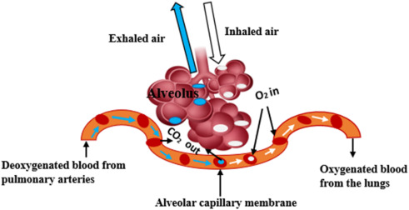
Figure 3: The process of oxygen absorption into the blood and carbon dioxide out into the alveoli.
Source: (Singh and Malarvili, 2023).
Oxygen is absorbed into the blood from the alveoli by diffusion. The above picture shows that inhaled air is consuming Oxygen, which is going to the lungs and becomes oxygenated blood from the lungs (Singh and Malarvili, 2023). It also shows that the Oxygenated blood from the lungs is processed, and the alveolar capillary membrane pressure is the deoxygenated blood from the pulmonary arteries. So, Carbon dioxide is exhaled from the alveoli.
Oxygen absorption into the blood
Inhalation is the process of absorption of oxygen from the atmosphere (Esquinas, 2023). When humans breathe in air, it is absorbed into tiny air sacs in the human lungs called alveoli. Besides, by diffusion process, oxygen passes through the thin walls of the alveoli into the adjacent capillaries into the blood. Transport is the process by which oxygen binds to haemoglobin in human red blood cells (Dua et al., 2020). It carries it into the rest of the body. From the above picture, it is found that during inhalation, oxygen exists in the red blood cells of the body, and the blood transports the oxygenated blood to the whole body.
Releasing Carbon dioxide from the alveoli
Transport is the process of carrying carbon dioxide in the human body. Carbon dioxide is a waste product in the human body (BBC, 2024). It is carried from the body’s tissues to the lungs in the blood. From the above picture, it is found that deoxygenated blood from pulmonary arteries is reaching the alveolar capillary membrane, which is exhaled by the breathing process. By the transport process, carbon dioxide is carried from the body’s tissues to the lungs in the blood, and the Diffusion process focuses on carbon dioxide moving from the blood in the capillaries into the alveoli, and the Exhalation process helps to breathe out the carbon dioxide from the alveoli (Zambon, 2022).
The inflammatory mechanism:
Augmented levels of nuisances in the respiratory system activate an inflammatory response, which leads to swelling in the lung tissue (Yamaguchi, 2020). The inflammatory mechanism will be explained in the following section:
The Immune Cell Activation process includes epithelial cells and resident immune cells, such as mast cells and macrophages, in the lungs (Singh and Malarvili, 2023). It releases inflammatory mediators like histamine, cytokines and leukotrienes. These mediators cause the local blood vessels to widen and become holey. It Increased Blood Flow and Vessel Permeability in the lungs (Majeed, 2019). This consents fluid, plasma proteins and supplementary immune cells, such as eosinophils and neutrophils, to departure the bloodstream and arrive in the lung tissue. Swelling or Edema occurs because of the accretion of this fluid in the interstitial spaces. It is the area between the blood vessels and air sacs. Besides, the liquid in the interstitial spaces and within the airway walls of the human body itself is identified as pulmonary swelling. The impact of the swelling and inflammation on the respiration is very high (Israel, Gibson and Chung, 2019). Impact on respiration will be shown in this section:
The swelling congeals the airway walls of the human body (Esquinas, 2023). It reduces the width of the bronchial tube. The Airway Narrowing makes the movement of air in and out of the lungs harder. The swollen airways generate additional mucus as a defensive mechanism to trap and eject irritants (Feary, Cullinan and Suojalehto, 2020). This phlegm extra clogs the previously narrowed airways, which increases resistance to airflow. The fluid accumulation in the lung tissue enhances the distance between the air in the alveoli and the blood in the capillaries. It leads to hypoxemia. During the process, the lungs become less elastic, which leads to shortness of breath.

4. Recording and tracking respiratory functions
How recording peak flow readings helps
Recording and tracking peak flow readings (PFR) helps people with asthma to monitor and carefully manage their health condition (Dua et al., 2020).
Symptoms of asthma can vary from day to day. PFR provides an objective, numerical measurement of how well air is moving out of the lungs (Zambon, 2022). It also helps to identify triggers by tracking daily activities and potential exposures. For example, the PFR helps to identify specific triggers that can cause lung function to drop by monitoring health conditions (Zambon, 2022). In addition, a healthcare provider can use the peak flow data to identify and determine the current situation of the patients and provide the most accurate medication for them. In addition, peak flow frequently declines hours or even days before an individual experiences perceptible indications like puffed or shortness of breath. This early cautionary consent for timely involvement with medication, possibly avoiding a severe asthma attack.
Reasons for the importance of tracking and recording
The importance of tracking PFR cannot be denied. For example, to ensure proactive management of asthma, tracking is essential to identify symptoms (Singh and Malarvili, 2023). Besides, consistent monitoring can help individuals feel more in control of their conditions. In addition, it helps in informing healthcare providers with accurate information that helps to make an effective medication facility for patients.
Consequences of not tracking peak flow readings
If not tracking peak flow readings, patients may face the issue of delayed recognition of worsening asthma. Besides, it will be difficult to identify triggers that impact asthma (Majeed, 2019). In addition, providing appropriate medication may be tough for the healthcare providers. Not tracking information may increase the risk of hospitalisation and poor long-term control of health. It may make the heart condition worse.

5. Recommendations
Evidence-based strategies for improving the well-being of people with asthma can include a combination of personalised health and social care and lifestyle changes (Israel, Gibson and Chung, 2019).
Health and social care recommendations:
People with asthma should move toward a more personalised strategy to manage asthma, such as integrating mental and physical health care services. In addition, high-quality and accessible primary care is a must for early diagnosis. It can help better control on condition (Gajjar, Rough and Burnett, 2025). So, people with asthma should focus on managing accessible primary care. Besides, the community should support people with asthma by determining social support and supporting them in self-management skills. Family members should be involved in the self-management plan and support them by creating an effective environment.
Lifestyle changes:
People with asthma should focus on an anti-inflammatory diet that can help manage asthma. In addition, physical activities like brisk walking, cycling are beneficial for asthma patients. So, they should focus on moderate-level activities to manage asthma (Feary, Cullinan and Suojalehto, 2020). Stress can worsen asthma symptoms. People with Asthma should focus on yoga, medication or deep breathing exercises.
Health promotion:
Healthcare providers and community support agencies can focus on education on asthma (Dua et al., 2020). For example, support systems can focus on using inhalers correctly and recognising symptoms.
Lifestyle Interventions
Following a healthy eating plan, such as fruits, whole grains, and vegetables, can help to ensure better health conditions for people with asthma (Esquinas, 2023). Besides, limited consumption of sugary drinks and refined carbohydrates can also help to manage asthma. Moreover, regular physical activities, monitoring blood sugar closely, staying hydrated, quitting smoking and limiting alcohol intake can help people with asthma to manage their respiratory system effectively. So, people with asthma need to focus on following these things.

6. Conclusion
Asthma is a chronic respiratory disease. Family history, hay fever, allergies and atopy, secondhand smoke and occupational asthma are the risk factors for people with Asthma. The process of mechanical respiration includes inhalation and exhalation. Inhalation is an active process that brings air into the lungs. Exhalation is naturally an inactive process that transfers air out of the lungs. Oxygen is absorbed into the blood from the alveoli by diffusion, transport and airflow processes. Transport is the process of carrying carbon dioxide in the human body, which helps to remove carbon from the body. Augmented levels of nuisances in the respiratory system activate an inflammatory response, which leads to swelling in the lung tissue. Recording and tracking peak flow readings (PFR) helps people with asthma to monitor and carefully manage their health condition.

References
BBC (2024). Structure and function of the gas exchange system - Respiration and gas exchange - KS3 Biology. [online] BBC Bitesize. Available at: https://www.bbc.co.uk/bitesize/articles/zk9t6g8.
BYJU'S (2020). Mechanism Of Breathing - Explore Mechanism Of Respiration In Detail. [online] BYJUS. Available at: https://byjus.com/biology/mechanism-of-breathing/.
Dua, K., Hansbro, P.M., Wadhwa, R., Pont, L.G., Williams, K.A. and Haghi, M. (2020). Targeting Chronic Inflammatory Lung Diseases Using Advanced Drug Delivery Systems. Academic Press.
Esquinas, A.M. (2023). Noninvasive Mechanical Ventilation. Springer Nature.
Feary, J., Cullinan, P. and Suojalehto, H. (2020). Occupational and Environmental Lung Disease. European Respiratory Society.
Gajjar, D., Rough, E. and Burnett, H. (2025). World Asthma Day. [online] House of Commons Library. Available at: https://commonslibrary.parliament.uk/research-briefings/cdp-2025-0104/.
Israel, E., Gibson, P.G. and Chung, K.F. (2019). Severe Asthma. European Respiratory Society.
Majeed, A. (2019). Global deaths, prevalence and disability for chronic obstructive pulmonary disease and asthma. [online] Medical Centre. Available at: https://blogs.imperial.ac.uk/medical-centre/2017/08/25/global-deaths-prevalence-and-disability-for-chronic-obstructive-pulmonary-disease-and-asthma/.
Singh, O.P. and Malarvili, M.B. (2023). Lung Gas Exchange - an overview | ScienceDirect Topics. [online] www.sciencedirect.com. Available at: https://www.sciencedirect.com/topics/biochemistry-genetics-and-molecular-biology/lung-gas-exchange.
Yamaguchi, K. (2020). Structure-function relationships in various respiratory systems: connecting to the next generation. Singapore: Springer.
Zambon, M. (2022). Ultrasound of the Diaphragm and the Respiratory Muscles. CRC Press.

