

MODULE NAME: ENTERPRISE AND ENTREPRENEURSHIP
MODULE CODE: LCLM4006
BUSINESS PLAN FOR THE EXPANSION OF MILANO LOUNGE

Student Name: VERONICA CONTINO
Student ID: 2524741
Lecturer: BOHDAN KOVALOV

- Executive Summary
Milano Lounge is an established café, restaurant and lounge in Quinton, Birmingham, offering food, coffee, alcoholic drinks and entertainment throughout the day. This business plan focuses on the expansion and sustainable growth of the existing business. The proposed investment will allow Milano Lounge to take over the neighbouring premises, improve the interior layout, increase seating capacity and develop an outdoor terrace. The expansion will support the separation of the restaurant and lounge areas and create opportunities for evening entertainment.
The plan analyses the external business environment, competitors, marketing strategy and financial requirements. The proposed investment of approximately £75,000 to increase, clients, capacity and support long-term business growth.
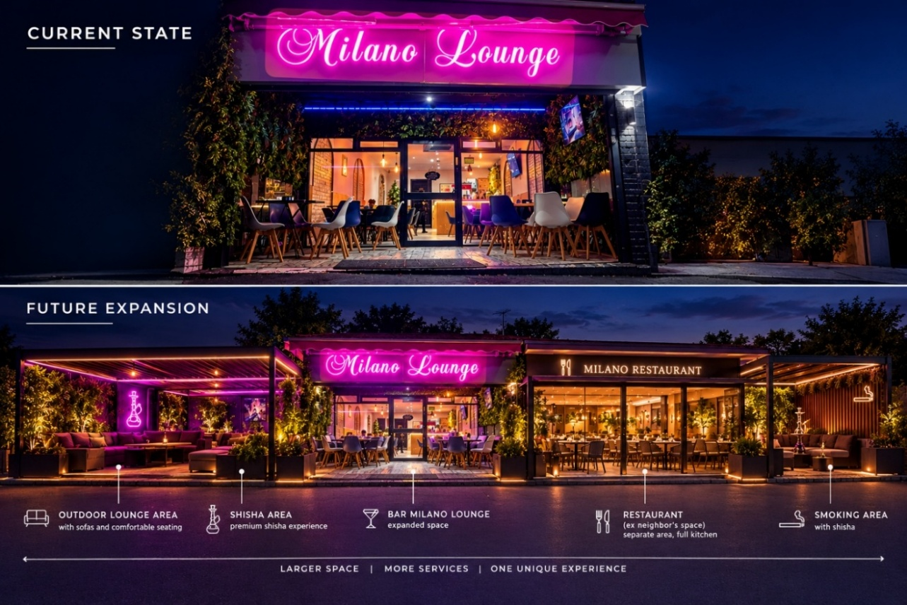

TABLE OF CONTENTS

1. Overview of the Business Idea ........................................ 1

2. Market Research ............................................................. 2

I).1 PESTEL Analysis ........................................................ 2

II).2 Competitor Analysis .................................................. 3

3. Marketing Communications ............................................ 4

4. Financial Plan ................................................................ 5

5. Conclusion ...................................................................... 6

6. Reference List ................................................................. 7

Milano Lounge is an Italian café, restaurant and lounge located in Quinton, Birmingham. The business has been operating for four years and has developed as an all-day venue offering food, drinks and social experiences. The concept combines a traditional Italian café during the daytime with a relaxed lounge environment in the evening, offering a wide range of products and services.
During the morning, the business operates as a coffee shop, serving traditional coffee drinks such as espresso, macchiato, cappuccino…etc with breakfast options. During lunchtime and the afternoon, customers can enjoy hot and cold food, snacks, meals, coffee and afternoon treats. The business also offers an aperitivo-style experience for customers who want to relax or enjoy food and drinks.
In the evening, the focus changes on the lounge side, with cocktails, beers, alcoholic beverages and music creating a relaxed atmosphere.
The business is managed by the owner, who is responsible for the overall management of Milano Lounge and its daily operations.
The business currently employs two waitresses responsible for serving customers. The owner are directly involved, allowing them to maintain control over food and drink quality, customer service and the overall customer experience.
The main objective of the proposed investment is to expand and improve Milano Lounge. The neighbouring premises is expected to become available soon, creating an opportunity to increase space. Taking over this property would allow Milano Lounge to separate the café and restaurant activities from the evening lounge area, creating a more organised layout and improving the customer experience. The investment would also support an outdoor terrace with additional seating and a designated area for smokers and shisha customers, subject to relevant permissions and regulations. The business would also seek permission to provide music later in the evening. As part of its growth strategy, Milano Lounge will focus on reducing food waste, using recyclable packaging, working with local suppliers and creating additional local employment.

- PESTEL Analysis
A PESTEL analysis can be used to identify the external factors that may affect Milano Lounge and future expansion.
The analysis considers political, economic, social, technological, environmental and legal factors.
POLITICAL:
Local government policies and licensing requirements are important for Milano Lounge because the proposed expansion involves additional premises, outdoor seating, alcohol and late-night entertainment. Birmingham City Council requires businesses to obtain the appropriate premises licence for activities such as selling alcohol, providing regulated entertainment and serving late-night refreshments. Outdoor customer seating on public highways may also require a pavement licence. Therefore, maintaining good communication with the local authority will be important when developing the expansion plan.
ECONOMIC:
The hospitality sector is affected by increases in operating costs, including food, energy, wages and other business expenses. The Office for National Statistics continues to monitor inflation specifically for the restaurants and hotels sector, showing that price changes in hospitality remain an important economic consideration. Milano Lounge can respond by maintaining competitive prices, controlling costs and offering different products at different price points throughout the day.

SOCIAL:
Milano Lounge benefits from its ability to attract different customer groups at different times. The café can serve customers looking for breakfast and coffee in the morning, while the restaurant can attract customers during lunch and the afternoon. In the evening, cocktails, alcoholic drinks, music and a lounge atmosphere can attract customers looking for a social place to meet friends.
The proposed outdoor terrace and larger premises could increase the attractiveness of the business and provide customers with more choice.
TECHNOLOGICAL:
Technology can support the growth of Milano Lounge through social media, digital payments, online reviews and digital marketing. Platforms such as Instagram and TikTok can be used to promote coffee, food, cocktails, events and the future outdoor area. Positive customer reviews can attract new customers.
ENVIRONMENTAL:
As a food and hospitality business, Milano Lounge produces food and packaging waste. The UK Government's food and drink waste hierarchy encourages businesses to prevent food waste where possible, while surplus food can potentially be redistributed or donated. As part of the expansion, Milano Lounge could reduce waste through better stock management, recycling and the use of recyclable packaging. The business could also work with local suppliers where possible and introduce more energy-efficient equipment when purchasing new items.

LEGAL:
Milano Lounge already holds an alcohol licence, but any changes to the premises or additional licensable activities must meet requirements.
Recorded or live music in a business will generally require the appropriate music licence, while late-night entertainment may also involve premises licensing requirements. The proposed shisha area also requires careful planning because shisha smoking is subject to smoke-free legislation. Smoking is not permitted in enclosed or substantially enclosed public places or workplaces, meaning the proposed outdoor area would need to comply with the relevant requirements.

- Competitor Analysis
Milano Lounge operates in a competitive hospitality market, with both cafés and evening venues operating around Quinton in Birmingham. Local competitors include Toast & Latte and No.393, both located-on Hagley Road West in Quinton. These businesses creating competition for breakfast, coffee and daytime customers. Toast & Latte and No.393 both have established local customers.
Milano Lounge also faces competition from businesses targeting evening customers. The New Talbot Quinton is a local bar and grill offering food and drinks, while Bar One Quinton operates as a bar with late opening hours. These businesses compete for customers looking for an evening social environment.
There is also strong competition from specialist shisha and lounge venues across Birmingham. For example, Ayaa Lounge offers shisha, cocktails, food and late-night opening, while Luxor lounge combines shisha, drinks, food and desserts. Ayaa Lounge specifically promotes shisha, cocktails, food and late-night entertainment, demonstrating the demand for this type of experience in Birmingham.
However, Milano Lounge can differentiate itself through its combination of an Italian café, restaurant and evening lounge under one business. Rather than focusing only on coffee, restaurant dining or shisha, the proposed expansion would allow Milano Lounge to provide different experiences throughout the day. The addition of the neighbouring premises and an outdoor terrace could further increase capacity and allow the restaurant and lounge functions to be separated.
- Marketing Communications
Milano Lounge will use an integrated marketing communications strategy to attract new customers, retain existing customers and promote its planned expansion. The main target market will include residents, young adults, families, couples and groups of friends looking for food, coffee and an evening social experience, different products depending on the time of day.
Milano Lounge will use platforms such as Instagram, TikTok, to share photographs and short videos of its food, coffee, cocktails, atmosphere and future outdoor terrace. Content can be adapted to different customers, with breakfast and coffee promotions during the morning and food, aperitivo, cocktails, music and evening events promoted later in the day. This approach can increase and encourage customers to visit the business at different times.
The business will also use promotional activities to support the expansion, include special offers during the launch of the new area, happy-hour promotions, seasonal menus, loyalty rewards and special events. This could encourage repeat visits by offering customers rewards after a certain number of purchases.
Customer reviews will also be important for building trust and attracting new customers.
Finally, Milano Lounge will develop relationships with the local community, working with local suppliers, creating local employment opportunities.

- Financial Plan
The proposed expansion of Milano Lounge is expected to require approximately £75,000 of investment. This funding would be used to take over and adapt the neighbouring premises, improve the interior, purchase furniture and equipment, develop the outdoor terrace and support marketing and licensing costs.
The proposed budget would include £20,000 for renovation and interior improvements, £12,000 for the outdoor terrace and seating, £10,000 for furniture and equipment, £8,000 for the neighbouring premises and initial property costs, £5,000 for licences, professional services and compliance, £5,000 for initial stock and marketing, and £15,000 as a contingency fund for unexpected costs.
The investment could be financed through a combination of an external business loan or private investment and the owner's contribution. External funding would reduce the immediate financial pressure on the existing business, while the owner's contribution would demonstrate commitment to the expansion. The investment will increase capacity, improve the customer experience and create opportunities for higher sales through additional daytime and evening customers.

- Conclusion
Milano Lounge has strong potential to grow by expanding its existing café, restaurant and lounge concept.
The proposed investment would increase capacity, improve the customer experience and create new opportunities through an outdoor area and a larger, more organised space.
The business can also strengthen its position through digital marketing, sustainability and community engagement. With appropriate funding, planning and compliance with legal requirements, the expansion could support the long-term growth and competitiveness of Milano Lounge.

- Reference List

- Birmingham City Council (2025) Pavement licences. Birmingham City Council. Accessed 8 October 2026.
- Department for Environment, Food & Rural Affairs (2024) Food and drink waste hierarchy: deal with surplus and waste. GOV.UK. Accessed 8 October 2026.
- GOV.UK (2026a) Get a licence to play live or recorded music. GOV.UK. Accessed 8 October 2026.
- GOV.UK (2026b) Premises licence (England and Wales). GOV.UK. Accessed 8 October 2026.
- GOV.UK (2026c) Smoking at work: the law. GOV.UK. Accessed 8 October 2026.
- Office for National Statistics (2026) Consumer price inflation, UK. ONS. Accessed 8 October 2026.
- Ayaa Lounge (2026) Ayaa Lounge. Accessed 8 October 2026.

