Student: Ekaterina Hristova
1919046
Lecturer: Dr Toyin Adisa

Academic and Employability Skills (BMSW4001)

Table of Contents
Introduction 3
Article One: Employability Skills: The skills you need to get a job 4
Article two: How to keep your job skills current 5
Article three: Future-Proof Human Capabilities: Raising the Future Employability of Graduates 6
Article four: Addressing employability challenges: a framework for improving the employability of graduates in Botswana 8
Personal employability analysis 10
Conclusion 11
Reference 12

Introduction
Employability refers to one’s ability to attain initial employment, maintain and succeed in that employment or even swithching job when needed. To become employable, one needs to have a range of personal skills and attributes that make one able toperform his duties (Gill, 2018). In this paper, four article related to employability have been summarized. The first one is regarding basic employability concept and skills. Then the second one tells how to keep updated with current skills to remain employable. The third one validate a specific Human capacity framework which makes one employable. Then the last article presents a sepcific country case and proposes a framework for enhancing employability. All the understanding gatherd from theses report helped to analyze personal employability through SWOT analysis. In today’s dinamic and changing world, empliyability is a very crucial issue that should be taken seriously by all the stakeholders.

Article One: Employability Skills: The skills you need to get a job
The skills that have a common need in any type of job are called employability skills. These skills make one employable. Employers expect each job candidate to be equipped with these soft skills. These help an employee to flourish throughout his career. On the other hand, the job-specific skills are taught on the job. The most valued employability skills are in the area of working with others, being reliable and dependable, and enthusiasm to learn new skills (Doyle, 2019).
To work and cope up with a team, one needs good interpersonal skills. As a member of a group one, has to negotiate with others, cooperate with others, and solve problems together. Good interpersonal skills help to build a warm relation with co-workers. A variety of skills are covered in this area. Communication skills include verbal communication, non-verbal communication, and listening. Verbal communication refers to face to face or written communication. Nonverbal communication refers to body language, tone of voice. Listening refers to the ability to interpret verbal and nonverbal communication(Doyle, 2019).
Emotional intelligence refers to the ability to control their own and others’ emotional behavior. Negotiation and influencing skills help to reach to resolve conflict and reach a solution. Problem-solving skill is needed to work efficiently with the team and perform the given task effectively. All these skills aren’t required at a time rather it enhances one’s employability.
Being reliable and dependable means acting responsibly and becoming trustworthy to others. This is very crucial to shine in a job career. To become reliable, one needs to perform his task timely and responsively. A reliable employee will take responsibility in danger and manage the unforeseen situation efficiently. A reliable employee will see where works need to be done and take action to do the work. He will be creative and efficient in decision making.
A highly employable employee will have a high willingness to learn new skills and knowledge. He will very cautious about personal development. He will track the changing environment around the workplace and will shape himself according to meet the changes. He is highly flexible and adaptive. So, a wide range of skills are demanded by the employers and we all can make a unique contribution to an organization by our skills.

Article two: How to keep your job skills current
The way how things are done is continuously changing. So does the work environment. New skills are emerging as the workplace is getting up to date to cope up with social and environmental change. As a result, the employees also need to update themselves with new skills to get promotion and switch jobs. This article suggests 10 ways to keep one’s job skills current (Skillsyouneed, 2020).
The first one is to look for what are the most demanded skills in one’s occupation or by employers. These skills are both general and job-specific. Then comes talking with the human resource staff of the current organization to get a detailed understanding. Analyzing high performing employees’ background professional history, following them on LinkedIn, attending online workshops and conferences will also help to gain more insight.
Thirdly, following industry leaders on LinkedIn or other social media will help to understand the new direction and skills needed in one’s profession. Then after identifying the required skills, a professional development plan needs to be developed. Engaging with different professional organizations, conferences, or online workshops to develop those skills.
Then number five, six, and seven are attending workshops, going to professional schools, and attending professional conferences or other events. Many paid online workshops can help to develop the necessary skills. Many educational institutions also provide a range of professional skill development programs. Attending professional networking conference helps to compare one’s skills with others in the same profession and fulfill the skill gaps. Then reading professional journals also helps to track the changing trends and develop oneself accordingly.
Volunteering is in its organization on different projects helps to develop and practice skills that have been gained through the above process. While it is important to be updated with hard skills, there is always scope to develop interpersonal skills. So these are the way how one can keep himself updated in case of both hard and soft skills.

Article three: Future-Proof Human Capabilities: Raising the Future Employability of Graduates
This is a data-driven article trying to analyze and validate the Human Capacity Framework of Queensland Tertiary Admission Centre with other recognized frameworks. As there has been a changing trend regarding how job tasks are organized due to the use of artificial intelligence and automation, many researchers are trying to draw a basic framework that identifies future skill needs and basic employability skills (Wilson et al., (2019).
A capability framework focus on both explicit and tacit knowledge. Capability dimensions include technical skills, soft skills, personal attributes, and cognitive mindset. QTAC in collaboration with Institute for Working Futures has released Human Capability Framework version 3.0 in November 2018 which includes fourteen capabilities such as personal drive, personal learning, adaptive mindset, cultural and social intelligence, empathy, entrepreneurial thinking, ethics and integrity, communication, collaboration, creativity, critical thinking, problem-solving, digital acumen, customer focus. Each capability has some indicators of denoting proficiency level seven. The goal of this framework was to capture core capabilities in the future workplace.
To identify any gaps overlaps, or potential refinements of this framework, HCF was applied as an organizing map for classifying the capability content of other capability frameworks. The other capability frameworks that were selected for comparison are Future skills-focused framework, Australian university graduate capabilities, and outcomes, Australian public service, and industrial capability framework (Okay-Somerville and Scholarios, 2017). This article has applied multiple texts, data-driven, and statistical techniques to analyze the framework.
The comparative analysis revealed some overlaps. Learning, career planning, and development were overlapped in capabilities: 1. Personal initiative and drive and 2. Personal learning and mastery. Ethics and values were overlapped in 1. Personal initiative and drive and 7. Ethics (Wilson et al., (2019). Through data-driven analysis, the strongest capability correlation among the capabilities was identified. The correlations are given below:
Table 1:Correlation among the capabilities
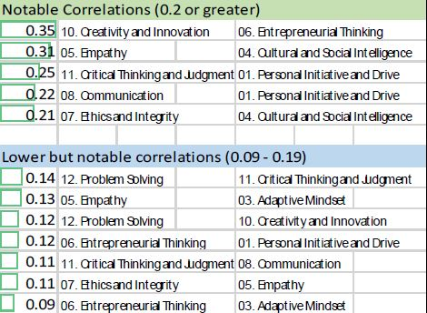
Most of the correlations are very low because of the design work done in the process of developing the framework. Another analysis called LDA analysis has been done here to explore more about the overlaps through adjusting the topic clusters. The LDA analysis has revealed some unmatched items that help to evaluate the current themes and any implication for the HCF capability set.
The co-occurrence analysis provides some crucial insights which they can apply to helps different universities who are willing to deploy capability frameworks that focus on graduate employability. The research has revealed some conflict between evaluating skills based on today’s needs and future needs (Rowe and Zegwaard, 2017). Comparison with other frameworks using different techniques, eight-core future capabilities core to graduates was confirmed and then validation research using the modified Delphi approach supported the original findings. The other six capabilities scored high with industry experts and stakeholders but in the comparative analysis, they scored poorly compared to other capabilities. The capabilities are ranked below from high to low:
Table 2: QTAC validated future capabilities
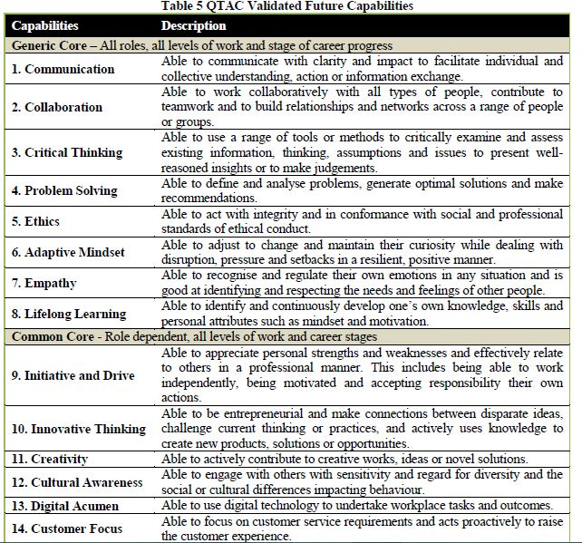
This article provides some valuable understanding of the required skillset for high employability. This article also helps to develop an understanding of how to develop skill frameworks and evaluate the frameworks using different techniques and reach a conclusion.

Article four: Addressing employability challenges: a framework for improving the employability of graduates in Botswana
This paper is concerned with the employability problem of a specific country, Botswana. This paper uses a qualitative and descriptive approach to evaluate the knowledge related to employability skills and attributes of the students of Botswana University and also suggests a framework to enhance employability (Pheko and Molefhe, 2017).
In any stage of development, unemployment is a great problem for policymakers requiring them to develop strategies to generate enough jobs. Necessary skills, knowledge, and personal attributes are crucial to seek employment (Beausaert et al., 2019). Besides the natural imbalance between supply and demand for labor, skill mismatch also plays a significant role.
Since independence, Botswana is spending a significant portion of its budget on education and skill development to meet the human resource needs of the 21st century. The country is transforming from an agriculture-led economy to a formal sector-based economy requiring a wide range of skills. Despite significant investment in education and skill development, youth unemployment has remained a concern for policymakers (Han-Yu et al.,(2018). The employability level of the youth plays a significant role in getting employment. Organizations always look for employees with high employability to reduce training and orientation costs. Higher institutions are the most important stakeholder in developing employability as they act as a direct bridge to the workplace and develop the required skills in the graduates. This paper used 14 employability skills for the study purpose identifies by Martin et al. (2008)
The study conducted on 83 students reveals that the top five skills mentioned by the students such as job-specific skills, enthusiasm, vocational job-seeking, personal presentation, problem-solving are rated as the last five skills on priority by martin’s study. The top three skills such as numeracy, literacy, and communication aren’t identified as important by the students. Maybe this is why university graduates lack the necessary skills needed by employers (Misra and Khurana, 2017). To identify necessary skills, all stakeholders should collaborate. In the next part, the students expressed their skepticism regarding their employability skills referring to the newspaper reports that Botswana graduates don’t possess employability skills. But the unemployment problem may have many other reasons such as slow economic growth, lack of diversity, etc. To improve the situation, they suggested that employers and universities should detail the required skills to enhance their employability and demanded that they should be provided chances to engage in part-time jobs and internships(Stålbrandt et al., 2019).

To improve the employability situation, this paper proposed a 4E framework which is Employee-Educator-Employer-Employability Framework.
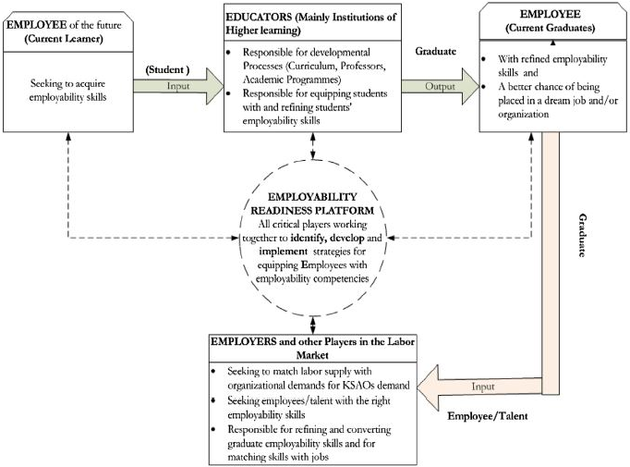
Figure 1: Educator-Employee-Employer-Employability (4E) framework
The employability readiness platform will work as an independent hub of the employability information and all the key players will contribute to providing the necessary information. Employers will identify the skills and attributes required in the workplace. The educators play the most important roles. They design their programs in such a way that the graduates can develop all the necessary skills. Students and employees also plays an important role in creating new knowledge and solving current challenges.

Personal employability analysis
To assess my employability level, I have done a personal SWOT analysis. The SWOT analysis is given below:
Strength | Weakness
3 years of work experience as a PT  Level 2 and Level 3 PT certificates  Working well as a team player as well as self-motivation  Communication skills  Negotiation and persuasion skills  Leadership ability  Organizational skills  The ability to work under pressure  Confidence | Limited service lines  Limited education  Hard worker
Opportunity | Threats
Working on a managerial position  Taking training courses and mentoring opportunities  Developing your own gym clothes brand | High competition in the market  Limited time and resources to Develop
As a job candidate, I am equipped with some very important strengths that are valued in the industry. Work experience of 3 years as well as professional certificates represent my job specific skills that is widely preferble by the employers. Employers take any job or internship experience very seriously while selecting job candidates. Communication, negotiation, leadership and organizing skills represent the soft skills that employers seek in every candidate. Because these can not be trained by workshop or programs. So, the strenths have enhanced my employability to greater extent. But limited service lines, limited education and not being hard working are my weakness though I think these can be overcome. I have a huge opportunity to work on a managerial position and developing my own gym clotes brand as I have expertise on this area. But high comepetition in the job market and limited time to develop mayself is threat for me. These threat must be overcome by utilizing the limited time available to develop myself. Thus, from the personal SWOT analysis it seems that I have great employability but there is still scope to improve.

Conclusion
This whole paper gives a fantastic understanding about the employability skills and how frameworks are formed to enhance employability of a graduate. The Botswana case helps to understand how graduate employability of a particular country can be analyzed and devloped through integrated effort all all important stakeholders. The paper also helps to identify the roles of the stakeholders in enhancing employability. All these understandings are very crucial to analyze one’s own employability and develop oneself to garave opportunity in one’s own area of specialization. Collaboration between universities and employers are the most important thing that should be focused on to enhance employability of the fresh graduates (Suleman, 2018). Also, employees or job candidates should have information about the latest trends and demand sof their industry to keep their employability updated.

Reference
Bowles, M., Bowes, N. and Wilson, P. (2019). Future-proof human capabilities: Raising the future employability of graduates. International Journal of Business and Social Science, 10(11), pp.18-29.
Doyle, A. (2019). 6 Ways To Keep Your Job Skills Current. [online] The Balance Careers. Available at: <https://www.thebalancecareers.com/how-to-keep-your-job-skills-current-2063756> [Accessed 13 July 2020].
Gill, R.J. (2018). Building employability skills for higher education students: An Australian example. Journal of Teaching and Learning for Graduate Employability, 9(1), pp.84-92.
Misra, R.K. and Khurana, K. (2017). Employability skills among information technology professionals: A literature review. Procedia computer science, 122, pp.63-70.
Okay-Somerville, B. and Scholarios, D. (2017). Position, possession or process? Understanding objective and subjective employability during university-to-work transitions. Studies in higher education, 42(7), pp.1275-1291.
Ornellas, A., Falkner, K. and Stålbrandt, E.E. (2019). Enhancing graduates’ employability skills through authentic learning approaches. Higher education, skills and work-based learning.
Peng, M.Y.P., Sheng-Hwa, T. and Han-Yu, W. (2018), July. The Impact of Professors' Transformational Leadership on University Students' Employability Development based on Social Cognitive Career Theory. In Proceedings of the 2nd International Conference on Education and Multimedia Technology (pp. 54-58).
Pheko, M.M. and Molefhe, K. (2017). Addressing employability challenges: a framework for improving the employability of graduates in Botswana. International Journal of Adolescence and Youth, 22(4), pp.455-469.
Römgens, I., Scoupe, R. and Beausaert, S., (2019). Unraveling the concept of employability, bringing together research on employability in higher education and the workplace. Studies in Higher Education, pp.1-16.
Rowe, A.D. and Zegwaard, K.E. (2017). Developing graduate employability skills and attributes: Curriculum enhancement through work-integrated learning.
Skillsyouneed.com. (2020). Employability Skills | Skillsyouneed. [online] Available at: <https://www.skillsyouneed.com/general/employability-skills.html> [Accessed 13 July 2020].
Suleman, F. (2018). The employability skills of higher education graduates: insights into conceptual frameworks and methodological options. Higher Education, 76(2), pp.263-278.

