

Name: Mohammad Ariful Islam
Student Number: 1905728
Module: Managing In Complex Environment: Strategies, Insights, and Solutions

Asda people management issues: A Case study of Asda
Selected Issues: 1. Employee satisfaction and motivation issue
2. Employee gender pay gap issue

Executive summary:
Asda, the third biggest retail supermarket in the UK has suffered badly in recent years due to people management issues. Two issues that have hampered Asda’s brand image badly in recent years are the gender pay gap issue and employee dissatisfaction issue in the workplace. This report aims to present facts and arguments to Asda’s board members regarding the importance of employee job satisfaction in the workplace. This report draws attention to the fact that employees' dissatisfaction in the workplace could demotivate staff morally which could result in less productivity. Moreover, this report focuses on the point that unsatisfied employees are not willing to give their best to satisfy customers which could make customers unhappy. This report also aims to convince Asda Board members so they take the initiative to solve the people management issues to the earliest which have created a negative impact on employees' workplace and have stopped employees to keep themselves motivated with their work, therefore a detailed analysis with related arguments and judgment on the topics have been added to this report. This analysis aim is to make sure that Asda board members have understood the fact that employees are the asset to an organization especially when they are satisfied with their work, so based on the findings and analysis some recommendations have been made for Asda’s board members.

Table of Contents:
1.Introduction …………………………………………………………………………………………………….. 5
2.ASDA statistics …………………………………………………………………………………………………..5
3.ASDA HR strategy …………………………………………………………………………………………….. 6
4.ASDA people management issues …………………………………………………………………….. 7
5.Literature review …………………………………………………………………………………………….. 10
6.Features of job satisfaction ……………………………………………………………………………….11
7. Different Models of job satisfaction …………………………………………………………………..12
8.Factors affecting job satisfaction …………………………………………………………………………14
9.Importance and benefits of employee job satisfaction …………………………………………16
9.1. Reduce Turnover ………………..…………………………………………………..………….16
9.2. Higher Productivity …………………………………………………………………………….. 17
9.3.Better Customer Service ……………………………………………………………………… 17
9.4. Brand Ambassadors ………………………………………………………………………….…17
10.Analysis of Asda people management issues ………………………………………………………18
11.Recommendations …………………………………………………………………………………….……… 19
12. Conclusion ………………………………………………………………………………………………………….22
13. References ……………………………………………………………………………………………………….. 24

1.Introduction:
Employees are the most important and valuable assets for an organization as organization success or failure highly depends on employees. Employees' performances can create an opportunity for an organization to become successful. Every successful organization has become successful because of the hard work of its employees. The owner of virgin group Richard Branson once said, look after your employees, they will take care of your business. So, an organization needs to understand that employee engagement is like an investment that will pay back high, moreover, to win in the market place organization must win in the workplace. This is a business report based on Asda, one of the biggest retail supermarkets in the UK. However, recently Asda has faced an issue related to people management. Asda had faced issues linked to employees' dissatisfaction with their job contract which hampered Asda’s brand image badly. This report aims to draw the attention of Asda’s board member to the importance of employees' job satisfaction. Moreover, this following business report will also focus on the pay gap between men and women currently facing in Asda. To achieve the objectives of the report, the following activities were undertaken: Firstly, the main issue which is employee job dissatisfaction were outlined in the report. Also, in this report, the gender pay gap issue of Asda has been highlighted as a second issue. Moreover, the benefits of employees' job satisfaction alongside the importance that organizations could get are also highlighted in this report. And, finally, recommendations were made for Asda board members regarding focusing on Asda,s people management issues.
2.ASDA statistics:
Founded in 1965 Asda has become the third biggest retail supermarket in the United Kingdom with a market share of 14.5% (Kantar, 2020) only behind to Tesco and Sainsbury’s who has 26.8 % and 14.9% of the total market share respectively in the UK retail industry (Kantar, 2020). Currently, Asda has more than 145,000 workers working at Asda, moreover, more than 18 million customers and 98% of UK houses are also served by the Asda employees every week (ASDA, 2020). In the year 2018, Asda has seen its operating profit increased by 9.2% to £803.2 million (ASDA, 2020) compared to the previous year. As a result of the increase in operating profit Asda total revenue also up by 3.1% to £22.92 billion in the year 2018 (Mcsherry, 2019). However, the British company Asda has become a subsidiary company of Walmart in the year 1999 when the world’s biggest retailer Walmart has bought the British supermarket Asda with the price of (£6.72 billion) $10.8 billion (BBC News, 1999), which was one of the biggest retail acquisition in the British history at that time. Asda is still operating in the UK as a subsidiary company of Walmart.
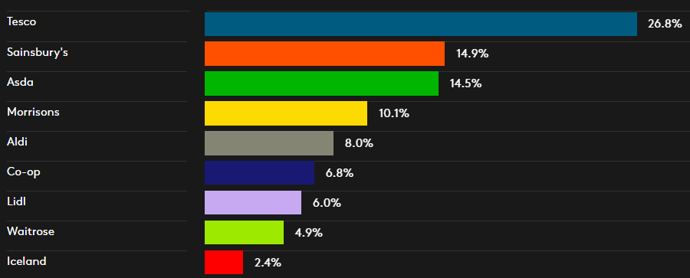
Great Britain retail supermarket market share in 2020 (KANTAR, 2020)

3.Asda HR strategy:
Asda’s employees are the heart of the organization's growth and success which helps the organization to meet the high expectations of the customers. Asda HR strategy is mainly developed around the employees. Asda employees play the most important role while HR strategy has been developed. Asda as an organization believes that employees are the most powerful tools that can connect the business with the customers so that customers can get the best service they desire, therefore, Asda HR strategy and operations are tailored to fulfill the individual needs of employees so that customers can get the best service from employees. Therefore, Asda’s HR strategy is built around three key pillars namely employees' culture, employees' talent, and ways of working (CIPD, 2020). As a driver of performance, ASDA is very much aware that employee engagement is very vital for business growth and also to ensure that customer satisfaction remains high employee engagement can be used as a major lever. Asda always believes that it is very important for the business to keep its employees happy as only happy employees can create customer satisfaction effectively. Asda’s HR strategy has developed in three stages, firstly employees' talent. Asda is always keen to use the talent that employees have therefore the HR team focus on the particular talent that an employee has to make proper use of the talent so the customer can get the most benefit from the employee also the business get benefitted. However, while using the employee's talent Asda HR team maintains the culture of the workplace, the way of working in the workplace remains the same so employees can give the customers the higher satisfaction that the customers desire. Asda as a business believes that employees should be treated in a respected way and there should be respect within the employees as well so the workplace motivation remains high all the time. Asda HR strategy is conducted in such a way so every worker has got the opportunity to improve their work attitude and be motivated all the time in the workplace. Asda believes that employees are the pride of the business, therefore, they should be treated in a fair way to keep the workplace motivated.

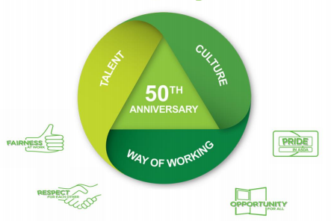
Asda HR strategy (CIPD,2020)

4.ASDA people management issues:
Usually, Asda’s HR strategy is well established and well planned. Asda has a strong people management strategy already implemented in the workplace. However, in recent years Asda’s brand image has been damaged due to few people management issues. The company has faced wide criticism for its unexpected people management issues that have happened in recent years. From those issues, I will emphasize on two people management issues in this report, the first issue is employees' job dissatisfaction, and the second issue is the gender pay gap in Asda. The first issue which is related to job dissatisfaction has hampered the Asda brand image heavily. In the last quarter of 2019, the British retail company Asda has announced that it will change its contract with the workers. A new contract has been implemented for all of Asda’s e employees and they all have to sign the new contract to continue work for the supermarket. The new contract has seen the basic hourly payment will raise from £8.84 to £9.18 per hour from 1st April 2020, however, the basic hourly pay rate will change with the premium location, London employees will get paid £10.31 for per hour (Hotten, 2019). Although the new contract has seen Asda employee's basic hourly rate increased, other facilities that employees had before been scrapped in the new contract which was the main reason for Asda employee's dissatisfaction. The new contract has described that employees paid break will be scrapped which means Asda employees will not get paid anymore while they are in the break while doing their shift. Not only that, working on bank holidays has become compulsory for every worker it means Asda workers have to work on bank holidays according to the new contract (Hotten, 2019). Moreover, the night shift workers will see cut in their payment as well which Asda employees have described as a very harsh decision (Ascher, 2019). According to Asda's new contract, employees working shifts might changes anytime without prior notice it means employees could have witnessed their working hours' could changes from any time from five in the morning to 12 at night, which could hamper Asda employees work-life balance heavily. In addition, according to the new contract Asda has got the right to ask any employee to work wherever and whenever including bank holidays which means Asda employees will lose their job flexibility (Butler, 2019). Although Asda has seen its operating profit has increased by 9.2% to £802.3 million in the financial year 2018, but the company has changed the contract which caused huge dissatisfaction among the employees. The employees have seen the new contract as a barrier to their financial income. Most of the Asda employees have opposed the new contract, however, Asda has said the new contract will benefit the employees on a long-term basis. According to the GMB union which has organized a protest immediately after the new contract was given to the employees said that 93% of its member within Asda employees has opposed the new contract (Webber, 2019). Moreover, the GMB union has claimed that the new contract could see at least 6000 employees could be financially worse off who are currently on hourly pay (Butler, 2019). Not only this the GMB union has also claimed that more than 3000 employees could lose up to £500 per year because of the changes, among them more than 300 employees could get harder hit (Butler, 2019). These new contract changes that have been made by Asda in 2019 has seen a fierce reaction from the employees, which has left the Asda employees demotivated in the workplace. Moreover, Asda employees have felt more agony when they came to know that almost 12,000 Asda staffs could lose their job after they declined to sign the new contract, however, Asda has denied that allegation (Jahshan, 2019). However, the overall scenario has demotivated Asda employees in a big way.
Another people management that the British supermarket has faced in recent years is the gender pay gap issue which has seen Asda employees went to the court. The gender pay gap issue is a very serious issue for an organization as it can create a negative environment in the workplace. Also, the gender pay gap can demotivate employees morally which could create obstacles in overall business growth as business success mainly depends on employees. The gender pay gap is something that shows the difference in average hourly earnings of men and women across an organization regardless of their job roles. According to Asda Gender pay Report 2019, Asda's median pay gap was 6.5% in the year 2019 which means the men's and women's median pay difference in Asda was 6.5% in the year 2019 (ASDA, 2020). Moreover, the mean pay difference between men and women in Asda was 11.1% in according to Asda’s gender pay report 2019 (ASDA, 2020). At Asda, 84% of total employees work on an hourly basis pay, therefore, a pay gap of 11.1% between men and women is a big difference. Moreover, in Asda women employees have paid less bonuses than men employees. According to the Asda gender pay report 2019, the median and mean bonus gap between women and men employees at Asda were 17.6% and 49.5% respectively in 2019 (ASDA gender pay report, 2019) although Asda has more female employees than men. Asda female workers were accounted for 56% of total workers in 2019 (ASDA gender pay report, 2019). In contrast with that in Asda, only 36% of women workers have occupied a senior-level job in Asda, whereas 74% of women have got a job in junior levels which shows the senior-level job in Asda is male-dominant (ASDA gender pay report, 2019). These above statistics have shown that Asda women employees are getting less paid than men employees although the job roles are the same, this unequal gender pay has become a serious concern for Asda as nowadays discrimination between men and women could hamper an organization business growth severely especially if it happens in such competitive sector such as retail sector.
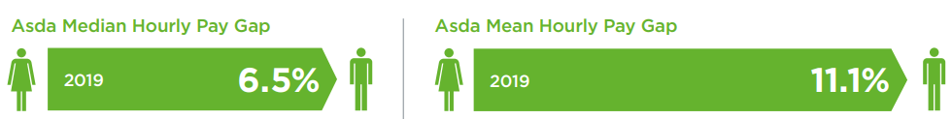
Difference between Asda employees hourly pay in 2019 (ASDA, 2020)

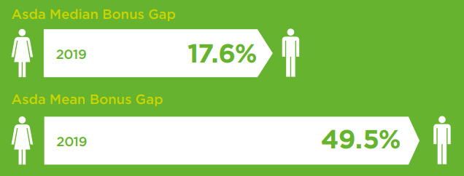
Bonus Gap between Asda employees in 2019 (ASDA,2020)

5.Literature review:
Employees are the most important asset for an organization as an organization's success or failure mainly depends on the employees, therefore, job satisfaction is not only important for employees also for the employers as a satisfied employee is regarded as an asset for an organization. Employee satisfaction is a measure of how happy workers are with their job and working environment. To describe whether employees are happy, contented, and fulfilling their desire and needs at work, the terminology of employee satisfaction is been used. According to Moyes and Newsome (2008), job satisfaction refers to the level of fulfillment of one's needs, wants, and desires in the workplace. A positive ambiance at the workplace arises from employee satisfaction in the work or workplace. Employee felling towards the work or workplace could give the idea whether an employee's needs are being met in the workplace and how satisfied are employees with the overall experience of their workplace. Employees' job satisfaction has usually influenced by many external factors; however, it remains something internal that has to do with the way how the employee feels. Therefore, Hoppock (1953) has stated job satisfaction as a combination of psychological, physiological, and environmental factors that cause a person to become truly satisfied with the job. Employee job satisfaction usually happens due to a set of factors that cause a feeling of satisfaction. Vroom (1964) has stated that employee job satisfaction is the way how employees feel about their work and its various aspects. Employees' job satisfaction represents a combination of positive and negative feelings that employees have towards their work and workplace. Job satisfaction often matched the awards that an individual often desire. Davis & Newstrom (1985) have stated that individual behavior and desire in the workplace are closely linked with job satisfaction. Employees' sense of achievement and success in the job is also linked with job satisfaction. Job satisfaction happens when someone enjoys works, doing it well, and get rewarded for a particular job. Job satisfaction further involves enthusiasm and happiness in one’s work. Kaliski (2007) has stated recognition, income, promotion in the workplace are the key achievements that came from employees' job satisfaction. Employees' attitudes or feeling towards their work also refers to job satisfaction. Employees Positive and favorable approach towards work shows job satisfaction whereas a negative and unfavorable approach towards work reveals job dissatisfaction (Armstrong, 2006). Satisfied employees are usually more productive in the workplace. Employees are usually more loyal and productive when they are satisfied in their work or workplace (Hunter & Tietyan, 1997), moreover, these satisfied employees affect customer satisfaction and organizational productivity in a positive way (Miller, 2006). Therefore, it is very important for an organization to make sure workers within the organizations are fully satisfied with the work or workplace as it is the precondition for increasing productivity, responsiveness, and quality and customer service. Heskett et al. (1994) has stated that to create a chain of positive actions that end in an improved company performance more satisfied are needed. Moreover, employee retention is also influenced by employee satisfaction (Derek & Wilburn, 2002).

6.Features of job satisfaction:
When it comes to efficiency and effectiveness of an organization, employee job satisfaction is considered as the main factor for the organization. However, job satisfaction has many features, among those, Spector (1997) has listed three important features of job satisfaction. The First feature is human values should be the fact that should guide an organization. Those organizations that are guided by human values are usually treated their employees with respect and fairness. In these cases, employee effectiveness might be regarded as an indicator of job satisfaction. A good emotional and mental state of employees may indicate a high level of job satisfaction in the workplace. Secondly, the functioning and activities of the organization’s business will be affected by the employees' behavior however it depends on their level of job satisfaction. So, it is easily assumable from the previous point that employee’s positive behavior will arise from job satisfaction, and in contrast, employees' negative behavior will arise from employees' job dissatisfaction. Thirdly, job satisfaction may serve as indicators of organizational activities. Through job satisfaction, assessment extraordinary levels of satisfaction in various authoritative units can be characterized, however, thus can fill in as a decent sign concerning which organization unit changes that would boost performance ought to be made.

7.Different Models of job satisfaction:
Employees' job satisfaction in the workplace depends on many external factors however the external factors re the main factors that determine whether employees are satisfied in their work or workplace. Christian, Iyer, and Soberman (2006) have identified a few factors that mainly affect employees' job satisfaction, these factors have been categorized into 4 elements. According to Christian, Iyer, and Soberman (2006), the four factors that could influence employees' job satisfaction are job-related factors, job performance, firm performance, and role perceptions. Christian, Iyer, and Soberman (2006) have developed a model of employees' job satisfaction which includes these above four elements.
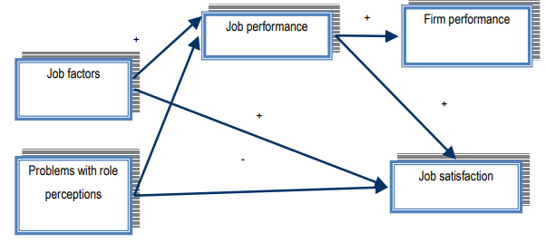
Christan, Iyer and Soberman model of job satisfaction, (Christian et al, 2006)
According to Christian et al (2006) job satisfaction model, employee job satisfaction in the workplace has depended on four elements that are highly interconnected with each other, moreover, all these four elements are very much essential for employees to attain job satisfaction in the workplace.
In 1967 Lawler and porter have also developed a model of job satisfaction here they have given special importance on the impact of rewards on employee job satisfaction which is different from the Christen et al (2006) job satisfaction model.
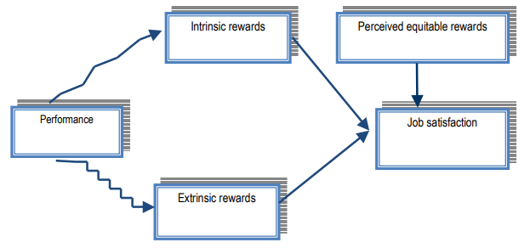
Job satisfaction model of Lawler’s and Porter’s (Lawler & Porter, 1967)
According to Lawler and Porter's (1967) job satisfaction model, job satisfaction is directly connected with intrinsic rewards and extrinsic rewards. They have argued that through the provision of intrinsic and extrinsic rewards employees’ performance in the workplace could lead to job satisfaction.
However, in 1990 Locke and Latham have provided a different type of model of employee job satisfaction. They started from the assumption that employees who are given the highest task and on whom the organization has high expectations of success could deliver success while performing tasks. Therefore, Locke and Latham (1990) have identified success as a detrimental factor that causes employee job satisfaction.
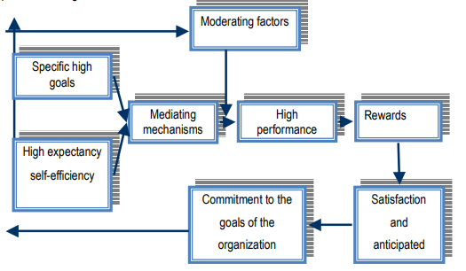
Job Satisfaction model of Locke and Latham (Locke & Latham, 1990)

8.Factors affecting job satisfaction:
A series of factors such as the nature of work, salary, advancement opportunities, management, workgroups, and work conditions influence employees' job satisfaction in the workplace. Therefore, Rue and Byars (2003) have provided a different approach regarding employee job satisfaction. They have identified these (given below) factors as the determinant’s factors of employee job satisfaction and dissatisfaction.
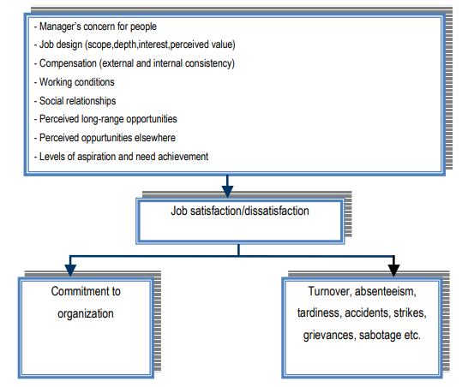
Determinants of Job satisfaction and dissatisfaction (Rue & Byars, 2003)
While discussing components of job satisfaction the fact that has to be kept in mind that these factors could also create job dissatisfaction There is no unanimity with respect to this issue between authors, moreover both authors have agreed that job satisfaction and dissatisfaction are two opposite and excludable phenomena. However, the main point of Rue and Byars (2003) findings was a few factors that affect employees in the workplace which also occurs job satisfaction and job dissatisfaction in the workplace.
The most applied theory for employee job satisfaction that has been developed by Fedrick Herzberg in 1959 is known as the two-factor theory. In this theory, Herzberg (1959) has stated that certain factors in the workplace create employee job satisfaction whilst a separate set of factors prompts employee dissatisfaction, all of which act independently of each other. Herzberg's (1959) theory has proposed that to improve job attitude and productivity in the workplace, the administration must perceive and take care of the two arrangements of attributes and not accept that an increase in job satisfaction prompts a decline in job dissatisfaction.
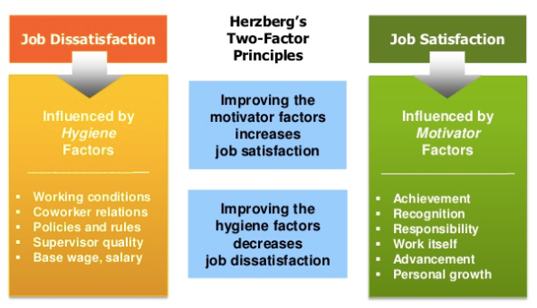
Employees Job Satisfaction factors, (Herzberg, 1959)
Herzberg's two-way theory has identified such factors that influenced employees' job satisfaction in the workplace, these factors have a direct impact on employees’ job satisfaction. Any changes in these factors could create employees' job dissatisfaction at any time in the workplace which possibly could morally demotivate employees. As a result of staff demotivation, organizations could witness a big drop in their productivity level.

9.Importance and benefits of employee job satisfaction:
For many reasons, satisfied employees are an enormous asset to any organization. The benefits that satisfied employees could bring to an organization are given below:
9.1.Reduce turnover: Happy employees always willing to stay in the same workplace for many years. Satisfied employees tend to work for the same organization for a long time which resulted in workers' turnover rate always remains very low for the organization. High workers turnover can create a negative impact in the workplace also can demotivate other workers. High turnover can be a nightmare for employers and organizations due to the time and money investment involved in re-hiring and re-training qualified talent. It is not possible for an organization to keep the employees’ turnover rate at zero, however by making employees job satisfaction top priority organizations or employers can mitigate the risk. According to Freeman's (2005) study, employee turnover gets reduced by 50% of the norms for that business that can excel employees' satisfaction issues, moreover, satisfied employees in the workplace can lower the labor cost by 12% as long as the employee turnover rate remains low.
9.2.Higher productivity: According to a study that has been conducted by Armstrong (2006), higher productivity in the workplace can be achieved by the workers who have reported higher job satisfaction which indicates productivity in a workplace has a relation with employees' job satisfaction. Satisfied workers will feel more devoted to a company’s success, therefore, work harder to achieve higher productivity for the organization. Carpitella (2003) has stated that less turnover and absenteeism happen in the workplace if employees are satisfied with the work and workplace, which ensures higher productivity.
9.3.Better customer service: Usually satisfied employees are happier people in general, which means satisfied employees are willing to give better customer service. A satisfied employee is like an asset to an organization. According to Freeman (2005), satisfied employees in the workplace increase customer satisfaction to an average of 95%. Employees could bring a positive environment in the workplace if they are happy with their job, which will ensure that customer gets better service from the employees. In contrast, employees' negative attitudes in the workplace could hamper staff motivation because of that customer would end up not getting quality service as they desire. So, it is important for an organization to keep its employees satisfied as employees are mainly responsible to produce quality service to its customers. Therefore, Allen and Wilburn (2002) have stated that the satisfaction of the employee who embodies that company is direly related to customer satisfaction which leads to the success of the company. Moreover, Brown (2006) argued that employee satisfaction and customer satisfaction have a strong link, also customer satisfaction has a strong link with the future revenue of the organization.
9.4.Brand ambassadors: satisfied employees are regarded as an asset to a company moreover, happy employees also could work as a brand ambassador for the company by telling everyone about the company positive attitude towards employees which could attract more customers effectively as nowadays customers also consider employees attitude towards the workplace so they can get the best service from the employees as they desire. Only a satisfied employee will end up telling everyone the positive thing about the company which could increase more customer engagement. Therefore, Carpitella (2003) has described happy workers as a brand ambassador for the organization.

10.Analysis of Asda people management issues:
Asda is a well-known British retail supermarket that has faced extreme people management issues in recent years. Due to those people management issues, the Asda brand image has got hit badly. The first issue which I will put light on is the gender pay gap issue. The gender gap issue is such an issue that most of the organization in the UK is currently considering seriously as company reputation is getting hit hardy due to this issue also this issue is creating demotivation with the employees, as a result, employee productivity is getting hit. For the analysis of this issue, I have chosen Sainsbury's which is another retail supermarket whom Asda is competing to become the 2nd biggest supermarket chain based on market share. According to Kantar (2020) Great Britain retail supermarket market share report, Asda has 14.5 % of the total market share whereas Sainbury’s is only above to Asda with a market share of 14.9%. Both organizations are very close to each other compare to market share therefore both organizations are fighting to keep the second place as the UK retail market is very competitive. Although Asda was behind Sainsbury’s total market share, however, Asda’s operating profit was higher than Sainsbury's in 2018. In 2018, Asda has seen its operating profit increased by 9.2% to £803.2 (Asda corporate report, 2020) million compared to Sainsbury's pre-tax profit of £635 million which was a 7.8% increased from the previous year (ITV news, 2019). Sainsbury's was far behind Asda compared to pre-tax profit as well as on increase in profit percentage. However, although Sainsbury's pre-tax profit was lower than Asda, Sainburys has announced that it will increase its employees' per hour salary from 1st April 2020. Asda has also announced that it will increase its employees' per hour wages as well. Sainsbury's has announced that it will increase the sales assistant per hour salary to £9.20 outside London, and in London (zone1 &2 only), the sales assistant will get paid £9.80 for per hour job compared to Asda’s £9 for outside London and £9.18 for sales assistant in the London (Gray, 2020). These statistics are showing that although Asda has done more profit compared to its main competitor Sainsbury's but Asda staffs have seen they are getting less pay than Sainsbury's which sparks anger in Asda employees. Moreover, the gender pay gap issue has also created conflict between Asda employees and management. Asda management has been criticized badly in recent years due to its massive gap in gender payment which has created outrages in Asda female staffs, as a result, Asda female staff went to court to claim their rights. According to the Asda gender pay gap report 2019, the median and mean gender pay gap were 6.5% and 11.1% respectively. Whereas Asda’s main competitor Sainbrusy median and mean gender pay gap were 3.8% and 10.5% respectively in 2019 which was much lower than Asda (Sainsbury's gender pay report, 2019) although Asda has more female employees (56%) compared to 41.2% of Sainsbury's, which suggested that Asda management did not take enough initiative to lower down the wage gap between man and women which has created job dissatisfaction among Asda’s female workers. Although Sainsbury's is a male dominant (58.8% staffs are men) retail supermarket, but, the gender pay gap is still lower than Asda although Asda has more female employees (56%). Moreover, in 2019 Asda employees witnessed their paid break while working, bank holidays break as well as work flexibility has been scrapped by the Asda management which created a huge conflict between management and employees. These two issues which are the gender pay gap issue and work flexibly issue has indicated that Asda people management is not going in the right direction and it needs to reform as soon as possible to restore its employees' job satisfaction which is essential for business growth, especially in such competitive market.

11.Recommendations:
Based on the above evidence and discussion of various issues related to Asda's people management problem following recommendations are suggested:
11.1.Gender pay gap issue resolves: One of the two people management issues that I have highlighted in this report which the Brtish supermarket is facing in recent years is the gender pay gap issue. The gender pay gap issue is quite big in Asda compared to other retail supermarkets in the UK as it has hampered its workplace motivation badly. The interesting fact is most of the Asda employees at the junior level are women (56%), although the gender pay gap is that high, the mean gender gap was 11.1% between men and women employees according to the Asda gender pay report 2019 (ASDA,2020). As a female worker's dominant supermarket, Asda board members can not bear to see most of its employees are unsatisfied with their work which could decrease Asda’s productivity level permanently. Therefore, Asda should consider this issue seriously, it should decrease the pay gap between men and women employees in the workplace as soon as possible, moreover, Asda should take a long term plan to show its employees that the organization is working on its gender pay gap and in coming years the organization has planned to reduce the gender pay gap to zero. However, in that meantime to keep female employees happy and satisfied Asda could introduce a new bonus scheme for them or can arrange extra pay for their overtime work. Moreover, to keep female workers motivated in the workplace Asda should add more female employees at the company senior level currently which is only 36% whereas 74% employees at Asda senior level are men, according to Asda 2020 gender pay gap report ( Asda, 2020), by that Asda can restore the faith of female employees as employees at the senior level are mainly responsible for any changes that could happen in Asda, so high number of female employees at a senior level could guarantee that changes are bound to happen to reduce the gender pay gap among Asda employees.
11.2.Improve employee satisfaction: The moral of the company can be seen in employee attitudes, basically, employee attitudes are typically a reflection of the company moral. Happy employees are extremely important in the area of customer service and sales as organization employees represent the company to the public. Asda employees are the face of the organization, as the company is mainly doing its business in retail sales. Based on the above analysis these below recommendations have been given to Asda board members to improve employee satisfaction in the workplace:
11.3.Clear and consistent communication: In many organizations, employees do not even know the company's mission, vision, goals, or objectives. To get the best from the employee’s organization has to build such corporate culture where every employee will be an integral part of the organization where every employee could bring their own competencies that could benefit the whole organization. Organizations should let an employee understood how they can directly contribute to the organization's success. By that, employees will understand their value and will feel more closer to the business which eventually could motivate employees to contribute more to the business. Asda board members should take the opportunity to improve employee satisfaction in the workplace by giving the recognition that employees deserve in the workplace.
Getting to know your employees: Organizations should understand the feelings that employees have about their work or workplace. Organizations should be thoughtful about the wellbeing of employees. Employee's benefits should come first where actions an organization takes. Asda board of members should also think about employee satisfaction therefore, they should arrange training and other improvement programs to give indications to the employees that Asda as an organization is interested in employees' success and it values every single employee’s improvement opportunity.
11.4.Fair compensation and benefits: The recent people management issue that has created all the employees' outrages is related to their new job contract which has seen them losing their paid break money as well as the flexibility of working hours. Asda should restructure its new contract policy or should add more benefits so Asda employees feel that their rights as a worker did not scrap by the Asda. The most important part organization are policies of compensation and benefits, however, an organization should make its policies which is the best fit for its employees whereas Asda has done the mistake in its policies which has caused all the employees' dissatisfaction issue.
11.5.Reward for employee contributions: Reward in the workplace is something that could lift employee motivation very high. Reward in the workplace could motivate employees to reach new levels. In recent time above explained people management issues have demotivated Asda employees heavily, therefore, it is vital for Asda board members to bring the motivation back into the workplace, there, Asda should start to give or increase its reward policy if already implemented for its employees' excellent contribution to its workplace which massively benefitted Asda, by that Asda employees might get back the satisfaction that has lost due to recent people management issues.
11.6.Safe working conditions: Organizations should invest in employees by making sure that the tools and equipment that are being used do not keep employees from being successful. On the basis of that point, Asda should introduce the latest and best tools and technology for its employees in the workplace that could help the employees to deliver the best performance to the company and for its customers, however, while implementing these new tools and technology Asda should consider worker health and safety program so no harm happens at all to its employees.
11.7.Flexible working time: To increase employees' productivity it is important for organizations to create a productive environment in the workplace. Due to the recent contract changes that have been made by Asda where Asda employees have lost flexibility of their working time, which eventually occurred dissatisfaction in employees, should have been brought back by Asda board members as study reveals that there is a strong positive correlation between flexibility in the workplace and employee satisfaction and productivity. Therefore, to increase or keep the productivity level high Asda should be given its employees the flexibility of choosing their working times so Asda employees could maintain a balance between work life and family life, which could create employee satisfaction and help them keep motivated in the workplace.
To make it more clear for Asda board members, different ways of keeping/ improving employee satisfaction are also given below in a table which Asda could use effectively to keep its employees satisfied and motivated in the workplace:
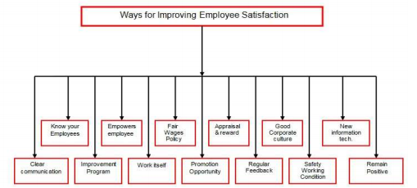
Ways of improving employee satisfaction in the workplace

12. Conclusion:
Organizations around the world now considered people management issues very seriously as it could hamper the organization's brand image badly, also it could create dissatisfaction within employees which could lead to staff demotivation. As per the above analysis of this report, it is understandable that Asda has faced two people management issues which have created a negative impact on the employees. There is no doubt that issues have hampered Asda’s brand image very badly, however, every organization has strengths and Asda's strength always has been its employees, therefore, it has become a challenging task for the Asda HR department to resolve these issues. In this report, it has been explained to the Asda board members the ways that Aasd could improve its employees’ satisfaction. With the help of different models and theories, this report aims to give the Asda board members a proper indication of the benefits and importance of satisfied employees in the workplace, so, the issues that have been identified as a challenge for Asda can be taken into serious consideration and get a solution as soon as possible which could keep Asda employees remain satisfied and motivated in the workplace.

13.References:
- ASDA. (2020). Company Facts. Available at: https://corporate.asda.com/our-story/company-facts
- ASDA. (2020). Asda Group Limited publishes annual statutory accounts. Available at: https://corporate.asda.com/newsroom/2019/09/16/asda-group-limited-publishes-annual-statutory-accounts
- KANTAR. (2020). Great Britain: Grocery Market Share. Available at: https://www. Kantarworldpanel.com/grocery-market-share/great-britain/snapshot
- Mcsherry, M. (2019). Asda revenue up 3.1% to £23bn as profit tops £803m. Available at: https://northernfinancialreview.com/2019/09/17/asda-2018-revenue-up-3-1-to-23bn-as-profit-tops-803m/
- BBC NEWS. (1999). Business: The Company File- Walmart bids fro ASDA. Available at: http://news.bbc.co.uk/1/hi/business/368430.stm
- CIPD. (2020) . Asda valuing your talent case study. Available at: https://www.cipd. co .uk/ Images/case-study-asda_tcm18-19985.pdf
- Jahshan, E. (2019). Asda denies reports of 12,000 staff facing the sack for not signing a new contract. Available at: https://www.retailgazette.co.uk/blog/2019/10/12000-asda-staff-face-sack-if-they-dont-sign-new-contract/
- Hotten, R. (2019). Asda workers are 'terrified for their jobs. Available at: https://www.bbc.co.uk/news/business-50246335
- Butler, S. (2019). Up to 12,000 Asda workers could lose jobs amid contract row. Available at: https://www.theguardian.com/business/2019/oct/21/up-to-12000-asda-workers-risk-losing-their-jobs-amid-contract-row
- Ascher, H. (2019). Asda's contract changes are 'just not fair'. Available at: https://www.bbc.co.uk/news/business-50122703
- ASDA. (2020). Asda publishes its 2019 Gender Pay Report, Available at https://corporate.asda.com/newsroom/2020/01/13/asda-publishes-its-2019-gender-pay-report
- Scott, K. (2019). Asda reports a 12.4% mean gender pay gap for 2018. Available at: https://employeebenefits.co.uk/asda-reports-pay-gap-2018/#:~:text=Over%20the% 20current%20reporting%20period,male%20employees%20received%20bonus%20payments.&text=The%20majority%20(86%25)%20of,employees%2C%20would%20be%200%25
- ASDA gender pays report 2019. (2020). Gender pay report 2019. Available at: https://cdn.corporate.walmart.com/52/97/0e2fd3274e3db2ef299cd90d6f31/asda-gender-pay-report-2019-final130120.pdf
- Allen, D., and Wilburn, M. (2002). Linking customer and employee satisfaction to the bottom line, ASQ quality press publications cat log. Milwaukee, WI
- Freeman, S. (2005). Employee satisfaction: The key to a successful company. Available at: http://library.lp.findlaw.com/articles /file/00301 /008927/ title/ Subject / topic/Employment
- Carpitella, B. (2003). Make residential construction the industry of choice [Electronic version]. Professional Builder
- Brown, M. (2006). Keeping source: using the right metrics to draw world-class performance. Taylor & Francis: Oxfordshire
- Moyes, G. D., & Shao, L. P., Newsome, M. (2008). Comparative analysis of employee job satisfaction in the accounting profession. Journal of Business & Economics Research, 6(2), 65-81
- Hunter, W., & Tietyen, D. (1997). Business to business marketing: Creating a community of customers. Lincolnwood-Illinois: McGraw-Hill Professional
- Miller, J. L. (2006). Coach Yourself to Succeed @ Work: How to Achieve Optimal Performance and Job Satisfaction. Pittsburgh: Dorrance Publishing Co
- Heskett, L., Jones, T., Loveman, G., Sasser, W., & Schlesinger, L. (1994). Putting the service-profit chain to work. Harvard Business Review 72 (2)
- Armstrong, M. (2006). A Handbook of Human Resource Management Practice. (10th Edition). Pp. 264. Kogan Page Publishing: London
- Davis, K., and Nestrom, J.W. (1985). Human Behavior at work: Organizational Behavior. (7th edition). pp. 109. McGraw Hill: New York
- Kaliski, B.S. (2007). Encyclopedia of Business and Finance. (2nd edition). pp. 446. Thompson Gale publisher: Detroit
- Vroom, H. (1964). Work and motivation. ( pp. 99). John Wiley and Sons: New York
- Hoppock, R. (1935). Job Satisfaction. (pp. 47). Harper and Brothers: New York
- Spector, E. (1997). Job satisfaction: Application, assessment, causes, and consequences. Sage Publications Inc.: California
- Lawler, E., and Porter, L. (1967). “The Effect of Performance on Job Satisfaction.” Industrial Relations, vol.7, pp. 20–28
- Locke, E., & Latham, G. (1990). A theory of goal setting and task performance. Prentice-Hall: NewJersey
- Christen, M., Iyer, G., and Soberman, D. (2006). Job Satisfaction, Job Performance, and Effort: A Reexamination Using Agency Theory. Journal of Marketing. Vol. 70, pp. 137-150
- Rue, L., and Byars, L. (2003). Management, Skills, and Application. (10 ed.). pp.259. McGraw-Hill/Irwin: New York
- Herzberg, F (1959). The Motivation to Work (2nd ed.). New York: John Wiley
- ITV News. (2019). Sainsbury's profits surge but the supermarket chain suffers a £46m hit from the failed Asda merger. Available at: https://www.itv.com/news/2019-05-01/sainsburys-sees-profits-rise-but-reveals-46m-hit-from-failed-asda-bid
- Gray, S. (2020). Tesco, Waitrose, and Aldi among best-paying supermarkets - who pays the most? Salaries here. Available at: https://www.express.co.uk/life-style/life/1235506/tesco-sainsburys-asda-aldi-lidl-waitrose-salary-pay-full-list-uk
- Sainsbury’s. (2020). Gender pay report 2019. Available at: https://www.about.sainsburys .co.uk/making-a-difference/gender-pay-gap

