

ASSESSMENT - 1: CONCEPT AND KNOWLEDGE ABOUT ENTERPRISE AND ENTREPRENEURSHIP

STUDENT ID -2131583
STUDENT NAME: SHUHAIB AKKALATH LECTURER: ISAIAH OINO
Executive Summary
The idea of entrepreneurial activities and associated factors with it not only demonstrates their impact in an organisational context but also signifies their contribution to organisational growth. This report has managed to define those perceptions with explained details. Moreover, a difference between “for profit” and “not for profit” small enterprises has been explored in this report. Additionally, the theoretical context justifies that having an engaged and loyal workforce is necessary for retrieving efficient outcomes from entrepreneurial activities to offer an in-depth elaboration of the context.

Table of Contents
Introduction 3
Critical evaluation of traits, characteristics, attributes, and motivation of entrepreneurs based on theoretical concepts 3
Traits, characteristics, and attributes associated with entrepreneurship 3
Motivational techniques suitable for improving the efficiency of entrepreneurship 6
Differentiation between “for profit” and “not for profit” organisations considered entrepreneurs’ values and beliefs 8
Difference between “For-profit” and “Not for profit” organisations 8
Discrepancy in entrepreneurial values and beliefs regarding “for profit” and “not for profit” small enterprises 9
Application of examples to support the discussion 11
Conclusion 12
References 13

Introduction
Understanding the significance of entrepreneurship and enterprise concepts is an important perspective for organisations to operate efficiently. Insufficient knowledge of entrepreneurship characteristics, attributes, and motivational factors can lead to failure in operational performance. Additionally, comprehension of the difference between “for profit” and “not for profit” enterprises often contribute to determining approaches to entrepreneurship. This assignment concentrates on exploring those factors and concepts through theoretical underpinnings and examples to rationalise the value in operational and organisational management practices.

Critical evaluation of traits, characteristics, attributes, and motivation of entrepreneurs based on theoretical concepts

Traits, characteristics, and attributes associated with entrepreneurship
The idea of entrepreneurship is considered one of the core fundamentals of business operations and management where the presence of appropriate traits and characteristics is accountable for development and progress. According to Akhmetshin et al. (2019), the formation of entrepreneurial thinking among entrepreneurs is significant as it allows them to realise and develop creativity-related attributes. Concerning this opinion, the following factors are acknowledged as major entrepreneurial characteristics, traits and attributes that are required for further development.
- Visionary skills, passion, and innovativeness
- Morality and ethical awareness
- Risk-taking ability and persistence
- The resilience of competitive nature
These are some important skills and attributes that a successful entrepreneur requires. As opined by Şahin et al. (2019), in entrepreneurship, a manifestation of combined personality attributes is capable of conceptualising better outcomes. The aforementioned traits are not only beneficial for establishing entrepreneurial effectiveness in operational activities but are also essential for assuring suitable strategic management of an organisation. Since the idea of strategic fit is subjected to capability, resources, and competence apart from the business environment, these skills are vital to ensure that perspectives (Lecture 2-STM, Slide 4). Attributes and characteristics of entrepreneurship mentioned previously are responsible to manage resources and competencies of an organisation accordingly to achieve maximum benefits.
The “theory of social behaviour” in entrepreneurship justifies the importance of developing the required traits and attributes in an entrepreneur to become successful in a complex business environment. According to the “theory of social behaviour in entrepreneurship” activities of individuals and their association with surroundings is considered responsible for behavioural patterns. Tornikoski and Maalaoui (2019) mentioned in this regard that the complexity of the current business environment has transformed entrepreneurial intentions into a set of actions to ensure the proper operability of business performance. Therefore, developing an applicable set of behavioural patterns through stated skills and characteristics to accomplish those actions is advantageous for supporting the significance of entrepreneurship.
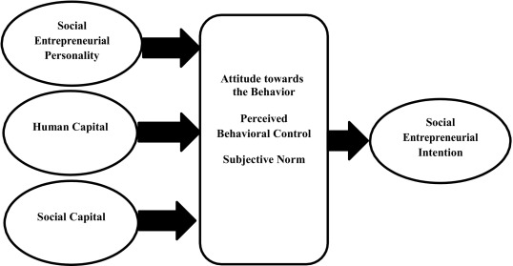
Figure 1: Aspects of social entrepreneurial intentions
(Source: sciencedirect.com, 2019)
Several other attributes related to successful entrepreneurs have been identified. The ability to manage a robust work ethic, creative ideas, consistency in the learning process, and motivational ability for self-starters are some of those attributes important for entrepreneurial activities (forbes.com, 2020). The innovation theory of entrepreneurship introduced by J.A. Schumpeter can rationalise these traits. This concept of entrepreneurship permits exploration of the opportunity to analyse the business environment and incorporate innovative ideas according to this. Nonetheless, a major drawback of the innovation theory of entrepreneurship is the excessive focus on innovative functions rather than risk factors and organisation alongside large-scale business operations (Lüdeke‐Freund, 2020). Hence, it is understandable that for achieving an effective business outcome, it is important for organisations to prioritise balancing the afore-stated abilities to achieve strategic success in business operations.
The main perception of traits and characteristics of leadership is mainly concentrated on the aim of stimulating social change and improving work outcomes. Based on the viewpoint of Genkin et al. (2020), it is to be stated that proper entrepreneurship raises living and working standards for all creating functional and safer operational opportunities. For instance, the transformational entrepreneurial attribute of Sundar Pichai including his decision-making skills and business insight has helped Google and Alphabet to establish them as a tech-giant and global leader despite the market competition. In contrast, Bouncken et al. (2020) opined that the facilitation of collaborative work culture, knowledge sharing, and requirement for work satisfaction has led to innovation and entrepreneurship. “The need for achievement theory” in this regard rationalises the importance of values and motives to exploit opportunities. Additionally, it also sustains the previous opinion signifying the stress on accomplishing excellence standards.
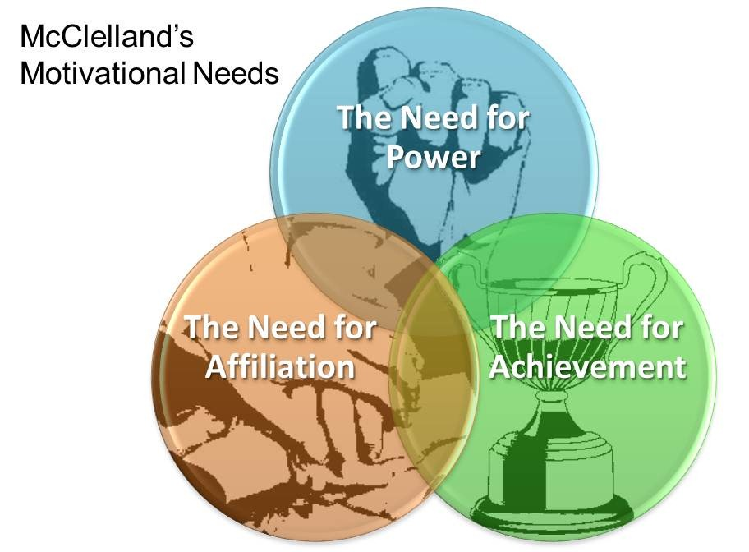
Figure 2: Conditions in Needs for achievement theory for entrepreneurship
(Source: sites.google.com, 2019)
Attributes of entrepreneurship involving the traits of adaptability allow entrepreneurs to be more effective according to changing dynamics of market trends and requirements. It has been discussed that understanding organisational purpose based on factors such as governance, ethics, and stakeholders improved leadership and culture related to it (Strategic Purpose Slides, p.3). Having a trait such as adaptability escalates the potential to retrieve effective and successful entrepreneurial results.

Motivational techniques suitable for improving the efficiency of entrepreneurship
Motivation and its interrelation with motivational factors are responsible for determining whether an entrepreneurial practice is effective or not. Several motivational factors are considered in this scenario that can be helpful for entrepreneurs to preserve the effectiveness of their workforce. As mentioned by Kuswati (2019), motivation is an entity that is accountable for supporting human behaviour in engaging them with work responsibilities to achieve optimal results. Observing these statements, the following factors are often used by entrepreneurs to motivate their subordinates.
- Monetary initiatives and other rewards
- Professional and personal growth opportunities
- Training and development facilities
- Clear job accountabilities and continuous feedback
- Assurance of job security
These motivational techniques are often used by entrepreneurs in the creation of an engaging workforce. Based on “Maslow’s hierarchy of needs”, it can be explained that addressing the physical and psychological needs of an individual helps in keeping the workforce motivated and dedicated (Kang, 2020). Entrepreneurial success is highly dependent on these factors as it determines the efficiency of entrepreneurial practices.
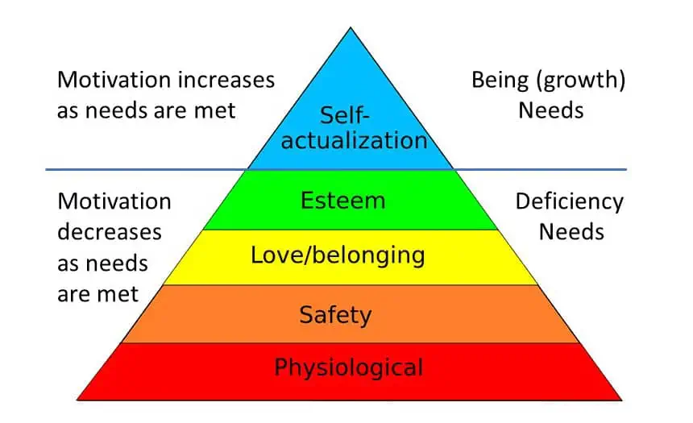
Figure 3: Motivation dependence explained by Maslow’s hierarchy of needs
(Source: simplypsychology.org, 2022)
Focusing on motivational factors involved with approaches of entrepreneurship is not only to assure engagement in the workforce but also to secure their loyalty and active involvement in operational performances. As stated by Poblete et al. (2019), the notion of cognitive entrepreneurship is concentrated on comprehending individual attitudes towards the process based on internal and external motivators. At the same time, individual perception towards entrepreneurship is also known for acting as an influencing factor in this scenario. The practices mentioned previously in this regard may become beneficial for entrepreneurs in securing proper management of operational activities.
Understanding the needs of others is an essential standpoint for the successful implementation of entrepreneurship. Abdullah and Othman (2021) mentioned that in modern society, an adaptation of entrepreneurship and developing skills, creativity, innovation, and growth potential are contemplated as vital market trends. In light of Herzberg’s hygiene theory, it can be explained that recognising motivators for intrinsic satisfaction helps in becoming more productive and efficient (Sonnenschein et al., 2022). For obtaining a better entrepreneurial outcome, the preservation of these motivational components can be significantly advantageous for both entrepreneurs and business firms.
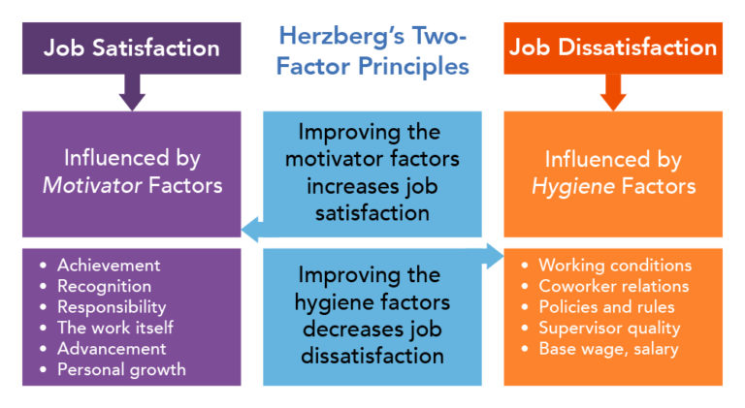
Figure 4: Factors involved in Herzberg’s Hygiene theory for motivation
(Source: courses.lumenlearning.com, 2022)
Initiating entrepreneurial practices based on integrated motivational factors increases its efficiency. Considering current trends in global corporations, it has become more important for corporations to address their employees' needs and requirements. According to the opinion of Chiat and Panatik (2019), motivational components affect employee empowerment, loyalty, and performance resulting in positive job satisfaction. Flexibility, control over the situation, team performance and others are acknowledged to be motivational factors for entrepreneurs that help them in conserving their effective entrepreneurship outcomes. Hence, it is understandable that the inclusion of motivators in this context is consequential for both entrepreneurs and their subordinates based on their surrounding requirements.

Differentiation between “for profit” and “not for profit” organisations considered entrepreneurs’ values and beliefs
The idea of “for profit” and “not for profit” small organisations is valuable for entrepreneurs to establish their beliefs based on the necessities related to them. Most business activities are associated with profit-related operations. Nonetheless, Hinton (2020) explained that the concept of “not-for-profit organisations” diminishes structurally-driven expectations for profitability considering growth as an imperative. Regardless of the approaches, strategic management is essential for both types of organisations. Following this, it has been observed that the process of strategic dynamics is more focused on developing such a structure that involves changes occurring in both internal and external environments (Strategy Dynamics C5, p.3). It aims to strategise initiatives for mitigating potential consequences. However, there are some visible factors that can differentiate “for profit” and “not for profit” organisations from each other.

Difference between “For-profit” and “Not for profit” organisations
“For-profit” organisations | “Not for profit” organisations
- Companies require investors to ensure the operability and organisational growth of the company  - Gaining target profits are the main aim for this organisation  - Audience for “for profit” organisation is noticeably limited since they are more restricted to identifying ideal customers, investors, and others (Roszkowska, 2020)  - Leadership techniques and organisational culture is more focused in such as that can help in achieving financial goals  - Different ownership model can be applied in “for profit organisation” (Alam, 2022)  - In comparison to “Not for profit” organisations, no such accountability compliance is applicable for these companies | - Donations are used as a resource for seeking funding or capital for operations rather than investments  - The main aspect of “not-for-profit” organisations is to offer service to community without expecting profits (Jiao et al., 2022)  - This type of organisation has a broader range of audience in comparison to “for profit” companies due to their community services  - Both leadership and culture is dedicated to guide services in such a way that can benefit in better community services  - No specific owners are present for this type organisation  - “Not for profit” organisation requires to show compliance with accountability considerations for having tax-exempt
Table 1: The difference between two types of organisations
(Source: created by author)
The approach of entrepreneurship is different for each type of organisation considering their influence in gaining targeted objectives for profitability and charity community services. Thomas and Van Slyke (2019) mentioned that recent entrepreneurship programs have been more inclined toward helping non-profit enterprises regardless of their growing importance in the corporate sector due to globalisation. Therefore, beliefs and values associated with this process have differed from each other as well.

Discrepancy in entrepreneurial values and beliefs regarding “for profit” and “not for profit” small enterprises
Small organisations mostly consist of a wider opportunity for growth regardless of the dominance of MNCs in the domestic and global market with the assistance of appropriate entrepreneurial mindset. The key belief that every entrepreneur should need to adhere to is their compliance with the vision of “continuous experimentation” (medium.com, 2022). Apart from that, several other beliefs are present that are used for shaping success opportunities of entrepreneurs regardless of their engagement with “for profit” or “not for profit” small enterprises. “Always having control over factors”, “capability of finding solutions in adverse situations”, “ability to minimise risks”, “rather than stressing, propelling that energy into action”, and others are major beliefs that successful entrepreneurs stand by (medium.com, 2022). These considerations are applicable to both types of enterprises undertaken in this context.
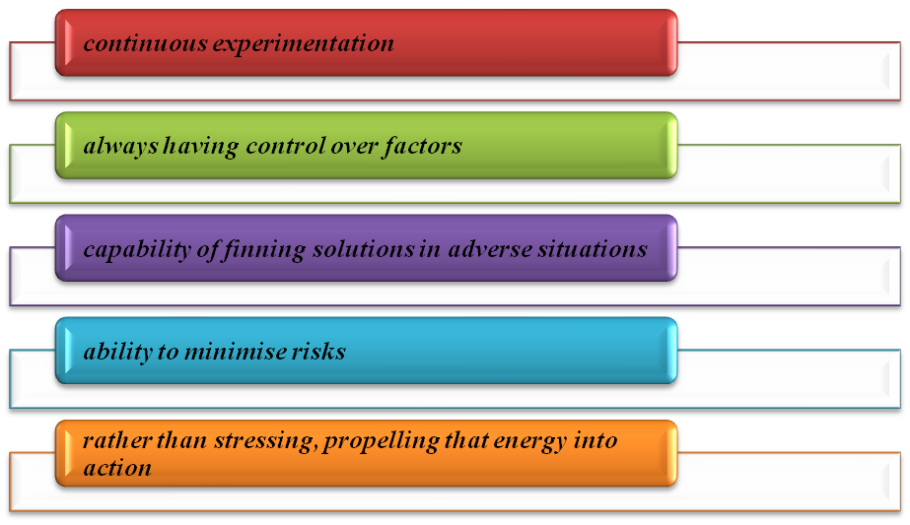
Figure 5: Entrepreneurial values
(Source: created by author)
The functional and regulatory perception for “for profit” and “not for profit” small enterprises differ from each other; entrepreneurial values and beliefs have an utmost contribution to achieving optimal performances in both cases. In research by Al‐Tabbaa et al. (2022), it has been explained that for leveraging the potential to address complex situations, non-profit entrepreneurship has manifested a relation to innovations and proactiveness. Values followed by entrepreneurs in this regard are acknowledged for acting as driving factors for the overall performance outcomes.
Guiding values in entrepreneurship are subjected to several factors. Vision, honesty, generosity, having a positive mindset, the ability to persuasive communication, and incorporation of intrinsic motivations, are primary values considered in successful entrepreneurship (aofund.org, 2022). Both “for profit” and “not for profit” small enterprises can incorporate these entrepreneurial values in determining the course of their actions. On the contrary, Morris et al. (2021) argued that entrepreneurship is an action that is utilised for identifying and exploiting potential opportunities in order to create value. The significance of this process is understandable in both types of enterprises regardless of their operational objectives. The previous discussion has revealed that “for profit” and “not for profit” small enterprises have fundamental differences that enterprises require to contemplate before initiating any strategic operations.
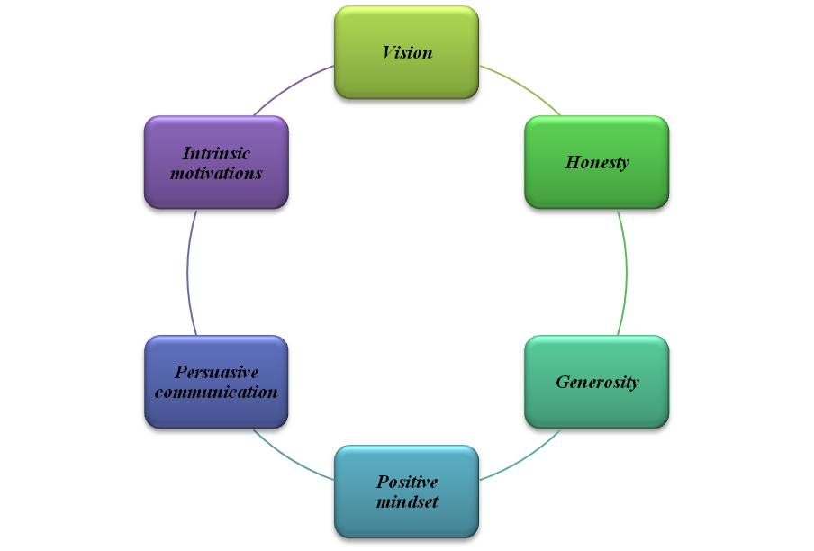
Figure 6: Entrepreneurial values
(Source: created by author)
Incorporating values and beliefs followed by social entrepreneurs or others are aimed at achieving maximum performance effectiveness despite having fundamental differences in operational approaches. According to Rüsch et al. (2019), entrepreneur orientation is a special interest for companies to develop new and advanced solutions. The aforementioned values and beliefs are utilised in intensifying those aspects for any type of company including “for profit” and “not for profit” small enterprises.

Application of examples to support the discussion
The entire discussion on entrepreneurship, its characteristics, values, beliefs, and their involvement in the betterment of operational and organisational performance rationalise their significance in the current context. For example, characteristics and initiatives followed by Elon Musk in his entrepreneurial actions involve persistence, commitment, initiatives for system disruption, and imagination (inc.com, 2022). These approaches have been proven to be beneficial for Tesla's CEO to act as a determinant of successful entrepreneurship. On the other hand, Sundar Pichai is known to follow transformational approaches for his entrepreneurial activities. Despite such differences, both entrepreneurs have managed to sustain profitable and beneficial results in business operations and production processes.
Most entrepreneurial activities are based on surrounding requirements and target audiences. Although it is different for non-profit organisations considering their initiatives towards community services, some similarities are also noticeable. An example of social entrepreneurship is justifiable in those scenarios. For instance, Seventh Generation, known for its personal care products, is known to commit to a $15 billion donation for community service and climate justice (seventhgeneration.com, 2023). Such a contribution does not require known profits but rather prioritises community services. This is a major instance of supporting the significance of social entrepreneurship.

Conclusion
Involvement of entrepreneurial activities in organisational operations and determining their contribution to the process of strategic management has been discussed in this scenario. The discussion has drawn a conclusion about the importance of different values, characteristics, and attributes of entrepreneurship that support organisational and operational development. The inability of preserving consistency in operational activity, risk mitigation procedures, and incorporating innovative ideas in performance often causes failure in entrepreneurial activities. This fact can be concluded from this study. Furthermore, it is also understandable that regardless of different type of organisational settings, fundamental perceptions of entrepreneurship remain constant. It can be summarised that having characteristics such as hornets, persistence, and others are vital for making entrepreneurship successful. Both “for profit” and “not for profit” organisation also demonstrates compliance to these factors that can be concluded from this assessment.

References
Abdullah, N.N. and Othman, M.B., (2021). Investigating the Limitations of Integrated Tasks on Youth Entrepreneurship in Kurdistan Region. Путеводитель предпринимателя, 14(2), pp.179-190.
Akhmetshin, E.M., Mueller, J.E., Yumashev, A.V., Kozachek, A.V., Prikhodko, A.N. and Safonova, E.E., (2019). Acquisition of entrepreneurial skills and competences: Curriculum development and evaluation for higher education. Journal of Entrepreneurship Education, 22(1), pp.1-12.
Alam, G.M., (2022). The Relationship between Figureheads and Managerial Leaders in the Private University Sector: A Decentralised, Competency-Based Leadership Model for Sustainable Higher Education. Sustainability, 14(19), p.12279.
Al‐Tabbaa, O., Ciulli, F. and Kolk, A., (2022). Nonprofit entrepreneurial orientation in the context of cross‐sector collaboration. British Journal of Management, 33(2), pp.1024-1053.
Aofund.org, (2022). “Entrepreneurial Mindset: 5 Characteristics to Cultivate”. Available at: https://aofund.org/resource/entrepreneurial-mindset-5-characteristics-to-cultivate/, [Accessed on: 1st January 2023]
Bouncken, R., Ratzmann, M., Barwinski, R. and Kraus, S., (2020). Coworking spaces: Empowerment for entrepreneurship and innovation in the digital and sharing economy. Journal of Business Research, 114, pp.102-110.
Chiat, L.C. and Panatik, S.A., (2019). Perceptions of employee turnover intention by Herzberg’s motivation-hygiene theory: A systematic literature review. Journal of Research in Psychology, 1(2), pp.10-15.
Courses.lumenlearning.com, (2022). “Herzberg’s Two-Factor Theory”. Available at: https://courses.lumenlearning.com/wm-organizationalbehavior/chapter/herzbergs-two-factor-theory/, [Accessed on: 1st January 2023]
Forbes.com, (2020). “Six Personality Traits Of Successful Entrepreneurs”. Available at: https://www.forbes.com/sites/theyec/2020/05/11/six-personality-traits-of-successful-entrepreneurs/?sh=7f70a9e170ba, [Accessed on: 1st January 2023]
Genkin, E., Filin, S., Velikorossov, V., Kydyrova, Z. and Anufriyev, K., (2020). The fourth industrial revolution: personnel, business and state. In E3S Web of Conferences (Vol. 159, p. 04012). EDP Sciences.
Hinton, J.B., (2020). Fit for purpose? Clarifying the critical role of profit for sustainability. Journal of political ecology, 27(1), pp.236-262.
Inc.com, (2022). “Elon Musk’s Top 4 Entrepreneurial Traits”. Available at: https://www.inc.com/lisa-calhoun/elon-musks-top-4-entrepreneurial-traits.html, [Accessed on: 1st January 2023]
Jiao, L., Harrison, G. and Chen, J., (2022). Revenue growth in not‐for‐profit organisations: The effects of interactive and diagnostic controls and organisational culture. Accounting & Finance.
Kang, E., (2020). The relationship between reinforcement of employee's customer-centric behavior and employee motivation factors. Advances in Social Sciences Research Journal, 7(7), pp.338-347.
Kuswati, Y., (2019). Motivation role in improving work effectiveness. Budapest International Research and Critics Institute-Journal (BIRCI-Journal), 2(4), pp.281-288.
Lecture 2-STM, Slide 4
Lüdeke‐Freund, F., (2020). Sustainable entrepreneurship, innovation, and business models: Integrative framework and propositions for future research. Business Strategy and the Environment, 29(2), pp.665-681.
Medium.com, (2022). “7 Beliefs Of Successful Entrepreneurs”. Available at: https://medium.com/swlh/7-beliefs-of-successful-entrepreneurs-cc29f3097e14, [Accessed on: 1st January 2023]
Morris, M.H., Santos, S.C. and Kuratko, D.F., (2021). The great divides in social entrepreneurship and where they lead us. Small business economics, 57(3), pp.1089-1106.
Poblete, C., Sena, V. and Fernandez de Arroyabe, J.C., (2019). How do motivational factors influence entrepreneurs’ perception of business opportunities in different stages of entrepreneurship?. European Journal of Work and Organizational Psychology, 28(2), pp.179-190.
Roszkowska, P., (2020). Fintech in financial reporting and audit for fraud prevention and safeguarding equity investments. Journal of Accounting & Organizational Change.
Rüsch, S., Wilkesmann, M. and Bastini, K., (2019). The effects of entrepreneurial orientation on strategy choice and management control in nonprofit organizations. Problems and Perspectives in Management, 17(3), p.153.
Şahin, F., Karadağ, H. and Tuncer, B., (2019). Big five personality traits, entrepreneurial self-efficacy and entrepreneurial intention: A configurational approach. International Journal of Entrepreneurial Behavior & Research.
Sciencedirect.com, (2019). “Predicting social entrepreneurial intention: A meta-analytic path analysis based on the theory of planned behavior”. Available at: https://www.sciencedirect.com/science/article/abs/pii/S0148296318305824, [Accessed on: 1st January 2023]
Seventhgeneration.com, (2023). “Climate Justice & Equity”. Available at: https://www.seventhgeneration.com/climate-justice, [Accessed on: 1st January 2023]
Simplypsychology.org, (2022). “Maslow's Hierarchy of Needs”. Available at: https://www.simplypsychology.org/maslow.html, [Accessed on: 1st January 2023]
Sites.google.com, (2019). “Achievement Motivation Theory”. Available at: https://sites.google.com/site/learnteachtech/home/learning-theory/achievementmotivationtheory, [Accessed on: 1st January 2023]
Sonnenschein, K., Hagen, Ø., Rostad, I.S. and Wiik, R., (2022). “Make it possible for more people to work at home!” representations of employee motivation and job satisfaction in Danish and Norwegian newspapers during the COVID-19 pandemic. Frontiers in Psychology, 13.
Strategic Purpose Slides, p.3
Strategy Dynamics C5, p.3
Thomas, T.P. and Van Slyke, C., (2019). The need for nonprofit entrepreneurship education. Journal of Education for Business, 94(7), pp.440-445.
Tornikoski, E. and Maalaoui, A., (2019). Critical reflections–The Theory of Planned Behaviour: An interview with Icek Ajzen with implications for entrepreneurship research. International Small Business Journal, 37(5), pp.536-550.

