

EFFECTIVE TEAMWORK AND COMMUNICATION
BMSW 4002_LON (ETW)

Student Name Almpiona Ntemai
Student Number 1920427
Lecture Name Akinseye Aluko

Contents
INTRODUCTION 3
LITERATURE REVIEW 4
CONCEPT AND PRINCIPLES 6
ANALYSIS 7
PRACTICAL IMPLEMENTATION 8
CONCLUSION 11
REFERENCES 12

INTRODUCTION
The effective team's channels of communication in the company are developing the coordination between the managers and every staff members that cooperate to achieve the organisational targets. Communication is referred to as the transfer of concepts, knowledge and information from different individuals. The data can also be easily exchanged amongst the dealing parties that can be done non-verbally as well as verbally. Also, the teamwork is referred to as the activity of performing the actions that are allotted in the team that is advantageous for the company. The effective channelling for communication is very essential for each company to make the relations amongst each other that enhances the understanding as well as knowledge of each member and developing the work performance (Khawam et al., 2017).
There are two types of communication channels that take place between the receiver as well as the sender and these are non-verbal and verbal communications. Verbal communication contributes to the written and oral form of communication that benefits in sharing the data with the benefit of face-to-face communication with the help of radio, emails, televisions and reports. Nevertheless, the non-verbal of communication that is referred to the body language with the actions, gestures, hand movements and eye-contact. The effective utilisation of communication that is non-verbal in developing verbal communication which can be understood with ease. The following portfolio focuses on identifying the ideas for communication and teamwork at the company by taking in consideration the performance of the company chosen Zara and its working of the team that communicates the theories as well as the models that are implemented in the company to enhance the current practice and achieve effective results.

LITERATURE REVIEW
COMMUNICATION IN WORKPLACE
Arsith(2019),Stated that, the procedure of communication for sharing the information as well as message with different individuals and accomplishing the response regarding the competence because of which the data is received by the receiver. As communication is the most crucial aspect of the company that is engaged in day to day communication to accomplish effective knowledge and understand the responsibilities and roles as well as the work as per the organisational objectives. Forsyth(2018),added to the discussion that, that with the proper utilisation of communication procedure the sender of the message encodes the message and sends to the receiver with the help of effective channels. After this, the receiver decodes the message and then fives the feedback for the sender this procedure of communication is impacted with the help of noise which refers to the barriers which are adversely influential for the interaction amongst two different communicators.
According toGutiérrez(2019),the importance for the process of communication in the organisation with the help of various advantages of the communication like enhancing the level of coordination and cooperation with the members of the team and organisation develops the performance and productivity for the staff members, also by sharing suitable and significant data enhances. The knowledge and individual learning by maintaining the products and services and maintaining the long-standing relationship between the employees and the employer, which enhances the satisfaction and level of motivation for the staff members and attaining the organisational objectives. It is said that the company should use the communication models that are effective to accomplish the effectiveness and the models that involve the transactional and linear and interactive model that plays a major role in transferring the data to each other (Khawam et al., 2017).
GROUP DYNAMICS
Kiweewa(2018),stated that group dynamics is referred as the behaviour of the people that are in the team the psychology and nature of the members of team benefits in comprehending the method that responds in any specific situation. Group dynamics is the effective decision making which is considered in the interest as well as behaviour for the people that satisfy their requirements and encourage them to accomplish the organisational targets effectively while working. The aspect of group dynamics is referred to the psychological behaviour of the individuals, proper education and the process of communication. The actions and performance of team members impact the leader hat modifies the personal needs as well as the environment for the individual. Therefore, the group dynamics are advantageous as well as the company also achieves the desired targets that is combined with the work of the entire team (Tripathy, 2018).
Lynch(2018), explains that the group dynamics of the team has an enduring and effective leader as the life cycle of the group is understood by the members of the team as the leader should realise the abilities, encouragement, interest as well as aptitude of each member of the team that enhances the efficiency and enhance the work performance of team members. Thus, communication is the primary aspect for each team that plays a major role in the accomplishment of organisational targets.
ORGANISATIONAL TEAM WORKING
Khawam(2017),added to the discussion, teamwork is the practice for two and more individuals that work together with continuous communication, resource sharing and interdependency that emphasis on the accomplishment of the similar targets. Working in a team in the same company is very advantageous in accomplishing the organisational and personal targets as it enhances the collaboration, problem-solving, communication, learning and cooperation of the individual with the effective use of teamwork which can perform effectively with a proper dedication towards work each team of Zara has an effective leader who helps them to work on the correct route by offering sufficient support and training, opportunities for development and motivating the workforce by providing them with the correct feedback which is advantageous for staff members in enhancing the work performance and developing the skills and knowledge (Lynch et al., 2018).

CONCEPT AND PRINCIPLES
The teamwork that is effective in the organisation can be balanced with the use of different theories and models for the development of the group. The Belbin's nine-team role in developing the coordination between the members of the team and allotting the duties and roles that are based on their line of interest as well as calibre which encourages the staff members to perform effective work for the proficiency that is for the achievement of the organisational targets (Tripathy, 2018). On the other hand, the theory of Tuchman for the enhancement of the group development contributes five different stages that are used by the company for team management and the stages are forming, norming, performing and adjourning. The model of interaction is the effective model that is utilised in business to balance the continuous and proper interaction amongst the leader and the staff members as well as with the investors of the company to accomplish the results that are desired in the company (Gutiérrez et al., 2019).
To enhance the communication the leaders, as well as the managers of the company, should enhance the team members encouragement and also motivate them to take part in the meetings of the team and should make them understand the requirement and importance of communication of both informal and formal interaction with the colleague as the staff members do that with the help of informal communication. Also while interacting with the higher authorities the formal interaction must be taken into consideration (Arsith et al., 2019).

ANALYSIS
Each model that is used by the company for enhancing the communication flow for effective team management in the company has the advantage as well as obstacles, therefore, the company should assess the advantages and disadvantages for every model and the appropriate mode should be applied in the company to enhance the productivity and work performance of the entire company by achieving the success (Kiweewa et al., 2018). The communication model is highly advantageous as it benefits the sender in accomplishing the feedback from the receiver for the objective of mass interaction. The disadvantage of this model is that the feedback that is received from the receiver can take much time to approach the sender. With the use of the Tuckman model, it will benefit Zara in team management effectively by performing the work stepwise for enhancing the communication and also developing the enduring relation amongst the members of tea. The bad implementation of this communication model can result in enhancing of difficulties and confusion as well as the arguments which lead in the ineffective performance of work from the staff members and the company (Khawam et al., 2017).

PRACTICAL IMPLEMENTATION
BELBIN’S TEAM ROLE MODEL
In this model, the team leader is accountable to implement Belbin's team role effectively between the members of the team in Zara. Primarily, the leader should focus on benefiting each member of the team to analyse the strengths. The leader should allow the roles to each worker in proper alignment of the strengths that are discovered. The organisational leader requires to utilise the strengths of each team member in an effective method to achieve the organisational targets. The members of the team must work effectively with the use of their competences and strengths with a correct method for accomplishing the task in the given time (Tripathy, 2018). There are nine roles which are performed by the members of the team in Zara as per the Belbin's that are as under-
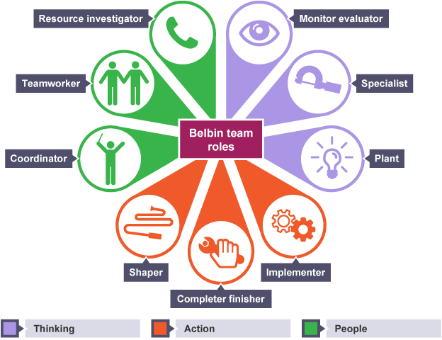
Figure 1 Belbin's team roles
Source (Forsyth, 2018)
The implementation of Belbin’s team role model in Zara id very advantageous for the company and the staff members as the staff members can assess the strength and it can also work as per the adjusting performance and behaviour for the organisational benefit. These nine roles are also classified in three different heads which are action-oriented, though-oriented and people-oriented (Talman, 2018). The action-oriented team is allotted with the work that is related to the performance that is actual as these all role involve implementer, shaper and the finisher. The people-oriented role benefits in gathering the team as and satisfy the roles of an allocator of resource, coordinator and team-mates. Also, the thinking-oriented individuals in team emphasis on the issues that are technical and also the critical thinking procedure monitor the factors that benefit in enhancing the action-oriented performance of the individuals (Tripathy, 2018). Therefore, these combinations benefit in balancing the teams in Zara and attaining the goals of the team.
TUCKMAN’S GROUP DEVELOPMENT THEORY
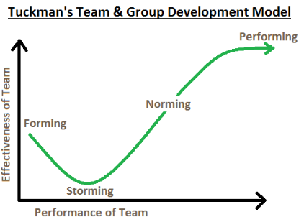
Figure 2 Tuckman's group development theory
Source (Taherdoost, 2018)
FORMING
This is the primary stage from where the team is formed the members of team are unaware of their job roles and accountabilities at this stage of team forming as each member of team should be guided properly before starting their work (Talman, 2018).
STORMING
At this phase, the main objective is clear to each member of the team as it has more conflicts because of the difference in point of views and various perspective of every tea. The job duties that are allotted to every member is based on their area of interest and capabilities (Gutiérrez et al., 2019).
NORMING
The members of the team are well versed of the job roles and accountabilities as the team members at this stage make some initiative and efforts to communicate and emphasis on common targets (Taherdoost, 2018).
PERFORMING
At this stage where the actual performance for the members of team members begins as the members are highly committed towards the accomplishment of team targets in this stage.
Therefore, the implementation of this phase in Zara benefits in completing the actions in teams and accomplishing the success in the business (Forsyth, 2018).
INTERACTIONAL COMMUNICATION MODEL
The use of the communication model at the company benefits in delivering the message, information, knowledge and ideas with the sender to the receiver and make sure that data is understood with the help of feedback. It is also known as the communication model (Khawam et al., 2017).
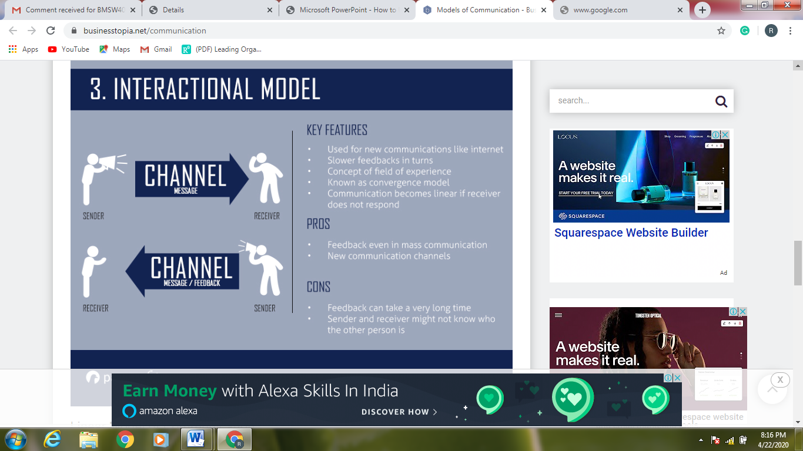
Figure 3 Interactional communication model
Source (Talman, 2018)

CONCLUSION
Thus, in this report emphasis of the proper application of team management, models of communication and development of teams in Zara for enhancement of the present practice and also for developing the work performance of the staff members that are working in the company. Therefore, developing potential working environment is very important for communication and teamwork in the organisation that is analysed in this report.

REFERENCES
Arsith, M. and PopaTanase, D.A.(2019). Sign, Language, Significance and Communication. EIRP Proceedings, 14(1).
Forsyth, D.R. (2018). Group dynamics. Cengage Learning.
Gutiérrez, L., Flores, V., Keith, B. and Quelopana, A. (2019). Using the Belbin method and models for predicting the academic performance of engineering students. Computer Applications in Engineering Education, 27(2), pp.500-509.
Khawam, A.M., DiDona, T. and Hernández, B.S. (2017). Effectiveness of teamwork in the workplace. International Journal of Sciences: Basic and Applied Research (IJSBAR), 32(3), pp.267-286.
Kiweewa, J.M., Gilbride, D., Luke, M. and Clingerman, T.(2018). Tracking growth factors in experiential training groups through Tuckman’s conceptual model. The Journal for Specialists in Group Work, 43(3), pp.274-296.
Lynch, D.S., Lynch, M.J. and Clemens, C.M.(2018). Belbin Team Roles. The Handbook of Communication Training: A Best Practices Framework for Assessing and Developing Competence.
Taherdoost, H. (2018). A review of technology acceptance and adoption models and theories. Procedia manufacturing, 22, pp.960-967.
Talman, J.(2018), August. Enhancing Teamwork in Group Projects by Applying Principles of Project Management. In Innovations in Teaching & Learning Conference Proceedings (Vol. 10).
Tripathy, M.(2018). Building quality teamwork to achieve excellence in business organizations. International research journal of management, IT and social sciences, 5(3), pp.1-7.

