
Student Name: Shemeka Williams

Student Number: 1913883

Module Name: Workplace Culture and its Impact on Organisation Efficiency

Module Number: BMSW5105 WCO

Lecturer Name: Rexon Niting

Executive summary
Tesco is operating with a leading position in the supermarket sector of the UK. The organisation is aimed at providing an affordable and healthy diet to its customers. The present report provides an assessment of the impact of external environmental factors including the Covid-19 pandemic and ethical dilemmas on the performance of Tesco. The report includes different tools such as PESTEL analysis, Porter's five forces analysis, and Cultural web model to examine the impact of external environmental factors, analyse industrial conditions, and determine the organisational culture of Tesco. Through the analysis, it was identified that Covid-19, Brexity, change in customer perception, climate change, and online shopping are some of the external factors that are making an impact on the performance of Tesco. The report has analysed the cultural environment of Tesco and examined the impact of organisational culture on its financial and non-financial performance. Lastly, the impact of workplace bullying and harassment and employee health and safety as the two ethical issues was assessed and the measures that are adopted by Tesco to address these issues were discussed in the report.
Contents
1. Introduction 4
2. Company’s Background 4
3. Business environment Analysis 5
3.1. PESTEL Analysis 5
3.2. Porter’s Five Forces Analysis 7
3.3. Organisation culture 8
4. Organisational Culture and External Factors 11
4.1. Covid-19 11
4.2. Online Shopping 11
4.3. Climate Change 12
4.4. Changes in Customer Behavior 13
4.5. Brexit 13
5. Organisational Culture and Performance 13
5.1. Financial Performance 14
5.2. Non-financial Performance 15
6. Ethical Dilemma 17
6.1. Workplace Harassment and Bullying 18
6.2. Safety and Health of Employees 18
7. Conclusion and Recommendations 19
References 21
Appendix 24

- Introduction

This report is aimed at assessing the impact of external environmental factors including the global pandemic Covid-19 and ethical dilemmas on the organisational culture and performance. The emergence of the Covid-19 pandemic has changed the way businesses operate and perform their activities. Most of the companies are now operating virtually through virtual meetings and online assessment of tasks. Covid-19 has introduced both challenges and opportunities for the organisations and now, it depends on the individual characteristics of the organisation to either benefit from new conditions or face challenges through the implementation of incompetent approaches.

The assignment will provide a critical assessment of the culture and context of Tesco and evaluate its external environment through PESTEL analysis. The industry analysis of the organisation will be conducted through Porter’s five forces analysis to determine the extent to which internal rivalry and bargaining power of customers and suppliers along with the threat of substitutes can impact the performance of the organisation. In addition to this, the culture of the organisation will be discussed through a cultural WEB model and the impact of some external factors on the culture and performance of the organisation will be identified. Lastly, ethical dilemmas faced by modern organisations will be examined and the impact of any two identified ethical dilemmas on the performance of Tesco will be identified.
- Company’s Background
Tesco is a leading supermarket in the UK and it is recognised as the biggest private employer in the country. The company was established in 1919 to provide everyday affordable, sustainable and healthy food to its customers to improve the quality of life and standards of livings. The organisation has set a mission statement that highlights the importance of staff members and their efforts for its success. Tesco is currently providing employment opportunities to over 360,000 employees in its 3,146 stores (Winterman, 2013). To ensure its growth, the organisation includes its staff members and volunteers in business development plans to get new ideas and explore new dimensions of the business. It is the third-largest supermarket in the world with its stores in more than 12 countries of the world (Winterman, 2013). The company is generating £57.9 billion statutory revenue and £1,736 million statutory operating profit (Tesco PLC, 2021).

- Business environment Analysis

A range of business environmental analysis tools including PESTEL analysis, Porter’s five forces analysis, and Web Culture will be used in this report. PESTEL analysis is a tool that is used to examine external environmental factors including political, economic, technological, environmental, and legal factors that can impact the performance of an organisation. Porter’s five force analysis, on the other hand, examines the industrial setting in which a business is operating by examining the threat of substitutes, the threat of new entrants, the bargaining power of suppliers and customers, and internal rivalry in the industry (Perera, 2020). Lastly, the cultural web model helps in the examination of the culture of an organisation by identifying and understanding different factors that can influence the organisational culture.

  - PESTEL Analysis

PESTEL analysis for Tesco Plc is given below:

Figure 1: PESTLE Analysis (Perera, 2020)

Political Factors

The political environment of the UK has witnessed some shifts after Brexit. These changes in the political environment have also led to the imposition of new rules and standards that are affecting the performance of organisations operating in the UK. Tesco can also face challenges due to these political changes because of the imposition of new trade policies and difficulties in the recruitment of employees.

Economic Factors
The value of the pound has declined in recent years because of the changes in the political environment and the introduction of new policies for the performance of businesses (Ostroff, 2020). The emergence of Covid-19 has also shifted the focus of governments towards the health of people which has also affected the economic position of the countries. This decline in the pound’s value can impact the performance of businesses operating in the UK.

Social Factors

The choices of customers have changed after the outbreak of Covid-19. While on one side, customers want to visit physical stores, on the other side, they want to prioritise their safety and prefer to buy groceries online. In addition to this, people have lost their jobs and businesses have been closed during the lockdown and because of this, many customers have stated that they will buy only essential products (Eger et al., 2021). However, these changes in social conditions can make a very minimal impact on Tesco because the company is selling essential products that customers are willing to purchase despite a decline in their purchase power.

Technological Factors

Along with several other changes in lifestyle, Covid-19 has also shifted the attention of people towards new shopping patterns (Eger et al., 2021). Many customers are now preferring online shopping and many others want the facility of self-checkout in the stores to avoid human contact. The integration of new technologies that are now easily available to the companies can offer several advantages to Tesco. For example, Tesco is using digital media and social networking sites for the promotion of its business.

Environmental Factors

The eating habits of customers are changing with time. Many customers are now switching to a vegan diet to maintain a healthy lifestyle and save animals. In addition to this, customers are also demanding companies produce products through environment-friendly mechanisms to make minimum impacts on the environment and contribute to the reduction of climate change.

Legal Factors

Due to Covid-19, businesses are now required to follow certain precautionary measures and policies such as only allowing customers with a mask inside the stores to protect their health of customers. In addition to this, stores are restricted to allow only a certain percentage of customers at a time in the store to avoid human contact and reduce the spread of the virus. The imposition of these changes along with the introduction of new export and import policies for businesses in the UK can impact the performance of companies.
With the help of the above analysis, Covid-19, technological advancements, and customer demands are identified as the key drivers of change for Tesco.

  - Porter’s Five Forces Analysis

Porter’s five forces analysis for Tesco is given below:
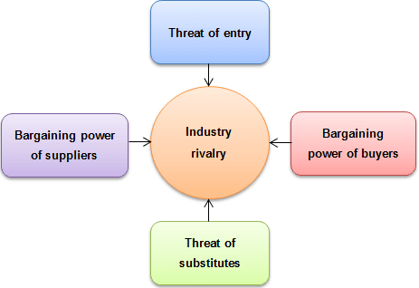
Figure 2: Porter's Five Force Analysis (Perera, 2020)
Internal Rivalry

Internal rivalry in the supermarket sector is very high because of the presence of big names like Tesco, Aldi, Sainsbury, and others. Big companies are competing to maintain their customers and attracting new customers by introducing budget-friendly prices and new product ranges which is leading to increased competition in the market (Lan and Dobson, 2017).

Threat of Substitutes

The threat of substitutes is relatively low for the retail sector because customers must buy essential products and grocery items to run their households. While they can switch from one brand to another, it is difficult for them to choose one store over the other when there is a very minimum or no difference in the price and quality of products. In addition to this, the substitutes of grocery items are not easily available which also reduces this threat for Tesco.

The threat of New Entrants

The threat of new entrants is high in the retail sector despite the presence of big names operating with a leading position in the market. New entrants can make a place in the market by offering a new variety of products and using different pricing approaches that can allow them to attract new customers and improve their position.

Bargaining Power of Customers

The bargaining power of customers is very high in the supermarket because of the availability of multiple choices to customers. Due to the high competition in the market, customers have the choice to switch from one brand to another if they are not satisfied with the quality and prices of products.

Bargaining Power of Suppliers

The bargaining power of suppliers is moderate in the supermarket sector because most of the companies prefer to produce products on their own and rely on the suppliers for a very minimum number of items. However, the bargaining power of suppliers is relatively weak for Tesco because suppliers want to associate themselves with reputable brands and adjust according to the requirements of the companies.

  - Organisation culture

Organisational culture is comprised of shared values and beliefs about how individuals should interact with each other and what strategies should be adopted to make decisions and perform different activities within the organisation (Alvesson, 2013). Key elements of organisational culture include the environment, management, employees, and history of an organisation. Tesco considers itself to be an employee-owned company (Tesco Controls, 2021). The organisation has developed a team-oriented culture that helps in fostering innovation and development and helps in building a desire in the employees to sincerely contribute to the betterment of the organisation.
Further explanation of Tesco’s culture is provided with the help of John’s cultural web model.
John’s cultural web is a theoretical framework that considers different cultural elements as primary factors in building the culture of an organisation. This model is comprised of six cultural elements including power structure, organisational structure, control systems, stories, rituals and routines, and symbols (Cooper et al., 2018). A visual description of this framework is provided below:
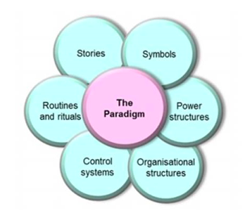
Figure 3 Cultural Web Model (Johnson et al., 2017)
Stories

Stories are related to the past and present events of the company. In the context of Tesco, stories can be used to describe the initial events when Tesco was established in 1919 by Jack Cohen to recent years when Tesco was forced to close its 57 outlets due to economic crisis in 2014 and to the days in 2015 when the company decided to diversify its product range (Eeph.org.uk, 2021).

Rituals and Routines

Rituals and routines describe the daily actions of individuals that indicate acceptable behaviour in the organisation. Tesco's baseline is "Every Little Helps" which shows that the organisation acknowledges the contribution of all its employees regardless of the extent to which their efforts contribute to the growth of the organisation. Tesco has maintained a friendly environment and expects all employees to behave in a professional but warm manner. The organisation also conducts events to highlight the contribution of its workers and describe the importance of different situations.

Symbols

Symbols provide a visual representation of the organisation such as logos, dress code, and decorations (Tesco, 2021). Tesco’s employees are expected to follow a dress code. The logo of the company is given below:
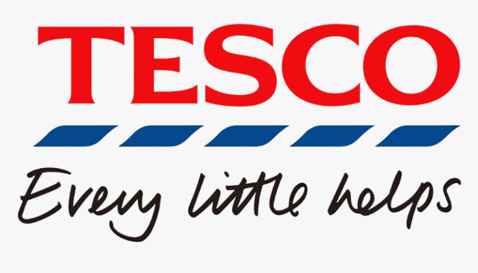
Figure 4 Tesco Logo
Organisational Structure

Organisation structure describes the influential entities of the organisation and defines the contribution of different members within the context of their position in the organisation. Tesco is following a functional approach which suggests that decision-making power is allocated to the senior management in the organisation. However, other staff members are also invited to organisational meetings and their training and development needs are highlighted to introduce positive changes in the organisation.

Control Systems

Control systems indicate the way the organisation is managed. It includes quality systems, rewards, and financial systems. Tesco rewards its employees according to their contribution to its growth and acquires the feedback of its staff members through the survey to understand and implement the concerns of employees.

Power Structure

Power structure describes the hierarchy and power dynamics of an organisation. Tesco has also maintained a hierarchical structure which suggests that people in higher positions have more power than those in the lower position.

- Organisational Culture and External Factors
With the help of the above analysis, five external factors that are making a visible impact on the performance of the organisation are identified. An explanation of these factors along with the measures that can be adopted by Tesco to address these factors is given below:

  - Covid-19

The global pandemic Covid-19 has made the most visible and drastic impact on businesses. Even though Tesco was initially negatively impacted by the pandemic, the organisation later observed a visible increase in its revenues when customers begin to stock essentials and started getting used to the lockdown conditions imposed by the government. Recently, the company has stated that despite an increase in its sales, its yearly profits are declined due to Covid-19 (BBC News, 2021). To manage the negative impacts of the pandemic, the organisation can offer discounted bundles and collaborate with other brands to increase its sales and revenues.

  - Online Shopping

Online shopping became a trend after governments-imposed lockdown to reduce the spread of coronavirus. Tesco also acquired a large percentage of its revenues from online sales in 2020/2021 (Peters, 2021). The following image shows that online shopping has become an integral part of Tesco’s operations and income in recent years.
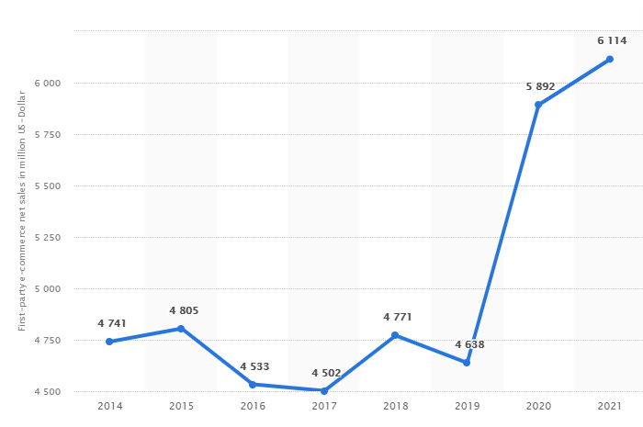
Figure 5 Tesco Online Sales (Peters, 2021)
However, around 27% of customers have also stated that they do not prefer to shop online from Tesco because of the given reasons:
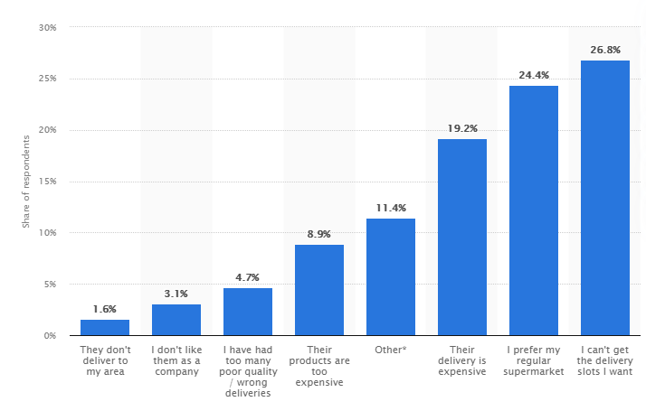
Figure 6 Customer Complaints of Tesco (Blázquez, 2021)
To get maximum benefits from online shopping, Tesco should open its stores in more accessible locations and conduct online surveys to identify the concerns of customers.

  - Climate Change

Climate change is affecting the health of people and leading to several changes in the lifestyle of customers. Many businesses including Tesco are taking measures to contribute to the development of a green environment to reduce the extent of climate change. Tesco has also unveiled its new “climate manifesto” to provide a healthy and sustainable diet to customers, reduce food wastes and become a net-zero business by 2035 (edie.net, 2021). With the help of this manifesto, Tesco is aiming to cut carbon from energy usage, the transition of EVs (electric vehicles), support the production of sustainable food, and tackle wastages related to food packaging and production (edie.net, 2021). In addition to this, the company can also add a new range of sustainable products to attract more customers.

  - Changes in Customer Behavior

The attitude of customers towards shopping has visibly changed in recent years. Due to a decline in the purchasing power of customers, most of the customers are planning to introduce some changes in their shopping patterns to only purchase essential products instead of spending their income on luxury items. Although this factor cannot make a significant impact on the sales of food items of Tesco, the company can still face some challenges in the sales of electronic items and other luxury items. The company can manage these changes by increasing the promotion of luxury items through different channels and offering discounts on products that are less likely to be sold.

  - Brexit

Brexit has affected the performance of organisations operating in the UK. Businesses are struggling to manage the prices of their products due to the introduction of new trade policies. In addition to this, employees belonging to the EU are also facing difficulties in the management of their jobs in the UK, due to which, many businesses are looking for new employees to manage their day-to-day operations. These changes have also affected the performance of Tesco but the company can manage the impact of Brexit by providing travel facilities to employees living in distant locations and offering more jobs that can be performed virtually to maintain the maximum number of its employees.

- Organisational Culture and Performance

Organisational culture refers to the way activities are performed and beliefs are shared in an organisation. It plays an important role in shaping the behaviour of employees in an organisation to improve their performance and increase their involvement in organisational activities (Alvesson and Sveningsson, 2015). Tesco has maintained a friendly environment and a supportive culture. The organisation has based its culture on trust and respect and considered these two factors crucial for its success (Tesco-careers.com, 2021). In Tesco, the efforts of employees are acknowledged and they are rewarded to increase their motivation to serve the organisation.
In this section of the report, the impact of organisational culture on the financial and non-financial performance of Tesco will be assessed.

  - Financial Performance

Financial performance describes the ability of an organisation to use available resources to generate revenues and achieve its objectives. Financial performance is indicated through the income statement, cash flow statement, and balance sheet of a company.
As mentioned in the below figure, Tesco has generated around £53 billion in the UK and the Republic of Ireland. This shows an increase of over £1 billion in comparison to the previous financial year of the company. However, the profit and ROI of the company have decreased in the UK and reached 1,866 million in the year 2020-21 (Blázquez, 2021).
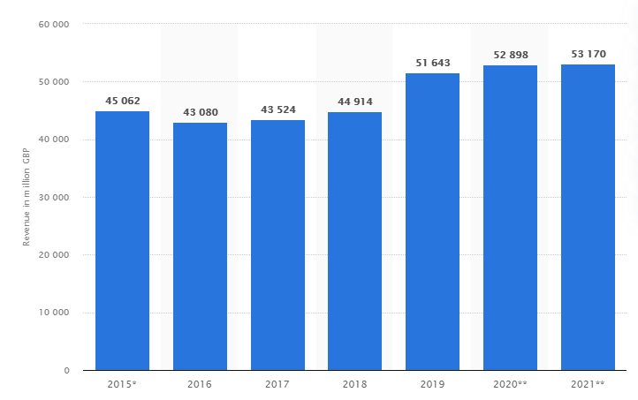
Figure 7 Tesco Income 2015-2021 (Blázquez, 2021)

The sources and uses of cash at Tesco illustrate in the below figure:
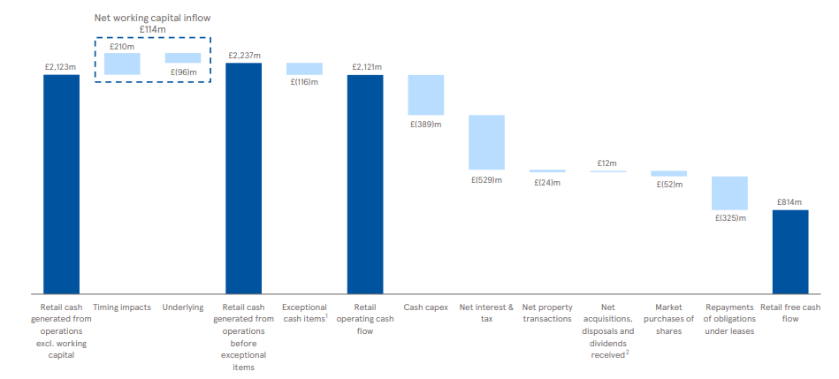
Figure 8 Tesco Sources and Uses of Cash (Tesco, 2019)
As per the below figure, the cash flow of the organisation has increased in recent years with a slight decline in the retail free cash flow in 2019-2020 (Tesco, 2019). A visual illustration of the information is provided in the below figure:
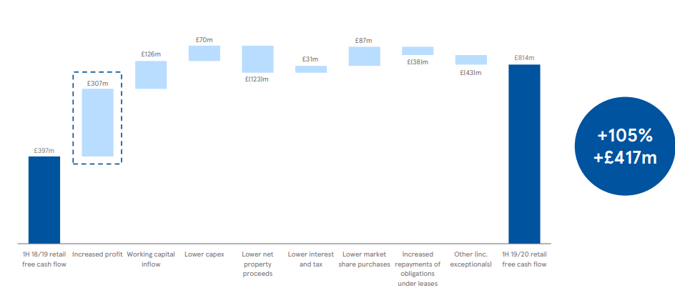
Figure 9 Tesco year-on-year cash flow (Tesco, 2019)
Tesco has successfully managed to maintain an organisational culture that can foster progress and motivate the employees to work for the long-term growth of the organisation. However, fluctuation in the revenues and cash flow of the organisation indicates that Tesco will need to make some amendments in the existing culture to manage the performance of employees in the context of changes in the external environment.

  - Non-financial Performance

Non-financial performance indicates the ability of an organisation to satisfy its customers, offer high-quality services, retain existing customers and attract new customers, manage its reputation and provide training to its employees. In the context of organisational culture, the non-financial performance of an organisation is related to its ability to maintain a culture of mutual respect and trust. A positive organisational culture that offers equal opportunities for growth to all employees can contribute to the achievement of organisational goals and management of its non-financial performance. As mentioned earlier, Tesco has developed a culture of respect and trust in the workplace and regarded these two elements as critical for its success. It can be assumed that the organisation is using these elements to maintain a culture that provides growth opportunities and encourage employees to participate in different activities.
As mentioned in the below figure, the value perception of Tesco has improved in recent times. This shows that the organisation has managed to promote a culture that fosters improved performance and established a proper management system to secure the needs of its employees.

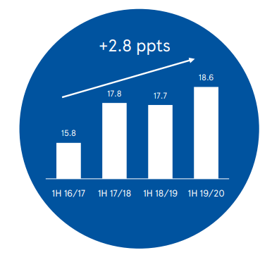
Figure 10 Tesco Value Perception (Tesco, 2019)

The following figure is indicating that the quality perception of Tesco has also improved in the past few years:
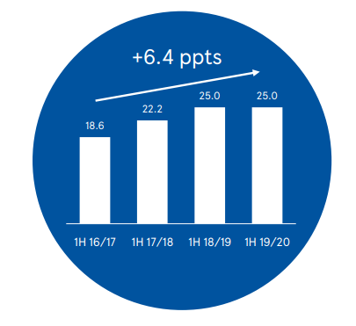
Figure 11 Tesco Quality Perception (Tesco, 2019)

Lastly, the trust of Tesco's customers in the quality of its products and services has also increased in recent years. As shown in the below figure:
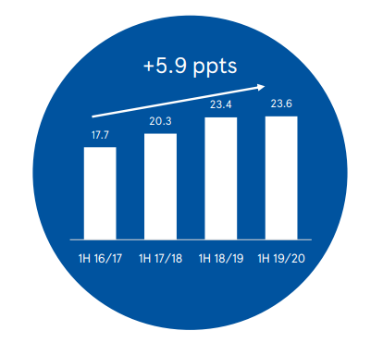
Figure 12 Tesco Customer Trust (Tesco, 2019)

The improvement in the perception, trust, and quality of Tesco indicates a positive role of the organisational culture in its performance and development.

- Ethical Dilemma

Ethical dilemma refers to the problem in decision-making where the organisation has two or more options available but neither of them is applicable from an ethical viewpoint. Modern-day organisations are facing several ethical issues that are not only affecting the performance of their employees but also leading to controversies that can negatively impact their reputations. For example, harassment and workplace discrimination has become a major concern for organisations despite the ongoing awareness campaigns and development of strict policies. Management of the privacy of customers and employees has also become an ethical concern for most businesses because several companies have been accused of accessing customer data without their permission. In most cases, customers click the agree button without reading the requirements of the agreement that leads to challenges for both customers and the companies. Two of the ethical dilemmas or ethical issues that can or have impacted the performance of Tesco are given below:

  - Workplace Harassment and Bullying

Any type of action or behaviour that can offend someone and make him/her feel uncomfortable is considered bullying and harassment. According to the Equality Act 2010, bullying and harassment can include spreading false information, unfair treatment towards one or more individuals, picking on someone regularly, and denying access of someone to promotion opportunities (GOV.UK, 2021). Many organisations are struggling to maintain an environment where employees can function without getting harassed or bullied based on their colour, religion, gender, age, body type, and sexual orientation. Despite that workplace harassment and bullying have become an ethical dilemma that is becoming a concern for organisations.
Tesco is addressing harassment and bullying by clearly stating that all individuals are welcome in the organisation to offer their services and avail different growth opportunities. Tesco acknowledges the importance of employee safety and it is taking measures to ensure that all employees feel safe and secure in the organisation. The organisation is committed to providing an environment that is free from any type of bullying and harassment to all its employees and volunteers (Tesco PLC, 2021). The organisation’s management takes complaints related to harassment and bullying very seriously and investigates the matter with complete sincerity to provide confidence to its employees. Any employee who is found to be breaching this policy is dealt with strict disciplinary measures that can also lead to immediate dismissal. Tesco is following the conditions and standards of the Equality Act 2010 to provide a safe environment to its employees (Tesco PLC, 2021).

  - Safety and Health of Employees

The retail, food trade, wholesale and MVR sectors accounted for twelve fatal injuries in 2016/2017 and represented 7% of fatal injuries in the overall workplace environment of the UK. Even though the chances of workplace injuries are relatively low in the retail sector, there is still the potential of serious harm to the physical and mental health of employees. Most of the fatal injuries in the retail industry are caused by trips, falls, and slips because stores are crowded by employees, customers, and the general public, and the employees are expected to arrange heavy stuff and speedily perform their jobs. These chances are especially higher for organisations operating with many stores (Health & Safety Consultants, 2021). Considering this factor, Tesco has taken different measures to ensure the wellbeing and safety of its employees. The occupation health and safety and fire safety engineering are offered by experts within the Group People Safety Department of the company. Business processes that can generate safety risks are also managed by professionals with a post-graduate diploma or degree in safety, members of IOSH (Institute of Occupation Safety and Healthy), and IFE (Fellow of Institute of Fire Engineers). The organisation has also established a network of safety experts supporting different areas of the business at a local scale. The CEO of the company leads the strategies adopted for the health and safety of employees and customers. It shows that Tesco is aware of the potential impacts of health and safety risks on not only the performance of its employees but also on its reputation and long-term growth and development (Tesco Plc, 2021).

- Conclusion and Recommendations

The purpose of this assignment was to assess the impact of broader external environmental factors including Covid-19 and ethical dilemmas on the performance of modern-day organisations. In this context, Tesco Plc was selected to assess the influence of external environmental factors and determine the response of the organisation towards potential threats and changes in the external environment. The report provided a critical assessment of organisational context and culture along with an evaluation of the organisation through the application of relevant environmental tools and techniques. In addition to this, organisational culture and ethical behaviour were also discussed in the context of Tesco. In the light of the above findings and analysis, the following recommendations are provided to Tesco:
- The organisation can conduct regular surveys to determine the response of customers towards its services.
- The organisation can establish its stores in more accessible areas and offer its services at more reasonable prices to attract and retain its customers.
- The organisation can offer discounts and add bundles on products that are less likely to be sold due to Covid-19 and a decline in the economic strength of customers.

Individual Reflective Account
I will use Kolb’s reflective cycle to reflect on the learning and skills acquired through this module.
Kolb’s Learning Cycle
Kolb’s learning cycle is a reflective tool based on four stages including concrete experience, reflective observation, abstract conceptualisation, and active experimentation (McLeod, 2017). These stages are described in the context of my personal experience below:
Concrete Experience
Throughout this module, I got several opportunities to expand my knowledge and get an understanding of different factors that can improve my performance in the future. With the help of this module, I acquired several skills that can help me in my professional career including decision-making and critical thinking skills. I acquired these skills through the tasks that were assigned to me by the instructors. I enjoyed working on tasks that required me to use critical approaches to evaluate different elements and select from different available options to improve my knowledge.
Reflective Observation
Even though I enjoyed the learnings of this module, I believe that I could have shown better performance in some areas where I showed reluctance and preferred other activities over the tasks. However, I still managed to gain different skills and improve the knowledge that can help me in getting a job in the desired organisation and contribute to the betterment of organisations in the future.
Abstract Conceptualisation
Overall, I am glad that I got an opportunity to benefit from the learnings of this module. I have noticed several changes in my behaviour after getting enrolled in this module. For example, ever since I have learned that organisations demand punctual and highly motivated employees (Yusuf, 2021), I have increased my involvement in activities that can improve my physical health and allow me to excel in different areas without compromising on my wellbeing. In addition to this, I have also developed a schedule to develop punctuality and time-management skills that can help me in the future.
Active Experimentation
Organisations look for highly competitive and talented employees to divide their responsibilities. After getting an understanding of the organisational culture through this module, I have realised that I will need to develop some skills to excel in my career and a job in the desired profession. I have also developed a personal development plan to improve my performance in different areas and progress towards the achievement of my career objectives. First of all, I will follow a healthy diet and exercise regularly to improve my physical and mental health. In addition to this, I will also install time management applications to develop punctuality and avoid the habit of procrastination that can negatively impact my performance. After the completion of my degree, I will work as an intern in reputed organisations and enrol in training programs conducted by the organisations to acquire the skills that are required in the professional world.

References
Alvesson, M., 2013. Understanding organisational culture. 2nd ed. Los Angeles: SAGE.
Alvesson, M. and Sveningsson, S., 2015. Changing organisational culture: cultural change work in progress. Second ed. London: Routledge.
BBC News. 2021. Tesco counts cost of Covid trading as profits drop. [online] Available at: <https://www.bbc.com/news/business-56742832> [Accessed 28 August 2021].
Blázquez, A., 2021. UK: reasons for not shopping at Tesco online 2020 | Statista. [online] Statista. Available at: <https://www.statista.com/statistics/1235099/reasons-for-not-shopping-at-tesco-online-united-kingdom/> [Accessed 28 August 2021].
Blázquez, A., 2021. Tesco: revenue 2019 | Statista. [online] Statista. Available at: <https://www.statista.com/statistics/490931/tesco-group-finance-revenue-united-kingdom-uk/> [Accessed 28 August 2021].
Cooper, M., Collins, M., Bernard, R., Schwann, S. and Knox, R. 2018. “Criterion-related validity of the cultural web when assessing safety culture”, Safety Science, 111 (1), pp. 49-66.
edie.net. 2021. Tesco unveils climate manifesto to assist net-zero target. [online] Available at: <https://www.edie.net/news/9/Tesco-unveils-climate-manifesto-to-assist-net-zero-target/> [Accessed 28 August 2021].
Eeph.org.uk. 2021. Tesco and the key milestones it has reached. [online] Available at: <https://www.eeph.org.uk/key-milestones.php> [Accessed 28 August 2021].
Johnson, G., Scholes, K. and Whittington, R. 2017. Exploring Corporate Strategy: Text & Cases. 11th ed., Harlow: Pearson Education Limited.
Eger, L., Komárková, L., Egerová, D. and Mičík, M., 2021. The effect of COVID-19 on consumer shopping behaviour: Generational cohort perspective. Journal of Retailing and Consumer Services, 61, p.102542.
GOV.UK. 2021. Workplace bullying and harassment. [online] Available at: <https://www.gov.uk/workplace-bullying-and-harassment> [Accessed 28 August 2021].
Health & Safety Consultants - Risk Assessment Solutions. 2021. Health & Safety & Fire Safety For Retail Stores - Health & Safety Consultants - Risk Assessment Solutions. [online] Available at: <https://www.workplace-rm.com/health-safety-fire-safety-for-retail-stores/> [Accessed 28 August 2021].
Lan, H. and Dobson, P.W., 2017. Healthy competition to support healthy eating? An investigation of fruit and vegetable pricing in UK supermarkets. Journal of Agricultural Economics, 68(3), pp.881-900.
McLeod, S., 2017. Kolb's learning styles and experiential learning cycle. Simply psychology.
Ostroff, C., 2020. British Pound Falls to Lowest Level Since 1985. [online] WSJ. Available at: <https://www.wsj.com/articles/british-pound-falls-to-lowest-level-since-1985-11584537813> [Accessed 28 August 2021].
Perera, R., 2020. Understanding Porter’s Five Forces Analysis. Nerdynaut.
Peters, L., 2021. E-Commerce net sales of tesco.com from 2014 to 2021 | Statista. [online] Statista. Available at: <https://www.statista.com/forecasts/1218318/tesco-revenue-development-ecommercedb> [Accessed 28 August 2021].
Tesco-careers.com. 2021. Culture | Tesco Careers. [online] Available at: <https://www.tesco-careers.com/explore-our-world/our-culture/#:~:text=We%20know%20that%20looking%20after,try%20their%20hardest%20for%20customers.> [Accessed 28 August 2021].
Tesco PLC. 2021. Key Facts. [online] Available at: <https://www.tescoplc.com/about/key-facts/> [Accessed 28 August 2021].
Tesco Controls, Inc. 2021. Company Culture | Control System Integrator | Tesco Controls, Inc.. [online] Available at: <https://tescocontrols.com/about-us/careers/your-career-join-in/company-culture/> [Accessed 28 August 2021].
Tesco. 2021. CE Dress Code and Appearance Polic. [online] Available at: <https://d2io1s13lhj42h.cloudfront.net/wp-content/uploads/sites/5/2016/04/01092448/ce-dress-code-and-appearance-policy-06-2019.pdf> [Accessed 28 August 2021].
Tesco. 2019. Serving shoppers a little better every day.. [online] Available at: <https://www.tescoplc.com/media/755220/interims-presentation_investor21.pdf> [Accessed 28 August 2021].
Tesco PLC. 2021. Bullying and Harassment. [online] Available at: <https://www.tescoplc.com/sustainability/documents/policies/bullying-and-harassment/> [Accessed 28 August 2021].
Tesco Plc. 2021. Ensuring health and safety in the workplace. [online] Available at: <https://www.tescoplc.com/sustainability/documents/policies/ensuring-health-and-safety-in-the-workplace/> [Accessed 28 August 2021].
Winterman, D., 2013. Tesco: How one supermarket came to dominate. [online] BBC News. Available at: <https://www.bbc.com/news/magazine-23988795> [Accessed 28 August 2021].
Yusuf, M., 2021. The Effects of the Intrinsic Motivation and Extrinsic Motivation on Employee Performance with Job Satisfaction as an Intervening Variable at PT. Alwi Assegaf Palembang. Journal Management, Business, and Accounting, 20(1), pp.18-3

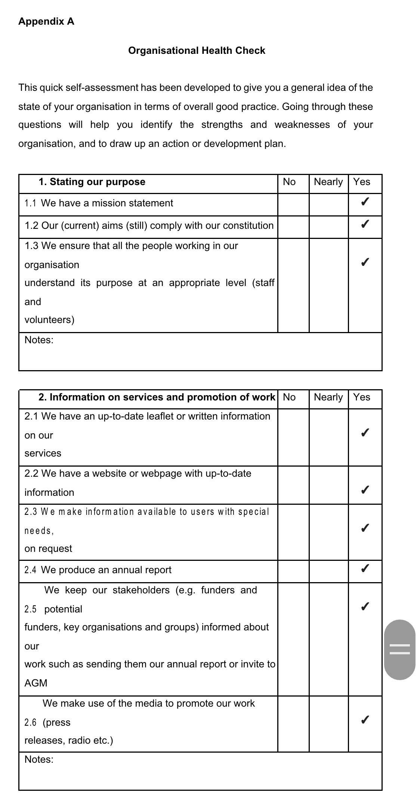
Appendix






