

Living with Care: The Older Person
Assessment 2
Supporting Paper

Student name:​ Jeneba Marah

Student ID: ​ 1816724

Module name: Mental Disorders and Psychopathology​

Module code: BMHP6009

Lecturer name: Diola Bijlhout
Table of Contents
Debate Standpoint 3
Views on the debate 3
Debate discussion 3
Statistics on ageing UK population 4
Government support and services for aged peoples 5
Impact of Covid 19 cases over UK older population 5
Reference List 7

Debate Standpoint
In this context, the debate standpoint regarding the ageing population does not pose any challenges for health and social care systems. Instead, it has significant benefits that are considered left for realising by humankind and the country.

Views on the debate
in this regard, the central topic of discussion is entirely focused on the country's highly increased ageing population (Age International, 2022). Though there are various controversial facts regarding the side effects of the ageing population increments in the country, there are many secretive positive points of this pattern of the population significantly. Such as one of the most significant benefits or positive influences in the view towards the high margin of the ageing population is considered to be the development of sustainable society significantly. The proven real-time point is the country Japan has a higher level of the ageing population tends to maintain an eco-friendly atmosphere.

Debate discussion
In the debate regarding the challenges posed by the ageing population towards the health and social care systems of any country, various vital facts have been taken under consideration, such as the connection or link between overpopulation and ageing population in different developing countries like India. Better contribution to the economy is considered one of the most vital benefits of the ageing population increments (Nickels et al., 2021). In addition to that, a significant fact of family relationships such as nuclear family and joint family effectiveness and informativeness is also the primary critical supporting point that reflects ageing population showcases better bonding between joint families and better care of old age people. Instead of reducing in-country healthcare system and medical interventions better possibilities of care home generations, healthcare infrastructures are getting solidifies in this context. It has been identified that the ageing population directly impacts the country's economy as it boosts wages and works productivity and reduces interest rates. In many areas of urban regions, the overall employment margin of older people gets enhanced.

Statistics on ageing UK population
According to the evaluations of Mahesh et al. (2020), it has been identified that the average age of the UK population is around 40.5 years which is in the higher range in the case of all the developing countries around the globe. With the increasing ages of the UK population, the chance of facing multiple health-related concerns increases over time (Nickels et al., 2021). The accounted facts also suggest that the UK population, 19%, are aged more than 65 years, and it is around 12.3 million people. It has also been accounted that 23% of the UK population are on the verge of being called the aged population with an age of more than 45 years. Almost 15.21% of the UK population has an age over 70 years which is concerning to the health society of the UK. In the last few years, it has also been evaluated that the number of people aged more than 90 years has increased by 2.5 times in the UK. As per the strategic evaluation and identification, it has also been evaluated that in between the tenure of 24th May to -20th June, 70% of the admission cases were conducted due to people less than 65 years.
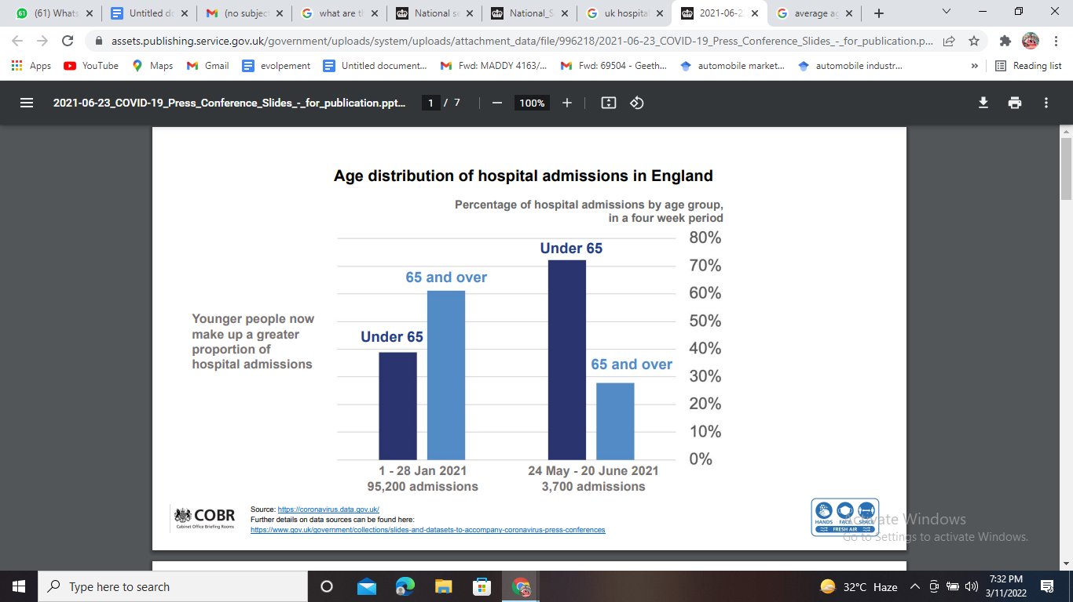
Figure 1: Age-based admission cases in the UK
(Source: Holt et al. 2020)

Government support and services for aged peoples
There are multiple types of support and services provided by the UK Government and legislative associations from the government. The UK Government provides the first and essential services through the national service framework for older adults. According to the evaluations and certification to prevent unnecessary hospital admissions and support early discharge, the legislative authority takes a reasonable charge and provides exceptional care to individuals with long-term illnesses (Holt et al., 2020). The government also offers primary care for mental illness patients and residential care and nursing Home facilities to individuals over the age range of 60 years. The government also provides older adults with physiotherapy, community dental services, pharmacist district base nurses, health visitors care home services and many things that are very seldom available in other countries.
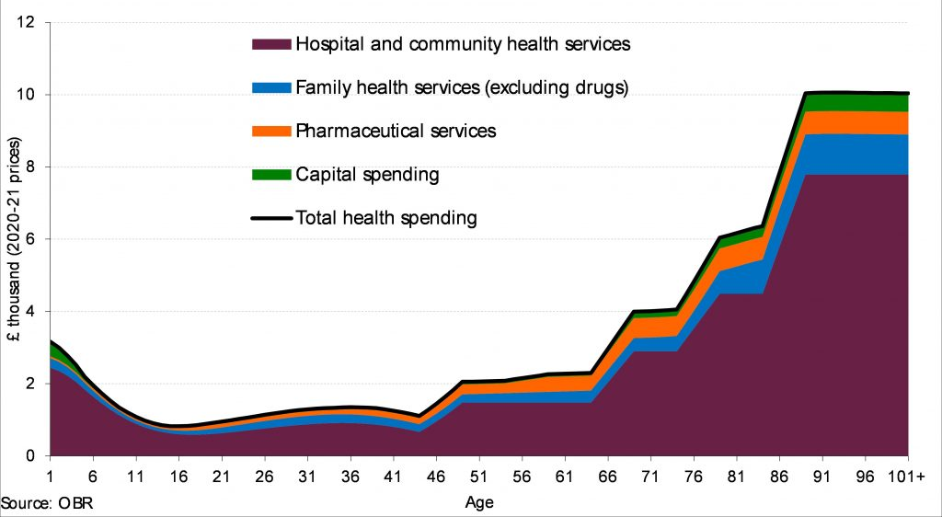
Figure 2: Age-based services in the UK
(Source: Liotta et al. 2018)

Impact of Covid 19 cases over UK older population
The impact of Covid-19 over the UK population was immensely influential and has brought in a massive crisis to the societal causes (Liotta et al., 2018). As per the evaluations and recorded facts, it is identified that the total number of positive cases held in the UK till now is 19457976. In the last seven days, the account number of positive cases is close to 371662 (. The number of deaths accounted for around the UK throughout the Covid-19 162624. The individuals who had responded to the treatment and became fully cured are close to 18182482.
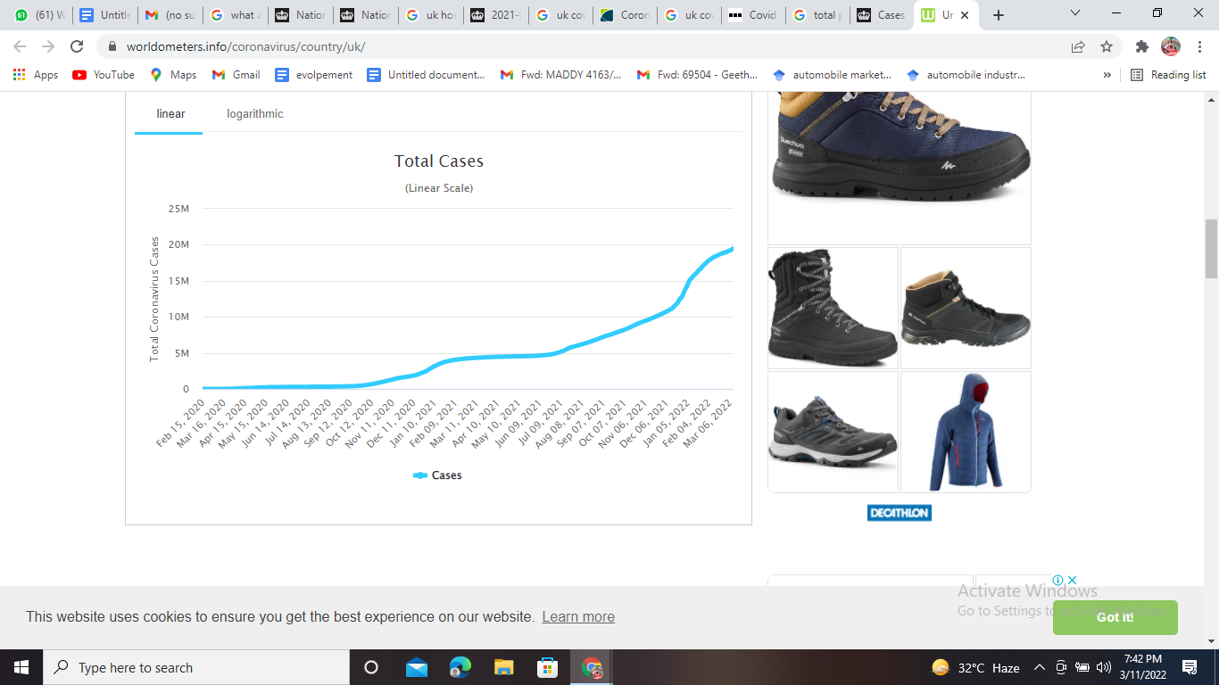
Figure 3: Covid graph over the time
(Source: Pastorino et al. 2019)
While doing the year-based evaluation, it is accounted that the most vulnerable age of covid cases according to the figures is evaluated to be the age range people over 75 years with 48.7% deaths. Then comes the age range of 65 to 74 years, with a percentage of death close to 24.9% (Pastorino et al., 2019). then the vulnerability comes to the age range of 45 to 64 years with 22.4% death cases. The lowest number of death cases is accounted for people between 0217 years, with death ratios around 0.06%.

Reference List
Holt, N.R., Neumann, J.T., McNeil, J.J., Cheng, A.C., Unit, H.E. and Prahan, V., (2020). Implications of COVID-19 in an ageing population. Med J Aust, 213(8), pp.342-344.https://www.mja.com.au/system/files/2020-05/Holt%20mja20.00649%20-%206%20May%202020.pdf
Liotta, G., Canhao, H., Cenko, F., Cutini, R., Vellone, E., Illario, M., Kardas, P., Poscia, A., Sousa, R.D., Palombi, L. and Marazzi, M.C., (2018). Active ageing in Europe: adding healthy life to years. Frontiers in medicine, 5, p.123.https://www.frontiersin.org/articles/10.3389/fmed.2018.00123/full
Mahesh, S., van der Werf, E., Mallappa, M., Vithoulkas, G. and Lai, N.M., (2020). Long-term health effects of antipyretic drug use in the ageing population: protocol for a systematic review. F1000Research, 9, p.1288.http://f1000researchdata.s3.amazonaws.com/manuscripts/29987/7ac856ad-8bc5-4396-86f9-54ebc41e366e_27145_-_seema_mahesh.pdf
Nickels, L., Hameau, S., Nair, V.K., Barr, P. and Biedermann, B., (2019). Ageing with bilingualism: benefits and challenges. Speech, Language and Hearing, 22(1), pp.32-50.https://espace.curtin.edu.au/bitstream/handle/20.500.11937/76232/76472.pdf?sequence=3
Pastorino, R., De Vito, C., Migliara, G., Glocker, K., Binenbaum, I., Ricciardi, W. and Boccia, S., (2019). Benefits and challenges of Big Data in healthcare: an overview of the European initiatives. European journal of public health, 29(Supplement_3), pp.23-27.https://academic.oup.com/eurpub/article/29/Supplement_3/23/5628051?ref=hackernoon.com
Radford, K., Chapman, G., Bainbridge, H.T. and Halvorsen, B., (2018). The ageing population in Australia: Implications for the workforce. In Work and Identity (pp. 39-54). Palgrave Macmillan, Cham.https://www.researchgate.net/profile/Hugh-Bainbridge/publication/323360548_The_Ageing_Population_in_Australia_Implications_for_the_Workforce/links/5afe0551aca272b5d848abd0/The-Ageing-Population-in-Australia-Implications-for-the-Workforce.pdf
The positive impacts of an ageing population | Age International (2022). Available at: https://www.ageinternational.org.uk/policy-research/expert-voices/the-positive-impacts-of-an-ageing-population/

