The evolution of violence in the human past and how time changes our perceptions of the conflict in the past?
,

It is understood that Humans have been hitting each other with things for a very long time, but for how long and of what kind. The debates around how violent our human past is, is continuously being investigated, opinions differing from the idea presented by Hobbs that we are innately violent creatures to the concept of the Noble Savage where compassion is at the core of human nature. Though the concept must be explored with more depth considering upbringings, social pressures and human evolution. It is indisputable that interpersonal violence in pre-history occurred, though to what extent is up for debate. It is important to understand the reasoning behind the differing arguments of how violent our past truly was. In the 20th century when archaeological exploration into the violent pre-historic past began to be explored in more detail it could be suggested that the interpretation of the violence was influenced by the proximity to the second world war, and political climate of the era and time of excavation and exploration may lead to biases towards viewing the past in a less violent light. (Keeley, 1997)
By looking at skeletons found through excavation it is possible to gain a clearer understanding on how present violence was in our prehistoric past. broken bones that have healed and trauma that may have led to death of the individual can be seen in the skeletal record. In recent years more improved understanding of the properties of bone fractures have leads to the discovery more evidence signifying violence as previously thought damage that may have occurred after death may now be the result of interpersonal violence. (Walker, 2001) Violence in the upper palaeolithic is present though evidence of violence present in the skeletal record is few and far between due to the age of the remains. Interpersonal violence may be present in multiple palaeolithic burials found in Europe, such as the Dolni Věstonice triple burial where trauma to the skulls of two individuals suggest that they were sacrificed prior to burial (Formicola, et al., 2001) Other evidence of violence present in the palaeolithic can be seen with the multiple burials such as the Maszycka cave in Poland, where evidence of cannibalism is present in the crushed skulls of two possible family groups. (Petru, 2018) The small-scale interpersonal violence among group members is much more prevalent than any larger scale war-like violence that is more noticeable after the introduction of agriculture, where sedentary life begins to become more commonplace. (Wrangham, 2019)

Through the exploration of primates found today it is possible to theorise that there was more violence in the pre-historic past prior to homo-sapiens evolution. Hare 2017 suggests that due to the increase in brain size and therefore through the use of self-control the need for more aggressive behaviours became less necessary. (Wrangham, 2019) In chimpanzee groups there is a high rate of inter-personal and inter group violence, it is possible that similar attitudes where present in early human past as chimpanzees are often seen engaging in their own warfare.

it is undeniable that the human past is filled with violence and that the interpersonal violence may have been extremely prevalent, the wide-spread evidence of cannibalism, such as is present in the Mancos site in south America;
“several similar collections have been described that show the same pattern of massive perimortem breakage and percussion damage with evidence of subsequent processing, cutmarks, and burning that strongly suggest consumption of human flesh by other humans” (Walker, 2001)

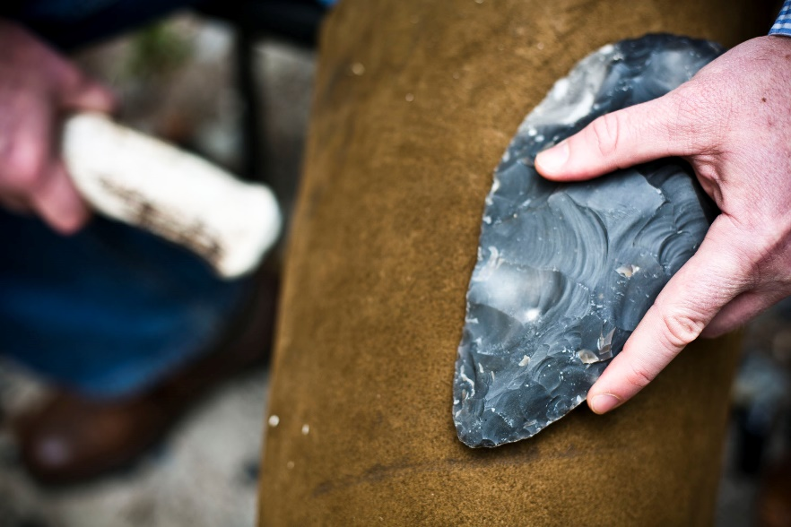
This Photo by Unknown Author is licensed under CC BY

The earliest known tools dated to 3.3milion years ago, found in 2012 in Turkana, (McGeough & Haerenberg, 2019) the use of tools enabled the prolonged survival of pre-historic peoples and can present a clear insight into how interpersonal violence may have been committed. It is easy to see in the archaeological record, tools found at burial-sites such as arrow shot, can clearly indicate that it was violence that may have led to the death of the individual. Tools such as axes are practical when used for chopping trees and wood but could also cause damage to a group member or other person, it is in the case of a useful tool such as an axe that may present difficulties in identifying as the tool would unlikely be present at the site of burial. One example of tools used as a means to inflict harm can be seen with the neanderthal individual known as Shanidar 3, found in the Shanidar caves in Iraq and who is thought to be around 45000-35000 years old. A small partially healed stab wound is present on the rib of the individual and it is possible that this led to their death. (Churchill, et al., 2009)
Tools became more specialised once agriculture, farming and animal domestication lead to a greater number of people living more sedentary lives. It is with this move to sedentary life that an increase in collective violence can be seen. It was predominantly during the Neolithic that violence truly emerged with societal pressures, and differing nature between groups leading to more large-scale violence though there are exceptions to this during the palaeolithic near east, such as a large group of individuals in Jebel Sahaba necropolis where 59 individuals where killed Along the Nile river border in Sudan. (Patou-Mathis, 2021)
It is with these changes rom mobile to sedentary life that the nature of conflict and violence begins to change. These societies without “state-level institutions” such as overarching laws and rules, followed by a majority of the population, may have lead to the increase in external conflict towards neighbours and external groups, “ in societies without state-level institutions by contrast, violent behaviour may be actively encouraged,” (Patou-Mathis, 2021)The reasoning for this ‘encouraged’ violence could be because of many factors, resource acquisition, land and territory being established, a rise in population density.
Keeley presents the idea that conflict was not so much a result of population density but more so for the acquisition of resources between societies. War being a prime example of the inter group violence often overlook by pre-historians. The presence of exotic goods found on sites are often seen by archaeologists as evidence of pre-historic exchange, Keeley presents the idea that these goods may have been evidence supporting the idea of war.
“Thus archaeologists doubly pacify the past by assuming that all exotic items are evidence of exchange and that exchange preludes war… war moves goods and people just as effectively ... as exchange, and exchange can easily incite war.” (Keeley, 1997)
The interpretations provided by archaeologists are reliant on the physical evidence present at the site of excavation, such as tools or goods, the understanding of whether these came into the possession of the pre-historic groups through exchange, war, or violence is effected by political and social climate of the time of discovery, Keeley suggests that the proximity to world war 2 in the 20th century have lead to the un-intentional softening of the violence of history in order to disconnect from the recent history of the world war (Helms, 1999)
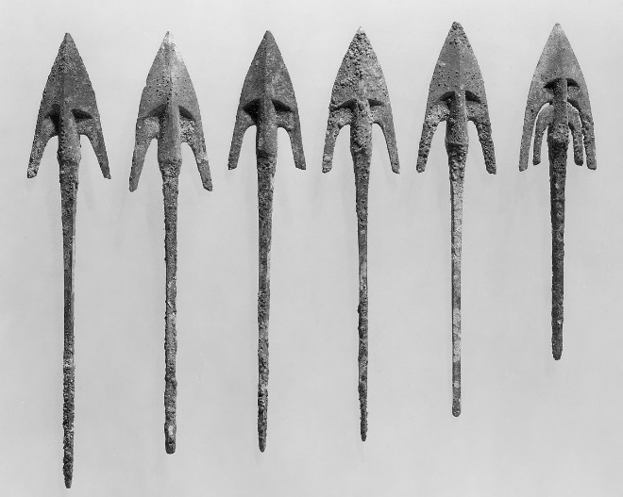

Topographical evidence such as Hillforts may be able to give us an insight into the British past and how tools and warfare evolved during the iron age. At Maiden Castle 20,000 stone pebbles were discovered at the entrance to the fort. In the past hillforts where viewed as fortresses and strong evidence indicating to tribal warfare between neighbouring groups, and it has also been theorised by Sir Mortimer Wheeler that the use of ramparts in the construction of hillforts may have lead to the development of slingshot-technology (Heritige, 2020)
When discussing the iron ages, and the pre-romanization of the British Isles it is imperative to understand the romantic notions of ‘Celtic peoples’ developed during the romantic period have influenced how the iron age is viewed. (Hill, 1995)Though archaeological development, from the 1930’s until present have began to shed more light on cultures of the time the pre-conceived perceptions of iron age Britain are still prevalent.
It is now more Widley believed that the hillforts were used more so as enclosed settlements and areas with multiple roles including commerce, animal pounds and most notably displays of power. (Heritige, 2020)There is still much debate over how conflict was present during the iron age pre-romanization, though it is understood that the various tribes found in the British Isles were often involved in wars between each other and more likely than not there would have been trade between the various groups, the roles of hillforts in relation to these wars was most likely as a symbol of power, as well as offering some defensive properties. It is during the conquest by Rome where perhaps a clearer image of how violent the native Britons where begins to emerge.
Described as Barbarians and depicted as being violent and magical people, Cesar noted how skilled of fighters the Britons where, “In chariot fighting the Britons begin by driving all over the field hurling javelins … then … they jump down from their chariots and engage on foot.” (Heritige, 2020) It is talks about how the Britons themselves were formidable foes against the Roman conquerors stating that the Warriors could sit in a bog for multiple days without the need to move. Herodian writes of the “fierceness” of the Britons during Severus’ time in Britain
“They are very fierce and dangerous fighters, protected only by a narrow shield and a spear, with a sword slung from their naked bodies. They are not familiar with the use of breast-plates and helmets, considering them to be an impediment to crossing the marshes.” (Herodian & Whittaker, 2015)
These examples show how the Romans viewed the native Britain tribes and though these accounts are more than likely showing a bias towards the power of the Britons and therefore highlighting the victory of Rome in that conquering of the untamed land it is important to note that there was scaling conflict present in the local tribes as shown by how long they were in conflict with Rome. It is said that history is written by the victors, and despite the bias in such accounts it is nevertheless a valuable source into understanding just how much violence was in our and how it is perceived today.
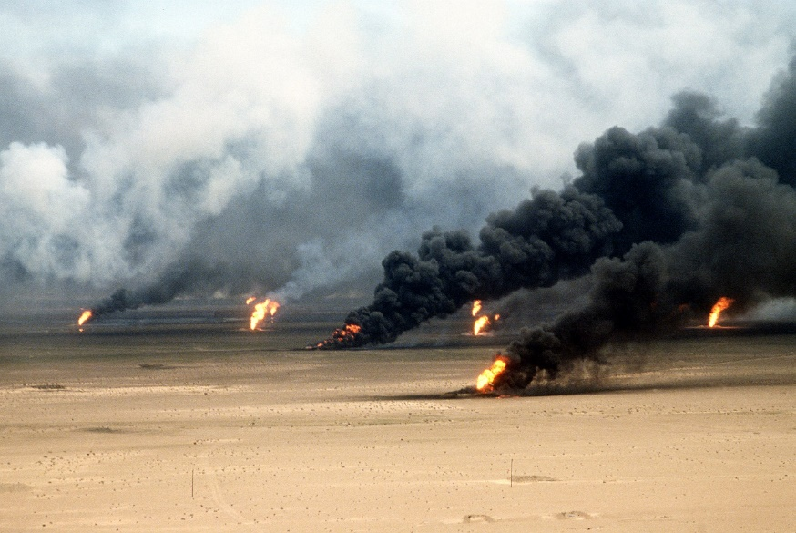
It can be argued that violence is more prevalent today than in the past, with wars, political violence, police brutality, violence in media being witnessed and surrounding the modern human. With the constant bombardment of distant violence, in day-to-day life it is easy to see how this may be the case. Though it is also possible that violence is not in fact more prevalent today but instead has evolved into a new form, globally witnessed in the day-to-day life, present in all media and on the news though not experienced or felt in the same way as our prehistoric and historic past. (Di Leo & McClennen, 2012)
It is not fighting over resources 2 support individual tribal groups wars of conquest but instead background noise. We romanticise the past and its violence creating our own heroic biased storeys of historical figures and claiming pride at being a warrior nation. There is a disconnect between the violence in our past and the violence felt today. Jeffrey R. Di Leo and Sophia A. McClennen writes “While violence is everywhere more apparent, it is also everywhere ignored and hidden.” (Di Leo & McClennen, 2012)
The violence present in the pre-historic past is determined by the un-conscious views of the academic, socio-economic climate of the time effects the perceived level of violence in the past and the romanticisation of past eras. This is prominently seen with the archaeological explorations in the 20th century and the proximity to the second world war but it is also prevalent in how media and nations today view their own past, and how the connection to violent leaders and conflict is given narrative which has influence on media and how violence is easily witnessed in the modern world.

References
Churchill, S. E. et al., 2009. Shanidar 3 Neandertal rib puncture wound and paleolithic weaponry. Journal of Human Evolution, 57(2), pp. 162-178.
Di Leo, J. R. & McClennen, S. A., 2012. Postscript on Violence. symploke, 20(2), pp. 241-250.
Formicola, V., Pontrandolfi, A. & Svoboda, J., 2001. The Upper Paleolithic Triple Burial of Dolnı´ Veˇ stonice: Pathology ad Funerary Behavior. AMERICAN JOURNAL OF PHYSICAL ANTHROPOLOGY, Volume 115, pp. 372-379.
Helms, M. W., 1999. Review: [Untitled]. Journal of World History, 10(2), pp. 431-434.
Heritige, E., 2020. English Heritage. [Online]
Available at: https://www.english-heritage.org.uk/learn/story-of-england/prehistory/war/
[Accessed 20 March 2021].
Herodian & Whittaker, C. R., 2015. History of the Empire. Cambridge, Mass: Harvard University.
Hill, J. D., 1995. The Pre-Roman Iron Age in Britain and Ireland (Ca. 800 B.C. to A.D. 100): An Overview.. Journal of World Prehistory, 9(1), pp. 47-98.
Keeley, L., 1997. War before Civilisation: The Myth of the Peacful savage. New York: Oxford University Press .
McGeough, J. A. & Haerenberg, R. S., 2019. Hand Tool. Britannica.
Patou-Mathis, M., 2021. The Origins of Violence. [Online]
Available at: https://en.unesco.org/courier/2020-1/origins-violence#:~:text=Currently%2C%20the%20most%20ancient%20traces,observed%20on%20Palaeolithic%20human%20bones
[Accessed 20 March 2021].
Petru, S., 2018. Identity and fear – Burials in the Upper Paleolithic. Documenta Praehistorica, Volume XLV, pp. 1-6.
Walker, P. L., 2001. A Bioarchaeological Perspective on the History of Violence. Annual Review of Anthropology, Volume 30, pp. 573-596.
Wrangham, R. W., 2019. Hypotheses for the Evolution of Reduced Reactive Aggression in the Context of Human Self-Domestication. Front. Psychol, 10(1914).

