Tuckman’s team development theory
Task 3a
Social psychologist Dr. Bruce Wayne Tuckman published his four stages of team development, “Tuckman’s Stages”, in 1965 [1]. The Tuckman team development theory was made by Bruce Tuckman it documents the 5 stages that teams go through during the time the team is formed. These five stages are Forming, Storming, Norming, Performing and Adjourning. [2]His Theory goes into detail about these five key stages during team formation and documents about the hardships and achievements within each one. It should also be noted that Tuckman states that not all teams go through all stages and that some teams take longer to go through some stages than others might. The theory can also be applied to any scenario in which a person is in a group environment and not just work, some other examples in which this theory can apply include family units, in school when making friends, sports teams and research teams.
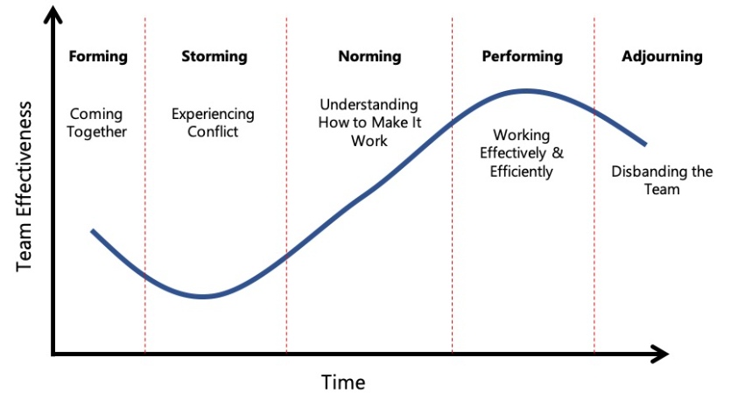
Figure 1 – Tuckman’s five stages of team development [3]

Storming is when after the group has come together and time has gone on the initial cordiality between team members ends. This is because people have been able to get to know each other for a small amount of time and have worked out a general understanding of each other. Conflict arises due to different personalities and differences in working styles [2] . People begin to get annoyed with each other since they each work in different ways which sometimes don’t work well with each other this is a source of friction between team members.
Power struggles also occur in this stage where a number of people will try and dominate the group. Clashes occur due to different personalities and differences in working styles [4] . People naturally value different things because of that people in a group will prioritise, assign value and devote time to tasks that others might disagree with. This creates friction between the group as people try to become more powerful in the group to bring about their vision and steer the group in a direction that they think is best. Often these power struggles happen to the detriment of the group as cohesion begins to break down and factions arise over who's side you're on dividing the group.
Another thing which occurs in this phase of group formation is people begin to show competitive behaviour in which they try and one up each other. People begin to compete for the recognition of the team leader to further their careers and gain notoriety in the wider organization. Within the group there may also be a need to compete for recourses as they feel the task they have been assigned is more important to the group as a whole .

References

[1] | Institute Project management , “The 5 Stages of Team Development: Tuckman’s Model,” 9 December 2022. [Online]. Available: https://instituteprojectmanagement.com/blog/the-5-stages-of-team-development/. [Accessed 9th February 2026].
[2] | E. -. Louise, “Get Your New Group or Team Performing Beautifully!,” The Coaching Tools Company.com, 8 July 2024. [Online]. Available: https://www.thecoachingtoolscompany.com/get-your-team-performing-beautifully-with-this-powerful-group-development-model/?srsltid=AfmBOooHx3kWV7iw0CZsNgR3_IpipxTdW8ag6_gYEN4D_ZdgfzBj7OMH. [Accessed 9 February 2026].
[3] | B. Brearly, “The 5 Stages of Team Development,” Thoughtful Leader , [Online]. Available: https://www.thoughtfulleader.com/people-management/5-stages-of-team-development/. [Accessed 9 February 2026].
[4] | Y. D. a. X. Wei, ““The Spillover Effect of Interteam Conflict on Intra-Team Status Struggles and Performance: The Moderating Role of Interteam Status Dispersion,” Group dynamics,” “The Spillover Effect of Interteam Conflict on Intra-Team Status Struggles and Performance: The Moderating Role of Interteam Status Dispersion,” Group dynamics, vol. 29, p. 99, 2025.

