Supporting Essay on Blogs

In planning and developing my blog posts, I considered a series of Marketing mix, The Marketing communications mix, Advertising principles, and marketing theories.

In order for our project to succeed, and in considering our advertisement blogs I did an extensive research into our products, brand, market, consumer needs and consumer wants, and our target audience. I therefore considered the marketing mix. Marketing mix is simply about putting the right product or a combination thereof in the place, at the right time, and at the right price. It might be challenging doing this well, as one ought to know every aspect of the business.

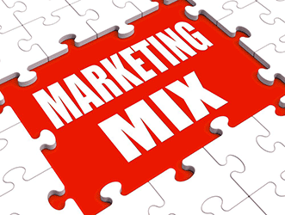
The marketing mix is predominantly associated with the 4P’s of marketing, the 7P’s of service marketing, and the 4Cs theories that were developed in the 1990s.

Marketing Mix 4P’s

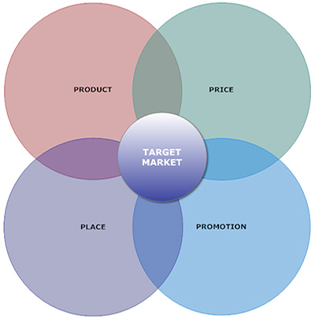
Marketing expert E. Jerome McCarthy created the Marketing 4Ps in the 1960s. the marketing 4Ps are the foundation of the idea of marketing mix.
# 1 Marketing Mix – Product

A product is an item that is built or produced to satisfy the needs of a certain group of people. The product can be intangible or tangible as it can be in the form of services or goods – in this case, watches. You must have the right type of product that is in demand for your market. During the product development phase, the marketer must do an extensive research on the life cycle of the product that are to be created. The product has a certain life cycle which includes the growth phase, the maturity phase, and the sales decline phase. It is important for marketers to reinvent their products to stimulate more demand once it reaches the sales decline phase. Marketers must also create the right product mix. It could be wise to expand your current product mix by diversifying and increasing the depth of the product line. Marketers must ask themselves the question, “what can I do to offer a better product to this group of people than my competitors”.

In developing the right product, the following questions must be answered,

- What does the customer wants from the product?
- How will the customer use it?
- Where will the customer use it?
- What features must the product have to meet the customer’s need?
- Are there any necessary features that you missed out?
- Are you creating features that are not needed by the customer?
- What’s the name of the product?
- Does it have a catchy name?
- What are the sizes or colours available?
- How is the product different from the products of your competitors?
- What does the product look like?

#2 Marketing Mix – Price

The price of the product is basically the amount that a customer pays for to enjoy it. Price is a very important component of the marketing mix definition and component of a marketing plan as it determines the firm’s profit and survival. Adjusting the price of the product has a big impact on the entire marketing strategy as well as greatly affecting the sales and demand of the product. Pricing always help shape the perception of your product in consumers eyes. A low price usually means an inferior good in the consumers’ eyes as they compare your good to a competitor. Prices too high will make the customers value their money over your product.

#3 Marketing Mix – Place

You have to position and distribute the product in a place that is accessible to potential buyers. This comes with a deep understanding of the target market which will make you discover the most efficient positioning and distribution channels that directly speak with your market.

Here are some of the questions that you should answer in developing your distribution strategy:

- Where do your clients look for your product?
- What kind of stores do potential clients go to?
- How do you access the different distribution channels?
- How is your distribution strategy different from your competitors?
- Do you need to sell in an online store?

#4 Marketing Mix – Promotion

Promotion can boost brand recognition and sales. Promotion is comprised of various elements like:
- Sales Organization
- Public Relations
- Advertising
- Sales Promotion

Advertising typically covers communication methods that are paid for like television advertisements, radio commercials, print media, and internet advertisements. In recent times, there seems to be a shift in focus offline to the online world.
Public relations, on the other hand, are communications that are typically not paid for. This includes press releases, exhibitions, sponsorship deals, seminars, conferences, and events. Word of mouth is also a type of product promotion. It is an informal communication about the benefit of the product by satisfied customers and ordinary individuals. The sales staff plays a very important role in public relations and word of mouth.

Marketing Mix 7Ps

The 7Ps model is a marketing model that modifies the 4Ps model. Although more used in the service industry, it could also be relevant in tangible product marketing.

Marketing Mix 4Cs

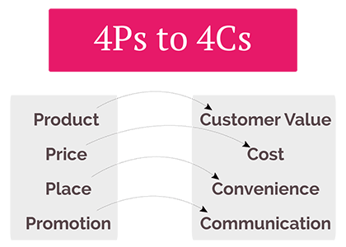

The 4Cs marketing model was developed by Robert F. Lauterborn in 1990. It is a modification of the 4Ps model, and rather an extension of it.

The Marketing Communication Mix

- Advertising
- Direct Marketing
- Public Relations
- Sales Promotion
- Personal Selling

Online – Internet

- Search Engines
Pay per click
Natural (organic) listings
- Social Networks
- Banner ads
- Affiliate sites / links
- E mail

Marketing Mix 7Ps

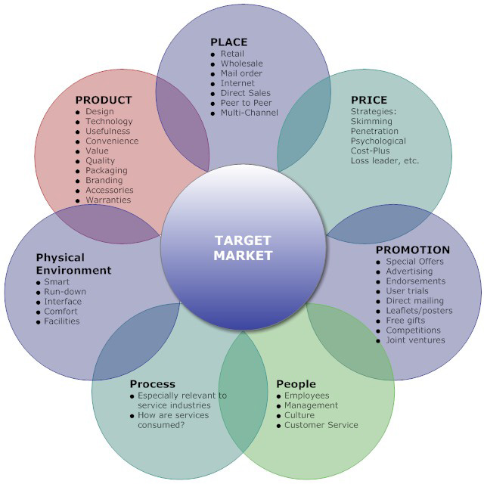

Advertising

‘The advertising budget of your organization can be an investment producing profits or an expense producing nothing’ - Drayton Bird.

DRIP Model: Differentiates, Reminds, Informs, Persuades.
Good Advertising would be clever, consistent, repetitive, graphic and conveys the message. Message ought to be balanced – emotional, rational and likeability.

Message balance includes:

- High involvement – rational
- Low involvement – emotional / image based
- Coordination and consistency

References

Kotler, Philip, Armstrong, Gary; Principles of Marketing, 17th edition, Publisher: Hoboken: Pearson Higher Education, 2018 . . . (ie 2017)
http://www.marketingpower.com
mywebwriters.com
Professional Academy
The American Marketing Association
The Marketing Mix

Name: Joy Lillian Modupe Atunrose
Student ID: 1708230
Module: Marketing Fundamentals
Module code: SBUS4109

