Student name:
Agnieszka Janina Wilkosz

Student ID number: 2115098

Programme: BA (Hons) Management and Leadership – Skills for the Workplace

Module: Emergent Leadership Skills in the Workplace

Module code: BMSW6101

Lecturer: Rebecca Stewart

Assignment Title: Portfolio

Table of Contents
Introduction- Part 1 2
Critical Explanation of Theory X, Y & Z Leadership. 5
Situational Leadership and Organizational Example. 11
Conclusion- Part 1 15
Recommendations 15
References- Part 1 16
Introduction- part 2 19
Experience (What?) 20
Reflection (So what?) 22
Action (Now what?) 24
Conclusion- Part 2 25
References- Part 2 26

Introduction- Part 1

Leadership is directing, supervising, and influencing others to perform tasks following planned instructions. It depends on the leadership whether the goals will be achieved (Persada, 2023). In the 21st century, leadership is one of the most frequently discussed issues in business. There was significant increase in the number of articles published on leadership, from 136 in the 1970s to 258 in the 1980s, 1,105 in the 1990s and 10,062 in 2001/2002 (Bolden, 2004).

"Whereas leaders are seen as charismatic and often are admired and held in high esteem, managers frequently are thought of as the organization's taskmasters with a whip in one hand and a bullhorn for screaming out orders in the other hand" (Kotterman, 2006, p13).

Leadership is one of the oldest professions in the world, while management is a new phenomenon. Due to the emergence of large organizations, there was a need to create a system regulating work, and dealing with issues of power, and control. Manager who reduces internal chaos, ensures order and consistency of many processes in the workplace (Kotterman, 2006). Leaders and managers influence others by using specific powers, but they differ. While managers keep the workplace running smoothly, leaders test current positions and encourage new roles while looking for long-term goals. Organizations need influential leaders and managers to succeed (Algahtani, 2014), and their roles should be complementary (Wajdi, 2017).

The trait-based approach used until the late 1940s (Khan, 2017) believed that a leader should possess certain characteristics to be successful (Bolden, 2003). This approach suggested that leadership skills are innate (Khan, 2017). The problem with the trait approach is that as many traits were identified as there were studies conducted, so it showed that consistent traits could not be identified. Some features appeared frequently in research, such as charisma, intelligence, technical skills, kindness, motivation and commitment to tasks, social skills, and emotion control. In 1974, Stogdill created a list of traits and skills that is presented image below (Bolden, 2003).

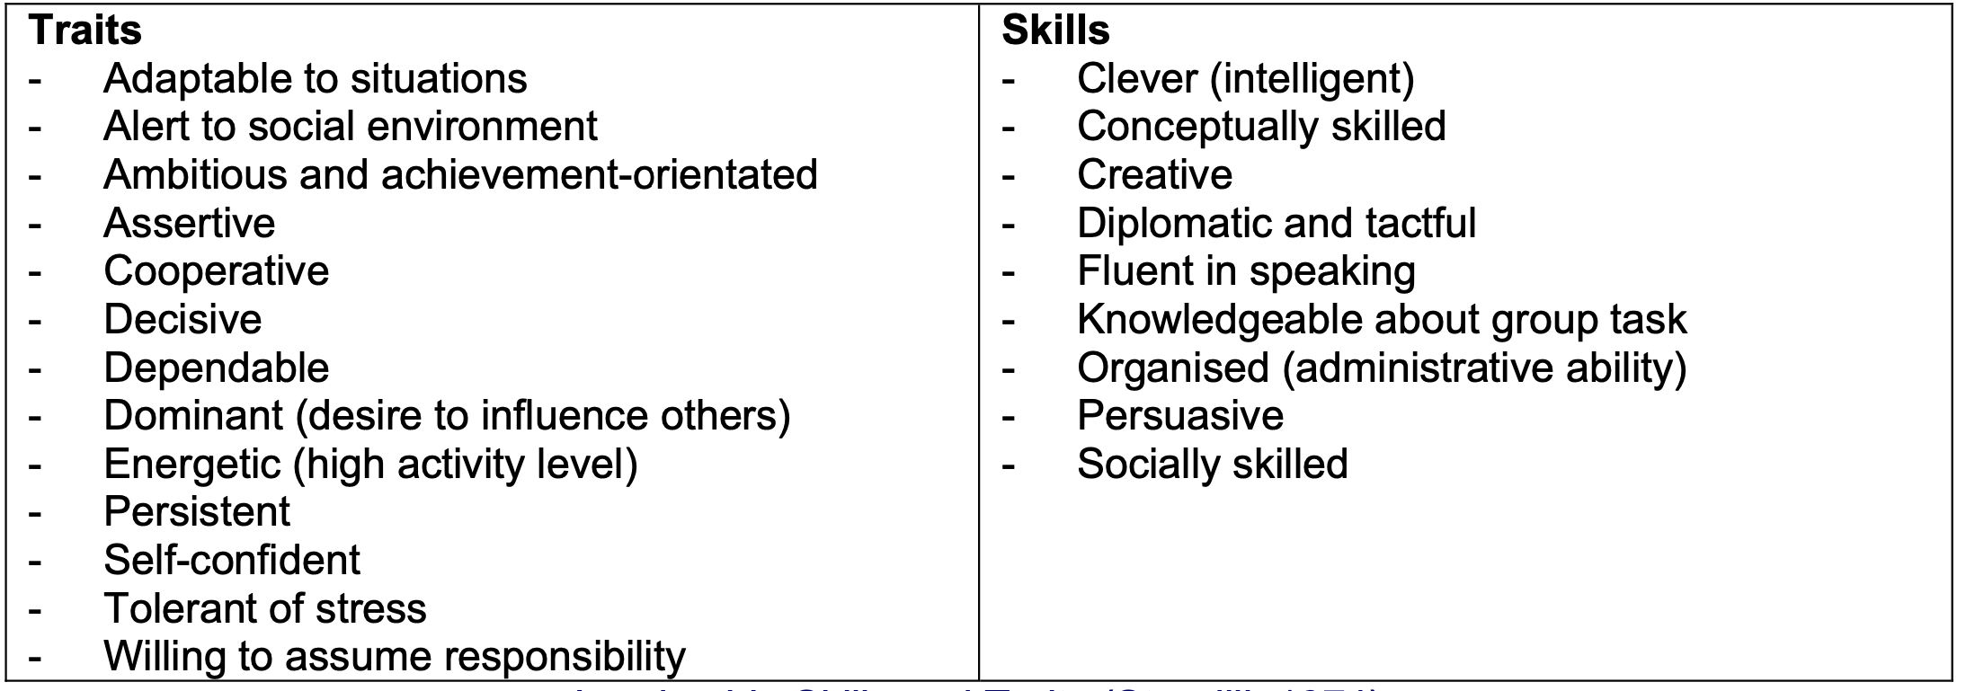
Figure 1: List of traits and skills (Source; Bolden, 2003)

Until the 1960s, a behavioural approach was common (Khan, 2017) that focused on what leaders do, not on their characteristics. Various patterns of behaviour are observed and categorized as leadership styles (Bolden, 2003).
There are many leadership models, but the three most basic are theories X, Y, and Z, which have stood the test of time (Mallette, 2005).
This report will focus on leadership. The following section will define and describe Theories X, Y, and Z. Then the above-mentioned theories will be compared, and their advantages and disadvantages will be presented. Next part will be focus on contingency leadership.

Critical Explanation of Theory X, Y & Z Leadership.

Leadership in a small business is identified as essential to ensuring the growth and survival of the company (Vidal, 2017). Small company owners use a variety of approaches and styles (Howard, 2019) and exhibit more traditional leadership styles (Arslan, 2013). Many small business leaders become more involved in organizing every aspect of the company's operations (Howard, 2019). One leadership style cannot be used in all situations, and not all leaders use the same leadership style to achieve organizational goals (Putra, 2019). There are many leadership models, but the three most basic are theories X, Y and Z, which have stood the test of time (Mallette, 2005). Theories X and Y were the most important theories to develop in the 20th century (Bonaros, 2006).
Douglas McGregor, in 1960, developed his dual management theories: Theory X and Theory Y. The theories are that leaders hold certain beliefs about their employees, influencing how they act with employees. In 1981, William Ouchi developed a related leadership theory called Theory Z. This theory is like theories X and Y. However, it places more emphasis on the attitudes and behaviours of the employees rather than the leaders. (Peterson, 2004).
According to Theory X and Theory Y, leaders make assumptions about employees. These views may be pessimistic, which McGregor called Theory X, and a more optimistic view Theory Y (Kopelman, 2012).

Theory X

Theory X is an authoritarian leadership style; the leader centralizes power and makes decisions without consulting colleagues. McGregor believed Theory X emphasized meeting lower needs and rewards focused on pay and benefits. (Hakim, 2022). The basis of the theory is that Theory X leaders assume that employees are lazy and avoid responsibility. The assumptions of Theory X assume that employees must be controlled and threatened with punishment (Arslan, 2013). Employees try to avoid responsibility and have relatively little ambition. Employees wait for the leader to tell them what tasks to perform (Peterson, 2004).
Most employees enjoy mentoring (Pavlidis, 2021). According to this theory, workers have a natural aversion to work and will avoid it if they can. The leader should control, coerce, and direct employees (Bonaros, 2006).

According to Theory X, the leader must create conditions where staff will be forced to work (Pavlidis, 2021). Employees prefer to be directed, avoid responsibility, and desire security. Employees are indifferent to the company's needs and naturally resistant to change. Workers should be rewarded when they perform their jobs appropriately and punished when they do not (Bonaros, 2006). There is a noticeable correlation between McGregor's theory X, theory Y and Abraham Maslow's hierarchy of needs theory. McGregor combined both models to demonstrate the correlation between theories (Johnson, 2018). The image below shows a correlation between Theory X, Theory Y and Maslow's hierarchy of needs.

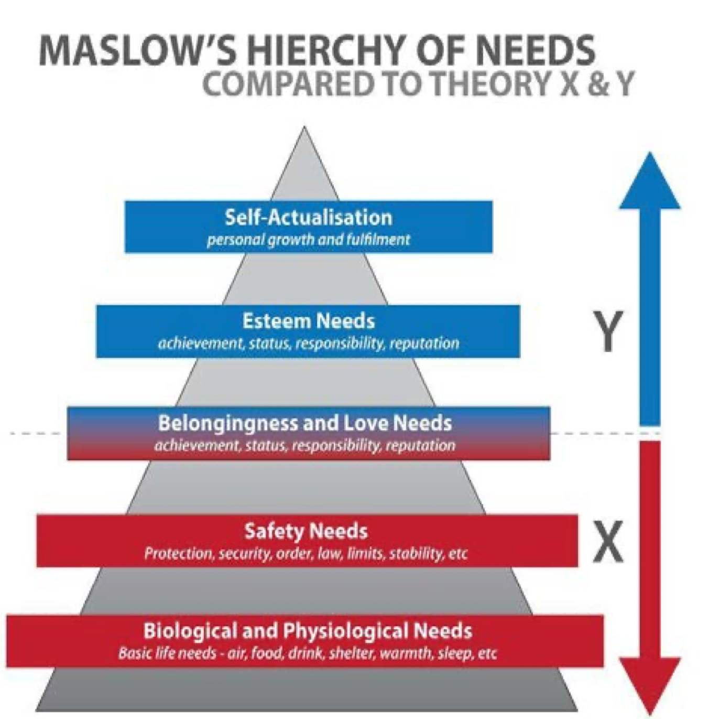
Figure 2 Maslow's hierarchy of needs compared to Theory X & Y (Source: Johnson, 2018).

Theory Y

The leader's role in Theory Y changed to a more democratic leadership style. Y leaders believe employees are committed to their work and responsible for finding answers. Leaders believe their employees accept and crave responsibility (Hakim, 2022). Theory Y states that people want to direct and control themselves. They strive to expand their spheres of influence and take on additional responsibility (Peterson, 2004). Theory Y states employees are motivated and want to be responsible for tasks. Leaders value their employees, and assume individual competencies are essential to the success of the individual and the organisation (Bonaros, 2006). McGregor viewed Theory Y leaders as those who assume that employees care about the organisation, will seek responsibility, and exercise self-control (Arslan, 2013).

Theory Z

The work on Theory Z was started by McGregor and completed by William Ouchi, who explained its principles by comparing Japanese (type J), and American (type A) organisations. The Theory is like theories X and Y but emphasises the employees' attitudes and behaviours rather than the leaders. The Theory places trust and responsibility on the employee; that is, responsibility for success or failure is shared between employees and leaders. In many Japanese companies, employees are guaranteed a job for life, which increases their loyalty to the company. Moreover, Japanese companies tend to be more interested in their employees' lives outside of work. Companies operating under Theory Z are characterised by more stable employment, job security, and managers who care about their employees (Peterson, 2004).
Theory Z promotes consistent work that ensures high productivity and job satisfaction. The most important aspect of this Theory is that for participative management to work, management must have a high degree of trust in the organisation's members (Hakim, 2022).
Each Theory demonstrates the ability of leaders and employees to increase the productivity and effectiveness of their work. Theory X assumes that employees do not like to work and are lazy, and theory Y assumes that employees are committed and creative. Theory Z, on the other hand, assumes that people have an innate motivation not only to do their job but also to be loyal to the company (Aydin, 2012).

Poor leadership practices and management skills in small businesses are the cause of many failures. Small business leaders strongly influence how employees achieve organisational goals and need a better understanding of leadership styles to demonstrate development and progress in achieving organisational goals and objectives (Valdiserri, 2010).
Theory X remains part of the basic managerial structure. Due to its authoritarian style, Theory X can be used by small businesses that promote little autonomy and require high levels of productivity. On the other hand, small companies that focus on creativity and autonomy engage in Theory Y (Zhang, 2013).

Compared to McGregor's XY theory, Z theory is not just a proposal of a management model that distinguishes the attitude of employees (Zhang, 2013).
The assumptions of Theories Y and Z about people being productive and their leaders being people-oriented are different from those in Theory X. According to Theory X, rewards and punishments are the only means of motivation. In contrast, Theory Y takes the opposite view, claiming that people derive satisfaction from their work (Aydin, 2012).

In Theory Y and Z, leaders are perceived as coaches- they help employees increase productivity. Theories Y and Z are group-oriented, but Theory X is more individual-oriented (Aydin, 2012). Theory Z has a more participatory style than Theory Y. Theory Z includes collective decision-making, long-term employment, job security, job rotation, general understanding of the company's operations, slow promotion, training and continuous improvement, and holistic care for the employee and his family (Zhang, 2013). In contrast, Theory X leaders are more authoritarian and task-oriented, while Theory Y leaders are more participative. Theory X and Theory Y have a much more formal leadership style than Theory Z. In Theory Z, leaders trust their employees, and Theory Z leaders have a people-centric approach (Aydin, 2012).

When it comes to power, in Theory X, the leader retains most of the power. In Theory Y, the leader considers employees' opinions but retains authority when making decisions. In Theory Z, the leader's ability to exercise power and authority results from the employee's complete trust and the leader allows the employee to take an active part in decision-making (Aydin, 2012).

People are different; some are adaptable, others are innovative, some need control, and others are motivated by trust and the opportunity to do more than just the primary task at work. Some want to develop, and others come to work to pay their bills. Therefore, leadership is becoming increasingly complex (Bobic, 2003.) Also, with age, people change their attitudes and requirements. Men and women differ in attitudes and behaviours, genetic characteristics, and socialisation. Women tend to take in more information and consume it quickly, while men focus on a piece of information to achieve a goal (Kingsumrit, 2012). Men have more power than women. Women still face discrimination in the workplace, are excluded from the most influential leadership positions, progress slower in their careers, and have less authority in the workplace (Kingsumrit, 2012).

Theory X's disadvantage is its negative and one-sided assumptions about human nature; it can produce short-term results. In such a company, there is repression and regimes of employees. Leaders ignore employee engagement. In Theory Y, the advantage is that leaders maintain an optimistic view of employees, and employees put in effort painlessly and willingly. Theory Y refers to a democratic and humanistic approach. The main benefit of using Theory Y is increased work efficiency and employee involvement in the organisation's functioning. The main disadvantage of this Theory is that employees may abuse their freedom, and it may not be possible for the leader to make decisions constantly. The main advantage of using Theory Z is that employees usually stay in the organisation longer/permanently and can participate in decision-making. It also develops a strong bond of unity with the organisation and increases loyalty to the organisation. The main disadvantage is that unproductive workers find a comfortable shelter. The opportunity for potential migrant workers from outside is minimised. Employees may place less importance on work than on home and family. Making consensus-based decisions will lead to delays (Aithal, 2016).
The advantage of Theory X and Y is that they have different approaches to dealing with different types of people. Theory X can be used for new employees because they often follow the plan set by the leader. On the other hand, an already experienced employee may naturally fit into the Theory Y category because worker already understands the expectations and consequences of the assigned task. The disadvantage is that the leader may have both Theory X and Theory Y employees in the team. Theory X may be used by organisations that promote little autonomy and require high productivity. An example of a company operating under the influence of Theory Y is Google. Even though it is a massive company, it shows that it uses a classic approach to leadership. This Theory works excellently in a company that operates worldwide. However, it can also be very applicable in a small business as both need to sustain growth and deal with interpersonal issues with staff. Google brings together employees from different age groups, cultural backgrounds, physical abilities and disabilities, race, religion, gender, and sexual orientation. Google uses Theory Y because of its optimistic leadership style and creative and participative culture (Johnson, 2018).
One of the benefits of incorporating Theory Y into Google's organisation is that by providing autonomy, employees can be more creative without the constraints of traditional work hours or location. Employees can work when they feel most productive, even working from home. Employees can make better decisions because they are not under constant supervision by their supervisor. Unfortunately, this Theory also has drawbacks that Google struggled with, which included failure to complete tasks on the original deadlines. It, therefore, leads to a loss of profits (Johnson, 2018).
Another example is Amazon, which uses both Theory X and Y. By using Theory Y, they encourage employees to be creative, but for the same reason, employees are constantly monitored and evaluated (Theory X). Although the corporation is known for providing its employees with great rewards and incentives, employees are often punished through layoffs. Amazon's culture motivates employees to develop themselves but allows for little flexibility. Unfortunately, even though employees are highly motivated to develop, the pressure to achieve their goals can be considered toxic.
Amazon and Google are huge companies, and it is only possible to understand some employees. However, due to its flat structure, a small company can understand the personal work style of each employee and what motivates. The leader can adapt the management style to the employee's needs. In this way, leaders create a work environment that is consistent with the organisation's culture and meets the organisation's overall goals (Johnson, 2018).

Situational Leadership and Organizational Example.

"The complexities of today pose challenges to leadership; organizations of all sizes are composed of people with sufficient autonomy to create their greatness, and leaders must ensure its sustainability by aligning the interests of all members with the vision, mission and values of such organizations" (Vidal, 2017, p.1).

Leadership skills and styles are responsible for the success of small businesses, which are more susceptible to market fluctuations and competition (Arslan, 2013).
Contingency theories of leadership analyze how situational factors change a particular leader's behavioural effectiveness and leadership style. It is assumed that neither the leader's characteristics, behaviour, or style automatically shape the leader. The key is the appropriateness of leadership styles to the situations leaders encounter. Among the various contingency theories, one of the most important was formulated (da Cruz, 2011) by Fiedler in the mid-1960s - the theory of emergency leadership (Fiedler, 2015)
Contingency theory focuses on the leader and the situations in which he or she leads. This theory emphasized the importance of adapting the leadership style to the situation (da Cruz, 2011). The decisions made by leaders are flexible and allow for adaptation to current situations. Therefore, leadership characteristics depend on the situation (problem), and no universal leadership style exists. Leaders strive to understand the emerging situation and adapt the most appropriate leadership style (Childs, 2022).
The LPC scale is used to measure leadership style.

"To classify leadership styles, Fiedler developed the Least Preferred Contributor (LPC) scale. This measure is represented in the form of a questionnaire in which respondents are asked to describe the colleague they least like working with, for example, given a list of 16 adjectives related to bipolar disorder on a scale of 1 to 8 (unfriendly - friendly, uncooperative - cooperative; introvert-extrovert). The responses on this scale are summed, and means are calculated to represent the LPC" (da Cruz, 2011, p.12).

If LPC is high, the style is oriented towards interpersonal relationships- these leaders are motivated by establishing closer relationships with employees. If the level of LPC is low, the co-worker is described in a relatively negative way, and the style is task-oriented (da Cruz, 2011).
This theory suggests that different situations require different leadership styles. Leaders should adapt their style to the demands of the situation to achieve maximum effectiveness. To sum up, Fiedler's contingency theory emphasises the importance of adapting the leadership style to a specific situation, which can increase the leader's effectiveness in managing people and tasks (da Cruz, 2011).

Small businesses are particularly vulnerable to external disruptions due to their limited resources and potential lack of disaster planning and preparedness. The company's operations are influenced by:
- internal factors - these are factors existing inside the organisation,
- external factors occurring outside the organisation (natural disasters, changes in consumer trends, political-economic changes, pandemics), both of which are part of the decision-making process for contingent leaders (Childs, 2022).

Due to the increasing uncertainty the world is facing due to climate change, political conflicts, wars and cyberterrorism, the role of leaders is significant to ensure the functioning of companies of all sizes. Leaders must be able to transition from one leadership style to another or demonstrate multiple leadership styles simultaneously to meet the organisation's and its employees' changing needs (Balasubramanian, 2022). There are many tools for analysing the external environment such as PESTEL means political, economic, social, technological, environmental, and legal factors (Cadle, 2010).
One of the factors affecting companies was COVID. In the early stages of the pandemic crisis, many organisational leaders crumbled under the pressure, while others managed to navigate the crisis successfully. It demonstrated the importance of having strong leadership during a crisis, which enabled organisations to cope with the crisis and even capitalise on the opportunities it presented. The Covid-19 was the ultimate test for organisational leaders around the world (Ratten, 2023).

The next one is The Ukrainian-Russian conflict, one of the most significant contemporary business problems. It has become a political and social issue affecting business practices worldwide. The war impacted economies in the region and worldwide, mainly through gas prices and inflation. As countries are still recovering from the effects of the COVID-19 pandemic, the conflict is impacting supply chains and energy prices (Ratten, 2023).

Technology factors - emerging technologies such as automation and robotics, big data analytics, the Internet, cloud computing, mobile technologies, and AI- can support shifting towards more connected, decentralised systems in small businesses (Bessière, 2019). It is of great importance in the case of a technology-based industry. However, technology has become an essential part of every business today, where most operations are carried out through the Internet and technology. Therefore, the technical environment is crucial. Technology has become an essential part of consumers' lives and is a value driver for organisations (Perera, 2017). With technological development, there are many cyber-attacks that the leader must deal with to reassure both employees and customers that everything is under control.

For next part will be use example on image bellow.


Figure 3 Real life examples From UK organisations for assessment

Small companies have many advantages compared to large ones, such as their competitive structure, higher efficiency, the ability to catch up with new requirements and technologies much more accessible, more excellent resistance to economic crisis, and decisions are easier to make due to the flat structure.
Therefore, small business owners will potentially have access to higher levels of productivity and cognitive abilities. Additionally, small businesses can access labour-intensive business opportunities and markets that were only the privilege of large companies. (de Souza, 2022).
The introduction of TOBi, an artificial intelligence-based system Vodafone uses to assess callers' needs and route calls to appropriate departments, can significantly impact day-to-day leadership in the customer service department (Vodacom, 2023).
Artificial intelligence can perform simple tasks, allowing employees to focus on more complex tasks. Leaders must adapt their people management strategies to leverage artificial intelligence's capabilities effectively. It may include retraining employees to perform more complex tasks. AI systems generate vast amounts of data on customer interactions. Leaders can use this data to make informed decisions, identify patterns, anticipate customer needs, and improve service quality. Leaders must develop data literacy within their teams to derive valuable insights from AI-generated data. AI-powered systems like TOBi can improve customer experience by providing quick and accurate responses. The introduction of artificial intelligence in Vodafone's customer service department can transform everyday leadership practices. Leaders will need to adapt to a more data-driven and technology-integrated environment, supporting a culture of continuous learning and the ethical use of artificial intelligence to deliver better customer experiences. Leaders must also prepare for crises related to the use of AI. Artificial intelligence is still being learned and may make mistakes impacting employees and the company. Due to the operation of a small enterprise, leaders must be prepared for a situation in which, for example, there will be no Internet for several hours, and artificial intelligence will stop working. They must have well-trained employees who can replace artificial intelligence to some extent or have a solution prepared, such as today's employees working from home. Leaders must trust artificial intelligence greatly, but they must remember that people and technology can make mistakes (de Souza, 2022).

Conclusion- Part 1

The study of leadership theories, with particular emphasis on their application to small businesses, highlights the critical role of leadership in dealing with the challenges of the 21st century. Traditional Theory X, Y, and Z models and situational leadership approaches offer valuable insights for small business leaders looking to optimize their strategies.

In the context of small enterprises, where resources and adaptability are most important, the theory of situational leadership becomes particularly important. The ability of leaders to adapt their approach to specific situations is essential to success. The impact of global events such as the COVID-19 pandemic underscores the importance of leaders in steering small businesses through unforeseen circumstances.

Artificial intelligence integration, exemplified by Vodafone's AI-powered customer service, creates opportunities and challenges for small business leaders. Adapting to technological advances while maintaining a people-centric approach is crucial for sustainable growth.

Recommendations

In my opinion, continuing education is crucial for small business leaders, especially when it comes to staying up to date with technology trends. The priority is employee involvement and maintaining a high level of adaptability. Crisis preparedness, shared decision-making, and responsible technology integration should be forefront of leadership strategies.
I believe leaders who combine traditional and contemporary theories, manage crises, and use technology will ensure lasting success for small businesses in an ever-changing business landscape. There is no one leadership style for all situations in a company. Since small companies are particularly susceptible to market fluctuations, they should have solid leadership that can adapt to any situation.

References- Part 1

- Aithal, P.S. and Kumar, P.M. (2016) Organizational behavior in 21st century–'Theory A' for managing people for performance. IOSR Journal of Business and Management (IOSR-JBM), 18(7), pp.126-134.)
- Algahtani, A. (2014) Are leadership and management different? A review. Journal of management policies and practices, 2(3), pp.71-82.
- Arslan, A. and Staub, S. (2013) Theory X and theory Y type leadership behavior and its impact on organizational performance: Small business owners in the Şishane Lighting and Chandelier District. Procedia-social and behavioral sciences, 75, pp.102-111.
- Aydin, O.T. (2012) ‘The impact of theory x, theory y and theory z on research performance: An empirical study from a Turkish university’. International Journal of Advances in Management and Economics, 1(5), pp.24-30.
- Balasubramanian, S. and Fernandes, C., 2022. Confirmation of a crisis leadership model and its effectiveness: lessons from the COVID-19 pandemic. Cogent Business & Management, 9(1), p.2022824.
- Bessière, D. et al. (2019) ‘A vision of re-distributed manufacturing for the UK’s consumer goods industry’, Production planning & control, 30(7), pp. 555–567. Available at: https://doi.org/10.1080/09537287.2018.1540053.
- Bobic, M.P. and Davis, W.E. (2003) ‘A kind word for Theory X: Or why so many newfangled management techniques quickly fail’. Journal of Public Administration Research and Theory, 13(3), pp.239-264.
- Bolden, R. (2004) What is leadership?. Centre for Leadership Studies, University of Exeter.
- Bolden, R., Gosling, J., Marturano, A. and Dennison, P. (2003) A review of leadership theory and competency frameworks.
- Bonaros, D.J. (2006) ‘A study of transformational leadership and student achievement in inner-city elementary schools’. Florida Atlantic University.
- Cadle, J., Paul, D. and Turner, P. (2010) ‘Business analysis techniques’. British Informatics Society Limited
- Childs, M., Turner, T., Sneed, C. and Berry, A. (2022) ‘A contingency theory approach to understanding small retail business continuity during Covid‐19’. Family and Consumer Sciences Research Journal, 50(3), pp.216-230.
- da Cruz, M.R.P., Nunes, A.J.S. and Pinheiro, P.G. (2011) ‘Fiedler's Contingency Theory: Practical Application of the Least Preferred Coworker (LPC) Scale’. IUP Journal of Organizational Behavior, 10(4).
- de Souza Meirelles, F. (2022) Factors Influencing the Adoption Intention of Artificial Intelligence in Small Businesses.
- Fiedler, F.R.E.D. (2015) ‘Contingency theory of leadership. Organizational behavior 1: essential theories of motivation and leadership’, 232, pp.1-2015.
- Hakim, R.F., Nurdin, D. and Sudarsyah, A. (2022) ‘Analysis of Leadership, Management, and Supervision Models Using XY Theory’. In Proceeding of International Conference on Research of Educational Administration and Management (ICREAM) (Vol. 6, No. 1, pp. 54-57).
- Howard, T.L., Ulferts, G.W. and Hannon, J. (2019) ‘Leadership styles of small business owners: Linking theory to application’. Journal of Leadership, Accountability and Ethics, 16(2), pp.47-55.
- Hughes, R.L., Ginnett, R.C. and Curphy, G.J. (1998) ‘Contingency theories of leadership. Leading organizations: Perspectives for a new era’, pp.141-157.
- Johnson, J., Irizarry, M., Nguyen, N. and Maloney, P. (2018) Part 1: Foundational theories of human motivation.
- Khan, Z.A., Bhat, S.J. and Hussanie, I. (2017) ‘Understanding leadership theories-A review for researchers. Asian Journal of Research in Social Sciences and Humanities’, 7(5), pp.249-264.
- Kingsumrit, N. (2012) Preference among managers of different demographics and levels of management for mcgregor's theory x and theory y or the use of negative vs positive motivations: a study of 25 selected four-star hotels in Bnagkok.
- Kopelman, R.E., Prottas, D.J. and Falk, D.W. (2012) ‘Further development of a measure of Theory X and Y managerial assumptions’. Journal of Managerial Issues, pp.450-470.
- Kotterman, J. (2006) ‘Leadership versus management: what's the difference?’ The Journal for Quality and Participation, 29(2), p.13.
- Maccoby, M. (2000) ‘The human side: Understanding the difference between management and leadership. Research-Technology Management’, 43(1), pp.57-59.
- Mallette, L.A. (2005) ‘Theory Pi-engineering leadership not your theory X, Y or Z leaders’. In 2005 IEEE Aerospace Conference (pp. 4389-4397). IEEE.
- Pavlidis, N. (2021) ‘Theoretical Leadership Models. International Journal of Finance, Insurance and Risk Management’, 11(4), pp.24-36.
- Perera, R. (2017) The PESTLE analysis. Nerdynaut.
- Persada, I.N. and Nabella, S.D. (2023) ‘The influence of leadership, motivation and incitive on the performance of personal of the operations section of Polda Kepri’. International Journal of Accounting, Management, Economics and Social Sciences (IJAMESC), 1(4), pp.403-416.
- Peterson, A.M. and Ehlert, D.A. (2004) Organizational structures Managing Pharmacy Practice: Principles, Strategies, and Systems, p.25.
- Putra, E.D. and Cho, S. (2019) ‘Characteristics of small business leadership from employees’ perspective’: A qualitative study. International Journal of Hospitality Management, 78, pp.36-46
- Ratten, V. (2023) ‘The Ukraine/Russia conflict: Geopolitical and international business strategies’. Thunderbird International Business Review, 65(2), pp.265-271.
- Valdiserri, G.A. and Wilson, J.L. (2010) ‘The study of leadership in small business organizations: Impact on profitability and organizational success’. The Entrepreneurial Executive, 15, p.47.
- Vidal, G.G., Campdesuñer, R.P., Rodríguez, A.S. and Vivar, R.M. (2017) ‘Contingency theory to study leadership styles of small businesses owner-managers at Santo Domingo, Ecuador’. International Journal of Engineering Business Management, 9, p.1847979017743172.
- Vodacom. (2023) TOBi - The Vodacom ChatBot | Vodacom. [online] Available at: https://www.vodacom.co.za/vodacom/shopping/v/tobi#:~:text=TOBi%20is%20a%20digital%20assistant [Accessed 18 Nov. 2023].
- Wajdi, B.N. (2017) ‘The differences between management and leadership’. Sinergi: Jurnal Ilmiah Ilmu Manajemen, 7(1).

Introduction- part 2

Taking the Emergent Leadership Skills module, BMSW 6101, provides a comprehensive exploration of the essential traits and styles achievable for effective leadership in today's workplace. Throughout the module, I deepened my understanding of leadership by recognizing the nuances between leadership and management. I gained insight into the evolution of leadership and its different perspectives. An important area of research is the impact of culture on a leader, as well as six key characteristics. An additional one-session module covered leadership theories X, Y and Z. Subsequent sessions provided in-depth insight into leadership styles related to tasks and relationships, explaining their practical applications. The development of effective leadership skills and the correlation between strong interpersonal skills and effective leadership were emphasized. The course also covers leadership in contemporary organizations and various other leadership theories. Final sessions focused on ethics in leadership, ethical decision-making, and acting as a leader. In addition to theoretical knowledge, the classes included classes, tests and discussions that allowed for practical testing of the acquired knowledge and exchange of experiences related to leadership. The most interesting topic for me while writing the first part of the report was situational leadership. The purpose of this reflection report is to synthesize my educational experience, delve deeper into my leadership style, and outline potential areas of growth and improvement. The report will be based on the 'What' series of reflections created by John Driscoll. In the report, I will use three questions (Gladd, 2020). The image below shows how the reflection will be constructed.

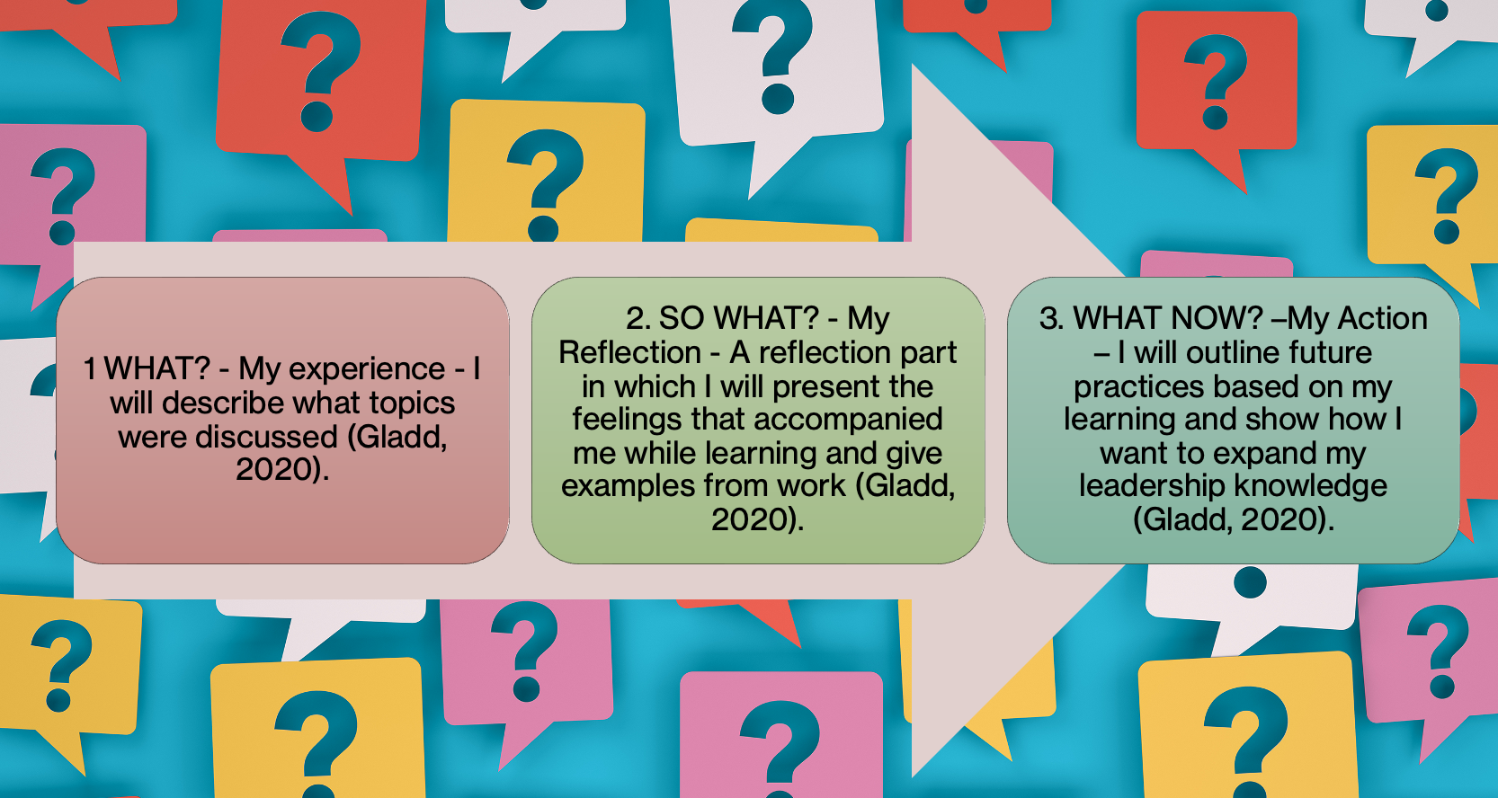
Figure 4 the 'What' series of reflections use in this report.

Experience (What?)

During the classes, I explored the intricacies of effective leadership, gaining a comprehensive understanding of its basic principles and theories. The initial lessons explained the distinction between leadership and management, showing these roles as distinct but complementary organisational functions. While managers ensure the smooth execution of daily tasks, leaders guide current positions and inspire new roles (Algahtani, 2014). This understanding emphasised the essential coexistence of leadership and management for organisational success (Wajdi, 2017).

Moreover, the class provided an in-depth exploration of theories X, Y and Z in leadership, providing an understanding of leadership dynamics. Based on my previous exposure to theories X and Y in the context of organisational culture and its use in employee motivation, I delved deeper into these theories, recognising how leaders' underlying beliefs about their team members significantly shape their approach to leadership. While Douglas McGregor's Theories X and Y emphasised beliefs about employees, William Ouchi's Theory Z emphasised the critical role of employee attitudes and behaviours, positioning it as an extension of earlier theories (Peterson, 2004).

The module also delved into various aspects of leadership, including the innate nature of leadership, identifying leadership traits, and the debate on whether effective leadership is an innate trait or a learned skill. Additionally, a comprehensive exploration of Transformation Theory offered a situational perspective, emphasising the importance of identifying contextual variables to determine the most appropriate and effective leadership style in specific circumstances (Bolden, 2003). Closely examining ethics in leadership has further enriched my understanding by highlighting ethical considerations integral to effective leadership decision-making processes.
The sessions provided a comprehensive overview of leadership traits and styles and delved into the practical application of leadership theories and skills in real-world scenarios. I actively participated in discussions, exercises, and assessments, which facilitated a holistic understanding of the complex dynamics of leadership in the modern workplace.

The most exciting topic was the Contingency theories of leadership. They showed me that there is no single leadership style in a crisis and that how a leader treats his or her employees will depend on the situation the company finds itself in. No matter the organisation's size, each is influenced by internal and external factors that make leadership different. It shows that being a leader means constant learning and improvement. Technological disruption, crises, pandemics, cyber wars, and cyber-attacks continue to create new, unknown situations that leaders must sort out (Balasubramanian, 2022).

Reflection (So what?)

As I delved into the nuances of leadership, I became intrigued by the complex balance between leadership and management. Initially, I did not see many differences between managers and leaders. Recognising that managers drive operational efficiency and leaders inspire innovation and long-term vision has helped me appreciate the complementary nature of these roles. This understanding profoundly impacted my perspective on organisational dynamics, emphasising the need to foster collaboration between leadership and management teams for growth.

Exploring Theories X, Y, and Z gave me valuable insight into the core beliefs shaping my leadership approach. Understanding how leaders' perceptions of employees influence their leadership styles led me to evaluate my beliefs and assumptions critically. This awareness has highlighted the importance of adopting a more empathetic approach to leadership that considers individual team members' diverse attitudes and behaviours. People are different, and their motivation for their work is different. Knowing the people you work with is good because it allows you to adjust the appropriate leadership style. Of course, each company will require a slightly different approach, but by adapting the style, it will be easier for the leader to achieve the best results for his team. While writing part 1, I learned from one of the articles I read that a company such as Amazon uses the X and Y leadership styles, and Google uses Theory Y. Even though such large, dynamically developing companies use classic theories that have stood the test of time. it was interesting and surprising at the same time.
Also, during the debate during classes, we wondered whether a leader must be born or can be learned. It was an intriguing conversation because it showed different opinions on this topic. In my opinion, a leader should have charisma, but a leader can learn many things.

I was very impressed by the comprehensive exploration of ethics in leadership. Reflecting on past experiences, I saw instances where ethical considerations were crucial in shaping decision-making processes. This realisation reinforced the importance of cultivating a solid ethical framework as part of my future leadership practices, ensuring that ethical considerations remain at the forefront of decision-making, even in complex and challenging situations.

Exploring leadership theory in the Emergent Leadership Skills module was highly informative. These theories emphasised the dynamic nature of leadership, emphasising that one leadership style is only applied sometimes, especially in crises. The realisation that effective leadership depends on a company's specific circumstances challenged my preconceived notions about the rigidity of leadership.
Organisations of all sizes are uniquely shaped by many internal and external elements, which has changed my perspective on leadership. It made me realise that leadership requires constant learning and improvement. The understanding that every crisis requires a tailored leadership response has highlighted the importance of flexibility and adaptability in leadership positions. In a rapidly changing world full of technological crises, pandemics, and cyber-attacks, the importance of contingency theory is becoming increasingly obvious.
This newfound awareness leads me to view leadership not as a set of rules but as a dynamic skill set that requires constant evolution. Recognising that each organisation requires a tailored leadership strategy encourages learning. The emergence of new, unfamiliar situations highlights the need for leaders to be agile learners who can cope with unfamiliar situations. The saying that people learn all their lives is true.

Thanks to the classes, I better understand leadership styles, and Theory X dominated my previous work.
It was a warehouse where the target came first. There was constant monitoring, penalties for missing a target and rewards for achieving it. However, there was no room for creativity, development, or responsibility, so the job was boring for me after two years. I was not developing, and this place could not surprise me with anything other than increasing my target. There were no challenges. After this experience, I know companies managed by category X must be in the right place. In my current job, the leader uses more theory Y, where we organise our working day ourselves, and no one stands behind my back telling me what to do and when. I know my responsibilities ideally and have greater responsibility. However, sometimes my leader has to turn on the situational management mode, and then the day at work looks different, but it still allows for independence. Comparing these two styles, I feel much better as a Theory Y employee because it gives me more opportunities and job satisfaction. However, if I were the leader of this company, I would use Theory X in some situations to have more control and be sure that everything was done correctly.

Action (Now what?)

I can use the knowledge acquired during classes in the future. Although I am not currently working in a leadership position, I do not have the opportunity to practically use the knowledge I have acquired in the workplace. However, expanding my knowledge in this area allowed me to understand better the decisions my leader made in my current workplace. Understanding these principles, I can better understand why I make certain decisions. I also notice what mistakes are being made, which is sometimes frustrating. It shows me that clearly defined rules that apply to all employees and are consistently followed would facilitate cooperation and improve the atmosphere. I can also use the knowledge I acquire during my studies, for example, during group projects, by actively applying leadership concepts and skills. Trying to adapt the approach depends on the project's nature and cooperation with different people.
Also, Reflection on Ethics in the Student Environment. By focusing on ethical aspects in relationships with colleagues, for example, in the context of honesty in group work, respecting diversity of views, and participating in Online Discussions and Courses. By actively participating in online discussions on educational platforms, sharing your perspective and acquired knowledge. I could take online leadership courses, use the LinkedIn platform, and read scientific articles about leadership on Google Scholar. They will also be able to expand their knowledge by talking to people currently in leadership roles in the workplace to get their views on leadership situations. I will also be able to use this knowledge when my leader goes on vacation, and I will be able to perform his duties during that time. Thanks to the acquired theoretical knowledge and numerous activities during classes and discussions on this topic, I can take over his duties for this time so that the acquired knowledge can be used in practice.
One of the topics in which I would like to expand my knowledge is leadership in a Multigenerational Context (Dealing with Millennials and Generation Z) because cooperation in teams composed of different generations is becoming a standard. I want to explore how to effectively manage a team of Millennials and Generation Z to maintain balance and understanding between generations.
I can expand my knowledge on this topic by using online resources, such as courses on the LinkedIn Learning platform, focusing on multigenerational management. Contingency theories of leadership were also an exciting topic because all companies are currently influenced by various factors that a good leader must deal with. Just like in the case of the COVID-19 pandemic, no one was ready for what happened and how leaders had to change their leadership strategies to lead effectively. There are many such situations in the 21st century, and it should be remembered that one leadership style is only suitable for some situations.

Conclusion- Part 2

The Emergent Leadership Skills module, BMSW 6101, played a key role in shaping my understanding of effective leadership. The complementarity of leadership roles was highlighted, delving into core beliefs through theories X, Y, and Z. Exploring the nuances of leadership, ethics, and practical applications in real-world scenarios provided understanding of the issues.

Reflection (so what?):

The module provided a diverse perspective on leadership, recognizing the balance between leadership and management. Insights from Theories X, Y, and Z highlighted the importance of empathy and adaptability in leadership. Ethics research has shown ethical considerations in decision-making processes.

Action (what now?):

Although I am not currently in a leadership role, I can apply this knowledge to better understand the decisions I make in my current workplace. Active participation in online courses and discussions, contact with current leaders, and further reading will help in continuous learning. Exploring the future includes multi-generational leadership and a focus on contingency theories to adapt to changing challenges.

Overall, the module not only enriched theoretical knowledge, but also instilled a mindset based on continuous learning and adaptability, essential for future leadership roles.

References- Part 2

- Algahtani, A. (2014) ‘Are leadership and management different?’ A review. Journal of management policies and practices, 2(3), pp.71-82.
- Balasubramanian, S. and Fernandes, C. (2022) ‘Confirmation of a crisis leadership model and its effectiveness: lessons from the COVID-19 pandemic’. Cogent Business & Management, 9(1), p.2022824.
- Gladd, J., (2020) John Driscoll’s “What?” Cycle of Reflection. Write What Matters.
- Peterson, A.M. and Ehlert, D.A. (2004) ‘Organizational structures Managing Pharmacy Practice: Principles, Strategies, and Systems’, p.25.
- Wajdi, B.N. (2017) ‘The differences between management and leadership’. Sinergi: Jurnal Ilmiah Ilmu Manajemen, 7(1).

