Integrated Project (ACBA 6016)

New Centre of Excellence for Construction Training
Individual Submission

By
Anita Jade Davis
1908094

Individual Contributions Section – Photographic Evidence
08/10/2025


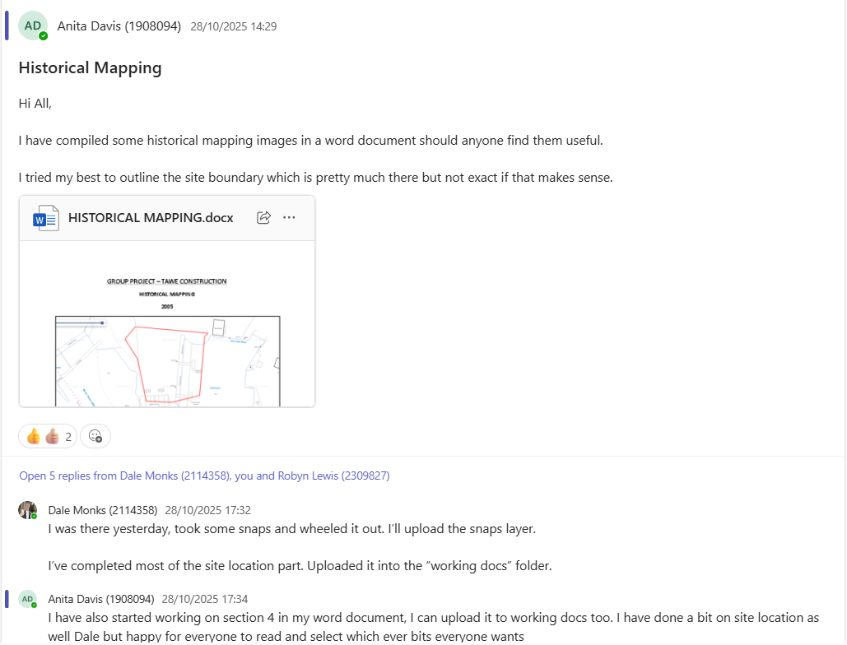
28/10/2025


05/12/2025


09/12/2025


04/02/2026
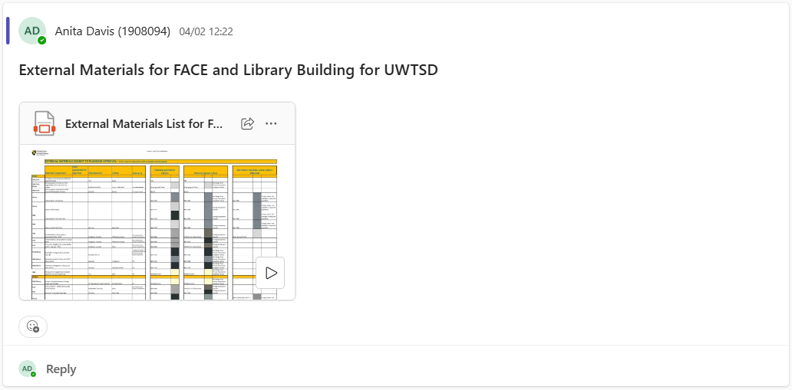

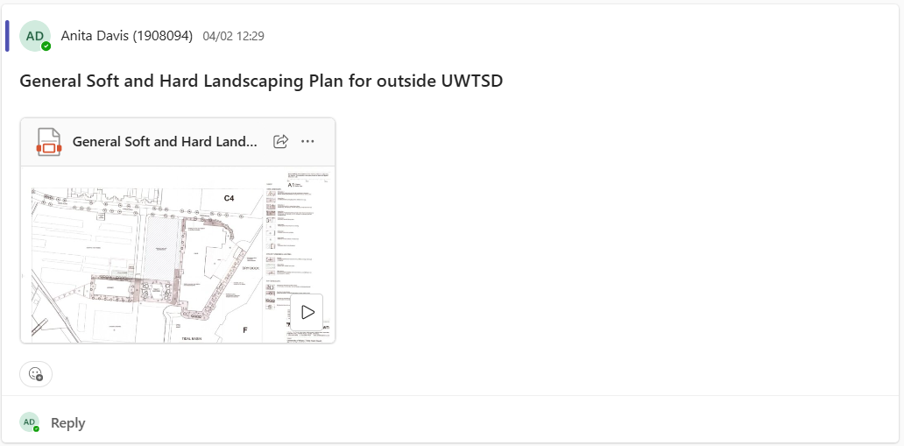





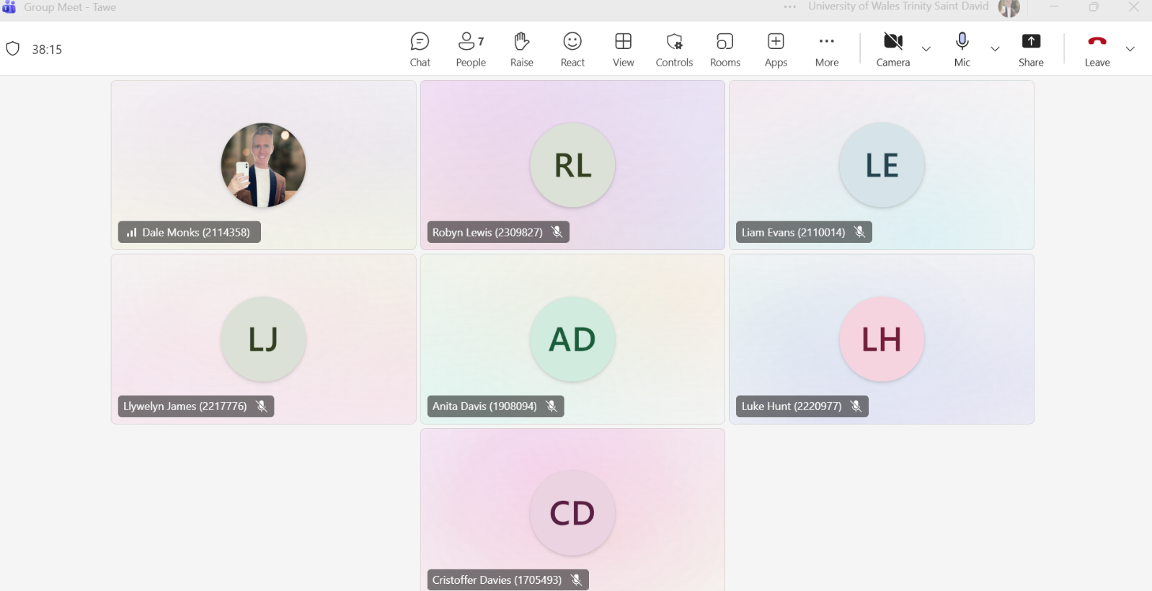
06/05/2026

11/05/2026




Feasibility Report – Individual Section Assignments

4.6 Site Geology, Substrata and Hydrology – Dale Monks & Anita Davis

Borehole log ‘SS69SE300’, and others surrounding the site show depths drilled to up to 30m, with suitable strata for building from 18m onwards of grey mudstone mixed with rock Appendix A Figure 7 (British Geology Survey, 2025).

The site is located within proximity to several significant water bodies, namely the River Tawe, a Tidal Basin and the Prince of Wales Dock. The River Tawe flows immediately south into Swansea Bay, and the Tidal Basin is believed to be connected to the Prince of Wales Dock based off Ordnance Surveys and BGS Mapping. The Prince of Wales Dock is part of Swansea Docks System which also includes King’s Dock and Queen’s Dock, which also discharges to Swansea Bay.

4.10 Archaeological Status – Dale Monks & Anita Davis

The proposed development site lies within a historically significant area characterised by extensive industrial and maritime activity, including former docklands, associated infrastructure, and a historic rail network. Although large-scale demolition during the 20th century has removed most above-ground structures, there remains a high likelihood of encountering sub-surface archaeological remains associated with post-medieval industrial and maritime use during excavation and groundworks.

In addition, there is potential for further archaeological features to be present beneath existing demolition and levelling deposits. The underlying geology—predominantly alluvial silts and peat—further elevates this potential. These soil conditions are recognised for their capacity to preserve both organic and inorganic archaeological materials in situ (Bowen, 2011), thereby increasing the sensitivity of the site from a heritage and conservation perspective.

4.11 SSI/SSSI/SNCI/AONB Status – Anita Davis

According to Magic Maps found on the Government website, there are no designated sites found within 500m of the site.

Figure 19 - Sensitive Designations Map (UK Government, 2025)

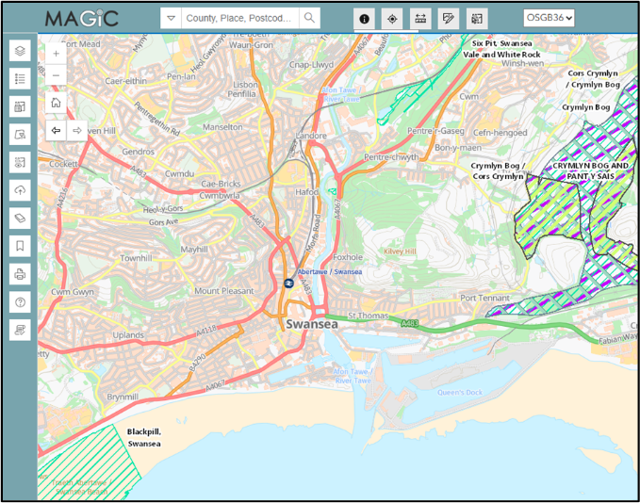

4.12 Condition Survey – Anita Davis
There are no existing structures on the site, so issues such as wet/dry rot, timber decay or any other internal building conditions do not apply to this site. The risk of asbestos is considered very low, with no evidence indicated in the borehole logs reviewed. The site is mostly open hardstanding with patches of low-level vegetation and scrub, and there are no trees or features that would be suitable for bat roosts on the site.
4.16 Ecology Report – Anita Davis
A preliminary review indicates the site has very limited ecological value. It is mostly hardstanding with some low-level scrub/vegetation, providing minimal habitat for wildlife, especially reptiles, nesting birds, and bat roosts. There is no evidence of protected species on the site. A simple Preliminary Ecological Appraisal (PEA) may be recommended at the planning stage, but no significant ecological constraints are expected.
4.17 Tree Assessment – Anita Davis
There are no trees present on the site, and therefore no need for an agricultural impact assessment. The absence of trees means there are no root protection zones, canopy constraints, or Tree Protection Orders (TPO) to be concerned about.
4.18.2 Initial Ecology Recommendations – Anita Davis
Although the initial walkover survey and aerial imagery identified the site as having minimal ecological value, it is recommended that a full Preliminary Ecological Appraisal (PEA) is undertaken by a competent ecologist prior to development. Any recommendations, mitigation measures, or further surveys identified within the report should also be undertaken.
5.6 Service Adequacy – Anita Davis
The proposed development is located within the established SA1 waterfront area, with close proximity to the UWTSD campus, and therefore benefits from existing transport links can be utilised to support the proposed development. An on-site car park is proposed to accommodate staff, students, and visitors.
Information and plans relating to utility infrastructure that indicated key services are present within or adjacent to the site, including gas, electricity, and drainage. This suggests that the site is already serviced and capable of supporting the proposed development in principle.
While the presence of these utilities reduces the need for extensive new infrastructure, the potential for increased demand associated with the development requires further consultation with the relevant providers at a later design stage.

Produced Indicative Site Layout and Floor Plans
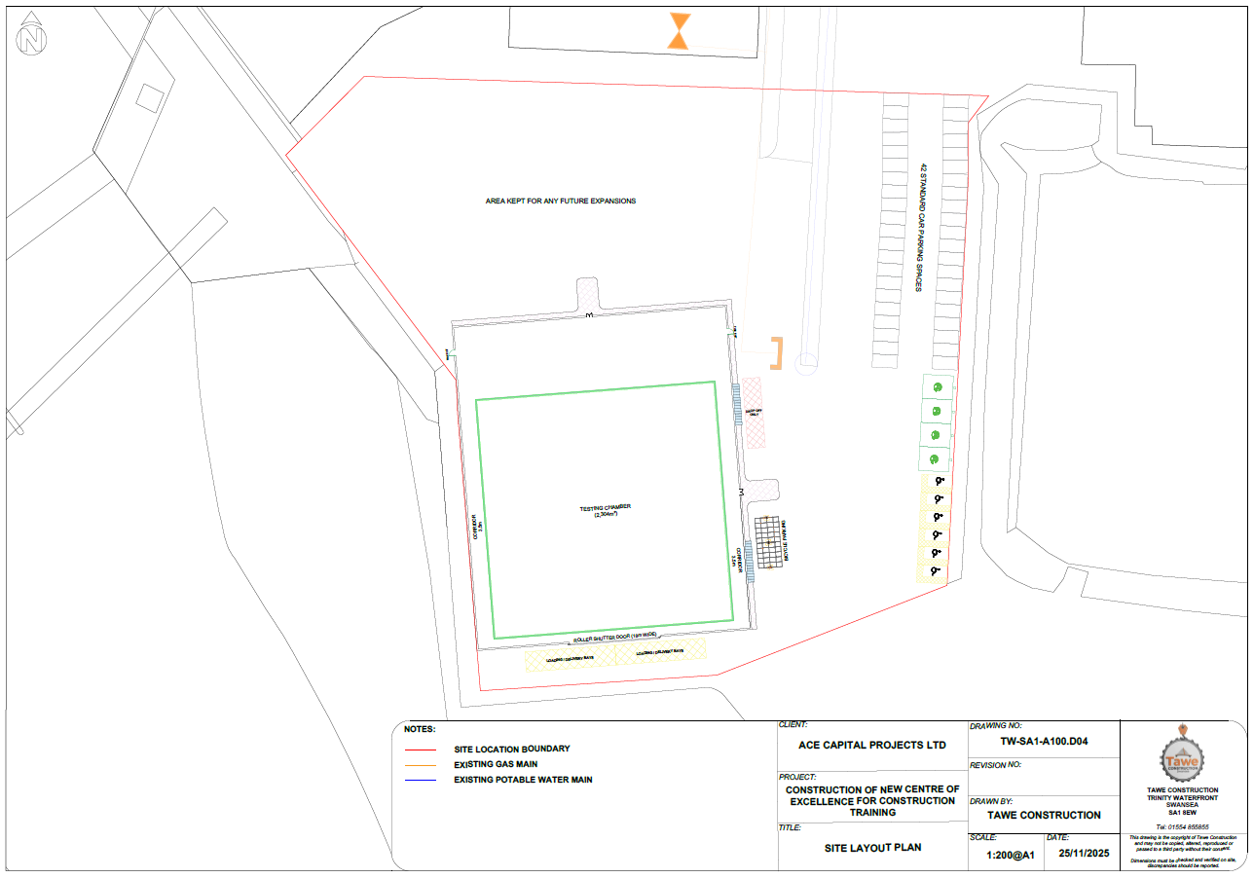
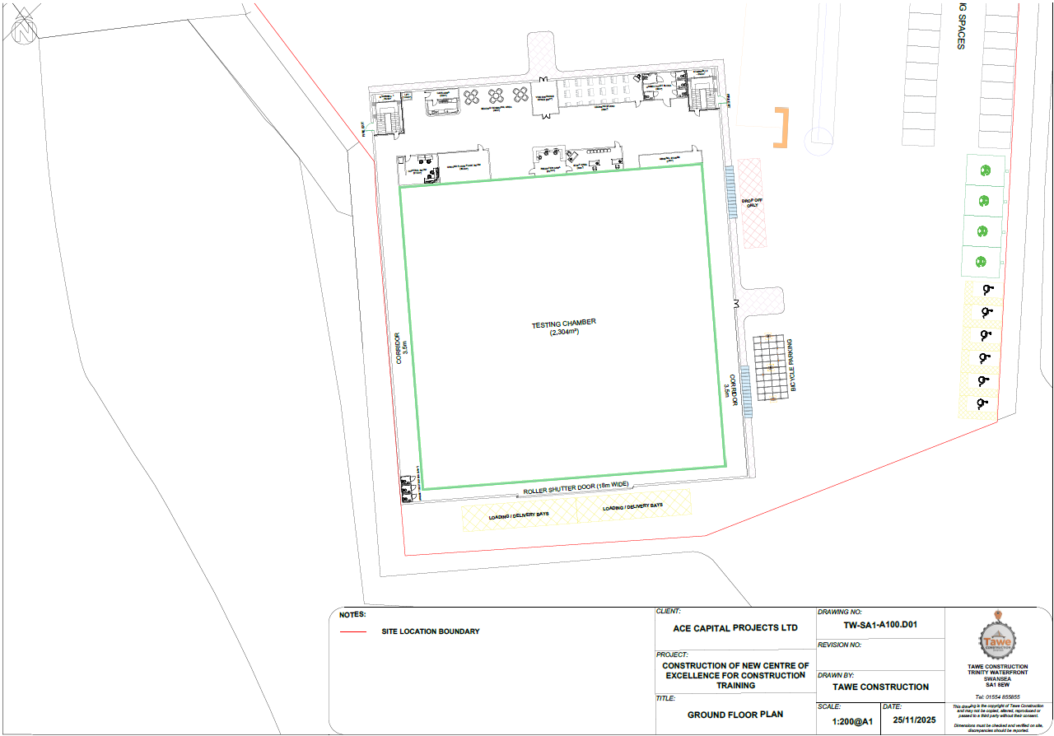
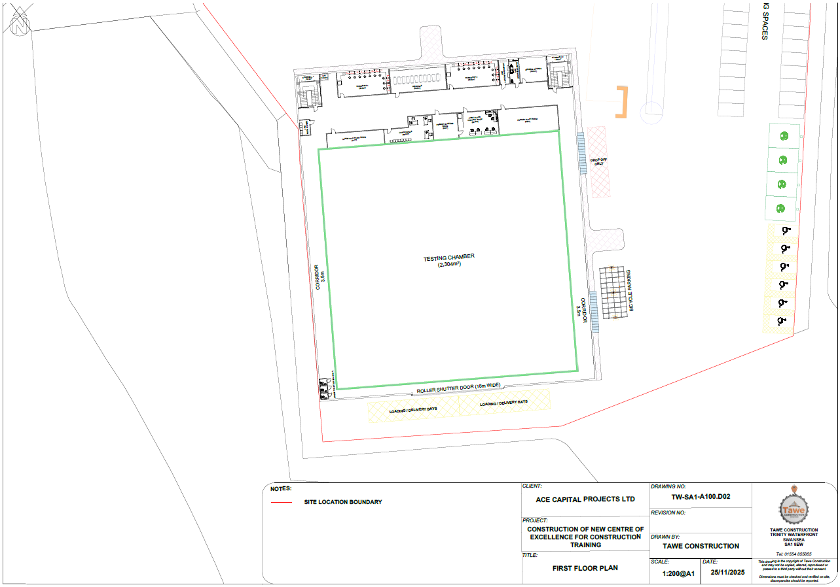
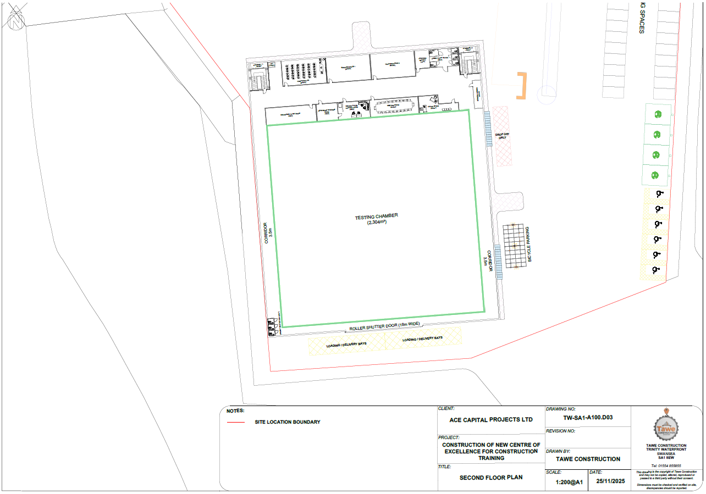
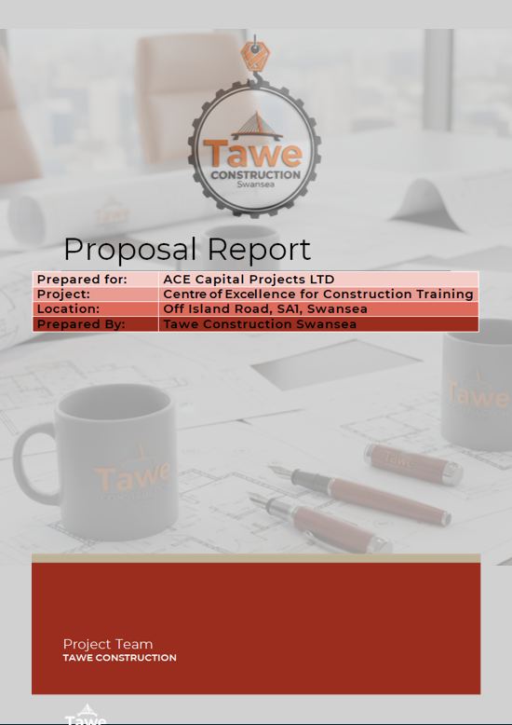


Document Control Sheet

Issued By | Tawe Construction
Client | ACE Capital Projects Ltd
Project Name | Centre of Excellence for Construction Training
Title | Ground Investigation Report
Doc Ref | 6016-TAWE-XX-XX-ZZ-C-GI
Project No | 6016
Status | S2
Date | 13/05/2026

Document Production Record

Prepared By | Anita Davis
Checked By
Approved By | Anita Davis

Document Revision Record
Issue | Status | Date | Revision Description | Approved
PO1 | S2 - Information | May 2026 | First Issue | AD

Table of Contents
1. Introduction 4
2. Desktop Study 5
2.1 Site Location and Description 5
2.2 Site History and Previous Land Use 5
2.3 Geology 6
2.4 Hydrogeology 7
2.5 Hydrology 7
2.6 Risk of Flooding 7
2.7 Nearby Sensitive Designations 7
2.8 Utility Mapping 7
2.9 Mining 8
2.10 Radon 8
2.11 Archaeological Records 8
3. Conceptual Ground Conditions 9
3.1 Anticipated Ground Conditions 9
3.2 Engineering Behaviour of Soils 9
3.2.1 Made Ground Properties 9
3.2.2 Shallow Marine Deposits Properties 11
3.2.3 Deeper Marine Deposits Properties 12
3.3 Groundwater 12
4. Geotechnical and Environmental Risk Assessment 13
4.1 Risk Assessment Methodology 13
4.2 Geotechnical Risks 13
4.3 Contamination Risks 13
4.4 Ground Gas Risks 13
4.5 Construction Risks 14
5. Foundation and Ground Engineering Design 15
5.1 Foundation Options 15
5.2 Recommended Foundation Strategy 15
5.3 Preliminary Piling Design 15
5.4 Construction Considerations 15
6. Conclusions and Recommendations 16

Index of Figures
Figure 1- Site Location Plan 5
Figure 2 – Historical Map (c. 1870s) 5
Figure 3 – Historical Map (c. 1910s) 6
Figure 4 – Historical Map (c. 1960s) 6
Figure 5 – Historical Map (c. 2005) 6
Figure 6 – Sensitive Designations Map 7
Figure 7 –Archaeological Data Service Map 8

List of Tables
Table 1 – Borehole Log Summary 9
Table 2 – Site Investigation Borehole Summary 9
Table 3 – SPT N Value Description 10
Table 4 – Particle Size Distribution Results for Made Ground 10
Table 5 – Atterberg Limit Test Results 10
Table 6 – Particle Size Distribution Results for Marine Deposits 11
Table 7 – Plasticity Index Test Results 11

Abbreviations
BGL – Below Ground Level
BGS – British Geological Survey
EQS – Environmental Quality Standards
FCA – Flood Consequence Assessment
LSBUD – Line Search Before You Dig
NRW – Natural Resources Wales
SPT – Standard Penetration Testing
SPZ – Source Protection Zone
UWTSD – University of Wales Trinity Saint David

Introduction
This report presents a desk based and conceptual ground investigation for a proposed Centre of Excellence for Construction Training for ACE Capital Project Ltd, located at land off Island Road, SA1 8EW in Swansea, adjacent to the University of Wales Trinity Saint David (UWTSD) campus.
The purpose of this study is to develop an understanding of the likely ground conditions and their implications in relation to geotechnical, environmental or contamination risks, using available geological mapping, historical land uses, and data available from adjacent site investigations. There has been no known intrusive ground investigation on the Site to date, therefore the findings are based on the interpretation of available data.
This assessment has been prepared in accordance with relevant UK geotechnical and environmental guidance, including but not limited to:
- BS EN 1997-1:2004 + A1:2013 Eurocode 7 Geotechnical design – Part 1 General rules
- BS EN 1997-2 (2007) Eurocode 7 Geotechnical design – Part 2 Ground Investigation and testing
- BS 5930:2015 + A1:2020 Code of practice for ground investigations
- BS 8004:2015 Code of practice for foundations (+A1:2020)
- BS 10175:2026 Investigation of potentially contaminated sites – Code of practice

Desktop Study

2.1 Site Location and Description
The site is located on land adjacent to Y Fforwm, off Island Road, SA1 Waterfront, SA1 8EW, and is shown in Figure 1. The six-figure grid reference for the approximate centre of the site is SS666925.
Figure 1 – Site Location Plan (OS Mapping)
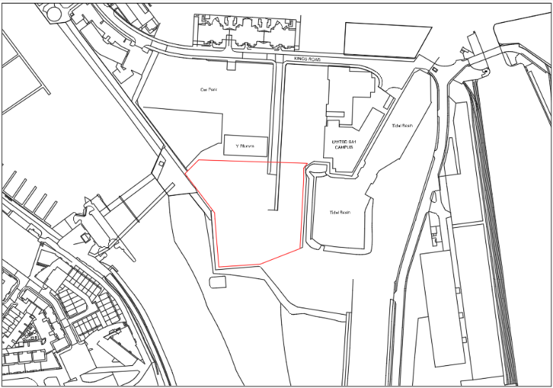

The site comprises an irregular plot of approximately 124,584.11m², based on the survey measurements undertaken using a surveyor’s wheel. It is bounded to the north by the Y Fforwm building and associated infrastructure, to the east by a pedestrian walkway and a tidal basin, and to the south and west by pedestrian pathway, with the River Tawe located beyond the pathways.
The site is currently vacant and predominantly consists of hardstanding, with areas of low-lying vegetation.
The proposed end use of the site is for a Centre of Excellence for Construction Training with associated infrastructure, intended for educational and training purposes.

2.2 Site History and Previous Land Use
A review of historical mapping for the site and its surrounding area is presented in Figures 2 – 5 below.
Figure 2 – Historical Map (c. 1870s) (Digimap, 1870s)
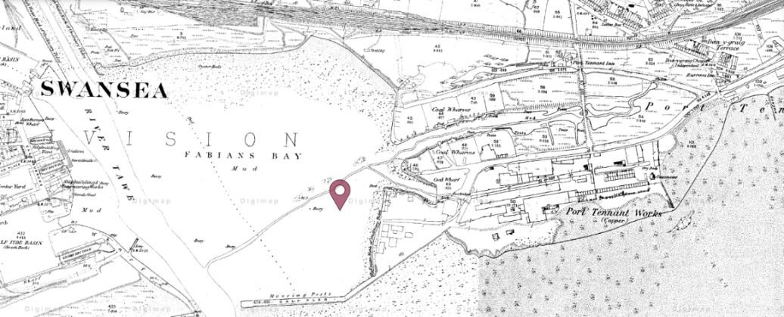

Figure 3 – Historical Map (c. 1910s) (Digimap, 1910s)
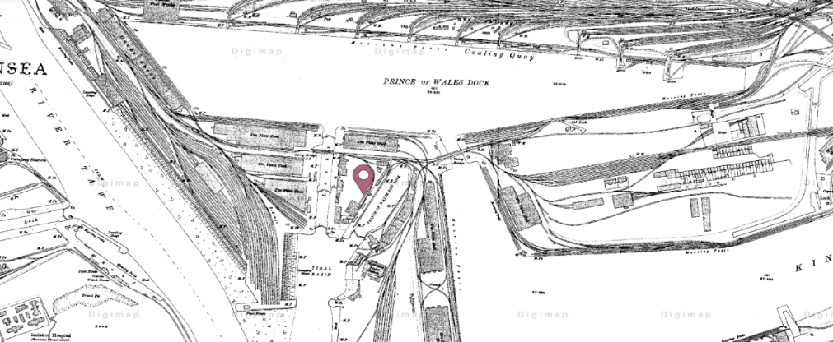

Figure 4 – Historical Map (c. 1960s) (Digimap, 1960s)
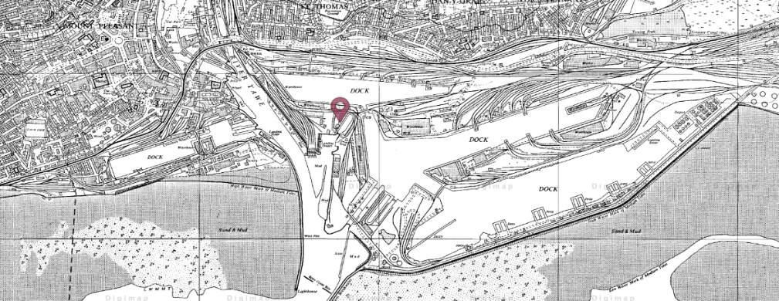

Figure 5 – Historical Map (c. 2005) (Digimap, 2005)
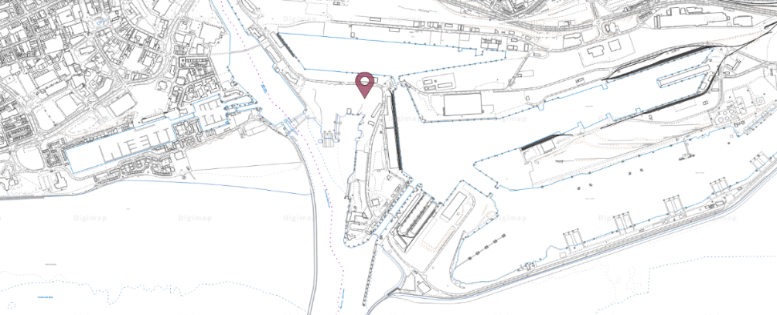

Historical mapping indicates that the site has undergone significant changes in land use, with early mapping from the 1880s shows the area as part of a tidal estuarine environment which suggests the presence of natural soft marine or alluvial deposits prior to any construction.
By the early 20th century, the site had been developed for industrial dock related use with features such as railway sidings, a plate shed, and nearby hydraulic power station, along with the tidal basin to the east and the River Tawe to the west. This continued into the 1960s with the adjacent site operating as a storage depot and the construction of King’s Road.
More recent mapping indicates that the site and surroundings have since been cleared, with removal of all industrial structures but the tidal basin and River Tawe still remain. The UWTSD campus and associated infrastructure surround the north of the site.

2.3 Geology
The online British Geological Survey (BGS) Geology Viewer identifies the site as being underlain by bedrock of the South Wales Middle Coal Measures Formation, comprising mudstone, siltstone and sandstone. These sedimentary deposits are fluvial, palustrine and shallow-marine in origin, typically associated with channels, floodplains and deltas of a river in a coastal setting.
Superficial deposits across the site are identified as Blown Sand, of aeolian origin and generally consisting of medium to fine grained materials (BGS Geology Viewer, n.d).
Based on the geological setting and historical land use, it is likely that these natural deposits are overlain by variable thicknesses of made ground associated with the development of the site and surrounding area.

2.4 Hydrogeology
The hydrogeological conditions of the site have been assumed based on information from an adjacent site development (specifically the Innovation Matrix development) located approximately 30m to the north of the site, which is considered representative due to similar geological and historical setting.
The underlying bedrock is classified as a Secondary ‘A’ Aquifer, capable of supporting groundwater flow at a local scale. Superficial deposits are considered to have low groundwater vulnerability, likely due to the presence of made ground (BGS Geology Viewer, n.d).
Groundwater is expected at shallow depths and may be tidally influenced, and the site is not located within a groundwater Source Protection Zone (SPZ).

2.5 Hydrology
The nearest surface water feature is a tidal basin located approximately 60m east of the site. The River Tawe lies approximately 85m to the south-west, with the Prince of Wales Dock and King’s Dock located approximately 230m to the north and 280m to the east, respectively. Distances are measured from the centre of the site.

2.6 Risk of Flooding
The site is located within Flood Zone 3 from both rivers and the sea as identified on the Natural Resources Wales (NRW) Flood Map for Planning (Natural Resources Wales, 2025).
A Flood Consequence Assessment (FCA) will be required under the TAN 15 Guidance and considerations made to the sustainable drainage systems design for the site.

2.7 Nearby Sensitive Designations
According to Magic Maps found on the Government website, there are no designated sites found within 500m of the site.
Figure 6 – Sensitive Designations Map (UK Government, 2025)

2.8 Utility Mapping
Utility Mapping records obtained from Welsh Water and Line Search Before You Dig (LSBUD) indicated the presence of a potable water main and a gas main entering the site from the northern boundary. The exact positions and depths should be confirmed on site through detailed utility surveys prior to construction works.

2.9 Mining
With reference to the Mining Remediation Authority interactive map viewer, the site is not located within a Development of High-Risk Area, and there are no recorded mine entries present within 50m of the site. No evidence of historic shallow coal mining or surface mining has been identified on the site or immediate vicinity (Mining Remediation Authority, 2026).
However, the site lies within a Coal Mining Reporting Area where past, present, or future underground coal mining may potentially influence ground stability. As such, a CON29M mining report is recommended at a detailed design stage.

2.10 Radon
The adjacent site is located within a lower probability radon area, where less than 1% of properties are estimated to be at or above the Action Level. Given the close proximity of the sites, it is considered reasonable to consider this site the same. No radon protective measures are considered necessary, subject to confirmation for the site.

2.11 Archaeological Records
Archaeological data for the site and surrounding area has been derived from the Archaeology Data Service interactive map and is shown in Figure 7 below with numerical references for clarity. These assets are located within the wider area of the site and not directly within the boundary, but they can still provide context of the historic land use and potential subsurface conditions.
Figure 7 – Archaeological Data Service Map (Archaeology Data Service, n.d)
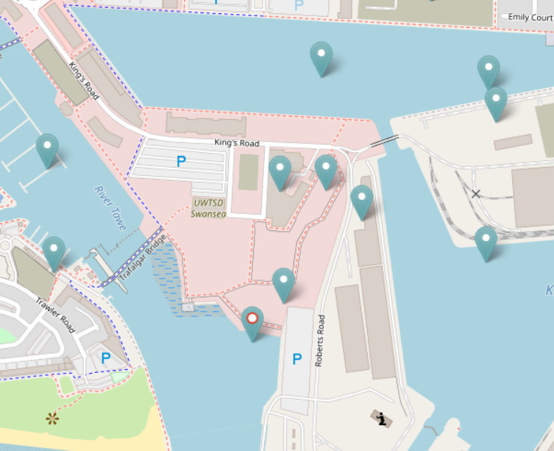

4
1
5

3
2

- Observation Post (probable WW2) – A brick-built structure recorded under the Defence of Britain Project overlooking the docks area with a view out to sea, described as probably a Second World War observation post (Archaeology Data Service, 2023).
- Thistle – A feature with no contextual information (Archaeology Data Service, 2023).
- Great Eastern Pier – Early maritime infrastructure associated with Fabian’s Bay (Archaeology Data Service, 2023).
- Prince of Wales Dry Dock – The final dry dock to be built at Swansea during the 19th century and was opened in 1898. It is located alongside the original lock entrance to the Prince of Wales Dock, the dry dock was owned and operated by the Prince of Wales Dry Dock Co. Ltd (Archaeology Data Service, 2023).
- Observation Post – A confirmed Defence of Britain database entry (Archaeology Data Service, 2002).

Whilst none are located within the site boundary, the recorded assets suggest there is potential for localised buried structures or obstructions. Given the extensive modern redevelopment within SA1 waterfront, any archaeological risk to development is considered low and manageable.

Conceptual Ground Conditions
This section provides a conceptual interpretation of the likely ground conditions at the site, based on available desk study information, nearby ground investigations, and borehole logs where available. The aim of this section is to develop an engineering understanding of anticipated ground conditions to inform geotechnical behaviour, associated ground risks, and foundation considerations.

3.1 Anticipated Ground Conditions
Borehole logs obtained from the BGS GeoIndex Onshore database, specifically BGS Borehole 370316 located within the site boundary indicate the soil profile summarised in Table 1.
Table 1 – Borehole Log Summary (BGS GeoIndex Onshore Database, 1880)
Depth (m AOD) | Thickness (m) | Soil Description
73.56 – 72.56 | 1 | Brown Sand
72.56 – 66.56 | 6 | Gravel
66.56 – 63.56 | 3 | Blue Clay
63.56 – 61.06 | 2.5 | Gravel
61.06 – 60.06 | 1 | Running Sand
60.06 – 54.06 | 6 | Shingle Sand & Gravel

The ground conditions encountered from the adjacent site investigation are summarised in Table 2.
Table 2 – Site Investigation Borehole Summary (Jubb, 2020)
Depth (m BGL) | Average Thickness (m) | Soil Description
GL – 5.0 to 8.5 | 6.1 | MADE GROUND – Grey sandy gravel
8.5 – 18.8 to 20.0 | 11.5 | MARINE DEPOSITS – Grey to brown silty sandy gravel and gravelly sand
18.8 – 20.0 + | - | SOUTH WALES COAL MEASURES – Strong dark grey mudstone

The borehole data from BGS and the adjacent site investigation indicate some comparable ground conditions, with some variation in the near-surface strata. The BGS borehole records show sands, gravels, and clay which is consistent with marine or estuarine environments, whereas the adjacent site identifies a significant thickness of made ground overlying similar deposits (Jubb, 2020).

The absence of made ground within the BGS logs reflects the age of the records and the differences in logging practices at the time of the investigation. Given the historical dockland use of the area, it is considered that made ground across the site is highly likely, although thickness may vary (BGS GeoIndex Onshore Database, 1880).

Both datasets indicate that marine deposits underlie the made ground, with bedrock anticipated at approximately 18 – 20m below ground level.

3.2 Engineering Behaviour of Soils
The engineering behaviours of the soils have been assumed and interpreted based on the results obtained from the adjacent site investigation, which is considered representative at this stage due to its proximity.

3.2.1 Made Ground Properties
SPT (Standard Penetration Testing) was undertaken within the made ground to assess the resistance of the soil to penetration using a split-spoon sampler. The results provide an indication of the density of granular soils and consistency of stiff clays, which is commonly used by geotechnical engineers to estimate engineering properties such as shear strength, bearing capacity, and liquefaction potential (Patel, 2019).

It was recorded that SPT N values within the made ground ranged between 10 and >50, with values greater than 50 usually resulting from SPT refusal on obstructions within the made ground. The removal of the refusal values resulted in the SPT N values ranging between 10 and 21, with an average of 16 and lower quartile value of 14 (Jubb, 2020).

The description of different SPT N values can be viewed in Table 3 below.
Table 3 – SPT N Value Description (ilyas, 2023)
SPT N Value | Description | Relative Density (%) | Friction Angle (°)
< 4 | Very Loose | < 20 | < 30
4 to 10 | Loose | 20 to 40 | 30 to 35
10 to 30 | Compact | 40 to 60 | 35 to 40
30 to 50 | Dense | 60 to 80 | 40 to 45
> 50 | Very Dense | > 80 | > 45

Based on the recorded SPT N Values, the made ground can generally be described as compact where refusal values are excluded. However, due to the heterogeneous nature of the made ground and the presence of obstructions, these values may not be representative across the whole site. The made ground is expected to be varying in strength and stiffness, and its suitability for supporting shallow foundations may be inconsistent over the site.
Particle size distribution testing was also undertaken on the made ground to determine the relative amount of particle sizes within the material. This information is used to classify the soil and assess its likely engineering behaviour, including strength, bearing capacity and drainage properties (Lees, 2024).
The results are summarised in Table 4 below.
Table 4 – Particle Size Distribution Results for Made Ground (Jubb, 2020)
Particle Size | Minimum (%) | Maximum (%) | Average (%)
Cobbles | 0 | 12.5 | 4
Gravel | 51.3 | 69.4 | 59
Sand | 12.9 | 36.9 | 26
Silt/Clay | 5.5 | 15.2 | 11

Based on the average particle size distribution, the made ground can be classified as clayey, very sandy GRAVEL with occasional cobble and boulder content. This indicates a predominantly coarse-grained material, which is likely to exhibit relatively good drainage properties and moderate shear strength. However, the presence of finer material such as silt and clay may influence overall behaviour.

Additionally, Atterberg Limit testing was undertaken on cohesive samples within the made ground to assess their plasticity characteristics. This test defines the moisture content at which soil transitions between different states, from solid to semi-solid, to plastic, and finally to liquid. The test identifies three limits: Shrinkage Limit, Plastic Limit and Liquid Limit. These are used to inform soil classification and indicate structural behaviours such as shear strength (Booth, 2024).
Table 5 – Atterberg Limit Test Results (Jubb, 2020)
 | Minimum | Maximum | Average
Natural Moisture Content | 11.6 | 12.4 | 12
Liquid Limit | 32 | 39 | 35
Plastic Limit | 21 | 24 | 22
Plasticity Index | 11 | 15 | 13

The made ground is described as a predominantly gravelly material with a minor cohesive fraction. Atterberg Limit testing indicates that it can be classified as a low plasticity clay with a low volume change potential. This suggests limited shrink-swell behaviour and relatively stable response to changes in moisture content.
Testing was only carried out on a finer fraction of material, so the results are not fully representative of the made ground across the site.
For design purposes, the material has been treated as a granular soil, with geotechnical characteristics derived from the test results. The angle of shearing resistance (Ø) has been estimated using correlations with SPT N Values based on Peck, Hanson and Thornburn (Foundation Engineering) resulting in a value of approximately 31°. The unit weight (Y) has been derived from BS8002:2015 Characteristic value for gravel with a value of 18kN/m³ and the modulus of elasticity (E) has been estimated from using empirical relationships from Bowles, (Foundation Analysis and Design) relating SPT N Value (< 15) and soil stiffness resulting in a value of approximately 12MPa (Jubb, 2020).
These values are considered appropriate for preliminary design purposes, but it must be noted that the made ground is highly variable in composition and may contain localised obstructions and cohesive material. A detailed site-specific ground investigation is recommended prior to the final design.

3.2.2 Shallow Marine Deposits Properties
SPT undertaken within the shallow marine deposits recorded N values generally ranging between 3 and 6, with an average of 5 and a lower quartile value of 4. Based on the descriptions presented in Table 3, these values indicate that the material is very loose to loose (Jubb, 2020).
Low SPT N values suggest that the deposits are likely to exhibit low density and low bearing capacity, suggesting a high potential for settlement which may require special foundation designs like piling or ground improvement techniques.
Three particle size distribution tests were carried out, and the results are summarised in Table 6 below.
Table 6 – Particle Size Distribution Results for Marine Deposits (Jubb, 2020)
Particle Size | Minimum (%) | Maximum (%) | Average (%)
Cobbles | 0 | 3.2 | 1
Gravel | 30.1 | 44.3 | 37
Sand | 41.8 | 49.3 | 45
Silt/Clay | 11.9 | 20.5 | 16

Based on the results, the granular material can be classified as silty, very gravelly SAND with occasional cobbles.
This grading indicates broadly coarse-grained material, however the presence of silt may influence drainage properties and reduce overall strength compared to clean sand.
One plasticity index test was carried out on the cohesive portion of the deposit with results summarised in Table 7 below.
Table 7 – Plasticity Index Test Results (Jubb, 2020)
Natural Moisture Content | Liquid Limit | Plastic Limit | Plasticity Index
24.1 | 33 | 20 | 13

The cohesive bands are classified as low plasticity and based on the correlation of 5.8* SPT N value, this gives an undrained shear strength (Cu) of 23kPa based on the lower value obtained.
This result indicates that the cohesive material is relatively weak, which may contribute to compressibility and potential settlement within the shallow marine deposits.
For design purposes, the material has been treated as granular soil, with geotechnical characteristics derived from the test results. The angle of shearing resistance (Ø), unit weight (Y), and modulus of elasticity (E) have all been derived using the same design guidance as the made ground section, with the results indicating 28°, 18kN/m³ and 6.6MPa, respectively.
The cohesive soil’s angle of shearing resistance is calculated as 30°, and the unit weight is 17kN/m³. The undrained shear strength (Cu) has been estimated from Stroud and Butler (The Standard Penetration Test and Engineering Properties of Glacial Materials,) resulting in an approximate value of 20kPa. The coefficient of compressibility (Mv) has been estimated from Stroud, M. A. (The standard penetration test in insensitive clays and soft rocks,) resulting in an approximate value of 0.337m²/MN (Jubb, 2020).

3.2.3 Deeper Marine Deposits Properties
Site investigation data has been taken from a separate investigation within SA1 development and has been noted within the Innovation Matrix report (Jubb, 2020).
SPT undertaken within deeper marine deposits with results varying between 24 to >50 with an average of 42 (when 50 used as maximum refusal value).
Based on this and the same design guidance, the angle of shearing resistance (Ø), unit weight (Y), and modulus of elasticity (E) have been estimated as 39°, 19kN/m³ and 22MPa, respectively (Jubb, 2020).
These results indicate that the deeper marine deposits are dense to very dense granular soils with high shear strength and stiffness, indicating that the bearing capacity is higher than the overlying materials.

3.3 Groundwater
Groundwater was generally not encountered within the trial pits; however, strikes were recorded in window sample locations within the shallow marine deposits at approximately 2 – 2.5m BGL (Below Ground Level).
Other site investigations within the surrounding area indicate a more variable groundwater regime, with shallow levels found in made ground between 1.1 – 2.7m BGL and deeper levels between 4 -6m BGL.
Standpipes were installed for monitoring purposes and largely showed dry conditions, with only one isolated recording at 2.8m. Monitoring visits were undertaken during both high and low tide conditions and did not indicate a consistent tidal response (Jubb, 2020).
Overall, the groundwater is interpreted as shallow, locally variable, and does not represent a stable groundwater table.

Geotechnical and Environmental Risk Assessment

4.1 Risk Assessment Methodology
A qualitative risk assessment has been undertaken based on a source-pathway-receptor model, which identifies potential hazards, how they may impact the site, and the receptors at risk, while allowing the significance of each risk to be evaluated. These have all been estimated based on available adjacent site investigation data.

4.2 Geotechnical Risks
The primary geotechnical risks are associated with the variable made ground, loose shallow marine deposits, and buried obstructions.
The made ground is heterogeneous and contains cobbles and possible historic foundations which may result in differential settlement, obstruction to piling or excavation, and variable bearing conditions.
The underlying shallow marine deposits are described as very loose to loose which indicates low bearing capacity and increased settlement potential.
Additionally, the presence of a historic dock wall introduces localised structural constraints, especially where surcharge loads or excavations are proposed.
Overall, these conditions present a moderate geotechnical risk, particularly for shallow foundations.

4.3 Contamination Risks
The main contamination risks are associated with the made ground, with samples obtained from depths of approximately 0.2m – 1.5m BGL. Results show that the majority of samples indicate generally low concentrations of contamination when assessed against human health criteria, with one exceedance of lead identified (Jubb, 2020).
Leachate testing also indicates generally low concentrations, with single exceedances recorded for arsenic, copper, and lead. These exceedances are considered minor, especially because Environmental Quality Standards (EQS) values relate to surface water rather than groundwater, and any migration would be diluted and attenuated within the underlying deposits (UK Government, 2026).
No asbestos was detected in any of the samples analysed.
Waste classification testing identified that some samples within the made ground have been classified as hazardous due to the presence of lead and zinc chromate. This relates primarily to waste handling and disposal rather than in-situ risk and suggests that appropriate safety measures should be in place during excavation and earthworks (Jubb, 2020).
Overall, no significant contamination risks have been identified to controlled waters or future end users, and contamination is considered a low risk for the proposed development, provided that protective measures when handling made ground are implemented during construction works.

4.4 Ground Gas Risks
Ground gas monitoring was undertaken on the adjacent site which recorded generally low gas concentrations, with methane detected at up to approximately 2.6% and carbon dioxide up to 1.4% on individual monitoring visits. Gas flow rates were low and there was no consistent buildup of gas observed across the monitoring period (Jubb, 2020).
Based on CIRIA C665 guidance, as the maximum methane value is above 1% and there are potential sources within the vicinity of the site, C665 states that consideration should be considered whether to characterise the site as Characteristic Situation 2 - low risk classification and it was deemed most appropriate (CIRIA, 2007).
In accordance with BS 8485:2015+A1:2019, the development is likely to require 3.5 points of protection comprising of:
- Structural barrier of the floor slab;
- Ventilation measures; and
- Gas resistant membranes (British Standard Institution, 2019).
Overall, the ground gas risk to the proposed development is considered low if the protective measures above are implemented as a minimum.

4.5 Construction Risks
The main construction risks relate to the implications of the ground conditions during earthworks. The presence of buried obstructions and potential remnants of historic foundations and the dock wall is likely to affect excavations and any piling operations. This may require the use of breaking equipment and removal of localised obstructions (Jubb, 2020).
Groundwater may be encountered during excavation works, particularly within the shallow marine deposits. As a result, temporary control measures such as dewatering may be required to maintain safe working conditions.
Any piling operations may also be affected by the variability of the ground conditions, with potential for refusal on obstructions and the need for pre-drilling or adjustment of piling locations to avoid existing buried structures.
Overall, construction risks are considered moderate and are primarily associated with ground variability and groundwater control.

Foundation and Ground Engineering Design

Foundation Options
Based on the conceptual ground conditions identified, shallow foundations are not considered feasible due to the thickness and variable nature of the made ground, which may lead to differential settlement and inconsistent bearing capacities.
Furthermore, the made ground on the adjacent site has been recorded up to depths of at least approximately 1.5m, removal and replacement of this material to allow for shallow foundations or ground bearing slabs would result in significant costs and construction difficulty due to disposal costs, presence of obstructions, and groundwater.
Deep foundations, such as piled solutions, are therefore considered the most appropriate option because they allow loads to be transferred to the underlying deeper marine deposits, which have been shown to provide higher bearing capacity and shear strength (Lees, n.d).

5.2 Recommended Foundation Strategy
The proposed development has a footprint of approximately 3607.5m² and has multiple storeys which will generate significant loading. A piled foundation is recommended as this approach will allow structural loads to be transferred through the made ground and shallow marine deposits into the underlying dense strata.
Based on available data, piles are likely to extend to depths of approximately 10m or greater to achieve adequate bearing within the deeper deposits. Driven steel tubular piles have been used to support structures on adjacent sites and are considered suitable to adopt on this development. Pre-drilling or excavating and removal of any obstructions at each pile location may be required due to the presence of buried foundations and cobbles within the made ground (Jubb, 2020).
Additionally, a suspended floor slab has also been recommended on other sites and should be adopted here to reduce settlement risk (Fatt, 2023).
Any pile design should be done in accordance with the relevant British standards such as BS EN 1997:1 Geotechnical Design and BS EN 1992:1 Design of Concrete Structures.

5.3 Preliminary Piling Design
The preliminary piling arrangement adopted for the proposed development is consistent with the strategy outlined in Section 5.2 and reflects the anticipated variation in structural loading across the building footprint.
In accordance with BS EN 1997-1:2004+A1:2013 and BS 8004:2015+A1:2020, a piled foundation solution is considered appropriate to transfer structural loads through the weaker shallow surface into more suitable strata at depth.
Driven steel tubular piles have been adopted on other developments within the SA1 area for their suitability for variable ground conditions. piles are anticipated to be approximately 344mm in diameter, installed using a percussive hammer system, and founded at depths typically ranging from approximately 10m to 19m BGL, subject to confirmation by detailed intrusive investigation. This range is considered appropriate to account for variability in made ground thickness and depth to denser marine deposits.
Pile layout is expected to follow a relatively regular grid in the standard teaching and office areas, with indicative spacing in the order of 4-6m centres. In contrast, reduced spacing and increased load transfer demand are anticipated around the testing chamber due to its large open plan nature and higher structural demands, where piles are likely to be more closely spaced and connected via larger reinforced concrete pile caps and transfer ground beams.
Reinforced concrete pile caps and ground beams are proposed to distribute structural loads between piles and to support the superstructure. Indicative ground beam sizes are expected to range from approximately 600mm x 700mm to 600mm to 800mm in typical areas, increasing locally up to approximately 900mm x 1500mm in areas with higher loading and structural transfer.
A suspended reinforced concrete slab is proposed to mitigate the effects of ground variability and potential settlement. Preliminary structural assumptions are based on C32/40 concrete and grade B500B reinforcement in accordance with BS EN 1992-1-1, BS 8500, and BS 4449.

5.4 Construction Considerations
Groundwater may be encountered at shallow depths, and temporary dewatering methods may be required during excavation works and should be considered before construction starts on site.
Pile positions may need to be adjusted to avoid any potential historic dock wall remnants, and any surcharge loads close to this should be carefully considered by a structural engineer.
The potential for difficult ground conditions such as loose or running sands should also be taken into consideration during piling operations.

Conclusions and Recommendations
Based on the desk study and interpretation of available site investigations within the surrounding area, the site is anticipated to be underlain by variable made ground overlying shallow marine deposits with deeper dense strata resent at depth. The made ground is heterogeneous and may contain localised obstructions, while the shallow marine deposits are identified as very loose to loose, indicating a low bearing capacity and a high potential for settlement. In contrast, the deeper deposits are dense and more suitable for supporting significant structural loads.
Groundwater conditions are thought to be shallow and variable which is likely to have an effect on excavation and construction activities. As a result, temporary dewatering and groundwater control measures should be incorporated into the construction methodology to maintain safe working conditions.
Contamination testing indicates generally low concentrations across the site, with only limited exceedances of lead in soils and arsenic, copper, and lead in leachate testing. These exceedances are not considered a significant risk to human health or controlled waters. However, some made ground samples were classified as hazardous due to the presence of lead and zinc chromate, which will require appropriate handling, segregation, and disposal in accordance with the relevant waste regulations during excavation works.
Ground gas risks have been assessed as low, provided that the protection measures outlined in Section 4.4 and in accordance with BS 8485:2015+A1:2019 are implemented within the building design.
Based on these findings, a piled foundation solution is recommended to transfer structural loads to suitable strata and should be designed in accordance with Eurocode 7 and undertaken by a competent structural and geotechnical engineer. A preliminary piled foundation arrangement is proposed comprising driven steel tubular piles, typically in the order of 344mm diameter, founded at approximate depths of 10m to 190m BGL. A suspended floor slab is also recommended and reflects approaches adopted on adjacent developments to reduce settlement risks.
Allowance should be made for pre-drilling or potential obstruction removal during piling works, and pile locations may need to be adjusted to account for potential buried structures, including remnants of the historic dock wall. These constraints should be confirmed through further intrusive investigation.
The piling design should also be subject to a piling risk assessment to prevent any new pathways that allow contamination to migrate to underlying groundwater, therefore protecting aquifers and other water sources.
In addition, due to the presence of shallow groundwater and the variable nature of the made ground, infiltration-based drainage systems such as soakaways are unlikely to be suitable. Alternative drainage strategies should be considered as part of the overall drainage design (CIRIA, 2015).
Overall, the site is considered suitable for the proposed development, provided that the recommended foundation solution, drainage approach, and construction mitigation measures are implemented. This is subject to confirmation through a detailed site-specific ground investigation which includes geotechnical testing, contamination sampling, and groundwater monitoring to reduce uncertainty in design parameters.

Main Report - Individual Sections
C. Site Layout Plan with Conceptual Foundation and Structural Design – Anita Davis
C.1 Site Layout Plans – Anita Davis
The following plans show the indicative layouts for the development and have been prepared on a conceptual basis to demonstrate the proposed arrangement of internal spaces, circulation routes, and overall building footprint within the site constraints identified during the feasibility study.
Inclusion of all layout and floor plans.
C.2 Preliminary Piling Design – Anita Davis
The preliminary piling arrangement for the proposed development is based on a filed foundation strategy consistent with other developments within the SA1 area.
A piled foundation system comprising driven steel tubular piles is proposed in accordance with BS EN 1997-1:2004+A1:2013 (Eurocode 7) and BS 8004:2015+A1:2020. This is considered appropriate for transferrin structural loads to the deeper, denser strata at depth, as described within the GI report.
Driven steel tubular piles, typically 344mm in diameter and installed using a percussive hammer, are assumed appropriate for preliminary design purposes. Pile founding depths are anticipated to range from approximately 10m to19m Below Ground Level (BGL), subject to verification through intrusive investigations.
The pile layout is assumed to adopt a generally regular grid arrangement for the teaching and office spaces, with indicative spacing of approximately 4-6m centres. In contrast, the testing chamber area is expected to impose higher structural demands due to its larger open span arrangement, resulting in locally increased pile density and the use of larger reinforced concrete pile caps and transfer ground beams to redistribute loads.
Reinforced concrete pile caps and ground beams are proposed to provide load transfer between piles and to support the superstructure. Indicative ground beam sizes are expected to vary from approximately 600 x 700mm to 600 x 800mm in typical areas, increasing locally up to approximately 900 x 1500mm in higher load transfer areas.
A suspended reinforced concrete slab is proposed across the development to accommodate ground variability and mitigate differential settlement effects.
Preliminary structural assumptions are based on C32/40 concrete and Grade B500B reinforcement in accordance with BS EN 1992-1-1 (Eurocode 2), BS 8500, and BS 4449.
This is subject to intrusive site investigation with chemical and geotechnical testing, along with a piling risk assessment.
C.3 Conceptual Structural Design – Anita Davis
The proposed development is assumed to adopt a steel frame superstructure supported on a piled foundation system and is considered acceptable on a conceptual basis. The proposed structural arrangement has been selected in response to the requirement of large open plan spaces within the testing chamber together with the anticipated variable ground conditions identified across the site.
A structural steel frame has been selected at this stage due to its high strength to weight ratio, speed of construction, and the ability to achieve long span structural arrangements. The reduced weight of the steel superstructure is also considered beneficial in reducing overall foundation loading. Structural steelwork would be designed in accordance with BS EN 1993-1-1:2022 Eurocode 3 – Design of Steel Structures (British Standard Institution, 2022).
The structural load path is assumed to transfer loads from floor slabs and roof structures into secondary steel beams, primary beams, steel columns, pile caps, and subsequently the foundation system. Composite floor slabs are assumed to act as horizontal diaphragms to assist with the distribution of lateral loads to the primary system in accordance with BS EN 1991-1-1:2025 Eurocode 1 – Actions on superstructures (British Standard Institution, 2025b). Wind loading should be undertaken in accordance with BS EN 1991-4:2005 (British Standard Institution, 2005).
The office and teaching space would comprise a regular structural grid with assumed column spacing of approximately 6-7.5m centres. Preliminary structural members are assumed to comprise composite floor slabs of approximately 130-150mm overall depth supported on secondary steel beams, with primary beams anticipated in the region of approximately 457-610mm deep Universal Beams and steel columns ranging from approximately 254mm x 254mm to 356mm x 368mm Universal Column sections, subject to detailed structural analysis and loading requirements.
The testing chamber, measuring approximately 48m x 48m, is proposed to comprise a long span steel roof structure supported on perimeter steel columns. Long span steel trusses or lattice girders are anticipated in order to achieve the required column-free internal testing environment. Preliminary truss depths of between 3-5m is anticipated and will be subject to detailed structural analysis. The use of structural steel within this area is considered appropriate due to its ability to efficiently span large distances whilst minimising structural self-weight and foundation loading.
Lateral stability is assumed to be provided through a combination of vertical steel bracing systems and moment resisting connections where required. Structural robustness and disproportionate collapse considerations would be outlined in accordance with BS EN 1991-1-1-7:2025 Eurocode 1 – Actions on structures (British Standard Institution, 2025a).
Due to the requirement of fire resistance within the educational and testing facility, structural steel members would require appropriate fire protection measures, potentially including intumescent coatings or board encasement systems, designed in accordance with BS EN 1993-1-2:2024 Eurocode 3 – Design of steel structures, structural fire design (British Standard Institution, 2024).
This arrangement is conceptual only and is subject to detailed geotechnical and structural design by a competent engineer informed by an intrusive site investigation.

References
Andrew, Lees, (2024) What is Particle Size Distribution in Soils. Available at: https://www.tensar.co.uk/resources/articles/what-is-particle-size-distribution-in-soils (Accessed: 14th March 2026)
Anjan, Patel (2019) Geotechnical Investigations and Improvement of Ground Conditions. Available at: https://www.sciencedirect.com/topics/engineering/standard-penetration-test (Accessed: 14th March 2026)
Archaeology Data Service (n.d) Archaeology Data Service Data Catalogue. Available at: https://archaeologydataservice.ac.uk/data-catalogue/resource/3f1508a794253d541dd2e9019b4a97ede94a8c006fdbce88da55a90c163c51ae (Accessed: 5 March 2026)
BGS British Geological Survey (n.d) BGS Geology Viewer. Available at: https://mapapps2.bgs.ac.uk/geoindex/home.html?layer=BGSBoreholes (Accessed: 5 March 2026)
BGS British Geological Survey (1880) GeoIndex (onshore). Available at: https://mapapps2.bgs.ac.uk/geoindex/home.html (Accessed: 14 March 2026)
British Standards Institution (2025a) Eurocode 1 – Actions on structures. Accidental actions
British Standards Institution (2025b) Eurocode 1 – Actions on superstructures. Specific weight of materials, self-weight of construction works and imposed loads for buildings
British Standards Institution (2005) Eurocode 1 – Actions on superstructures. General actions – Wind actions (+A1:2010) (incorporating corrigenda July 2009 and January 2010)
British Standards Institution (2019) Code of practice for the design of protective measures for methane and carbon dioxide ground gases for new buildings
British Standards Institution (2022) Eurocode 3. Design of steel structures. General rules and rules for buildings
British Standards Institution (2024) Eurocode 3. Design of steel structures. Structural fire design
British Standards Institution (2024) Eurocode 7. Geotechnical Design – General Rules
British Standards Institution (2016) Steel for the reinforcement of concrete. Weldable reinforcing steel. Bar, coil and decoiled product. Specification.
Dr. Justin, LAI, Woon, Fatt (2023) Suspended Ground Slab vs Non-suspended Ground Slab. Available at: https://ipm.my/suspended-ground-slab-vs-non-suspended-ground-slab/ (Accessed: 22 March 2026)
Federation of Piling Specialists (2011) Design of Piles to Eurocodes. Issue 04. Available at: https://www.fps.org.uk/position-papers/design-of-piles-to-eurocodes/ (Accessed: 14 March 2026)
George, Booth (2024) Atterberg Limit Testing. Available at: https://buildcomply.co.uk/glossary/atterberg-limit-testing (Accessed: 14 March 2026)
Ilyas, (2023) What is the SPT-N value? Significance, Calculation Method and Approximation
Jubb Consulting Engineers Ltd (2020) Innovation Matrix Ground Conditions Assessment Report
Natural Resources Wales (2025) Flood Map for Planning. Available at: https://flood-map-for-planning.naturalresources.wales/ (Accessed: 5 March 2026)
UK Government (2025) MAGIC Maps. Available at: https://magic.defra.gov.uk/MagicMap.html (Accessed: 28 December 2025)
UK Government (2026) Surface water pollution risk assessment for your environmental permit. Available at: https://www.gov.uk/guidance/surface-water-pollution-risk-assessment-for-your-environmental-permit#freshwaters (Accessed: 18th March 2026)
Wilson, S., Oliver, S., Mallett, H., Hutchings, H., Card, G. (2007) Assessing risks posed by hazardous ground gases to buildings (C665) CIRIA.
Woods Ballard, B., Wilson, S., Udale-Clarke, H., Illman, S., Scott, T., Ashley, R., Kellagher, R. (2015) The SuDS Manual (C753). London: CIRIA.

