School of Sport, Health & Outdoor Education

Assessment Feedback Sheet

Student No./Name: 1901872/ Lauren Rustage
Module: Adventure and Challenge in the Curriculum SHSS4074

Personal Evaluation – to support your academic progress please complete the section below BEFORE submitting your work.
What do you consider to be the best aspects of this work? |  |  | My understanding of the term Physical Literacy and my passion for adventurous activities. Asking the lectures for feedback on my essay before hand allowed me to push myself for the very best I can do.
Which aspects do you consider could have been improved in this piece of work? |  |  | Seeking out more new sources may have enhanced my work as I used sources which I have used before.
What have you found most satisfying whilst undertaking this submission? |  |  | I have really enjoyed looking more into the term Physical Literacy so I can plan lessons I take around this term for more beneficial lessons. Also, having new ideas for adventurous activities to do within schools for children to participate in these activities more often.
ASSESSMENT CRITERIA | Learning  Outcomes |  | GRADE
ASSESSMENT CRITERIA |  |  | Poor  < 20% | Weak  20-29% | Unsatisfactory  30-39% |  | Satisfactory  40 – 49% | Good  50 – 59% | Very Good  60 – 69% | Excellent  70 – 84% |  | Exceptional  85– 100% | %
Understanding of the concept of physical literacy | 3 |  |  |  |  |  |  |  |  |  |  |  | 40%
Awareness of the benefits of adventurous activities and outdoor learning | 3 |  |  |  |  |  |  |  |  |  |  |  | 40%
Links to literature and research to support opinions | 3 |  |  |  |  |  |  |  |  |  |  |  | 20%
It is expected that students will present work that is proof read, correctly referenced and adheres to the Assessment Checklist. Therefore a range of 0 – 10 marks will be deducted for non-completion of any of the points on the checklist below.
TUTOR COMMENTS:

Submission date: 03/04/20  via Turnitin |  | Return date:  (at least within 4 weeks) |  |  |  | Tutor: J HAYLOCK |  |  |  |  | Mark:

Evaluate how adventurous activities contribute to the development of children’s physical literacy.
This essay evaluates how adventurous activities can contribute the development of children’s physical literacy. According to Whitehead (2010), physical literacy develops the child holistically and is continually being developed throughout their lives, affordances can provide more opportunities to develop this (Gibson, 1986). Outdoor adventurous activities are one of the four areas of learning in The National Curriculum for PE in Wales (2008). Adventurous activities can be a great way to holistically develop a child (Dahlgren and Szczepanski, 1998). When children are developed holistically their physical, social, cognitive and affective domains are developed (Bailey et al., 2009). Learning outdoors, children get the chance for “hands-on methods and processes to make curricula and formulated aims to come alive” (Dahlgren and Szczepanski, 1998, p26).
Firstly, it is vital Schools and facilitators cover the 2008 Foundation Phase Framework (2015). In the Foundation Phase Framework (2015) are seven areas of learning including Knowledge and Understanding of the World. Within The National Curriculum for PE in Wales (2008) there are learning outcomes which can be split into the four domains of learning, social, cognitive, affective and physical (Bailey et al., 2009). Adventurous activities can develop the cognitive domain of learning as children are learning about the world, in the adventurous activities that they participate in (The National Curriculum for PE in Wales 2008). However, White (2014) mentions that Schools don't have the facilities or resources for adventurous activities to take place which can make it difficult for facilitators to take these adventurous activity lessons as they don’t have the correct resources. Settings need to have appropriate skills and environment to allow children to explore all areas of learning, develop lifelong skills and discover what is offered to them in the environment (White, 2014 & Gibson, 1986). The opportunities offered to children are relevant to them, they will be able to develop different skills in different environments (Gibson, 1986).
The social domain can be developed in adventurous activities through the five stages of group development (Tuckman, 1965 & Tuckman & Jensen, 1977). Groups will go through these stages and is a big part of socially developing whilst participating in adventurous activities (Tuckman, 1965). The first stage is forming, where a group meets for the first time, begins to understand what is expected from them, from the activity and they start to socialise (Tuckman,1965). When the activity begins and the level of challenge is increased conflict may arise and the group may challenge authority, storming (Tuckman, 1965). A number of opportunities will arise from different stages of development, the way an individual perceives an environment will drive their actions (Gibson, 1986). It is important that facilitators know the stages of group development and how to deal with each stage when taking children on adventurous activities because if they react negatively to conflict in the group not only can it enhance the conflict but also have an impact on other domains of learning such as the affective domain (Tuckman, 1965, Tuckman & Jensen, 1977 & Bailey et al., 2009).
Adventurous activities can develop the physical domain of learning (Bailey et al., 2009). Children participating in adventurous activities, experience the exhilaration of movement and their mental well-being develops (White, 2014). Adventurous activities develops sensory pathways in the child’s brain which helps to coordinate skills needed in life (White, 2014). This corresponds with McCurdy et al. (2010) work where it was found that the increase of inactive indoor lifestyle influenced people’s physical and mental health. Outdoor adventurous activities can reduce risk of obesity and brittle, weak, bones which can have a major impact on the quality of life a young person has (Dahlgren & Szczepanski 1998). Although, this finding contradicts the NHS (2019) treatment of obesity which doesn’t directly suggest that outdoor adventurous activity can reduce obesity.
The affective domain is developed by the certain teaching styles a facilitator decides to use (Mosston & Ashworth, 2002). The Mosston & Ashworth (2002) teaching style spectrum ranges from A-K, with A, command style, being more teacher-led and becoming more pupil-led throughout the spectrum. Teaching styles are excellent ways of developing certain skills within children especially when facilitating adventurous activities (Mosston & Ashworth, 2002). The teacher decides which style to use depending on the age, ability and the desired learning outcomes from The National Curriculum for PE in Wales (2008).
Following on from this, there are no specific rules when deciding a teaching style (Mosston & Ashworth, 2002). Teaching styles A-E are generally used for the acquisition of foundational movement skills, usually learnt by the age of seven-years old (The National Curriculum for PE in Wales, 2008). However, upper Primary and Secondary School pupils will still benefit from teaching styles A-E, this could be when starting out adventurous activities (Mosston & Ashworth, 2002). If a facilitator has a group of nine-year old's and uses a teaching style which gives them too much independence they may have a negative experience and not want to participate in adventurous activities again (The National Curriculum for PE in Wales, 2008 & Mosston & Ashworth, 2002). Children need to feel safe whilst also being out of their comfort zone, their affective domain will be positively developed (Bailey et al., 2009 & Mosston & Ashworth, 2002).
As previously mentioned, foundational movement skills are needed in order to participate in adventurous activities (The National Curriculum for PE in Wales, 2008). Once a child has these physical, social, affective and cognitive skills they can break through the proficiency barrier and participate in more complex activities (Seefeldt, 1980). Allowing them to have a wider range of skills and affordances to participate in these activities enables them to have a more fulfilling physical literacy journey and better motor development (Whitehead, 2010 & Gibson, 1986). Here an image of the Progression of Motor Proficiency Skill Level to clearly show the different stages of participating in activities (Seefeldt, 1980, p317).
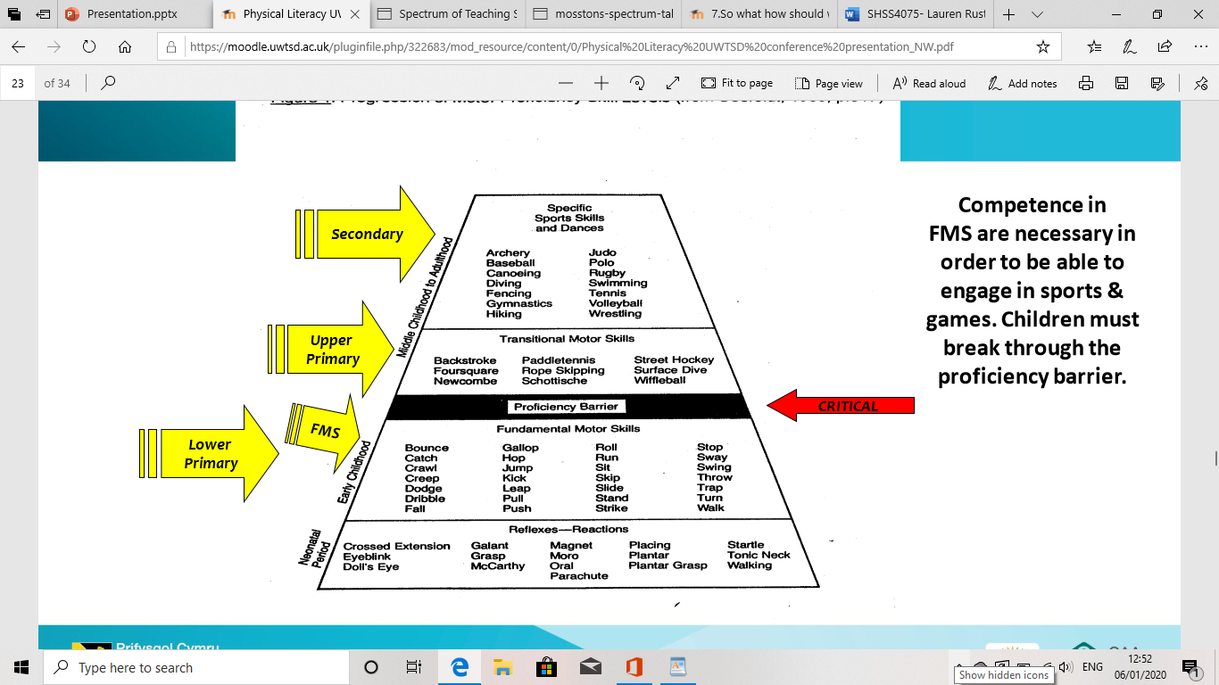 (Figure 1)
Similarly, the mountain of motor development (Clark & Metcalfe, 2003) shows that not only foundational movement skills are needed when participating in skillful activities but also the other domains of learning are needed (Bailey et al., 2009).
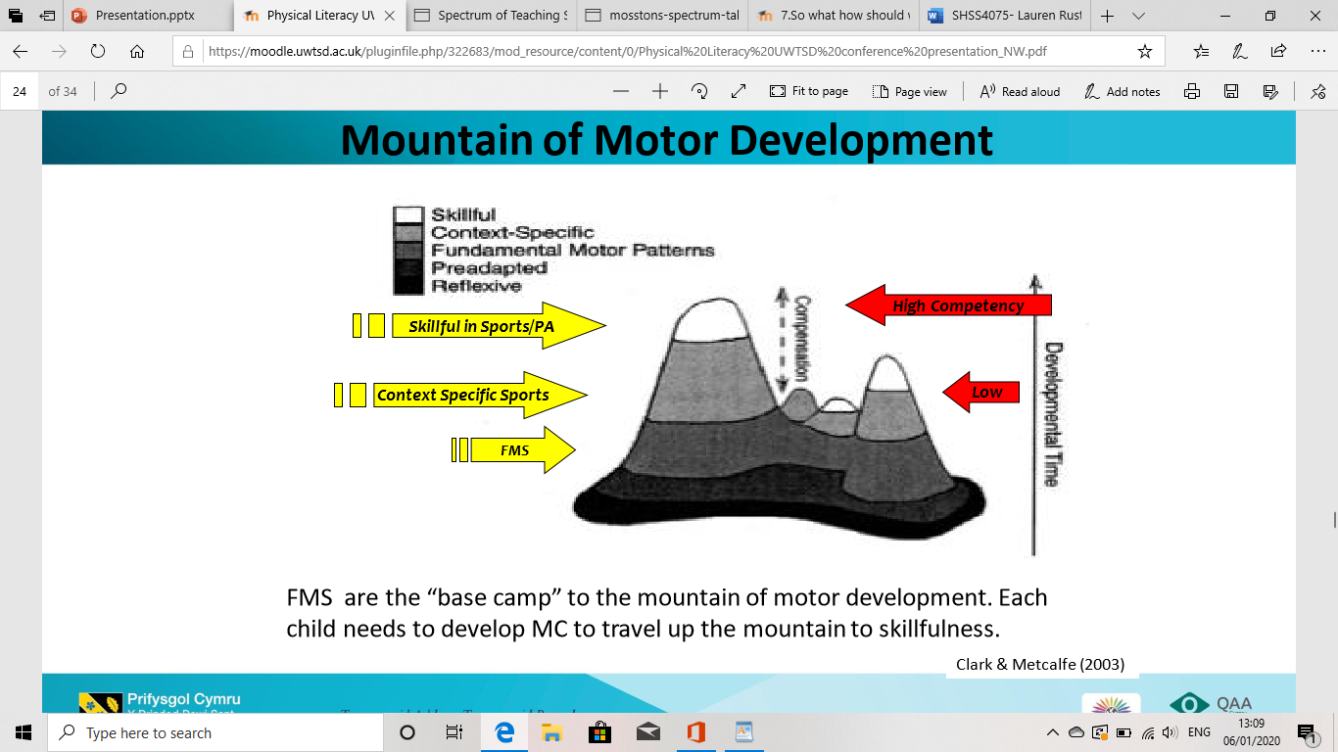 (Figure 2)
When facilitating any sort of activity within School it is vital that all children are included (The National Curriculum for PE in Wales 2008). This can be specifically linked to children with additional needs such as ADHD, Attention Deficit Hyperactivity Disorder (Louv, 2005). Facilitators can promote the importance of adventurous activities helping people with additional needs such as ADHD (Louv, 2005). Louv (2005) argues that being outdoors and in nature can have more of an effect on the concentration of children with ADHD than medication and behavioral therapies. Louv (2005) points out that the number of preschooler children with ADHD has increased by 369 percent from 2000 to 2003. Within Louv’s (2005) work, there is also a suggestion that if children with ADHD spend more time outdoors their symptoms can be reduced. Kuo and Andrea (2004) back up this this theory by a study carried out where children aged between 7-12 years with ADHD spend more time doing outdoor adventurous activities, specifically is green areas of the community and their symptoms of ADHD reduced. In another study carried out by Kuo and Andrea (2009), three groups of children were taken for a walk; one in a park, one in the neighborhood and one downtown. The children agreed that the walk in the park, the greenest of the three walks, was both the most fun and relaxing (Kuo & Andrea, 2009).
Facilitators have an impact on whether children get the full experience and advantages of adventurous activities (Humberstone & Stan, 2011). Humberstone and Stan (2011) observed 490 Primary Schools, within several of the Schools they found facilitators didn’t take children for adventurous activities because the children would get distracted by the outdoors. It is recognised that only a few of the facilitators knew that adventurous activities could support and bring out personal and social skills in the children (Lehte 2019). White’s (2014) work contradicts the facilitators perspectives by stating the importance of children spending time indoors and outdoors for their well-being. White (2014) also acknowledged how outdoors can help children in their physical, cognitive and emotional growth. During the observation by Humberstone’s and Stan’s (2011) the facilitators didn’t allow the children to participate in outdoor activities if they had misbehaved, despite seeing the potential benefits to a child’s physical literacy journey. When facilitators have this view of adventurous activities it can result in the children not getting the full value of these adventurous activities to enhance their physical literacy journey because the facilitators don’t fully understand the primary aim of adventurous activities (Szczepanski and Nicol, 2005).
To conclude, adventurous activities is proven to develop the physical literacy journey within a child, this could be an aim of Physical Education which facilitators try and achieve (Bailey et al., 2009 & The National Curriculum for PE in Wales, 2008). Physical Literacy holistically develops children by enhancing the domains of learning (Bailey et al., 2009 & Whitehead, 2010). Adventurous activities can impact positively on the mental and physical health of a child (McCurdy et al., 2010). Facilitators have a part in the affordances children have when participating in adventurous activities and although this can be a positive, if the facilitator doesn’t see the importance of this, children's learning can be hindered as a result of lack of time outdoors (White, 2014 & Gibson, 1986). The teaching styles a facilitator uses will also have an impact on what the children get out of the activity and this can be positive or negative for their physical literacy journey (Mosston & Ashworth, 2002 & Whitehead, 2010). With all the evidence supporting the advantages of children participating in adventurous activities, facilitators and Schools have a duty to take children outdoors for more activities (The National Curriculum for PE in Wales, 2008).
Word count: 1,650

References
Bailey, R. et al. (2009) ‘The educational benefits claimed for physical education and school sport: an academic review’, Research Papers in Education. 24 (1), pp. 1-27.
Dahlgren, L. O. & Szczepanski, A. (1998) Outdoor education. literary education and sensor experience. An attempt at defining the identity of outdoor education. Linköping University: Kinda Education Center.
Duffy, B. (1998) Supporting Creativity and Imagination in the Early Years. Buckingham: Open University Press.
Feeney, A. et al. (2018) ‘Knowing when to hold ‘em: regret and the relation between missed opportunities and risk taking in children, adolescents and adults’, Cognition & Emotion. 32 (3), pp. 608–615.
Figure 1. Seefeldt (1980) Progression of Motor Proficiency Skill Level. P.317
Figure 2. Clark, J. & Metcalf, J. (2002) ‘The Mountain of Motor Development: A Metaphor', Motor Development Research and Reviews.
Gibson, J. (1986) The ecological approach to visual perception. USA: Erlbaum.

Gulbenkian, C. (1982) The Arts in School. London: Calouste Gulbenkian Foundation.
Humberstone, B. & Stan, I. (2011) ‘Outdoor learning: Primary pupils’ experiences and teachers’ interaction in outdoor learning’, Education 3–13 International Journal of Primary, Elementary and Early Years Education. 39 (5), pp. 529–540.
Kuo, E. and Andrea, T. (2004) ‘A Potential Natural Treatment for Attention-Deficit/Hyperactivity Disorder: Evidence from a National Study’, American Journal of Public Health. 94 (9), pp. 1580-1586.
Louv, R. (2005) Last Child in the Woods: Saving Our Children from Nature-Deficit Disorder. Chapel Hill: Algonquin Books.
McCurdy L. et al. (2010) ‘Using Nature and Outdoor Activity to Improve Children’s Health’, Current Problems in Pediatric and Adolescent Health Care. 40 (5), pp. 102–217.
National Health Service (2019) Treatment – Obesity. Available at: https://www.nhs.uk/conditions/obesity/treatment/ (Accessed 27 October 2019).
Sisson, J. & Lash M. (2017) ‘Outdoor Learning Experiences Connecting Children to Nature’, YC: Young Children. 72 (4), pp.8–17.
Taylor, F. & Kuo, E. (2009) ‘Children with Attention Deficits Concentrate Better after Walk in the Park’, Journal of Attention Disorder. 12 (5), pp. 402-409.
Tuuling L. (2019) ‘Teachers' opinions on utilizing outdoor learning in the preschools of Estonia’, Journal of Adventure Education & Outdoor Learning. 19 (4), pp. 358–371.
Waite S., Huggings V. & Wickett, K. (2014) ‘Risky outdoor play: embracing uncertainty in pursuit of learning’, in Maynard T. and Waters J. (Eds.) Exploring outdoor play in the early years. Maidenhead: Open University Press.
Welsh Government (2015) Curriculum for Wales. Foundation Phase Framework. Available at: https://gov.wales/sites/default/files/publications/2018-02/foundation-phase-framework-revised-2015.pdf (Accessed 27 October 2019).
White, J. (2014) Playing and Learning Outdoors: Making Provision for High Quality Experiences in the Outdoor Environment with Children 3–7. 2nd ed. New York: Routledge.
White, R. & Stoecklin, V. (1997) Children’s Outdoor Play and Learning Environments: Returning to Nature. Available at: www.whitehutchinson.com/children/articles/outdoor.shtml (Accessed on 24 October 2019).
Wright, S. (2010) Understanding Creativity in Early Childhood. London: Sage Publication Ltd.

