
Skills for the Workplace
Module Assignment Submission
Student Name: | Howard Lewis
Student Number: | 2011712
Module No: | BMSK4008
Module Title: | Academic and Research Skills

Statement of Confirmation of Authenticity
By the act of making this submission, the student declares that this is the work of the student named above. The work has not, in whole or in part, been knowingly presented elsewhere for assessment, or where assessment has been built on a previous assessment, this has been identified. Where materials have been used from other sources it has been properly acknowledged. If this statement is untrue, the student acknowledges that an assessment offence has been committed.
Attention is drawn to the plagiarism and unfair practice policies of both the University and of ILM.
Permission for ILM to use this script
ILM uses learners’ submissions – on an anonymous basis – for assessment standardisation. By submitting, both the centre and the learner agree that ILM may use this script on condition that identifying information is removed. However, if you are unwilling to allow ILM use this script, please refuse by ticking the box: □

Table of Contents
Managing Remotely: Is it the Way Forward? 3
Part 1 3
1.1 Introduction 3
1.2 Research 3
1.3 Findings 3
1.4 Conclusion 4
Part 2 4
Personal Reflection on Managing Remotely 4
2.1 Description 5
2.2 Feelings 5
2.3 Evaluation 5
2.4 Analysis 5
2.5 Conclusion 6
References 7
Appendix 1 8
Appendix 2 9

Managing Remotely: Is it the Way Forward?

Part 1

1.1 Introduction
Here in these studies, you are going to see and be explained too in detail from research found. So let us move on and explain the benefits to remote working, some of these explanations are going to benefit an industry or organisation in such good ways they can work effectively, (e.g., team building and steps towards how you can all be on the same wavelength and reach your goals if followed correctly that is. But that is not all I am going to also show you, I am also going to show some downsides to remote working too. (e.g., breakdowns to the team or group building for remote working)), as it stands now let us all agree or lets’ just say for now, we do and will have pro’s and con’s to remote working so I am going to show you a few theories of how remote working can and cannot be essential, with the right people on your team anything is accomplishable as there are tasks simply some individuals (somebody alone without the know) cannot do alone.

1.2 Research
Here you are going to see a few examples to the steps of individual effectiveness and how it fits into the remote working role, but a lot of people have the different takes on each model but in the end they all seem to want the same results. Some of these models that will be explained throughout will be effective if used correctly to aid in becoming a better person and also better describes how remote working can benefit a person’s work. But do not be fooled there are also a lot of downfalls and floors to remote working, which will be explained further throughout with the pros and cons being explained along with the research to show how it has worked and has not worked for people. Past and present.

 This is an image of mark Connelly.
Webpage - About Change-Management-Coach.com

Mark Connelly has his own page and blogs to do with Stephen Covey and his 7 steps to effectiveness, Connelly also has his own take from what Stephen Covey has written following his own research of these steps.

Mark Connelly opens with a line that says pretty much what you would want to hear to keep reading on, it is as follows: –
“Stephen Covey reviewed 200 years of success literature and crystallized what he learnt into (7) seven habits (or steps if you prefer) that took the world by storm in 1989”.

Mark Connelly also believes in the powerful solutions for positive change, suppose he has to be considering that he is a change management coach himself. He has a webpage that is listed, and a blog page mentioned above (hyperlink) if you would like to follow further.
Positive change is needed especially whilst working from home (remotely) as part of a few downfalls to remote working is self-damaging and isolation etc.
Mark then also goes on to express another powerful quote which is as follows: –
“More than (3) three decades later and the (7) seven habits of highly effective people continue to be an influential business book delivering powerful lesson change”.

Now to remote working as it can be a very good way of work getting efficiently done or NOT!
Once you feel that you are more capable of remotely working it can get a lot easier, amongst researches a few businesses thrived throughout the pandemic that made a lot of us have to remotely work. According to a news article from: -

Exclusive: Remote working is just as effective, but it can hurt pay and promotion, HR execs warn - CityAM : CityAM

 CITYAM.com (logo pictured)
 Helen Llewellyn (pictured)
According to Helen Llewellyn, director of workplace specialist infinity wellbeing, for many people homeworking is more productive than office-based work.

Helen has released a statement that indicates remote working is better.
“Allowing or encouraging home working is generally good for the soul”,
also saying along her statements amongst the articles.
“Who wants to be stuck in a traffic jam or on a jam-packed tube when you could be having a coffee on your patio?
Her peer James Costello, co-founder of workplace mental health, health consultancy Born Human goes on to say: -

“Who wants to be stuck in a traffic jam or on a jam-packed tube when you could be having a coffee on your patio?

Stephen Covey is another source of effectiveness to remote working, by using his steps to remote working with his own theories. Covey had taken a lot of time to work out these simple steps to remote working, whilst used correctly they can help remote working a lot simpler. (especially if you have already done the and considered the Mark Connelly steps to self-Improvement)
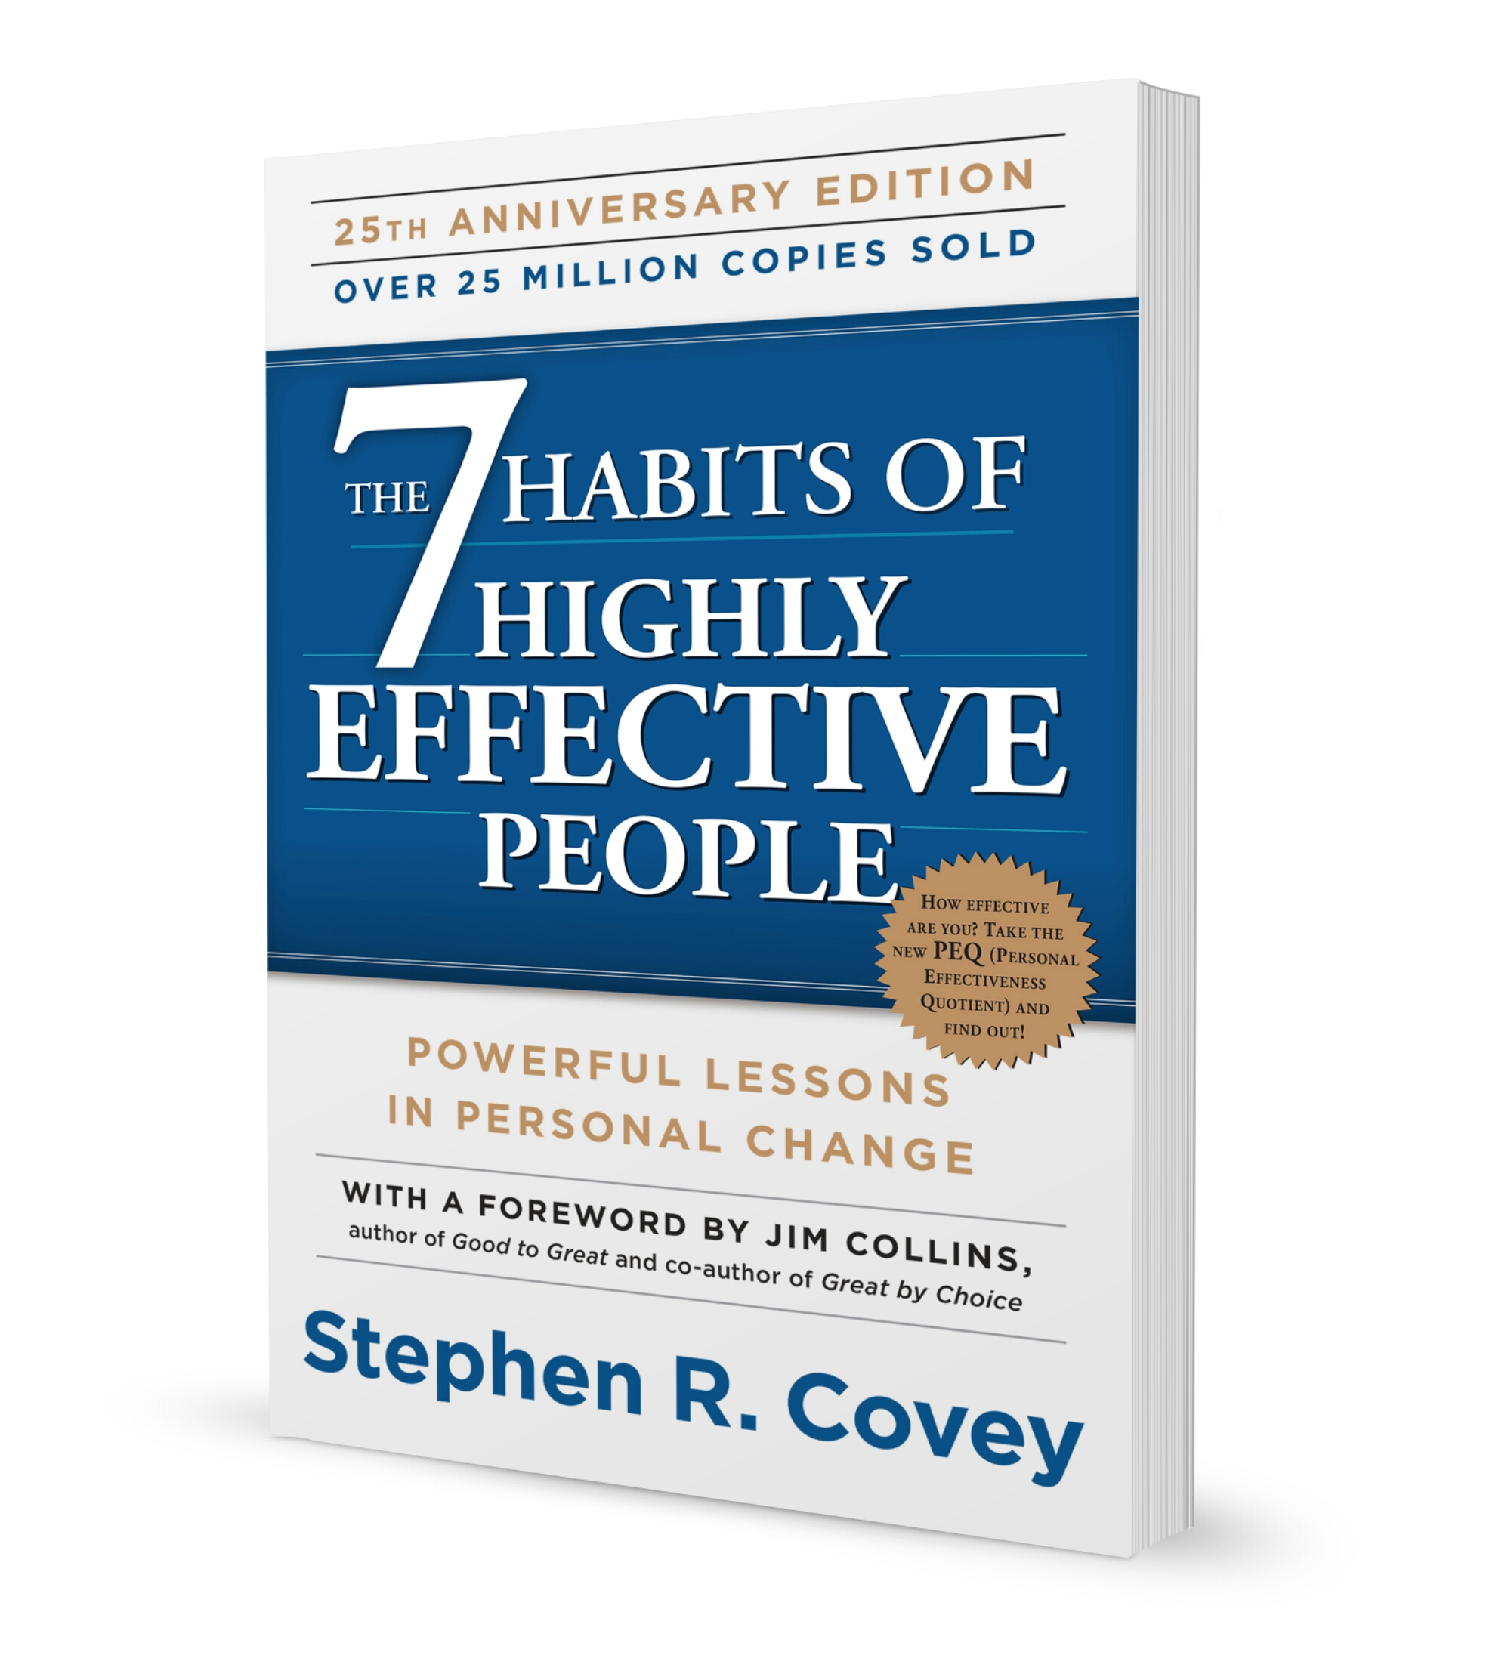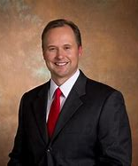
Stephen Covey 7 habits book Sean Covey
Nine proven techniques to optimise your remote learning - CMI (managers.org.uk)
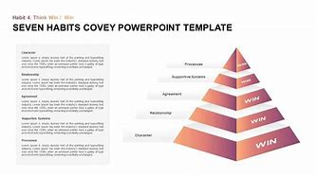
Below are a few examples of Stephen Coveys models and steps to effectiveness and how he came to his conclusions.

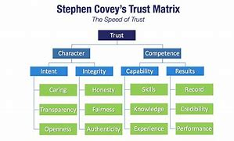
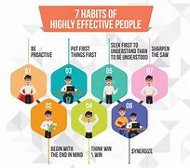
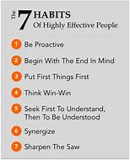
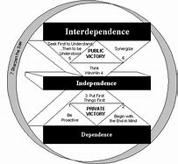

https://krisp.ai/blog/
Krisp is and has been a blogger for a few years and on May 21st, 2020 he had an article written to his blog page by a Sean Clark, Clark wrote about Stephen Covey, but not just him he also had a quote from Sean Covey who happens to be the son of Stephen covey the author of [The Seven Habits of Highly Effective People].
Sean Covey son of author Stephen Covey, it appears he has implemented his own theory from his fathers seven steps guide/model. Sean Covey’s quote goes on to say as stated below that: -
“Depending on what they are our habits will either make us or break us. We become what we repeatedly do”.
From the following site is a lot of insight to Stephen Covey’s modules and work. The 7 Habits of Highly Effective People (franklincovey.com)

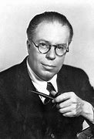
Christopher Morley (pictured above)
Christopher Morley is another name found whilst researching, he has his own take and outlook to the steps written by Stephen Covey. In the below website, Morley admits there are always going to be as he says: -
“Barriers that will pop-up and impede your path of learning”.
Following that, Morley also goes on to say and quote Stephen covey by saying, as Stephen Covey said: -
“Direct your finite energies to control what you can control”.
Nine proven techniques to optimise your remote learning - CMI (managers.org.uk)

1.4 Conclusion
Upon researching remote working you can see a pattern between all theorists, models or steps to success seen as they are all going for the same endgame (successful businessperson). With the right attitude and self-esteem, you can achieve a higher efficiency in almost everything you set your goals to. When you as an individual can manage time to accomplish your goals that is when you can achieve greater i.e., putting it into team efforts. From using this analysis, you can benefit by advancing in greater goals and help others towards reaching theirs if you do become a team member. Although it does seem as simple as eating cake but unfortunately it does not always go to plan, be it your anxiety, health issues, working conditions, isolation, depression and above all there is no way.
whilst during the pandemic people were not able to get rewarded in the usual manner for their achievements and goals due to being made that remote, national lockdowns were put in place by the Government meaning some businesses was not able to survive due to the time-length that these lockdowns were in implemented. e.g., celebrations, achievement ceremonies, work functions etc.
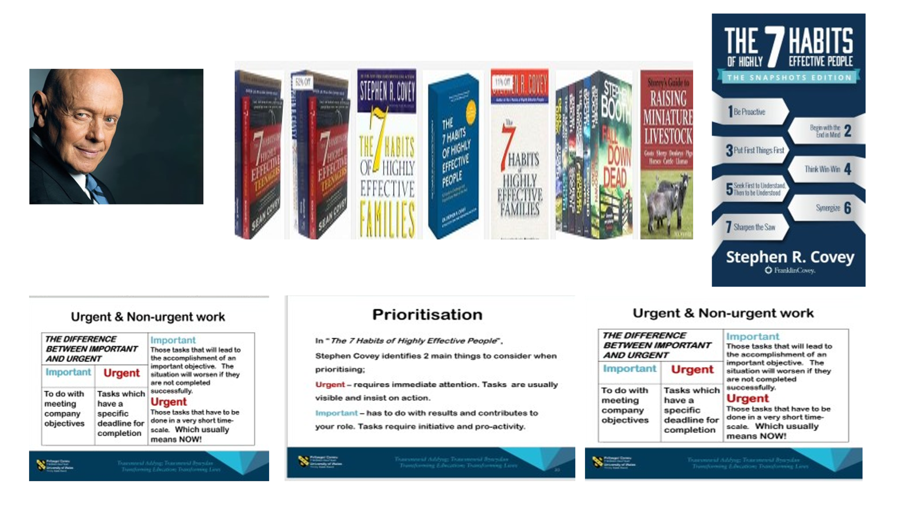

Above features Stephen Covey and his range of books to a successful you or team member.
Images obtained from: - The 7 Habits of Highly Effective People (franklincovey.com)

Part 2

Personal Reflection on Managing Remotely

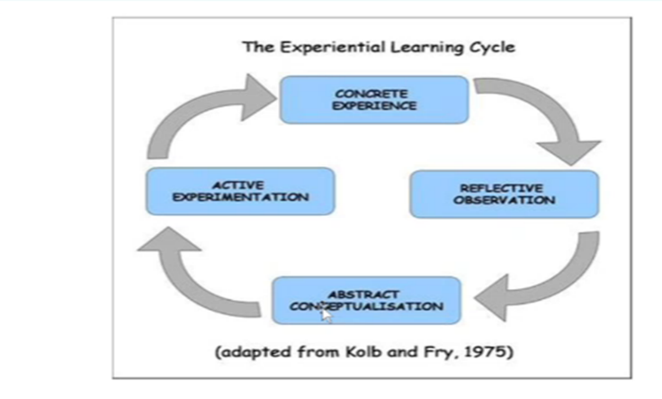
Gibbs (1988) Kolb and Fry (1975)
Above are a couple of reflection model images from Gibbs and Kolb and Fry you can use to help get your priorities in order and to eventually reach your set goals. Me personally I still have not been able to accommodate what is best for myself to use at this current time. Hopefully by the end of this course, I will be in a better position to choose which one best fits myself.

2.1 Description
Remote working is a good way of working for the business world in some instances, meaning they are still able to function if or when they have the right leader to conduct a team or even multiple teams to share workloads through 21st century technology as now we are able to share screens, meaning we can still collaborate as a team, or we can communicate and delegate workload still via an SMS (text message) or email, be them singular or to as many people as you choose to include, so it is a brilliant and effective way to get business done, but working this way can still make you feel isolated and can make some people feel a little depressed, so along with all this a business should still have an outreach programme in place and good communication, to ensure the good and healthy wellbeing of their staff.
I personally had never heard of the application Zoom prior to signing up for this university course, I was invited back for a video interview/ induction by using this application. I used to think everything was done via WhatsApp. Now we conduct our university sessions through new applications such as Microsoft Teams. This application allows us to continue to study as a class, and still allows us to interact with one another as we would have within a classroom setting. With this in mind and with software such as Microsoft Teams, we have also been able to set up a class support group within WhatsApp, to help and support each other in classwork or health if needed. This is another way of keeping in contact by video calling or messaging. More support is usually needed when someone is working remotely, as even though it is called Remotely, I believe that does not mean you should feel or made to feel alone.

2.2 Feelings
On a personal note, I can now see the positives and negatives to remote working and the devastation Covid has caused, which I am sure is the case for so many others in the same position right now. I myself am a prime example as to how remote working can change an individual, in a positive and negative way. I am going to mention the global pandemic Covid-19 as a prime example on how it has impacted with myself.
Prior to the pandemic hitting the country in 2019 I had a plumbing and heating business that was running successfully for nearly 6 years, When the pandemic hit the country, I was not able to work as the nation was put on lockdown, mean we had meeting and visiting conditions changed and many other restrictions put in place by the Government. For others such as myself, that relied on access to people’s houses and usually other close contact customer interactions, this then meant I was not able to continue trading and so had to seek other options. This is when I had the opportunity to complete an SIA doorman’s course as it was still available to complete and open at the time. Whilst on the SIA course I was also offered to participate in this university course, to be honest, I was hesitant as I am not an education chasing individual, well was not at the time lol. I had all these opportunities offered to be by the third lockdown. I did attempt to re-open my business and try again, but unfortunately, I could not survive another lockdown and restrictions, and finally made the tough decision to shut my business down.
This university course has been a great way and source in proving to myself more than possibly some others I know that remote working can work and can run just as successful as being out and about in the field so to say. It is still allowing me to better myself, whilst previously believing I had no other options, due to most all other professional areas I knew had been shut down or even put out of business like my own. But I can also see the benefits to remote working, as many businesses have still been able to work and operate remotely, which has kept a lot of the world moving without having to move per say.
Some businesses have thrived whilst others have failed. Due to the instabilities that Covid-19 brought with it, this then had questions around mental health. A lot of people became depressed due to the uncertainties of losing your job or line of work through no fault of your own. It can be devastating to an individual and to their wellbeing. It is always wise to check in with any employees, friends, family etc to ensure they are coping ok. But for me, having this option as I said to undertake studies and be able to better myself along the way, following devastation that Covid-19 has brought to my business, has been fantastic, especially as it is all currently being completed remotely, and it is being efficiently done in my opinion.

2.3 Evaluation
Upon evaluating the theories and steps available to us from other people’s experiences e.g., Stephen Covey, Belbin, Bruce Tuckman and so many more. Accompanied by my own experiences, there seems to be a lot of pros and cons to remote working or having to change to a home/remote working environment. Remote working can be efficient, yes, but can also make you feel more isolated and alone, so communication is key. Although you can always get other obstructions or distractions that cannot be the individual or the team’s fault, such as, if you incur communication errors, connection issues, such as loss of Wi-Fi or poor connection etc. This can be hard sometimes, especially if you have deadlines or tight timeframes whilst experiencing these issues. These can normally be explained during business hours as we all experience them at times, so we tend to understand in many cases.
Pro - to remote working, is that we have the means through 21st century technology to still be able to run and complete tasks and goals, while still being able to communicate as a team, or with your customers or clients.
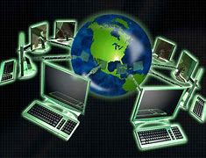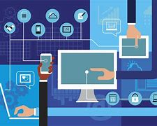
[images taken from Bing search engine – 21st century technology].
Con - to working remotely, is that even though we can still all communicate and delegate, we can still feel alone and isolated which may go missed by many people.

[Images from Bing search]
Pro - working remotely is also easier as I referred to earlier, you can have the comfort of the home instead of the car journey and traffic jams, along with noisy offices, call centres etc.
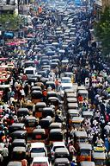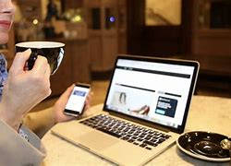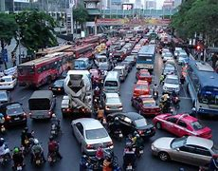
[Images from Bing search]
Con - the downside of having the comfort of home life while working, is that there can be multiple non-work-related distractions that you would not usually be used to in a working environment, such as children, pets, doorbell, visitors, non-work related calls, television distractions etc.
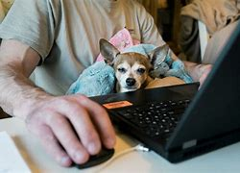
[Images from Bing search]
Pro – we are able to leave our workstation or now home area as often as we like as long as the work is successfully done. This could be quite handy, if you are easily stressed and need a moment away to compose yourself.
CON – it is too easy for an individual to be too relaxed and get lax daisy and not feel in the right frame of mind for work, so you can easily get distracted out of completing the required deadlines or tasks. Such as putting the television on in the background, and spending most of your time watching something instead of working.

2.4 Analysis
My analysis of remote working is that it seems that if you have an efficient enough working team, and can be trustworthy enough, then a business can thrive as it would have within the standard office environment. But if you do have a weak link or a team member easily distracted then that can have a negative impact on your or your teams work and overall goals and achievements. Remote working can also be negative as it can make you lazier. It can also make you feel more alone and depressed as you are as it says remote and could possibly make you feel less likely to ask for help and advice, but as long as you can have someone to reach out too or have a good team behind or around you, then you should effectively get your targets and goals achieved. Due to the pandemic that is currently happening all over the world (covid-19), many businesses have had to convert to remote working, and some of those who have not been able to, have even lost their jobs and livelihoods. A lot of emotions have come in to play here, with so many people now more than ever, especially as we currently have no way of de-stressing such as meeting up with your friends for a drink, meal etc, after a stressful day or week.

2.5 Conclusion
Remote working along with the right communication you can definitely make a business flourish. It can still be efficient and effective as long as you (if say you) or I am delegating then as long as we make it clear to whoever is needed or for who does what and when. Simply following a few steps to effectiveness can lead you or your team to success. With the technology we have and use everyday We can experience technical faults at any time, so as long as we can backup or save as we go along our work is less likely to be lost and we can try to send or redo what we were doing pretty sharpish afterwards, as these days technical faults through internet are and can usually be rectified quickly. The other benefits of not being in the field myself I am not constantly on materials and product runs anymore which saves me a lot of time I did not have spare before, so now with this course I am feeling the benefits of remote working more than ever, especially after thinking and feeling I had no other options when I had to stop trading myself.
I have looked at a lot of theories and steps on trying to better yourself and your team through trying times and if you can effectively work them into your everyday life, I cannot see how you can fail, but as I wrote before what was said against notarised Stephen Covey who is known for his work in this field and profession as an author of effectiveness, Stephen Covey’s son Sean Covey said:
“Depending on what they are our habits will either make us or break us. We become what we repeatedly do”.
This is where I am at with my way of thinking at the moment hence why I said earlier I have no fixed learning style, this is because I can get side-tracked and distracted easily, as I am not used to the home environment for my working or even learning conditions.

References

Gibbs, G. (1988) Learning by doing; A guide to teaching and learning methods. London: FEU

Ref - “Stephen Covey reviewed 200 years of success literature and crystallized what he learnt into (7) seven habits (or steps if you prefer) that took the world by storm in 1989”.

Mentioned Book - Stephen Covey and his 7 steps to effectiveness.

“More than (3) three decades later and the (7) seven habits of highly effective people continue to be an influential business. book delivering powerful lesson change”.

“Allowing or encouraging home working is generally good for the soul”, {by Helen Llewellyn}.

“Who wants to be stuck in a traffic jam or on a jam-packed tube when you could be having a coffee on your patio? {by James Costello, Helen Llewellyn’s peer}
Pg. 6: -

Blog -
Webpage: - https://krisp.ai/blog/
Quotes used: –
“Depending on what they are our habits will either make us or break us. We become what we repeatedly do”. {by Sean Covey, son of author Stephen Covey}.
Books and author: – From Stephen Covey’s modules and work.

The 7 Habits of Highly Effective People (franklincovey.com) Nine proven techniques to optimise your remote learning - CMI (managers.org.uk)

Pg. 7 conclusion and images of Stephen Coveys work and books.
A brief conclusion to some evidence and theories.
Bing images of Stephen Covey and book range to effectiveness.

Appendix 1

Pg. 3 About Mark Connelly.

Author and of Image of Mark Connelly.

Webpage -About Change-Management-Coach.com

Ref: –

“Stephen Covey reviewed 200 years of success literature and crystallized what he learnt into (7) seven habits (or steps if you prefer) that took the world by storm in 1989”.

Updated – 12th September 2020.

Mentioned - Stephen Covey and his 7 steps to effectiveness.

Pg. 4 other perspectives.

Named people and statements: -

Webpage used: - Exclusive: Remote working is just as effective, but it can hurt pay and promotion, HR execs warn - CityAM : CityAM

Cityam {logo taken from Bing images}.

Updated: - 20/04/21

Helen Llewellyn, Director of workplace specialist infinity wellbeing,
James Costello co-founder of workplace mental health, health consultancy Born Human.

Ref - “More than (3) three decades later and the (7) seven habits of highly effective people continue to be an influential business. book delivering powerful lesson change”.

Quotes: - From Helen Llewellyn and James Costello

“Allowing or encouraging home working is generally good for the soul”,
“Who wants to be stuck in a traffic jam or on a jam-packed tube when you could be having a coffee on your patio? {by James Costello, Helen Llewellyn’s peer}
Pg. 5 Examples of nine proven techniques images
Images -
Named people - Stephen Covey,7 habits book, Sean Covey and Christopher Morley.
Webpage link - Nine proven techniques to optimise your remote learning - CMI (managers.org.uk)

Pg.6

Blog -
Webpage: - (link) - https://krisp.ai/blog/
Quotes used: –

Quotes used by: -
Sean Covey, son of author Stephen Covey.

“Depending on what they are our habits will either make us or break us. We become what we repeatedly do”. {by Sean Covey, son of author Stephen Covey}.
Quote by Christopher Morley: -
“Barriers that will pop-up and impede your path of learning”.

“Direct your finite energies to control what you can control”. {Stephen Morley}
Author: - (link) The 7 Habits of Highly Effective People (franklincovey.com)

Pg. 7 conclusion and images of Stephen Coveys work and books.
A brief conclusion to some evidence and theories.
Bing images of Stephen Covey and book range to effectiveness.
Book written by Stephen Covey, (link) - The 7 Habits of Highly Effective People (franklincovey.com)

Pg. 8 Description and learning techniques.
Kolb and Fry (1975) learning and doing model; A guide and learning methods.
Gibbs, G. (1988) Learning by doing; A guide to teaching and learning methods. London: FEU

Pg. 9 Feelings (personal)

Pg. 10 Evaluation

Pg.11 Evaluation

Images taken from Bing search engine.

Pg. 12 My Analysis and Conclusion to remote working.

Quote: -
“Depending on what they are our habits will either make us or break us. We become what we repeatedly do”.{by Sean Covey}

