Title of the Coursework: Synthesize a solution to a potential real-life scenario.
Author: Andrew Gunney
Student ID: 2014950
Module Name and Code: Networks and Cyber Security Essentials ACCA4024
School of Applied Computing
Wales Institute of Science and Art
Date and Time of submission: Wednesday 14th July 2021 @ 15:00pm

Table of Contents
Contents
1. Introduction
2. Related Work/Review of Literature
2.1 Networks in General
2.2 Threats and Attacks
2.3 Mitigation
3. Design and Implementation
3.1 Weak Points/Vulnerabilities
3.2 Demonstration of an Attack
3.3 Implementation
3.4 Outcome
4. Mitigation Strategies and Recommendation
4.1 Importance of Strategies/Policies/Training/Practicing the Policies
4.2 Data Encryption Methods and Digital Signatures
4.3 Recommendations
4.4 Passwords
4.5 Physical Access Controls
4.6 User Access Management
4.7 Network Protocols
4.8 Networking Devices
5. Conclusion
6. Glossary
7. References
8. Bibliography
9. Appendices
9.1 Screenshots/Policies
9.2 List of Figures
10. List of Tables
10.1 Addressing Table for Packet Tracer Demonstration
10.2 User Accounts and Passwords for Packet Tracer Demonstration

1. Introduction
In this coursework I am going to discuss computer networks, the threats to them and potential attacks that could be made against them. Based on the scenario of Che-SI construction company, I will demonstrate to their policy makers, a potential attack that could be performed against their network. I will then recommend guidelines that the Security Chief can implement to help secure the network from future cyber-attacks.

- Related Work/ Review of Literature
  - Networks in General
Any two or more devices that can communicate with each other can be considered a network. The more devices that are communicating with each other, the bigger the network. A large company like Che-Si Construction may have thousands or even tens of thousands of devices that make up their network or networks. [16] The components that make up a network can be split into 3 categories.
End devices - Desktop Computers, Laptops, Printers, Photocopiers, Tablets, Smart Phones
Intermediate Devices - Switches, Routers, Firewalls, Wireless Routers
Network Media - Copper Cables, Fibre Optic Cables, Wireless Transmissions
Protocols have been developed overtime so that network devices and networks themselves can communicate with each other using a common language. [17] To be able to communicate there must be an agreement as to how messages are structured and that’s where protocols are so important as they govern message formats, sizes, patterns, timing, and how messages are encoded and encapsulated. The protocols themselves are established by international organisations or industry wide organisations such as the Institute of Electrical and Electronic Engineers (IEEE).
  - Threats and Attacks
Networks are vulnerable to attacks from anywhere and everywhere.[18] Company data and infrastructure are all potential targets for attacks by cybercriminals, hacktivists, vulnerability brokers and even state sponsored or corporate hackers.
Understanding the threats (potential dangers to the network or network components), vulnerabilities (weaknesses which could be exploited) and the risks (likelihood that a threat manages to exploit a weakness) gives an organisation a greater awareness of where they need to focus their attention to secure their network.

  - Mitigation

- Design and Implementation
  - Weak Points/ Vulnerabilities
  - By way of illustrating one type of attack that could potentially be used to target the company’s data and systems, I will use Cisco Packet Tracer to demonstrate how a sniffing attack can be used to gain a user’s credentials. The credentials will then be used by the attacker to access and download company data, in this case, files stored on an FTP server.
  - Implementation
[1] “Sniffing is the process of capturing-decoding-inspecting-interpreting the data from the packets transmitted over the transmission channel e.g. TCP/IP network.”. An attacker can use a sniffing tool (sometimes referred to as a network protocol analyser) to inspect packets of data as they travel across a network. [2][3] Attacks can happen passively by letting the sniffer ‘soak up’ the traffic as it passes through it, or actively. Active sniffing is where a tool tries to reach all parts of the network and must bypass any strategies enforced by network switches. The tool, which can be hardware or software based, inspects the packets to look for unencrypted, plaintext information/data that will benefit the attacker such as [1] usernames, passwords, credit card details, emails, or instant message/chat conversations.

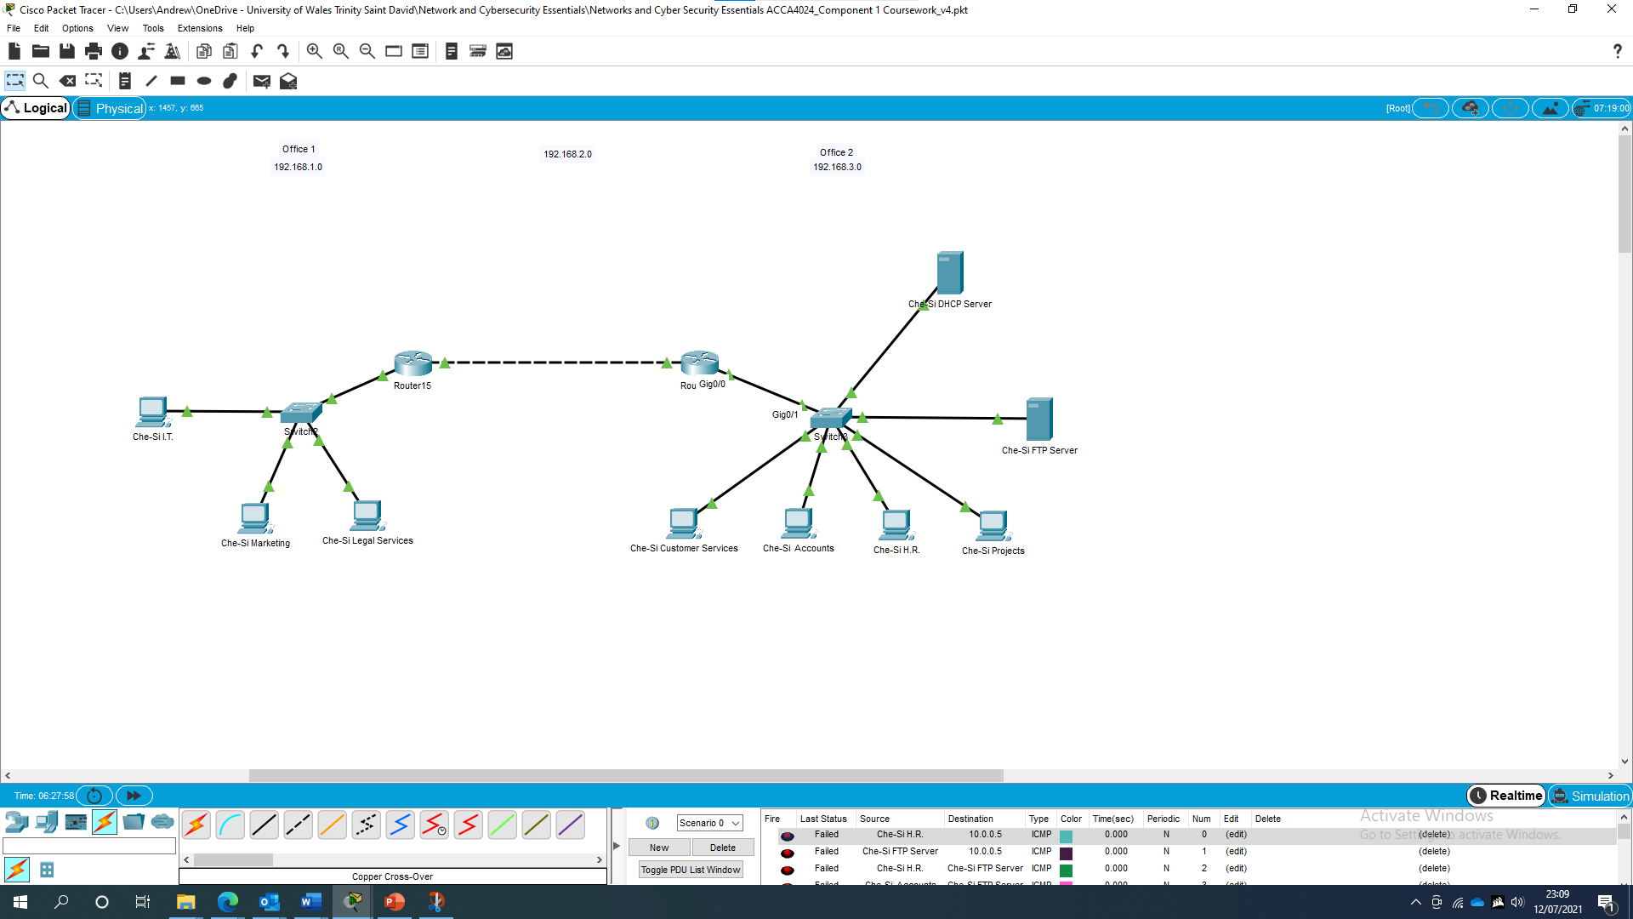
Figure 1. A Packet Tracer diagram of part of Che-Si’s network infrastructure.
For the purposes of the demonstration, an attacker has inserted a sniffer between two routers.

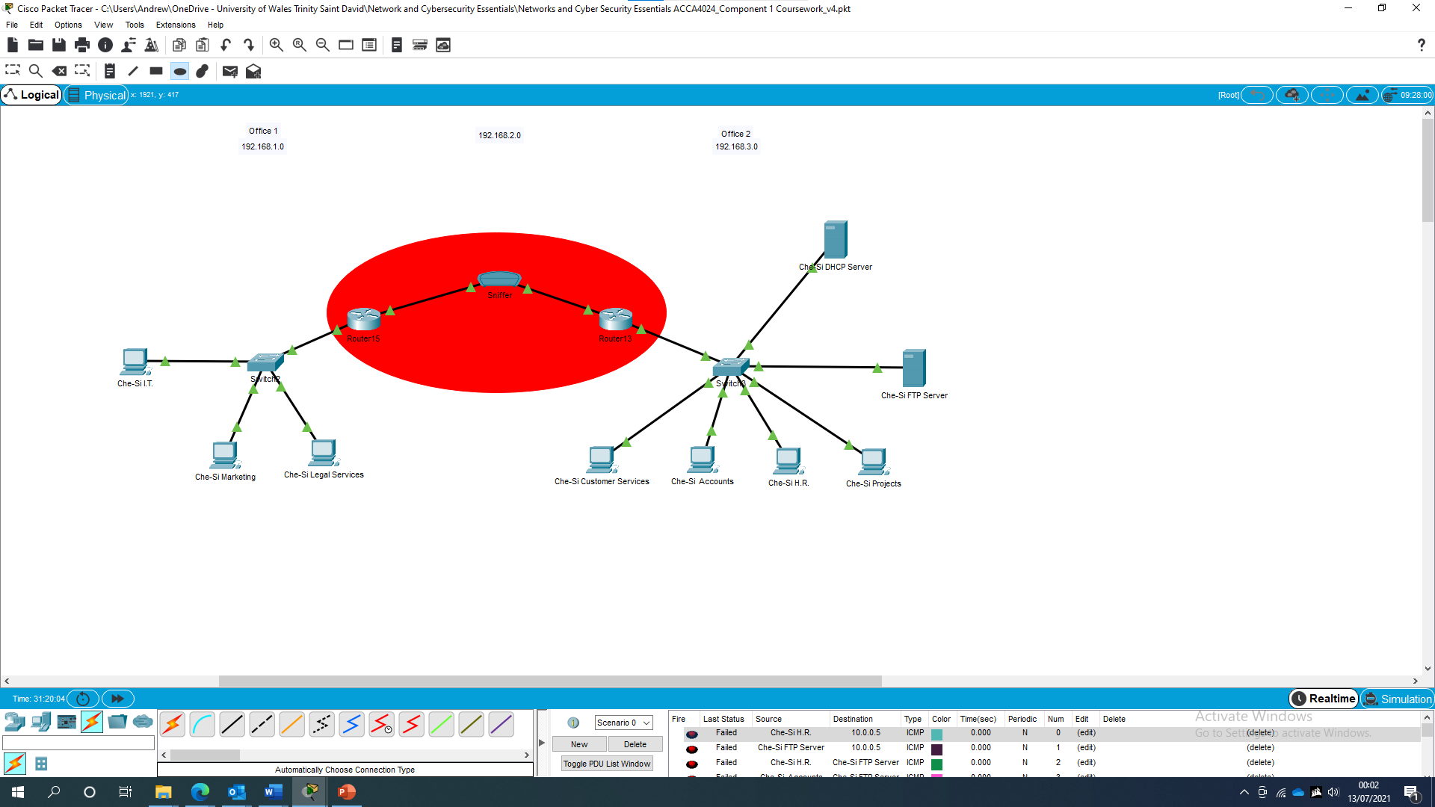
Figure 2. A Packet Tracer diagram showing that an attacker has inserted a sniffer between 2 routers.

The sniffer they have chosen for this attack, is a small hardware device, [4] however there are many software tools available. Some examples are [5] SniffPass, [6] Psnuffle, [7] Ace Password Sniffer and [8] WireShark.
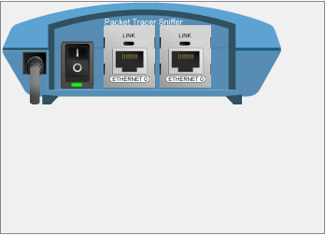
Figure 3. An image of the sniffer used in the attack.

The attacker has altered the cabling so that the packets now flow from Office 1’s network hosts, through Router 15, then through the sniffer, before continuing onwards to Router 13 and into Office 2’s network where they continue to their destination. This makes the attack, a passive attack. The sniffer will analyse packets as they pass through it, looking for those using the FTP protocol. The packets could potentially contain details of usernames, passwords and the names of files uploaded to or retrieved from the company’s FTP server.
A member of staff in Che-Si’s Legal department, wants to upload a confidential legal document to the company’s FTP server.
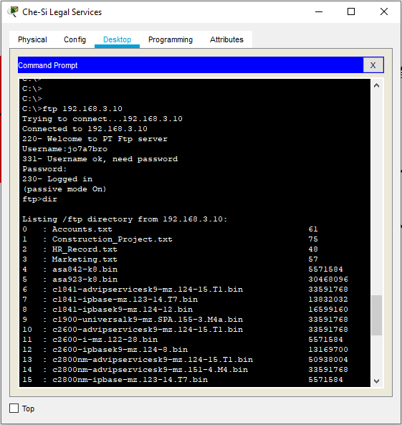
Figure 4. An image showing the member of staff using the Command Prompt to connect to the FTP server.
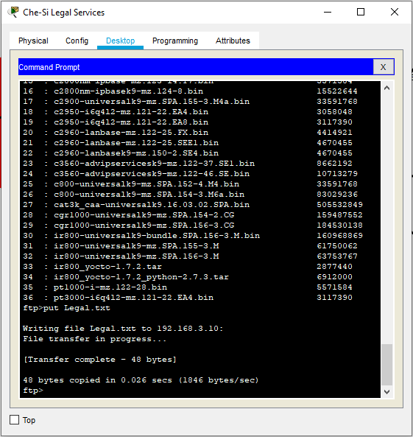
Figure 5. A screenshot showing that the confidential file has been uploaded.

Upon reviewing the packets inspected by the sniffer, the attacker finds they have retrieved the username and password, entered by the member of staff when connecting to the FTP server. They have also learned the destination host address where the packets were being sent which gives them information on how to contact to the FTP server.

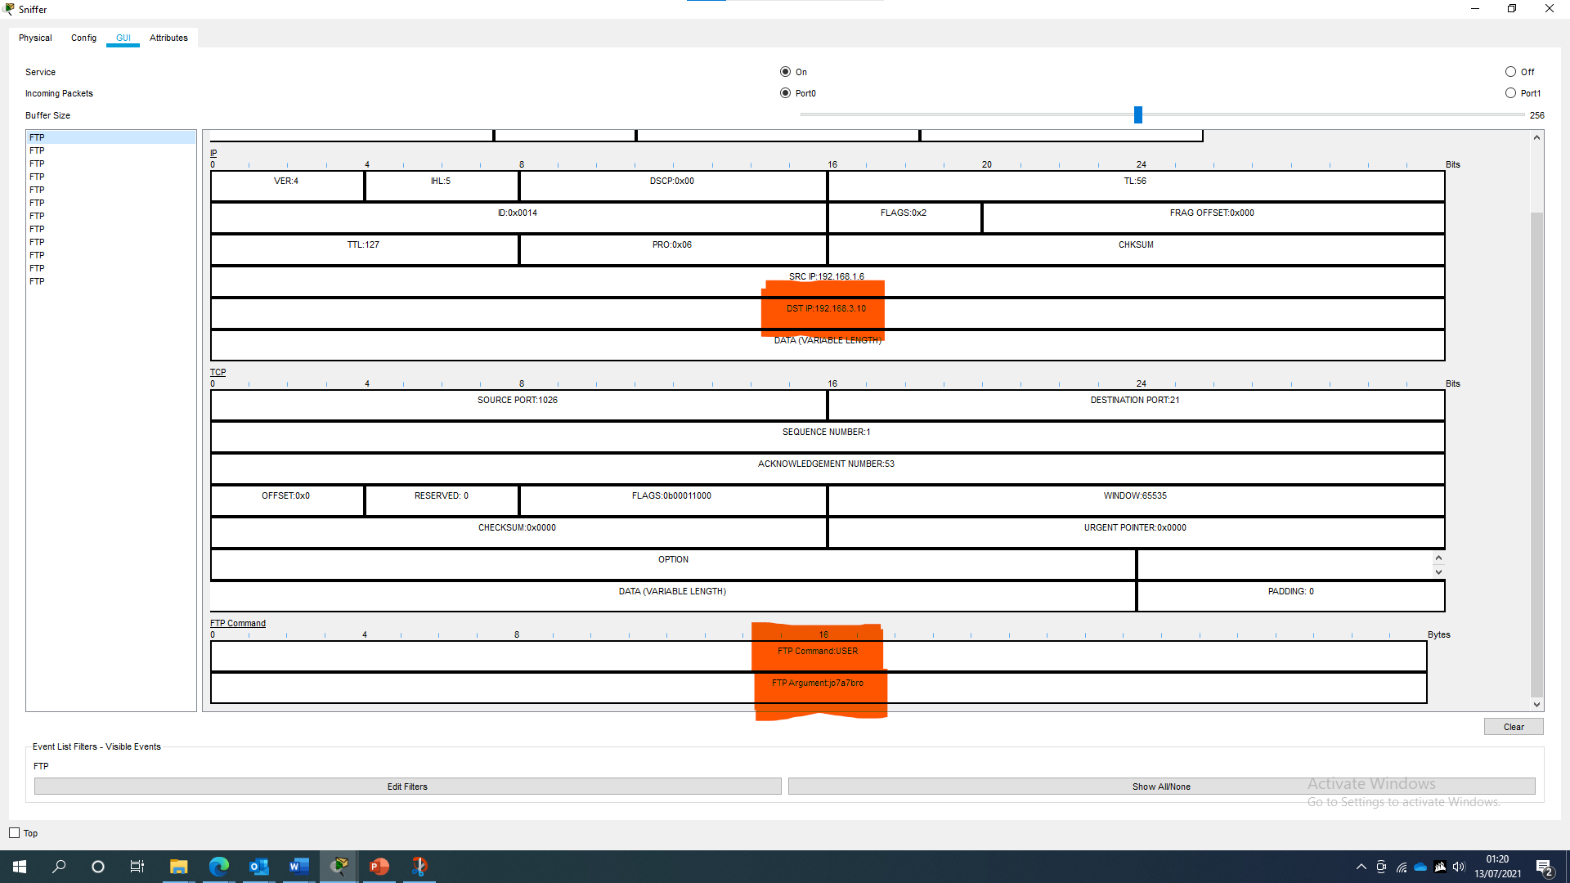
Figure 6. An Ethernet frame captured by the sniffer that displays the username entered by the member of staff and the IP address of the host (the FTP server).

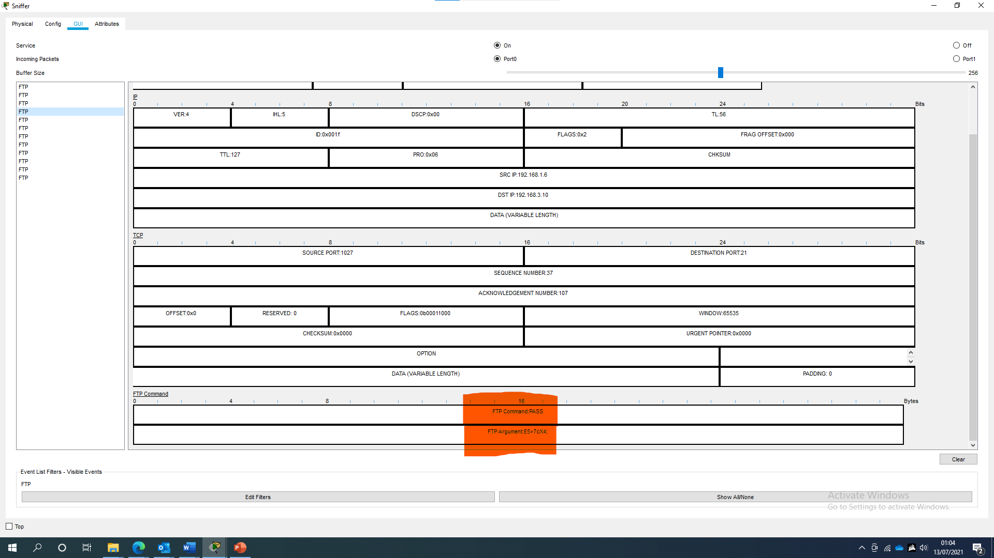
Figure 7. An Ethernet frame displaying the password entered by the member of staff.
The attacker has been able to retrieve a member of staff’s username (jo7a7bro) and password (E5>7cX4;), and the IP address of the FTP server (192.168.3.10). The attacker can now use these details to try and connect to the FTP server or even attempt to use them to gain access to other company systems or services.

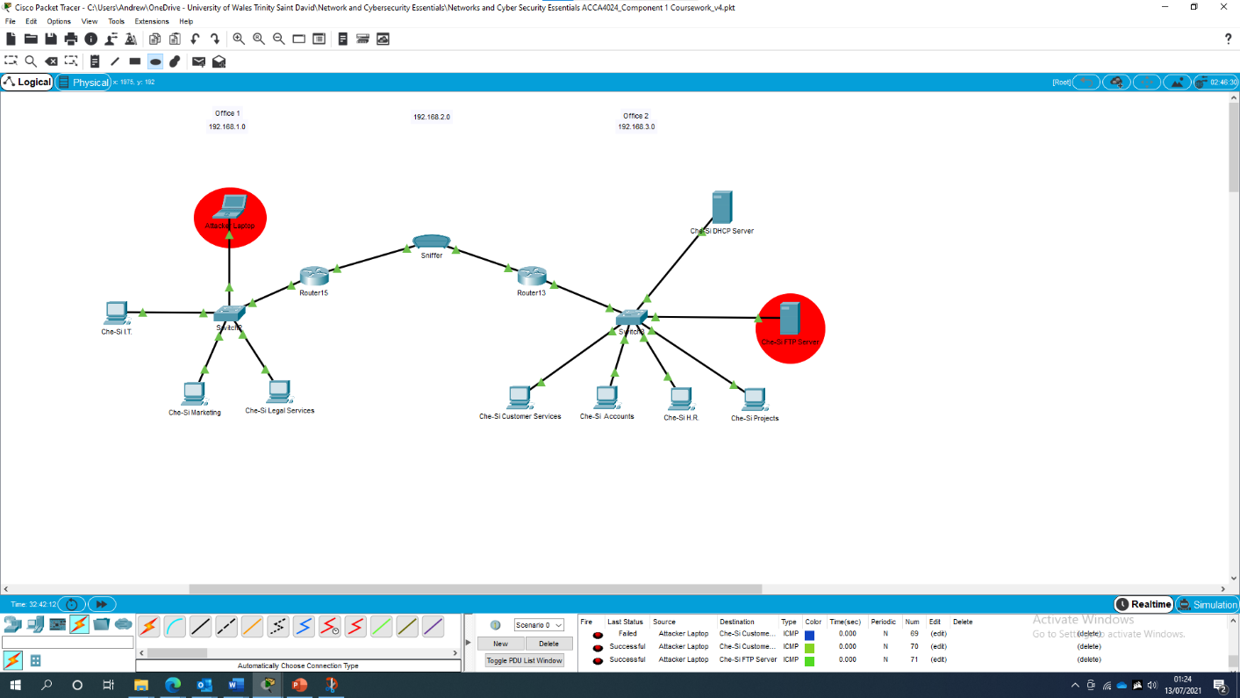
Figure 8. The attacker has connected their own device to the company’s network.
The attacker has connected their own device to the company’s network, and they will now use the credentials harvested by the sniffer, to try and gain access to company files/data, held on the FTP server.
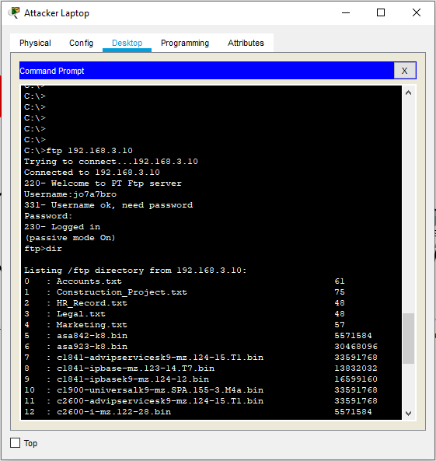
Figure 9. A command prompt from the Attacker’s laptop showing them using the harvested user credentials to connect to the FTP server.
Having gained access to the FTP server, the attacker now has access to many confidential company records. The attacker can copy these documents to their own laptop so if the access changes/is removed, they still have access to a wealth of company data.

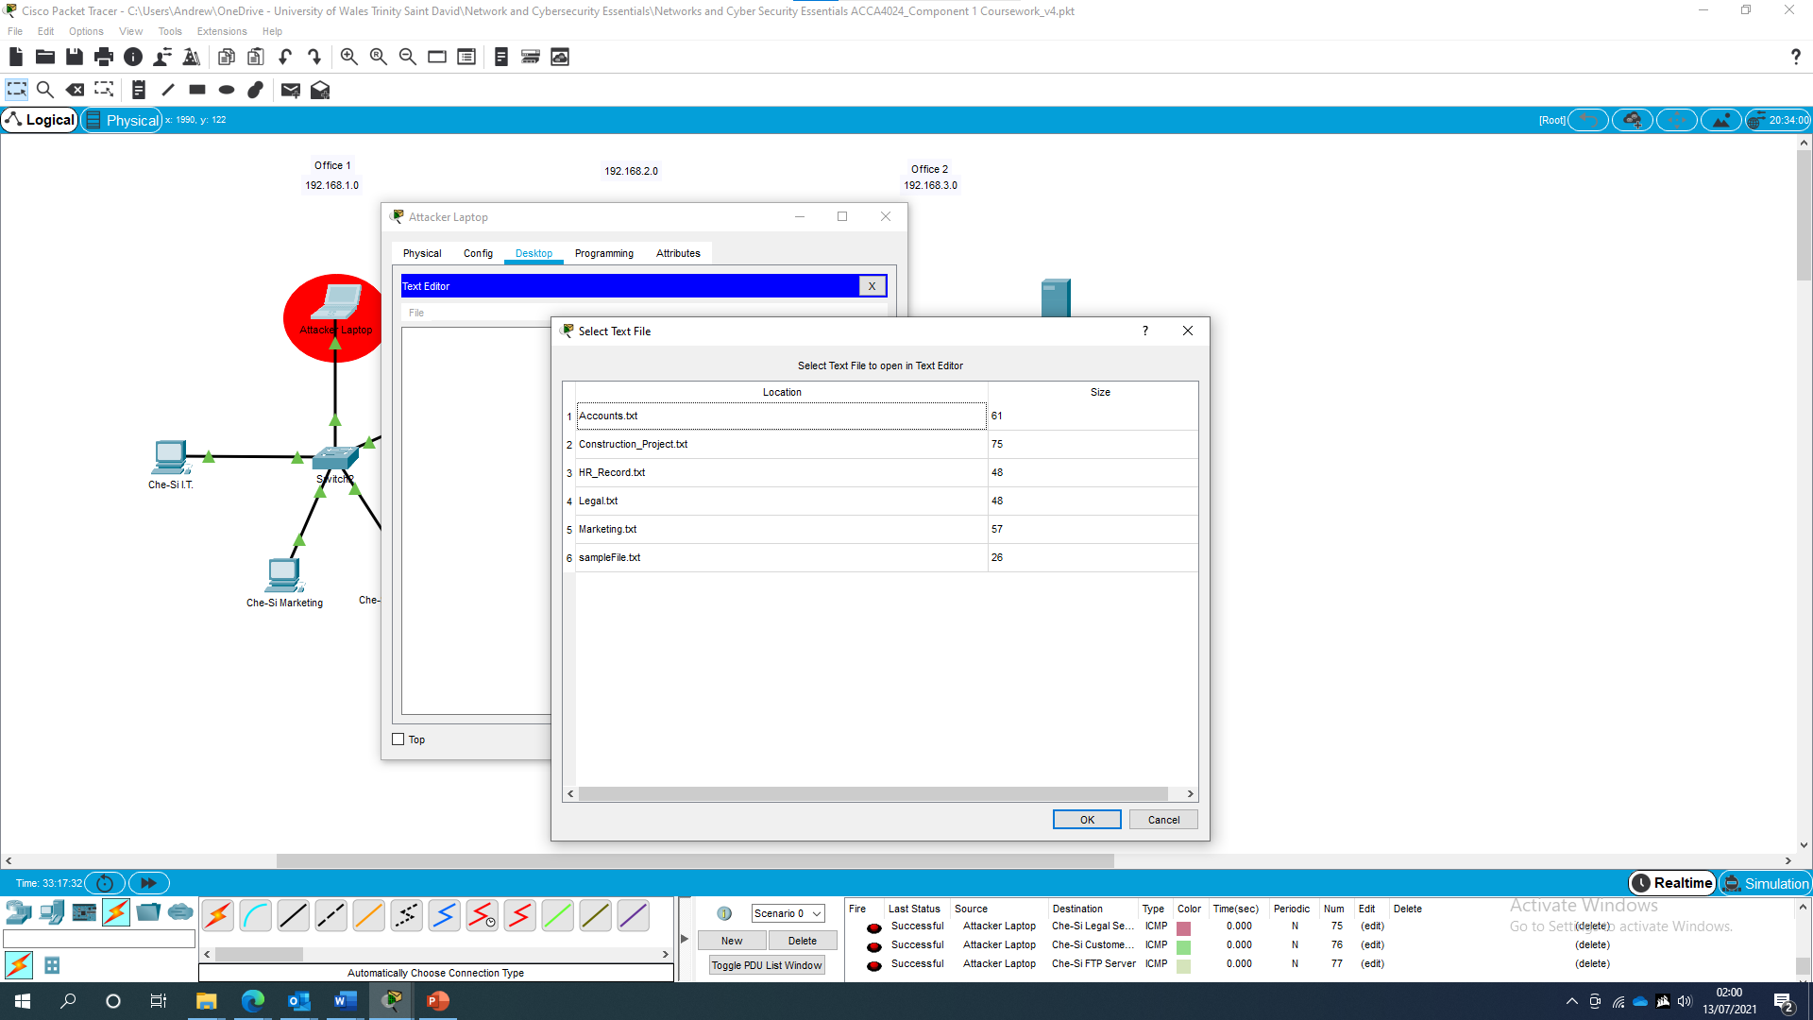
Figure 10. An image showing the contents of the attacker’s laptop and the confidential files they have downloaded.

  - Outcome
In this demonstration I have shown how an attacker can steal confidential company data using a sniffer attack. However, the attacker could have just as easily used their access to undertake malicious acts, such deleting/renaming files, changing passwords or configuration settings. If this were a real attack, the attacker would likely gain many more user’s credentials, potentially allowing them to gain further access to Che-Si’s network where they could steal more data or cause more harm.

- Mitigation Strategies and Recommendation
4.1 Importance of Strategies/ Policies/ training/ practicing the policies.
4.2 Data Encryption methods and Digital Signatures
[19] Encryption is the process of protecting data by using mathematical functions to change or scramble it so that is unreadable without the use of decryption key. Encryption methods will each have their own specific algorithm that they use to encrypt and decrypt messages. Known as ciphers, each follows a set of defined steps that first encrypt and decrypt a message.
4.3 Recommendations
Based on my demonstration of a sniffing attack in 3.3, I will make the following recommendations to Che-Si’s Security Chief. They are designed to strengthen network security without compromising the company’s 24x7 operations. If these mitigations were put in place, a successful sniffing attack would likely do much less harm than if these mitigations were not put in place.

4.4 Passwords
[10] [11] [12] The UK National Cyber Security Centre (UK NCSC) recommends the following measures to improve the security of passwords:
    - Create strong passwords made up of 3 random words.
    - Save passwords in web browsers.
    - Implement and turn on two-factor authentication (2FA).
    - Use single sign-on systems (SSO)
    - Do not enforce regular password expiry.
    - Do not use complexity requirements.
    - Turn on and enforce, automatic software updates.
    - Ensure data is backed up frequently.

4.5 Physical access controls [13] [14]
    - Physical security measures must always be adhered to. Security doors and windows must be closed securely. Filing cabinets and key safes must be locked. Access cards, PIN codes, keycodes must be kept secure and must be changed on a regular basis.
    - A clear desk policy should be implemented to ensure confidential information is not visible to unauthorised persons when staff are not at their desks.
    - Screens should be set to automatically lock after 10 minutes of inactivity.
    - All critical networking equipment, servers, switches, routers, firewalls etc must be located in secure areas, where access is restricted to authorised members of staff. Identities must be checked in these areas.
    - Members of staff working in secure areas should always challenge anyone not displaying a badge or visitor identification tag,
    - Appropriate intrusion and monitoring systems must be put in place in areas where critical networking equipment is located, e.g., window and door alarms, CCTV cameras, and motion detectors.

4.6 User Access Management [13] [14]
    - Users must only be given the lowest level of privileges required to carry out their job.
    - Administration or elevated privileges must not be used as a standard operating account. They must only be used for the function they are required for.
    - User IDs must not provide any indication as to the level of privileges that they confer.

4.7 Networking Protocols
- Protocols that allow the transmission of unencrypted plaintext data must be disabled, and appropriate secure methods used instead e.g. SSH, SFTP

4.8 Networking devices
- Passwords must be changed from the manufactures default.
- Privileged exec mode must be protected with a password.
- Passwords must be encrypted and not left as plaintext.
- Unused ports must be disabled.
- Security updates (firmware, software) must be applied when released by the manufacturer.
- Conclusion
In conclusion, Che-Si Construction have plenty of scope to review their network security and implement effective mitigations to prevent cyber-attacks. Their network is currently extremely vulnerable to attacks, as I have demonstrated in my sniffing attack. However, that demonstration was just one of many possible attacks that could seriously harm the company’s data, network infrastructure and reputation. No network will ever be completely secure. Attackers are constantly changing their methods of attack and so cyber security professionals will have to constantly adapt to these new attacks. Implementing the recommendations I have outlined in section 4, will go a long way towards securing the network and provide a solid platform from which the company can continue to strengthen its defences against further cyberattacks.

- Glossary (If required)

- References
[1] J. N. V. U. Jeyanthi Nagamalai at VIT University, "A Review on Various Sniffing Attacks and its Mitigation Techniques," Research Gate, December 2018. [Online]. Available: https://www.researchgate.net/publication/329467167_A_Review_on_Various_Sniffing_Attacks_and_its_Mitigation_Techniques. [Accessed 13 July 2021].
[2] N. Latto, "What Is a Sniffer and How Can You Prevent Sniffing?," Avast Software s.r.o., 8 July 2021. [Online]. Available: https://www.avg.com/en/signal/what-is-sniffer. [Accessed 13 July 2021].
[3] Belcic, "What is a Sniffer, and How Can I Protect Against Sniffing?," Avast Foundation, 14 May 2021. [Online]. Available: https://www.avast.com/c-sniffer. [Accessed 13 July 2021].
[4] Unknown, "Password Sniffing Attack," Shh.com, 2021. [Online]. Available: https://www.ssh.com/academy/attack/password-sniffing. [Accessed 13 July 2021].
[5] NirSoft, "SniffPass v1.13 - Password Monitoring Software," NirSoft, 2005-2012. [Online]. Available: http://www.nirsoft.net/utils/password_sniffer.html. [Accessed 13 May 2021].
[6] Max, "Max's Blog," 2010. [Online]. Available: http://remote-exploit.blogspot.com. [Accessed 13 July 2021].
[7] EffeTech, "Ace Password Sniffer," EffeTech, 2009. [Online]. Available: http://www.effetech.com/aps/. [Accessed 13 July 2021].
[8] Unknown, Wire Shark, 2021. [Online]. Available: https://www.wireshark.org. [Accessed 13 July 2021].
[9] Purnama1 - Published under licence by IOP Publishing Ltd - Journal of Physics: Conference Series, Volume 1511, International Conference on Science Education and Technology (ICOSETH) 2019, 23 November 2019, Surakarta, Indonesia
[10] Dan U, Device Security Research Lead, "Passwords, passwords everywhere," National Cyber Security Centre, 21 April 2019. [Online]. Available: https://www.ncsc.gov.uk/blog-post/passwords-passwords-everywhere. [Accessed 13 July 2021]
[11] National Cyber Security Centre, "Password administration for system owners," National Cyber Security Centre, 18 November 2018. [Online]. Available: https://www.ncsc.gov.uk/collection/passwords/updating-your-approach. [Accessed 13 July 2021].
[12] National Cyber Security Centre, "Improve your online security today," National Cyber Security Centre, Unknown. [Online]. Available: https://www.ncsc.gov.uk/cyberaware/home. [Accessed 13 July 2021].
[13] Information Governance Management Advisory Group Policy Sub Group. Group, "NHS Wales Information Security Policy," 26 June 2018. [Online]. Available: http://www.wales.nhs.uk/sites3/Documents/950/All%20Wales%20Information%20Security%20Policy%20v1.pdf. [Accessed 13 July 2021].
[14] Powys Teaching Health Board, “ICT Security Procedures and Guidelines”, Mar 2020. [Document]. [Accessed 13 July 2021].
[16] Cisco Netacademy Course - Network Essentials [Online]. Available: https://www.netacad.com. [Accessed 13 July 2021].
[17] Britannica, “Protocol”, Britannica, [Online]. Available: https://www.britannica.com/technology/protocol-computer-science. [Accessed 13 July 2021].
[18] N.Kaliyamurthy (2020). Threats, Vulnerabilities Attacks [PowerPoint Slides]. Available UWTSD Moodle.
[19] Information Commissioner’s Office, “What is encryption?” Information Commissioner’s Office [Online]. Available: https://ico.org.uk/for-organisations/guide-to-data-protection/guide-to-the-general-data-protection-regulation-gdpr/encryption/what-is-encryption/

8. Bibliography

9. Appendices
9.1 Screenshots/ Policies
9.2 List of Figures
Figure 1. A Packet Tracer diagram of part of Che-Si’s network infrastructure. 4
Figure 2. A Packet Tracer diagram showing that an attacker has inserted a sniffer between 2 routers. 4
Figure 3. An image of the sniffer used in the attack. 5
Figure 4. An image showing the member of staff using the Command Prompt to connect to the FTP server 5
Figure 5. A screenshot showing that the confidential file has been uploaded 6
Figure 6. An Ethernet frame captured by the sniffer that displays the username entered by the member of staff and the IP address of the host (the FTP server). 6
Figure 7. An Ethernet frame clearly showing the password entered by the member of staff. 7
Figure 8. The attacker has connected their own device to the company’s network 7
Figure 9. A command prompt from the Attacker’s laptop showing them using the harvested user credentials to connect to the FTP server. 8
Figure 10. An image showing the contents of the attacker’s laptop and the confidential files they have downloaded. 8

10. List of Tables
10.1 Addressing Table for Packet Tracer Demonstration

Device | IP Address | Subnet Mask | Default Gateway
Che-Si I.T. | 192.168.1.7 | 255.255.255.0 | 192.168.2.1
Che-Si Marketing | 192.168.1.5 | 255.255.255.0 | 192.168.2.1
Che-Si Legal Services | 192.168.1.6 | 255.255.255.0 | 192.168.2.1
Attacker Laptop | 192.168.1.8 | 255.255.255.0 | 192.168.2.1
Che-Si DHCP Server | 192.168.3.2 | 255.255.255.0 | 192.168.2.2
Che-Si FTP Server | 192.168.3.10 | 255.255.255.0 | 192.168.2.2
Che-Si Projects | 192.168.3.23 | 255.255.255.0 | 192.168.2.2
Che-Si H.R. | 192.168.3.22 | 255.255.255.0 | 192.168.2.2
Che-Si Accounts | 192.168.3.21 | 255.255.255.0 | 192.168.2.2
Che-Si Customer Services | 192.168.3.20 | 255.255.255.0 | 192.168.2.2
Router15 Gig 0/0 | 192.168.1.1 | 255.255.255.0
Router15 Gig 0/1 | 192.168.2.1 | 255.255.255.0
Router13 Gig 0/1 | 192.168.2.2 | 255.255.255.0
Router13 Gig 0/0 | 192.168.3.1 | 255.255.255.0

10.2 User Accounts and Passwords for Packet Tracer Demonstration

Username | Password | Department
cisco | cisco | Admin
client01 | p>&5%Md | Client
ja7a7bro | *?f+nLs4 | HR
jo7a7bro | E5>7cX4; | Legal
kp7a7bro | C3;gkARj | Marketing
mi7a7bro | L4CJ4_k6 | Projects
pa7a7bro | M)sR@c]3 | Accounts
pb7a7bro | Be8b$?X\ | I.T.

