

Creativity and Innovation
By Chris Bikos
2210947
22 March 2024
4386 Words

Contents List
Contents
Executive Summary 3
Task 1- Introduction 4
Task 2 – Amazon Pop-Up Store 7
Task 3 – Creativity Process 9
Task 4 – A Critical Evaluation 11
Task 5 – Organisational Climate & Leadership Styles 13
Conclusion 18
Reference List 19

Executive Summary
Creativity and innovation are now necessary for businesses to survive and stay competitive in the quickly evolving business environment of today. This research investigates the value of innovation and creativity in my company.
In order to increase awareness of the importance of creativity and innovation in all facets of human development, the United Nations declared April 21 to be World Creativity and Innovation Day (United Nations, nd).

Amazon.com, Inc., or simply Amazon, is one of the biggest and most significant technology and e-commerce enterprises in the world. Since its founding as an online book retailer, Amazon has expanded into a wide range of other markets and product categories, such as artificial intelligence, cloud computing, and digital streaming.
I propose to investigate the possibility of launching a pop-up shop on Amazon and, if successful, expanding the initiative across the country for this assignment. Colleagues will have the chance to purchase damaged goods at a discounted price by means of a pop-up store.
Additionally, this is a fantastic chance to perhaps boost sales and turn a solid profit. From a humanitarian perspective, a portion of sales might also be given to nearby nonprofit organisations.
Amazon will also benefit from this as it will be perceived as a firm that tries to do good, and employees will feel good about their purchases knowing that they may be able to help someone in need. But in order to make it happen, we'll closely look at the various dangers, obstacles, and motivators.

As stated by Dudovskiy (2022), Amazon must continue to run its business with flexibility and make decisions quickly in spite of the business's increasing complexity. The major obstacle to making this concept a reality will be the hierarchy that comes with it. We shall see in detail what challenges will be exposed and how to overcome them.

Complacency is a major barrier to creativity because it can be more comfortable to stick with what you know rather than try something new (Boyles, 2022). My goal is to provide the solutions required by this report and to make the pop-up store a feasible option for Amazon to use.



Task 1- Introduction
Jeff Bezos established the worldwide technology business Amazon in 1994. Amazon began as an online book retailer but has since grown to become one of the biggest online retailers in the world, carrying a wide range of commodities like clothing, electronics, and household goods. The company's cheap pricing, wide range of products, customer-centric approach, and effective delivery services are the main factors contributing to its success.

Amazon has greatly expanded its line of business outside e-commerce. It runs Amazon Web Services (AWS), a cloud computing provider that serves companies worldwide. Amazon has also dabbled with digital streaming services, offering music streaming through Amazon Music and video streaming through Amazon Prime Video. The business also produces consumer gadgets like Fire tablets, Kindle e-readers, and Echo smart speakers with Alexa built in.

Processing damaged and returned goods from customers is my current job as an Amazon Associate in the customer returns department. In the customer returns department, I also work in various departments, such as sorting clothing, shoes, and hardlines to be transferred to the appropriate stations for processing.

Creativity vs. Innovation: What's the Difference?
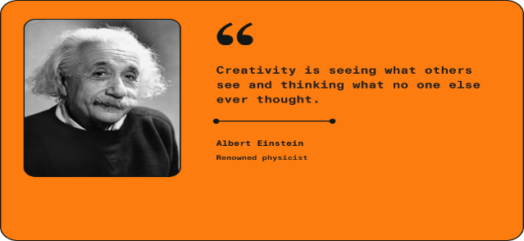
(This quote is great, it's so basic yet so true!)
This is a reflection on originality by Albert Einstein. Every individual, according to Einstein, has a distinct viewpoint that encourages creativity (Barnhart, 2021).

Creativity is the ability to think differently and apply new perspectives to old problems. It is a vital business talent that allows people to adapt and develop novel ideas that may be even more effective than tried-and-true ones (Peek, 2024).

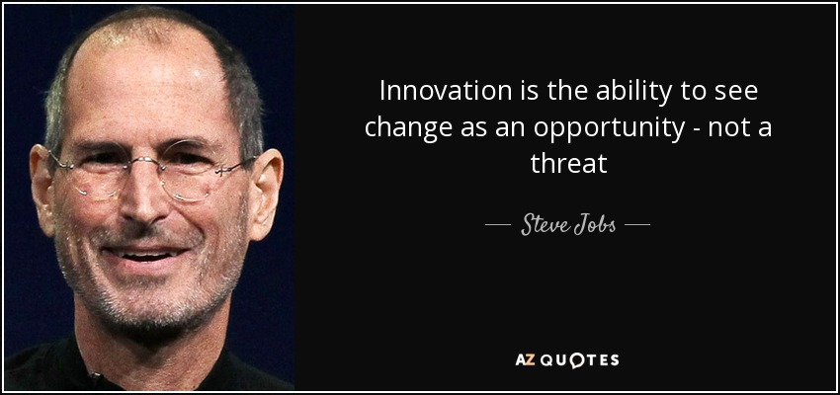
In addition to being a visionary leader, Steve Jobs, the co-founder of Apple Inc., was also a symbol of ingenuity, tenacity, and ground-breaking technological innovations (One Existence Foundation, 2023).

According to Mckinsey and Company (2022), innovation is the systematic process of developing and promoting game-changing products and services for customer adoption.

For Amazon, innovation is vitally crucial. Innovation has always been a top priority for Amazon and a vital component of its business plan.

Amazon prioritises understanding and meeting client needs. Creativity and innovation allow the organisation to constantly create new goods, services, and features that improve the consumer experience. By staying ahead of consumer trends and preferences, Amazon can preserve its competitive advantage while also attracting and keeping customers.

The business landscape is always changing, as new technology, consumer behaviours, and market dynamics shape the industry. Amazon can effectively adapt and evolve in response to these changes thanks to its creativity and innovation. By embracing innovation, Amazon can maintain agility and resilience in the face of unpredictability and upheaval.

Logistics Amazon

The operations covered by Amazon's logistics division are extensive and include fulfillment centres, shipping, warehousing, and more. To oversee its extensive network of warehouses, distribution hubs, transit, and delivery systems, Amazon mostly relies on logistics. A vital part of Amazon's operations is logistics, which makes sure that goods are accurately and efficiently picked, packed, and delivered to customers.
As Elgazzar (2021) states, research and applications in logistics are more crucial now than they have ever been. Given a heightened understanding of the operational, strategic, and financial effects logistics has on business success, logistics has grown in importance within the industry.
The establishment of a Pop-up store at my fulfilment centre in Swansea will heavily rely on logistics. Effective inventory management would be required of Amazon for processed damaged goods to be uploaded and appear as available for sale.
The best part of this concept is that Amazon already has enough warehouse space to keep the merchandise for the temporary store. Amazon can make better judgments to enhance its logistical operations and overall business plan by analysing sales data, colleague reviews, and other pertinent variables.
For every business, including an Amazon pop-up store, long-term viability, ongoing innovation, and achieving more with less are essential factors to take into account. Despite the fact that Amazon is mostly successful because to its creative business strategy, there are still important considerations when opening a pop-up store, like adapting to changing market conditions, effectively allocating resources, placing a high value on employee happiness, and reducing risks.
In business, logistical factors have always been strategically important. Retailers and wholesalers look beyond transportation and inventory management to consider one of the most important aspects of running a successful business: location in respect to markets or supply sources (Haskett, 1977).

This 1977 article, which is rather interesting, describes how computer technology was being adopted more and more in logistics and how it was being used for tasks like inventory management and route optimisation (definitely worth a read).
‌

Task 2 – Amazon Pop-Up Store
I'd like to introduce the Amazon Pop-Up store to the associates at my Fulfilment Centre in Swansea. I constantly hear co-workers stating that they wouldn't mind purchasing the product for less money. There are so many returns that are damaged for minor reasons, which provides an excellent opportunity to sell these products at a discount.
Part of the proceeds from the associates purchasing damaged products could be donated to local charity organisations, resulting in money well spent. Employees would have a positive feeling knowing that the money they spent was donated to a worthy cause—it's a win-win situation!

Radical or Incremental Innovation

According to several authors, the difference between radical and incremental innovation is crucial to understanding this area of research (Escrig-Tena et al., 2021, p. 107994).

The next step in developing a new idea is to determine whether it is a radical or incremental idea. Definitions should be provided to help understand these innovations (below):

Radical innovation is an invention that undermines or replaces an established business model. Radical innovation completely disrupts existing systems and processes in order to replace them with something new (Wright and Pratt).
Incremental innovation is the practice of adding modest, progressive improvements or enhancements to a current product, process, or service (Norelli, 2023).

Incremental Innovation
This creative approach would be incremental because Amazon currently donates damaged goods to local charities to assist them. By not renting a warehouse and hiring employees, this process could save the business money.
Additionally, by not having employees store the damaged goods once they are processed, Amazon may be able to reduce labour costs or reallocate resources to other departments.
The 4 P’s Model
Joe Tidd and John R. Bessant introduced the four Ps model in their management textbook "Managing Innovation: Integrating Technological, Market, and Organisational Change," which is a framework for organising and focusing innovation initiatives (Michigan State University, 2023).

The four P’s in this version stand for Position, Process, Product, and Paradigm. Below is a summary of every component:
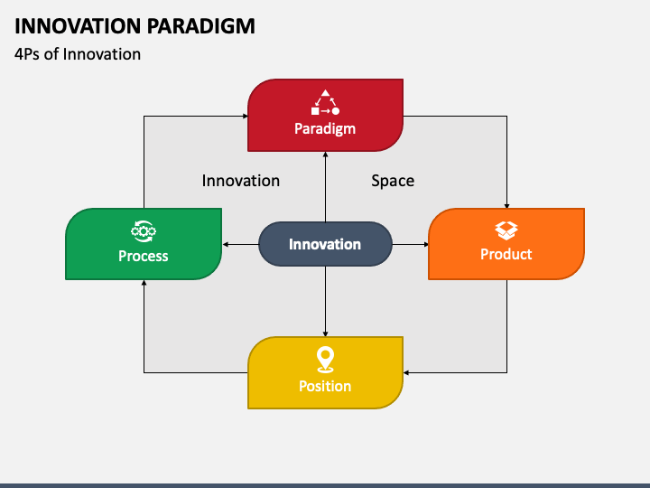

Product: In this context, "Product" refers to the offering that a firm provides, whether it's a tangible product or an intangible service. This is similar to the traditional marketing mix.

Process: "Process" describes the procedures and frameworks that a business uses to provide its clients with its goods and services.

Position: "Position" describes the market positioning approach a business uses to set itself apart from competitors and instill a distinctive value proposition in the eyes of consumers.

Paradigm: The term "paradigm" describes the underlying presumptions, convictions, and mental models that influence an organization's perspective of the market, its sector, and its own competencies.
My plan to launch a pop-up shop on Amazon will primarily depend on the product. An extensive and critical assessment of how processed damaged goods (Products) will be essential is provided below.
Product
The first step in developing a marketing plan is comprehending the product. Why and who needs it? (Twin, 2024). Establishing a pop-up shop on Amazon gives coworkers a special chance to interact more quickly and deeply with brands at a discounted price. A well-thought-out product strategy is necessary to maximise a pop-up store's effect and success.
Pop-up shops on Amazon can operate as focal points for workplace socialisation and community involvement, boosting employee morale. Amazon can test various price strategies for processed returned items by using pop-up storefronts, which offer a low-risk alternative. This enables them to get insightful input from colleagues and refine their strategy prior to growing their pop-up store or reaching every Amazon fulfilment centre.
A pop-up shop on Amazon can draw attention to the environmental advantages of purchasing used goods, making it more enticing to coworkers who value cutting back on waste and carbon emissions.

Selling used goods through a pop-up shop has several benefits overall, such as minimal overhead expenses, flexibility, carefully chosen shopping experiences, and chances for employee involvement and experimentation.

Task 3 – Creativity Process
More than ever, creativity and innovation are essential building blocks for our world to overcome obstacles, spur progress, and stand out in a cutthroat and demanding marketplace (Dias and Marinho-Araujo, 2023).

Being creative is a process rather than just having "lightbulb" moments. The Creativity Process has four stages, which will be covered in more detail.
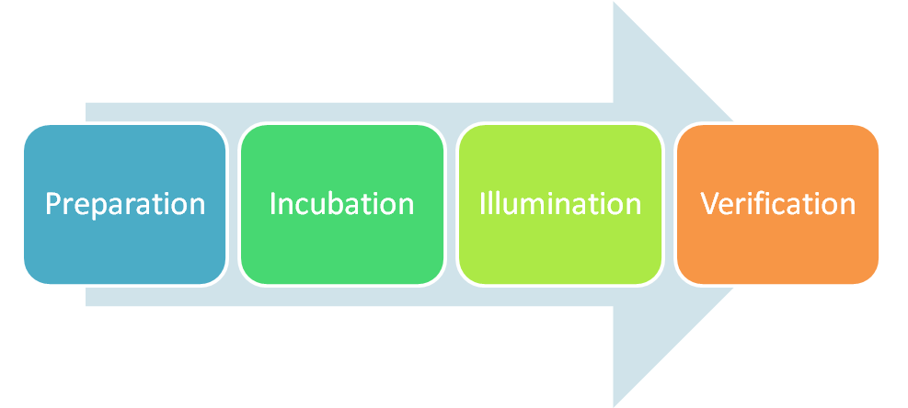
Preparation
The first steps in the creative process include preparation, which include obtaining materials and information, locating inspiration, and learning about the task or issue at hand (Gregoire, 2019).

Colleagues frequently provide input about damaged goods they handle daily. The one that consistently sticks out is that they say there is "nothing practically wrong with the item" and they would love to purchase the product at a reduced price.
Incubation
The incubation stage entails letting go of your concept once you've finished thinking about it. This phase enables you to let go of your concept and divert your attention from it, allowing your mind to unwind as you concentrate on other tasks (Indeed, 2022).

I had no idea how much damaged items was processed every day while I was working in a different department before. Only after being transferred to the returns department did, I realise how much was being handled and, more importantly, how small the errors were.
Every day when I got home after my shift, I was deep in thought, thinking there must be a way. I started pondering and even asked my wife for her thoughts on this.

Illumination – light bulb moment


This stage effectively captures the traditional "aha" or "eureka!" moment of realisation. But illumination is clearly more than a fleeting epiphany, as seen by the full stage devoted to it. This helps us realise that illumination is something we can and should strive for (The Interaction Design Foundation, 2022).

Yes, you guessed right, this was my Eureka moment! What if Amazon opened a Pop-Up Store for Associates and sold damaged items at a discount? Also designing an app for associates to see the current trends and products that are continuously updated.

Verification

As Hardymon (2021) states, bringing your idea to life is the last step in the process. This is the part where you really write your novel, draw your artwork, or invent something new. At last, you are prepared to present your novel concept to the world.
I was so proud of myself for coming up with a concept, but then reality sank in. I began to look at it from a different angle, asking myself questions such as whether any other Amazon FC was doing this, how much it would cost to develop this idea, and whether more formal evaluation was required.
The hard work begins now, and there is a great deal of research and preparation to be done before this vision becomes a reality.

Task 4 – A Critical Evaluation
Barriers and risks to introducing a new idea in a organisation like Amazon include resistance to change, resource constraints, a lack of support, risk aversion, communication barriers, competing priorities, intellectual property concerns, market acceptance uncertainties, and cultural resistance. Overcoming these problems requires perseverance, creative problem-solving, and effective communication.

I came across this photo of an Amazon Pop Up store in a shopping centre and was thinking how lovely it looked and how amazing it would be in my fulfilment centre. There are approximately 2000 employees in Amazon's warehouse in Swansea, so picture the revenue potential if pop-up stores were adopted across the country's 20+ locations.
Force Field Analysis

German-American social psychologist Kurt Lewin invented the force field analysis concept. He applied this idea to his social psychology research, mostly to identify the internal and environmental influences on decision-making (Reyes, 2023).

In the force-field analytic framework, driving forces are those that promote change, whereas restraining forces are those that prevent it (Han, et al, 2023). Please check below the results I obtained for my pop-up store utilising the Force Field Analysis.

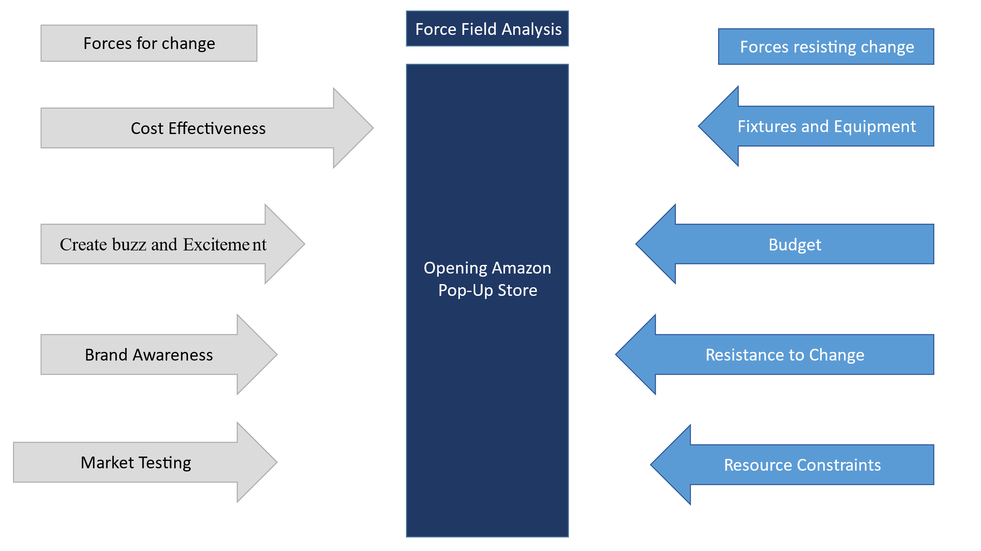
Pros

Cost-Effectiveness: When compared to conventional brick-and-mortar establishments, pop-up stores usually have reduced overhead costs. Since the pop-up shop will be located inside the Amazon fulfilment hub, the company won't be responsible for paying for expenses like rent or utilities. Since current employees would be moved, employing new employees would save time and money. Therefore, staffing should not be a problem either.

Create Buzz and Excitement: A pop-up store on Amazon would instill a sense of urgency and exclusivity among coworkers. They frequently create buzz and excitement, especially when they provide exclusive products, limited-time deals, or unique events.

Brand Awareness: An Amazon pop-up store would be fantastic from the brand's point of view because useful feedback may be supplied by coworkers while purchasing the items. The brands may get useful information from a variety of perspectives, which would benefit each brand in the long run for future items.
Market Testing: Pop-up stores allow brands to test new markets, products, or concepts with low risk. They can get vital input from Amazon colleagues, measure demand, and determine the possibility of growth or permanent retail sites depending on the pop-up's performance.

Cons

Fixtures and Equipment: Amazon will need to purchase fixtures, displays, and equipment like shelving, tables, racks, signage, and POS systems.
Budget: If this notion were applied throughout all Amazon fulfilment centres, it would incur significant budgetary costs such as manpower, additional insurance policies, marketing and advertising, and so on.
Resistance to Change: Employees may be resistant to new ideas because they disrupt conventional procedures or contradict long-held assumptions. Resistance can come from both coworkers and management.
Resource Constraints: Amazon does have an Innovation section, however it may have limited resources, making it difficult to acquire funding or support for new ideas.
Bureaucracy: Amazon has complicated hierarchies and bureaucratic processes, which can impede the flow of ideas. Obtaining approval from several levels of management can be time-consuming and difficult.

Staffing: Amazon will need to transfer employees from various departments to support the Pop-Up store, which could be a challenge depending on whether colleagues want to transfer and their department will allow them to go.

Overall, even though putting new ideas into practice might have a big impact, Amazon will carefully consider the Pros and Cons and skilfully handle the difficulties to increase the likelihood of success.

Task 5 – Organisational Climate & Leadership Styles
A to Z Amazon App

As associates, we can present our ideas on a variety of channels, including the A to Z App. You have access to every tool needed to balance your job and personal life at Amazon. Manage your personal details, request time off, view the most recent news, verify your schedule, and more with the app.
The Virtual Voice Associate (VOA) board on the A to Z App gives every Amazonian a voice when it comes to exchanging thoughts and concerns. You can also share fresh concepts and concerns about improvement using the Continuous Improvement Ideas Tool.
My fulfilment centre additionally features a Change and Innovation Team that generates fresh concepts for boosting income and enhancing pressing problems like health and safety. Therefore, the next stage in developing my proposal would be to present it to the Change and Innovation Team, who would determine its viability.
After weighing all the advantages and disadvantages, if the proposal is approved, our FC will put it into action. Once the Pop-Up store is operational and potentially successful, they will roll it out to the rest of the Amazon FC's and gain credit for the innovation.
Amazon Innovation Lab

“We have a highly talented team of innovative creatives and strategic problem solvers, working together in an agency-structured environment, including creative directors, art directors, strategists, designers, copywriters, design technologists, producers, program managers, and more. Explore the opportunities below to find your fit”.

So, this is Amazon's tagline for innovation. It would be difficult to convey this notion to them because of their hierarchical structure and the time-consuming nature of going through the proper channels for such a large company.
Organisational Climate
As Grobler and van Rensburg (2019) state, the primary method for studying organisational culture is qualitative research. This study examines how employees perceive and experience several organisational processes, including values, foundations, and leadership philosophies.

The general atmosphere or prevalent mood within an organisation is referred to as the "organisational climate." It includes all the staff members' views, attitudes, and sentiments on their coworkers, management, and the organization's overall culture.

Leaders demand and require innovation and invention from their teams, and they are constantly looking for ways to simplify. They are externally aware, seek out fresh ideas from all over, and are not constrained by the phrase "not invented here". As we try new things, we recognise that we may be misunderstood for an extended length of time (Amazon, 2021).

Shaping organisational climate entails building an environment that encourages positive attitudes, behaviours, and interactions among employees. These include leadership, team dynamics, job design, and organisational policies.

Let us take a closer look to understand these drivers of organisational climate:

Leadership

Many studies and streams of research have emphasised the importance of innovation in helping businesses thrive in today's competitive environment. Leadership has been shown to be a good predictor of creativity. Recent research has examined how various forms of leadership encourage creativity at the organisational, team, and individual levels (Al-A\’Ali, E.A. and Masmoudi, M, 2023).
Transformational Leadership

By pursuing meaningful services and missions, inspirational leaders have the power to bring about transformation in both themselves and their teams (Inam, 2019).

With the help of his transformational leadership style, Jeff Bezos was able to divide his staff into smaller teams, assign them distinct duties and issues, and enhance communication throughout the company in order to establish a customer-driven atmosphere at Amazon (Purple Quarter, 2023).

Transformational leadership is crucial because it inspires and motivates people to perform at their best and grow personally.

Authentic Leadership

The Nebraska-Lincoln Institute for Gallup Leadership at the University of Nebraska-Lincoln introduced the concept of authentic leadership in 2004. Authentic leadership includes four sub-dimensions: self-awareness, relationship transparency, balanced information processing, and an internalised moral stance (Jang and Chen 2022).

Jeff Bezos is an important role model for authentic leadership. He is a guy who has had a tremendous impact on the globe due to his exceptional leadership abilities and qualities. He has demonstrated true leadership by continuing to strive for personal growth (Hassan, 2021).

Authentic leaders strive to be true to themselves and their values, and their honesty and authenticity instill trust and confidence in their followers.

Team Dynamics

Navigating workplace dynamics and relationships professionally is critical for maintaining a healthy work environment. Invest in your professional development to improve your abilities and contribute effectively at work (Proffice Tech, 2023).
Team dynamics is a crucial concept that pertains to the interactions, relationships, and processes that exist inside a team and impact its overall effectiveness, productivity, and performance. It covers how members of a team interact, communicate, decide, and resolve disputes.

AWS (nd) states that an innovative team can be more flexible, agile, and quick to bring new ideas to market that satisfy consumer needs if its structure is well-considered and maximises the team's capacity to use its technical architecture (and vice versa).

Job Design
When it comes to business, creativity is a driving force behind innovation, problem-solving, and productivity. An environment created to stimulate creativity has the power to change everything, turning the ordinary into the exceptional (Calibre, 2024).

Amazon understands that innovation and creativity go hand in hand in order to continue thinking big and bringing fresh ideas to the table. There are countless ways for Amazonians to stay creative, from the company's Expressions Lab, which gives staff members access to art workshops and creative classes, to the Amazon Symphony Orchestra, a nearly 100-member ensemble made up of staff members who perform for the community several times a year (Amazon, 2019).

Policies, procedures, and practices

At Amazon, we work hard to solve it by making sure that our teams are small enough to move quickly and maintain a tight relationship with customers, and that they have the ownership, accountability, and necessary skills to carry out their tasks. This strategy reduces bureaucracy and increases the amount of time staff members may spend coming up with new ideas for clients (Amazon, nd).

In today's quickly changing corporate environment, innovation policies and practices are crucial for firms hoping to maintain their competitiveness, spur development, and succeed in the long run.

Ekvall’s Ten Dimensions
In 1994, Göran Ekvall a Swedish researcher, identified ten dimensions of an organisational climate that promote creativity and innovation (All Resources, 2020). These characteristics are interrelated and contribute to an organization's overall culture, influencing its ability to nurture creativity, innovation, and flexibility.

We've looked at organisational climate and its drivers; now let's look at it from a different angle, using Ekvall's 10 dimensions:

Dimension | Promoting Innovation | Inhibiting Innovation
Challenge | Amazon is renowned for having ambitious objectives and demanding standards for its workers. Innovative solutions are necessary for the company's sometimes difficult jobs and initiatives. | Even though Amazon challenges their employees, others argue that the leadership micromanages their employees, which can be frustrating.
Freedom | Despite its size, Amazon is renowned for its decentralised organisational structure, which grants teams and workers some degree of flexibility and autonomy when making decisions. | Freedom can be determined by the work you are allocated. Other jobs require productivity monitoring, while others do not, which is unfair to others.
Idea support | There are a variety of tools in place to promote employees' ideas, including internal innovation programs and leadership principles that prioritise customer focus and innovation. | Amazon's strong work culture and emphasis on attaining outcomes may put pressure on staff to choose short-term goals over long-term innovation.
Trust and openness | Their leadership values emphasise open communication and the value of varied perspectives, creating an environment in which employees may freely share their ideas and thoughts. | Concerns about equity in performance review, promotion decisions, and resource allocation may arise.
Dynamism and liveliness | Amazon is known for its lively and fast-paced work atmosphere. The corporation operates in a variety of areas, always introducing new ideas, products, and services. | Maintaining an innovative culture over time can be difficult, especially when the organisation grows and fatigue sets in.
Playfulness and humour | While Amazon is recognised for its hard work culture, there may still be opportunities for playfulness and humour in teams and interactions, which can build innovation and togetherness. | Aside from the Games Room, where personnel can relax and enjoy themselves, there are just a few additional off-site activities offered, such as charity walks.
Debates | Amazon's culture promotes data-driven decision-making and supports rigorous debate and discussion to find the best solutions, which is consistent with Ekvall's dimension of debate. | Even though Amazon encourages debate, it is frequently one-sided, with the typical response of "we'll take it into consideration when it comes to creative ideas."
Conflicts | Amazon's culture is noted for being driven and occasionally combative. While vigorous debate is encouraged, some have complained about a high-pressure workplace that may not always resolve issues productively. | There is often conflict because leadership solely follows what the Matrix says about efficiency, with no human emotion displayed.
Risk-taking | Amazon is known for its willingness to take chances and experiment with new ideas, as seen by its varied portfolio of initiatives outside of its main e-commerce company. | They are recognised for their willingness to take risks and try out new ideas, although not all of their initiatives are successful.
Idea time | Amazon is well known for promoting innovation with programmes like "working backwards" from customer wants and "day one" mentality. | Employees may feel pressurised to prioritise current tasks and deliverables over brainstorming and exploring new ideas.

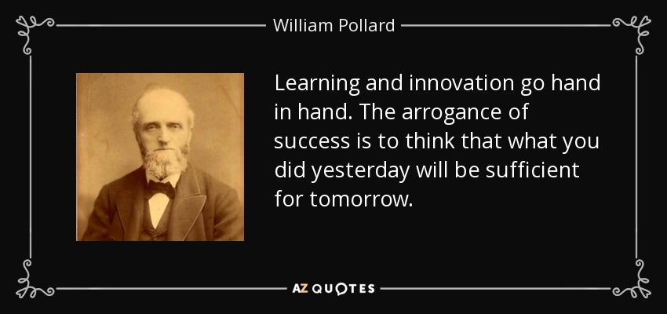

Creativity and innovation go hand in hand and are considered essential components of successful companies (Jeremiah, 2019).

Conclusion
Amazon's approach to creativity and innovation is distinguished by its dedication to experimentation, customer obsession, and unwavering pursuit of new ideas. Doing Ekvall's 10 dimensions reveals weaknesses that need to be corrected. One of Amazon's primary innovation challenges is balancing short-term demands with long-term innovation endeavours.
The company's hierarchy procedure would be the primary obstacle, despite the fact that the idea of launching a pop-up store would be advantageous for both workers and the business.
When it comes to creativity and innovation, leadership is taught and focuses on customer obsession rather than colleague happiness and improvement of their ideas.

According to Yoyn (2020), Amazon is facing a decision. Regarding how they treat its employees, Amazon and CEO Jeff Bezos are coming under heavy fire. How the firm handles these criticisms could have a significant impact on its future.

Decision-making power is frequently centralised at the top of the hierarchy in hierarchical organisations like Amazon. This may lead to a communication gap between top management and front-line staff, which will hinder the dissemination and adoption of new ideas by decision-makers.

Although associates have access to a variety of outlets for sharing their ideas, it can be disheartening when those ideas are not always taken seriously. It seems like they only have the different channels to demonstrate to everyone that they pay attention to the employees.
A local hub ought to be established so that ideas may be more precisely tracked down and closely observed. In order to keep the colleague informed, demonstrate that they listen, and value colleague engagement, feedback should also be offered if the idea is not successful.
Having had the notion to build a pop-up store for some time, I have truly enjoyed working on this task. I have learned so much about leadership and innovation in this course, which has opened my eyes and undoubtedly improved my skills.

In conclusion, opening an Amazon pop-up shop offers a special chance for the company to boost sales, cut expenses, give back to the community, and interact with staff members differently. Although Amazon excels in many areas, there is still room for improvement in terms of coworker input and collaboration.

Reference List

All Resources (2020) 10 dimensions for organisational creativity and innovation, Cultural Adaptations
Available at: https://www.culturaladaptations.com/resources/10-dimensions-for-organisational-creativity-and-innovation/
(Accessed: 17 March 2024)

Al-A\’Ali, E.A. and Masmoudi, M. (eds) (2023) Leadership and workplace culture in the digital era. Hershey, Pennsylvania: Business Science Reference
Amazon (2021) Leadership principles, UK About Amazon
Available at: https://www.aboutamazon.co.uk/who-we-are/leadership-principles
(Accessed: 16 March 2024)

Amazon, (nd) People: The Human Side of Innovation at Amazon
Available at: https://aws.amazon.com/executive-insights/content/the-human-side-of-innovation/#:~:text=To%20address%20that%20at%20Amazon,spend%20on%20innovating%20for%20customers
(Accessed: 13 March 2024)

Amazon (2019) 6 things that make Amazon a ‘best workplace for innovators’, US About Amazon. Available at: https://www.aboutamazon.com/news/workplace/6-things-that-make-amazon-a-best-workplace-for-innovators
(Accessed: 17 March 2024)

AWS (nd) High-performing organization - the amazon two pizza team | AWS
Available at: https://aws.amazon.com/executive-insights/content/amazon-two-pizza-team/ (Accessed: 17 March 2024)

Barnhart, B. (2021) 30 insightful creativity quotes to inspire innovation, Linearity blog. Available at: https://www.linearity.io/blog/creativity-quotes/
(Accessed: March 18, 2024)
Boyles, M. (2022) What is creative problem-solving & why is it important? Business Insights Blog
Available at: https://online.hbs.edu/blog/post/what-is-creative-problem-solving
(Accessed: 14 March 2024)

Calibre (2024) How to Design a Workspace that Encourages Creativity, Calibre-furniture.co.uk
Available at: https://www.calibre-furniture.co.uk/blog/how-to-design-a-workspace-that-encourages-creativity
(Accessed: 17 March 2024)
Dias, D. and Marinho-Araujo, C.M. (2023) Creativity and innovation for a better world. London: IntechOpen

Dudovskiy, J. (2022). Amazon Organizational Structure: a brief overview. [online] Business Research Methodology.
Available at: https://research-methodology.net/amazon-organizational-structure-2-2/.
(Accessed: 18 March 2024)

Elgazzar, S.H. (2021). International Business Logistics Journal ‘IBL’. International Business Logistics, 1(1), p.1
doi:https://doi.org/10.21622/ibl.2021.01.1.001
(Accessed: 16 March 2024)

Escrig-Tena, A.B., Segarra-Ciprés, M. and García-Juan, B. (2021) “Incremental and radical product innovation capabilities in a quality management context: Exploring the moderating effects of control mechanisms,” International journal of production economics, 232, pp. 107994
Gregoire, C. (2019) Understanding the four stages of the creative process, Ideas (en-GB). Available at: https://www.wework.com/en-GB/ideas/professional-development/creativity-culture/understanding-the-four-stages-of-the-creative-process
(Accessed: 15 March 2024)

Grobler, A. and Rensburg, M.J. van (2019) “Organisational climate, person-organisation fit and turn over intention: a generational perspective within a South African Higher Education Institution,” Studies in higher education (Dorchester-on-Thames), 44(11), pp. 2053–2065 Available at: https://doi.org/10.1080/03075079.2018.1492533.

Han, S.J. et al. (2023) “Why do employees welcome or refuse shared leadership?: A qualitative exploration through force‐field analysis,” Human resource development quarterly, 34(4), pp. 413–435
Available at: https://doi.org/10.1002/hrdq.21495.

Hardymon, A. (2021) The 5-step creative process, Pearce Center for Professional Communication. Available at: https://pearce.caah.clemson.edu/the-5-step-creative-process/ (Accessed: 15 March 2024)

Hassan, T. (2021) Perspectives on leadership: Case study of Amazon Inc.., LinkedIn
Available at: https://www.linkedin.com/pulse/perspectives-leadership-case-study-amazon-inc-taimoor-hassan/
(Accessed: 17 March 2024)

Heskett, J. L. (1977) “Logistics—essential to strategy,” Harvard business review, 1 Novembe.
Available at: https://hbr.org/1977/11/logistics-essential-to-strategy
(Accessed: 19 March 2024)

Inam, H. (2019) Transformational Leadership. Carpenteria, CA: linkedin.com

Indeed Editorial Team (2022) The creative process: Definition, steps, benefits and tips.
Available at: https://uk.indeed.com/career-advice/career-development/creative-process (Accessed: 16 March 2024)

Jang, E. and Chen, X. (2022) “How Can We Make a Sustainable Workplace? Workplace Ostracism, Employees’ Well-Being via Need Satisfaction and Moderated Mediation Role of Authentic Leadership,” Sustainability (Basel, Switzerland), 14(5), pp. 2869-.
Available at: https://doi.org/10.3390/su14052869

Jeremiah, R. (2019) Innovation and creativity: Doing both whilst doing neither, Linkedin.com
Available at: https://www.linkedin.com/pulse/innovation-creativity-doing-both-while-neither-rupin-jeremiah-ph-d-/
(Accessed: 20 March 2024)

McKinsey & Company (2022). What is innovation? Mckinsey.com.
Available at: https://www.mckinsey.com/featured-insights/mckinsey-explainers/what-is-innovation (Accessed: 20 March 2024)

Michigan State University (2023) Applying the 4 “PS” of innovation in healthcare
Available at: https://www.michiganstateuniversityonline.com/resources/healthcare-management/applying-4-ps-for-healthcare-innovation/
(Accessed: 20 March 2024)

Norelli, N. (2023) Radical Innovation & incremental innovation (pro’s and con’s), Linkedin.com. Available at: https://www.linkedin.com/pulse/radical-innovation-incremental-pros-cons-naomi-norelli/
(Accessed: March 19, 2024)

One Existence Foundation (2023) The inspiring journey of Steve Jobs: A tale of innovation and resilience, Linkedin.com.
Available at: https://www.linkedin.com/pulse/inspiring-journey-steve-jobs-tale-innovation/ (Accessed: 19 March 2024).

Peek, S. (2024) Creativity Is Not Innovation (But You Need Both). Business News Daily
Proffice Tech (2023) How to navigate workplace dynamics and relationships professionally, LinkedIn
Available at: https://www.linkedin.com/pulse/how-navigate-workplace-dynamics-relationships-proffice-tech/
(Accessed: 17 March 2024)

Purple Quarter (2023) The power of transformational leadership - how Bezos, jobs, Nadella lead by example, LinkedIn
Available at: https://www.linkedin.com/pulse/power-transformational-leadership-inspiring-positive-change/
(Accessed: 16 March 2024)

Reyes, J. (2022). Understanding Force Field Analysis. [online] SafetyCulture
Available at: https://safetyculture.com/topics/force-field-analysis/
(Accessed: 19 March 2024)

The Interaction Design Foundation (2020) “What are the stages of creativity?,” The Interaction Design Foundation
Available at: https://www.interaction-design.org/literature/article/what-are-the-stages-of-creativity
(Accessed: 13 March 2024)

Twin, A. (2024) The 4 PS of Marketing: What they are & how to use them successfully, Investopedia
Available at: https://www.investopedia.com/terms/f/four-ps.asp
(Accessed: 14 March 2024)

United Nations (no date) “World Creativity and Innovation Day - EN | united nations.”
Available at: https://www.un.org/en/observances/creativity-and-innovation-day
(Accessed: 11March 2024)

Wright, G. and Pratt, M. K. (2023) Radical innovation, CIO. TechTarget.
Available at: https://www.techtarget.com/searchcio/definition/radical-innovation
(Accessed: 12 March 2024)

Yohn, D. L. (2020) Amazon faces A crucible moment with employees, Forbes
Available at: https://www.forbes.com/sites/deniselyohn/2020/06/02/amazon-faces-a-crucible-moment-with-employees/?sh=a87b13c38228
(Accessed: 15 March 2024).

