  Component One:  What are the key skills required when working in the housekeeping team? 750 words (+/- 10%)  Contribution to Overall Module Assessment: 25% | Student No: | Andreea Balanescu  2211130
 | Module Title: | Operating Hotel Facilities
 | Module Code: | BMIH4006
 | Lecturer: | Lisa-Marie Bassler
In order to ensure efficient and effective management of cleaning and maintenance work, a varied range of skills are important when working in the housekeeping team. Three important areas can be divided into key skills required by members of the housekeeping crew: technical skills, interpersonal skills, and organisational skills (Bridger, 2018).
First, in order to perform their tasks effectively, members of the housekeeping team must be well-equipped with qualified skills. These skills involve the ability to use cleaning methods, a knowledge of safe handling and usage of washing machines and chemicals as well as an awareness of different hygiene practices for each area or surface (Jones, 2008).
Second, for the cleaning team members, it is crucial to have a good sense of rapport. They often work closely with other members of staff, as well as interact with guests, colleagues from other departments and sometimes even management. Effective communication skills are necessary for understanding instructions and complying with them, clarifying doubts or resolving conflicts. In order to handle guest queries, requests and complaints with professionalism and sympathy they should also possess excellent customer service skills (Casado, 2011).
Thirdly, in order to run a cleaning team smoothly, organisational skills are essential. To meet deadlines and to ensure appropriate cleaning of all areas, the housekeepers need to prioritise tasks and manage their time effectively.
They should have an excellent ability to plan and coordinate their work, particularly when dealing with a number of rooms or areas at once. Maintaining an inventory of cleaning supplies and equipment, ensuring their availability and reporting any shortcomings to the appropriate member of staff are also essential organisational skills (Mullins and Dossor, 2013). The housekeeping job is considered one that everyone can do, simple, and repetitive with tasks that can be physically demanding, but sometimes is required a high level of skills, effective cleaning to quality standards, safety regulation knowledge, responding to guests’ needs, computer system and maintenance knowledge (Wood, 2013).
In addition to these 3 main areas, there are several other skills which contribute to the efficient functioning of the housekeeper's team. Physical stamina is important, as often the cleaning work entails standing, moving, lifting and carrying out repetitive tasks. Safety is of the highest importance, and members of the Housekeeping Team should be well informed about safety regulations and procedures, including proper use of personal protective equipment. Flexibility and adaptability, work engagement with vigour and organizational effectiveness are also important characteristics, given that cleaning operations may need to be adjusted in case of unforeseeable circumstances or guest needs (Bakker and Leiter, 2010).
The three steps of the ERA cycle reflection process are the examination, reflection, and application of experience in personal development and improvement (Jasper, 2003). In order to ensure effective performance and customer satisfaction, it is necessary to have a number of key skills to work in a cleaning team. As a result of my experiences, I am able to determine the importance of these skills by taking into account an ERA cycle.
Competence in cleaning techniques, knowledge of cleaning equipment, and proper handling of chemicals are essential technical skills required for cleaning. Hard skills and soft skills are essential in the housekeeping department.
In ensuring the highest standards of hygiene, attention must be paid to details. Interpersonal skills also play a significant role, because effective communication and customer service help to develop good relations with guests and colleagues. In managing tasks, prioritising work and maintaining inventories, organisational skills have an important role.
In my work placement as a housekeeper, I am recognizing the value of those skills through reflection. I am becoming more efficient in dealing with various cleaning techniques and delivering high-quality results by sharpening my technical skills. I have learned how crucial it is to communicate clearly to let the reception team know about any faults in the room, teamwork and the impact that this can have on the resolution of conflicts as well as meeting guests' needs. I have been able to meet deadlines and maintain a well-stocked inventory because of effective time management and organization.
I have increased my work in the cleaning department through the daily application of these skills. I am ensuring thorough cleaning of the area by continuing to improve my technical skills. I am contributing to guest satisfaction through positive interactions and exceptional customer service. I will be able to efficiently manage my time and resources, which will ultimately benefit the team and the company as a whole, by effectively organising my tasks.

Word Count | 747

Component Two:
Contribution to Overall Module Assessment: 25%
In this scenario – You have just been promoted to team leader for a floor within the hotel. A guest complains that on their arrival, their room had not been properly cleaned. Create an action plan and answer the following questions.

Problem | Why did it happen? | What are you going to do? | How will you prevent this from happening in the future? | What measures would you introduce to improve team effectiveness?
Miscommunication in the housekeeping team department and front desk. The room was not ready for check-in, the front desk team did not ask for an update on the room, ineffective co-ordination. | The previous cleaning team and the team responsible for preparing the room failed to communicate or provide clear instructions. | Give a personal apology to the guest as a team leader for the inconvenience of an inappropriately clean room. Assuring them that their feedback is valuable and taking their concerns seriously. Connect the hotel team with a mobile app to improve communication. | In the interests of ensuring that guest requests and room status updates are communicated accurately and on schedule, establishing transparent communications channels between the Front Desk and Housekeeping Team. Any specific requests or concerns of the guest shall be discussed in regular meetings and briefings. | Would be vital to set clear objectives and expectations for the team. Making sure that members of the team understand their role and responsibilities, as well as any specific targets they are expected to achieve. That clarity will enable team members to achieve common goals, providing them with a sense of purpose and direction.
Short staff in the housekeeping team. | Due to high occupancy or other operational constraints, insufficient time or resources have been allocated for the cleaning of the room. SOPs (standard operating procedures) failed to be implemented. | In order to identify the root cause of this problem, need to draw up all necessary information and carry out a thorough investigation. This may include consultation with the housekeeping staff concerned, a review of cleaning schedules and instructions, as well an examination of any potential operational difficulties. Effective planning of tasks. | In order to ensure that members of the Housekeeping Team are fully familiar with cleaning techniques, equipment usage, and quality standards, updating their training programme. Attention to detail, clarity and time management will also be part of the training. In order to strengthen good practice, ongoing refreshers will be held. | For a united and efficient team, effective communication is essential. In order to ensure that progress, problems and ideas are discussed regularly by team members, encouraging open and transparent communication channels. In addition, encourage members of the team to share their opinions, suggestions and concerns in order to create an environment which values a diversity of views.
Lack of training and staff with no experience on the day at work. | Human error in handling or control of cleaning activities such as missing some areas or not properly addressing specific cleaning tasks. | Making sure that the guest's room is thoroughly cleaned in line with their expectations, to rectify the situation without delay. Assigning a skilled member of the Housekeeping Team to personally oversee cleaning in order to ensure that it meets the highest standards, if necessary. | In order to check room cleanliness, set up a regular quality control system. For the purposes of ensuring consistency and compliance with standards, these inspections may be carried out by supervisors and designated team members. Based on the results of these checks, immediate feedback and corrective actions will be provided. | The skills and motivation of the team members can be greatly enhanced by investing in training and professional development. Organise training for the enhancement of technical skills, such as cleaning techniques, use of equipment and safety procedures. Provide the opportunity to grow personally and professionally, such as by means of cross-training or access to relevant qualifications.
Faulty equipment made the cleaning procedures difficult and quality issues in the working practice. | Issues with equipment or supplies, for example, malfunction of cleaning tools and lack of availability of hygiene products. | Discussing the incident, reaffirming the importance of maintaining cleaning procedures and dealing with any possible issues or concerns that they have encountered, hold a meeting with the Housekeeping Team. Identifying priority areas for improvement will be supported by open communication. | Actively encourage guests to provide feedback on the cleanliness of their rooms and their overall satisfaction with the housekeeping services. This feedback shall be carefully observed and the relevant problems identified immediately rectified and included in training and operational updates. | The morale of the team and its motivation may be strengthened by recognising and celebrating their efforts and achievements. Create a system of recognising extraordinary performance, for example as "Employee of the Month" programs and occasional recognition events. Recognition of individual or team accomplishments is a sign of pride, and it encourages continued excellence.
Performance measures missing in place, and the housekeeping staff failed to be engaged in the workplace. | In order to guarantee consistent cleaning standards, there is a lack of appropriate supervision or quality control measures. | Arranging additional training to reinforce correct cleaning techniques, enhance attention to detail and provide guidance in dealing with specific problems when the investigation reveals a lack of training or supervision. In order to maintain a consistent standard for cleaning, regular monitoring and quality control inspections will be carried out. | Encouraging open communication, exchange of ideas and innovation will contribute to a culture of continuous improvement within the Housekeeping Team. In order to identify the areas of improvement and implement new strategies or techniques, regular team meetings will be held as well as brainstorming sessions. | Flexibility and effectiveness can be improved by promoting cooperation and cross-training in the team. In order to allow team members to learn from each other and acquire new skills, encourage knowledge sharing and cross-training initiatives. The team's capacity will be strengthened by this cross-pollination of expertise, allowing them to work together in peak periods or when they are absent.

Component Three:
Contribution to Overall Module Assessment: 50%
Your task is to create and prepare a presentation following the detailed scenario provided below.

As the floor housekeeping manager and given the recent guest complaints you need to put together a basic training presentation for your colleagues within the housekeeping team to get the best out of them, ensure that brand standard is being achieved and that Health and Safety procedures are also being followed.

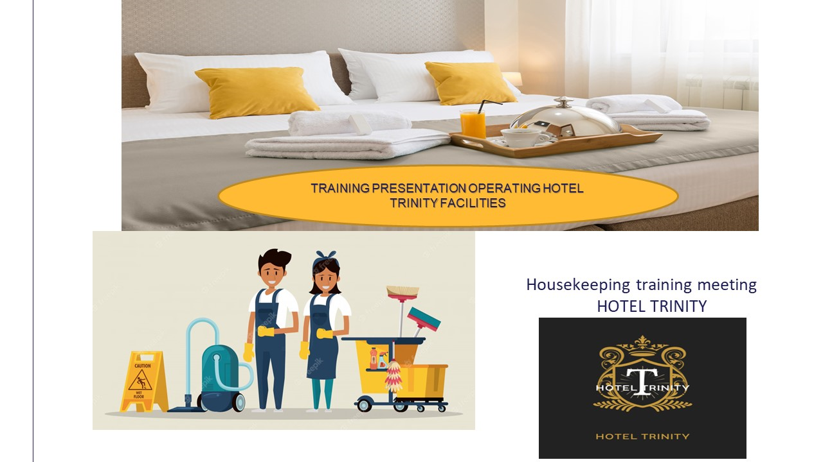

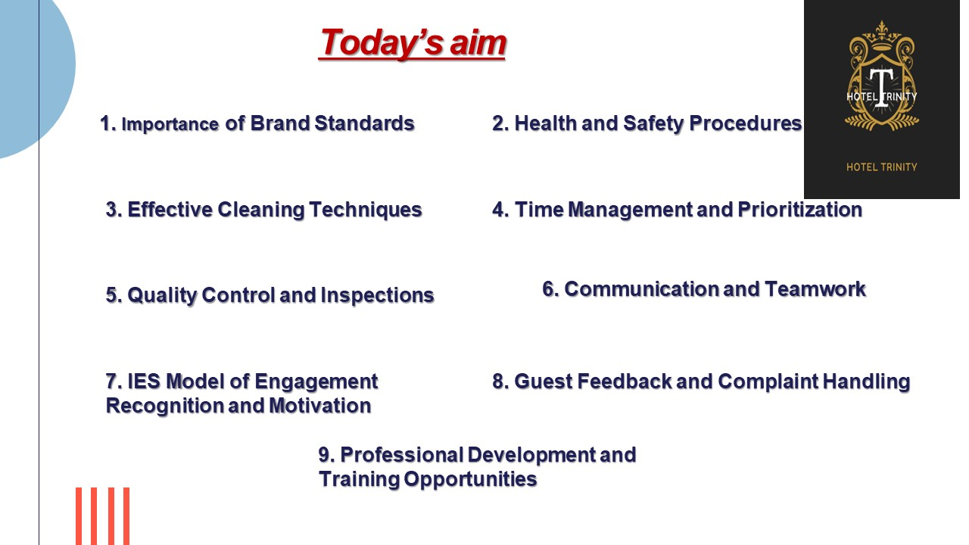

Training Notes: The basis of the reputation hotel is its brand standards. In order to provide a consistent and outstanding guest experience, they take into account the specific guidelines and expectations set by the hotel brand. Creating an important identity and enhancing the image of the hotel as a result of meeting these standards.
-cleanness in each room, which involves paying attention to every detail from dust and vacuuming all the way to polishing mirrors and windows. There is also a need to ensure the beds are furnished beautifully with crisp sheets, pillows and thoughtfully placed cushions. A lasting impression is made as soon as the guests walk into a room with meticulous cleaning and maintenance, making them appreciate it even more (Premier Inn, 2023).
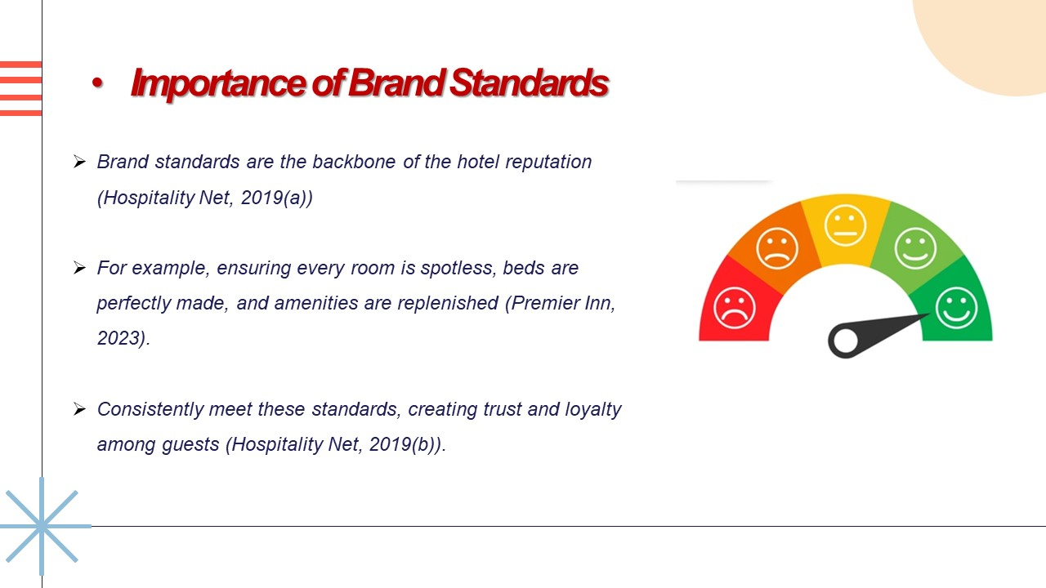

Training Notes: Furthermore, replenishing amenities is an essential aspect of brand standards. In each room, it will entail the restocking of bathing equipment, towels and other guest needs. Demonstrating the commitment to guest comfort and convenience through our constant offering of these services, which make them feel appreciated and well taken care of (Hospitality Net, 2019(a)).
Building trust and loyalty among guests when continuously meeting these brand standards. Knowing that maintaining identical standards in all rooms and facilities, the guests expect a certain level of quality and service. Building a positive reputation for the hotel by meeting and exceeding these expectations leads to repeat business, positive reviews and recommendations to others (Hospitality Net, 2019 (b)).

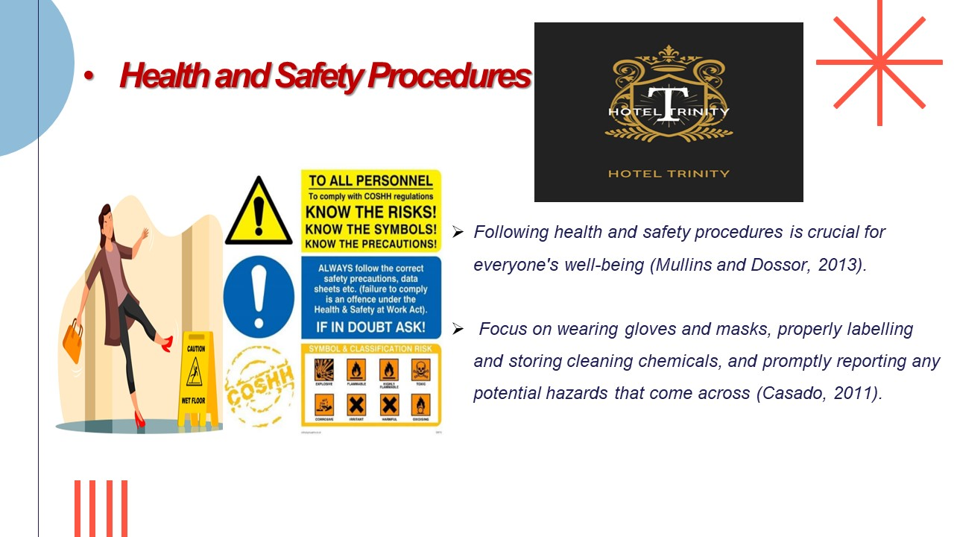

Training Notes: In order to protect the health and well-being of our cleaning staff and visitors, it is essential to comply with medical and safety rules. Ensure a safe working environment and reduce threats. By properly complying with these standards, one must place a high priority on the health and safety of all (Mullins and Dossor, 2013).
Gloves and masks are an essential part of health and safety procedures. The PPE items serve as an obstacle to protecting against exposure to harmful substances, such as cleaning chemicals or potential allergens. The risk of skin irritation, breathing difficulties and the spread of germs has been reduced by good use of gloves and masks.
Cleaning chemicals need to be correctly labelled and stored in addition to PPE. The name, usage instructions and other related hazards of each cleaning product should be specified on the label. This ensures that the team members are able to easily identify and handle the chemicals, minimising the risk of accidents and misuse. In addition, the prevention of accidental spills, leakages or mixed substances which could pose a potential health risk is ensured by proper chemical storage in designated areas.
Another significant aspect of health and safety practices is the timely reporting of potential hazards. Team members can report any safety concerns or hazards they encounter by encouraging an open communication channel. Reporting these risks immediately enables timely action to be adopted to resolve the situation and avoid accidents or injuries, even if it is a damaged piece of equipment, a slippery floor or an electrical problem (Casado, 2011).

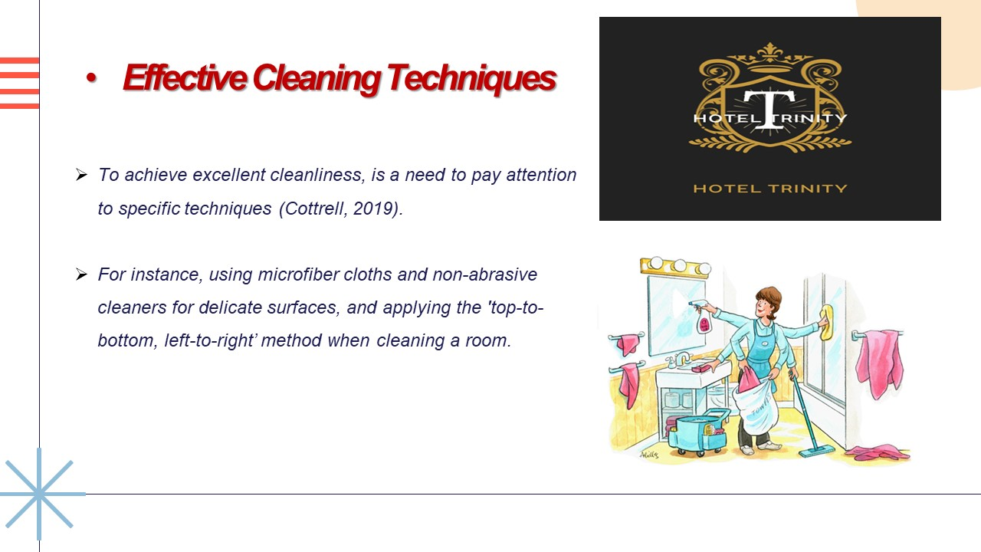

Training Notes: The use of specific techniques that maximise efficiency and deliver outstanding results is essential in order to achieve excellent hygiene. Ensuring that each room and area is thoroughly cleansed and maintained to high standards of hygiene, using the correct tools and proper cleaning techniques (Cottrell, 2019).
For delicate surfaces, microfiber cloths and nonabrasive cleaners are one effective method. In comparison to traditional cloth or sponge, microfiber cloth has fine fibres that effectively trap dirt and dust and provide superior cleaning performance. The disinfectants are gentle on the surface, reducing the risk of cracking or damaging sensitive surfaces such as glass, mirrors and polished furniture. These tools and products assist in maintaining surface integrity, as well as achieving a streakless polished finish with their combined use of nonabrasive cleaners.
The "top to bottom, left to right" method in the cleaning of a room is also an essential technique. This method ensures that the areas are not overlooked, and dirt and dust cannot be spread to other surfaces which have been cleaned. Starting from the top allows gravity to assist in the removal of dust and debris, which prevents them from settling on the lower surfaces.

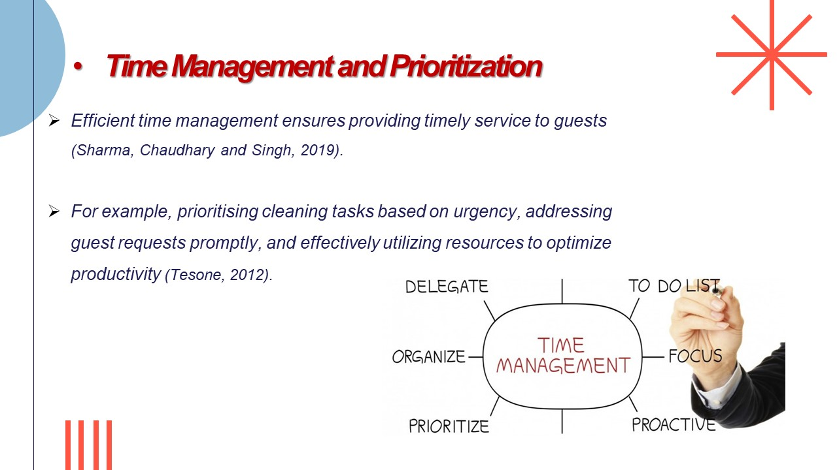

Training Notes: To ensure that our guests receive timely and excellent service, efficient time management is essential for the Department of Housekeeping to optimise operational efficiency, meet guest expectations and maintain a smooth working procedure (Sharma, Chaudhary and Singh, 2019).
Prioritising cleaning tasks based on urgency is an aspect of time management. The level of importance or urgency of some cleaning tasks is not the same. Efficiently allocate time and resources by identifying and prioritising tasks that require immediate attention, such as preparing rooms for arriving guests or dealing with specific guest requests. This approach ensures that critical tasks are finished on time, without prejudice to the guest's satisfaction (Tesone, 2012).
Another important element of efficient time management is the timely response to guests' requests. Guest satisfaction is the main priority, and a timely reply to their needs contributes to a positive experience. Demonstrating commitment to providing excellent service and improving guest satisfaction by immediately responding to requests for facilities, room services or other specific requirements (Johnston, Clark and Shulver, 2012).
Efficiency in resource utilisation is also essential to improve productivity. This shall include the proper allocation of staff to specific areas or tasks based on their competence and experience, efficient use of cleaning equipment and supplies as well as effective implementation of simplified procedures, and reduce wasted time and effort by effectively using resources, resulting in increased productivity and a smoother operation.

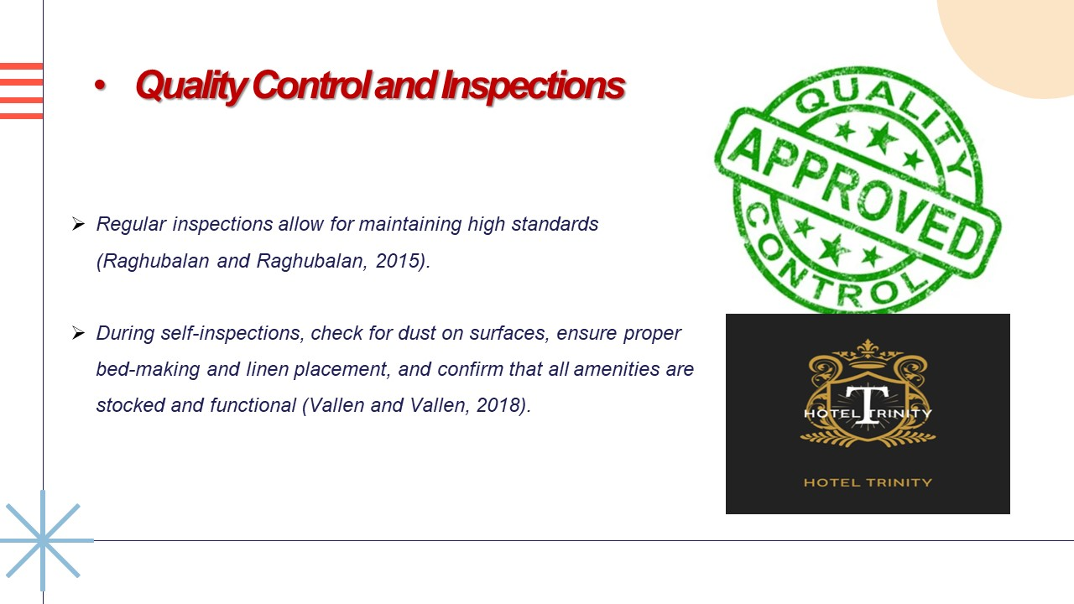

Training Notes: Regular checks in the cleaning department are a crucial element to maintain good standards. It will allow to establish areas of need for improvement, guarantee consistency with the service provided and maintain the hotel's reputation. Address all issues in a proactive manner through the process of self-checks, and keep striving for excellence (Raghubalan and Raghubalan, 2015).
Concentrating on different aspects to maintain quality standards during self-inspections. The inspection of dust on surfaces is one of the areas of inspection. Insufficient accumulation of dust can lead to an unclean and messy appearance, which hinders the cleanliness of the room as a whole, ensure that surfaces, including furniture, fittings and decorative objects, are free of dust and properly cleaned by carefully examining them.
Ensuring the proper manufacture and placement of bed linen is another important element of self-inspection. The visual appeal of this room is made possible by well-designed beds with neatly fitted sheets and comfortable pillows.
Ensure that the bedmaking process fulfils the established standards to create a pleasant and entertaining environment for the guests, through an exhaustive inspection of each bed. In addition, it is essential to check and confirm that all the facilities are in stock and functional. For comfort and convenience, guests rely on services such as toiletries, towels or washing machines. To guarantee the seamless and pleasurable stay of our guests, we can immediately deal with any shortcomings or maintenance needs by checking that these facilities are ready and functioning on an inspection (Vallen and Vallen, 2018).

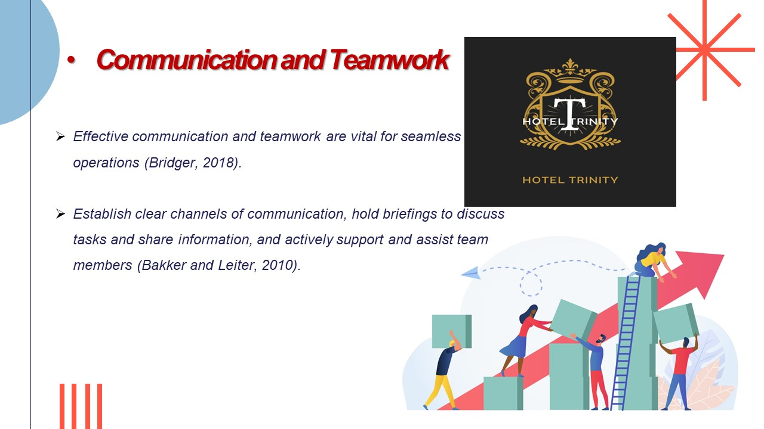

Training Notes: In order to ensure a smooth operation in the Housekeeping Department, efficient communication and teamwork are vital elements. Improving collaboration, coordination and overall efficiency through increased openness and clear channels of communication as well as supporting the supportive team environment (Bridger, 2022).
For an efficient collaboration, it is vital to establish clear communication channels. In doing so, the sharing of important information, updates and instructions will also be facilitated by using communication tools such as radios, communications systems or designated boards. It allows effective communication to be made, facilitates rapid replies and avoids misunderstandings by ensuring team members have access to the appropriate communications channels (Bakker and Leiter, 2010(a)).
Regular briefings are an opportunity for team members to meet and discuss their tasks, share information and address any problems or concerns. This briefing may be carried out at the beginning of each shift when a staff leader or manager is communicating objectives, priorities and special instructions for that day. This will guarantee that everyone is on the same page, understands responsibilities and knows how to plan and carry out their tasks successfully (Bakker and Leiter, 2010(b)).
The vital aspect of teamwork is continuous support and assistance to the other associates of the team. We encourage members of the team to help and support each other if needed, by sponsoring a culture of cooperation and collaboration. To this end, they may offer help on difficult tasks, share their knowledge or expertise and take the place of team members who are missing or understaffed. A positive work environment, improved morale and increased overall efficiency are encouraged by a strong sense of teamwork (Bridger, 2022).

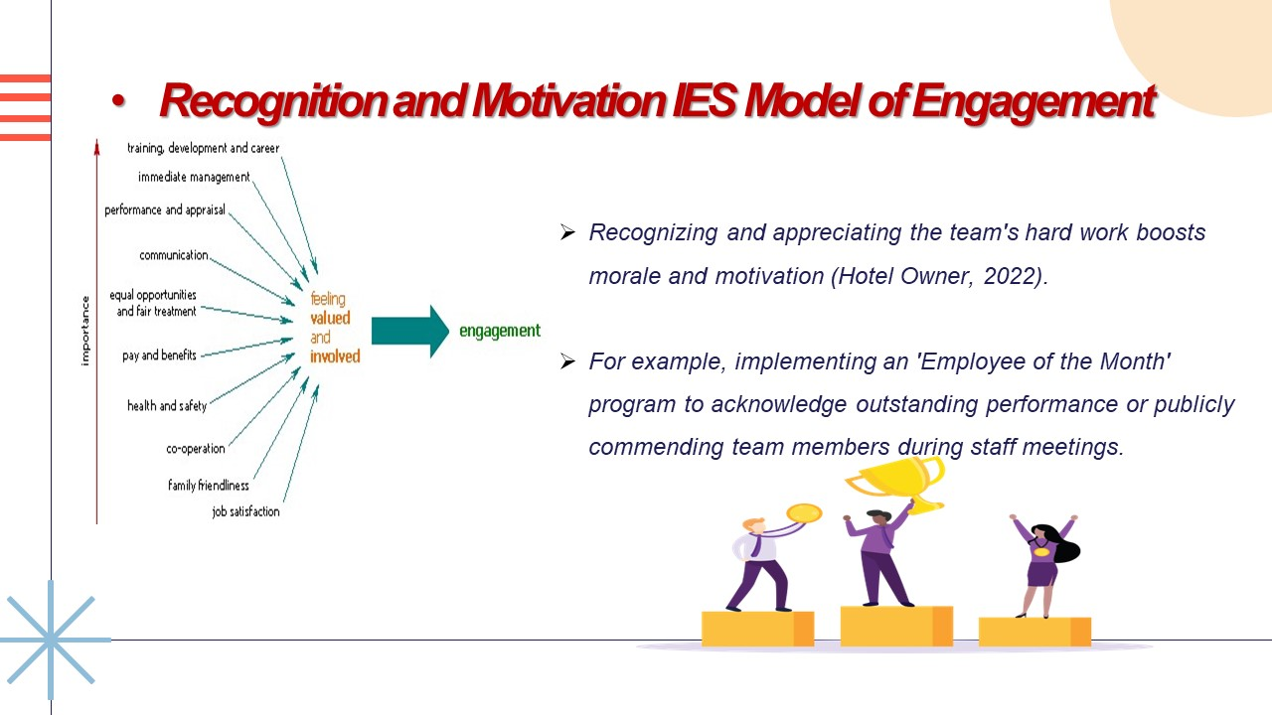

Training Notes: In order to improve morale, motivation and overall job satisfaction, recognizing and appreciating the hard work of the Housekeeping Team plays an important role. Creating a good working environment, in which excellence is encouraged and team members are proud of their achievements, through the implementation of recognition programmes and public praise (Hotel Owner, 2022).
Implementing an "employee of the month" programme is one efficient way to recognise good performance. These programs recognise and reward those team members that consistently achieve excellence in performance, a high level of dedication as well as outstanding results. Recognizing their contributions and publicly announcing their achievements, motivate the awarded employee and also inspire others to strive for excellence.
Another impactful way of expressing appreciation and recognition is by publicly lauding team members at staff meetings. Highlight the hard work of young people in front of their peers, by mentioning specific examples of exceptional performance or above and beyond. Not only is this public recognition a morale boost for the team member who has been recognised, but it encourages others to reach their full potential.
Regular feedback and appreciation for staff members on their own basis are essential in addition to formal recognition schemes. Recognition of their efforts and achievements, whether it be in personal correspondence, a thank you note or a tiny token of appreciation, helps to enhance the team's value and contribution. Personal recognition leads to a pleasant working environment and increases employees' sense of belonging and professional satisfaction (Quick, 2020). Give the best every day, have a positive attitude, go to extra mile, and be engaged adding value to the organisation Bridger, 2018).

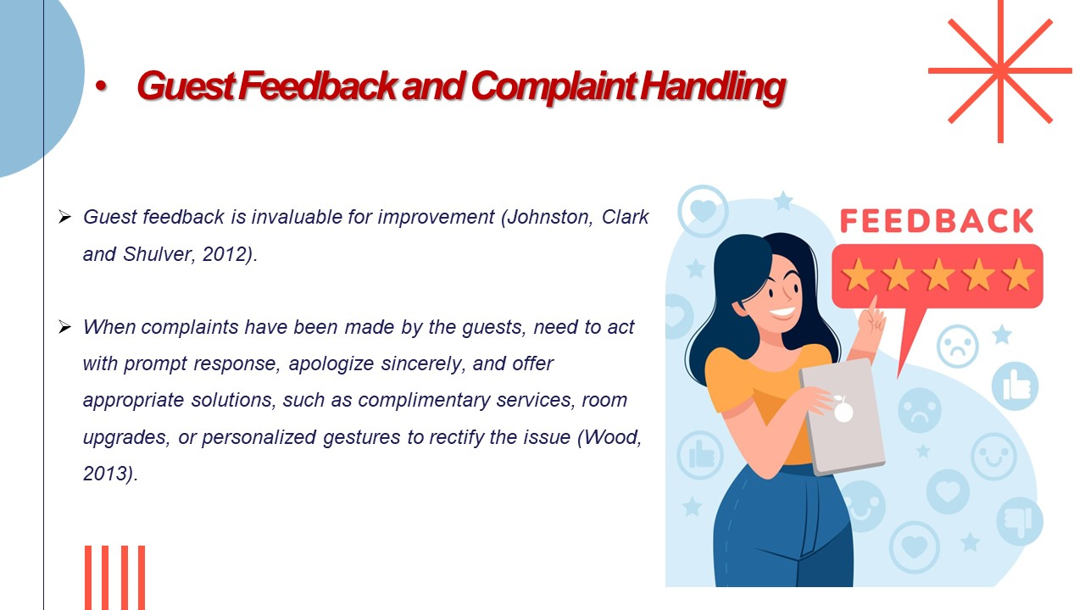

Training Notes: An invaluable source of continuous improvement in the housekeeping department is guest feedback. Gaining insight into their experience, identifying areas for improvement and guaranteeing that we meet or exceed their expectations by actively seeking and listening to guest feedback (Johnston, Clark and Shulver, 2012).
It is important to react rapidly and effectively in dealing with complaints from guests. The prompt reply will help to resolve the issues more quickly, reinforcing commitment to guest satisfaction. In showing to guests that their concerns are taken very seriously, addressing complaints as soon as possible and actively seeking resolution of the problem (Wood, 2013).
Sincere apologies are an essential part of complaint handling. When a guest has been affected by an issue, offering sincere apologies makes them feel sympathy and shows respect for their experience. In building confidence and repairing the damage that has been caused, a genuine apology is very important (Hospitality Net, 2019).
In addition to apologies, the provision of suitable solutions is necessary to resolve complaints. To resolve any inconvenience, these arrangements may also include complementary services like meal vouchers, spa treatments and room upgrades. In order to demonstrate our sincere concern for the guests' experiences, and commitment to remedying this issue, personalised gifts of paper or small gift items may also be provided (Rogers, 2013).

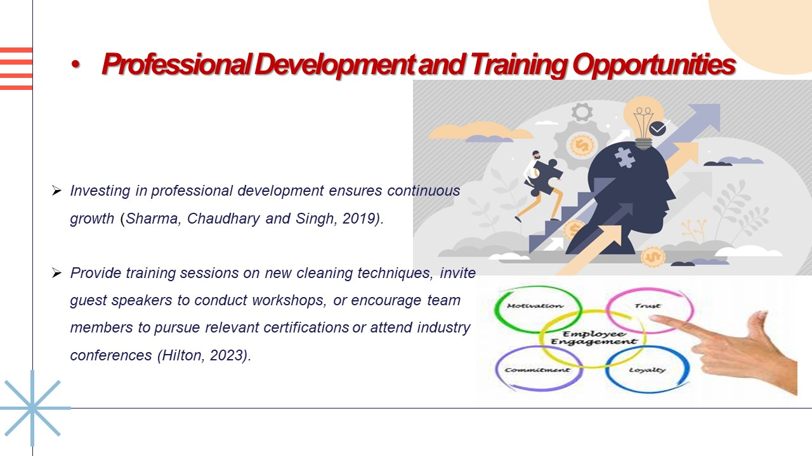

Training Notes: In order to continue growth, enhance skills and keep up with industry developments, invest in the training of cleaning staff, create a culture of learning and development that benefits both individuals and the organization as a whole by providing training, inviting guest speakers and encouraging team members to pursue certification and attend conferences (Sharma, Chaudhary and Singh, 2019).
An effective way of improving the knowledge and competencies of housekeepers is to offer training on new cleaning techniques. It is important to keep staff updated with the latest cleaning techniques and best practices, as practice and technologies continue to evolve. The topics to be discussed at training sessions may include advances in cleaning techniques, the efficient use of cleaning equipment as well as environmentally responsible cleaning practices. Providing team members with the tools and knowledge necessary to offer outstanding services through investment in their skills development (Jones, 2008).
Valuable insights and perspectives from industry experts may be gained by inviting guest speakers to conduct workshops or training sessions. The expertise of the guest speakers may be shared on a variety of topics relating to cleaning, customer service and hospitality management. Team members can be inspired by their experience and knowledge and can offer new perspectives on industry trends and best practices. Networking opportunities may also exist for team members, which will enable them to meet with experts in this field (Quick, 2020).
Supporting the professional development of the team by encouraging them to pursue relevant certifications or attend industry conferences. Their knowledge and career prospects can be validated by awarding certificates in areas like hospitality administration, customer service or cleaning standards. Learn from industry leaders, discover new trends and network with peers by attending industry conferences and workshops. Demonstrate commitment to the success and growth of these opportunities by promoting their participation (Hilton, 2023).

References

Bakker, A.B. and Leiter, M.P. (2010) Work engagement: a handbook of essential theory and research. Hove; Psychology Press.
Bridger, E. (2018) Employee engagement: a practical introduction. Second edition. London; Kogan Page Limited.
Canva (2023) Logo: Hotel Trinity Available at: https://www.canva.com/design/DAFkrVrjcKw/IinSARxs1rDfFvQYewWzjw/edit?analyticsCorrelationId=d29da75a-1367-4e5c-a05d-67538623f536 (Accessed date: 30 May 2023).
Casado, M.A. (2011) Housekeeping Management, 2nd Edition. Wiley Global Education.
Cottrell, S. (2019) The Study Skills Handbook. Fifth edition. London: Macmillan International Higher Education/Red Globe Press, an imprint of Springer Nature Limited.
Ferdinand, N. and Kitchin, P. (2012) Events management: an international approach. Los Angeles; London: Sage.
Hilton (2023) [online] Available at: https://esg.hilton.com/ (Accessed date: 20 May 2023).
Hospitality Net (2019) Hospitality Net – Home. [online] Hospitality Net. Available at: https://www.hospitalitynet.org/ (Accessed date: 18 May 2023).
Hotel Owner (2022) Hotel Owner. [online] Available at: https://www.hotelowner.co.uk/ (Accessed date: 15 May 2023).
Jasper, M. (2003) Beginning reflective practice. Cheltenham: Nelson Thornes.
Johnston, R., Clark, G. and Shulver, M. (2012) Service operations management: improving service delivery. 5th ed. Harlow: Pearson.
Jones, T.J.A. (2008) Professional management of housekeeping operations. Hoboken, N.J.: John Wiley & Sons.
Label source (2023) COSH sign Available at: https://www.labelsource.co.uk/labels/coshh--complying-with-coshh-sign-/csh121 (Accessed date: 7 June 2023).
Mullins, L.J. and Dossor, P. (2013) Hospitality management and organisational behaviour. Harlow: Pearson.
O’fallon, M.J. and Rutherford, D.G. (2019) Hotel management and operations. Hoboken, N.J.: Wiley.
Optii (2021) Housekeeping technology Available at: https://www.optiisolutions.com/product-suite Accesed date: 5 June 2023).
Prananaz (2023) Employee engagement. Available at: https://prananaz.com/savvy-executives-investing-employee-engagement/ (Accessed date: 30 May 2023).
Premier Inn (2023) Force For Good. [online] Available at: https://www.premierinn.com/gb/en/why/force-for-good.html (Accessed date: 18 May 2023).
Quick, L. (2020) Managing events: real challenges, real outcomes. London: Sage.
Raghubalan, G. and Raghubalan, S. (2015) Hotel Housekeeping: Operations and Management. New Delhi, India: Oxford University Press.
Research gate (2023) IES Model of Engagement. Available at: https://www.researchgate.net/figure/Showing-drivers-of-employee-engagement-as-identified-by-Institute-of-Employment-Studies_fig5_310492287 (Accessed date: 5 June 2023).
Rogers, T. (2013) Conferences and conventions: a global industry. 3rd ed. Abingdon; New York: Routledge, Cop.
Sharma, N., Chaudhary, N. and Singh, V.K. (2019) Management techniques for employee engagement in contemporary organizations. Hershey, Pennsylvania (701 E. Chocolate Avenue, Hershey, Pennsylvania, 17033, USA): IGI Global.
Tesone, D.V. (2012) Principles of Management for the Hospitality Industry. Routledge.
Tesone, D. (2010) Principles of management for the hospitality industry. 1st ed. Oxford: Butterworth-Heinemann, an imprint of Elsevier.
Vallen, G.K. and Vallen, J.J. (2018) Check-in Check-out: managing hotel operations. Boston: Pearson.
Wood, R.C. (2013) Key concepts in hospitality management. Edited by R.C. Wood. London: SAGE Publications Ltd.

