Managing People in Organisations (BMMB7025D)
Lecturer – Helen Evans

A critical analysis of Amcor Group in the current business environment and their influence on Human Resource Management

Student – Julian Phillips 2408627

Table of Contents:
- Executive Summary
- Introduction to Amcor
- External factors influencing HRM at Amcor
- Internal factors influencing HRM at Amcor
- Impact on HR Policies, procedures and processes
- Conclusion and Recommendations
- Bibliography

- Executive Summary

This report provides a critical analysis into the human resource management strategies of Amcor group. It is focused on how the HRM practices of Amcor are influences by external and internal factors with the downstream affect on policy and deployment.
Amcor is a multinational leader in the packaging industry with operations across the North America, EMEA and Asia pacific regions. The revenue of Amcor in 2024 was $13.8 billion with a global workforce of 41,000 employees, with rapid change upcoming due to the Berry global merger Amcor must ensure its HR strategy is in line with market and business demands.
The report explores how external influences utilising the PESTLE structure identifying aspects such as regulatory divergence, technological advances with AI and geopolitical impacts. Amcor achieves competitive advantage through organisational strategy and design, leadership style and expectations alongside the direct link to HRM policy for performance and talent.
Furthermore, the impact into policies in structured talent management inclusive of recruitment and the testing strategies complimenting a traditional interview process are analysed. The policies also include reference to the learning and development needs of the business to drive employee retention to ensure talent engagement.
In conclusion of the report it can be seen that the HRM approach of Amcor is influenced by dynamic factors both internal and external. To enhance the HRM proposition at Amcor recommendations are made regarding increasing the use of AI, ensuring green policy is considered and deployed via HRM and enhancing the talent mobility to include plants not only central functions.

- Introduction

Amcor Group, a global leader in the packaging industry, operates through two key divisions: flexible packaging, which includes films and foils, and rigid packaging, encompassing plastic bottles and closures. With a presence across Europe, the Middle East & Africa (EMEA), North America (NA), Latin America (LA), and Asia Pacific (AP), Amcor employs over 41,000 people worldwide to support its diverse operations (Amcor, 2024). The company’s HR strategy plays a critical role in sustaining its competitive advantage, ensuring an agile and skilled workforce capable of responding to evolving industry demands (Amcor, 2024).

The packaging industry is becoming increasingly competitive, driven by consumer preferences for sustainability, regulatory shifts, and technological advancements. In response, Amcor’s HR policies focus on talent acquisition, leadership development, and workforce adaptability to align with these market changes. A major strategic move in this direction is Amcor’s all-stock merger with Berry Global, which is expected to expand its global footprint and increase revenue to $24 billion (Giordano, 2024). This growth necessitates a robust HR strategy to manage organisational integration, cultural alignment, and talent retention effectively.

This report will evaluate the external and internal factors influencing Amcor’s HR strategy, analysing how talent management, employee engagement, and leadership development contribute to the company’s long-term success.

- External factors influencing HRM at Amcor
  - Political
Amcor operates within the global market, therefore must comply with diverse environmental regulations, labour laws and trade policies. Employment laws and regulatory requirements vary by region which influence the HR practices required. A challenge for global businesses comes with balancing the need for standardisation across the business with local requirements (Michael, 2006), this drives global policy requirements to be more strategic allowing the space for local regulations to be implemented as required. The company must navigate differing minimum wage laws, safety standards and union requirements which can impact employee engagement and recruiting practices. Using minimum wage differences as an example the difference per month in USD from the lowest to highest globally is Uganda at $35.23 vs Luxembourg at $3452.13, a differential of $3416.9 (Deel, 2024). Aspects such as these affect HR policy and business policy where the balance between EBIT and the adequate talent must be given critical priority. Immigration policy must be a critical consideration to HR for talent mobility, in the United States there are strict regulations regarding how many immigrants can enter per year. There are further rules regarding of the 140,000 “Green cards” available no more than 7% can come from any individual country (Kerr, 2020), from a HRM standpoint there must be consideration made of the talent being mobilised if there is a viability in being successfully granted entry to work.
  - Economic
Global economic environments can impact the ability to complete stringent workforce planning. In a situation such as an economic downturn restructuring and reduction of cost including labour reductions can occur. During the Covid-19 pandemic it is estimated 114million jobs were lost due to restructuring and labour reductions globally (Richter, 2021), this albeit an extreme example indicates the HR pressures that can occur with economic reductions. Conversely, economic growth can drive expansion requirements for the business requiring an increased talent hiring strategy in a region. Talent mobility is affected by economic trends via salary requirements in differing geographical locations. HR must ensure the recruitment strategy or talent mobility is relevant to the individuals and consideration of the economic environment. Whereas in the UK benefit proposals at times include private healthcare, in the United States it is crucial to the employee as a benefit due to the lack of a state-based system, the average cost of private healthcare in the UK is $1,200-$2,400 per person therefore up to $9,600 for a family of 4, in the US the average cost to a family of 4 was $22,463 in 2022 (EOR, 2023). Therefore, HR strategy in renumeration must consider the economic climate of the employee vs their current benefits package where talent mobility is required. Furthermore, where expansion into a different market is required, similar considerations must be given to the additional cost of entering the varying markets.
  - Social Factors
Amcor’s global workforce requires HRM strategy to consider Diversity, Equity, Inclusion and Belonging (DEIB). Different regions have varied expectations of the workplace, communication styles and management actions. Amcor promotes DEIB through creation of a collaborative and inclusive work environment (Amcor, 2024) where structures are in place to ensure the talent within the business are given space to grow and thrive across multiple regions. Failure to address cultural differences can be a hinderance to talent integration, where employees of differing societal expectations are moved without due process consideration of cultural differences (Søndergaard ,2001).

  - Technological Factors
AI is becoming a leading technological advancement that impacts Amcor as a global business. This advancement is positioned to create significant change in automating tasks which have traditionally been employee driven. The change to utilising AI for performance management vs traditional paper based reviews will have a large scale impact on roles for the future. This can be to change roles based on data being available making analyses more prevalent, but also the removal of some roles where AI will complete the tasks of the future. A report into the impact of AI on jobs states 300million roles are exposed to risk of AI automation (Goldman Sachs, 2023)
  - Legal Factors
Legal factors can impact HR strategy significantly at Amcor due to the multi-national footprint being exposed to regional differences. Regulation is different by region, but many similarities exist in how a business can ensure legal compliance is achieved. There are regulations around the globe which impact HRM from recruitment, payroll, manging working time, rights to leave work, health and safety, trade union representations, managing retirements and dismissals (Torrington et al, 2020). Further complexity of legal factors now exists with the widespread use of AI in the workplace, where the storage of information generated by AI and the control of usage must be governed. Significantly data protection laws must be upheld such as the General Data Protection Regulations (GDPR) in the European Union and United Kingdom (UK Government, 2025). Amcor must ensure robust data protection measures are in place with encryption, anonymisation and access controls to protect employee data being generated by AI (Du, 2024).

  - Environmental Factors
Sustainability is a core focus for Amcor group. As a business the company aims to produce 100% recyclable or reusable packaging, the current proportion of recyclable materials is at 60% of revenue generated being through these sustainable products (Amcor, 2024). These targets have an influence on HR talent policy when hiring to ensure the sustainability and green agenda are built into processes, and therefore the talent recruited by the business. Employee’s training must also include environmental responsibility within the learning and development sector to bring the overall knowledge level to a required state driving sustainability as a core goal for the organisation. Green HRM policies can also be implemented such as paperless offices to reduce waste, hybrid or home working options where possible also contribute to environmental success by not creatin unnecessary travel for employees (Renwick et al, 2013).

- Internal factors influencing HRM at Amcor
4.1 Organisational Culture
Amcor strive to create a culture of talent, commercial excellence, operational leadership, innovation, and financial disciplines utilising the “Amcor Way” (Fig 1). The HRM policies are directly linked to these key factors through the performance and talent management policies, leadership development programmes and employee engagement strategy. Amcor promote a culture of outperformance which is to not only meet the requirements but exceed them. This can be linked into HRM policy where the performance management aspects are directly linked to the Amcor leadership framework.
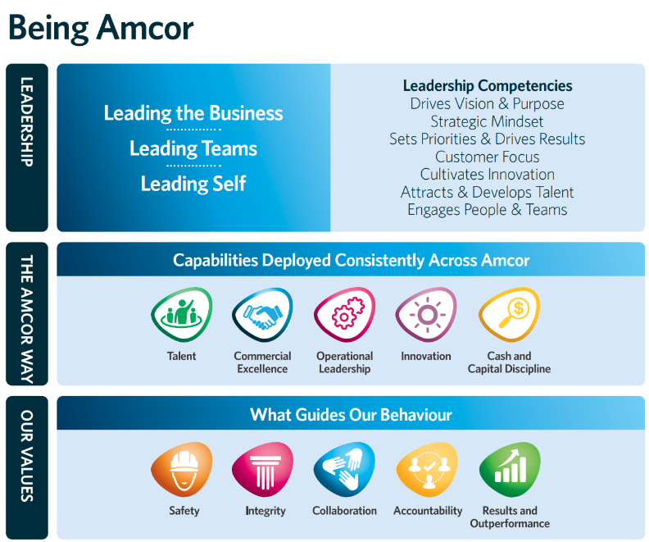
Fig 1.
Where an employee outperforms, the HR talent strategy will identify as a high potential employee which guides the policy deployment to develop and retain this employee via developmental and financial gains. Ensuring a strong alignment between organisational culture and HR policy enhances the value proposition to the individual which strengthens employee engagement and retention of talent (Schein et al, 2017). The upcoming merger with Berry Global (Giordano, 2024) will be a critical cultural integration to the Amcor way of a separate large-scale business, ensuring a seamless merge of the two businesses and cultures will be crucial to success and HRM must be integral to the process with policy deployment specific to the merger task.

4.2 Leadership and Management
HRM at Amcor has a large focus on leadership and management, this ensures all leaders in the business have a defined set of behaviours expected to drive an engaged and positive workforce. Outside of the Amcor leadership framework there are several HR strategies to ensure leaders recognise the employees who are performing well via development plans, retention incentives and talent assignment defined for growth of the individual. Bravo is a HR tool for recognition to be utilised by leaders to highlight a specific achievement by and employee who has outperformed to expectations gaining a competitive edge for the business. Amcor utilises this tool to complete a form (Fig 2) about the employee by the leader which is then shown during a live webcast of senior executive leaders celebrating the employee’s who have been nominated.
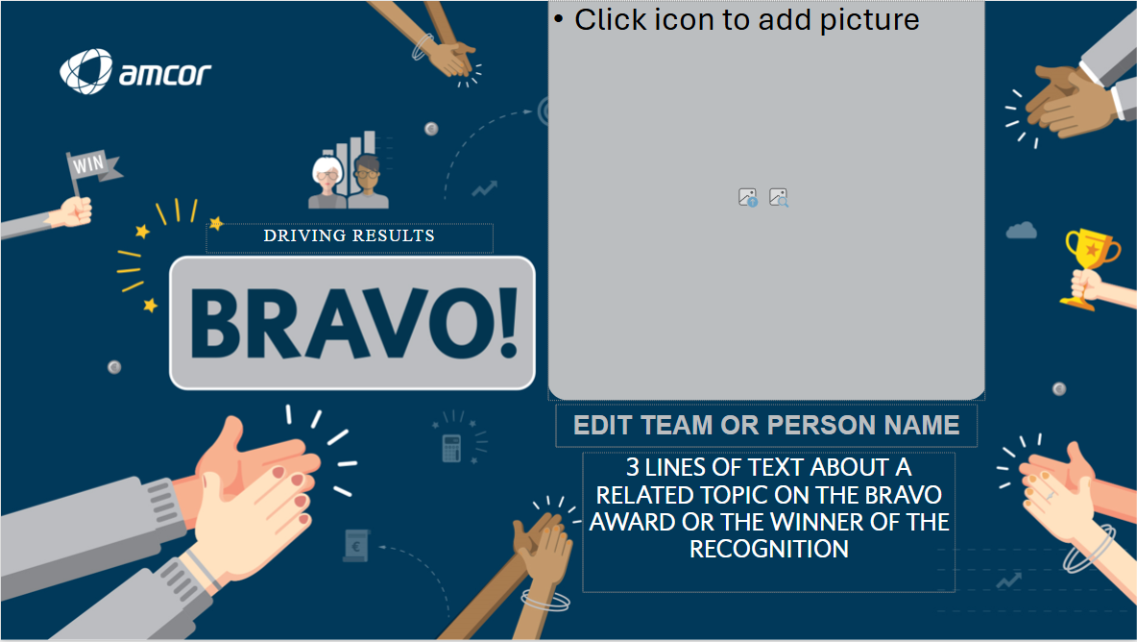
Fig 2.
According to Dulewicz et al (2005) leadership can be broadly grouped into three styles, Goal oriented, Involving, Engaging. Amcor strive to utilise the engaging style of leadership to drive facilitating others in achieving the goals and direction of the business, this allows development of capability to be a core factor for the HR strategy in the organisation and removes the reliance on authoritarian style management which was historically common in Western business practices (Pizzolitto et al, 2023).

4.3 Organisational Structure
Amcor operates with a regionalised structure and within this a matrix organisation. The regions are split into North America which reports into one president, Europe middle east and Africa which has separate president, Latin America which has a president but reports into the North American structure, and finally Asia pacific which has a president but reports into the European structure. All of the above report into a Chief Operating Officer and then Chief Executive Officer. Amcor. The structure successfully utilises the G3 strategy of ensuring the CEO, CFO and CHRO are closely aligned with business strategy (Sing, 2020) this allows the executive team to ensure strategy, financial resources and talent support are in place for long term success. According to Egelhoff et al (2017), the two-dimensional matrix organisation consists of hierarchical flow through of direct line into a manager but also a secondary line into a functional head. The structure at Amcor follows a similar matrix structure where all plant level senior managers report to the general manager, however all support functional heads also have a secondary reporting line into their functional directors. For example, the site HR manager would report into the GM but also have secondary reporting into the regional HR director, this is common across all support functions of Quality, Health and Safety, Continuous Improvement and Finance. Utilising such a structure allows the operational side of manufacturing to be supported by strong links from the plant into central functions via the local management team, this drives consistent strategy across regions and global functions.

- Impact on HR Policies, procedures and processes
Talent is critical to the success of all businesses, therefore the factors influencing Amcor must be considered when engaging in a Talent/Recruitment policy. Amcor utilises a structured talent management process to ensure performance management is utilised with commonality across the global business. The failure to identify next generation leaders and failing to attract top talent was ranked highest by a survey of CEOs in 2015 (Collings et al, 2017), this indicates the need for a strong and structured process as utilised by Amcor which begins at the year end review stage. The process is continuous throughout the financial year beginning with a manger review and scoring against objectives as 1 – Significant improvement needed, 2 – Needs improvement, 3- Meets expectations, 4 – Exceeds expectations, 5- Outstanding. Following the scoring and review goal setting for the next financial year begins which include developmental and business goals. In month 4 the first talent council occurs with the GM moving into month 5 where the business unit review all talent identified. This cycle continues with 1-1 meetings and a mid-year review to check progress, finally ending with the overall business group review identifying regional/global talent pools. During the process there is also a rating for if an individual is a “high potential” employee for the future, or a “successor” for the next higher-level role, these are measured as ready now, 1 job away or 2 jobs away dependant on the developmental needs of the individual to carry out the requirements of the role.
Recruitment is also impacted by the factors stated to ensure that the correct talent is acquired for the organisation. Amcor utilise multiple round interviews for positions working on a two levels upward strategy. For example, a general manager would have the first stage interview with the business unit director, followed by a second interview by the business group vice president. Amcor also utilises psychometric testing to analyse the drivers, behaviours and competencies required against a role profile. These tests are designed to measure a candidate’s suitability against a given role with a scientifically designed test and unbiased results (Korn ferry, unknown). However, it is crucial these tests only form part of the recruitment process and are not designed to be used as the full basis for decision on recruitment.
Learning and development must also be considered as impacted, with the “war for talent” ongoing amongst global businesses it is critical development is a key strategic tool (Beechler et al, 2009). Amcor must ensure it’s talent is continuously developed via the individual development plan which all employees at management level and above must complete annually. This ensures the talent is being developed into the next generation of leaders and experts to drive the business towards long term strategic goals. Amcor has a large focus on sustainability so must develop employees to understand how they can individually impact the goals and become part of the long-term plan of recyclability in the business.
- Conclusion and recommendations
Amcor’s HRM approach is influenced by a range of dynamic internal and external factors. Operating on a global scale it is influenced by geopolitical factors which can influence the strategies taken in HRM ensuring cultural context and local regulatory issues are considered in global and more succinctly local policy making. The internal drivers in organisational culture, leadership and structure are utilised to ensure policies are aligned with global objectives but ensuring local needs are being managed. The upcoming merger with Berry Global will require significant care by the HR function to integrate not only the people, but also the cultural requirements of Amcor into the Berry workforce. Amcor must continue to develop their HR strategy alongside business goals utilising the G3 structure at executive level, and driving policy deployment across the company to ensure the business is competitive and future ready.
The following recommendations are proposed to enhance the HRM proposition at Amcor.
  - Expand usage of AI workforce analytics – Amcor should expand their use of AI to forecast future needs and skills gaps. This will allow the business to leverage big data to enable strategic decision making at executive and local level for talent management internally and externally when recruiting.
  - Increase presence of green HRM policies – There is a large focus on sustainability on a global level but less within the HR function regarding policies. Amcor should include sustainability within the goal setting process for employees outside of the core function. This can embed sustainability into the culture and will align the global business to the strategic goal.
  - Increase Talent Mobility – Amcor have a talent mobility programme which is strong when taking employees to the central offices in Zurich. However, this is not the case for plant level movements. The business should revisit the policy in light of plant requirements not only central requirements, this can include remote support or expatriate support when required. Increasing the mobility of talent can ensure the correct skills are deployed to any issue at pace therefore increasing company performance.

Bibliography:
- Amcor. (2024). Sustainability Report FY24. [Online]. Amcor. Available at: https://sustainability.amcor.com/content/dam/amcor-sustaiability-reports/reponability-report/sustain [Accessed 22 March 2025].
- Giordano, G. (2024). Amcor to Buy Berry Global in Blockbuster Deal. [Online]. Plastics Today. Available at: https://www.plasticstoday.com/packaging/amcor-to-buy-berry-global-in-blockbuster-deal [Accessed 23 March 2025].
- Michael, A., 2006. A handbook of human resource management practice/Michael Armstrong.–10th ed.
- Deel. (2024). Minimum wage by country. [Online]. Deel. Available at: https://www.deel.com/blog/minimum-wage-by-country/ [Accessed 23 March 2025].
- Kerr, W.R. (2020) 'Global Talent and U.S. Immigration Policy', National Bureau of Economic Research Working Paper Series. Cambridge, MA: National Bureau of Economic Research. Available at: https://www.hbs.edu/ris/Publication%20Files/20-107_0967f1ab-1d23-4d54-b5a1-c884234d9b31.pdf (Accessed: 22 March 2025).
- Richter, F. (2021). COVID-19 has caused a huge amount of lost working hours. [Online]. World Economic Forum. Available at: https://www.weforum.org/stories/2021/02/covid-employment-global-job-loss [Accessed 23 March 2025].
- EOR. (2023). Differences between US and UK Employer Costs. [Online]. EORUK. Available at: https://www.eoruk.com/latest-advice/differences-us-uk-employer-costs/ [Accessed 23 March 2025].
- Søndergaard, Mikael. (2001). • Geert Hofstede, Culture’s Consequences: Comparing Values, Behaviours, Institutions, and Organizations Across Nations,. International Journal of Cross Cultural Management. 243 - 246.
- Goldman Sachs. (2023). Generative AI could raise global GDP by 7%. [Online]. Goldman Sachs. Available at: https://www.goldmansachs.com/insights/articles/generative-ai-could-raise-global-gdp-by-7-percent.htm [Accessed 6 April 2025].
- Renwick, D.W.S., Redman, T. and Maguire, S. (2013), Green Human Resource Management: A Review and Research Agenda*. International Journal of Management Reviews, 15: 1-14. https://doi.org/10.1111/j.1468-2370.2011.00328.x
- Torrington, D. et al. (2020) Human resource management. 11th edition. Harlow: Pearson Education Limited.
- UK Government (2025) Data protection. Available at: https://www.gov.uk/data-protection (Accessed: 30 March 2025)
- Du, J., 2024. Ethical and Legal Challenges of AI in Human Resource Management. Journal of Computing and Electronic Information Management, 13(2), p.2024.
- Schein, E.H. and Schein, P. (2017) Organizational culture and leadership. Fifth edition. Hoboken, N.J: Wiley.
- Dulewicz, V. and Higgs, M., 2005. Assessing leadership styles and organisational context. Journal of managerial psychology, 20(2), pp.105-123.
- Pizzolitto, E., Verna, I. and Venditti, M., 2023. Authoritarian leadership styles and performance: a systematic literature review and research agenda. Management Review Quarterly, 73(2), pp.841-871.
- Singh G. (2020). C-suite Collaboration between G3’ team - CEO, CFO and CHRO. [Online]. Linkedin. Available at: https://www.linkedin.com/pulse/c-suite-collaboration-between-g3-team-ceo-cfo-chro-gurdip-dadyal/ [Accessed 6 April 2025].
- Egelhoff, W.G. and Wolf, J. (2017) Understanding Matrix Structures and their Alternatives : The Key to Designing and Managing Large, Complex Organizations. 1st ed. 2017. London: Palgrave Macmillan UK. Available at: https://doi.org/10.1057/978-1-137-57975-1.
- Collings, D.G., Mellahi, K. and Cascio, W.F. (eds) (2017) The Oxford handbook of talent management. Oxford: Oxford University Press.
- Korn Ferry (unknown) Candidate guide: Assessments. Available at: https://www.kornferry.com/careers/candidates/candidate-guide-assessments (Accessed: 30 March 2025).
- Beechler, S. and Woodward, I.C. (2009) ‘The global “war for talent”’, Journal of international management, 15(3), pp. 273–285. Available at: https://doi.org/10.1016/j.intman.2009.01.002.

