University of Wales Trinity Saint David
School of Engineering



Computational Analysis of Turbulence within an MOCVD Reaction Chamber

Independent Project
ACMA6013

Rachel Williams
2208603
BEng Mechanical Engineering
June 2026

Declaration of Authenticity
This thesis is the result of the author’s own original research. It has been composed by the author and has not been previously submitted for examination which has led to the award of a degree.

Signed: Rachel Williams Date: 01/06/2026

Abstract
This study investigates the influence of graphite component surface roughness on gas flow behaviour and wafer quality with a Metal-Organic Chemical Vapour Deposition (MOCVD) reactor. Surface degradation of an internal reactor components is a recognised industrial concern; however, its effect on flow dynamics and subsequent process performance remains insufficiently quantified. This work aims to determine whether a measurable relationship exists between graphite surface roughness, internal flow characteristics, and critical to quality outputs in compound semiconductor wafer production.
A combined experimental and computational approach was adopted. Surface roughness measurements were obtained from graphite reactor components used across four production campaigns and converted to equivalent sand grain roughness for implementation within Computational Fluid Dynamics (CFD) models. Detailed Computer Aided Design (CAD) representations of the reactor geometry were developed and used to simulate gas flow behaviour under representative operating conditions. CFD simulations were performed using a Finite Volume Method under steady-state assumptions, with turbulence modelled using a RANS based approach. A mesh independence study was conducted to ensure numerical stability. Simulation outputs were compared against empirical production data, which consisted of the yield data across 192 production runs.
The study highlights a limitation in conventional CFD approaches for MOCVD systems when surface degradation effects are incorporated through wall-function-based roughness models. The findings suggest that more advanced near-wall modelling and multi-physics simulation approaches, alongside higher-resolution empirical datasets, are required to fully understand the role of surface condition in reactor performance and wafer quality.

Acknowledgements
The author would like to thank Jordan Jenkins and Emma Davies for their guidance and support throughout the duration of this project. Appreciation is also extended to the industry contact who provided access to production data and those who assisted with the acquisition of reactor component measurements. Finally, thanks are given to colleagues and peers for their advice and support during the completion of this work.
Table of Contents
Declaration of Authenticity 2
Abstract 3
Acknowledgements 4
Table of Figures 7
Table of Tables 7
Abbreviations 8
1.0 Introduction 9
1.1 Problem statement 9
1.2 Aims and Objectives 9
1.3 Scope and Limitations 10
1.4 Methodology Overview 11
1.5 Time Management 12
2.0 Literature Review 15
2.1 MOCVD 15
2.2 Characterisation of Wafers 17
2.3 Computational Fluid Dynamics 18
2.4 Experimental Design 19
3.0 Methodology 21
3.1 Overall approach 21
3.2 Data Collection 21
3.3 CAD Modelling 21
3.4 CFD setup 22
3.5 Data Analysis 23
3.6 Validation and Reliability 23
3.7 Limitations of the Methodology 23
3.8 Mesh Independence Study 24
4.0 Results 27
4.1 CAD Modelling and Surface Roughness Values 27
4.2 Empirical Data 28
4.3 CFD Analysis 29
5.0 Discussion 37
5.1 Overview of Key Findings 37
5.2 Influence of Surface Roughness on Simulated Flow Behaviour 37
5.3 Relationship Between Surface Roughness and Yield 38
5.4 Comparison Between CFD analysis and Empirical Findings 38
5.5 Evaluation of Objectives 39
5.6 Limitations and Model Constraints 39
6.0 Conclusions 40
7.0 Future Work 41
7.1 Improvements to Methodology and CFD Modelling 41
7.2 Expansion of Empirical Data Collection 42
7.3 Further Investigation of Boundary Layer Behaviour 43
7.4 Potential Industrial Applications 43
8.0 References 45

Table of Figures
Figure 1 - Gantt Chart 13
Figure 2 - Gantt Chart 13
Figure 3 - Top View of Chamber 27
Figure 4 - Side View of Chamber 27
Figure 5 – Yield Rate of the Campaigns as a Function of Surface Roughness 29
Figure 6 – Relationship Between Turbulence Intensity and Surface Roughness 30
Figure 7 – Relationship Between Turbulent Dissipation and Surface Roughness 31
Figure 8 – Relationship Between Turbulent Energy and Surface Roughness 31
Figure 9 – Relationship Between Turbulent Length and Surface Roughness 32
Figure 10 – Relationship Between Turbulent Time and Surface Roughness 32
Figure 11 – Relationship Between Turbulent Time and Surface Roughness 33
Figure 12 – Relationship Between Flow Velocity and Surface Roughness 33
Figure 13 – Relationship Between Friction Force and Surface Roughness 34
Figure 14 – Relationship Between Circumferential Velocity and Surface Roughness 34
Figure 15 – Relationship Between Radial Velocity and Surface Roughness 35
Figure 16 – Relationship Between Radial Velocity and Surface Roughness 35
Figure 17 – Percentage Change of All Parameters for Differing Values of Surface Roughness 36

Table of Tables
Table 1 – Simulation Parameters 24
Table 2 – Results of Mesh Independence Study 25
Table 3 – Percentage Change Between Mesh Densities 25
Table 4 - Measured Surface Roughness of Graphite Components 28
Table 5 – Surface Roughness Converted to Sand Grain Height 28
Table 6 - Calculated Yield Rates of Campaigns 28
Table 7 – Results of CFD Analysis 30

Abbreviations
Abbreviation | Meaning
BJTs  CAD  CFD  CVD  DoE  GaAs  GaN  GII  InP  InSb  LED  LES  MOCVD  MOSFET  MOVPE  OMVPE  Ra  RANS  RSM  SE  UV | Bipolar Junction Transistors  Computer Aided Design  Computational Fluid Dynamics  Chemical Vapour Deposition  Design of Experiments  Gallium Arsenide  Gallium Nitride  Grazing Incidence Interferometry  Indium Phosphide  Indium Antimonide  Light Emitting Diode  Large Eddy Simulation  Metal Organic Chemical Vapour Deposition  Metal Oxide Semiconductor Field Effect Transistor  Metal Organic Vapour Phase Epitaxy  Organometallic Vapour Phase Epitaxy  Arithmetic Mean Surface Roughness  Reynolds-Averaged Navier-Stokes  Response Surface Methodology  Spectroscopic Ellipsometry  Ultraviolet

Introduction

Problem statement
The presence of turbulence within Metal-Organic Chemical Vapour Deposition (MOCVD) reactors is widely accepted as detrimental to wafer quality. However, the underlying contributing factors to flow disturbances remain insufficiently investigated. In particular, the influence of internal chamber components’ surface roughness on gas flow behaviour and its subsequent impact upon uniformity and wafer yield remains insufficiently understood. This is of importance as surface roughness directly affect boundary layer development, which governs mass and heat transfer at the substrate surface.
This lack of empirical evidence presents a challenge for process optimisation. Uncontrolled variability within the reaction chamber can lead to reduced product quality, increased material and energy waste, and decreased manufacturing efficiency. Addressing this knowledge gap is therefore essential for improving both process reliability and industrial performance.

Aims and Objectives
The primary aim of this project was to investigate the influence of graphite component surface roughness on parameters deemed critical to quality in the growth of compound semiconductor wafers. Specifically, the study aimed to quantify the relationship between surface roughness and key process performance indicators.
Within semiconductor wafer manufacture manufacturing, yield refers to the proportion of the manufactured wafers that meets quality standards and are suitable for downstream processing. In this study, empirical data consisted of campaign yield alongside measured surface roughness values of graphite components used during production.
To achieve this aim, a series of objectives were defined to guide the study and ensure a structured approach within the analysis. These objectives focused on CAD model development, CFD simulation, data acquisition, and comparative analysis between simulated and empirical results.
The first objective was to create detailed CAD models of the graphite components located within the reaction chamber. Due to the absence of technical drawings, this required direct physical measurement of the components. The accuracy of these models was essential to ensure reliable CFD simulation results.
The second objective set was to gather all relevant process data and material properties required for the simulations. This included gas flow rates, concentrations and densities, and chamber temperatures at each layer within the production run.
The third objective was to conduct CFD simulations to investigate the impact of surface roughness on gas flow behaviour. These simulations were used to model the movement of gases within the reactor, with particular attention given to identifying the presence and extent of turbulent flows. By altering surface roughness parameters within the models, the simulations aimed to replicate variations within the processes caused by the components utilised within the process.
The final objective was to compile and analyse production run data corresponding the graphite components measured and modelled within the study. The production run data analysed included the number of wafers that passed or failed quality characterisation. By comparing the results of the production runs with the results of the CFD simulations, the project would evaluate any potential correlations between surface roughness, flow characteristics and wafer quality.
Within this study, the independent variable was the surface roughness of the graphite components, quantified through equivalent sand grain roughness height. The dependent variables included both CFD-derived flow characteristics and empirical performance indicators, evaluated through the overall yield of the process. Process parameters, such as flow rate, pressure, reactor geometry, and temperature, were treated as controlled variables within the simulations, to ensure a consistent basis for comparison.

Scope and Limitations
This study focused upon evaluating the influence of graphite component surface roughness within a single MOCVD reactor configuration. The analysis is based on a defined set of 192 production runs across four campaigns, within which each components surface characteristics, process conditions, and the results of the production run are evaluated.
The scope of the work was limited to graphite components located within the reaction chamber, selected due to their direct interaction with the gas flow and the observed degradation of their surfaces over time. Other potential influencing factors, such as precursor material variations (such as concentrations or mass flow rate) and external environmental conditions were assumed constant. While these factors were assumed constant, it is acknowledged that subtle variations in precursor flow rates and temperature distributions may influence process outcomes and represent potential points of uncertainty.
CFD was used as the primary analytical tool for the investigation of flow behaviour. While CFD provides valuable insight into internal reactor conditions, it is required that several simplifying assumptions be made for the computational feasibility of the study. These simplifications include idealised boundary conditions, reduced chemical complexity, and geometric simplifications. In particular, the rotational motion of the susceptor and substrates, which occurs during normal operation was not incorporated into the simulations. The exclusion of rotational motion is a significant limitation, as rotation is known to affect flow uniformity and mixing within MOCVD reactors. Its omission may therefore reduce the accuracy of predicted flow behaviour.
As a result, the simulations presented in this study are not intended to provide exact quantitative predictions of gas flow behaviour within the chamber. Instead, they are used to identify relative trends and potential relationships between surface roughness and flow patterns. The validity of these findings is therefore dependent on the accuracy of the input data, including component dimensions and surface roughness measurements, as well as the assumptions inherent within the modelling approach.
The relatively small sample size of campaigns limits the extent to which the findings can be generalised across different reactor configurations or operating conditions. Consequently, the results of this study should be interpreted within the context of the specific system analysed, with further validation recommended for broader industrial applications.

Methodology Overview
The methodology adopted in this study integrates experimental measurement, digital modelling, and computational analysis to investigate the relationship between graphite component surface roughness, gas flow behaviour, and wafer quality within a Metal-Organic Chemical Vapour Deposition (MOCVD) reactor.
Surface roughness measurements were first obtained for graphite components utilised across a series of production runs. These measurements provided quantitative input data representing the physical condition of internal reactor components. To ensure reliability, appropriate validation procedures were applied to the measurement instruments and data collection process.
The internal geometry of the reactor was subsequently reconstructed through the development of detailed Computer-Aided Design (CAD) models. These models incorporated the measured component dimensions and surface characteristics, enabling an accurate representation of the reactor environment for further analysis.
Computational Fluid Dynamics (CFD) simulations were then conducted using the developed CAD models to analyse gas flow behaviour within the reaction chamber. The simulations were designed to evaluate key flow characteristics, with particular emphasis on identifying regions of instability and the potential onset of turbulence. Relevant process parameters, including temperature distributions, gas flow rates, and material concentrations, were incorporated to replicate operational conditions as closely as practicable.
To ensure the numerical reliability of the simulation results, a mesh independence study was performed. This involved systematically refining the computational mesh and evaluating the impact of the mesh refinement on the key flow parameters, ensuring the simulation outputs were not significantly influenced by discretisation error.
The outputs of the CFD simulations were compared with corresponding production data. This comparative approach enabled the assessment of potential correlations between surface roughness, flow dynamics, and critical-to-quality performance indicators.
It is acknowledged that the modelling approach involves several simplifying assumptions necessary for computational feasibility. As such, the methodology is primarily intended to identify relative trends and relationships rather than provide absolute predictive accuracy. Nevertheless, the combined use of experimental data and simulation-based analysis provides a robust framework for evaluating the influence of component surface condition on MOCVD process performance.

Time Management
A structured project timeline was developed at the beginning of the project to organise the various stages of research and ensure consistent progression towards the completion of the project. This timeline was depicted using Gantt charts, which provided a clear visual framework for scheduling tasks, monitoring progress, and identifying deviations from planned milestones.
The project was divided into key phases, beginning with the proposal stage, which involved initial background research, topic selection, and the development of a formal project proposal. This was followed by a literature review stage, where relevant academic sources were identified and critically assessed to establish the context and the need for the study.
The methodology design phase focused on determining the research approach, including the selection of appropriate tools and techniques such as CAD modelling and CFD simulation. The data collection phase was conducted in two stages, the first of which involved conducting physical measurements of the graphite components, including dimensional data and surface roughness. The second stage consisted of compiling process data, such as reactor temperatures, gas flow rates, concentrations, and pressure conditions, alongside production outcome data.
Following data collection, the analysis phase involved processing the gathered data, performing the CFD simulations, and interpreting the results to identify a correlation between the surface roughness and run results. The final stages of the project consisted of drafting the project report, integrating findings with the literature, and completing revision and finalisation tasks such as editing, proofreading, and formatting prior to submission.

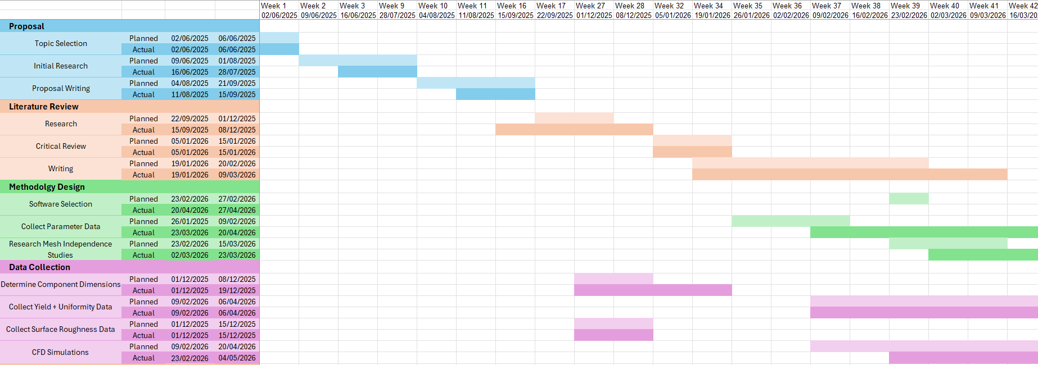
Figure 1 - Gantt Chart

Figure 2 - Gantt Chart
Figures 1 and 2 show the Gantt Chart created at the beginning of the project, where the planned and actual completion dates for each objective is displayed. While the initial timeline provided a structured framework, several tasks were completed later than anticipated. These delays were primarily attributed to external factors, including competing workload commitments, which limited the time available for data collection and analysis.
Additional delays were encountered during the CAD and CFD modelling stages due to technical issues associated with remote desktop access. Furthermore, the coordination and acquisition of production results proved more time consuming than initially expected. A significant deviation from the original timeline occurred during the software selection phase. The project was initially intended to utilise ANSYS Fluent for the CFD simulations, however, due to the software’s complexity and the associated learning curve, progression of the project was limited. Therefore, a decision was made to transition to SOLIDWORKS Flow, which required an alternative modelling approach. This change necessitated the re-drawing of the CAD models, resulting in further delays.
Despite these challenges, the Gantt chart remained an effective tool for monitoring overall progress of the project, ensuring that critical milestones were achieved and that the project remained on the correct trajectory for completion.
Upon reflection, the project highlights the importance of incorporating contingency time within the planning stage to account for unforeseen challenges, particularly when utilising an unfamiliar complex software tool. During the completion of this project the structured approach to time management, supported by detailed planning and continuous monitoring, proved effective in maintaining overall project direction and achieving the intended outcomes.

Literature Review

MOCVD
According to C. A. Wang (2019) MOCVD is a widely adopted technique in the fabrication of compound semiconductor wafers, which are then post-processed, lithography to imprint circuit boards, which are key to the operation of a range of microelectronic and optoelectronic devices, such as LEDs, Metal Oxide Semiconductor Field Effect Transitors (MOSFETs), and bipolar junction transistors (BJTs) (Dupuis, 2003; Grodzinski et al., 1995). The performance of these devices is heavily reliant upon the atomic structure and uniformity of the semiconductor chips, meaning process stability essential.
MOCVD is a specialised form of CVD that utilises organometallic precursors to deposit thin crystalline films onto heated substrates. As outlined by Jones & Hitchman (2009), this technique enables the growth of high-quality epitaxial layers with precise control over composition and thickness, making it particularly suitable for large-scale industrial applications.
According to C. A. Wang (2019), the origins of MOCVD can be traced back to as early as the 19th century, with early applications involving the deposition of metals such as tungsten and nickel from volatile compounds. Over time, the technique evolved significantly, with key milestones such as the deposition of silicon in the early 20th century and the development of industrial coatings for glass by companies such as Pilkington in the 1980s. The rapid expansion of the micro-electronics industry from the 1970s onward further accelerated advancements in CVD technologies, driven by the need for precise control over film thickness and doping.
The introduction of metal-organic precursors in the 1960s marked a significant advancement in the field, enabling the deposition of compound semiconductors such as gallium arsenide (GaAs), indium phosphide (InP), and indium antimonide (InSb). These materials form the basis of many modern optoelectronic devices. Gallium nitride (GaN) based semiconductors have enabled the development of high efficiency blue and green LEDs, with more recent advancements extending into the ultraviolet (UV) spectrum (Maruska & Rhines, 2015). UV LEDs have attracted particular attention due to their potential applications in sterilisation and disinfection, due to their non-contact properties in comparison with traditional chemical methods (Song et al., 2016).
A critical factor in the MOCVD process is the control of gas flow dynamics within the reaction chamber. The process relies on the transport of precursor gases to the heated substrate surface, where they undergo chemical reactions to form solid thin films. The characteristics of the flow, particularly where it remains laminar or becomes turbulent, plays a significant role in determining the quality of the deposited layers. Jiang et al. (2016) note the importance of maintaining laminar flow conditions to ensure uniform deposition across the wafer surface. Similarly, Y. Li et al. (2025) emphasise that turbulence can introduce instability in mass and heat transfer, leading to undesired effects such as non-uniform deposition rates, increased likelihood of parasitic reactions, and contamination within the reaction chamber.
These flow characteristics directly influence on key quality indicators within semiconductor manufacturing including reflectance, luminous intensity, and structural uniformity. Poor uniformity in the structure of the lattice will impact upon the yield of the process, other potential impacts upon the yield includes contaminants within the reaction chamber (oxygen), and temperature differences or incorrect temperatures across the wafer surface. Variations within these parameters significantly degrade the performance of the devices they would be utilised in, particularly in optoelectronic applications where wavelength emissions and luminous intensity are highly sensitive to the uniformity of the structure (Noor et al., 2026).
Despite the recognised importance of flow dynamics, there remains limited understanding of factors influencing flow behaviour within MOCVD reactors. One such factor is the surface roughness of the internal reactor components. Graphite is commonly used in MOCVD reactors due to its high thermal stability and chemical resistance; however, surface degradation over time may influence boundary layer behaviour and the onset of turbulence. This gap is particularly relevant in industrial settings, where components are subject to wear, constant thermal cycling, and chemical exposure throughout their operational lifetime.
A key challenge in studying MOCVD systems is the inaccessibility of the reaction chamber during operation. High temperatures and controlled atmospheres prevent direct observation of internal flow behaviour. Consequently, CFD has become a commonly employed tool for evaluating and simulating the gas paths within the chamber during production. While CFD provides valuable insights, studies incorporating experimental validation remain limited.
Y. Li et al. (2025) present a detailed study of a zinc oxide MOCVD reactor, employing a finite volume method (FVM). Their work integrates Response Surface Methodology (RSM) to optimise rotational speed of the susceptor during processing. However, the study relies on simplified geometries and assumes idealised smooth surfaces within the chamber, limiting its applicability to industrial systems.
Y. Li et al. (2025) further conclude that maintaining laminar flow conditions is essential for achieving high quality thin film deposition, citing the detrimental effects of turbulence, which included unstable heat and mass transfer, increased residence time of by-products, and the promotion of parasitic gas-phase reactions.
Similarly, He et al. (2022) investigate a showerhead reactor using CFD coupled with swarm intelligence optimisation, which demonstrated improved deposition performance through parameter optimisation. However, as with other studies, the analysis does not account for the influence of surface roughness on flow behaviour, representing a consistent limitation across the literature.
A consistent assumption of idealised smooth reactor surfaces is observed throughout the literature. While appropriate for simplified modelling, this neglects the reality of industrial systems, where component degradation after repeated use may influence flow behaviour.

Characterisation of Wafers
Wafer quality in this study is assessed using three key characterisation techniques: Surfscan haze/particle monitoring, spectroscopic ellipsometry (SE), grazing incidence interferometry (GII).
Surface contamination and defect inspection are critical aspects of semiconductor wafer characterisation, as even nanoscale particles can significantly impact device yield and reliability. Surfscan systems are laser-scattering inspection tools that are widely used in semiconductor manufacturing to detect particles, haze, and surface defects on polished wafers. The technique operates by directing a laser beam across the wafer surface and measuring scattered light intensity. Discrete particles generate localised scattering signals, while haze measurements quantify diffuse scattering caused by microroughness, contamination films, or process-induced surface damage (Takami, 1997).
SE is an optical, non-destructive technique that measures changes in the polarisation state of reflected light to extract information regarding film thickness and optical properties. By analysing the amplitude ratio and phase difference between reflected light components, SE provides highly sensitive measurements of thin-film characteristics.
The study conducted by Persson et al. (2000) highlights SE as a precise and efficient method for routine characterisation. It can determine both thickness and optical constants simultaneously, provided an appropriate model is used. The technique benefits from rapid data acquisition and relatively simple instrumentation making it well-suited for production environments.
SE relies heavily on model-based analysis, meaning that accurate results depend on prior knowledge of material composition and structure. In complex systems, with multiple unknown parameters, such as interlayer mixing or compositional variations, fitting procedures may yield ambiguous or non-physical solutions.
GII is a specialised optical metrology technique used for high-sensitivity surface topography measurements. Unlike conventional interferometry, the incident beam strikes the surface at a very shallow angle, effectively increasing measurement sensitivity to surface height variations and allowing rough or partially polished surfaces to be examined. This characteristic makes GII useful during intermediate manufacturing stages where surfaces may not posses optical-quality finishes.
In semiconductor applications, GII is used to assess wafer flatness, surfaces quality, and topography. Because the effective optical path difference is amplified by the grazing geometry, the technique can detect nanometre-scale deviations over relatively over relatively large areas. The method provides highly accurate three-dimensional surface maps and provides detailed information regarding rough surfaces that are difficult to measure using conventional interferometric techniques.
GII typically measures surface geometry rather than material composition or film properties. Complex alignment requirements, sensitive to vibration, and challenges associated with highly curved geometries can limit its implementation. Consequently, GII is often utilised at a complementary technique alongside SE, profilometry, and scattering-based inspection systems to provide a comprehensive assessment of wafer quality (Schwider et al., 2016).

Computational Fluid Dynamics
Computation Fluid Dynamics (CFD) is a numerical modelling technique used to analyse fluid flow, heat transfer, and species transport by solving the governing conservation equations of mass, momentum, and energy. According to Versteeg & Malalasekera (2007) these equations are typically expressed in the form of the Navier-Stokes equations. Due to their complexity, analytical solutions are limited to simplified cases, making numerical approaches essential for realistic systems (Martins et al., 2014).
CFD is widely applied across engineering disciplines, including aerospace, automotive, and chemical processing (Anderson, 1995). In semiconductor manufacturing, it enables analysis of reactor conditions that cannot be directly observed. For MOCVD processes, CFD is particularly valuable for studying gas flow distribution, temperature gradients, and turbulence.
Othman et al. (2013) highlight key limitations associated with CFD, they note that many studies rely on simplified geometries and two-dimensional models, which may fail to capture complex three-dimensional flow structures. More advanced simulations, such as those conducted by J. Li et al. (2018), incorporate rotational effects and transient conditions, providing more realistic models of flow behaviour. Their findings indicate that rotational speed influences growth uniformity, although its impact may be secondary to other factors.
While advanced simulations can incorporate complex influential parameters such as rotation and material phase changes, many studies continue to rely on simplifying assumptions, including idealised geometries and laminar flow conditions. Furthermore, neither study explicitly account for nor investigate the effects of surface roughness, further emphasising the need for investigation into the scale of the effects of surface roughness within the MOCVD process.

Experimental Design
Experimental design is a critical aspect of engineering research, particularly in studies that combine physical measurements with computational modelling techniques such as CFD. A well-structured experimental design ensures that data collection, simulation setup, and analytical procedures are conducted systematically, improving the reliability stability, and reproducibility of the results. Within CFD-based investigations, experiment design is especially important due to the sensitivity of simulations to input parameters, boundary conditions, and modelling assumptions.
In engineering research, experimental design refers to the structured planning of investigations to ensure that relationships between variables can be effectively identified and analysed. The application of Design of Experiments (DoE) methodologies enables researchers to minimise unnecessary experimentation while maximising the amount of meaningful information obtained from the study. Román-Ramírez & Marco (2022) explain that experimental design techniques are widely adopted in engineering disciplines to evaluate the relationship between input variable and process responses efficiently. In the context of CFD studies, this is particularly valuable due to the significant computational resources required for high-fidelity simulations.
Within fluid dynamics research, experimental design commonly involves the careful selection of operating conditions, geometric parameters, and validation methods. Barber et al. (2012) highlight the importance of integrating CFD with Experimental Fluid Dynamics (EFD), arguing that computational studies are most reliable when supported by experimental data and systematic validation procedures. Their work demonstrates how CFD can be used not only to analyse flow behaviour, but also to guide the design of experiments and optimise data collection strategies.
A key consideration within CFD experimental design is the level of geometric and physical simplification applied to the computational model. Excessive simplification may reduce computational cost but can compromise the validity of the simulation results. Othman et al. (2013) argue that many reactor-flow studies rely upon overly simplified geometries and two-dimensional models, which may fail to accurately capture complex flow behaviour within industrial systems. This issue is particularly relevant in MOCVD research, where internal chamber geometry, flow distribution, and thermal gradients strongly influence process performance. The selections of appropriate modelling assumptions therefore form a fundamental part of the experimental design process.
Another important element of CFD experimental design is validation and verification. Validation refers to assessing whether the simulation accurately represents physical behaviour, while verification ensures that the numerical model has been implemented correctly. One commonly adopted verification technique is the mesh independence study, which evaluates whether further refinement of the computational mesh significantly alters the simulation results. Mesh independence studies are important within CFD research to ensure that results are not dependent on mesh density alone, thereby improving confidence in numerical findings. R. Wang et al. (2024) emphasise the importance of validation against experimental data and appropriate mesh refinement strategies in achieving reliable CFD results for complex flow systems.
In studies involving MOCVD reactors, experimental design is further complicated by the inability to directly observe internal flow behaviour during operation. Elevated temperatures, reactive gases, and controlled atmospheres make direct measurement impractical, increasing reliance on computational approaches. Process variables must be selected carefully, with realistic boundary conditions defined, and simulation outputs should be compared against measurable data where possible. Momeni et al. (2022) discuss the value of integrating CFD simulations with experimental validation in MOCVD research, showing how combined computational and experimental methodologies can improve understanding of deposition behaviour and process optimisation.
For the present study, the experimental design was structured to establish potential relationships between graphite component surface roughness, gas flow behaviour, and wafer quality indicators. Physical measurements of component geometry and surface roughness were integrated with CFD simulations and compared against production yield data. This combined methodology enables both qualitative and quantitative evaluation of flow behaviour while acknowledging the practical limitations associated with industrial reactor environments.

Methodology

Overall approach
This study adopts a quantitative, simulation driven approach to investigate the relationship between graphite component surface roughness, gas flow behaviour, and wafer quality within an MOCVD reaction chamber. The study integrates experimental results with CFD modelling to enable analysis of internal reactor conditions that are not directly observable during operation.
The methodology is structured to establish a link between physical component characteristics and process performance. Surface roughness measurements provide input data, which were incorporated as variables within the CFD simulations, to evaluate their influence on flow behaviour within the reaction chamber. The resulting flow characteristics obtained from the simulations are then compared with production yield data from corresponding campaigns. This enabled the identification of potential correlations between simulated flow behaviour and the quality outcomes of the process.

Data Collection
Graphite components located within the reaction chamber were measured to determine their dimensions to create the models. Due to the absence of technical drawings, all dimensions were determined using a combination of vernier callipers, depth gauges, and measuring tape for larger dimensions.
To improve measurement reliability, multiple readings were taken for each dimension and compared across instruments where possible. Any discrepancies were evaluated, and average values were used in the final CAD models. This approach minimised measurement uncertainty and improves geometric accuracy.
Surface roughness measurements were obtained for each graphite component using a contact profilometer. Measurements were taken at multiple locations on each component to account for spatial variation in surface condition. The arithmetic mean roughness value (Ra) was recorded and subsequently converted to equivalent sand grain roughness, by applying a conversion factor of 5.86. This method, outlined by Adams et al. (2012), provides an approximation of sand grain roughness, suitable for incorporation with CFD simulation. Averages values were then calculated to provide a representative surface roughness for each campaign, as the simulation software did not permit the assignment of individual roughness values to separate components.

CAD Modelling
The internal geometry of the MOCVD reaction chamber was reconstructed using CAD software, SOLIDWORKS. The graphite components were modelled individually based on the measured dimensions and subsequently assembled to replicate the configuration of the reaction chamber.
Given the complexity of the reactor geometry, simplifications were applied to ensure computational feasibility. Features deemed to have minimal influence on flow behaviour, such as minor surface details or external fixtures, were omitted. However, all components directly interacting with the gas flow were retained to preserve the integrity of the simulation domain.
The resulting CAD model defined the physical boundaries of the computational domain and severed as the basis for the CFD simulations.

CFD setup
CFD simulations were conducted to analyse gas flow behaviour within the reaction chamber under representative operating conditions. The simulations were performed using FVM, solving the governing equations of mass, momentum, and energy conservation. Turbulence was modelled using a Reynolds-Average Navier-Stokes (RANS) approach, which provides a time-average solution to turbulent flow fields and is computationally efficient for industrial scale geometries. Large Eddy Simulation (LES), while more accurate in resolving transient eddy structures, was not implemented due to its significantly higher computational cost and mesh resolution requirements(Bensow et al., 2006).
Boundary conditions were defined to replicate operational conditions. A mass flow rate of 0.5kg/s was specified at the inlet, reflecting process control during operation. The reactor operates at a pressure of 100mbar, regulated via a throttle valve and vacuum pump, therefore, pressure outlet boundary conditions of 100mbar were applied at all outlet locations.
Several simplifying assumptions were introduced to reduce computational cost. The flow was assumed to be steady-state, and chemical reactions within the chamber were neglected. The inlet gas composition was defined as 50% nitrogen and 50% hydrogen; however, this represents a simplification compared to production conditions, where metal-organic precursors (e.g. trimethyl gallium and trimethyl indium) are present.
This simplification neglects the influence of reactive species, which may alter gas properties such as density and viscosity, as well as affect reaction kinetics and flow behaviour of the simulations. While these assumptions limit the model’s ability to capture the full process complexity, they enable focused analysis of flow behaviour and surface roughness effects within the specified geometry.
Surface roughness was incorporated into the CFD model through equivalent sand grain roughness height, enabling the simulation to account for its effect on boundary layer development and flow resistance. This approach provides a practical method for linking measured roughness values to flow behaviour within the numerical model.

Data Analysis
The outputs of the CFD simulations were analysed by the identified key flow characteristics, including velocity distribution, flow patterns, and regions of recirculation or turbulence. Particular attention was given to deviations from laminar flow behaviour, as these are associated with reduced process stability.
The simulation results were then compared with the calculated yield of the campaigns. This comparative analysis aimed to identify potential correlations between surface roughness and flow behaviour, and in turn, their effects on wafer quality and process performance.
Where possible, trends were evaluated qualitatively and quantitatively to assess the strength of these relationships.

Validation and Reliability
To ensure the reliability of the methodology, measurement tools were validated using calibrated reference standards. Surface roughness measurements were verified using samples of known roughness, while dimensional measurement tools were checked against calibration blocks. To further reduce uncertainty, measurements were repeated three times and an average was taken.
Although full experimental validation of the CFD model was not feasible within the scope of this study, due to the compounding effect of the simplifications made, the results have been deemed as reliable for identifying trends rather than providing absolute predictions.
Wafer quality assessment was based on a multi-technique evaluation process used in production, providing a robust and reliable measure of the yield for each campaign.

Limitations of the Methodology
Several limitations are inherent within the adopted methodology. The exclusion of rotational effects within the CFD simulations represents a significant simplification, as rotation of the main chamber components would significantly impact the flow patterns and mixing behaviour of the simulation. Similarly, the simplification of the chemical complexity of the process to create the CFD simulations also impacted the accuracy of the modelling.
Furthermore, the relatively small sample size of campaigns restricts the statistical reliability of the findings. The study is also limited to a single reactor configuration and therefore the results may not be directly informative for chambers of different configurations.
Despite these limitations, the methodology provides a robust framework for exploring the relationship between surface roughness and flow behaviour, offering insight into a previously under investigated aspect of MOCVD process optimisation.

Mesh Independence Study
A mesh independence study was conducted to ensure that the numerical results obtained from the CFD simulations were not significantly impacted by the spatial discretisation of the computational domain. In CFD analysis, the governing equations are solved in discrete form over a finite number of control volumes, meaning that the accuracy and stability of the solution are dependent on mesh resolution. An insufficiently refined mesh may fail to resolve important spatial gradients in velocity, pressure, and turbulence quantities, leading to discretisation error and inaccurate flow prediction. Conversely, excessively fine meshes increase computational cost significantly, often without producing meaningful improvement in solution accuracy once the asymptotic range of convergence has been achieved. Therefore, identifying an optimal mesh density is essential to ensure a balance between numerical accuracy and computational efficiency.
To evaluate mesh sensitivity, a systematic refinement approach was implemented. The computational domain, based on the reconstructed geometry of the reaction chamber, was discretised using the SolidWorks Flow Simulation meshing tool. A series of progressively refined meshes were generated by increasing the number of elements present in the mesh, while maintaining consistent geometry and boundary condition definitions across all simulations. This ensure that any variation in results could be attributed solely to changes in mesh density rather than changes in simulation parameters.
Table 1 – Simulation Parameters
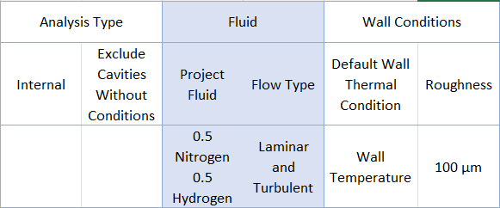
Table 2 – Results of Mesh Independence Study
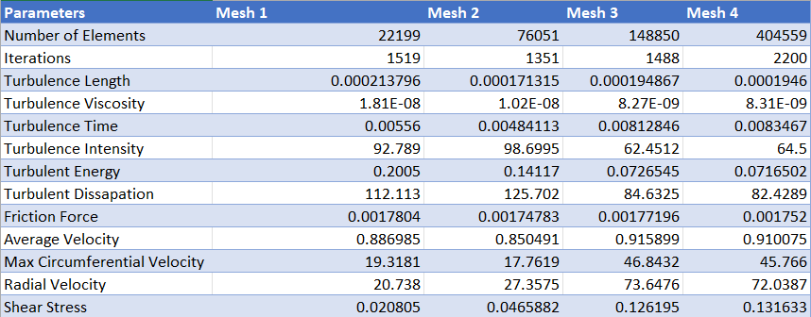
For each mesh configuration, steady-state simulations were performed under identical solver settings, turbulence models, and convergence criteria. Key flow variables were selected based on their relevance to global flow behaviour and near-wall effects, consisting of turbulence intensity, turbulence length, turbulence viscosity, turbulent time, turbulent energy, turbulent dissipation, friction force, velocity, circumferential velocity, radial velocity, and shear stress. The selection of both global and near-wall parameters ensure that mesh performance was assessed in terms of both bulk flow behaviour and boundary layer resolution. The results of these monitored variables across successive mesh refinements are presented in Table 2.
Table 3 – Percentage Change Between Mesh Densities
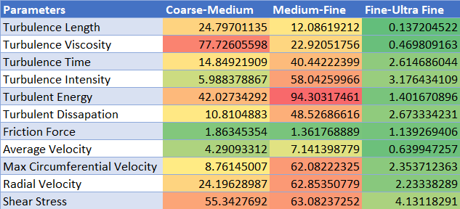

Mesh independence was assessed by comparing percentage differences in the monitored variables between successive mesh levels. A solution was considered mesh independent when further refinement resulted in changes of less than 10% in all monitored parameters. This threshold is consistent with previously reported CFD methodology studies in engineering applications, as utilised by Ghavidel et al. (2020), in the selected monitoring parameters. The comparison of the percentage changes between mesh densities can be seen in Table 3, showing the change between the fine and ultra fine meshes to be negligible, showcasing that the fine mesh, which contained 148850 elements, was suitable for use within this CFD study.

Results

CAD Modelling and Surface Roughness Values
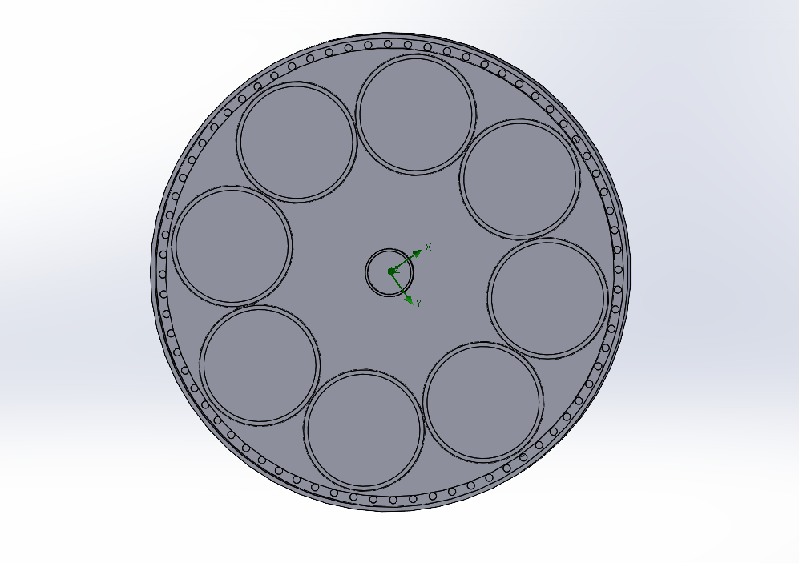
Figure 3 - Top View of Chamber
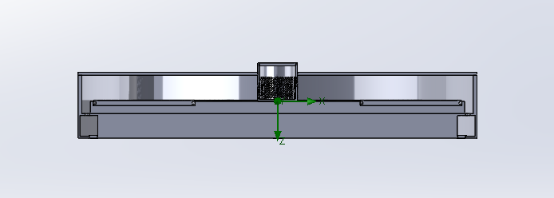
Figure 4 - Side View of Chamber
The dimensions of the graphite components measured were modelled in SolidWorks. These individual component models were then assembled to replicate the configuration of the reaction chamber. A cross-sectional view of the resulting assembly is shown in Figures 3 and 4. This CAD model formed the basis of the computational domain used in the CFD simulations.
Table 4 - Measured Surface Roughness of Graphite Components
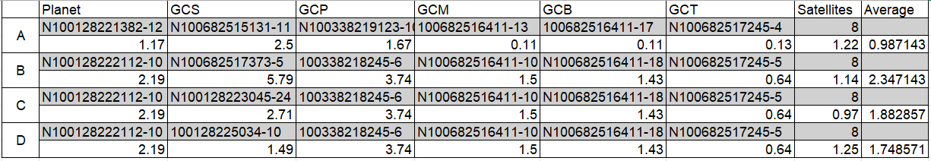
Table 4 presents the measured surface roughness values for the graphite components used across the different production campaigns. The table includes the serial numbers of each of the components, as well as the campaigns in which these components were used. Surface roughness measurements were taken at multiple locations on each component, and the average value for each component is reported.
Table 5 – Surface Roughness Converted to Sand Grain Height
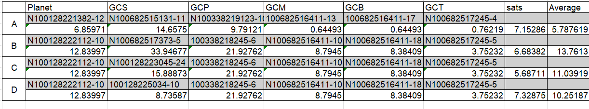
Table 5 shows the corresponding surface roughness values converted to equivalent sand grain height, the method of conversion for this measurement was discussed in the methodology. As shown, the average sand grain height for the components used in campaigns A, B, C, and D were 5.79 $μm$,13.76 $μm$, 11.04 $μm$, and 10.25 $μm$, respectively. These values indicate a clear variation in surface condition between campaigns, with the largest variation featured between campaigns A and B.

Empirical Data
Table 6 - Calculated Yield Rates of Campaigns
Campaign | Pass Rate of Wafers
A | 94.68%
B | 80.26%
C | 88.89%
D | 84.29%

Four campaigns were analysed, comprising of 192 production runs. The initial calculated yield for Campaign B was significantly below expectations, at 64.04%. Further investigation identified that 57 wafers failed during this campaign due to an undisclosable reason. As these failures were determined to be unrelated to wafer quality, they were excluded from the yield calculation. Following this adjustment, the recalculated yield for Campaign B increased to 80.26%, as presented in Table 6.

Figure 5 – Yield Rate of the Campaigns as a Function of Surface Roughness
Figure 5 was created by plotting the calculated yield rate against the calculated average of the surface roughness of the cell components, depicted in Table 4. As can be seen from Figure 4 despite the lower number of data points, there seems to be an indication of a trend that increasing values of surface roughness may be linked to lower values of yield.

CFD Analysis
The mesh selected for the CFD simulations consisted of 148,850 elements, as determined through the mesh independence study. This mesh provided an appropriate balance between computational efficiency and solution accuracy.
Surface roughness was systematically varied across the simulations, while all other boundary conditions and solver settings were held constant. This approach ensured that any observed changes in flow behaviour could be attributed to variations in surface roughness. A control case with zero surface roughness was also included to provide a baseline for comparison.
Table 7 – Results of CFD Analysis
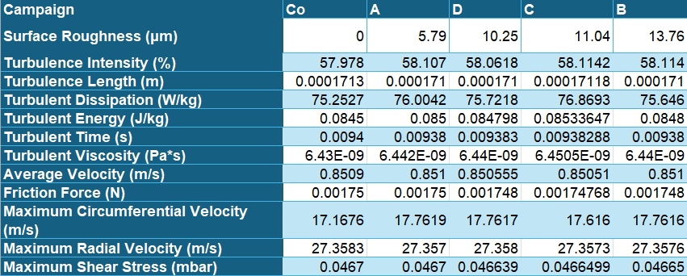
The results of the CFD simulations are presented in Table 7. Overall, the variation in output parameters across the range of surface roughness values was minimal, indicating a limited sensitivity of macroscopic flow behaviour to surface condition under the modelled conditions.

Figure 6 – Relationship Between Turbulence Intensity and Surface Roughness
Figure 6 illustrates the relationship between surface roughness and maximum turbulence intensity. A slight increase in turbulence intensity is observed with increasing surface roughness; however, the variation is minimal and does not exhibit a consistent trend. An outlier is present at a surface roughness of 10.25 µm, where the turbulence intensity is marginally lower than at 5.79 µm. overall, the data suggests that surface roughness has a negligible effect on turbulence intensity within the investigated range.

Figure 7 – Relationship Between Turbulent Dissipation and Surface Roughness
Displayed in Figure 7 is the scatter plot created from the data in Table 7, displaying the values for turbulent dissipation at varying input values of surface roughness. From Figure 7 it can be seen that the turbulent dissipation is trending downwards as the surface roughness increases, with outliers at surface roughness’s of 11.04 µm, which has the highest value of turbulent dissipation at 76.8693 W/kg, and 0 µm, with a turbulent dissipation of 75.2527 W/kg.

Figure 8 – Relationship Between Turbulent Energy and Surface Roughness
Figure 8 is a scatter plot depicting the relationship between the turbulent energy values calculated within the simulations and increasing values of surface roughness. A similar pattern is seen within Figures 7 and 8, supporting the consistency of the simulations, where a potential trend may be seen in the decreasing values for surface roughness’s of 5.79 µm, 10.25 µm, and 13.76 µm. However, like Figure 8, there is two outliers to this pattern, at 11.04 µm and 0 µm.

Figure 9 – Relationship Between Turbulent Length and Surface Roughness
Figure 9 shows a scatter plot created to depict the relationship between turbulent length and surface roughness. The data shows extremely small variation across surface roughness values, with turbulent length remaining effectively constant at approximately 0.000171 m. Very slight increases are observed at 11.04 µm (0.00017118) and 0 µm (0.00017125). These results suggest that surface roughness has no significant influence on turbulent length within the range investigated.

Figure 10 – Relationship Between Turbulent Time and Surface Roughness
Figure 10 illustrates the variation in turbulent time with increasing surface roughness. The results indicate a very slight decreasing trend from 0.0094 s at 0 µm to 0.00938 s at higher values of surface roughness. Minor fluctuations are present, but overall variation is minimal. This suggests that turbulent time is largely unaffected by changes in surface roughness of the components.

Figure 11 – Relationship Between Turbulent Time and Surface Roughness
Displayed in Figure 11 is the relationship between turbulent viscosity and surface roughness. A very slight increasing trend can be observed, with values rising from $6.43{×10}^{-9} Pa∙s$ at 0 µm to $6.45{×10}^{-9} Pa∙s$ at 11.04 µm. Despite this small increase, the variation remains minimal, indicating that surface roughness has only a marginal effect on turbulent viscosity.

Figure 12 – Relationship Between Flow Velocity and Surface Roughness
Figure 12 shows the relationship between average flow velocity and surface roughness. The data indicates negligible variation, with values remaining close to 0.851 m/s across all cases. A slight peak is observed at 10.25 µm (0.850555 m/s), but overall, the flow velocity remains effectively constant. This suggests that surface roughness does not significantly impact the bulk flow velocity in the system.

Figure 13 – Relationship Between Friction Force and Surface Roughness
Figure 13 presents the variation of friction force with surface roughness. A small increase in friction force is seen as roughness increases, rising from 0.00175 N at 0 µm to 0.001748 N at higher roughness values. While the change is minimal, the trend suggests a slight dependence of frictional effects on surface roughness, consistent with theoretical expectations.

Figure 14 – Relationship Between Circumferential Velocity and Surface Roughness
Figure 14 depicts the relationship between maximum circumferential velocity and surface roughness. The results show a noticeable increase from 17.1676 m/s at 0 µm to 17.7619 m/s at a surface roughness of 5.79 µm. after this increase, the values stabilise with only minor fluctuations. This indicates that surface roughness may have a modest influence on circumferential velocity, perhaps in particular when transitioning from a smooth to a rough surface.

Figure 15 – Relationship Between Radial Velocity and Surface Roughness
Figure 15 illustrates the variation of maximum radial velocity with surface roughness. The values remain highly consistent, at approximately 27.35 m/s across all cases. Only negligible differences are observed between data points indicating that radial velocity if effectively independent of surface roughness within the investigated setup.

Figure 16 – Relationship Between Radial Velocity and Surface Roughness
Figure 16 shows the relationship between maximum shear stress and surface roughness. The data indicates a slight decreasing trend, with values reducing from 0.0467 mbar at 0 µm to 0.04665 at 13.76 µm. The variation is minimal, suggesting that surface roughness has only a minor effect on shear stress under the given conditions.

Figure 17 – Percentage Change of All Parameters for Differing Values of Surface Roughness
Figure 17 depicts the percentage of change across all monitored output parameters at varying values of surface roughness. The percentage change across all parameters was minimal, as shown in Figure 17. Most variables exhibited changes below 0.5%, including turbulence intensity, turbulent length, turbulent time, average velocity, turbulent viscosity, friction force, radial velocity, and shear stress. Turbulent energy shows a slightly higher variation of approximately 1%, while turbulent dissipation displayed a variation of over 2%. The largest change was observed in maximum circumferential velocity at 3.35%. Figure 17, overall, shows that only a small degree of variation occurs across the monitored parameters at the values of surface roughness input.

Discussion

Overview of Key Findings
This study investigated the influence of graphite component surface roughness on gas flow behaviour and wafer yield for an MOCVD reaction chamber. The empirical results indicated a negative correlation between surface roughness and the percentage of wafers that passed testing, suggesting that increased roughness is associated with reduced process performance. In contrast, the CFD simulations demonstrated that variations in surface roughness had minimal impact on macroscopic flow characteristics, with most monitored parameters showing negligible changes. This contrast between the empirical results and the results of the CFD analysis forms the basis for the following discussion.

Influence of Surface Roughness on Simulated Flow Behaviour
The CFD analysis indicates that surface roughness has a negligible effect on bulk flow behaviour within the reaction chamber under the simulated conditions. Turbulence-related parameters, including turbulence intensity, turbulent energy, turbulent dissipation, turbulent length, and turbulent time, exhibited minimal variation across the investigated range of surface roughness. No consistent trends were observed, suggesting that the overall turbulence structure remains unchanged.
Similarly, velocity-related parameters, including average flow velocity, circumferential velocity, and radial velocity, showed only minor fluctuations with no clear directional trend. These variations are small in magnitude and are likely attributable to numerical sensitivity than meaningful variations. Wall-related parameters, such as friction force and shear stress, also shows minimal variation, despite theoretical expectations that increased surface roughness would enhance wall friction and boundary layer disruption.
These findings contrast with classical fluid dynamics theory, where increased surface roughness is typically associated with increased turbulence and flow resistance REF. however, the lack of observed effect suggests that the magnitude of surface roughness applied in this study in insufficient to significantly influence the boundary layer under the given operating conditions. Furthermore, the used of standard wall functions within the CFD model may limit the sensitivity of the simulation to surface roughness effects, as such approaches approximate near-wall behaviour rather than resolving it explicitly.
The results are broadly consistent with existing MOCVD CFD studies, where surface roughness is considered as negligible (Jiang et al., 2016; Y. Li et al., 2025). However, the lack of studies that investigate the effect of the surface roughness on process quality outputs, justify the requirement of this study and further work on investigation of effects of a broader range of surfaces roughness.

Relationship Between Surface Roughness and Yield
The empirical data collected from production campaigns indicates a negative relationship between surface roughness and campaign yield. An increase in average surface roughness of 8 µm corresponded to a reduction in yield of 15.23%. This suggests that surface condition influences process performance.
This observation aligns with the broader understanding that process stability and laminar flows are critical to semiconductor manufacturing (Noor et al., 2026). Variations in deposition conditions can lead to defects, non-uniform film growth, and reduced device performance. However, the strength of the correlation observed in this study is limited by the relatively small dataset and the presence of uncontrolled variables, including temperature variations and contamination.
As a result, while the trend is indicative of a relationship, it cannot be considered conclusive. Further data would be required to establish a statistically robust correlation. Within this study, the reliability of the results, and confidence within the cause of the correlation would be improved if the results of testing were further analysed to determine the cause of failing wafers. This would allow for the isolation of the wafers that have failed due to non-laminar flow or disrupted boundary layers.

Comparison Between CFD analysis and Empirical Findings
A key outcome of this study is the discrepancy between the empirical results and the CFD outputs. While empirical data suggests that increased surface roughness reduces the yield of the process, the CFD simulations indicate that surface roughness has little to no effect on macroscopic flow behaviour.
This indicates that the mechanisms through which surface roughness effects the process are not captured within CFD model. One possible explanation is that surface roughness affects the micro-scale characteristics of the processes, rather than the bulk gas flow. For example, rough surface may promote premature mixing, particle adhesion or accumulation, increasing the likelihood of contamination related defects. This is consistent with findings in wafer characterisation studies, where surface contamination is a key contributor to decreases in yield (Takami, 1997).
Additionally, surface roughness may influence localised boundary layer behaviour, heat transfer, or chemical reaction kinetics on the surface of the substrate. MOCVD processes are highly sensitive to temperature and reaction conditions (Jones & Hitchman, 2009), and small variations at the surface level may significantly affect film growth without altering global flow properties.
Another contributing factor may be the limitations of the CFD model. The exclusion of rotational effects, simplified gas composition, and mesh resolution constraints reduce the model’s ability to accurately capture complex interactions. The CFD model is based on the solution of the Navier-Stokes equations, which describe macroscopic flow behaviour. However, these equations do not capture micro-scale surface interactions such as particle adhesion or surface contamination. As a result, the model is inherently limited in its ability to represent mechanisms that may influence wafer yield at the surface level.

Evaluation of Objectives
The objectives of this study were largely achieved. Accurate CAD models of the reactor components were developed, enabling the construction of a representative computational domain. Relevant process data and surface roughness measurements were successfully collected and incorporated into the simulations.
CFD simulations were conducted to investigate the influence of surface roughness on flow behaviour, and a comparative analysis with collected yield data based on wafer testing was performed. While the simulations did not identify a significant effect of surface roughness on flow characteristics, they provided valuable insight into the limitations of the modelling approach and the complexity of the system.
Overall, the study achieved its aim of evaluating the relationship between surface roughness, gas flow behaviour, and wafer yield.

Limitations and Model Constraints
Several limitations must be considered when interpreting the results of this study. The CFD model incorporates several simplifying assumptions, including steady-state flow and simplified gas composition. The rotational motion of the susceptor and substrates were also not included within the CFD analysis, despite its clear impact upon flow behaviour.
Additionally, the mesh resolution may not be sufficient to capture fine-scale surface roughness effects, particularly where the roughness height is small relative to the overall geometry. This limitation may not have been identified in the mesh independence study, as only changes in global parameters were monitored rather than the local mesh resolution at the scale of the surface roughness. As a result, small variations in the surface roughness may not have been adequately captured within the mesh. Furthermore, the use of standard wall functions further limits the model’s ability to resolve near-wall behaviour. The use of a RANS modelling approach further contributes to this limitation, as time-averaging of the governing equations inherently smooth transient turbulent structures that may be sensitive to surface roughness.
From an experimental perspective, the limited number of production campaigns restricts the statistical reliability of the observed correlation between surface roughness and yield. Furthermore, uncontrolled variables within the production environment may have influenced the results.

Conclusions
This study set out to investigate the influence of graphite component surface roughness on gas flow behaviour and wafer quality within an MOCVD reaction chamber. By integrating empirical production results with CFD simulations, the work aimed to determine whether a measurable relationship exists between internal component surface condition, reactor flow characteristics, and key process performance indicators.
The analysis of industrial production data indicates a negative relationship between surface roughness and wafer yield. Across the campaigns analysed, increased graphite surface roughness was associated with a reduction in wafer pass rate, suggesting that component surface degradation over time may contribute to reduced process performance. However, this relationship is based on a limited dataset and cannot be considered definitive due to the presence of uncontrolled operational variables across production runs.
In contrast, the CFD simulations demonstrate that variations in surface roughness have minimal influence on macroscopic gas flow behaviour within the reactor under the conditions modelled. Across all cases, key flow parameters remained relatively consistent, indicating that large scale velocity and turbulence parameters within the chamber are not sensitive to the range of surface roughness values analysed. This indicates that surface roughness, within the ranges tested, does not significantly alter the overall reactor flow structure.
The discrepancy between the empirical and numerical findings suggests that the reduction in yield observed in the production data analysed is unlikely to be driven by changes in bulk gas dynamics alone. Instead, the influence of surface roughness is more likely to arise from localised or micro-scale mechanisms not captured within the CFD model, such as boundary layer effects, particle adhesion or surface contamination.
Overall, the study demonstrates that while graphite component surface roughness appears to correlate with reduced wafer yield in industrial operation, this effect is not explained by the macroscopic flow variations predicted within the CFD simulations. The findings therefore highlight a potential limitation with the CFD model created and suggests that additional multi-scale or near-wall modelling, alongside more detailed experimental characterisation, is required to fully understand the effects of surface condition in MOCVD process performance.

Future Work
While this study has provided insight into the relationship between graphite component surface roughness, gas flow behaviour, and wafer yield within the MOCVD process, several areas remain for further development. The observed discrepancy between empirical production data and CFD results highlights limitations in both the dataset used for analysis and the modelling approach. Future work should therefore focus on improving methodological robustness, expanding the range of investigated conditions, and developing a deeper understanding of the physical mechanisms governing near-wall behaviour in MOCVD systems.

Improvements to Methodology and CFD Modelling
A key limitation identified in this study is the relatively narrow range of surface roughness values used in the CFD simulations. Although the results indicate minimal sensitivity of bulk flow parameters to surface roughness, this may be a consequence of the limited roughness range applied rather than a true lack of physical influence. Future CFD work should therefore expand the range of surface roughness values significantly beyond those observed in the current dataset.
In particular, simulations should investigate both lower and higher extremes of surface roughness to determine whether a threshold exists at which surface roughness begins to meaningfully influence flow behaviour. The relationship between roughness and turbulence may be non-linear, and that effects only become apparent beyond a certain magnitude of roughness, relative to the scale of the reactor geometry. As such, a wider parametric study would therefore help establish whether the negligible changes observed in this study are representative of a true insensitivity, a limitation of the CFD model utilised, or an insensitivity only within the range of surface roughness values investigated.
In addition, further CFD studies should consider refining the near-wall modelling approach. The current use of standard wall functions provides an efficient but approximate representation of surface roughness effects. More advanced turbulence models, such as Large Eddy Simulation (LES) would improve sensitivity to boundary layer disturbances caused by surface texture. If computational resources permit, near-wall mesh refinement could also be increased to better resolve gradients in velocity and shear stress close to the graphite surfaces.
Another important improvement would be incorporation of rotational effects within the reactor model. The susceptor and wafer rotation play a significant role in redistributing flow and heat within MOCVD systems. Their exclusion in this study simplifies the system but may mask important interactions between surface roughness and dynamic flow structures. Including rotational motion in future simulations would provide a more realistic representation of industrial operating conditions and may reveal secondary effects not captured in the current steady-state model.
Finally, future CFD work should consider coupling fluid flow with additional physical phenomena, such as heat transfer and species transport. Since MOCVD processes are strongly affected by temperature gradients and chemical reaction kinetics, isolating flow behaviour alone may not fully capture the mechanisms responsible for yield variation. A multi-physics approach would therefore provide a more comprehensive understanding of how surface condition influences overall process performance.

Expansion of Empirical Data Collection
The empirical component of this study is limited by the relatively small number of production campaigns analysed. While a trend between surface roughness and yield was observed, the statistical strength of this relationship remains limited. Future work should therefore focus upon expanding the dataset to include a significantly larger number of productions runs over across multiple reactors.
Increasing the number of campaigns would improve the reliability of the observed trends and allow for more robust statistical analysis, including correlation coefficients and regression modelling. This would help distinguish genuine process-related effects from random variation or uncontrolled operational influences. A larger data set would also allow for the investigation of potential lag effects, where surface degradation may influence yield over the course of the campaign, as the growth present on the surface of the components increases with every run.
In addition to increasing dataset size, future empirical work should aim to improve the granularity of data collection. Rather than relying solely on average surface roughness values per component or campaign, spatially resolved measurements of surface roughness could be recorded. This would allow for the identification of localised patterns of surface roughness on each component, and their potential correlation with specific defect types or yield losses.
Similarly, wafer quality assessment could be expanded beyond simple pass/fail yield metrics. Incorporating defect classification, particle counts, reflectance, and intensity, would enable a more detailed understanding of how surface roughness may influence specific failure mechanisms. This would be particularly valuable in distinguishing whether roughness primarily contributes to contamination, non-uniform deposition, or structural defects within the wafer lattice.
Longitudinal monitoring of both surface roughness over time would also improve understanding of degradation behaviour. By tracking the surface roughness of the graphite components, as well as the process performance of the campaigns utilising these components, would allow for the evaluation of critical roughness thresholds beyond which process performance begins to deteriorate significantly. Monitoring the deterioration of the graphite components over time would also allow for predictions of graphite wear and potentially predict the shelf life of graphite components before the process performance begins to be impacted upon.

Further Investigation of Boundary Layer Behaviour
One of the key conclusions of this study is that the influence of surface roughness on wafer yield is not adequately explained by the changes in bulk gas flow behaviour, as seen from the CFD simulations. This suggests that the dominant mechanisms may occur at the boundary layer or micro-scale level, which are not fully resolved within the current CFD framework.
Future research should therefore focus on detailed investigation of boundary layer behaviour over realistic graphite surfaces under MOCVD operating conditions. In particular, the interaction between surface roughness and near-wall turbulence structures should be examined in greater detail. This may involve the use of high-resolution meshes or specialised turbulence models capable of resolving small-scale eddies and near-wall velocity gradients.
In addition, the role of surface roughness in particle dynamics should be explored. Rough surfaces may act as nucleation sites for particle adhesion, potentially contributing to contamination with the reaction chamber. This could directly impact wafer quality without significantly impacting the bulk flow behaviour. Modelling discrete particle transport and deposition within the chamber would therefore provide valuable insight into these mechanisms.
Chemical effects at the boundary layer should also be considered. In MOCVD processes, reactions occur at or near the substrate surface, and local variations in flow, temperature, or particle energy may influence reaction rates. Surface roughness may influence residence time, reactant concentration gradients, or heat transfer efficiency, all of which may affect film growth without production noticeable changes in global flow properties. Coupled chemical reaction modelling would therefore be an important extension of the current work completed.

Potential Industrial Applications
Despite the limitations identified, the findings of this study have several potential implications for industrial MOCVD operation and maintenance strategies. The observed relationship between surface roughness and wafer yield suggests that monitoring and controlling the condition of internal graphite components may represent a valuable optimisation tool.
In industrial settings, predictive maintenance strategies could be developed based on surface roughness monitoring. By establishing acceptable roughness thresholds linked to yield performance, workers may be able to monitor the surface roughness of the components to determine if they are suitable for use within the reactors, before a reduction in yield is seen. This would help minimise downtime and maintain consistent product quality.
Furthermore, integrating surface condition monitoring into existing process control frameworks could enhance overall reactor output reliability. For example, combining surface roughness measurements with real time flow control may aid in the maintaining of high process yields.
The findings also highlight the limitations of relying solely on CFD models that do not account for micro-scale surface effects. Research may be required into more suitable industrial process simulation tools, which may be better equipped at evaluating the effect of surface roughness on near-wall flow behaviour. This would improve the predictive accuracy of the model and better align simulation outputs with the observed yield.
Finally, the results of this study may inform improved design of reactor components. If surface roughness is confirmed to negatively influence yield through boundary layer behaviour or contamination mechanisms, then the development of more wear-resistant graphite coatings may provide a route for increasing the shelf life of components, as well as increased yield for the process.

References
Adams, T., Grant, C., & Watson, H. (2012). A Simple Algorithm to Relate Measured Surface Roughness to Equivalent Sand-grain Roughness. International Journal of Mechanical Engineering and Mechatronics. https://doi.org/10.11159/ijmem.2012.008
Anderson, J. D. (1995). Computational Fluid Dynamics. McGraw-Hill, Inc.
Barber, T. J., Doig, G., Beves, C., Watson, I., & Diasinos, S. (2012). Synergistic integration of computational fluid dynamics and experimental fluid dynamics for ground effect aerodynamics studies. Proceedings of the Institution of Mechanical Engineers, Part G: Journal of Aerospace Engineering, 226(6), 602–619. https://doi.org/10.1177/0954410011414321
Bensow, R. E., Fureby, C., Liefvendahl, M., & Persson, T. (2006). A Comparative Study of RANS, DES and LES.
Dupuis, R. D. (2003). Metalorganic Chemical Vapor Deposition (MOCVD). Encyclopedia of Physical Science and Technology, 495–511. https://doi.org/10.1016/B0-12-227410-5/00427-0
Ghavidel, A., Rashki, M., Ghohani Arab, H., & Azhdary Moghaddam, M. (2020). Reliability mesh convergence analysis by introducing expanded control variates. Frontiers of Structural and Civil Engineering, 14(4), 1012–1023. https://doi.org/10.1007/s11709-020-0631-6
Grodzinski, P., DenBaars, S. P., & Lee, H. P. (1995). From research to manufacture—The evolution of MOCVD. The Journal of The Minerals, Metals & Materials Society (TMS), 47, 25–32.
He, Y., Wang, J., Luo, T., & Pei, Y. (2022). Analysis and optimization of MOCVD flow ratio based on machine learning and PSO algorithm. Journal of Crystal Growth, 590. https://doi.org/10.1016/j.jcrysgro.2022.126683
Jiang, Z., Yan, H., Liu, S., Zhang, Z., Gan, Z., & Fang, H. (2016). Uniformity investigation of MOCVD-grown LED layers. Crystal Research and Technology, 51(1), 30–40. https://doi.org/10.1002/crat.201500135
Jones, A. C., & Hitchman, M. L. (2009). Chemical Vapour Depostion: Precursors, Processes and Applications. The Royal Society of Chemistry.
Li, J., Fei, Z. Y., Xu, Y. F., Wang, J., Fan, B. F., Ma, X. J., & Wang, G. (2018). Study on the optimization of the deposition rate of planetary GAN-MOCVD films based on CFD simulation and the corresponding surface model. Royal Society Open Science, 5(2). https://doi.org/10.1098/rsos.171757
Li, Y., Liang, J., Lin, Y., Lu, Y., Wang, Z., Dai, H., & Li, J. (2025). Research on MOCVD structure design and process parameters based on CFD numerical simulation. Journal of Crystal Growth, 671. https://doi.org/10.1016/j.jcrysgro.2025.128366
Martins, N. M. C., Carriço, N. J. G., Covas, D. I. C., & Ramos, H. M. (2014). VELOCITY-DISTRIBUTION IN PRESSURIZED PIPE FLOW USING CFD: MESH INDEPENDENCE ANALYSIS. Proceedings of the 3rd IAHR Europe Congress.
Maruska, H. P., & Rhines, W. C. (2015). A modern perspective on the history of semiconductor nitride blue light sources. Solid-State Electronics, 111, 32–41. https://doi.org/10.1016/J.SSE.2015.04.010
Momeni, K., Ji, Y., Nayir, N., Sakib, N., Zhu, H., Paul, S., Choudhury, T. H., Neshani, S., van Duin, A. C. T., Redwing, J. M., & Chen, L. Q. (2022). A computational framework for guiding the MOCVD-growth of wafer-scale 2D materials. Npj Computational Materials, 8(1). https://doi.org/10.1038/s41524-022-00936-y
Noor, Z., Usman, M., Ali, S., Naveed, A., Hafeez, A., & Ali, A. (2026). MOCVD Growth of Next-Generation III–V Semiconductor Devices: In Review. In Photonics (Vol. 13, Number 3). Multidisciplinary Digital Publishing Institute (MDPI). https://doi.org/10.3390/photonics13030273
Othman, S. H., Abdul Rashid, S., Mohd Ghazi, T. I., & Abdullah, N. (2013). 3D CFD simulations of MOCVD synthesis system of titanium dioxide nanoparticles. Journal of Nanomaterials, 2013. https://doi.org/10.1155/2013/123256
Persson, L., Lovestam, N. G., Sodervall, U., & Watjen, U. (2000). Comparative study of RBS, SIMS and VASE for characterisation of high electron mobility transistors. Nuclear Instruments and Methods in Physics Research B, 161–163, 482–486. www.elsevier.nl/locate/nimb
Román-Ramírez, L. A., & Marco, J. (2022). Design of experiments applied to lithium-ion batteries: A literature review. In Applied Energy (Vol. 320). Elsevier Ltd. https://doi.org/10.1016/j.apenergy.2022.119305
Schwider, J., Kellermann, C., Lindlein, N., Rothau, S., & Mantel, K. (2016). Grazing incidence interferometry for rough convex aspherics. http://arxiv.org/abs/1612.08046
Song, K., Mohseni, M., & Taghipour, F. (2016). Application of ultraviolet light-emitting diodes (UV-LEDs) for water disinfection: A review. In Water Research (Vol. 94, pp. 341–349). Elsevier Ltd. https://doi.org/10.1016/j.watres.2016.03.003
Takami, K. (1997). Defect inspection of wafers by laser scattering. Materials Science and Engineering, 181–187.
Versteeg, H. K., & Malalasekera, W. (2007). An Introduction to Computational Fluid Dynamics (2nd Edition). https://www.flowthermolab.com/wp-content/uploads/2021/11/Versteeg_Malalasekera_2ed.pdf
Wang, C. A. (2019). Early history of MOVPE reactor development. Journal of Crystal Growth, 506, 190–200. https://doi.org/10.1016/J.JCRYSGRO.2018.10.004
Wang, R., Gao, F., Chew, J., Marxen, O., & Sun, Z. (2024). ADVANCED MODELLING OF FLOW AND HEAT TRANSFER IN ROTATING DISC CAVITIES USING OPEN-SOURCE CFD. . Journal of Engineering for Gas Turbines and Power, 146(6).

