
Component 2: Written Report

Student Name: Anisa Ali
Student Number: 2427959
BSc Health and Social Care
Module: Protecting and Supporting Families in Health and Care
Module Code: BMHP5021
Assignment Title: Component 2: Written Report
Report Title:
An Examination and Analysis of How the Early Help System is Signposted to UK Families Through Local Authority Websites: A Comparative Review of Leeds City Council, Southwark Council and Norfolk County Council

Table of Contents
1. Introduction 3
2. Understanding the Early Help System 3
2.1 Definition and Purpose of Early Help 3
2.2 Legislative and Policy Context 3
3. Multi-Agency Working in Early Help 4
3.1 Definition of Multi-Agency Working 4
3.2 Agencies Involved 4
3.3 Benefits and Challenges 4
4. Evaluation of Local Authority Websites 4
4.1 Leeds City Council Website 4
4.2 Southwark Council Website 5
4.3 Norfolk County Council Website 5
5. Comparative Analysis of Website Communication 6
5.1 Comparative Discussion 6
5.2 Comparison of Key Features 7
5.3 Critical Analysis 7
6. Conclusion and Recommendations 7
6.1 Conclusion 7
6.2 Recommendations 8
7. Reference List 9

1. Introduction
Early Help is a key component of safeguarding and family support in the UK, aiming to identify and address emerging needs before problems escalate and require statutory intervention (GOV.UK, 2022). Early Help aims to enhance outcomes for children, young people and families and reduce risks and vulnerabilities in the long term by providing support at the right time, and early intervention, where appropriate.
Websites are a key source of information, guidance and pathways to support services for families and local authorities have an important role to play in communicating them to families. Good online communication can help make the service more accessible, and help encourage families to ask for help as early as possible.
This report assesses and compares the communication of Early Help and family support services offered by Leeds City Council, Southwark Council and Norfolk County Council via their websites. They were chosen to represent a variety of settings: Leeds is a large metropolitan area, Southwark a diverse and urban London Borough and Norfolk is a predominantly rural county. The report analyzes how they do it, the pros and cons of their methods, and areas of growth.

2. Understanding the Early Help System

2.1 Definition and Purpose of Early Help
Early Help is a term used to describe the help offered to children, young people and families at the earliest opportunity to ensure that problems are prevented from escalating and outcomes are improved (Taylor, Drayton and Mcbride, 2021). It takes a proactive and early intervention strategy, recognizing needs as early as possible and arranging for the right support before problems get out of hand. Early Help can link to issues such as parenting problems, poor school attendance, emotional wellbeing, financial difficulties and living circumstances.
The key focus of Early help is to minimise the risk of children making it to a crisis stage and therefore needing statutory safeguarding interventions. Professionals can support families to build resilience and their ability to meet children's needs through timely assessment and coordinated support.

2.2 Legislative and Policy Context
There are key pieces of legislation and policy frameworks which underpin the Early Help system. The Children Act 1989 introduced the 'welfare of the child' principle and its duties on local authorities (Children Act 1989). The Children Act 2004 added to this further reinforced inter-agency working with safeguarding partnerships and the sharing of services.
Further, Working Together to Safeguard Children 2023 highlights the need for multi-agency working and early help to keep children safe from harm (Department for Education, 2025). Local safeguarding arrangements are coordinated by those who are responsible for safeguarding partnerships, including local authorities, health services and the police. So, it is vital that families are able to see and access information on local authority websites which is accessible and easy to understand when families need it.

3. Multi-Agency Working in Early Help

3.1 Definition of Multi-Agency Working
Multi-agency working in Early Help is cooperation between professionals in different sectors to jointly consider and act early on the need of children and families. It is supported by a culture of shared accountability, co-ordinated planning and integrated safeguarding practice to prevent escalation to statutory intervention as set out in the statutory guidance Working Together to Safeguard Children (Department for Education, 2025).

3.2 Agencies Involved
Some key agencies are social workers, schools, health visitors, NHS, the police and voluntary agencies. They bring different expertise to the table: schools can be alert to attendance and behaviour issues early; health professionals can focus on developmental and emotional wellbeing issues. (Chambers, Cantrell and Booth, 2021) Statutory services may not be available to offer flexible community-based support that is provided by voluntary organisations.

3.3 Benefits and Challenges
Multi-agency working allows for a holistic assessment, incorporating professional viewpoints, better identification of risk and support for more effective long-term outcomes (NSPCC, 2025). Its success is sometimes limited by lack of integration in information sharing systems, agency communication gaps, and shortage of resources that can delay response of coordinated agencies. These structural barriers can affect the impact of early intervention and can create gaps in early intervention service delivery.
Link to Website Communication
This multi-agency system of effective Early Help relies on the clarity in how this is communicated to families from a critical perspective. Local authority websites need to break down complicated inter-agency practices into clear, easy to follow pathways, or families could be oblivious to how services link together, and how to get the appropriate support they need in a timely manner, to achieve the preventative objective of Early Help (Department of Health & Social Care, 2025).

4. Evaluation of Local Authority Websites

4.1 Leeds City Council Website
Leeds City Council's website offers Early Help in a wide range of services including ‘Children and families', ‘Housing', ‘Benefits' and ‘Health and social care'. The categorisation is useful in terms of general navigation in the system, but Early Help is not highlighted on the home page and so users need to read through several service pathways to get to support (Leeds City Council, 2019). This helps to reduce immediacy, as this is essential in Early Help provision where an early intervention needs to be delivered in a timely fashion (Department for Education, 2025).
The site is clear and accessible, with headings like Report a child protection concern and Keeping children safe, but Early Help is not always labelled, and may not be clear to non-professional users. Language is primarily service focused and not family focused, which could be problematic for users with low digital literacy.
There are some clear referral routes available, such as reporting concerns or accessing support services, although these are not always provided in a step-by-step, simplified way. There is cross-over support services across various categories: housing, benefits and safeguarding for example, which shows a holistic approach, but may lead to fragmentation.
There are accessibility features, e.g. online forms and digital service access, but these are not clearly marked as accessibility features.

4.2 Southwark Council Website
The website has a clearer and more user centric and community-focused layout, with a prominent banner at the top of the homepage saying ‘Hello, welcome to Southwark' and a list of popular things to do including paying Council Tax, bin days and housing services. This task based approach enhances usability by focusing on the most common user needs, as opposed to bureaucratic categories (Southwark Council, 2020).
Early Help is part of 'Children, young people and families' alongside safeguarding and children's social care. This integration shows a clear safeguarding structure, but the pathway of Early Help is not readily identifiable as a separate pathway, making it less visible for families who are specifically requesting Early Help intervention support (Department for Education, 2025).
Language is usually easy to understand, more so than in Leeds. Support for Early Help accessibility through clear signposting to report a child at risk and access to family support services. Community engagement tools like consultation and volunteering are also being seen, which is indicative of a broader preventative community model (Stevens et al., 2024).
Southwark is best known for its accessibility elements, such as the ability to provide translation services, access to digital inclusion support and local information based on postcodes, reaching a range of user groups better.

4.3 Norfolk County Council Website
The structure of Norfolk County Council's website is simple and structured, suitable for serving a geographically spread out rural population. The organization of key service categories is clearly set out, making it easy to navigate, for example “Children and families”, “Care, support and health” and “Roads and transport” (Norfolk County Council, 2024).
Children and families services are combined with childcare and early learning and safeguarding, and provide Early Help related support throughout. This is sensible, but Early Help is not particularly well marketed as a unique concept, particularly for families that do not know the term 'safeguarding' (Selwyn, 2022).
Language is well understood and accessible with a smaller number of technical terms than urban councils. Referral pathways are more linear and followable, especially via community directory connections and family support areas. This simplicity aids usability, but reduces explanatory depth.
Family support services are offered, although they do seem to be fewer in extent than those offered in urban councils, in line with service delivery constraints in rural areas (Pullmann et al., 2009). Accessibility features are also included such as internet directories and signposting to local services, but there is limited use of digital tools to engage with, and there is less multilingual support than in Southwark.
One of the challenges is that there is no explicit explanation of how services relate to each other among different agencies, and families may not be able to fully understand the relationships. Generally, Norfolk has the clearest way of navigating overall with less visibility of service and less embedding of Early Help concepts.

5. Comparative Analysis of Website Communication

5.1 Comparative Discussion
There is consistent commitment to safeguarding and provision of Early Help related services across all three authorities and it is aligned with statutory guidance on Working Together to Safeguard Children (Department for Education, 2025). But there is a lot of variability when it comes to the effectiveness of communication and digital design and service integration.
Leeds has a good level of service breadth, however has a weak navigation system which may leave families unable to easily find Early Help. Southwark is more user-centred, with task-based navigation and with more accessibility features like digital inclusion support and translation tools, resulting in it being better suited for diverse urban populations (Djatmiko, Sinaga and Pawirosumarto, 2025). The simplest structure is in Norfolk, where there is less depth and understanding of integrated services, but more usability for rural users.
Any differences between them can be attributed to urban vs rural communication needs: Southwark is focused on ease of access to communication, Leeds on volume, and Norfolk on simplicity.

5.2 Comparison of Key Features
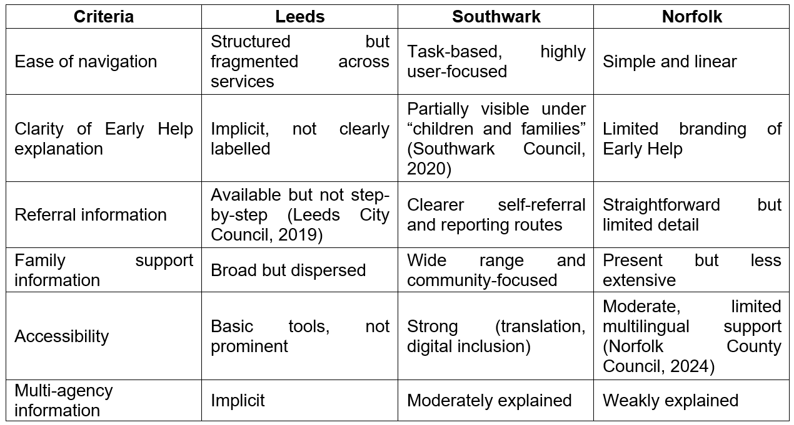

5.3 Critical Analysis
Overall, Southwark Council is best meeting the Early Help aims through clearer pathways, good accessibility and through being user centred. Additionally, it is the most family-friendly website, especially for communities with diverse needs that need translation and digital assistance.
Aside from the depth of information, however, Norfolk offers the clearest route of navigation for the user with low digital confidence, and so will enable them to easily locate assistance quickly.
Leeds is comprehensive but the least effective in immediate early help signposting as a result of weak structure, and may delay early help. This is important because Early Help effectiveness relies on timely access to help, before needs escalate (Department for Education, 2025).

6. Conclusion and Recommendations

6.1 Conclusion
The analysis clearly shows the differences in the level of signposting for Early Help on the websites of Leeds City Council, Southwark Council and Norfolk County Council. While service provision is good, the information is extensive but fragmented, reducing the usability and potentially delaying early interventions. The structure of Norfolk is simple and accessible but lacks depth and articulation of multi-agency working which diminishes the understanding of users around how support systems are connected. Overall, Southwark is the most effective as it provides more clarity around the design to the task, better accessibility features and more visible referral pathways that align with the preventative purpose of Early Help as outlined in the Department for Education (2025).

6.2 Recommendations
Early Help is to be a preferred route to services not a 'backdoor' and delays to accessing appropriate support are to be minimised (Tahir and Krogstie, 2023). All information on the site should be delivered in simple language, with adequate multilingual support and steps should be taken to address structural inequalities to access online services. The cognitive load of users should be reduced by streamlining and clarifying referral pathways, making them more linear and allowing users to self-refer in time-critical situations (Abou Leila, 2026). Better accessibility can also be achieved by improvements such as better mobile optimisation, increased visibility to screen-reader compatibility and simplified page layouts for digitally-excluded users. Last, multi-agency processes should be made more transparent to increase understanding of these processes for users (Department for Education, 2025).

7. Reference List
Abou Leila, R. (2026). Improving Referral and Continuity of Care Through Structured Outpatient Disposition Planning Enabled by Electronic Referrals: A Quality Improvement Study. Cureus. doi:https://doi.org/10.7759/cureus.100727.
Chambers, D., Cantrell, A. and Booth, A. (2021). Recognition of Risk and Prevention in Safeguarding of Children and Young people: a Mapping Review and Component Analysis of Service Development Interventions Aimed at Health and Social Care Professionals. BMC Health Services Research, [online] 21(1). doi:https://doi.org/10.1186/s12913-021-07257-8.
Children Act (1989). Children Act 1989. [online] legislation.gov.uk. Available at: https://www.legislation.gov.uk/ukpga/1989/41/contents.
Department for Education (2025). Working Together to Safeguard Children. [online] GOV.UK. Available at: https://www.gov.uk/government/publications/working-together-to-safeguard-children--2.
Department of Health & Social Care (2025). Care and Support Statutory Guidance. [online] GOV.UK. Available at: https://www.gov.uk/government/publications/care-act-statutory-guidance/care-and-support-statutory-guidance.
Djatmiko, G.H., Sinaga, O. and Pawirosumarto, S. (2025). Digital Transformation and Social Inclusion in Public Services: A Qualitative Analysis of E-Government Adoption for Marginalized Communities in Sustainable Governance. Sustainability, [online] 17(7), pp.2908–2908. doi:10.3390/su17072908.
GOV.UK (2022). Supporting Families: Early Help System guide. [online] GOV.UK. Available at: https://www.gov.uk/government/publications/supporting-families-early-help-system-guide.
Leeds City Council (2019). Leeds City Council. [online] Leeds.gov.uk. Available at: https://www.leeds.gov.uk/.
Norfolk County Council (2024). Home - Norfolk County Council. [online] www.norfolk.gov.uk. Available at: https://www.norfolk.gov.uk/.
NSPCC (2025). Effective multi-agency working and information sharing: evidence snapshot | NSPCC Learning. [online] NSPCC Learning. Available at: https://learning.nspcc.org.uk/research-resources/2025/effective-multi-agency-working-information-sharing-evidence-snapshot.
Pullmann, M.D., VanHooser, S., Hoffman, C. and Heflinger, C.A. (2009). Barriers to and Supports of Family Participation in a Rural System of Care for Children with Serious Emotional Problems. Community Mental Health Journal, 46(3), pp.211–220. doi:10.1007/s10597-009-9208-5.
Selwyn, R. (2022). Early help for children and families. Paediatrics and Child Health, 32(3). doi:https://doi.org/10.1016/j.paed.2021.12.002.
Southwark Council (2020). Southwark Council. [online] Southwark.gov.uk. Available at: https://www.southwark.gov.uk/.
Stevens, M., Brimblecombe, N., Gowen, S., Skyer, R. and Moriarty, J. (2024). Young carers’ experiences of services and support: What is helpful and how can support be improved? PloS one, 19(3), pp.e0300551-e0300551. doi:10.1371/journal.pone.0300551.
Tahir, R. and Krogstie, J. (2023). Impact of Navigation Aid and Spatial Ability Skills on Wayfinding Performance and Workload in Indoor-Outdoor Campus Navigation: Challenges and Design. Applied Sciences, [online] 13(17), p.9508. doi:https://doi.org/10.3390/app13179508.
Taylor, S., Drayton, E. and Mcbride, T. (2021). Evaluating early help: A guide to evaluation of complex local early help systems. [online] ResearchGate. Available at: https://www.researchgate.net/publication/356144005_Evaluating_early_help_A_guide_to_evaluation_of_complex_local_early_help_systems.

