

LOCATION: HAVERFORWEST | LLEOLIAD: HWLFFORDD
LEVEL 5 | LEFEL5
EXAMINATION PERIOD | CYFNOD ARHOLIADAU
MAY 2022 | MAI 2022

MODULE CODE: ACCB5011
Advanced Software Development

TIME: 2 HOURS + 1 hour download / upload time
ANSWER ALL OF SECTION A
ANSWER TWO OUT OF THREE IN SECTION B

Equipment or materials required – Spreadsheet, Word processor
Adnoddau neu ddefnyddiau sydd eu hangen – As above

SECTION A – YOU MUST ANSWER THIS QUESTION
QUESTION ONE
Array Data Size | BubbleSort() | QuickSort()
2,500 | 26018 | 1163
5,000 | 64381 | 2404
7,500 | 192011 | 4279
10,000 | 394472 | 4693
12,500 | 550358 | 6532
15,000 | 698480 | 8002
17,500 | 948148 | 9689
20,000 | 1238053 | 11277
Table 1.1
- Table 1.1 above shows the execution time of the C++ functions for the Bubble Sort and Quick Sort Algorithms. Each of these functions has been timed (in milliseconds) when processing a range of data arrays containing datasets between 2500 and 20000 items.
Use a suitable spreadsheet application to plot each of these functions, demonstrating the relationship between time and data size, on separate charts. For each chart add a trendline and use this to estimate the time complexity of each function using Big O notation. Copy and paste your charts in to your answer file.
[10 marks]

- Using the pseudocode below, state the time complexity of each of the functions using Big O notation, giving a reason for your answer

Bubble sort algorithm
FUNCTION bubblesort(array)
SET swapMade TO true
WHILE swapMade IS true
SET swapMade TO false
Start at index 0
FOR index = 0 TO array.size()-2
IF array[index] > [index+1] THEN
SET temp TO array[index]
SET array[index] TO array[index + 1]
SET array[index + 1] TO temp
SET swapMade TO true
END IF
NEXT index
END WHILE
END FUNCTION

Quick Sort – Partition algorithm
FUNCTION partition(array, first, last):
SET pivot TO array[first]
SET left TO first + 1
SET right TO last
SET done TO False
WHILE NOT done:
WHILE left <= right AND array[left] <= pivot
SET left TO left + 1
END WHILE
WHILE array[right] >= pivot AND right >= left
SET right TO right -1
END WHILE
IF right < left THEN
SET done TO True
ELSE
SET temp TO array[left]
SET array[left] TO array[right]
SET array[right] TO temp
END IF
END WHILE
SET temp TO array[first]
SET array[first] TO array[right]
SET array[right] TO temp

RETURN right
END FUNCTION

Quick Sort algorithm

FUNCTION quickSort (array, start, end):
IF start < end THEN

SET pivot TO partition(array, start, end)

quickSort(array, start, pivot -1)
quickSort(array, pivot + 1, end)

RETURN array
END FUNCTION
[8 marks]
- The quicksort algorithm shown above is a recursive algorithm.
- Using the quicksort algorithm code as an example, explain the concept of recursive algorithms.
- Identify a segment of code where recursion occurs.
[7 marks]

SECTION B – ANSWER TWO OUT OF THE THREE QUESTIONS IN THIS SECTION.
QUESTION TWO
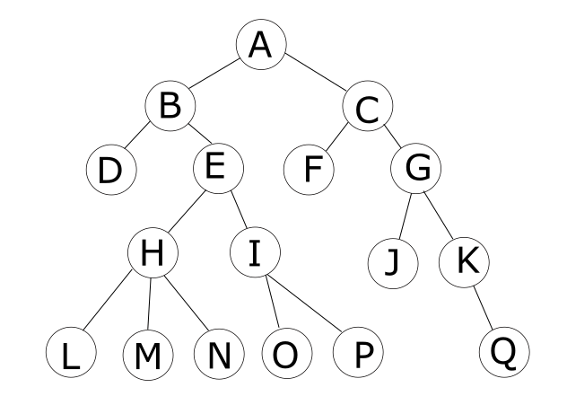
Figure 2.1

- Illustrate the operation of the Depth First Search algorithm by applying it to the graph shown in Figure 2.1 above, listing the nodes’ contents in the order they were visited and stating any assumptions you made.
Provide an analysis of this algorithm including a discussion of its running time, memory usage and limitations (if any).
[9 marks]

- Describe how a queue data structure and while loop can be used to implement a Breadth First Search algorithm.
Apply your algorithm to the graph of figure 2.1, showing the contents of the queue after each iteration of the loop.
[10 marks]

- Describe the two main operations on a queue, that add or remove items to a singularly linked list.
[6 marks]

QUESTION THREE
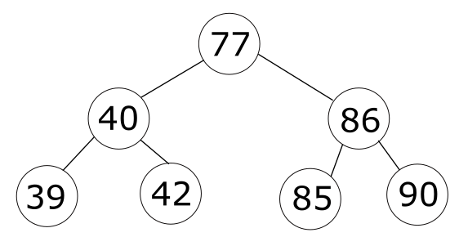
Figure 3.1
- Using the binary tree shown in figure 3.1 above, write down the data read in the order in which the nodes are visited for…
  - pre-order traversal of the tree.
  - post-order traversal of the tree.
  - in-order traversal of the tree
Ensure you indicate which is the first node visited in each of your answers.
[12 marks]

- Insert the number 65 into the binary search tree in figure 3.1 above. Describe the procedure, showing the choices made at each stage of the traversal.
Analyse this operation and hence state the best- and worst-case running times using Big-O notation, showing with examples how these situations can occur.
[8 marks]

- Explain how the number 40 is deleted from the search tree shown in figure 3.1 above and hence redraw the resulting tree.
[5 marks]

QUESTION FOUR
- Describe what is meant by the term “hashing” in the context of referencing records in a table. In your answer describe the steps involved.
[4 marks]
0
1
2
3 | 8
4 | 23
5
6
7
8
9
10
Table 4.1
- An item is to be inserted into the table 4.1 using the open addressing (closed hashing) method to resolve collisions. The hash function uses linear probing to resolve collisions and is given by:
Index = (hash(v)+i) mod m
Where hash(v)= v mod m
Where v is the number to be stored and m is the number of memory locations available

Calculate the table address for a record key value of 36 and draw a diagram to illustrate the table after insertion of this key.
[6 marks]
- An alternative method of collision prevention is quadratic probing using the following function:
Index= (hash(v)+i²) mod m
Where hash(v)= v mod m
If quadratic probing was used in question b) above what would be the table address for the same record key value of 36. Draw a diagram to illustrate the table after insertion of this key. Does this approach solve the clustering problem? If so, then explain how?
[8 marks]
- Another method used to implement hashing is “separate chaining.” Explain this method. What are the advantages and disadvantages of using this approach when compared with closed hashing?
[7 marks]

End/Diwedd

