

Student name: Sylvie Djeuga Djeuga
Student ID: 2335842
Module name: Introduction to Physiology
Module code: BMHP5023
Lecturer name: Bianca Sanfilippo
Assessment: Component 1: Written Assignment (Case Study Report)

1. Introduction
Diabetes mellitus is defined as a complex chronic metabolic disorder associated with high glucose concentrations in the blood because of the deficiency of insulin secretion or action or both (NHS England, 2018). It is among the most serious contemporary challenges to global community health because of its major impacts on individuals as well as health care and social organizations too. According to statistics in the UK, diabetes continues to rise steadily among UK adults to date, with at least 4 million patients currently suffering from diabetes (NHS Digital, 2019).
This condition can further be divided into Type 1 diabetes, which is the result of autoimmunity to pancreatic beta cells and is characterized by absolute insulin deficiency, and Type 2 diabetes, which is primarily the result of insulin resistance and relative insulin deficiency (NHS England, 2018). Type 2 diabetes constitutes around 90% of all diabetes cases and is especially linked to modifiable lifestyle components such as obesity, lack of physical activity, and unhealthy dietary habits (Public Health England, 2019).
Understanding diabetes pathophysiology, associated risk factors, and emphasizing the value of self-monitoring of blood glucose is imperative for effective diabetes management. As a practice nurse practicing at a general practice setting, educating patients to empower them to make lifestyle changes is highly effective for better health outcomes and prevention of complications associated with diabetes (NHS Digital, 2019).
- What is Diabetes and Its Risk Factors
Definition and Types of Diabetes
Diabetes mellitus is a metabolic dysfunction associated with chronic hyperglycemia because of abnormalities of insulin secretion, insulin action, or both (NHS England, 2018). There are two major types of diabetes:
Type 1 Diabetes Mellitus (T1DM): This is an autoimmune condition where beta cells responsible for insulin production in the pancreas are destroyed. This condition is associated with absolute insulin deficiency (World Health Organization). This mostly occurs among children but can happen at any age (NHS Digital, 2019).
Type 2 Diabetes Mellitus (T2DM): It involves insulin resistance and insulin secretion deficiency. It is linked to factors like obesity, high blood pressure, and lipid abnormalities associated with metabolic syndromes (Public Health England, 2019). Type 2 diabetes constitutes about 90% of all cases of diabetes in the UK, while statistics have shown a rise of more than 60% among cases diagnosed over the past decade (NHS Digital, 2019). This may be linked to high obesity levels and a sedentary lifestyle.

- Risk Factors
Being aware of risk factors for Type 2 diabetes is crucial for prevention and intervention:
Obesity and Overweight: The excess amount of adiposity, especially central adiposity, affects insulin sensitivity and triggers inflammation culminating into insulin resistance (NHS England, 2018).
Physical Inactivity: A sedentary lifestyle reduces glucose uptake by muscle cells, thereby raising blood glucose concentration and insulin resistance (Public Health England, 2019).
Unhealthy diet: A diet rich in saturated fat, sugar, and highly processed foods is associated with obesity and metabolic dysfunction (NHS Digital, 2019).
Age: The risk factor tends to rise notably beyond the age of 40 years and is more prevalent among older individuals (NHSE 2018).
Genetic and Ethnic Factors: Family history and being from high-risk ethnic groups (South Asian, African, and Caribbean) put one at higher risk for having this condition (Public Health England, 2019). Other Medical Conditions: Conditions such as Hypertension and Dyslipidaemia carry a higher risk (NHS Digital, 2019). **Consequences of Risk Factors** A number of these risk factors can also be controlled by making lifestyle changes, thus emphasizing the need for patient education and interventions to avoid or delay the development of Type 2 diabetes.

2. Maintenance of Blood Sugar Levels
Physiological Regulation
The control of blood glucose is very subtle and is primarily supported by two hormones: insulin and glucagon, which are secreted by the pancreas (NHS Improvement, 2017). Typically, under fasting conditions, glucose levels are normally regulated to remain between 4-7 mmol/L.
Role of insulin
When glucose is ingested, the glucose levels in the bloodstream rise, causing pancreatic beta cells to release insulin, which triggers glucose to enter muscle and adipose tissue cells and to be stored as glycogen in the liver (NHS Digital, 2019). This helps to reduce glucose levels in the bloodstream to normal.
Function of Glucagon When fasting or between meals, for instance, insulin secretion is suppressed to zero levels, thereby decreasing glucose concentrations in the bloodstream and hence stimuli for the pancreatic alpha cells to release glucagon hormones to respond to this challenge (NHS Improvement, 2017). Mechanism of Regulation This regulation aids in ensuring adequate glucose reaches tissues, especially organs like the human brain for its daily functions. Any malfunctions of this regulation mechanism, as seen in diabetic patients, may result in high or low glucose concentrations entering the bloodstream and causing any person's health complications (NHS Digital, 2019).

3. Cellular Metabolism
Cellular Energy Generation
The cells use glucose to generate energy through cellular respiration, which also requires oxygen (NHS England, 2018). This involves several stages:
Glycolysis: Glucose is converted to pyruvate in the cytoplasm to produce ATP and NADH (NHS Digital, 2019).
Pyruvate Oxidation and Kreb's Cycle: The pyruvate is transferred to the mitochondria and converted to acetyl-CoA before entering Kreb's Cycle and forming extra NADH and FADH2 molecules (NHS Improvement
Electron Transport Chain: NADH and FADH2 donate electrons to the electron transport chain to generate ATP. Oxygen is the final electron acceptor to form water (NHS Digital, 2019).
Importance of Oxygen
A lack of oxygen affects ATP synthesis efficiency. When oxygen is deficient, cells begin practicing anaerobic respiration to generate ATP, making lactic acids and potentially causing inefficiencies at the cellular level (NHS England, 2018). **Implications for People with Diabetes** Poor circulation, also prevalent among diabetic patients, may lead to inadequate tissue oxygenation, thereby affecting tissue cellular metabolism and causing complications like peripheral neuropathy and diabetic wounds (NHS Digital, 2019).
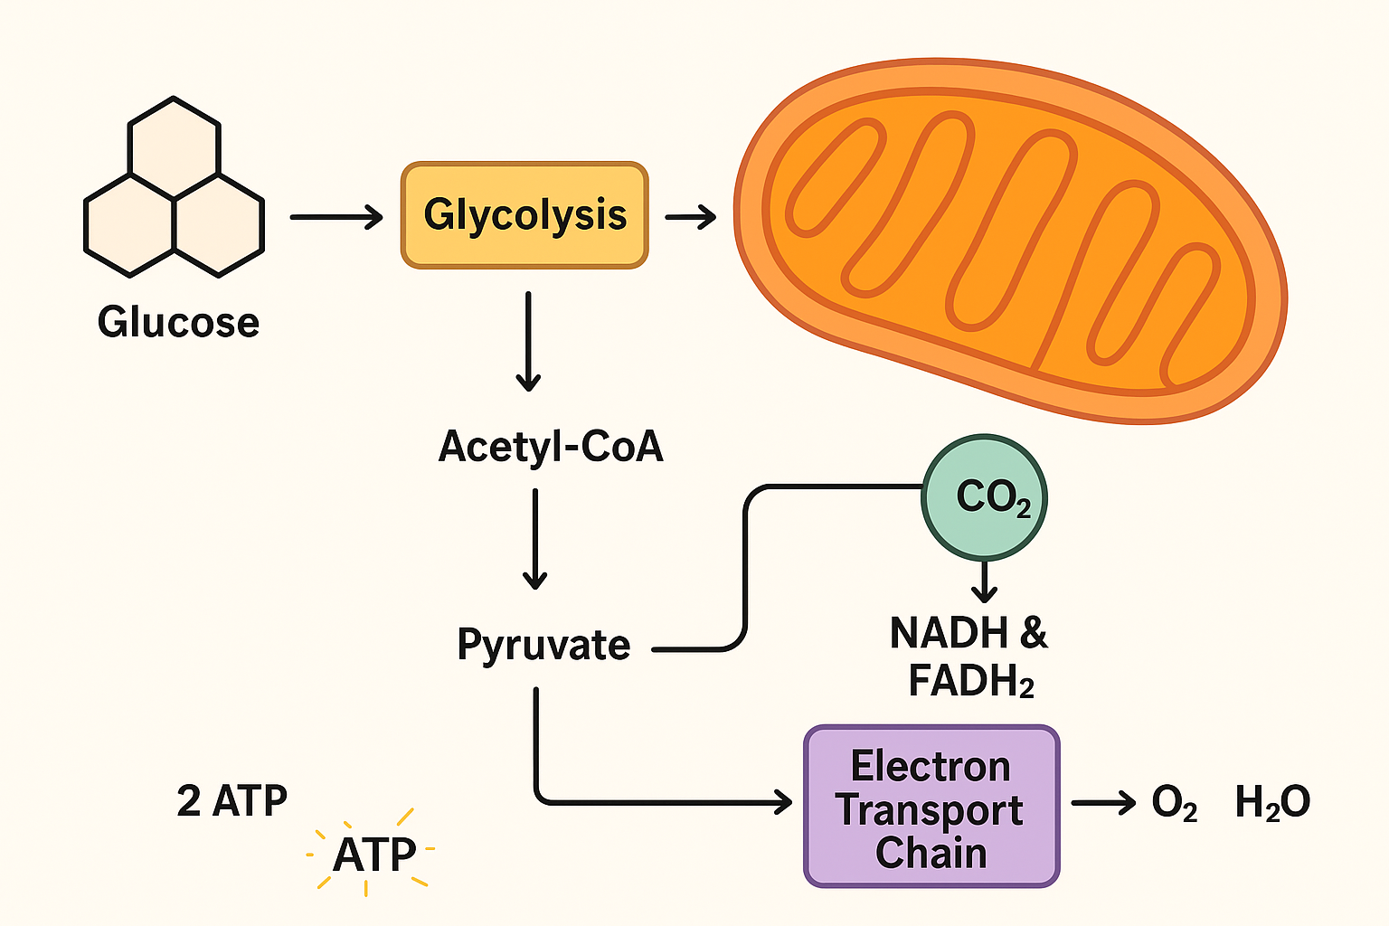

4. Recording and tracking blood sugar levels for type 2 diabetes
The Role of Blood Glucose Monitoring in Managing Type 2 Diabetes
Why Monitoring Matters?
It is very crucial for Type 2 diabetic patients to monitor their glucose levels because it helps them monitor their diabetes control at all times. It helps patients and physicians:
Detect hypo- or hyperglycaemia to avoid emergencies (NHS England, 2018).
Assess the effectiveness of treatment courses, such as medications and lifestyle changes (Public Health England, 2019).
Try to find associations regarding meals, exercise, or drug compliance (NHS Digital, 2019).
Encourage patients to make informed decisions regarding their daily activities and food intake (NHS Improvement, 2017).
Methods of Monitoring
Numerous techniques involve:
Self-Monitoring of Blood Glucose (SMBG): Using glucose meters to monitor your own levels at home at intervals such as before meals or fasting (NHS Digital 2019).
Continuous Glucose Monitoring (CGM): Technology offering real-time glucose values from sensors is helpful for detailed glucose analysis but is not as prevalent within primary care settings (NHS England, 2018).
Advantages of Tracking When monitored longitudinally, trends emerge to allow specific intervention strategies to improve glycaemic management and minimize risks associated with complications like cardiovascular events, nephropathy, retinopathy, and neuropathy (Public Health England, 2019).

5. Recommendations
Evidence-Based Lifestyle Changes to Improve Outcomes
Dietary Interventions
A healthy diet is very helpful for regulating glucose levels. It is found that maintaining a healthy diet rich in whole grains, vegetables, lean proteins, and healthy fats is very effective for regulating glycemic levels (NHS Digital, 2019).
Low Glycemic Index Diets: Low GI foods result in a slower rise in blood sugar concentration, thereby avoiding peak highs (NHS Improvement, 2017).
Mediterranean diet: This dietary regimen is high in fruits, vegetables, olive oil, and fish and is associated with the prevention and management of T2DM (Public Health England, 2019).
Portion control and eating schedule: Eating smaller meals prevents large fluctuations in sugar levels in your bloodstream.
Physical Activity
Engaging in physical exercises enhances insulin sensitivity and also helps to control one's weight. According to UK guidelines, one is advised to participate in at least 150 minutes of moderate physical activity weekly, for example, brisk walking, cycling, or swimming (NHS England, 2018).
Resistance Training: It helps to increase muscle mass, thus further enhancing glucose uptake (NHS Digital, 2019).
Benefits: Reducing HbA1c levels, lowering blood pressures, normalizing lipid levels, and helping to lose weight (Public Health England, 2019).
Weight Management: Weight loss also impacts glycemic control significantly. According to many studies, losing 5-10% of one's body weight reduces the use of medication and helps to improve glycemic levels (NHS Improvement, 2017). Smoking Cessation Smoking impacts insulin resistance, cardiovascular risk factors, and affects blood circulation; thus, ensuring wound healing is impossible (Public Health England, 2019). Smoking cessation and counseling remain vital components of nursing care. Alcohol Consumption Excessive consumption of alcohol can result in fluctuations of sugar levels within the bloodstream and may result in obesity as a result of high calorie intake (NHS Digital, 2019). Psychological Well-being Additionally, addressing mental illness management, stress management, and social support is also vital for ensuring patient cooperation for lifestyle modification because behavioural change is dependent on psychology (NHS England, 2018).

6. Conclusion
In conclusion, effective management of Type 2 diabetes requires an emphasis on educating patients about the physiology of diabetes development and promoting lifestyle habits to monitor and control blood sugar levels. Modifiable lifestyle risk factors such as obesity, lack of exercise, and improper dietary habits have greatly influenced insulin dysfunction leading to diabetic complications. Awareness among patients to monitor their own diabetic levels enhances effective management and helps treat unusual situations before complications arise. Modifying lifestyles to adopt healthier habits such as healthy eating habits, healthier lifestyle habits like physical activities, maintaining normal Body Mass Index, stopping smokers, and practicing controlled consumption of alcoholic drinks helps manage patients' glycemia associated with diabetic complications and improves diabetic patients' lifestyle. As professionals offering healthcare services to patients, nurses are key players to influence diabetic patients to modify their lifestyles by practicing healthier habits associated with effective diabetes management and ensuring diabetic patients' lifestyles are healthier than before to create healthier environments among diabetic patients.
References
British Broadcasting Corporation (BBC). (2019). 'Diabetes statistics in the UK'. Available at: https://www.bbc.co.uk/news/health-48661281 (Accessed: 31 October 2025).
International Diabetes Federation (IDF). (2019). IDF Diabetes Atlas. 9th ed. Available at: https://diabetesatlas.org (Accessed: 31 October 2025).
Morris, M. S., Wylie-Rosett, J., and Wolever, T. M. (2017). 'Physical activity and glycemic control in adults with Type 2 diabetes', Diabetes & Metabolism, 43(3), pp. 256-262.
NHS Digital (2019). Diabetes in England: Annual Report 2019. Available at: https://digital.nhs.uk (Accessed: 31 October 2025).
NHS Digital (2020). National Diabetes Audit 2019-2020. Available at: https://digital.nhs.uk (Accessed: 31 October 2025).
NHS England (2018). The NHS Long Term Plan. Available at: https://www.england.nhs.uk/long-term-plan/ (Accessed: 31 October 2025).
NHS Improvement (2017). Diabetes Pathway Overview. Available at: https://improvement.nhs.uk (Accessed: 31 October 2025).
Public Health England (2019). Health Matters: Preventing Type 2 Diabetes. Available at: https://www.gov.uk/government/publications/health-matters-preventing-type-2-diabetes (Accessed: 31 October 2025).
World Health Organization (WHO) (2016). Global Report on Diabetes. Available at: https://www.who.int (Accessed: 31 October 2025).
UK National Institute for Health and Care Excellence (NICE) (2015). Diabetes in adults: diagnosis and management (NG17). Available at: https://www.nice.org.uk/guidance/ng17 (Accessed: 31 October 2025

