University of Wales
Trinity Saint David
School of Applied Computing

Title: HTML & CSS Web Development

Module: Introduction to Web and Database Concepts
Code: ACCA 4023
Student: Martin Darzins
Student no.: 1909722
Programme: Computing Portfolio – Applied Computing: Year 1
Lecturer: Gareth Jones
Due Date: 26th April 2021

Acknowledgements
The author acknowledges the content from the UWTSD Moodle module course Introduction to Web and Database Concepts.

Table of Contents
1 Acknowledgements ii
3 Introduction 1
3.1 Aims 1
3.2 Objectives 1
4 Task 1 – website 2
5 task 2 – report 2
5.1 Introduction 2
5.2 Requirements 2
5.3 Implementation 2
5.3.1 Screenshots 3
5.3.2 Validation & Results 10
5.4 Evaluation – General 12
5.4.1 Usability & User Experience (UX) 12
5.4.2 Accessibility 13
5.4.3 Search Engine Optimisation (SEO) 13
5.5 Evaluation - Specific MT Spa related results 14
5.5.1 Usefulness 14
5.5.2 Accessibility 14
5.5.3 SEO – ONPAGE 15
6 References 17
6.1 Images 18
6.2 Abbreviations 18
7 Report Planning Methodology 19
8 Appendices 20
8.1 HTML 20
8.2 CSS 21

Figure 1: Wireframe for MT Spa website 2
Figure 2: Screenshot - Overview 3
Figure 3: Screenshot - Home 4
Figure 4: Screenshot - About Us 5
Figure 5: Screenshot - Services 6
Figure 6: Screenshot - Benefits 7
Figure 7: Screenshot – Contact 8
Figure 8: Screenshots - T&C's and COVID 9
Figure 9: Screenshots - Treatments 9
Figure 10: Validation - HTML 10
Figure 11: Validation - CSS 11
Figure 12: Mobile Friendly 16

Introduction

Aims
The aim of this report is to demonstrate a systematic understanding and application of the fundamental concepts, technologies and standards required for building and rendering web pages, in relation to the task set of creating a website.

Objectives
Along with the designed web pages, HTML (Hypertext Markup Language) and CSS (Cascading Style Sheets) codes, the report will detail various definitions, requirements, implementation, validation and evaluation activities, including a summary of the accessibility, usability and Search Engine Optimisation (SEO) of the created website.

Task 1 – website
Please refer to the separately submitted (zipped) file, which contains the individual website folders/files for; images, documents, CSS and HTML codes utilised throughout this website.

task 2 – report

Introduction
Despite Will Rogers informing us that “Advertising is the art of convincing people to spend money they don’t have, for something they don’t need” [1], this website, by effectively presenting and communicating the services available to our potential customers, increases the awareness and benefits of our different types of therapies, treatments and facilities. Thus, providing essential relief to those suffering from impediment/injury and increasing Company profits via additional bookings by converting more website visits into sales through the use of website CTA (Calls to Action).

Requirements
The created website relates to a fictitious business, offering Massage, Therapy and Spa facilities (MT Spa Ltd) to the general public. The contents of this report will detail the website home and landing pages, to highlight the Services (treatment and holistic) options available, along with Company Team member, therapy Benefits and Contact/Payment details. The targeted clientele being affluent mainly ageing adults and those suffering from injury/illness; however, MT Spa Ltd welcomes all who require the facilities for purely relaxation purposes.

Implementation
After determining the website theme, to aid the design and planning activities a wireframe (two-dimensional illustration of a page's interface) was constructed, in order to visualise the overall look, space construction and content priority/hierarchy.
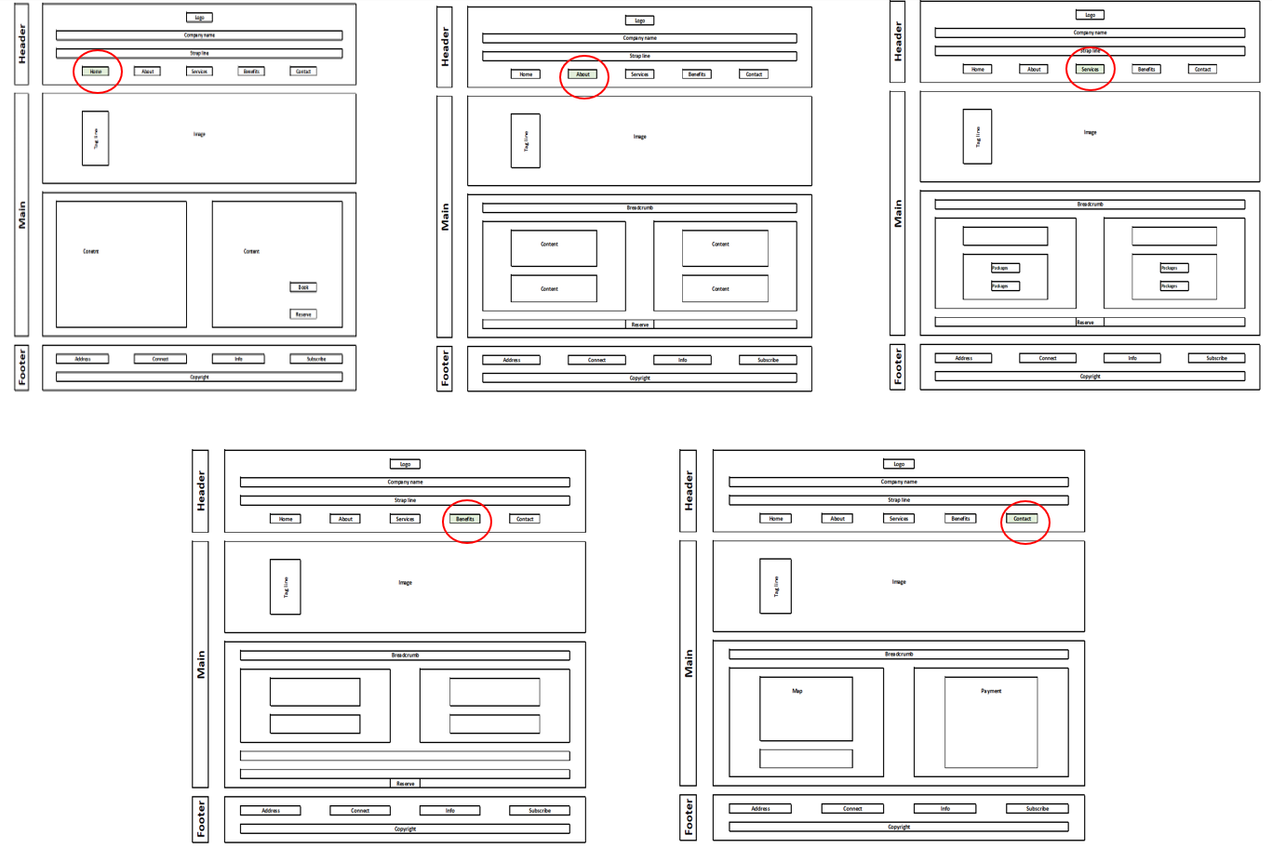
Figure 1: Wireframe for MT Spa website

Screenshots
In order the meet the MT Spa concept, the following: Home, About Us, Services, Benefits and Contact/Payment pages were developed.
Incorporated into each page is the ability to connect with previous (breadcrumb) and latter (navbar) elements of the website, along with various links to offsite pages, relating to:
- Enquiries/Contact
- Social Media (Facebook etc)
- Terms & Conditions of Sale and COVID compliance
- Newsletter Subscription
- Reservations
- Pricing and Package Details
- Responsive Location Map
- Credit Card Payment Facility
Resulting overview of website pages developed:
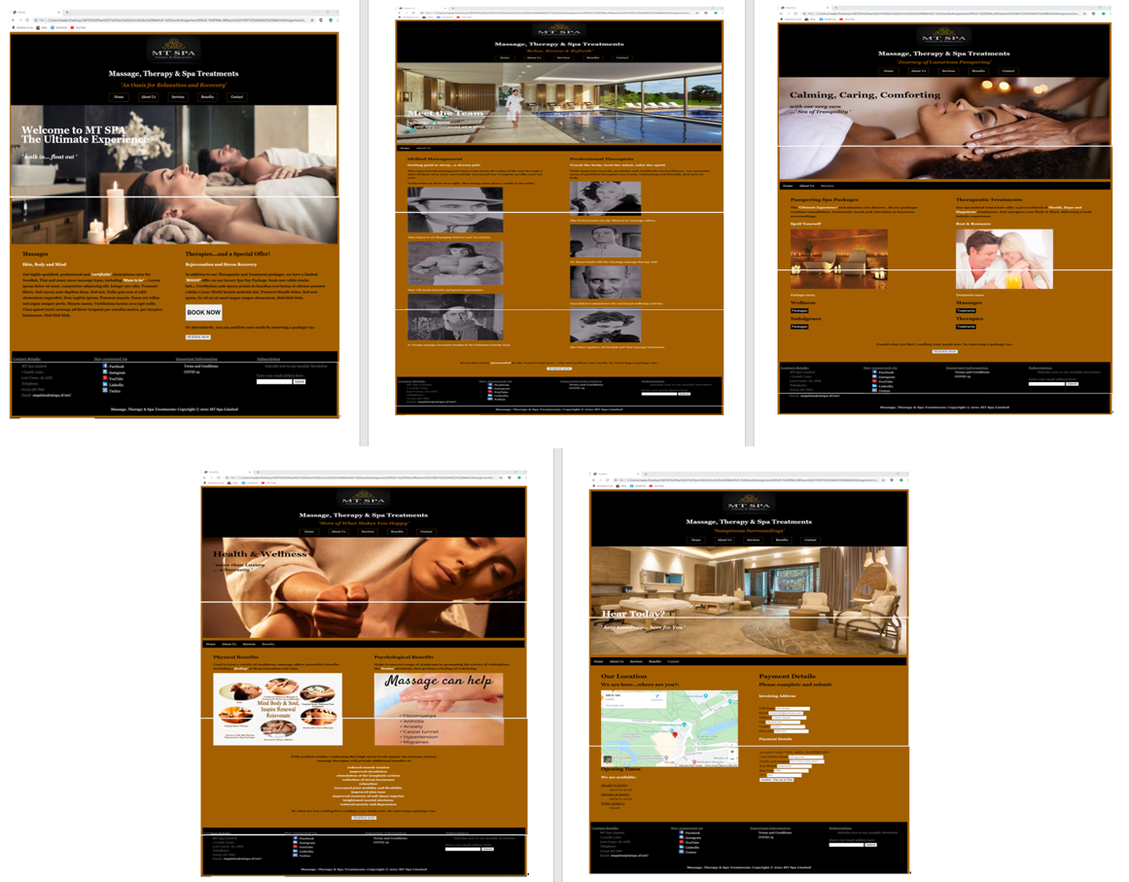
Figure 2: Screenshot - Overview
Maintaining an overall theme of opulence, by keeping to warm, rich colour tones throughout, standardising on font-family (Georgia), layouts, positioning and media/communication techniques.
Standardising logos throughout document and links help maintain Company ethos/branding.

Home page (index.html) for MT Spa Ltd
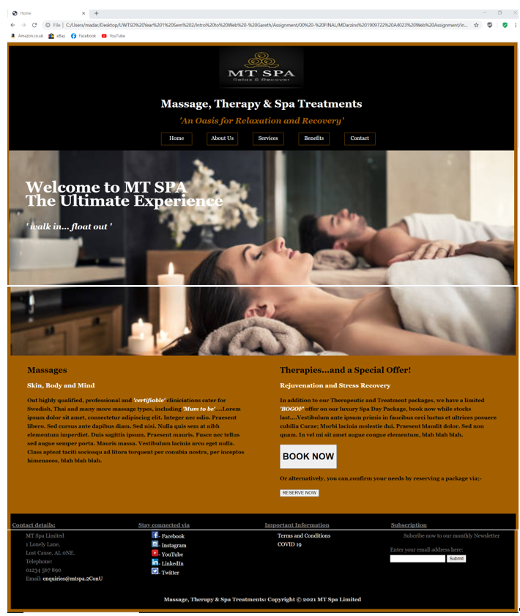
Figure 3: Screenshot - Home

About Us (Team at MT Spa)
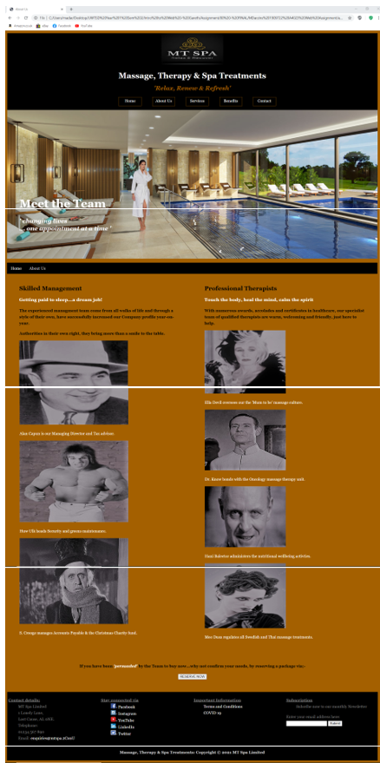
Figure 4: Screenshot - About Us

Services (Treatments available at MT Spa)
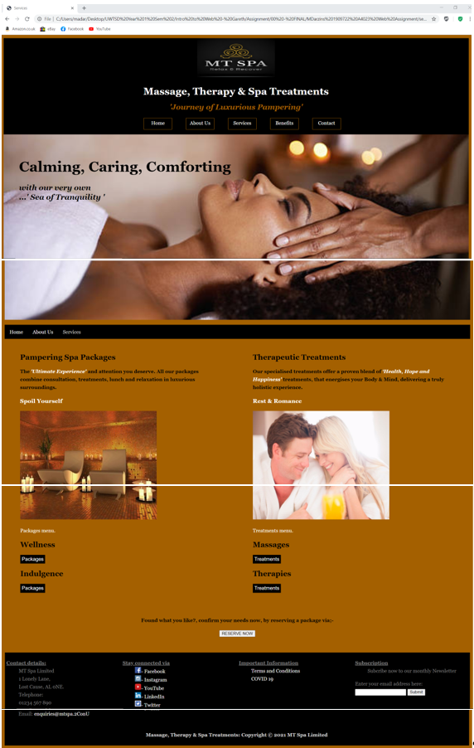
Figure 5: Screenshot - Services

Benefits (of Massage Treatment/Therapy)
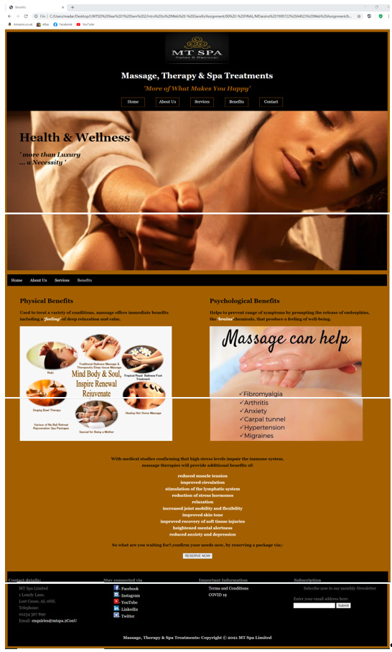
Figure 6: Screenshot - Benefits

Contact (and Payment method details at MT Spa)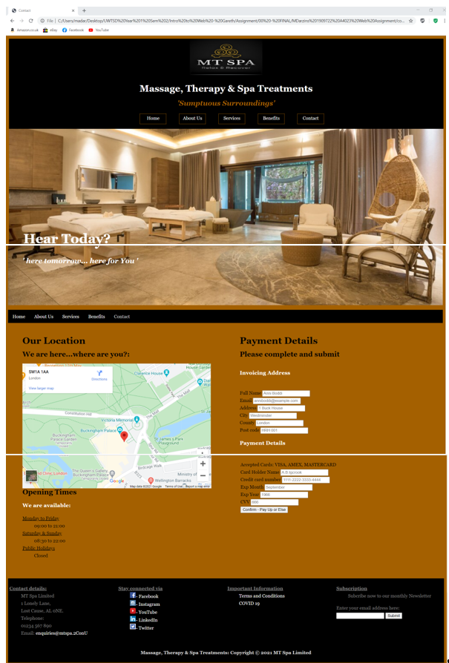
Figure 7: Screenshot – Contact

Other Attached Linked Documents
Various linked buttons, lead the User to documentation to further detail the requirements, facilities, treatments and pricing schedules, available at MT Spa, such as:
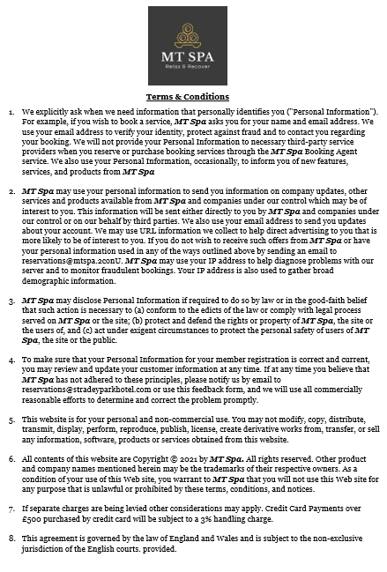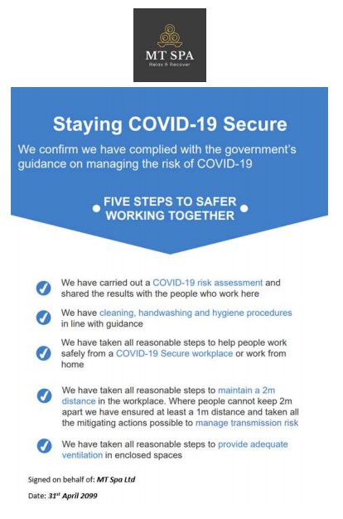
Figure 8: Screenshots - T&C's and COVID
Typical Treatment details available via various button links are:
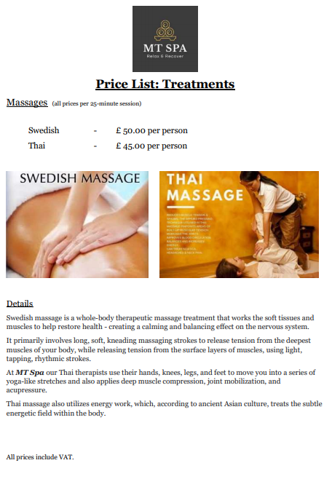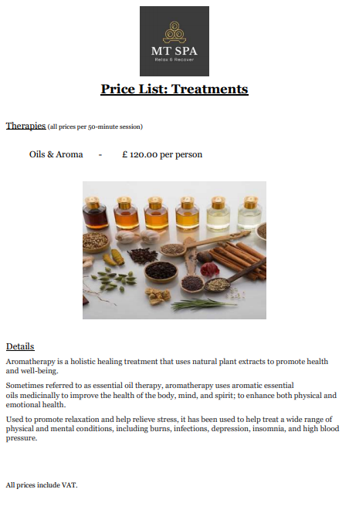
Figure 9: Screenshots - Treatments

Validation & Results

HTML
In order of magnitude (largest number of errors first), the original HTML validation query via w3c Validator, confirmed the following errors:
- No space between attributes
- Duplicate attribute
- Attribute not allowed
- Element missing child
- Unclosed element
- Stray tag end/doctype/start tag
- Illegal character
As XML is a more forgiving programming language and after addressing the majority of the above, only 11 errors remain, none of which adversely affect website usability. These remaining errors being:
    - Space not allowed
    - Attributes not allowed as child
    - Lacks section headings
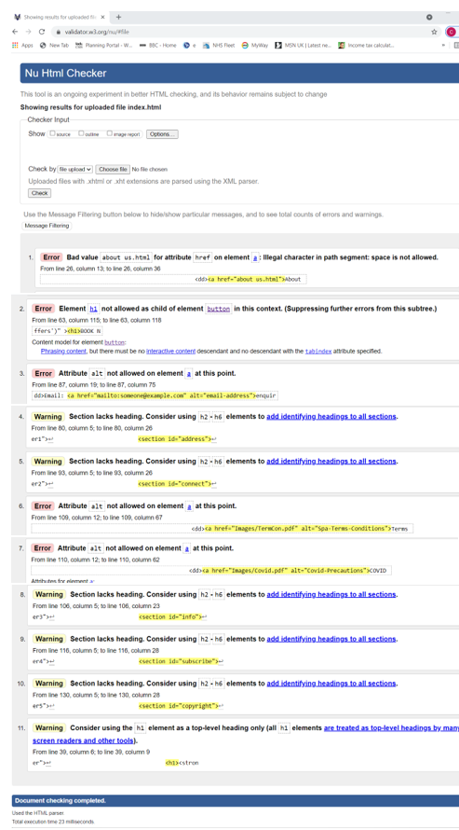
Figure 10: Validation - HTML

CSS
The original CSS review identified the following errors, via w3c Jigsaw:
- Value errors – not a value
- Parse errors
- Whitespace – family names
After adjustment only 2 errors remained covering:
- Parse error
- Family names containing whitespace
Similarly, these remaining errors do not adversely affect performance.
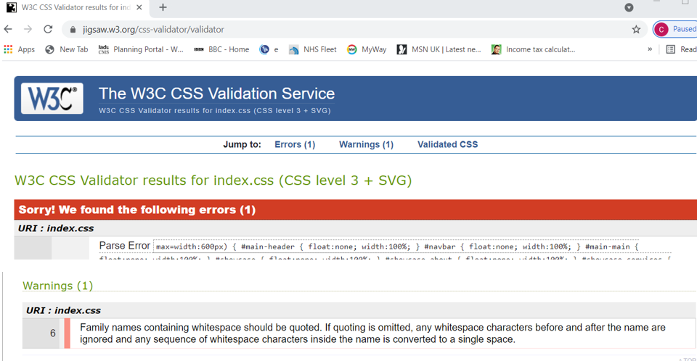
Figure 11: Validation - CSS

Evaluation – General
In general, a quality website will contain various factors that include consistency, colours, typography, imagery, simplicity and functionality, that when well designed, will contribute to how it is perceived. The basic elements of good design cover content, usability, aesthetics, visibility and interaction, and has a layout that is symmetrical, clear and orderly, and evident as to what is expected of visitors when they ‘land’.
Improvements are further enhanced by adopting CRAP (Contrast, Repetition, Alignment, Proximity) website design techniques, where:
- Contrast makes distinctive elements stand out, used to drive a user attention to specific elements in a design including colour, size, type and shape.
- Repetition maintains design consistency, enabling user familiarisation with the method information is presented.
- Alignment determines where each element is located in the design, usually in either edge or centre format, deliberately organising information to create order, leading to overall design cohesiveness.
- Proximity maintains the improved user experience through ensuring that related elements are placed/grouped closely to each other [2].
A quality commercial website will provide relevant, useful content and a good user experience, that reaches your target audience, increases the number of user visits, resulting in longer user website session times, lower ‘bounce’ and greater conversion (CTA) rates [3], all leading to improved commercial success. Bounce rates analyse web traffic and measures visitors entering/leaving websites rather than continuing to view other pages within the same site [4].

Usability & User Experience (UX)
Usability relates to website functionality whereas UX concerns the website experience, both are important and closely connected in that if users cannot find the information, they get frustrated. The more difficult the website, the higher the ‘bounce’ rate, this poor experience will lead to lower user website returns, less referrals, and a decrease in conversions (CTA), whereas a usable website creates a positive user attitude with all the associated benefits. With many differing definitions of usability existing, Quesenbery has expanded upon the Nielsen definition to develop five dimensions of usability to include effectiveness, efficiency, engagement, error tolerance and ease of learning [5, 6].
But fundamentally, the better website usability the more users will enjoy the experience, and better results will be achieved by having:
    - Navigation – clear and easy site browsing.
    - Performance – optimisation.
    - Readability - easy to read, not confusing.
    - Responsiveness - needing to work well on all devices.

Accessibility
Accessibility is not limited to those who are disabled but also includes types of devices (mobiles), equipment (mouse/keyboard) and connectivity. Making website more accessible to everyone increases the numbers of potential visitors and thereby the associated commercial benefits. This not only makes financial and moral sense, but it is also a UK legal requirement under the Equality Act 2010, where site owners are required to make 'reasonable adjustments', to make their sites accessible to and anticipate the needs of, people with disabilities, including those with:
- impaired vision
- motor difficulties
- cognitive impairments
- learning disabilities
- deafness or impaired hearing
Website accessibility applies to both individual elements, features and the entire web experience ensuring that all content, functionality, tools and techniques are designed, developed and made available to all, so that persons can perceive, understand, navigate, interact with and contribute to the Web. These are summarised in the Web Content Accessibility Guidelines (WCAG) acronym POUR detailing the four main principles, which state that content must be [7, 8]:
- Perceivable
- Operable
- Understandable
- Robust

Search Engine Optimisation (SEO)
SEO is the process of getting your website pages to rank higher in search engines, such as Google, it improves the quality and quantity of website traffic to websites from search engine result pages (SERPs). As user search options are the main method of discovering online content, the higher the search engine ranking, the more likely traffic to your website will increase. Typically, 3 types of searches exist, these being [9, 10]:
- Technical SEO – where website and server optimisations assist search engine spiders, crawl and index the site more effectively to help improve organic rankings.
- On-page SEO – factors on your own website that you can control.
- Off-page SEO – factors that link from other (off) sites to your website (backlinks/social media).

Evaluation - Specific MT Spa related results

Usefulness
The MT Spa website scores highly on all the key areas of usability, design, functions, look, feel and ease of use. The consistent colour scheme, font and text/box positioning and repetition confirms the opulent branding themes with simple and descriptive marketing headings and tag/straplines. All adding to the illusion of a luxurious, professionally run Spa, with numerous facilities/treatments.
Straight forward navigation bar leading the user from one section to the other in a logical sequence, whilst leaving any returning user direct access to any section from any section.
All required content is readily available either directly from the particular page or via clearly signposted link buttons. Added functionalities include direct email and newsletter communications, as well as other multi-media arenas, such as Facebook, Instagram, YouTube, LinkedIn and Twitter. Online payment facilities along with responsive map directions are also made available.
Recommendation for future enhancement would be to add the calendar facility to allow Users to see own treatment bookings and advance availability.

Accessibility
Utilising the WCAG2 accessibility acronym (POUR) the MT Spa website meets most of the basic requirements, in that:
Perceivable
- Images have text alternatives provided, which can be adapted for other disabilities by amending into larger print, braille, voice and/or symbols.
- None of the links are time based.
- Content can be viewed in different manners without compromising data.
- The colour scheme not only reflects the exclusivity and luxury of the facilities, but it also complies with various luminosity and colour contrasting requirements.
- Foreground and backgrounds are clearly distinguishable, and there is no audio to c.
Operable
- All details and functions are accessible by keyboard and are not time dependent.
- No flicking/flashing graphics/animations.
- Simple, clear and easy navigation bars, with large font, with ‘ breadcrumb; functionality detailing where on the website the user is currently.
- Web structure flows in a clear and logical order, enabling content to be readily and easily found/accessed/read.
Understandable
- Short, simple and fully understandable headings and content descriptors make the website easy to read and comprehend.
- All links have been tested to ensure that they appear and work as expected, in predictable manners.
- Further programming could be employed to assist the user in avoiding entering mistakes and/or showing them how to correct any errors.
- The html programming language has been set as English (en) but can be easily amended to suit particular requirements.
Robust
- It is believed that the system maximises compatibility requirements for all current and future , assistive technologies.
- Consistency throughout the various website pages and links, whether text-font, header/main/footer/navigation bar structures, ensures familiarity and ease of use.
- Unique id’s incorporated throughout.

SEO – ONPAGE
On-page SEO is important to increase your website’s chances of showing up in the search results. Optimising for on-site factors on a regular basis can help improve your rankings, traffic, and conversions.
Quality Content
Competitor websites researched via google to ensure that the MT Spa website contains useful relevant authoritative, trustworthy information from professionally quailed therapists, will rank highly in SEO due to its nature of utilising EAT.
Page Titles & Content
Each page has relevant title names, guiding User to content (Massage, Therapy, Treatments, Spa) with key word identifiers (Rejuvenation, Stress Recovery, Skin, Body, Mind, Relaxation, Renew, Refresh, Professional, Certified, Skilled, Healing, Calming, Comforting, Caring, Pampering, Therapeutic, Wellness, Indulgence, Spa, Gyn, Couples, Beauty, Swedish, Thai, Mum to be massage, Oil, Aromatherapy, Salt & Oncology treatments, Health both Physical & Psychological benefits).
Headings & Formatting
Short descriptive headings incorporated throughout, with target key words within descriptive text. Structured formatting adopted H1, H2, etc, with use of Bold, Underline, Italics etc used to bring attention to key attributes. These compelling headlines help spark user interest enticing further reading and make it stand out in any SERP results.
Images
Informative images utilise throughout all with ‘alt’ descriptors and some themselves containing detailed information and kept in 4:3 ratio.
URL optimisation - Not incorporated, but breadcrumb to make site easier to use has been.
Internal & External Links
Straightforward solid internal links to Package descriptions, Pricing, Terms and Conditions and COVID safety information. Only external link is to a trusted google maps, useful and relevant to potential users.
Page Loading Speeds - Whilst relevant is not applicable in this scenario.
User Engagement
The website look, and simple headings, tags and strap lines make it easier to use and informative to potential customers, ensuring that users will not ‘bounce’, but instead continue on and perhaps return to the website at a later date.
Mobile Friendly
Website designed for multi-media use enabling readability when viewed via smaller screen sizes.
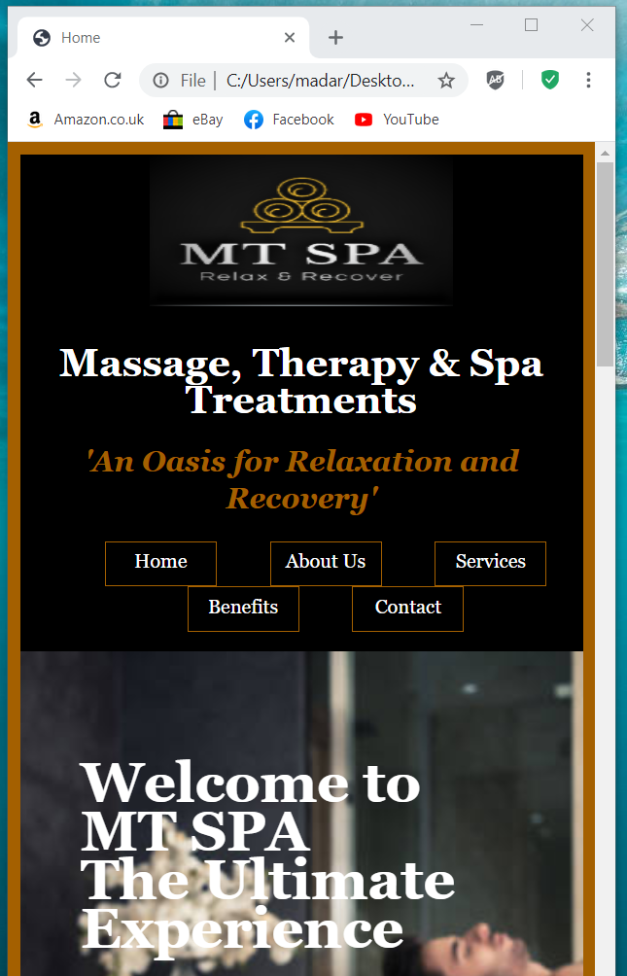
Figure 12: Mobile Friendly
Social Media Blogs
Full access to the major players (Facebook, Instagram, YouTube, LinkedIn and Twitter) have been incorporated into the website.
Word count: 2,099 (excluding Title page and sections 1 - 3, and 6 - 8)

References
[1] azquotes.com, “Advertising”, 2021. [Online].
Available: https://www.azquotes.com/quote/249431
[Accessed: Apr, 08, 2021].

[2] N. Deshdeep, “How to Use C.R.A.P. Design Principles for Better UX?”, Mar, 30, 2021. [Online].
Available: https://vwo.com/blog/crap-design-principles/
[Accessed: Apr, 06, 2021].

[3] commonplaces.com, “How to Measure Website Performance Using KPI’s”, Apr, 06,2018. [Online].
Available: https://www.commonplaces.com/blog/how-to-measure-website-performance-using-kpis
[Accessed: Apr, 09, 2021].

[4] wikipedia.org, “Bounce rate”, 2021. [Online].
Available: https://en.wikipedia.org/wiki/Bounce_rate
[Accessed: Apr, 09, 2021].

[5] E.B. Visser, M. Weiderman,
‘An empirical study on website usability elements and how they affect search engine optimisation’, 2011.
SA Journal of Information Management 13(1), Art. #428, 9 pages.
doi: 10.4102/sajim. v13i1.428.

[6] D. Green, J.M. Pearson,
‘ Development of a Web Site Usability Instrument based on ISO 9241-11’, 2006.
The Journal of Computer Information Systems, 47 1: ProQuest Central, p 66.

[7] K, Krol, D. Zdonek,
‘ Local Government Website Accessibility – Evidence from Poland’, Mar, 31, 2020.
Administrative Sciences MDPI, 2020, 10,22: 17 pages.
doi:10.3390/admsci10020022.

[8] E.B. Lilly,
‘Creating accessible web sites: An introduction’, 2001.
The Electronic Library; Volume 19, Number 6; ProQuest Central, pp 397-404.
MCB University Press, ISSN 0264-0473.

[9] H. Zuze, M. Weideman,
‘Keyword stuffing and the big three search engines’, 2013.
Online Information Review; Volume 37, Number 2; Emerald Group Publishing Ltd, pp 268-286.
1468-4527 doi: 10.1108/OIR-11-2011-0193.

[10] R.A. Malaga,
‘The Value of Search Engine Optimization’, 2007.
Journal of Electronic Commerce in Organizations; Volume 5, Issue 3, pp 68-82.
IGI Publishing.

Images
Courtesy of:
Wix.com
Lastminute.com
Pngfree.com
Instagram.com
Ubereats.com
Linkedin.com
Twitter.com
Cardenpark.co.uk
Imdb.com
Youtube.com
Youtube.com
Insider.com
Pininterest.com
Whatculture.com
Pngegg.com
Goop.com
Uk.saunas.co.uk
Freepik.com
Soha.com
Dreamstime.com
Visitnorfolk.co.uk
Spabreaks.com
Facebook.com
Healthline.com
Birthpool.net.au
Facebook.com
Scalar.usc.edu
Treatwell.co.uk
Solathaispa.uk
Kindpng.com
Nz.linked.com
Marriott.co.uk

Abbreviations
CRAP Contrast, Repetition, Alignment, Proximity
CTA Calls to action
CTR Click thru rate
CSS Cascading style sheets
EAT Expertise Authoritativeness Trustworthiness
HTML Hypertext markup language
POUR Perceivable, Operable, Understandable, Robust.
SEO Search engine optimisation
SERP Search engine results page
SOAC School of applied computing
UWTSD University of Wales Trinity Saint David
UX User experience
WCAG Web content accessibility guidelines
YMYL Your money or your life

Report Planning Methodology
This HTML and CSS Web Development report assignment was completed by adhering to the following activities:
- Read and understand the report brief.
- Make plan (Gantt chart) including time management – planning/research most time consuming, catering for other exams.
- Create report format and style – using Moodle template example.
- Follow structure of:
  - Title Page
  - Acknowledgements
  - Introduction
  - Main Body
  - Reference
  - Appendices
- Define the problem and purpose of the report – decide assignment title, aims & objectives.
- Define audience – Lecturer/Tutor (Gareth Jones).
- Brainstorm (Mindmaps) and determine ideas to include.
- Research and gather information (Library, internet etc).
- Collect, sort, evaluate organise material.
- Complete references (as you go) during all research phases.
- Analyse research/material.
- Prepare outline drafts.
- Write the draft report, check spelling and grammar.
- Submit draft into Turnitin for similarity check.
- Incorporate changes into final redraft.
- Submit final report via Turnitin before 26th April 2021.

Appendices

HTML
Text listings shown in greater detail within specific HTML files submitted separately, as part of web site Task 1 assignment.
HTML – text listings
<!DOCTYPE html>
<html>
<head>
<title>
<meta>
<link>
<body>
<header>
<div>
<a>
<img>
<h1>
<strong>
<nav>
<em>
<h2>
<dl>
<dt>
<dd>
<main>
<section>
<h3>
<b>
<p>
<form>
<button>
<footer>
<label>
<br>
<label>
<input type>
<ul>
<li>
<h2>
<span>
<i>
<h4>
<iframe>

CSS
Text listings are also shown in greater detail within specific CSS file submitted separately, as part of web site Task 1 assignment.
CSS - text listing
body
{
background-color: #a46000;
color: black;
font-family: georgia, times new roman, serif;
font-size: 16px;
line-height: 1.6em;
margin:5px;
padding: 5px;
box-sizing: border-box;
text-align: justify;
}
/* header - ALL */
#main-header
{
color:white;
text-align: center;
line-height:1.9em;
}
.container1
{
width:100%;
height: auto;
overflow:hidden;
background-color:black;
box-sizing: border-box;
}
#navbar
{
color:#a46000;
text-align: center;
}
#navbar dd
{
display:inline-block;
width: 90px;
height: 35px;
border: 1px solid #a46000;
}
a
{
color: white;
text-decoration: none;
}
a:hover
{
color:#a46000;
}
.container3
{
width:100%;
height: auto;
overflow:hidden;
background-color:#a46000;
box-sizing: border-box;
color:black;
text-align:left;
padding: 0px;
}
.container3 h3
{
color:white;
}
#main-main
{
float: none;
width: 100%;
box-sizing: border-box;
}
ul.breadcrumb
{
padding: 10px 16px;
list-style: none;
background-color: black;
}
ul.breadcrumb li
{
display: inline-block;
font-size: 16px;
}
ul.breadcrumb li+li:before
{
padding: 8px;
color: black;
content: "/\00a0";
}
ul.breadcrumb li a
{
color: white;
text-decoration: none;
}
ul.breadcrumb li a:hover
{
color: #a46000;
text-decoration: underline;
}
.dropbtn {
background-color: black;
color: white;
padding: 5px;
font-size: 16px;
border: none;
}
.dropdown {
position: relative;
display: inline-block;
}
.dropdown-content {
display: none;
position: absolute;
background-color: lightgray;
min-width: 160px;
box-shadow: 0px 8px 16px 0px rgba(0,0,0,0.2);
z-index: 1;
}
.dropdown-content a {
color: black;
padding: 1px 10px;
text-decoration: none;
display: block;
}
.dropdown-content a:hover {background-color: #ddd;}
.dropdown:hover .dropdown-content {display: block;}
.dropdown:hover .dropbtn {background-color: #a46000;}
#showcase
{
background-image:url("Images/couples-treatment.jpg");
background-repeat: no-repeat;
background-position: center;
background-size: cover;
opacity: 1.0;
min-height: 500px;
text-align: center;
padding:50px;
}
#main-banner
{
width:100%;
color: white;
text-align:left;
line-height:2.5em;
}
#main-banner h1
{
font-size: 46px;
}
#main1
{
float:left;
width:50%;
box-sizing: border-box;
padding:50px;
padding-top:10px;
}
#sidebar
{
float: left;
width:50%;
box-sizing: border-box;
padding:50px;
padding-top:10px;
}
#showcase-about
{
background-image:url("Images/wet-lounge.jpg");
background-repeat: no-repeat;
background-position: center;
background-size: cover;
opacity: 1.0;
min-height: 500px;
text-align: center;
padding: 50px;
}
#showcase-services
{
background-image:url("Images/head-massage-spa.jpg");
background-repeat: no-repeat;
background-position: center;
background-size: cover;
opacity: 1.0;
min-height: 500px;
text-align: center;
padding: 50px;
}
#showcase-benefits
{
background-image:url("Images/neck-massage.jpg");
background-repeat: no-repeat;
background-position: center;
background-size: cover;
opacity: 1.0;
min-height: 500px;
text-align: center;
padding:50px;
}
#showcase-contact
{
background-image:url("Images/luxury-treatment-room.jpg");
background-repeat: no-repeat;
background-position: center;
background-size: cover;
opacity: 1.0;
min-height: 500px;
text-align: center;
padding:50px;
}
#main-banner-about
{
padding-top: 275px;
padding-left:0px;
width:100%;
color: white;
text-align:left;
line-height:1.9em;
}
#main-banner-services
{
padding-left:0px;
width:100%;
color: black;
text-align:left;
line-height:1.9em;
}
#main-banner-benefits
{
padding-left:0px;
width:100%;
color: black;
text-align:left;
line-height:1.9em;
}
#main-banner-contact
{
padding-top:275px;
padding-left:0px;
width:100%;
color: white;
text-align:left;
line-height:1.9em;
}
#main-banner-about h1
{
font-size:46px;
}
#main-banner-services h1
{
font-size:46px;
}
#main-banner-benefits h1
{
font-size:46px;
}
#main-banner-contact h1
{
font-size:46px;
}
#main1-about
{
float:left;
width:50%;
box-sizing: border-box;
padding: 50px;
padding-top:10px;
}
#main1-services
{
float:left;
width:50%;
box-sizing: border-box;
padding: 50px;
padding-top:10px;
}
#main1-benefits
{
float:left;
width:50%;
box-sizing: border-box;
padding: 50px;
padding-top:10px;
}
#main1-contact
{
float:left;
width:50%;
box-sizing: border-box;
padding: 50px;
padding-top:10px;
}
#main1-images-about p
{
color: white;
}
#main1-images-services p
{
color: white;
}
#main1-images-benefits p
{
color: white;
}
#main1-map-contact iframe
{
float:left;
width:100%;
box-sizing: border-box;
}
#sidebar-about
{
float: left;
width:50%;
box-sizing: border-box;
padding: 50px;
padding-top:10px;
}
#sidebar2-about
{
float: left;
text-align: center;
width:100%;
box-sizing: border-box;
padding: 50px;
padding-top:10px;
background-color: #a46000;
}
#sidebar-services
{
float: left;
width:50%;
box-sizing: border-box;
padding: 50px;
padding-top:10px;
}
#sidebar2-services
{

float: left;
text-align: center;
width:100%;
box-sizing: border-box;
padding: 50px;
padding-top:10px;
background-color: #a46000;
}
#sidebar-benefits
{
float: left;
width:50%;
box-sizing: border-box;
padding: 50px;
padding-top:10px;
}
#sidebar2-benefits
{
text-align: center;
width:100%;
box-sizing: border-box;
padding: 50px;
padding-top:10px;
}
#sidebar2-benefits dd
{
color:white;
}
#sidebar-contact
{
float: left;
width:50%;
box-sizing: border-box;
padding: 50px;
padding-top:10px;
}
#sidebar-contact form
{
float: left;
width:100%;
box-sizing: border-box;
}
#sidebar-images-about p
{
color: white;
}
#sidebar-images-services p
{
color: white;
}
#sidebar-images-benefits p
{
color: white;
}
.container4
{
width:100%;
height: auto;
overflow:hidden;
background-color:black;
box-sizing: border-box;
}
dt
{
text-decoration:underline;
}
/* footer - ALL */
#main-footer
{
width: 100%;
box-sizing: border-box;
color:gray;
font-size:16px;
}
#footer1
{
float: left;
width:25%;
height: auto;
padding: 5px;
box-sizing: border-box;
text-align:left;
}
#footer2
{
float:left;
width:25%;
height: auto;
padding: 5px;
box-sizing: border-box;
text-align:left;
}
#footer3
{
float:left;
width:25%;
height: auto;
padding: 5px;
box-sizing: border-box;
text-align:left;
}
#footer4
{
float:left;
width:25%;
height: auto;
padding: 5px;
box-sizing: border-box;
text-align:left;
}
#footer5
{
float: left;
width:100%;
height: auto;
color:lightgray;
box-sizing: border-box;
text-align:center;
}
@media (max=width:600px)
{
#main-header
{
float:none;
width:100%;
}
#navbar
{
float:none;
width:100%;
}
#main-main
{
float:none;
width:100%;
}
#showcase
{
float:none;
width:100%;
}
#showcase-about
{
float:none;
width:100%;
}
#showcase-services
{
float:none;
width:100%;
}
#showcase-benefits
{
float:none;
width:100%;
}
#showcase-contact
{
float:none;
width:100%;
}
#main-banner
{
float:none;
width:100%;
}
#main-banner-about
{
float:none;
width:100%;
}
#main-banner-services
{
float:none;
width:100%;
}
#main-banner-benefits
{
float:none;
width:100%;
}
#main-banner-contact
{
float:none;
width:100%;
}
#main1
{
float:none;
width:100%;
}
#main1-about
{
float:none;
width:100%;
}
#main1-images-about
{
float:none;
width:100%;
}
#main1-services
{
float:none;
width:100%;
}
#main1-images-services
{
float:none;
width:100%;
}
#main1-benefits
{
float:none;
width:100%;
}
#main1-images-benefits
{
float:none;
width:100%;
}
#main1-contact
{
float:none;
width:100%;
}
#main1-images-contact
{
float:none;
width:100%;
}
#sidebar
{
float:none;
width:100%;
}
#sidebar-about
{
float:none;
width:100%;
}
#sidebar-images-about
{
float:none;
width:100%;
}
#sidebar-services
{
float:none;
width:100%;
}
#sidebar-images-services
{
float:none;
width:100%;
}
#sidebar-benefits
{
float:none;
width:100%;
}
#sidebar-images-benefits
{
float:none;
width:100%;
}
#sidebar-contact
{
float:none;
width:100%;
}
#sidebar-images-contacts
{
float:none;
width:100%;
}
#main-footer
{
float:none;
width:100%;
}
#footer1
{
float:none;
width:100%;
}
#address
{
float:none;
width:100%;
}
#footer2
{
float:none;
width:100%;
}
#connect
{
float:none;
width:100%;
}
#footer3
{
float:none;
width:100%;
}
#info
{
float:none;
width:100%;
}
#footer4
{
float:none;
width:100%;
}
#subscribe
{
float:none;
width:100%;
}
#footer5
{
float:none;
width:100%;
}
#copyright
{
float:none;
width:100%;
}
}

