Student Name: Precious Grant Whittaker
Student number: 2412252
Module code: BMHP6026
Module: Digital Transformation in the health and social care
Assignment Title: Component 1 written Report
Lecturer Name: Martrin Svejda

Table of contents
Introduction…………………………………………………………. Page 3
Impact of Virtual Wards on Service Delivery………………….. Page 4 - 6
Impact of Virtual Wards on Patients/Service Users…………. Page 7- 8

Conclusion and Recommendations…………………………….. Page 9
References…………………………………………………………… Page 10-11

A Critical Evaluation of Virtual Wards as a Digital Innovation: The Impact on
service Delivery and Patients/Service Users in UK Health and Social Care.

Introduction
Digital technology has developed progressively essential within UK health and social care as services seek new approaches to delivering safe and effective care while responding to pressures on hospital services. One digital innovation that has expanded within the National Health Service is the technology enabled virtual ward, also known as Hospital at Home. NHS England recommended the rollout of COVID virtual wards in 2021, followed by guidance supporting the development of technology enabled virtual wards (NHS England, 2021a; NHS England, 2021b).
Virtual wards may support admission avoidance and enable some patients to depart hospital earlier while remaining to accept appropriate clinical care at home (NHS England, 2022). However, implementation also raises important considerations relating to service integration, cost-effectiveness, patient safety, digital exclusion, equitable access and information governance. This report adopts a thematic approach to critically evaluate technology enabled virtual wards, focusing on two themes: service delivery and patients/service users. Both the potential benefits and limitations of this model of care will be considered.
Overview of the Digital Innovation
Technology enabled virtual wards allow selected patients to get hospital care inside their own households rather than remaining in hospital. Patients are supported by multidisciplinary clinical teams through home visits, remote consultations and regular clinical reviews (NHS England, 2021b). Digital technologies, including mobile apps, wearable devices and remote monitoring equipment, enable healthcare professionals to observe patients conditions and identify when further clinical assessment may be required (NHS England, 2021b). Virtual wards have been implemented across NHS services in England, including at Wrightington, Wigan and Leigh Teaching Hospitals NHS Foundation Trust, where their impact on hospital bed use and costs has been evaluated (Jalilian et al., 2024).

Impact of Virtual Wards on Service Delivery
Virtual wards may improve NHS service delivery by reducing avoidable hospital admissions and supporting earlier discharge. NHS England (2024c) identifies these benefits as important for improving patient flow and releasing hospital capacity. An evaluation of 29 virtual ward pathways in Southeast England creates approximately one non-elective admission avoided for every 2.5 virtual ward admissions, with stronger results in more established services (NHS England, 2024b).
However, this association does not establish that virtual wards directly caused fewer admissions. Norman et al. (2023) found encouraging evidence for Hospital at Home models but highlighted that research specifically examining virtual wards was more limited. Therefore, although NHS evaluations suggest operational benefits, further independent research is required to establish whether these improvements can be sustained across different patient groups and healthcare settings.
An important limitation is that the Southeast England evaluation examined established and developing virtual ward pathways, which may have differed in staffing, patient selection and clinical arrangements (NHS England, 2024b). Consequently, improvements reported in one region may not be reproduced across all NHS organisations. This supports the need for evaluations that consider local service conditions alongside admission rates, rather than treating reduced hospital activity as evidence of effectiveness on its own.
Cost-effectiveness is another important consideration because reducing hospital bed use does not necessarily produce financial savings. At Wrightington, Wigan and Leigh Teaching Hospitals NHS Foundation Trust, virtual ward patients had approximately 3.07 fewer inpatient bed days, while the estimated cost per hospital bed day saved was £935 matched with £536 for an established non-elective hospital bed day (Jalilian et al., 2024).
Similarly, Norman et al. (2023) identified methodological limitations in the available economic evidence. Shi et al. (2024) also found insufficient cost effectiveness evidence for models using higher levels of technology.
Together, these findings challenge the assumption that virtual wards automatically offer better value for money. Their financial sustainability may depend on patient numbers, service utilisation and the resources required to deliver safe care.
Furthermore, the findings from Wrightington, Wigan and Leigh represent one hospital setting and may not reflect the costs of virtual wards operating with different staffing models or patient populations (Jalilian et al., 2024). Although reducing inpatient bed days could improve patient flow, financial savings may be limited if hospitals continue to maintain the same staffing and infrastructure. Therefore, NHS organisations should consider the overall cost of delivering care across hospital and community settings rather than focusing only on the number of hospital beds released.
Effective service delivery also depends on communication between hospital, community and primary care teams. NHS England (2024b) highlights the importance of integrated clinical pathways, while NICE (2023) identifies the need for digital platforms to work effectively with electronic patient records and medical devices.
However, Shi et al. (2024) found that virtual ward models varied considerably in their clinical activities, workforce arrangements and technology. This makes it difficult to assume that evidence from one service will apply equally to another.
Therefore, introducing digital monitoring equipment alone is unlikely to improve service delivery without effective information sharing, staff training and clear clinical responsibilities.
Sustainability remains a further challenge as virtual ward services expand. NHS England (2024c) emphasises the importance of appropriate staffing, technology and patient selection. However, Norman et al. (2023) identified organisational and clinical barriers to implementation, while Shi et al. (2024) highlighted continuing uncertainty about the additional benefits of more intensive technology. This suggests that expanding virtual ward capacity without sufficient workforce and digital infrastructure may place additional pressure on services rather than improve efficiency.
Overall, virtual wards offer opportunities to improve hospital capacity and patient flow, but their success depends on clinical integration, financial sustainability and ongoing evaluation rather than expansion alone.

Figure 1 demonstrates the expansion of virtual ward capacity in England, increasing from 9,713 beds in July 2023 to 11,833 beds by March 2024 (NHS England, 2024a). Occupancy also increased from 64.1% to 72% during the same period (NHS England, 2024a). This suggests increasing utilisation of virtual wards within NHS service delivery. However, increased capacity and occupancy do not independently demonstrate improved clinical outcomes, cost-effectiveness or reductions in hospital admissions. Furthermore, NHS England classifies its virtual ward capacity and occupancy figures as management evidence and recommends that the data should be interpreted with attention (NHS England, 2026b). Therefore, these statistics must be considered alongside independent research on patient outcomes, financial costs and hospital admissions before conclusions can be drawn about the overall effectiveness of virtual wards.

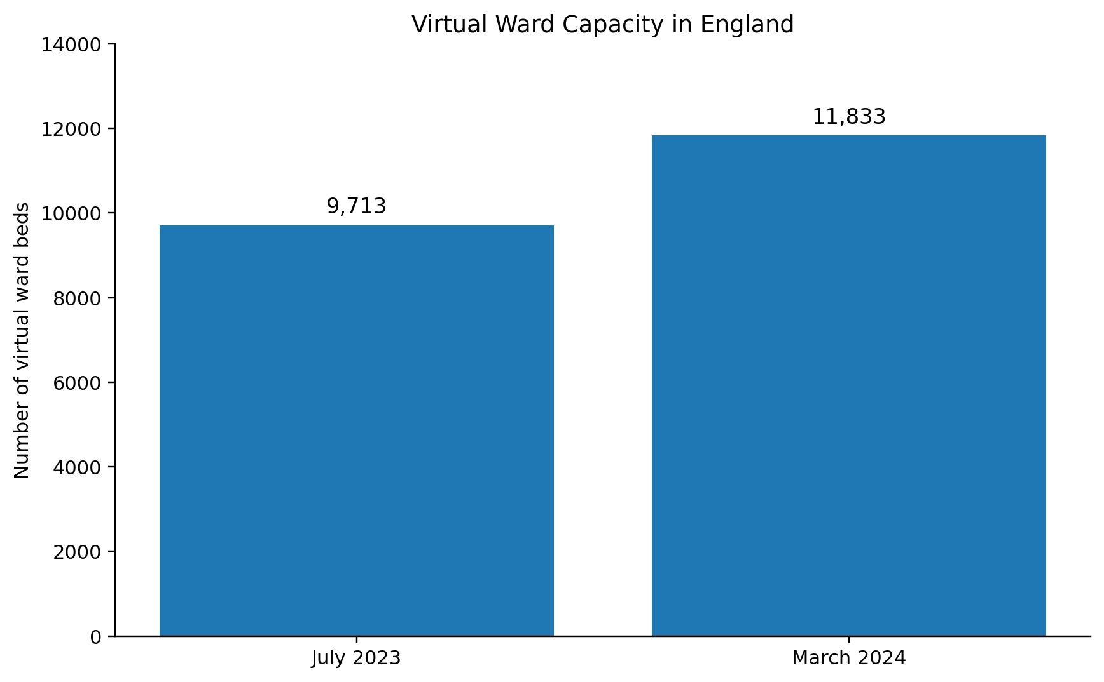

Figure 1. Virtual ward capacity in England, July 2023 - March 2024
Source: Adapted from NHS England (2024a).

Impact of Virtual Wards on Patients/Service Users
Virtual wards may improve patients' experiences by allowing suitable individuals to receive hospital-level care in familiar surroundings, potentially increasing comfort, independence and convenience (NHS England, 2024c). Norman et al. (2023) identified generally positive patient satisfaction findings within Hospital at Home research, supporting the potential benefits of home-based care. However, the review also highlighted limitations in the available evidence, particularly concerning technology-enabled virtual wards.
This suggests that positive experiences from established Hospital at Home services cannot automatically be generalised to all virtual ward patients. Individual clinical needs, home circumstances and access to support must therefore be considered when assessing whether this model provides genuinely person-centred care. A further consideration is whether patient satisfaction reflects the effectiveness of virtual ward care or simply a preference for receiving treatment at home. Norman et al. (2023) identified generally positive patient experiences, but the evidence does not establish that all patients benefit equally. For example, individuals requiring greater clinical supervision or support from family carers may experience home-based treatment differently. Therefore, patient satisfaction should be assessed alongside clinical outcomes, patient choice and the level of support available at home.
Digital exclusion presents a significant challenge to equitable access. NHS England (2023a) recognises that limited digital skills, unreliable internet access and difficulties using technology may prevent some patients from benefiting from digital healthcare.
Supporting this concern, Fox et al. (2022) found that 31.5% of patients referred to a COVID virtual ward at a Northwest London teaching hospital did not use the digital application, with language barriers, insufficient training and limited IT skills contributing to non-use.
However, findings from one COVID-specific service cannot necessarily represent all virtual ward populations.
Nevertheless, this evidence challenges the assumption that providing digital equipment alone ensures equal access. NHS organisations should therefore offer accessible information, practical training and non-digital monitoring alternatives, although these measures may require extra resources (NHS England, 2023a).
Digital exclusion also raises questions about whether virtual wards are equally suitable for patients with different social circumstances. The findings of Fox et al. (2022) suggest that barriers to using digital monitoring extend beyond access to equipment and include communication and confidence with technology. Therefore, simply providing a device may not address the underlying inequalities. NHS services should evaluate which patients are unable to participate digitally and whether alternative monitoring arrangements achieve comparable access to safe care. Fox et al. (2022) demonstrate practical obstacles to digital engagement among virtual ward patients, while NHS England (2023) presents digital healthcare as a key mechanism for service transformation. This contrast highlights the risk that digital innovations may unintentionally widen health inequalities if adequate support is not provided.
Patient safety also requires critical consideration when acute care is delivered at home. NHS England (2024c) identifies remote monitoring and clinical review as important mechanisms for recognising deterioration and supporting timely intervention. However, Shi et al. (2024) found that although virtual wards and Hospital at Home models may provide safe inpatient care, the certainty of evidence for several outcomes remained limited. This creates uncertainty about whether technology enabled monitoring consistently achieves comparable safety outcomes across different services. Furthermore, clinical deterioration may occur between observations, meaning that technology cannot replace professional judgement and face-to-face assessment when required. Appropriate patient selection, clear escalation procedures and timely clinical intervention are therefore essential (NHS England, 2024c).
Confidentiality and information governance are additional considerations because virtual wards require sensitive patient information to be collected and shared between healthcare professionals. Under UK GDPR, health information is confidential as special category data needing extra safeguards (Information Commissioner's Office, 2024).
Although information sharing can support coordinated care, unnecessary access may compromise patient confidentiality (NHS England, 2026a). The Caldicott Principles provide an important framework: Principles 1, 3 and 4 require justified use, minimum necessary information and restricted access, while Principle 7 recognises the importance of appropriate information sharing for patient care. Principle 8 needs patients to be informed about how their confidential data is used (National Data Guardian, 2020). Therefore, virtual ward services must balance the clinical benefits of information sharing with patients' rights to privacy and confidentiality.

Conclusion and Recommendations
This thematic evaluation demonstrates that technology enabled virtual wards offer potential benefits for both NHS service delivery and patient’s/service users. NHS England (2024c) identifies opportunities to reduce hospital admissions and support earlier discharge, while Norman et al. (2023) found generally positive patient experiences within Hospital at Home research. However, findings reported by NHS England should be interpreted alongside independent evidence from systematic reviews and economic evaluations, which highlight continuing uncertainty regarding cost effectiveness, safety outcomes and implementation across different settings (Norman et al., 2023; Jalilian et al., 2024; Shi et al., 2024).
Several recommendations arise from this evaluation. NHS organisations should assess patients' clinical suitability and ability to participate safely in home-based care, ensuring appropriate monitoring and clear escalation procedures (NHS England, 2024c). To address digital exclusion, accessible information, practical training and non-digital alternatives should be available, particularly for patients experiencing language or technological barriers (Fox et al., 2022; NHS England, 2023a). Effective communication between hospital, primary and community care teams is also essential, supported by digital systems (NICE, 2023).
Furthermore, virtual ward services must protect sensitive patient information while enabling appropriate sharing for safe clinical care, in accordance with UK GDPR and the Caldicott Principles (Information Commissioner’s Office, 2024; National Data Guardian, 2020). NHS organisations should regularly evaluate admission rates, patient outcomes, experiences, costs and inequalities rather than assuming that increased virtual ward capacity automatically demonstrates success (NHS England, 2024c).
Overall, virtual wards represent a promising digital innovation within UK health and social care. However, current evidence suggests that their long term effectiveness, safety and cost-effectiveness remain dependent on robust evaluation, workforce capacity, effective service integration and equitable access to digital technologies. Consequently, future expansion should prioritise evidence-based implementation rather than assuming that increased capacity alone demonstrates success.

References
Fox, R., Saeed, Z., Khan, S., Robertson, H., Crisford, S., Wiggam, A., Foley, A., Raza, F. and Wright, M. (2022) ‘Lessons learnt for digital inclusion in underserved communities from implementing a COVID virtual ward’, PLOS Digital Health. Available at: https://doi.org/10.1371/journal.pdig.0000146. (Accessed 4 October 2026).
Information Commissioner’s Office (2024) What is special category data? Available at: https://ico.org.uk/for-organisations/uk-gdpr-guidance-and-resources/lawful-basis/special-category-data/what-is-special-category-data/ (Accessed: 4 October 2026).
Jalilian, A., Sedda, L., Unsworth, A. and Farrier, M. (2024) ‘Length of stay and economic sustainability of virtual ward care in a medium-sized hospital of the UK: a retrospective longitudinal study’, British Medical Journal Open, 14(1), pp.e081378. Available at: https://doi.org/10.1136/bmjopen-2023-081378 (Accessed: 4 October 2026).
National Data Guardian (2020) The Caldicott Principles. Available at: https://www.gov.uk/government/publications/the-caldicott-principles (Accessed: 4 October 2026).
National Institute for Health and Care Excellence (NICE) (2023) Virtual ward platform technologies for acute respiratory infections: early value assessment. HTG697. Available at: https://www.nice.org.uk/guidance/htg697 (Accessed: 4 October 2026).
NHS England (2021a) COVID virtual ward. Available at: https://www.england.nhs.uk/coronavirus/publication/covid-virtual-ward/ (Accessed: 4 October 2026).
NHS England (2021b) A guide to setting up technology-enabled virtual wards. Available at: https://www.england.nhs.uk/long-read/a-guide-to-setting-up-technology-enabled-virtual-wards/ (Accessed: 4 October 2026).
NHS England (2022) Supporting information for integrated care system leads: Enablers for success: virtual wards including hospital at home. Available at: https://www.england.nhs.uk/wp-content/uploads/2021/12/B1478-supporting-guidance-virtual-ward-including-hospital-at-home-march-2022-update.pdf (Accessed: 4 October 2026).
NHS England (2023) Inclusive digital healthcare: a framework for NHS action on digital inclusion. Available at: https://www.england.nhs.uk/long-read/inclusive-digital-healthcare-a-framework-for-nhs-action-on-digital-inclusion/ (Accessed: 4 October 2026).
NHS England (2024a) Performance report 2023/24. Available at: https://www.england.nhs.uk/long-read/performance-report-23-24/ (Accessed: 4 October 2026).
NHS England (2024b) Summary of South East region virtual wards evaluation. Available at: https://www.england.nhs.uk/long-read/summary-of-south-east-region-virtual-wards-evaluation/ (Accessed: 4 October 2026).
NHS England (2024c) Virtual wards operational framework. Available at: https://www.england.nhs.uk/long-read/virtual-wards-operational-framework/ (Accessed: 4 October 2026).
NHS England (2026a) Virtual wards. Available at: https://digital.nhs.uk/data-and-information/information-governance/guidance/virtual-wards (Accessed: 4 October 2026).
NHS England (2026b) Virtual Ward. Available at: https://www.england.nhs.uk/statistics/statistical-work-areas/virtual-ward/ (Accessed: 4 October 2026).
Norman, G., Bennett, P. and Vardy, E.R.L.C. (2023) ‘Virtual wards: a rapid evidence synthesis and implications for the care of older people’, Age and Ageing, 52(1), pp.afac319. Available at: https://doi.org/10.1093/ageing/afac319. (Accessed: 5 October 2026).
Shi, C., Dumville, J., Rubinstein, F., Norman, G., Ullah, A., Bashir, S., Bower, P. and Vardy, E.R.L.C. (2024) ‘Inpatient-level care at home delivered by virtual wards and hospital at home: a systematic review and meta-analysis of complex interventions and their components’, BMC Medicine, (22), pp.145. Available at: https://doi.org/10.1186/s12916-024-03312-3.

