EcoRide Database Report
Introduction to Web and Database Concepts
Tyler Bate (2304031)
ACCA4023 BSc
Contents
1. Introduction 1
2. Scenario Overview 1
3. Database Design and Implementation 2
3.1 Entity Identification and Relationships 2
3.2 ERD Design and Normalisation 2
3.3 Table Implementation and Constraints 3
4. Query Development and System Use 3
5. Validation and Testing 4
6. Design Decisions and Reflection 5
7. Conclusion 6
8. References 6

1. Introduction
This report documents the design, implementation, and evaluation of a relational database system developed for the EcoRide electric bike rental scheme. The database was implemented using Microsoft Access and designed to replace inefficient paper-based records and basic spreadsheets currently used by the organisation. The system follows established database design principles, including entity modelling, normalisation, referential integrity, and structured validation.
The purpose of this report is to support Task 2 of the coursework by explaining the scenario context, justifying key design decisions, demonstrating practical use of the database through queries, and evaluating the system using validation and testing. The report also reflects on challenges encountered during development and identifies potential future improvements. Throughout the report, relevant academic and technical sources are referenced using IEEE citation style to demonstrate engagement with database design literature.

2. Scenario Overview
EcoRide is a green transport initiative launched by a local authority to encourage environmentally friendly and healthy commuting. The service operates across several public locations, including parks, train stations, and university campuses. Riders must register with the service and are then able to rent an electric bike from one station and return it to another nearby station.
Prior to the proposed solution, EcoRide relied on paper forms and spreadsheets to record rider details, bike usage, and maintenance information. This approach caused several operational problems, including limited visibility of which bikes were available or currently in use, difficulty tracking maintenance history, occasional double bookings, and challenges identifying unreturned bikes. These issues made it difficult for management to analyse service usage or produce accurate operational summaries.
The aim of the database system is to provide a structured, centralised solution that supports rider registration, bike inventory management, rental transactions, maintenance tracking, and staff involvement. By implementing a relational database, EcoRide can improve data accuracy, reduce redundancy, and enable meaningful analysis of usage patterns and operational performance [1], [2].

3. Database Design and Implementation

3.1 Entity Identification and Relationships
Following analysis of the scenario, the following core entities were identified:
- Rider – stores personal and contact details of registered users
- Bike – stores information about individual electric bikes
- BikeType – categorises bikes by type
- Station – represents rental and return locations
- Rental – records rental transactions
- Staff – stores staff member details
- MaintenanceLog – records bike servicing and inspection history
Each entity represents a real-world object within the EcoRide system. Relationships between entities were defined using primary and foreign keys. For example, a Rider may have many Rental records, but each Rental record is associated with exactly one Rider. Similarly, a Bike may appear in many Rental and MaintenanceLog records, allowing full tracking of usage and maintenance history.
This approach follows standard relational modelling principles and ensures that data relationships are explicit, enforceable, and scalable [1].

3.2 ERD Design and Normalisation
An Entity–Relationship Diagram (ERD) was produced using the Microsoft Access Relationships tool. The ERD visually represents entities, attributes, primary keys, foreign keys, and the cardinality of relationships between tables.
The database design was normalised to Third Normal Form (3NF). Each table stores data about a single subject, and all non-key attributes depend only on the primary key. For example, bike type information is stored separately in the BikeType table rather than being repeated for every bike. This reduces redundancy, improves consistency, and simplifies future maintenance [1], [2].
- 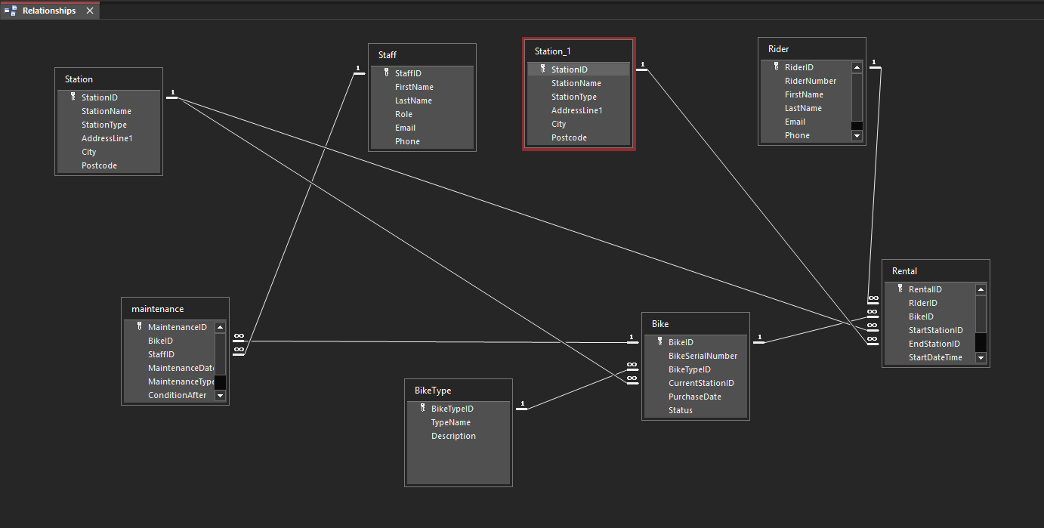Figure 1: ERD / Relationships diagram

3.3 Table Implementation and Constraints
Tables were implemented in Microsoft Access using appropriate data types. AutoNumber fields were used for all primary keys, while Number (Long Integer) fields were used for foreign keys to ensure compatibility. Referential integrity was enforced on all relationships, ensuring that related records must exist before being referenced.
Additional constraints were applied to improve data quality:
- Validation rules ensure logical data entry, such as preventing an EndDateTime earlier than StartDateTime.
- NULL values are permitted for EndDateTime and EndStationID in the Rental table to allow for ongoing rentals.
- Cascade updates were enabled to maintain key consistency, while cascade deletes were avoided to prevent accidental data loss.
These constraints help ensure that the database accurately reflects real-world operations and prevents invalid or inconsistent data entry [3].
- 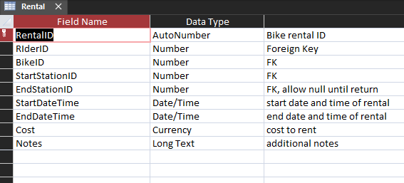Figure 2: Rental table – Design View

4. Query Development and System Use
A series of practical queries were developed to demonstrate how the database can be used to support EcoRide’s operational and analytical needs. The queries align with the examples suggested in the assignment brief and provide meaningful insights into bike availability, service requirements, and rider activity patterns. These queries enable staff to quickly identify which bikes are in use, which require maintenance, and how frequently individual bikes or riders use the service.
Implemented queries include:
• Bikes currently out on rental
• Bike availability overview
• Rentals by a particular rider (parameter query)
• Rider usage summary
• Most frequently used bikes
• Bikes due for service
• Maintenance history by bike
• Unreturned rentals over 24 hours
Parameter queries were used where appropriate to allow flexible user input, improving usability and relevance for staff. Aggregate queries were implemented to summarise data and highlight trends such as high-usage bikes or frequent riders. Together, these queries demonstrate how structured relational data can be transformed into useful information to support operational monitoring and informed decision-making [4], [5].
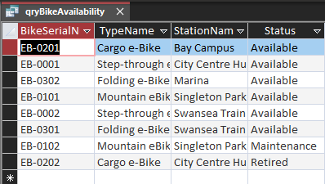
- Figure 3: Query – Bike availability
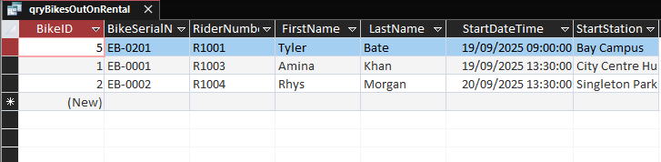
- Figure 4: Query – Bikes currently out on rental
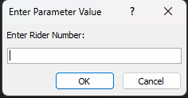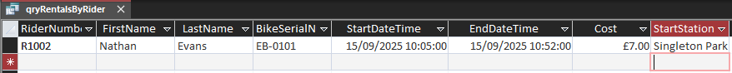
- Figure 5: Query – Rentals by rider number
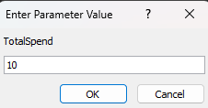
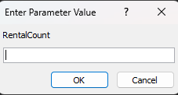
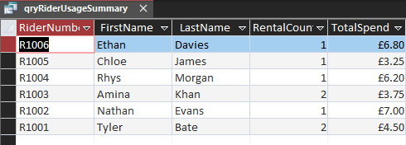
- Figure 6: Query – Rider usage summary
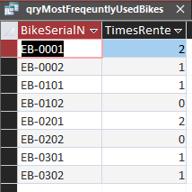
- Figure 7: Query – Most frequently used bikes
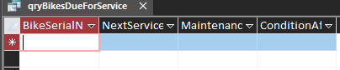
- Figure 8: Query – Bikes due for service (none due in next 30 days)
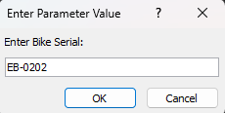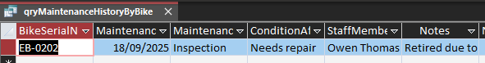
- Figure 9: Query – Maintenance history by bike
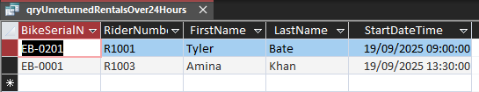
- Figure 10: Query – Unreturned rentals over 24 hours

5. Validation and Testing
Validation and testing were carried out to confirm that the database meets the functional requirements of the EcoRide system and enforces data integrity throughout. Each test was designed to simulate common user or data entry errors and to confirm that the database correctly prevents invalid data while allowing valid operational scenarios. For each test, the expected outcome was compared with the actual system behaviour.
Key validation tests included attempting to enter invalid RiderID and BikeID values in the Rental table. These tests confirmed that referential integrity constraints were correctly enforced, as Microsoft Access prevented records from being saved when related records did not exist in the parent tables. This ensures that all rental transactions are always linked to valid riders and bikes, maintaining consistency across the database.
Additional testing confirmed that the system correctly supports ongoing rentals. By allowing NULL values in the EndDateTime field, the database can accurately represent bikes that are currently in use. This behaviour aligns with the real-world requirements of the scenario and enables accurate query results for bikes currently out on rental.
Date validation was also tested by attempting to enter an EndDateTime earlier than the corresponding StartDateTime. The database correctly blocked this action due to a table-level validation rule, ensuring that all rental periods remain logically valid. This prevents incorrect or misleading rental duration data from being stored.
Maintenance records were tested to ensure that each entry must reference a valid bike and staff member. Referential integrity constraints prevented orphan maintenance records from being created, ensuring that all servicing and inspection data remains traceable and meaningful.
Finally, query results were verified against the underlying table data to confirm accuracy. Queries consistently returned the expected records, demonstrating that the database structure, relationships, and validation rules work together effectively to support reliable data retrieval. Overall, the successful completion of these tests demonstrates that the validation rules and integrity constraints were correctly implemented and function as intended [3].
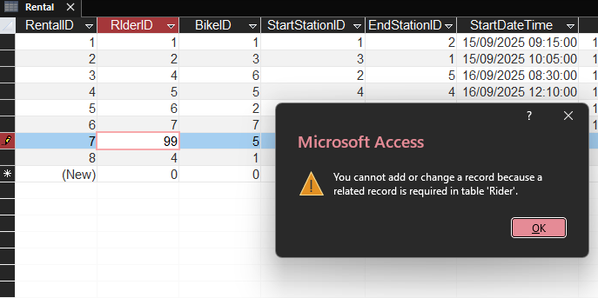
- Figure 11: Referential integrity error – invalid RiderID
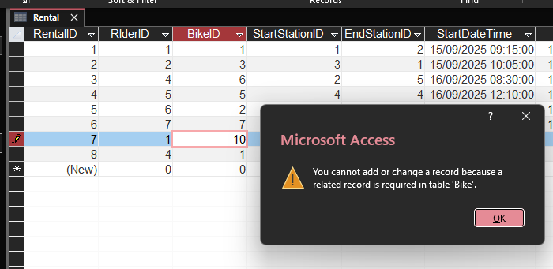
- Figure 12: Referential integrity error – invalid BikeID
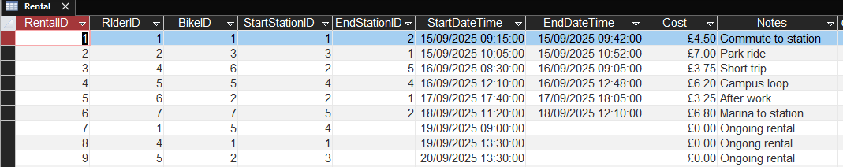
- Figure 13: Ongoing rental saved with NULL EndDateTime
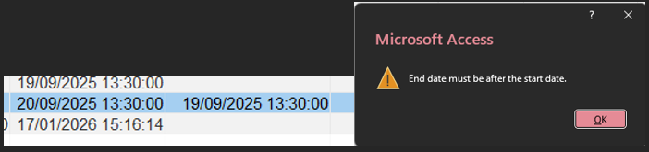
- Figure 14: Validation error – EndDateTime before StartDateTime
- Figure 15: Correct results from bikes-out-on-rental query
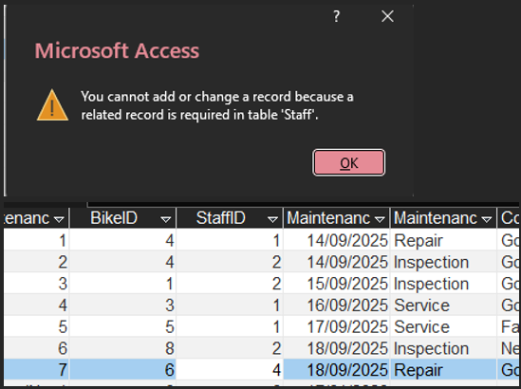
- Figure 16: Referential integrity enforced in MaintenanceLog

6. Design Decisions and Reflection
Several key design decisions were made to ensure the database was robust and aligned with the scenario. Separating bike types and maintenance records into their own tables improved normalisation and reduced redundancy. Allowing NULL values for EndDateTime enabled accurate representation of ongoing rentals. Queries were designed to balance operational needs with analytical insight.
One challenge encountered was managing multiple relationships to the Station table for start and end locations within the Rental table. This required careful relationship configuration in Access. Another challenge involved applying validation rules at the correct level, particularly when rules involved multiple fields.
If the system were extended further, potential improvements could include automated bike status updates, user-friendly data entry forms, and reports summarising revenue and long-term usage trends. These enhancements would further improve usability and analytical capability [4], [5].

7. Conclusion
The EcoRide database system successfully fulfils the requirements outlined in the assignment brief. It provides a structured, normalised solution that improves data accuracy, enforces integrity, and supports meaningful analysis of service usage. Through effective design, implementation, querying, and validation, the system demonstrates a clear understanding of relational database concepts and their practical application within a real-world context.

8. References
[1] R. Elmasri and S. B. Navathe, Fundamentals of Database Systems, 7th ed. Harlow, UK: Pearson Education, 2016.
Available: https://www.pearson.com/en-gb/subject-catalog/p/fundamentals-of-database-systems/P200000006392
[2] T. Connolly and C. Begg, Database Systems: A Practical Approach to Design, Implementation, and Management, 6th ed. Harlow, UK: Pearson Education, 2015.
Available: https://www.pearson.com/en-gb/subject-catalog/p/database-systems/P200000006383
[3] Microsoft, “Database design basics,” Microsoft Learn, 2024.
Available: https://learn.microsoft.com/en-us/office/troubleshoot/access/database-design-basics
[4] Microsoft, “Create and use queries in Access,” Microsoft Learn, 2024.
Available: https://support.microsoft.com/en-gb/office/create-and-use-queries-in-access-399c8f6b-ec3d-48df-b16a-6f4f90eb8c13
[5] W3Schools, “SQL JOIN,” W3Schools Online Web Tutorials, 2024.
Available: https://www.w3schools.com/sql/sql_join.asp

