
International business communication challenges
The challenges and sensitivities from a British perspective of doing business with South Africa

January 10 2020
University of Wales Trinity Saint David

Executive Summary

Table of Contents
Executive Summary I
1.0 Introduction 1
2.0 Main Findings 2
2.1 Hofstede’s Cultural Dimensions Theory 2
2.1.1 Hofstede’s Cultural Dimensions Analysis of United Kingdom 2
2.1.2 Hofstede’s Cultural Dimensions Analysis of South Africa 2
2.1.3 Discussion both Countries Cultural Background 3
2.2 Possible Barriers 3
2.3 Gift Giving 5
2.3.1 Gift Giving Etiquette in United Kingdom 5
2.3.2 Gift Giving Etiquette in South Africa 6
2.3.3 Discussions 6
3.0 Conclusion 7
4.0 References 8
Appendix I - Hofstede’s Cultural Dimension Theory 11
Appendix II - Hofstede cultural dimension of UK 12
Appendix III - Hofstede cultural dimension of South Africa 13
Appendix IV - Corruption Perceptions Index of UK in 2017 14
Appendix V - Corruption Perceptions Index of South Africa 15
Appendix VI - Unacceptable Gifts List in South Africa 16

1.0 Introduction
The international business communication means the communication needed to across international borders, which is highly frequent with the world economy becoming increasing closely related, in which. While there are often frictions and challenges in international business communication due to the different cultural backgrounds of countries (Carte et al, 2008).

A company with a British background culture, which always has own expectations during conducts international business. When it comes to meetings, for instance, it is hoped that the partner will be there on time, besides, the atmosphere is expected to be alleviated by self-deprecating humor when talking (Swift and Lawrence, 2003).

However, South Africa, different from UK culture, also has its own behavior pattern in carrying out business activities (Zondi, 2017). The meeting in South Africa is expected to make an appointment a month in advance (Harms, 2018). Additionally, it's best to wait until the woman reaches out before shaking hands during the first time greeting in South Africa (Evason, 2015).

What similarity, differences are, and challenges

2.0 Main Findings
South Africa has long been called Rainbow Nation due to its mixed cultural identity (Macquisten, 2016). Britain, as a western country with another different culture, should to be more cautious about business relations since there are massive barrier challenges and culture sensitive. There are more details will be elaborate as following, therefore, next, this report will use Hofstede’s cultural dimension theory to analyze the background culture of the two countries, so as to provide powerful evidence with the UK for further infer the business preferences of the target countries.

2.1 Hofstede’s Cultural Dimensions Theory
Hofstede’s cultural dimension is a theory developed by Greet Hofstede with the large-scale questionnaire data analysis between the 1960s and 1970s, which aims to understand the differences cultures and to provide theoretical users with a methodology for doing business across different cultures (Hofstede, 1980). The specific six dimensions of the theory can be referred to in Appendix I.

2.1.1 Hofstede’s Cultural Dimensions Analysis of United Kingdom
Appendix II provides an overview results of the British cultural dimension analysis, the highest (89) of which is individualism, meaning Britons prefer individual activities to collective activities, correspondingly, the embodiment of the business is that Britons always expect to have individual space for independent thinking (Stone, 2017) and emphasis privacy (Sorokowska. et al, 2017).

The lowest value (35) in the figure is power distance and uncertainty avoidance index, which shows that the organizational structure of British companies is more democratic, flat, likewise there are fewer regulatory constraints on employees, and employees are more willing to work in a relaxed atmosphere (Tamkin, 2016).

2.1.2 Hofstede’s Cultural Dimensions Analysis of South Africa
According to Appendix III, the highest index (65) of South Africa's analysis is individualism, which means that relationships between employers and employees tend to have loose management among South African companies, and employees expect to be managed by individualization (Eaton and Louw, 2000).

Long-term orientation is the lowest value (34) in South African cultural analysis, indicating that South Africans have a high degree of respect for traditional culture. Furthermore, if as a British company in the process of working with South Africa, South Africa's counterpart are hoping to gain the results/benefits from the cooperation in the short term (Makka and Nieuwenhuizen, 2018).

2.1.3 Discussion both Countries Cultural Background
Both South Africa and the United Kingdom are highly individualistic countries, indicating both sides will provide for each other with a suitable individual space in the process of cooperation, which will cause less misunderstanding of personal privacy invasion. Meanwhile, both South Africa and the United Kingdom pay great attention to the timeliness (Cornelis, 2016), and usually, South Africans follow British politeness, formal handshake, and business card exchange (Kelly, 2019).

Therefore, it can be concluded that although Britain and South Africa have different cultural backgrounds, the cultural theories of the two countries are the same in business, resulting there will not be too many differences between British and South African cultures.

2.2 Possible Barriers
Although the previous analysis presents an optimistic result, there will still be many details that need to be paid attention to during establishing the international partnership, and the barriers that may exist are the part that this section will analyze next.

1. Language Barriers
Although Britain and South Africa have the same official language - English, there will still be some differences in the use of English, such as sports shoes, British English will call it as ‘Trainers’, but in South African English, it will be ‘Tekkies’. This is because South Africa has 11 official languages, some words are selected from Africans English and the black national languages (YouTube, 2018).

Different description words of the same item and different meanings of the same words may lead to linguistic misunderstandings, that is, the two sides are not ready to understand the key points of the conversation, resulting in the deviation of the mission track, as well as possible to inadvertently offend partners with words. (Kamper and Niesler, 2014).

Besides, some South Africans speak at a fast pace with a heavy accent, as a result, special attention needs to be paid to communication due to asking people to repeat what they say is seen by South Africans as quite disrespectful (Kelly, 2019).

- Culture Barriers
Humor was accepted when doing business in South Africa, which is mainly used as an icebreaker. Meanwhile, humor is widely adopted by the British in the process of conversation as well. However, the cautious attitude towards the degree during the cooperation and frequency of humor needs to be taken in order to avoid blurring out because of nonprofessional (Evason, 2015).

Furthermore, it is also necessary for UK companies to consider not only the cultural differences between countries but also the organizational cultural mission that different organizational managers will formulate. Even if the external cultural environment will affect everyone's development track and mode of thinking as well as the corporate culture that the organization formulates for employees will affect the work orientation and working mode (El Khouly and Fadl, 2016).

Specifically, Handley and Louw (2019) pointed out that South Africa's organizational culture contains huge leadership styles similar to parental management which called paternalistically. As a result, there are may appear a problem, is that the Britisher might felt be violated even South Africa is individualism country as well since South Africa manager might interference the personal life of employees (Handley and Louw, 2019)

- Values Barriers
Owing to the high unemployment rate in South Africa (McGroarty, 2012), international partners may be inquired to provide jobs for South Africa counterpart families while working with South Africa (Berger et al, 2014), which easy to form a strong nepotism network within the enterprise (Evason, 2015).

Secondly, as described, ‘Ubntu’ is an significant value for South Acricans, meaning leaders will be involved in the work and non-working life of employees, which is contrary to Britain's pursuit of personal privacy space (Handley and Louw, 2019).

Besides, Appendix IV and Appendix V provides information about the corruption perception index (CPI) of South Africa and the United Kingdom, showing that there is a lots of number ranking gap in both countries, which are 71 and 8 respectively. The data, taken from a corruption perception index report (2017), ranked 180 countries and territories for the extent of corruption in the public sector with the form of a score. 0 means high corruption and 100 represents cleanliness.

Discussion
Primarily, even the use of the identical official language does not mean that the information can be accurately communicated and received in the process of communication. Secondly, as for the cultural background, there are some subtle difference even if the overall culture environment between countries are almost the same, such as the leadership style section in the business. Finally, each country has its own unique values that guide the way people behave and how they get along with others.

Therefore, when establishing a partnership with foreign countries, the language differences between the two parties should be understood in the early stages, even if the same words might appear with different special meanings of the technical terms. Additionally, it is necessary to be cautious about the cultural behavior of the partner during the cooperation.

For instance, through the CPI survey can known that although both the United Kingdom and South Africa score optimistically, while the value of South Africa is still lower than the United Kingdom, hence, there may be errors in the understanding of the concept of bribery between the two countries, that is to say, gifts in the South African concept will be regarded as bribery in the United Kingdom and may lead to legal action in the United Kingdom. Or it would be difficult for Britons to do business in South Africa since Britons have no habit and awareness of giving gifts to business partners. Bribery is already common relatively in South Africa, which means it may be a prerequisite for all operations, (Berger et al, 2014). (Is it feasible for the underlined section to refer to the inferences made by itself in other literature? Or need more powerful examples.)

2.3 Gift Giving
Gift giving has become an significant part of business as it is a good channel to express cooperation sincerity to partners and strengthen the relationship (Ramsey, 2013), while giving gifts is a complex area (Abigail, 2007). Hence, how to give gifts, and how to choose the appropriate gift to send the gift in the right approach is crucial.

2.3.1 Gift Giving Etiquette in United Kingdom
Most British companies are more likely to receive custom gifts that produce lasting impressions than ready-made general gifts (Fan, 2006). Additionally, Mintel (1999) pointed out in a research report that gifts with company logos will attract UK companies.

However, the UK has strict control over the value of business gifts. The British Institute of Business Ethics (2014) makes it clear in its code that gifts can be treated as gifts only if the intentions of gifts are consistent with business practice with not too expensive price. In the UK, many companies follow the gift value starting point for inland taxes within £100, including VAT, and recipients have to pay income tax (Bond, 1997).

2.3.2 Gift Giving Etiquette in South Africa
Similar to the UK, the majority of South African companies prefer to receive personalized gifts as well, which custom made by personal preference, such as barley wine for the Zulu people (Meador and Whit more, 2014), a golf ball engraved with the recipient's name .

However, there are s serious issue is that the current legislative framework in South Africa is not systematic, which will lead to the lack of guidance on the principles of employee code of conduct, resulting in corruption.

2.3.3 Discussions
The similarity between British and South African business gift-giving is that they are expected to be given personalized gifts. Nevertheless, gift giving still is a gray area in business, since the line between legitimate business gifts and illegal bribery depends on the understanding of bribery from the cooperative country. Therefore, there must be a consensus among givers on the meaning and obligations attached to gifts in order to prevent ambiguity and uncertainty about gifts and bribery (Vincent and Bezuidenhout, 2014).

In detail, each society has its own code of conduct, as well as business norms (Mintel,1997). For enterprises that want to expand into international markets, it is important to get a deep understanding of the rules and regulations governing gift giving and receiving in foreign cultures. For instance, gift-giving rituals are meaningful and more important than the gift itself under some particular background;

The British public sector is known to have strict controls on the value of acceptable business gifts, while South Africa also controls the price of gifts, what is lacking is the legal framework for describing the frequency of gifts given. Consequently, a practical approach to prevent corporate gifts and rewards from being seen as bribery is to ensure that the costs remain within a limited budget and frequency range. The overpriced gifts should be given with caution, as the move could face what could be seen as a bribe and create a negative impact on the business (Jocelyn, 2017). More seriously, it might lead to the action from the government.

3.0 Conclusion

4.0 References
Berger, Lena et al., 2014. The Influence of Context and Culture on Corporate Responsibility Expectations in South Africa. Journal of International Business Ethics, 7(2), pp.3–21.

Cornelis, E., 2019. Work Culture in South Africa - CareerProfessor.works. CareerProfessor.works. Available at: https://careerprofessor.works/work-culture-south-africa/ [Accessed 4 Dec. 2019].

Corporate Finance Institute., 2019. Hofstede’s Cultural Dimensions Theory - Overview and Categories. Available at: https://corporatefinanceinstitute.com/resources/knowledge/other/hofstedes-cultural-dimensions-theory/ [Accessed 2 Dec. 2019].

Carte, P. et al., 2008. Bridging the culture gap : a practical guide to international business communication 2nd ed., London: Kogan Page.

Devic, Z., Curcic & Radivojevic., 2014. Creating a Concept Marketing Communication in International Business-to-Business Market.

e.V., T., 2019. Corruption Perceptions Index 2017. www.transparency.org. Available at: https://www.transparency.org/news/feature/corruption_perceptions_index_2017 [Accessed 2 Dec. 2019].

El Khouly, S. & Fadl, N., 2016. The Impact of Organizational Culture on Work Quality. Competition Forum, 14(2), pp.210–215.

Eaton, L. & Louw, J., 2000. Culture and self in South Africa: Individualism-collectivism predictions. The Journal of Social Psychology, 140(2), pp.210–7.

Evason, N., 2015. South African Culture - References. Cultural Atlas. Available at: https://culturalatlas.sbs.com.au/south-african-culture/south-african-culture-references#south-african-culture-references [Accessed 2 Dec. 2019].

Fan, Y., 2006. Promoting business with corporate gifts - major issues and empirical evidence. Corporate Communications, 11(1), pp.43–55.

Gan Integrity., 2018. South Africa Corruption Report. Available at: https://www.ganintegrity.com/portal/country-profiles/south-africa/ [Accessed 1 Dec. 2019].

Gilfillan, B., 2010. When a gift is not a gift but a bribe. Polity.org.za. Available at: https://www.polity.org.za/article/when-a-gift-is-not-a-gift-but-a-bribe-2010-04-12 [Accessed 1 Dec. 2019].

Hofstede Insights., 2019. United Kingdom - Hofstede Insights. Available at: https://www.hofstede-insights.com/country/the-uk/ [Accessed 2 Dec. 2019].

Hofstede Insights., 2019. Country Comparison - Hofstede Insights. Available at: https://www.hofstede-insights.com/country-comparison/south-africa/ [Accessed 2 Dec. 2019].

Hofstede, G., 1980, Culture's Consequences: International Differences in Work-Related Values, Sage Publications, Beverly Hills, CA.

Harms. N, 2019. Business Etiquette Tips for South Africa. Travel Tips - USA Today. Available at: https://traveltips.usatoday.com/business-etiquette-tips-south-africa-16196.html [Accessed 2 Dec. 2019].

Handley, R. and Louw, M., 2019. The similarities and differences between South Africa and Chinese definitions and descriptions of leadership style: A mining joint venture case study. Proceedings of the 28th Annual Conference of the Southern African Institute of Management Scientists, pp.138-155.

Kelly, D., 2019. Don't Make a Cultural Mistake When Doing Business in South Africa. TripSavvy. Available at: https://www.tripsavvy.com/doing-business-south-africa-4061201 [Accessed 3 Dec. 2019].

Kamper, H. & Niesler, T.R., 2014. The impact of accent identification errors on speech recognition of South African English : research article. 110(1/2), pp.1–6.

Macquisten, I., 2016. Art Business South Africa. Apollo, 184(647), pp.98–99.

Meador, S. and Whitmore, J., 2019. The Ultimate Guide To Office Gift-Giving Etiquette. Business Insider. Available at: https://www.businessinsider.com/office-gift-giving-etiquette-during-holidays-2014-12?r=US&IR=T [Accessed 5 Dec. 2019].

Makka, A. & Nieuwenhuizen, C., 2018. Multinational enterprises perceptions of the national corporate social responsibility priority issues in South Africa. Social Responsibility Journal, 14(4), pp.828–842.

McGroarty, P., 2012. World News: South Africa's Jobs Problem --- Tiny Tax Base, High Unemployment Strains Social Safety Net; Road-Fee Plan Takes Toll. Wall Street Journal, pp.Wall Street Journal, 2012–05-08.

Ramsey, L., 2013. The etiquette of business gift giving. Savannah Morning News, pp.Savannah Morning News, 2013–11-20.

Stone, J., 2019. Britain is the most individualistic country in the EU. The Independent. Available at: https://www.independent.co.uk/news/uk/politics/brexit-britain-eurobarometer-individualism-soldarity-eu-politics-a8118581.html [Accessed 3 Dec. 2019].

Sirois, J., 2019. Is that Gift a Bribe? How to Avoid Violating Anti-Corruption Laws | Lexology. Lexology.com. Available at: https://www.lexology.com/library/detail.aspx?g=a16f15d9-d2e6-431a-a2e9-bfa94ac445f9 [Accessed 5 Dec. 2019].

Sorokowska, A. et al., 2017. Preferred Interpersonal Distances: A Global Comparison. Journal of Cross-Cultural Psychology, 48(4), pp.577-592.

Swift, J. & Lawrence, K., 2003. Business culture in Latin America: interactive learning for UK SMEs. Journal of European Industrial Training, 27(89), pp.389–397.

Stevens, A., 2007. global business etiquette: "When in Rome...". Accountancy SA, pp.36–37.

Tamkin, P., 2016. The Relationship between UK Management and Leadership and productivity. UK Commission for Employment and Skills, pp.1-97.

The Hofstede Centre., 2016. South Africa in Comparison to China. Available: https://geerthofstede.com/south-africa.html. [Accessed 4 Dec 2019].

Vincent, J. and Bezuidenhout, H., 2014. 'Best practices to regulate gifts in the South African public sector', Administratio Publica, 22(2), pp. 68-92.

Zondi, W., 2017. Challenges Facing Small Business Development in South AFRICA. International Journal of Economic Perspectives, pp.621–628.

Appendix I - Hofstede’s Cultural Dimension Theory
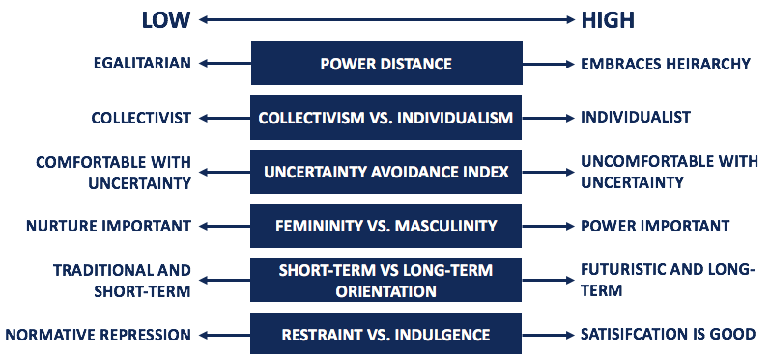
Source: corporatefinanceinstitute.com, 2019

- Power Distance: The extent to which authority is valued and respected in special culture (Hofstede, 1980).

- Collectivism vs. Individualism: Does society pay more attention to individual interests or collective interests, and whether the relationship between people is loose or more focused on family relations (Hofstede, 1980).

- Uncertainty Avoidance Index: The extent to which society can accept uncertainty and novelty (Hofstede, 1980).

- Femininity vs. Masculinity: Society shows male characteristics or female characteristics. In other words, it is the society's preference for achievement, attitudes and behaviors on gender equality (Hofstede, 1980).

- Short-term vs. Long-term Orientation: The satisfaction of people with the outcome of the goals is a tendency to be long-term or short-term, that is, whether the views of the strategy have a long-term vision (Hofstede, 1980).

- Restraint vs. Indulgence: The degree of social acceptance of people's basic needs to enjoy life and desire (Hofstede, 1980).

Appendix II - Hofstede cultural dimension of UK
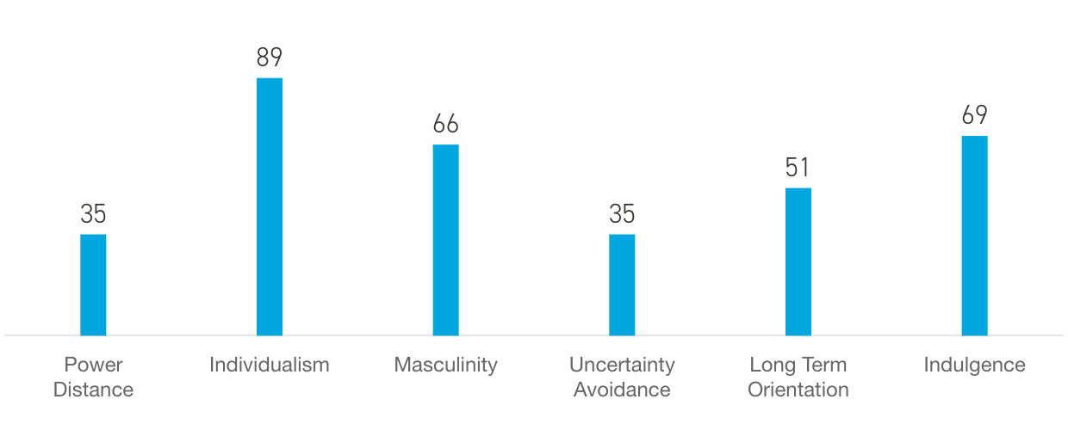
Source: HofstedeInsights.com, 2019

Appendix III - Hofstede cultural dimension of South Africa
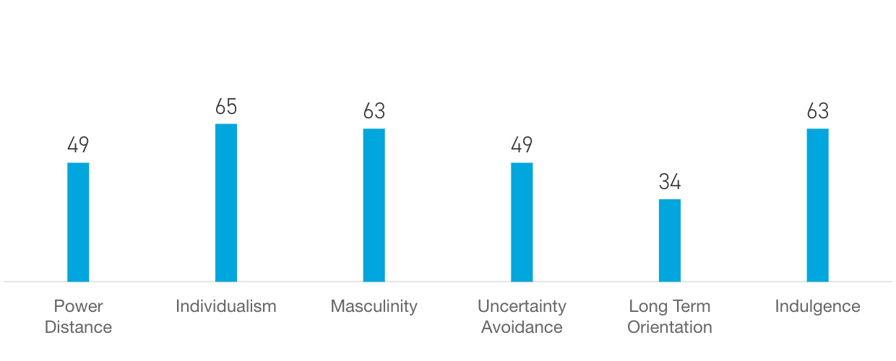
Source: HofstedeInsights.com, 2019

Appendix IV - Corruption Perceptions Index of UK in 2017
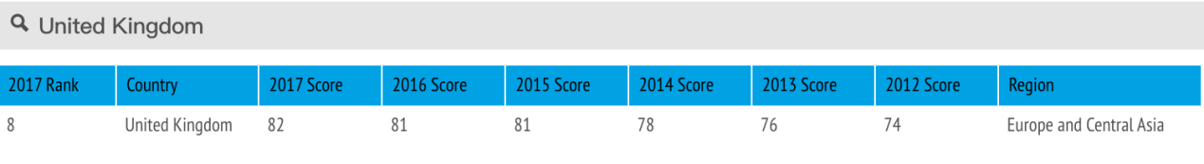
Source: TransparencyInterntional.com, 2019

Appendix V - Corruption Perceptions Index of South Africa
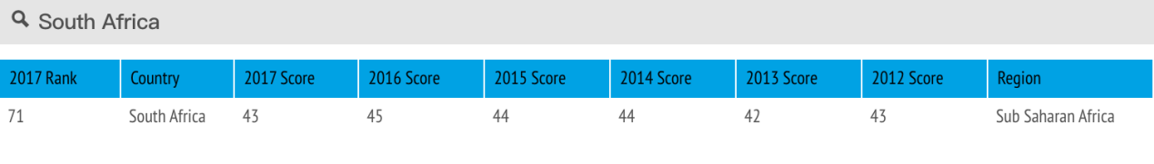
Source: TransparencyInterntional.com, 2019

Appendix VI - Unacceptable Gifts List in South Africa
• Are illegal or involve an improper, biased or dishonest act
• Would result in the violation of any law
• Are given for purposes of influencing the recipient
• Amount to loans from any company supplier, customer, etc (save for banking and financial institutions) or any preferential arrangement not readily available to the public
• Involving conduct of a sexual nature and/or violation of mutual respect
• Constitute reciprocal agreements (requiring anything in return for the gift)
• Resulting in breach of mutual respect
• Violate the company's ethics policy and code of conduct
• Resulting in the abuse of a position of authority
• May be construed as being given or received for an improper purpose.

(Gilfillan, 2010)

