My planned project
Name of project- Spotlight on my country
Duration of project- 3 weeks
My appendices for this part of my portfolio will show as AP, BP, CP etc to make it easier for the reader to find the appendices linking to my project.
As part of my time on placement at the Priory Project at Monkon Primary School, I am required to plan and deliver a programme of work for the young people. As well as that, I am also required to then critically review my programme of work.
The decision was made to carry out the below project after noticing there was a demand for it with the young people in my placement. I also concluded with the young people to ask if this was something they would like to know more about.
What is going to be achieved?
I am planning a programme of work to do with geography as I noticed a lack of knowledge within this subject in my work placement. The programme I am going to plan and deliver in my placement is going to be simple for the young people that I work with to understand effectively. I have decided to only talk about Wales within my project, again to keep it basic for the young people. As soon as I noticed a massive lack of knowledge about geography, I knew it was something I needed to teach the young people about.
The reason why there is such a lack of knowledge within the geography subject in my placement is because it is not a lesson that they get taught often, like English or maths. As most young people within my placement struggle educationally, they only stick to being taught the key lessons. Having said that, the lack of knowledge about geography is so much that the young people seem to not even understand the basics. I have been asked before by the young people if “Monkon is in Pembrokeshire?” or “Monkon and Wales are the same thing” or “Whats a town?”.
I don’t want the young people who I work with to become experts in geography after the programme, I just want them to have the basic knowledge of the important things they need to know. In other words, the types of lessons I will be delivering to the young people will be the same as what could be taught to primary school children. I also plan to run the programme around over St David’s Day (1st March) in order for it to fit in to being a project being run about Wales.
How is it going to be achieved?
There are several things I am going to do in order for the young people to achieve what it is I would like to see from them. The first and one of the most important things I am going to do is investigate different learning styles and how young people learn (Appendix AP). By doing this I am understanding the best way to deliver my programme and the different activities and sessions to run. I will then move on to investigate experiential learning (Appendix BP) again, this will help me to find the best ways to deliver my programme of work.
I will also put together a NAOMIE to plan my project (Appendix CP). A NAOMIE is a planning tool. It is only that I am already familiar with using and have used in past assignments. It’s a very effect way of showing a plan. It also shows the reader evidence that all parts of the project being planned for is being taken into consideration and that nothing gets left out. I will be using PowerPoints with information on as my main from of teaching the young people (Appendix DP).
Timescale of the programme
I am hoping to run the programme over a 3-week timeframe. For 1- 1 and a half hours per session to allow to overrun and for questions. I am looking to start my programme on either 11th Febuaury or 12th Febuaury 2020. The second session being on either 25th February or 26th February. Then the third and final session being on either 3rd March or 4th March. I will also use part of the last session as a reward for the young people, also linking this to St David’s Day.
I have started planning the project on the 14th January. By doing this I am giving myself enough time to get everything together, including resources. It also allows me to consider if any changes need to be made. By finishing my project by the first week of March, I am also giving myself enough time to critically review my project.

Indication of effectiveness
One of the main things I will be using to give an indication of effectiveness from the programme will be using simple worksheets as a resource for the young people (Appendix EP). Keeping worksheets that the young people have done is a simple yet effective way of finding out if they have learned the things you wanted them to. I will also give the young people time at the end of every session to ask questions. As well as this, I will also ask the young people quick questions throughout to see what it is they remember from the sessions. I will also ask my line manager for advice throughout running the project. To make sure what it is I am delivering is best for the young people, and they are gaining the best outcome from it.
As well as that, I will also be asking the young people to evaluate for me (Appendix FP). This is something I know the young people I work with are not very familiar in doing. So, I will make sure I give clear instructions when the time of evaluation comes. To make it simple for the young people to understand I will ask them to verbally feedback to me and will record some findings in the appendices.
I will also be putting together session plans to follow for each of the three sessions I will deliver (Appendix GP).

Linking my programme to policy
There are several policies in which I plan on linking my programme of work to. The first one is The Youth Work Strategy for Wales. The strategy sets out a shared vision for the future of youth work in Wales. The principles have been co-developed with young people and the youth work sector. The audience of the policy is young people aged 11-25 and the youth work organisations and youth work staff that support them, as well as wider stakeholders working to improve the outcome for young people. It sets out that youth work can mean different things to different people. It also states how youth work is not confined to single setting or context. It also explains how youth work practice can and does adapt and change lives. It also explores how trusted relationships lead young people to make better choices. It also states out another important factor which is that youth work has benefits for all young people but maximises the impacts of support aimed at the most vulnerable young people. Youth work has a unique way of empowering young people, using their voice to be heard and play an active role in designing. It also believes that the power and potential of youth work in Wales has not been fully realised. It states out too have full commitment to young people and youth work. The Welsh Government has begun by investing large levels of funding in the youth service in Wales. Saying we all have an important part to play.
Another important policy my programme links to is the Youth engagement and progression framework (Welsh Gov). This policy sets out that youth engagement and employment should be a priority for Wales. Its aim is for young people to overcome challenges around employment. It also sets out ways to reduce the number of 11-25-year olds who are not engaged in education, employment or training (NEET). By reducing this, it will have a massive impact on the lives of young people and with generations to come. It explains the cost of this is not just economic, but impacts on levels of unemployment, crime, well-being, substance misuse, premature death and early motherhood. Although there have been some improvements in recent years, there are still too many young people who disengage from education and training. There are ongoing commitments to tackling poverty, prioritising the needs of the poorest and protecting those most at risk of poverty. It also says how there is no shortage of organisations to support young people’s engagement and progression.
A third policy that links to my programme of work is the Well-being of Future Generations Act 2015 (Wales). The policy is about improving the social, economic, environmental and cultural well-being of Wales. My programme links to both the environmental and cultural side of this policy. This policy also has 7 well-being goals. These are a globally responsible Wales, a prosperous Wales, a resilient Wales, a healthier Wales, a more equal Wales, a Wales of cohesive communities, a Wales of vibrant culture and a thriving Welsh language. My programme of activities links to a number of these goals including a globally responsible Wales and a Wales of vibrant culture. The policy states how Wales faces several challenges now and in the future. Such as climate change, poverty health inequalities, jobs and growth. Several bodies including Welsh ministers, local authorities, local health boards and natural resources Wales are responsible for these improvements. The well-being goals show the kind of Wales that everyone wants to see, and the public bodies must work to achieve them. The Future Generations Commissioner for Wales role is to act as a guardian for the interests of future generations in Wales. It’s the duty that the above people need to achieve this, as by duty it means its law to do it.

Analysis of my programme of work
Name of project- Spotlight on my country

What went well with my programme of work?
I feel that there were several things which went well when running my project of work. The main thing which went well was that most of the young people really enjoyed taking part in the course and found the work that we did interesting. The young people were often asking questions about what we were learning, expanding their learning, and showing me that they wanted to learn more about the subject.
I feel that a second thing which went well when I was running my project was that I was teaching the young people about something which was quite new to them. The young people very rarely do lessons such as geography and history. This is because the class has such a big range of mixed ability students. Although, the subject in which I was teaching the young people was quite new to them it is very important for them to know and understand about Wales and its culture as it’s the county in which they live.
Another thing I felt went well with the young people was the work I set. There were only 3 worksheets in total that the young people completed (see appendices). However, there was also 3 PowerPoints. I delivered one PowerPoint per session. They were full of information and took quite a while to get though. This was because the young people asked so many questions and there was a lot of discussion happening. I allowed this to happen because after spending time researching different learning styles, and after working with these young people for quite a while, I learned that this is the best way that the majority of young people in thus class learn. Examples of questions that the young people were asking which lead to sometimes quite long discussions were:
- What is a tourist and are we one?
- Why would people come on holiday here?
- What is Welsh rarebit?
- Why do we speak Welsh?
- Why are maps so confusing?
- How can it be a city if it has no shops?
What didn’t go well with my programme of work?
The main thing which did not go so well with my programme of work was certain young people being disruptive and not allowing some of the others to work effectively. However, as these certain young people are not often in school. This only happened twice out of the three sessions and was easily managed by saying to the young people who were being disruptive that they can go and get on with other work somewhere else if they do not want to be here. This is quite a quick way of resolving the behaviour of these certain young people.
A second thing which did not go to plan with my programme of work, which could not be blamed on anyone was after the young people completed the course, the following week I bought the ingredients in so the young people could make welsh cakes as a reward for taking part in the course. However, we have one young girl in the class who has a server intolerance to eggs. Her allergy is that bad that she cannot be around raw eggs, no matter touch or make anything which include them. This is something which was planned for. I planned to do this activity when the young girl was meant to be attending college. However, on this certain day because of transport issues, she could not attend college and came to school for the day. Because of this, we had to remove the eggs from the classroom just in case the young girl got to close to them and had a reaction. I also then could not do this activity with the rest of the young people. This was something which some of the young people were not happy with as they were looking forward to cooking. Myself, along with the other members off staff explained that we were not able to do anything about the situation and I agreed with the them that we were going to do pancake making sometime soon, when we know we were not putting the young girl with the intolerance at any risk. (see appendices).

What could I have done differently with my programme of work?
The main thing I could have done differently when planning my programme of work is putting more consideration into the fact that this group of young people are such a range of mixed ability students. There are some students in the class who are aged 14 plus who can do GCSE work, or the equivalent of. However, there are other, younger members of the class who struggle to the extent that the require one-to-one work with LSAs. I tired to keep my programme of work as simple as possible as I was also aware that the knowledge of geography with the students in the class was not very high on average. With my project being planned around noticing there was a gap in this knowledge which needed to be taught. However, one thing I did notice was that the young people who have the higher ability found a lot of the worksheet quite easy and I felt as if they could have completed the work themselves without the aid of the PowerPoints. On the other hand, there was some young people who found the work difficult to complete. These young people were asking for help quite often, and at points myself along with the other staff members were struggling to help all the young people who needed it.
If I was to deliver another project which is like this one, I would make sure I have different worksheets for the different abilities in the class. I would make worksheets harder for the ones who can complete them. I would also make some easier sheets for the young people who struggle that little bit more. Another thing I would do, would be to ask all of the staff members to be available to help when running a session, as a lot of the young people were at different stages when completing the worksheets.

Appendices for my programme of work
Appendix AP
Different learning styles
The Seven Learning Styles
Visual (spatial): You prefer using pictures, images, and spatial understanding.
Aural (auditory-musical): You prefer using sound and music.
Verbal (linguistic): You prefer using words, both in speech and writing.
Physical (kinaesthetic): You prefer using your body, hands and sense of touch.
Logical (mathematical): You prefer using logic, reasoning and systems.
Social (interpersonal): You prefer to learn in groups or with other people.
Solitary (intrapersonal): You prefer to work alone and use self-study.

- Learning styles may affect learners more than what they think.
- The style or styles that best suit you will guide the way you learn.
- They can change quite often.
- Research shows that each different learning styles uses a different part of the brain.
- By involving more of the brain during learning, we remember what we learn.

https://www.teachermagazine.com.au/articles/tackling-the-learning-styles-myth (Accessed: 13th November 2019).
Appendix BP
Experimental learning
Experimental learning is learning by doing. There are no barriers in age, education, experience, ability, background or culture regarding learning through doing. Experimental learning is a process which engages the learner, it is not a passive way of passing stuff on. It also provides a platform for learning. Whilst the reflection of the experience also helps with the learning.

Examples of experimental learning-
- Playing outdoors
- Imaginative or pretend play
- Art
- Music
- Dance
- Nature

Kolb’s experimental learning theory
David Kolb developed his theory in 1984. He suggests that learning can be flexible in different situations. He also states that “learning is the process whereby knowledge is created through the transformation of experience”.
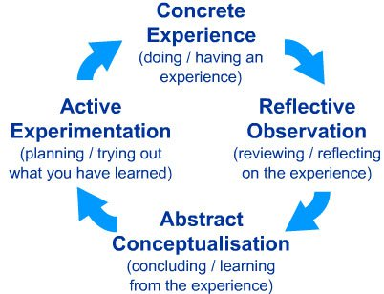

Appendix CP
NAOMIE planning model
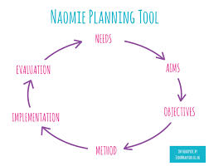https://www.judewharton.co.uk/2017/01/training-tips-thursday-6-planning-methods/ (Accessed: 14th January 2020).

Needs
To run a 3-week programme of work within my placement about geography, as there is a lack of knowledge within the class. Target group is 11- 15-year olds. However, simple sessions will be run. The equivalent to what is taught in primary schools.
To base the project on Wales, to make it simple for the young people to understand. And it being important for the young people to understand about where they live and the culture.
Aims
For the young people taking part in the sessions to gain a simple understanding on the country in which they live.
For the young people to answer basic questions about Wales and its culture.
To run the programme of work around the same time as St. David’s Day. Discussing briefly what St. David’s Day is.
For the young people to have a reward for taking part during the last session.
Objectives
Young people will complete simple worksheets for their knowledge to be recorded.
There will be fun activities and game throughout the programme to allow the young people to want to engage.
For the young people to have at least some knowledge of simple geography in order to help them if they do attend mainstream school at some point in their education.
For the knowledge learned help the young people for if they decide to travel around Wales at some point in their lives.
Method
Using PowerPoints as the main form of teaching the young people. These will include information as well as pictures for the young people to remain interested.
To make sure that they young people’s learning styles are explored, and to cater for all different learning styles that may be apparent.
Use experimental learning through the programme of work. To allow the young people to be interested in the learning. To make the learning more fun.
For the young people to evaluate the programme I have delivered for them. Stating both good and bad things, and things they would like to change.
To make and follow session plans for all the three sessions, also indicating on them what the potential problems could be.
Implementation
Resources include the computer in order to deliver the PowerPoint as well as worksheets. Coloured paper and buckets may also be used for the evaluation.
Other staff members may also need to attend times to help with sessions.
All the sessions will be run inside the setting of the school. Unless the reward involves leaving the school premises. May also use the school playground.
Each session will run for 1- 1 and a half hour to allow time for overrunning and the young people asking questions.
To have the programme finished by the first week of March to allow for time for me to then critically review my programme of work.
Evaluation
Young people to verbally evaluate the sessions and how they feel like it went.
To do it this way as the young people will not be used to using evaluation.
Verbally evaluating allows all the young people to have a say, and not struggle with the writing and spelling.
Overall went well, will now start to write a critical review on the programme of work.
At times, struggled to get some of the young people fully engaged. This may have been down to there being such a divide in the abilities within the class.

Appendix DP
PowerPoints
Session 1

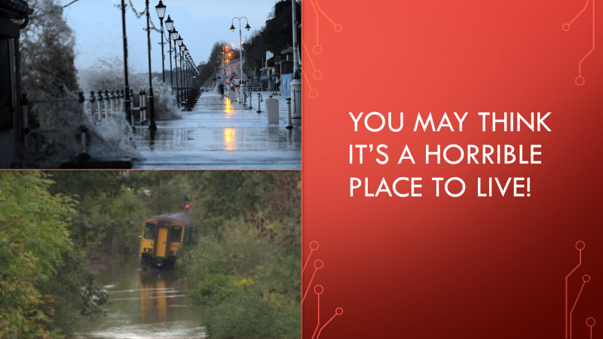
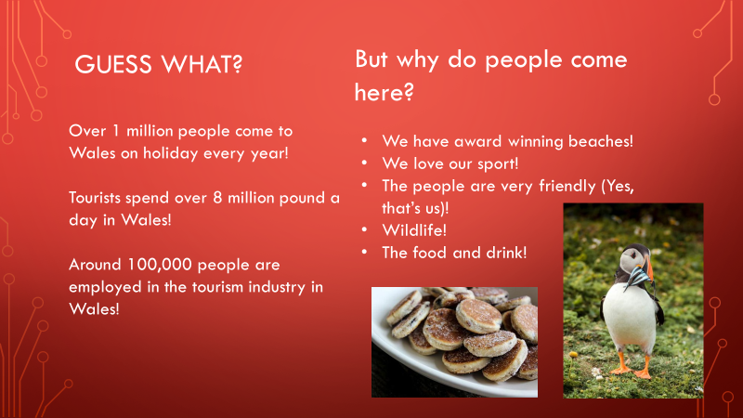
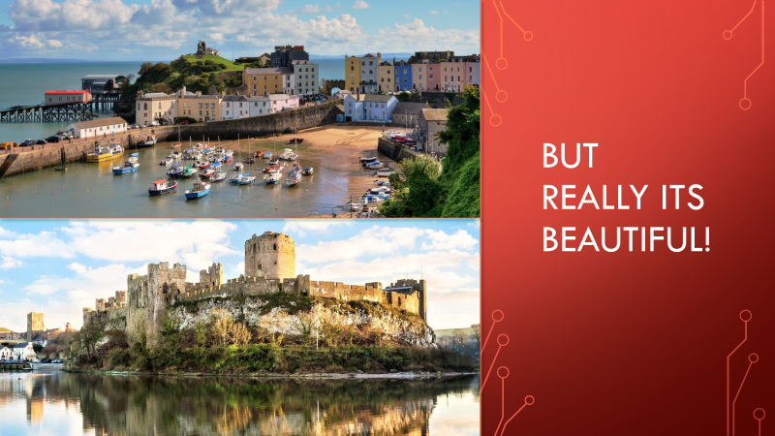

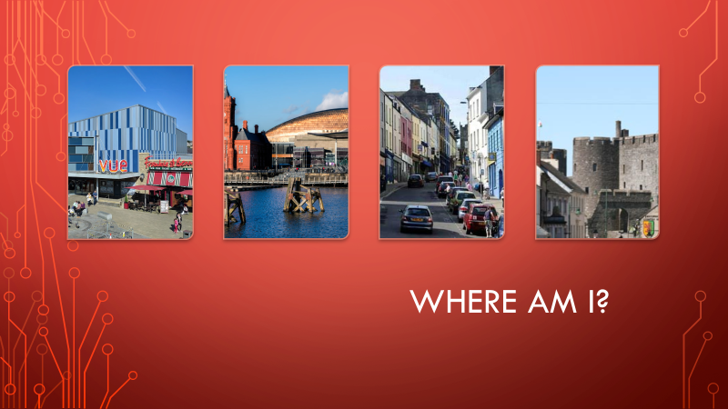

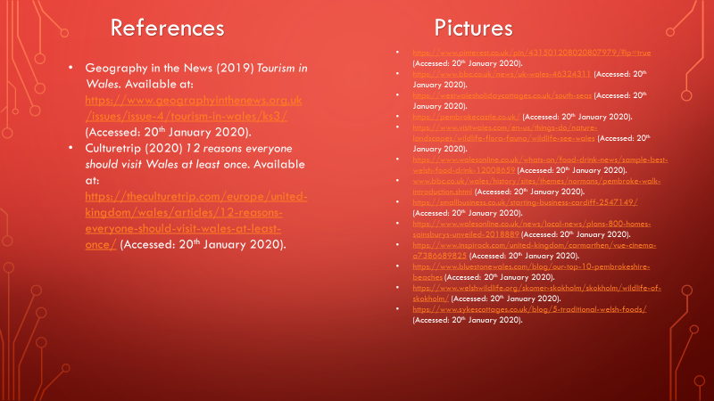

Session 2


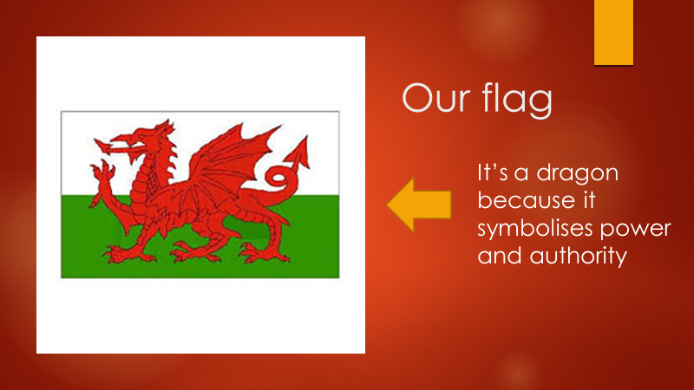
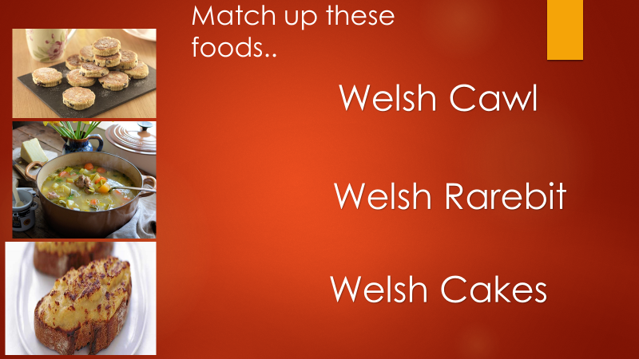
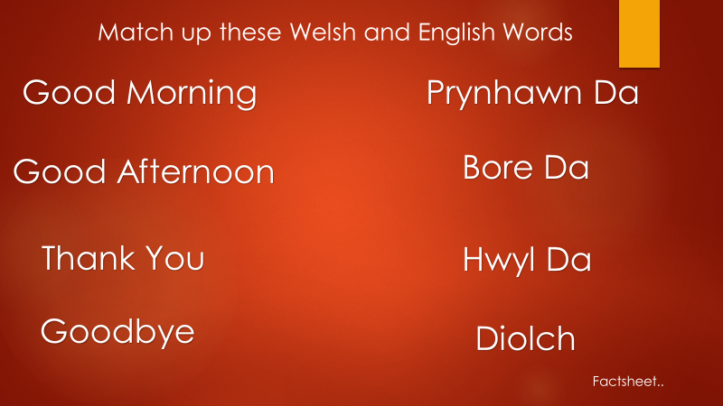
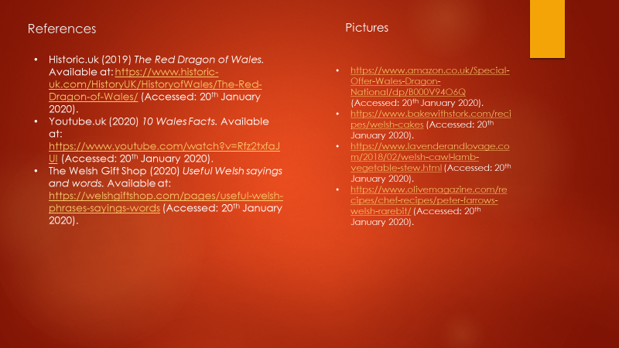

Session 3

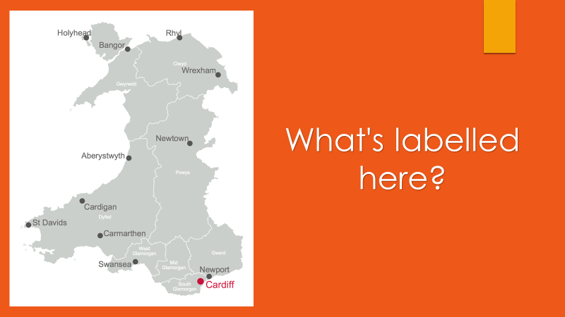
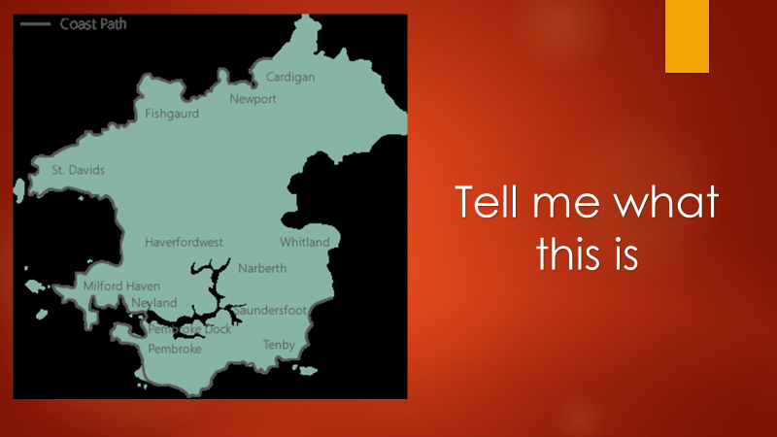
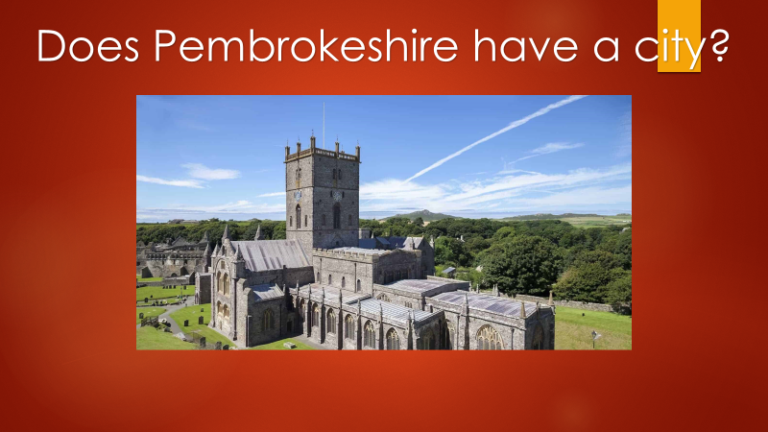

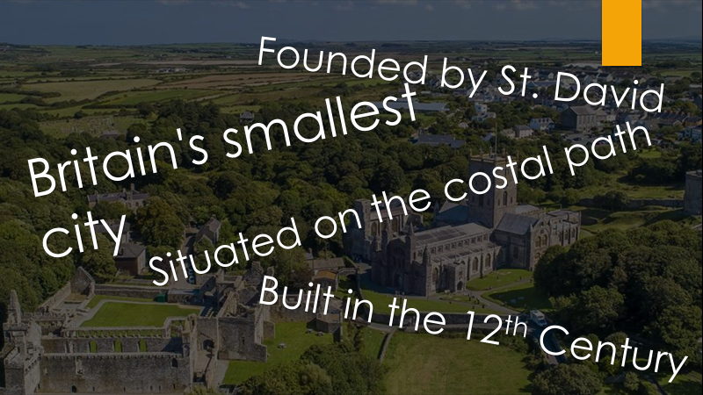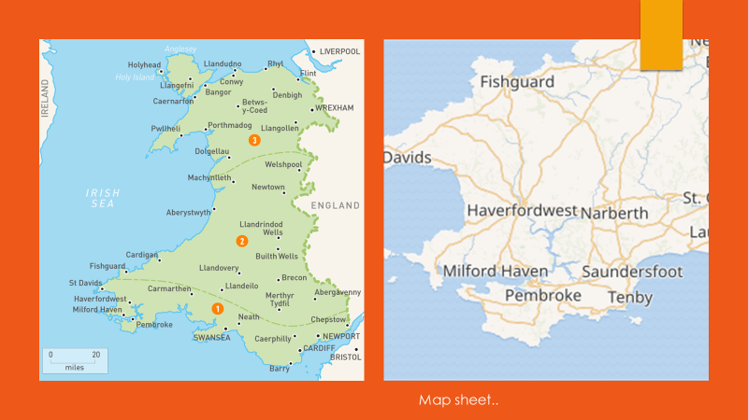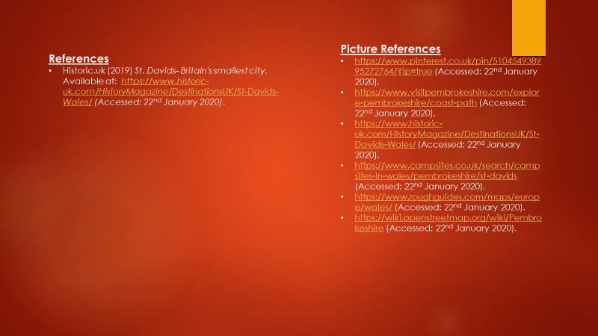

Appendix EP
Worksheets
Acrostic poem

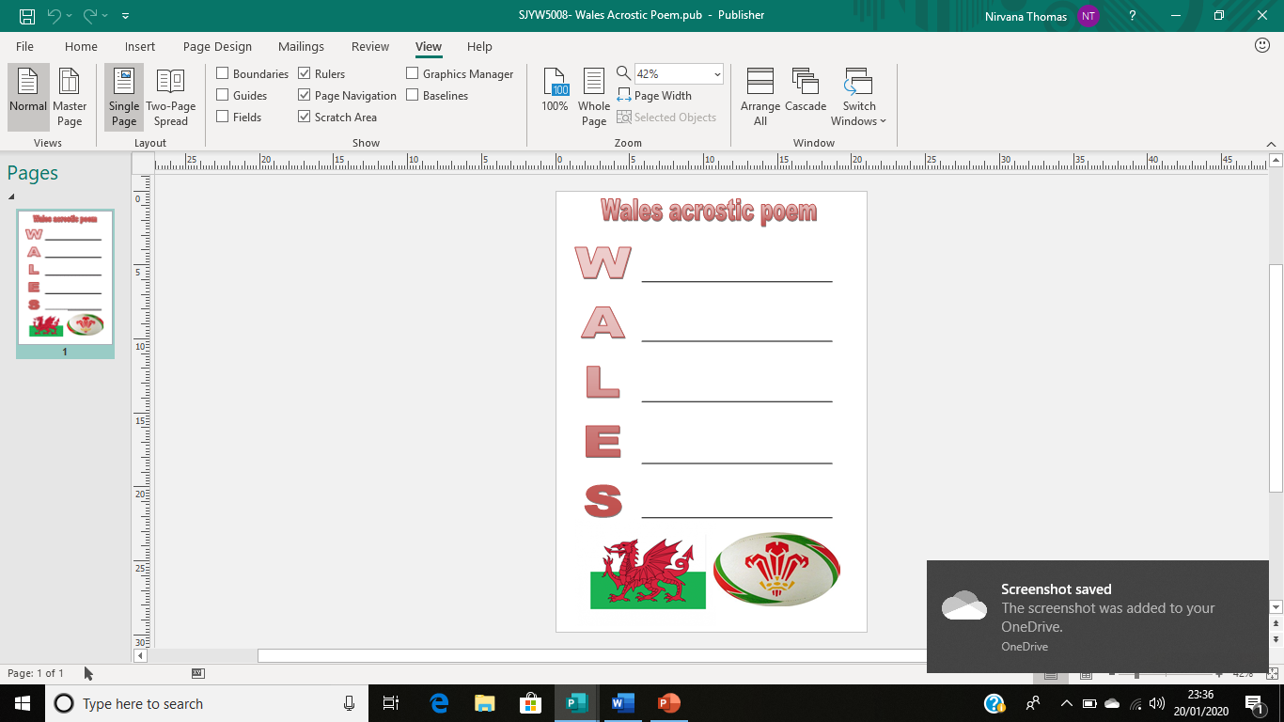

https://www.onestopfestival.com/shop/cymru-wales-flag-large/?v=79cba1185463 (Accessed: 20th January 2020).
https://www.pinterest.co.uk/pin/326370304232132306/?lp=true (Accessed: 20th January 2020).

Welsh map worksheet

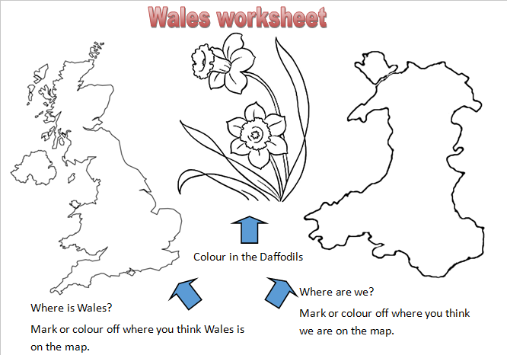

http://clipart-library.com/clipart/279714.htm (Accessed: 20th January 2020).
http://www.supercoloring.com/coloring-pages/united-kingdom-blank-outline-map (Accessed: 20th January 2020).
https://www.pinterest.ca/pin/472033604675298199/ (Accessed: 20th January 2020).
Welsh factsheet
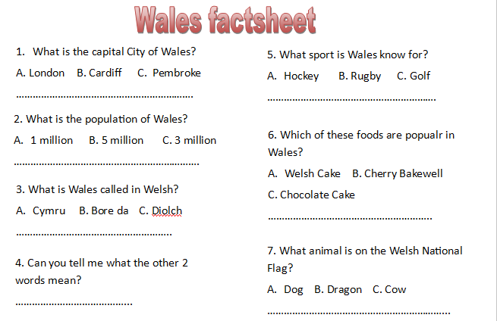

Appendix FP
Evaluation from young people
Young person A- “I liked learning more about where we live.” “I found out some interesting things about the Welsh culture.” “I would like to see more of geography lessons in school, as I enjoyed doing it.”
Young person B- “enjoyed it, but it’s not going to help me”. “I don’t really enjoy doing any lessons”. “I don’t like living in Wales anyway”.
Young person C- “I like doing the acrostic poems as we have done them before in class”. “was nice to have a different teacher teaching us”.
Young person D- “was good”. “enjoyed finding out the facts about Wales”. “Liked talking about the rugby in Wales”. “happy to not be doing maths”.

Appendix GP
Session plans
Plan 1
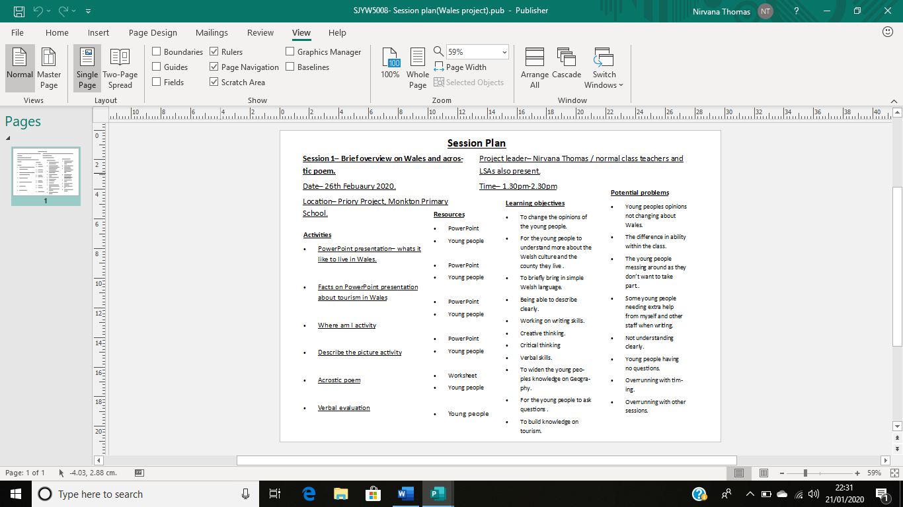
Plan 2
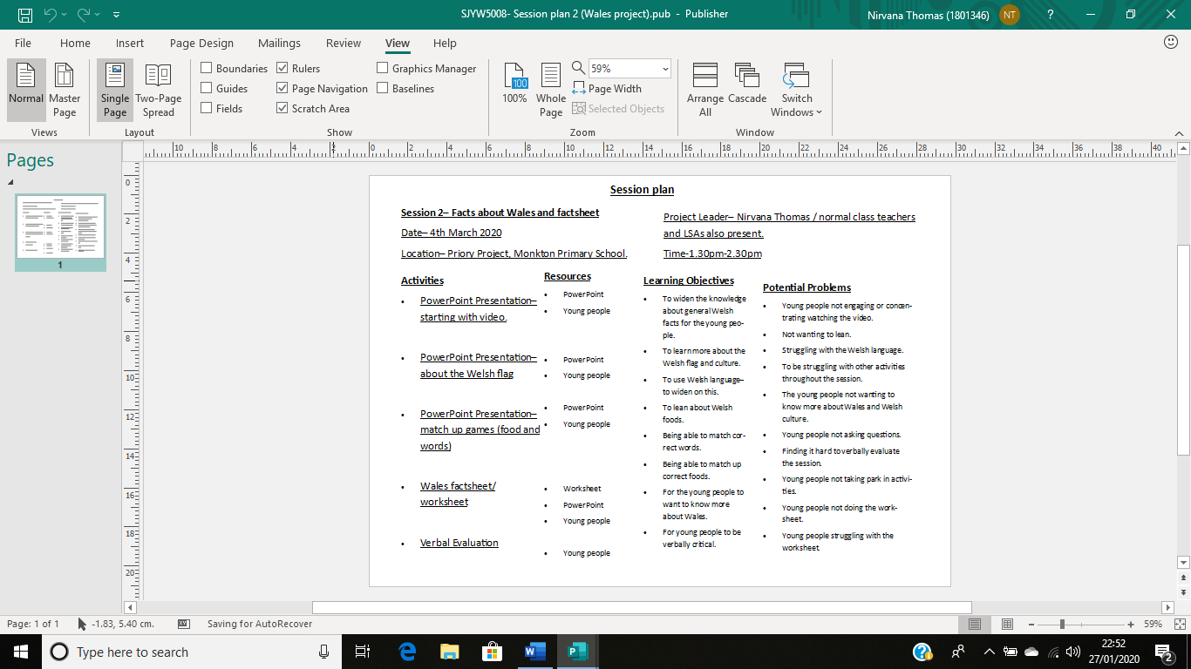
Plan 3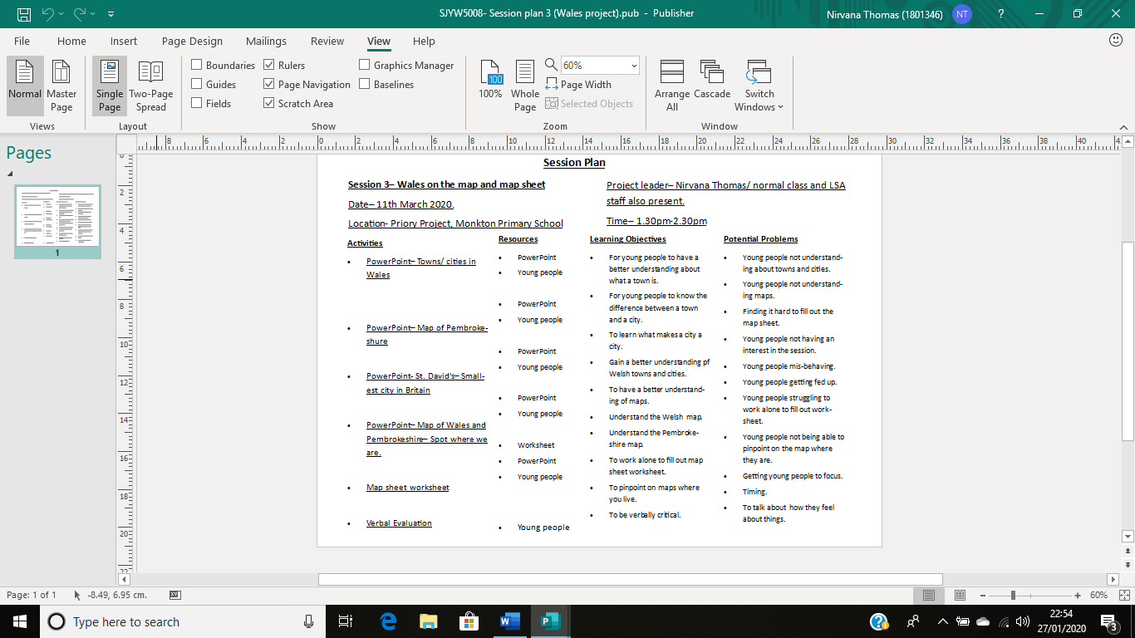

References

- Future Generations Commissioner for Wales (2015) Well-being of Future Generations (Wales) Act. Available at: https://futuregenerations.wales/about-us/future-generations-act/ (Accessed: 17th January 2020).
- Greenbridge alchemy limited (2017) The NAOMIE approach to planning. Available at: https://greenbridgealchemy.org/2017/01/23/the-naomie-approach-to-planning/ (Accessed: 14th January 2020).
- Learning-styles-online.com (2019) Overview of Learning Styles. Available at: https://www.learning-styles-online.com/overview/ (Accessed: 13th November 2019).
- Mcleod, S (2017) Kolb- learning styles. Available at: https://www.simplypsychology.org/learning-kolb.html (Accessed: 14th January 2020).
- MTLearning (2009) What is experimental learning? Available at: https://www.experientiallearning.org/about-mta/what-is-experiential-learning/ (Accessed: 14th January 2020).
- Persil (2019) What is ‘experimental learning’?. Wharton, J (2017) NAOMIE planning tool. Available at: https://www.judewharton.co.uk/2017/01/training-tips-thursday-6-planning-methods/ (Accessed: 14th January 2020).
- Welsh Government (2013) Youth Engagement and Progression Framework. Available at: https://gov.wales/sites/default/files/publications/2018-02/executive-summary.pdf (Accessed: 17th January 2020).
- Welsh Government (2019) Youth Work Strategy for Wales.
Available at: https://gov.wales/sites/default/files/publications/2019-06/youth-work-strategy-for-wales.pdf (Accessed: 17th January 2020).
- Wharton, J (2017) NAOMIE planning tool. Available at: https://www.judewharton.co.uk/2017/01/training-tips-thursday-6-planning-methods/ (Accessed: 14th January 2020).

