


Network Security (NS)

Lab 4

Faculty of Architecture, Computing & Engineering
I.Q. Building room 205
Swansea
SA1 6ED

Introduction

The labs given within this module is geared to assist you in carrying out penetration testing on systems. In a penetration test an Ethical Hacker attempts to break into a company’s network to find vulnerability or the weakest link in the network or the network system. They are also required to analyzes the company security policy and procedures and report any vulnerability to management.

An Ethical Hacker is a person who performs most of the same activities as a hacker but with the owner of the company’s permission. The distinction is important and can mean the difference between being charged with a crime or not being charged. Ethical Hackers are usually contracted to perform penetration tests or security tests. After pre-engagement activities, penetration testers begin gathering information about their targets. Often all the information learned from a client is the list of IP addresses and/or web domains that are in scope. Penetration testers then learn as much about the client and their systems as possible, from searching for employees on social networking sites to scanning die perimeter for live systems and open ports. Taking all the information gathered into account, penetration testers study the systems to find the best routes of attack. Tins is similar to what an attacker would door what an invading army would do when trying to breach the perimeter. Then penetration testers move into vulnerability analysis, the first phase where they are actively engaging the target.

Task 1:

Enumerating a Network Using SolarWinds Toolset

The SolarWinds Toolset provides the tools you need as a network engineer or network consultant to get your job done. Toolset includes best-of-breed solutions that work simply and precisely, providing the diagnostic, performance, and bandwidth measurements you want, without extraneous, unnecessary features.

Lab Objectives

The objective of tins lab is to help students learn and perform NetBIOS enumeration. NetBIOS enumeration is carried out to detect:
- Hardware MAC addresses across routers
- Hidden shared folders and writable ones
- Internal and external IP addresses

Getting started, you need:
- SolarWinds-Toolset-V10 located in the shared one drive
- You can also download the latest version of SolarWinds Toolset Scanner from the link http:/ /www.solarwmds.com/
- If you decide to download the latest version, then screenshots shown in the lab might differ
- Follow the Wizard driven installation process
- To run this tool Administrative privileges are required

Enumeration involves an active connection so that it can be logged. Typical information that attackers are looking for includes user account names for future password guessing attacks.

Lab Tasks
- Before installation:
  - Configure SNMP services and select Start Control Panel Administrative Tools Services.
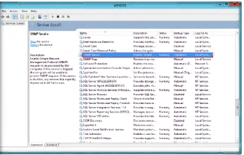

  - Double-click SNMP service.
  - Click the Security tab, and click Add... The SNMP Services Configuration window appears. Select READ ONLY from Community rights and Public in Community Name, and click Add.

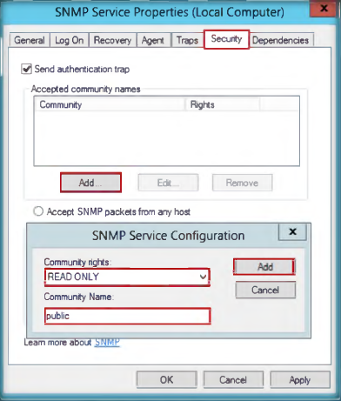

  - Select Accept SNMP packets from any host, and click OK.

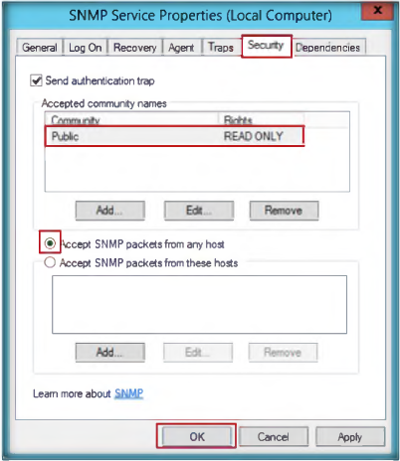

- Install SolarWinds Toolset
- After installation, Launch the Start menu by hovering the mouse cursor on the lower-left corner of the desktop.
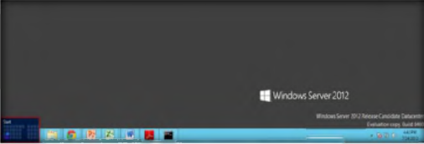

- Click the Workspace Studio app to open the SolarWinds Workspace Studio window.
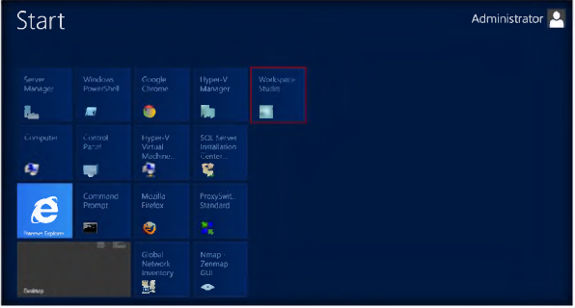

- The main window of SolarWinds Workspace Studio is shown in the following figure.
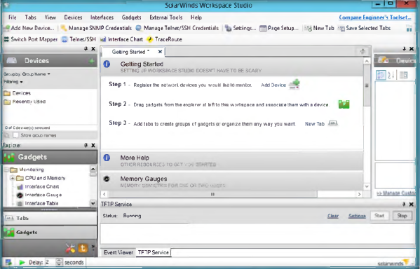

- Click External Tools, and then select Classic tools -> Network Discovery -> IP Network Browser.
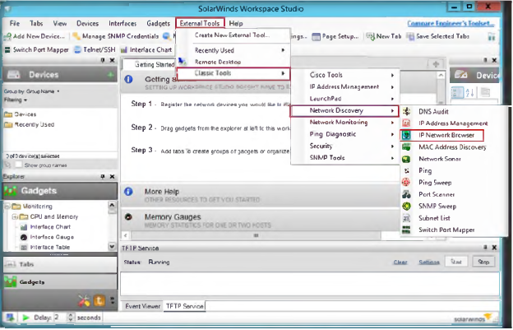

- IP Network Browser will be shown. Enter the Windows Virtual Machine IP address (10.0.0.7) and click Scan Device (the IP address will be different in your network). Or scan your DNS, Gateway or some other server on your network.

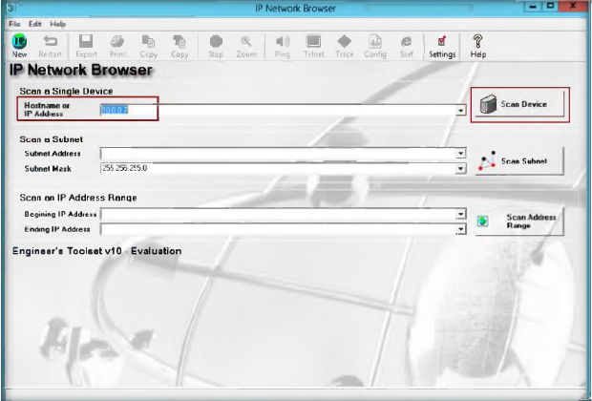

- It will show die result in a line with the IP address and name of thee computer that is being scanned.
- Now click the Plus (+) sign before the IP address

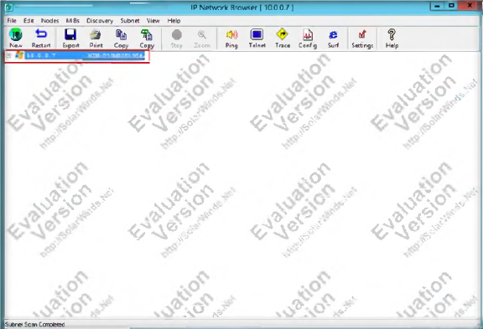

- It will list all the information of the targeted IP address.

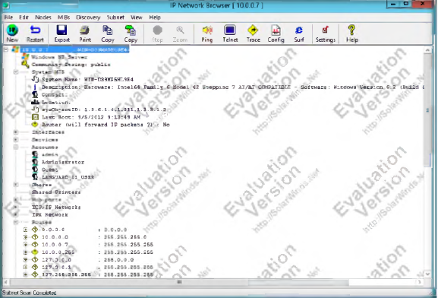

Lab Analysis

Analyze and document the results related to the lab exercise.

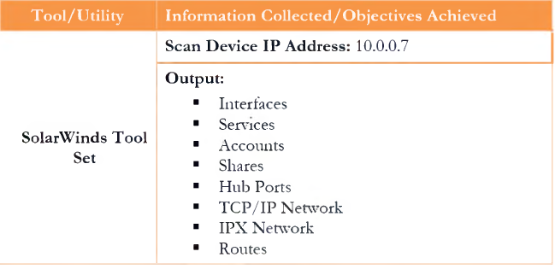

Questions:

- Analyze the details of die system such as user accounts, system MSI, hub ports, etc.
- Find the IP address and Mac address of the system.

Task 2
Enumerating the System Using Hyena

Hyena uses an Explorer-style interface for all operations, including right mouse click pop-up context menus for all objects. Management of users, groups (both local and global), shares, domains, computers, services, devices, events, files, printers and print jobs, sessions, open files, disk space, user rights, messaging, exporting job scheduling, processes, and printing are all supported.

Lab Scenario

The hacker enumerates applications and banners m addition to identifying user accounts and shared resources. In this lab. Hyena uses an Explorer-style interface for all operations, management of users, groups (both local and global), shares, domains, computers, services, devices, events, tiles, printers and print jobs, sessions, open tiles, disk space, user rights, messaging, exporting, job scheduling, processes, and printing are all supported. To be an expert ethical hacker and penetration tester, you must have sound knowledge of enumeration, which requires an active connection to the machine being attacked.

Lab Objectives

The objective of this lab is to help students learn and perform network enumeration:
- Users information in the system
- Services running in the system

Getting started, you need:
- Systemtools/Hyena located in the shared one drive
- You can also download the latest version of this tool from the link http://www.systemtools.com/hyena/download.litm
- If you decide to download the latest version, then screenshots shown in the lab might differ
- Follow the Wizard driven installation process
- To run this tool Administrative privileges are required

Enumeration is the process of extracting user names, machine names, network resources, shares, and services from a system. Enumeration techniques are conducted in an intranet environment

Lab Tasks
- After installation, Launch the Start menu by hovering the mouse cursor on the lower-left corner of the desktop.
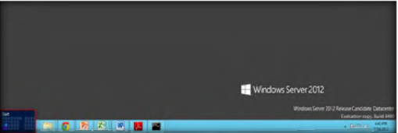

- Click the Hyena app to open 10. the Hyena window.
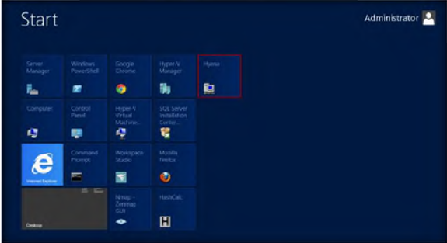

- The Registration window will appear. Click OK to continue.
- The main window of Hyena is shown in the following figure.
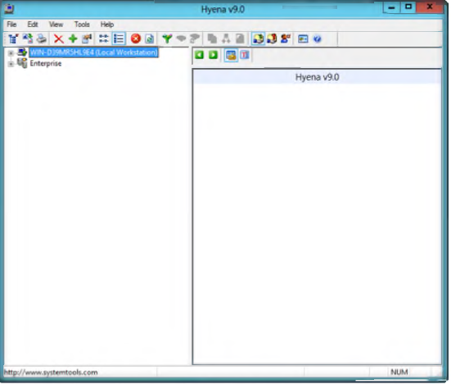

- Click + to expand Local workstation, and then click Users.
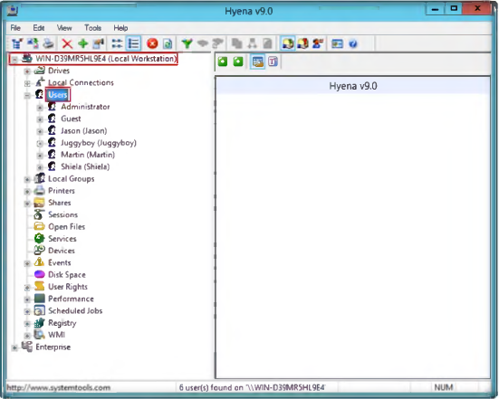

- To check the services running on the system, double-click Services

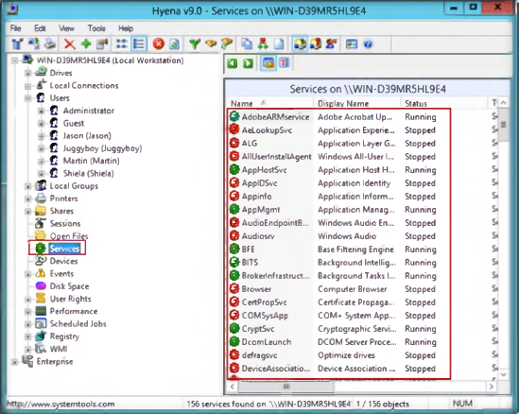

- To check the User Rights, click + to expand it.
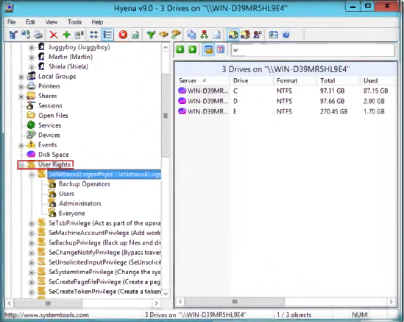

- To check the Scheduled jobs, click + to expand it.
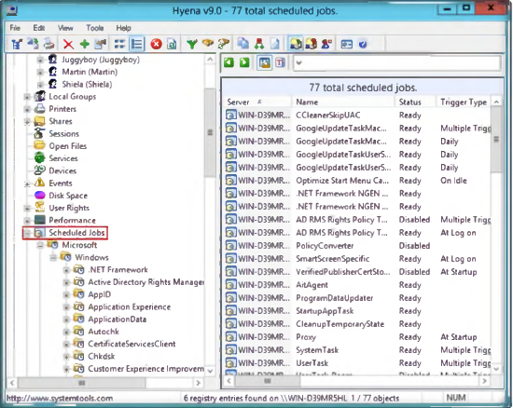

Lab Analysis

Analyse and document the results related to the lab exercise. Give your opinion on your target’s security ״ posture and exposure.



