Student Name: Gergana Nikolova Koeva
Student Number:1906187
Lecture Name: Dr. Gulnar Ali
Module Name: Psychology for Health and Social Care
Module Code: BMHP4003
Assignment Title: Applying Psychological perspectives in Health and Social Care

Page content
Introduction……………………………………………………………………………….3
What is life stage………………………………………………………………………...3
Old age …………………………………………………………………………………..3
Lifespan psychological theories ………………………………………………………4
Freud is recognising five life stages…………………………………………………..4
Erik Erikson’s theory……………………………………………………………………4
Theorise of successful aging………………………………………………………….5

Memory changes……………………………………………………………………….7
Widowhood……………………………………………………………………………..8
References……………………………………………………………………………..9

Introduction

The following ese is about the theatrical perspective regarding developmental psychology. I have chosen to talk about the old-age stage or late adulthood. I will discuss the human cognition, emotions and behaviour which identifying life stage above. I will relate a lifespan theory of Eric Erickson Psychosocial Theory and Sigmund Freud’s life stage’s theories to the old age or adult hood stage. I will talk about human cognition, emotions and behaviour during the old age stage and introduce a resent research as a supporting evidence.

What is life stage

A different phase of the life that all individual pass thought in a normal lifetime is called life stage. Each stage has a similar interest, action, and behaviour. The life stages are identified as an infancy, childhood, adolescence, young adulthood, mid-life, and old age (Lumen learning, 2012).

Old age

The final stage of the normal life span in the human beings is called old age or senescence. As an old age is frequently defined as 60years - 65years or older. The definition of the old age is not identified with the standard’s biological standpoints. The old age had two definitions, one it is the last stage of the process as and it is also an age group as a part of the oldest member of the generation. The old age is the time when the human beings are eligible of retirement or social programs of support. Old age it is the stage where is a lot of changes in the physical and mental condition (Cliffs notes, 2015).
Lifespan psychological theories
Sigmund Freud’s life stage theory
Sigmund Freud it is a creator of the psychosexual model of human development based on the body’s erogenous zones. According to Freud the neurologically matured zones activated the emotional world of the children and created the base of the later emotional health or mental disorientation in the adulthood.
Freud is recognising five life stages
- Oral Stage of Psychosexual Development (ages 0-18 months)
- Anal Stage of Psychosexual Development (18 months – 3 1/2 years)
- Phallic Stage of Psychosexual Development (3 1/2 years – 6 years)
- Latency Stage of Psychosexual Development (6 years – puberty)
- Genital Stage of Psychosexual Development (puberty – adulthood)
At some point the adulthood it reflects the childhood (APA Psycnet, 2020).
Erik Erikson’s theory
Erik Erikson is a stage theorist who converted Freud’s controversial theory of psychosexual development to psychological theory. According to Erikson the ego it is a positive contribution by balancing the attitudes at each stage. This process helps the children to develop into successful adults. Erik Erikson recognising eight life stages.
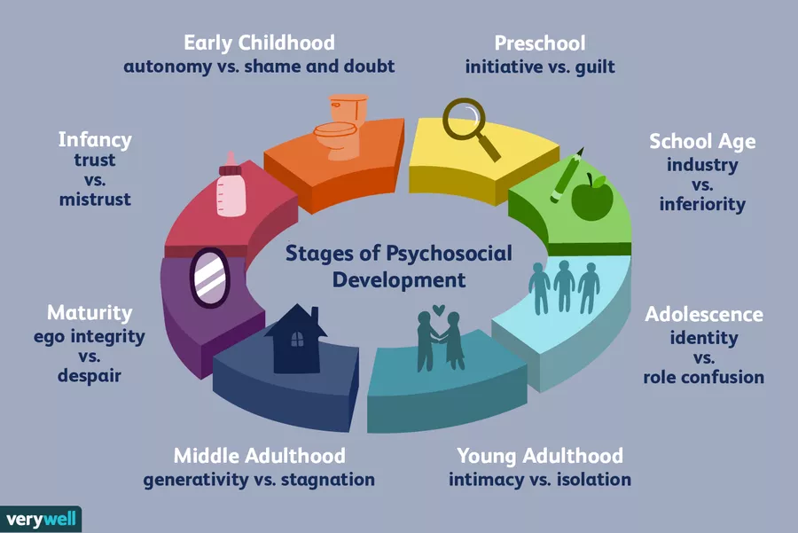
(Cherry, K., 2005)

According to Erik Erikson the age of 65 is the begin of late adulthood stage. He suggests that the conflict of integrity vs despair could be resolved by founding the meaning of the life satisfaction and will be better than to become disillusioned. Despite of that people are aging is not necessarily to mentally and physically deteriorated, some elderly people are very energized and engaged on activities which keeps them in a good condition.

Theorise of successful aging:

- Disengagement theories – Normal relieve from responsibility, allowing the young generation to take over. This is also a possess of opening an opportunity. Once they are relieved of responsibilities, they are content and happy, they received well-deserved rest and enjoying their retirement. They are satisfied whit they have achieved during their they previous life stages.
- The activity theory – The activities of the earlier years are investments in the late adulthood. Physical activities supporting physically, mentally, and social. Keep themselves in a good physical state make them to look and feel well and is slowing down the biological age.

Late adulthood is the last stage of the lifespan of physical and psychological changes. This stage is characterised with reduced mobility and ability to fight against illness and increasing the health problems. The aging process starting during the early adulthood with decreasing the reaction time, lack of sensory abilities, and cardiac functioning. Mussel stretching and changes on the skin is the most visible symptoms of the aging and more likely to bring the loss of confidence and depression There is also expected indicators of mental health issues, anxiety, loneliness etc. (The Editors of Encyclopedia Britannica, 2018).

Moving forward during this life stage of the lifespan human beings preparing them self for end of life. This stage is also related to many negative emotions which can affect their emotional stability. Loneliness is one of the biggest issues in terms of people of this stage living on they own. This is the one of the biggest problems in the modern society which is developing with different speed at the different geographic location and different culture environment. Some of the people of the late adulthood which live in the big cities alone in the flats, are unable to access outside due to lack of mobility or using walking aids unsuitable for lifts and stairs. Their relatives are living far away and not always have the possibility to visit them due to their busy life. Sometime this adult was seen only by them carers and social workers. The loneliest can provoke or unlock many secondary issues as a lack of motivation, depression, stress etc…
The adults which are part of social programs or live in nursing or care homes are involved in a social inclusion activity. Even that they do not seen their families often, them mind is occupied as they are surrounded of people at all the time. This can increase the chances of felling mentally better.

The adults who live in the small settlements with their families are less likely to develop such a problem as thy are mind occupied by seen the members of their families often and feel way better and needed. They are part of family process, they are including in taking family decisions and been asked for advises.

Memory changes
With the age memory also degenerates, the people from the old age stage tent to have a very hard time to remembered information. During this life stage the procedural memory its stays the same, the changes or declines are in the working memory. Procedural memory is responsible about particulars type of actions The working memory holds pieces of information which could be manipulated. Semantic memory helps to understand the things of meaning and based knowledge. This memory reminds stable during all life.
During the late adulthood stage of the lifespan is highly likely the human beings to perform decrease of cognitive abilities, such as memory, spatial abilities, abstract reasoning etc... One of the cognition problems is recognised as Alzheimer’s disease or Dementia

Cognitive effect seen in the people from the stage of the late adulthood are usually recognised as a Dementias. About 15%of the population over 65 occurs these disorders. Most of the cause of dementia is Alzheimer’s disease, a fatal disease-causing confusion, memory lapses and ends of lack of ability to do anything with science.

Retirement it is the life stage which it is around age of 65. People are happy when they are retired if they are not being forced to retire before they are ready ad have enough income to keep the similar living standard as before their retirement. The retirement should be a proses of satisfaction and relieve because of the hard work during the life. The chronic disease, such as rheumatism, arthritis etc. Could decrease the quality of our retirement time

Widowhood
One of the biggest stress in the life is the death of the long-time partner. This situation could bring a big depression and apathy. Losing your partner, you lose your half, you husband, your friend, the parent of your kids. Usually woman marry men old than they are and they live five to seven years longer than the men. The research shows that; there it is ten time as many widows than the widowers. The widowhood it is a very stressful and especially, if is sudden and in the early stage of the lifespan. I this hard time the needs of support are significant. The support of the close friends, family and other close people can be very helpful to manage this hard time in the life.
The late adulthood stage it is followed by death and dying. According to Elizabeth Keebler -Ross there it is a five reaction which characterize the behaviours of end of live person.
- Denial – this is the reaction of denying the reality and isolating from the event, this is usually the first and more often seen reaction.
- Anger – this is the reaction of jealousy and keep asking, why he is the chosen one to die?
- Bargaining – the reactions of seeking God or others for more time.
- Depression – the proses of separating the end of life person of his family and near people causes deep depression to find the
- Acceptance – this reaction is when the death is not sudden, and the person manage to fond the peace
Some of the dying people preferred to be at home with their families in this end of life time, to be in their own houses, room, bed by doing the things they used to during their life span (as much they can), or at least to remembered by seen the pictures, photographs etc.
Some of them preferred to end their life’s in a hospital or hospice for a terminal ill patient this way they can received an appropriate care by health care professionals which can meet their needs. This people (perhaps in pain), do not wish to give a hard time to their families and preferred to be remembered as they used to be before the illness. This decision is very har for the family members and the friends as well. The firs shock they will get when they see the grain, this will be followed by depression, appetites which could continue for a month. There is support groups, counsellors, social organizations which can give a very good support and help successful to manage walking through this process.

The old age stage or late adulthood is very important part of all lifespan. This is the reflection of all life stages and time for prepare for the end of life. This is the times when the changes in our body and mind are invertible and this cannot be changed. The quality of the lifespan will reflect into this last stage and it is all up to us how we can enjoy this last time of our life

References

Lumen learning (2012) Aging: Late Adulthood | Boundless Psychology [Online] Available at: https://courses.lumenlearning.com/boundless-psychology/chapter/aging-late-adulthood/
(Accessed: 20 August 2020).

Cliffs notes (2015) Development in Late Adulthood [Online] Available at: https://www.cliffsnotes.com/study-guides/psychology/psychology/developmental-psychology-age-13-to-65/development-in-late-adulthood/
(Accessed: 20 August 2020).

Cherry, K. (2005) Erik Erikson’s Stages of Psychosocial Development [Online] Verywell Mind Available at: https://www.verywellmind.com/erik-eriksons-stages-of-psychosocial-development-2795740.
(Accessed: 21 August 2020).

APA Psycnet (2020) Freud reappraised: A fresh look at psychoanalytic theory [Online] Available at: https://psycnet.apa.org/record/1989-98164-000.
(Accessed: 21 August 2020).

The Editors of Encyclopedia Britannica (2018) Old age In: Encyclopedia Britannica [Online] Available at: https://www.britannica.com/science/old-age.
(Accessed: 21 August 2020).

