

MODULE CODE: ECPT6006

ASSESSMENT COMPONENT: A Critical Evaluation of the Role of Digital Innovation in Professional Practice

STUDENT NAME: JIBAN BHUSAL

STUDENT NUMBER:2006085

Use of Generative AI in Assessment

(Lecturer to indicate Yes or No against each element)

RESEARCH | For this assessment, you can use Generative AI to support you in research, including searching for bibliography, using tools to summarise, compare and interrogate materials. | Yes ☒  No ☐
STRUCTURE | For this assessment, you can use Generative AI to support you in structuring your submission, including creating a draft argument structure, identifying parts and headings, etc. | Yes ☒  No ☐
PROOFREADING | For this assessment, you can use Generative AI to check your own text/creation for grammatical and syntactical mistakes, including rephrasing of your own work within specific standards. | Yes ☒  No ☐
WRITING | For this assessment, you can use Generative AI to create text for submission. | Yes ☐  No ☒
CREATIVE | For this assessment, you can use Generative AI to create creative materials, such as images. | Yes ☒  No ☐
PROGRAMING | For this assessment, you can use Generative AI to create and check code. | Yes ☐  No ☒
NONE | For this assessment, you are not allowed to use any type of Generative AI support. This includes research support, structure support, writing/proofreading support and creative support. | Yes ☐  No ☒

AI Acknowledgement
I acknowledge the use of Copilot on 29/11/ 2025 to summarise the books Pedagogies of digital learning in higher education and Revolutionize learning & development. On 26/11/2025, AI Copilot was used for researching TPACK model.
I confirm that I have not presented any AI generated text as my own work. I confirm that I have copies of my drafts, notes, and other resources I used before, and after the use of AI tools which I may be asked to provide in evidence.

A critical evaluation of the role of digital innovation in professional practice

Introduction
The role of digital technologies in professional practice has received increased attention in recent years. In the last few decades, there has been a surge of interest in the effects of digital innovation in teaching and learning. Many of us have frequently experienced and witnessed the use of digital technology in teaching and learning activities. The terminologies such as WhatsApp, Instagram, Zoom, Teams, Google Meet, E-portfolio, Distance learning, Online learning, Moodle, AI, ChatGPT have been familiar to us. In the countries where the institutions are able to use digital technologies, many activities have been taking place on a digital from; both teachers and students have access to log into their systems and engage in teaching and learning. In this assignment, I will first discuss the role of digital technologies in post study or further education teaching and learning environment, the ethical considerations when using the digital technologies and their use in the future. I will then talk about the digital technological tools I used in my own practice by looking at the different learning theories and model of technology integration, TPACK. The clear lesson plan included will demonstrate where and how Kahoot would be applied in context and attached pictures of implementation for evidence. The final section will include the critical evaluation and reflection of the digital tools I used in my teaching explaining its impact in my teaching and learning and future use of digital technological tools.

Literature Review
There is a growing body of evidence to suggest that education has been impacted by digital technologies, and particularly the Gen AI and the tool ChatGPT have influenced the society incredibly. Online and distance learning activities as well have been popular and celebrated by many which has been possible due to digital innovation. Various positive features of digital technology use in education have been found such as remote access, collaborative, interactive, adjustable, flexibility, time and energy saving, sustainability, cost effective. On the other hand, the negative attributes such as affordability, inclusiveness, reliability, online abuse, privacy, confidentiality, digital competency, well -being issues have been reported.
Pedagogy is described differently by different people. According to Beetham and Sharpe (2020) learning comes from both; naturally from the environment and the social interactions. Interchange between these two activities teaching and learning is pedagogy. Pedagogy is the way of knowing, thinking and doing. Many writers mention the term ‘transformation’ (Daniela (ed.) 2020; Selwyn, 2017; Betham and Sharpe 2020). Digital innovation has brought transformation to the lives of the learners, educators, educational institutions needing the pedagogy to be rethought and re done, Beetham and Sharpe (2020). There is a need for developing digital competence to utilize the technological advances as the transformation does not have any ending point, Daniela (ed.) (2020). The information is with and around us. According to Selwin (2017) teachers, students, organizations are benefitted from the digital technologies as he mentions that the learners can achieve knowledge or qualifications without the need of formal education, learners are at the centre and the institutions have advantage of modernising their teaching, be part of the wider community and receive wider opportunities. However, as the writer stresses, we should not think technologies as ready resolutions. With the popularity of online and distance learning courses there is a demand of new pedagogy as stated by Beetham and Sharpe (2020). Furthermore, Quinn (2014) stresses that today’s training are not up to the demands of today’s learning and development, and of modern students. The trainers need to act as an enabler and build the culture supporting collaboration and empowerment. Old models of training cannot fit to the current education world transformed by technology and suggestion is to support and share knowledge and use technology for continuous learning. Another benefit in regard to both teachers and students as presented by Race (2007) is that teachers do not have to be present in the class to provide the information, it is on the web, books, texts, resources in the library which can be accessed just through the weblink. Teachers are able to enhance their skill, get access various resources quickly for example, using AI tool like Copilot, ChatGPT, create resources instantly without needing us going back to find out resources, assimilate and synthesize them and make resources for teaching which demands a significant amount of time.
Moreover, as the new digital tools are emerging, the people are overwhelmed with the fast emergence of digital technologies, the organizations are not able to make an appropriate decision on the use of the digital technology tools as stated by Beetham and Sharpe (2020) either they are too quick to adopt the opportunities of digital innovation has brought or too quick to accept them without evaluating their effectiveness. As indicated by Race (2007) the leaners’ expectations have changed, instead of pen and paper they come with mobile, laptops and look for face value, therefore, the teachers not only have pressure to design and plan teaching, learning and assessment to meet the learners’ needs of digital age but also the competitions of the institutions. In the same vein, Kryukov and Gorin (2017) suggests being mindful of external factors such as demography, new technology, new generation students, education reforms that might affect the universities to implement digital technologies. As well as Beetham and Sharpe (2020) note that while the people have freedom from digital connectivity, the demand of the job has increased, the question lies here if the employees are receiving the income as per the demand of the job.
AI has been the latest public interest and ChatGPT the most popular tool which creates many contents in few minutes in different styles, formats allowing access to different individuals according to their needs. The opportunities are vast, the teachers can create customised teaching and learning materials, for example, interactive modules, quizzes or research which greatly helps to save their time (Owoseni, Kolade and Egbetokun, 2024). However, Bhatti et al. (2024) mention that there is an abuse, for example, students asking to write their essays not knowing its implications consequently failing them in their assessments. It is a cost to students, teachers and institutions as all of them require preparing and rearrange the assessments. There is a challenge for the institutions to use AI it is important to monitor the use of AI, the risk factors. Knowing how to use AI and understanding that AI is not the knowledge but a digital tool to generates knowledge by synthesizing, modifying. The teaching and learning process is not only about knowledge, it also is about critical thinking. Moreover, it is not guaranteed that the AI created information will be correct. So, it is also important to check for its reliability and authenticity. Let me mention here the personal experience which happened lately. My son who is in year 11 recently was preparing for his English literature exam, he is fond of using ChatGPT for research-based activities; however, prefers to stay authentic in his writing so never using its words. But for the sake of convenience, he asked ChatGPT to draw and summary and find a few useful quotations. However, it seems to essentially distort the core meaning or derive its own quote entirely. Thereby, this drew suspicion and lead him to question the authenticity of ChatGPT, leading him to find incredulity and its reliability. He knew this disparity only because he had read the book and the quotes previously in the classroom. In addition, the risks using AI could arise such as over reliance to AI questioning the creativity, academic integrity, accuracy, Equability, data security, privacy. Bhatti et al. (2024) suggests considering RRI framework which include preparing for both challenges and opportunities brought by the technology, reaching wider, using it for purpose, setting clear guidelines and policies by the stakeholders and educational institutions. Similar ideas have been discussed in the book of Urmeneta and Romero (eds) (2024). Pedagogical approaches and assessment have been transformed by AI as stated by Francis, Jones and Smith (2025) and advise to be sensible when integrating as AI creates very similar contents and images posing a challenge to academic integrity. AI creates text with the help of tokens, thereby there is no truth in the result/outcomes. Virtual Reality (VR) is another of trends in today’s education. VR is a transformative tool as stated by Ruiz, García and Villaverd (2025) which supports for interactive learning and increases learners’ motivation and participation and digital knowledge in learning. However, the challenges are huge cost to set up, lack of trained teachers. Another education innovation MOOC has drawn public attention, accessible to any learners without needing to register and pay. However, Johnston (2018) highlights that the institutions who are just progressing to the higher education for the first time have not been benefitted from this platform. It means MOOC is only the elite universities.
Despite having many benefits of digital technologies in teaching and learning and they can be very helpful as we might encounter the unforeseen circumstances like Covid- 19. However, as mentioned by (Keengwe,2023) the teachers and educators need to be skilled in digital technology to ensure meaningful learning and providing support to the learners’ need, they should feel comfortable to use the technology; otherwise, be the risk of them dropping the course. Affordability is another major concern to take advantages of these fast-growing digital technologies creating the boundary for inclusive learning as (Fry, Ketteridge and Marshall, 2003) notes the problem is not with the technologies that have emerged, but the issue is with the capability of the universities to adopt and to invest. Digital technologies as stated by Selwin (2017) are interactive and social in nature, they help us to connect and collaborate and have the capacity to store and process a large data. As claimed by Daniela (ed.) (2020) universities have been reshaped by globalization and digital technologies, the pedagogy needs to be aware of the cultures. The teachers need to prepare well as collaborative learning and interactive platforms are good for engagement and recommendation is to use digital technologies. Technology should not be considered just as a tool instead provides new opportunities/learning environment with its feature of supporting flexible learning, accessibility, and innovative. Connecting globally means offering and receiving opportunities as well facing issues like equity, access and cultural differences.
Ethical considerations are core aspects to be aware of when using these digital technological tools into our practice. The mains issues discussed by many are the accessibility, affordability, confidentiality, inclusiveness. One of the issues as termed by Spector (2016) is the division of the digital technology. Not all the learners have been benefitted from these innovations. Privacy and data protection of the users of digital technology is another area of concern. As suggested by Capurro (2009) and Hakimi, Eynon and Murphy (2021) there is a need to address these issues. How the institutions have addressed these issues and safeguard themselves and the learners play a significant role. For example, the learners use the public Wi-Fi to apply for their course, email to their teachers, communicate with other administrative staff, classmates log in to their accounts and access resources, their assessments and feedback. As suggested by O’Brien (2020) the educational institutions can put some measures in place to ensure the data of the learners and staff are handled as safely as possible which may include policies and procedures in handling of data, training, a designated person to work on this area for review. Affordability is another area of concern. Only the individuals, institutions who can afford are benefitted from the digital innovation, for example, most of the software platforms or tolls need expensive subscription to access their full features which can contribute effectively to the teachers planning, assessment and students learning. The ethical issues around education and digital technology need explored and researched.
Taken together, Alenezi, Wardat and Akour (2023) view the digital technology as a modern innovation and many institutions have invested huge amount to provide education with the demand of digital technologies by stablishing the ICT tools in the classroom, however, not everyone is equipped with the skills to use these new technologies into their practice. Also, the benefits of face-to-face teaching and learning activity cannot be denied. So, as the writers suggest there is a need to balance both outside and inside classroom learning. Educational institutions need adjustments as learned from the past, digital technological tools keep on emerging with more advanced features. If the digital technology keeps on advancing in this pace, what could be the learners be like in next ten years’ time, how the educational institutions prepare their staff (administrative and teaching) to meet the demands and changes and the expectations of the students as this problem prevails in current situation as well. Hence, the research is needed to look at the issues like safety, privacy, equity, digital competency in depth and come up with the solutions so that the digital innovation becomes the blessing not the burden.

Selection and Justification of appropriate teaching tool(s)
After researching various digital technological tools, I decided to use word wall in my practice as it was easier to set up and first step to build my confidence. At my next lesson I used Padlet for brainstorming and in the third session I used Kahoot for the quiz which is discussed in this assignment in more detail. The topic of the lesson where I used digital tool was personal care and continence management. This was the last session of the module, ‘Personal Care and Continence Management.’ I heard about Kahoot quiz at different occasions and decided to use Kahoot quiz as a formative assessment to check students’ understanding in an interactive and fun way. I prepared twenty quiz questions and used in the classroom. I ensured all the students were able to access the QR code from their mobile phone, general well-being check before planning this activity.
Digital technologies have been used to support learning. There is a link between digital technology and learning. To examine this association between technology and learning, we need to view the learning theories. Behaviourist theory applies when it comes to design and development. Instant feedback, step by step instruction are some of the features of behaviourist theorists. For example, to use the digital tool Kahoot I followed the stages to set up the account. Unlike behaviourist and cognitivist theories learning is an active process and activity based according to constructivist theories where assimilation, accommodation and adaptation of learning take place. Technology facilitates the learners to discover and build knowledge, also problem solving. The teacher’s role is to support learners to explore as the learners learn through both positive and negative experiences. According to socio-cultural theorists, learning is a social activity, interaction with other people supports for cognitive activity and learning. Support by others helps learners to make progress from one stage of their learning to the other. The less able can learn and progress by being in the social group of more abled. Vygotsky’s concept of the ‘Zone of Proximal development’ makes it clear that tasks can be too difficult to the individual, however, with the guidance and support from more knowledgeable the individual can learn and gradually becomes an independent learner which Jerome Burner refers this process as scaffolding. Collaborative, interactive learning are the main traits of education in digital age which ideas are extracted from socio- cultural theorists. So, these different theories as mentioned above by Selwin (2017) have influence to education and technology. The learning in the digital age is placed emphasis on connectivism. Kop and Hill (2008) states connectivism, a learning theory framework, continues to play an important role as the students become active participants and the students become independent learners from dependent learners. As mentioned above collaboration is one of the main features of digital technology in education which is related to constructive learning theory. Despite the fact that it has been claimed by many that education has been transformed by digital innovations, Selwyn (2017) argues that technology and learning theories are personal beliefs. So, it is important to be aware of these values and assumptions. Siemens (2004) mentions the similar view on these theories. Even though these theories have been considered the main theories, as these theories were developed before the time when learning was not influenced by digital technology unlike today’s education.
In this digital age where the teaching and learning is hugely influenced by digital technology, we, as teachers, need some guidance. TPACK, a digital integration framework, which means Technological Pedagogical Content Knowledge, developed by Mishra and Kaholer (2006) was applied in this context and the digital tool I used in my teaching practice. The main emphasis of this framework is that for a successful teaching and learning where technology included, we not only need to know how to use the tools but also how they fit into the pedagogy and the content of the subject. As described above by Selwin (2017, P.104), according to this model, the teacher integrates the technology into their teaching in terms of different types of knowledge that are involved’’ and technology becomes successful when the teacher uses three forms of knowledge content knowledge, pedagogical knowledge, technical knowledge which are termed as CK, PK and TK. The main focus of the model is the teacher’s awareness, forethought and planning of the technology.
To apply the model into my practice, CK is about having profound comprehension of the subject. Having been worked in health and social care, I have had a good content knowledge in personal care and continence management which further helped me to plan well how I was going to teach and how to integrate technology. PK stands for pedagogical knowledge where I required to demonstrate how to teach as I used teaching strategies like group work, pair work, discussion, feedback, demonstration, question-answer. Many digital software tools, platforms have been used in the education. How to use digital software tools and platforms effectively and purposefully comes under TK. Students had the access of mobile phones and were able to scan the QR code, I used the whiteboard and Kahoot to play the quiz and the students and I were comfortable to use the digital technological tool. The context was a college classroom where level two health and social care students were present. Applying this model into our practice we can check the gap in our knowledge and understanding and plan for progress and improvement. The purpose to use Kahoot was to reinforce learning by integrating technology into teaching and learning. Hence, TPACK incorporates our content knowledge in the subject area we teach, pedagogical knowledge how we teach the content of the subject and digital tools and technological knowledge how the tools are fit into our practice by which we expect the learning, which is creative, effective and inclusive. To draw the evaluation from my own experience from my current teaching at my placement I can make sense of TPACK model how important it is to have content knowledge, pedagogical knowledge and technological knowledge for a successful teaching. For one group of learners I have been finding balance in my teaching; however, for another group I feel I do not have much content knowledge as it is totally different module, it takes a significant amount of time for me to prepare for the session further impacting my pedagogical knowledge and integrating technology into teaching. Applying TPACK framework has helped me to plan and improve at my professional practice.

Application of the chosen learning tool: Kahoot
Learners can use different digital devices including their mobile phones to access this free game-based learning platform Kahoot which makes the learning fun and is suitable to all learners (Lin, Ganapathy and Kaur, 2018). Basuki and Hidayati (2019) describe Kahoot as collaborative, competitive and energetic. The lesson plan below shows where the digital tool was used and the context how it was used. The attached pictures demonstrate the implementation of the tool to provide the evidence.



Lesson Plan

Topic: Support Individuals with Personal Care and Continence Management |  | Class: Health and Social Care Level 2 Group B
Date: 20.11.2025 | Length of lesson: 1 hour 30mins |  | Number of students: 15
Resources required: PPT, whiteboard, mobile phones to access Kahoot Quiz, continence management items (Simulation Room)

Aim of Lesson: To develop an understanding of continence management by looking at person’s values, sexuality, and beliefs, the aids and equipment that can support the management of continence.

Learning Outcomes – The Learners Should Be Able To:

Explain how an individual’s beliefs, sexual preferences and values may affect the management of their continence.
Identify the aids and equipment that can support the management of continence

Previous student knowledge required for the session:
Some knowledge and understanding in personal care and continence management as the learners already had two lessons on this topic.

Anticipated difficulties (if applicable):
Internet issues, technical issues - I will seek help from my mentor and IT staff if needed. I will carry out a quick check before the lesson.

Kahoot Quiz – I will prepare the paper version of quiz just in case the Kahoot quiz doesn’t work. If ALN learners do not like Kahoot quiz, they will be supported with other activities.

Professional Standards (where are these being met within the session)

Plan and deliver the session effectively by devising a lesson plan with details and resources, for example, where the Kahoot quiz will be applied (prior to teaching and during teaching)
Apply inclusive teaching practice to ensure each learner’s learning needs are supported and responded to by checking if they have the devices to access the Kahoot Quiz. (Prior to teaching and during teaching
Use teaching strategies in varieties to engage learners and achieve the learning outcomes, Kahoot quiz to be used for formal assessment in this session.
Promote Welsh languages using Welsh language words, phrases, Bore da, Dawn, Diolch
Monitor learners during the use of digital tool for their well-being and safety.
Check the environment before or during the session to facilitate comfortable learning.
Demonstrate respect and dignity towards learners by listening to them, responding to them on a timely manner.

Lesson Detail:

Stage | Focus | Strategy | Time
Introduction  Development  Plenary/conclusion | Well Come  Ice breaker  Recap- what is continence?  Group Work:  Why is it important to consider a person’s values, sexuality, and beliefs when planning their continence support?  Pair Work:  Aids and Equipment that can support the management of continence  Simulation Room- Demonstration  Kahoot Quiz  Feedback on Kahoot Quiz  Any Questions  Thank you  Workbook – Question- answer | Discussion, feedback  Discussion, Lecturer, Feedback  Discussion, Lecture, Feedback  Demonstration  Question - Answer | 5 mins  10mins  10 mins  30 mins  15 mins  20 mins

Assessment Strategies: when and how are they included within the lesson?

Firstly, learners’ previous knowledge on continence management will be included through question answers at the introduction stage of the lesson – Recap from the previous lesson.

Secondly, other assessment methods like discussions, feedback, group work, and pair work will be included within the lesson at the development stage.

Finally, Kahoot quiz, Question – answer, feedback will be used in the plenary/conclusion using digital technological artifacts.

Informal reflection (to be completed after the session)

The students did not engage well in the group work, however, they participated and engaged very well in Kahoot quiz at the plenary stage. There were twenty quiz questions prepared. Even though students were interested in the quiz, they lost their patience towards the end of the quiz. As students felt pressure and competition, 10-15 questions could be the right balance when I plan in my next lessons for this group.
I could not manage to take students to the simulation room as they were busy answering the questions in their workbook. However, as a contingency plan, I took some of the continence items (commode, urine bottle) from Simulation room to demonstrate to the students.

Pictures - Evidence of implementation of Kahoot:
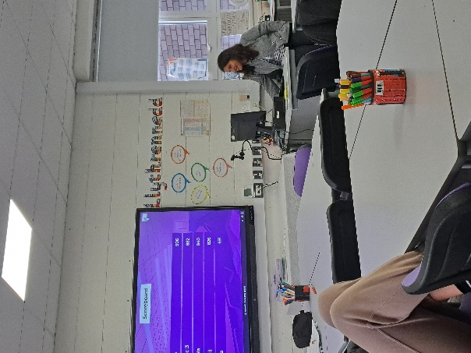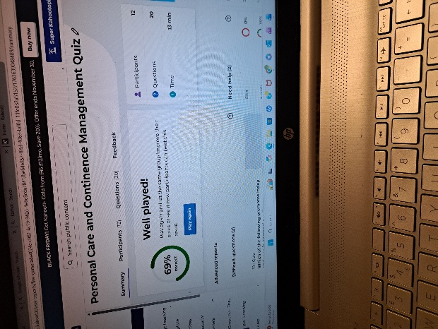
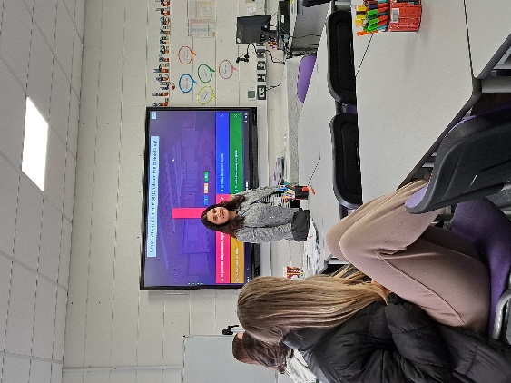
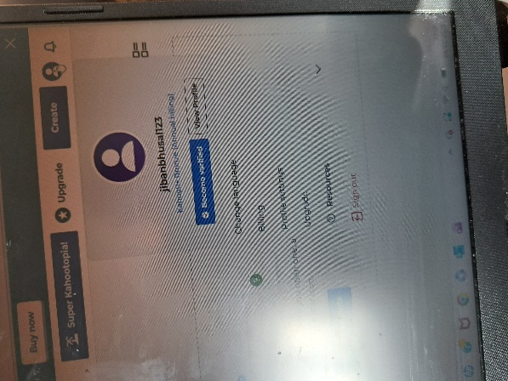

Evaluation and Reflection
Selwyn (2021, p 103) presents the term ‘’technology adoption’’ which means teachers build confidence and are willing to use technologies through experience, practice and awareness. Keengwe (2023, p.49) states, ‘’ Digital tool proficiency is a requirement for teacher educators who want to use technology to teach for meaningful learning.’’ To integrate digital technological tools in my professional practice I used word wall for my first lesson as a matching activity. In my second lesson I decided to use it differently as a flash card, where students had opportunity to see the image on the white board and guess the correct term, then flip over to check if their answers were correct. This activity engaged students well compared to the first matching one. I was able to move from what question to more open-ended questions why, where which led to more interaction and discussion in the class. I have started to use different tools on a regular basis in my teaching session as I have been developing confidence with practice at my lecture classes and in my placement, I found it effective to engage very enthusiastic and non-enthusiastic group of students. I have taken advantages of free versions of different tools which allows me to create two or three activities using my all-different emails. As Kahoot digital tool was more effective and I intend to use in my practice in the future, I have taken advantages of black Friday discount and have subscribed to this software tool where my all learners will be able to participate in the activity which was not the case with free versions. Kahoot is a digital platform or a software digital tool to use in teaching and learning and assessment which has collaborative, interactive, and engaging features. It is important to be clear that we need to use the digital technologies if it has purpose, not just for the sake of using it as suggested by Gravels (2021). The teacher needs to be comfortable, and the learners need to have access of the tool. Teacher’s knowledge and learner’s knowledge how to use the tool is also important. All the learners had mobile phones and features that they were able to engage use the QR code to participate in the quiz and they were comfortable to use the digital tool. To make the right decision which digital tool to use into our teaching learning we need to play with these tools as Siemens (2004) mentions that the learning is reshaped or redefined when we use the new tools. Until I used and played with these tools, they became like a big wall to fathom. Even though most students stated similar comments that they felt competitive and pressure, they would like Kahoot quiz in other classes in the future lessons. What I noticed as well was that one of the students who was quiet in most classes got really engaged and appeared highest on the scoreboard. Another interesting finding from using Kahoot was that learners lost their patience when they went over 12 quiz questions from group A. As they felt pressure and competitive during the quiz, designing reasonable amount of quiz questions is crucial which I will plan in my future lessons. However, I used the same quiz into another group of the same level and course, students continued to be engaged. There was another interesting finding at this time; two students expressed they will withdraw from playing the quiz if their answers continue to be incorrect.
Even though we might feel daunting to set up, create activities and applying it in the classroom at our early-stage practice, once we are comfortable and confident with the tool, they can be effective. We are able to edit the content and use the same activity at another time which hugely saves our time and energy. I was able to duplicate the quiz and use it for another group which took only few seconds. Furthermore, unless we use these tools practically, we will not be able to evaluate which tool is suitable for which group, learner or the context. Kahoot worked better to my group of learners than Padlet and the Word wall.
The Welsh Government has come up with the plan Digital 2030 to support PCET area where it outlines the aims such as building confidence on both teachers and students, enhanced learning through technology, if possible, design of appropriate curriculum, providing safe learning environment; both physical and virtual, monitoring any barriers and provision of continuous improvement.
There is no doubt that these digital tools will be beneficial and will be used in the future, however, they need to be distributed equally and make cost effective as the cost will be the barrier to access and apply them and see their efficacy in various context which create the digital divide and deprive one group against another.

Reference Lists:
Alenezi, M., Wardat, S. & Akour, M. (2023) ‘The need of integrating digital education in higher education,’ Challenges and Opportunities. Sustainability, 15(6), 4782. Available at: https://doi.org/10.3390/su15064782.
Akour, M. and Alenezi, M. (2022) Higher education future in the era of digital transformation. Education Sciences, 12(11), p.784.
Basuki, Y. and Hidayati, Y. (2019) ‘April. Kahoot! or Quizizz: The students’ perspectives’, In Proceedings of the 3rd English Language and Literature International Conference (ELLiC) (pp. 202-211).
Beetham and Sharpe (2020) Rethinking pedagogy for a digital age: principles and practices of design. 3rd edn. Routledge.
Bhatti, S.H. et al. (2024) ‘The impact of digital platforms on the creativity of remote workers through the mediating role of explicit and tacit knowledge sharing’, Journal of knowledge management, 28(8), pp. 2433–2459. Available at: https://doi.org/10.1108/JKM-08-2023-0682.
Capurro, R. (2009) ‘Digital ethics’, In Global Forum on Civilization and Peace (pp. 207-216).
Daniela, L. (ed.) (2020) Pedagogies of digital learning in higher education. Routledge. Available at: doi:10.4324/9781003019466.
Gravells, A. (2011) Principles and practices of assessment: a guide for assessors in the FE and skills sector. 4th edn. Learning Matters.
Francis, N.J., Jones, S. and Smith, D.P. (2025) ‘Generative AI in higher education: balancing innovation and integrity’, British Journal of Biomedical Science, 81, p. 14048. Available at: https://doi.org/10.3389/bjbs.2024.14048.
Fry, H., Ketteridge, S. & Marshall, S. (2003) A handbook for teaching and learning in higher education: enhancing academic practice. 2nd edn. Routledge. Available at: doi:10.4324/9780203416877
Johnston, B. (2018) Conceptualising the digital University: The intersection of policy, pedagogy and practice. Palgrave Macmillan. Available: doi:10.1007/978-3-319-99160-3.
Kaminskienė, L., Järvelä, S. and Lehtinen, E. (2022) ‘How does technology challenge teacher education?’, International Journal of Educational Technology in Higher Education, 19(1), pp. 1–9. Available at: doi:10.1186/s41239-022-00375-1
Keengwe, J. (2023) Innovative digital practices and globalization in higher education. Igi Global.
Kryukov, V. and Gorin, A. (2017) Digital technologies as education innovation at universities. Australian Educational Computing, 32(1), pp.1-16.
Lin, D.T.A., Ganapathy, M. and Kaur, M. (2018) ‘Kahoot! It: Gamification in higher education’, Pertanika Journal of Social Sciences and Humanities, 26(1), pp.565-582
Llanos-Ruiz, D., Abella-García, V. and Ausín-Villaverde, V. (2025) ‘Virtual reality in higher education: A Systematic Review Aligned with the Sustainable Development Goals’, Societies (Basel, Switzerland), 15(9), p. 251. Available at: https://doi.org/10.3390/soc15090251
Owoseni, A., Kolade, O. and Egbetokun, A. (2024) Generative AI in higher education: innovation strategies for teaching and learning. Palgrave Macmillion. Available at: https://doi.org/10.1007/978-3-031-60179-8.
Race, P. (2007) Making teaching work: ‘teaching smarter’ in post-compulsory education. SAGE Publications.
Selwyn, N. (2017) Education and technology: key issues and debates. 2nd edn. Bloomsbury Academic.
Fry, H., Ketteridge, S. & Marshall, S. (2003) A handbook for teaching and learning in higher education: enhancing academic practice. 2nd edn. Routledge. Available at: doi:10.4324/9780203416877.
Siemens, G. (2004) Elearnspace. Connectivism: a learning theory for the digital age. Elearnspace. org, pp.14-16.
Spector, J.M. (2016) Ethics in educational technology: towards a framework for ethical decision making in and for the discipline. Educational Technology Research and Development, 64(5), pp.1003-1011.
O'Brien, J. (2020) Digital ethics in higher education: 2020. EDUCAUSE Review (Online).
Timmis, S. et al. (2016) ‘Rethinking assessment in a digital age: opportunities, challenges and risks’, British Educational Research Journal, 42(3), pp. 454–476. Available at: https://doi.org/10.1002/berj.3215
The University of Manchester (2023) Academic phrase bank. Available at: Academic Phrasebank | The University of Manchester.
Welsh Government (2019) Digital 2030: strategic framework. Available at: Digital 2030: strategic framework | GOV.WALES

