Introduction and History
of Harrods
The history of this luxury department store started in 1834 , when Charles Henry Harrod set up a small grocery and tea store in East End of London , moving to Kenbridge in 1849 whit the intention of emphasising impeccable services of value , the store start to set up and sell from everything from medicine ,parfums ,stationery , fruits and vegetables .

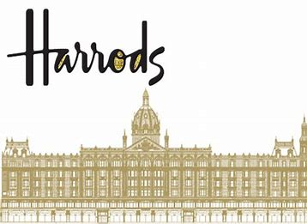
By 1868 the turnover increased to £1,000 weekly from £ 20,00 in 1853 . In 1880 Harrods employed 100 people ,how has working 6 days a week , in the same year the store burns down to the ground catching fire , but this disaster did not keep C. H. Harrod down from rebuilding the store and whit his help the store was reopen . Harrods fascinated many people whit its grate architecture , the store maintained its popularity and become one of the most luxury department store .
Now Harrods is the most biggest department store in London which attract people not only from London but all over the world . The store occupied five acre site and has over one million square feet of selling space in over 330 departments were offers to the customers everything from food to fashion , furniture’s to sport – wear plus 23 in-store restaurants serving every king of cuisine imaginable from pizza to sushi .
Harrods Management
People have various kinds of needs and Harrods tent for more then 100 years to satisfied them .
To understand people’s needs , Harrods its open in all the ways for all the people to express their opinions as web site , email ,post …etc .
Total Quality Management in Harrods (TQM) is build around the idea that individuals can always improve their work by learning new techniques and applying them . In TQM of Harrods , people master techniques ,such how to use the “six management and planning tools” required to resolve issues .This may sound complicated , but using such tools speeds up processes , eliminated task stages and reduces cost quickly .
The objective is to cut out waste and to increase customers satisfaction by performance and value .
Harrods management make responsible for the quality of their own work and it will usually inspire the employers to do excellent their work .
“ The more responsibility you give to the people , the greater their and productivity are likely to be “ ( Robert Heller).

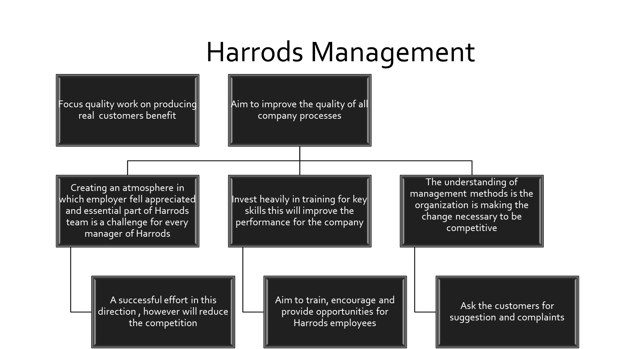
And now we are very pleased to introduce you into the fascinate world of Harrods and present you a few important and rarity products or services that you will found in department’s- store of Harrods .
Welcome to Harrods

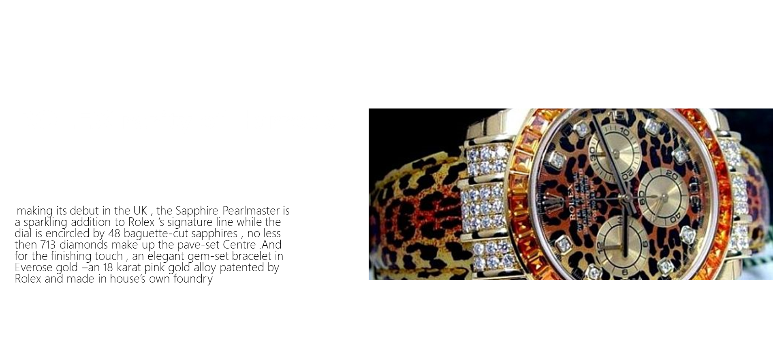

Henry Jacques
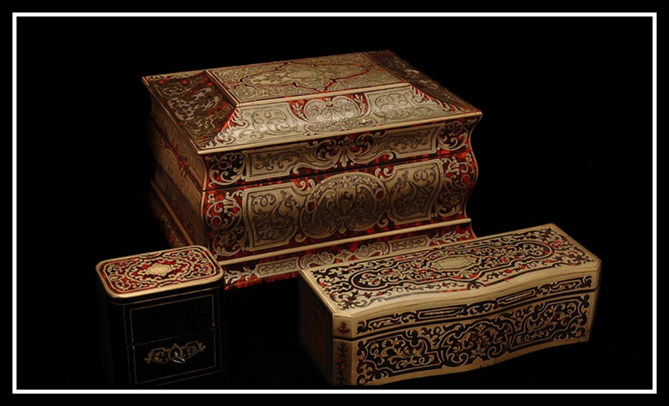
The niche perfumer and Salon Perfumes favourite presents the Gold Collection – a trio of antique chests each one cradling Baccarat crystal bottles ready to be filled whit a scent of your choose be that a signature fragrance or something more bespoke creation . Perfect for parfums that is to be truly treasured .
“The Gold Pagoda, the largest of the three is inlaid whit mother-of-pear, red tortoiseshell and brass .”
Chanel

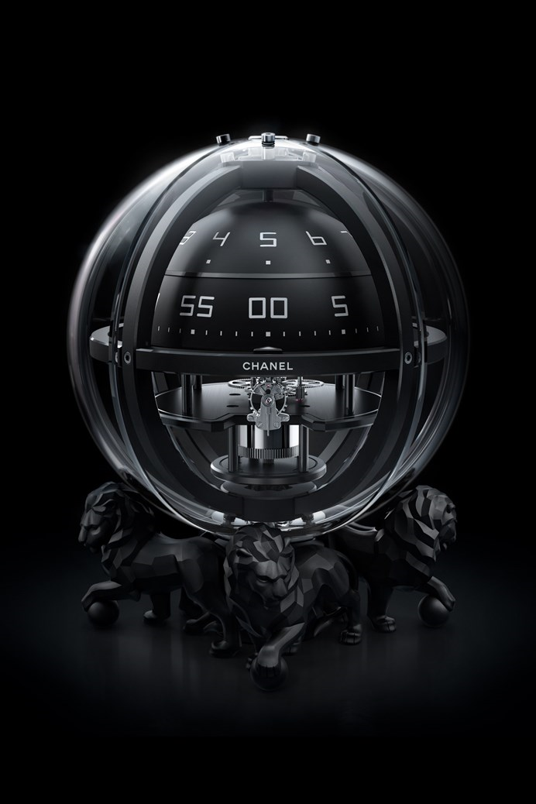
This ornament was Gabrielle Chanel favourite – a gleaming ball of rock whit crystal standing on a base of three lions , she was keeping this ornament in her luxury apartment in Paris and after a wile she decide to reborn a few ornaments for Harrods in limited edition Chromosphere clock , for the new design the lions are giving am all – black makeover into a glass sphere .
The Bulgari Boutique At Harrods
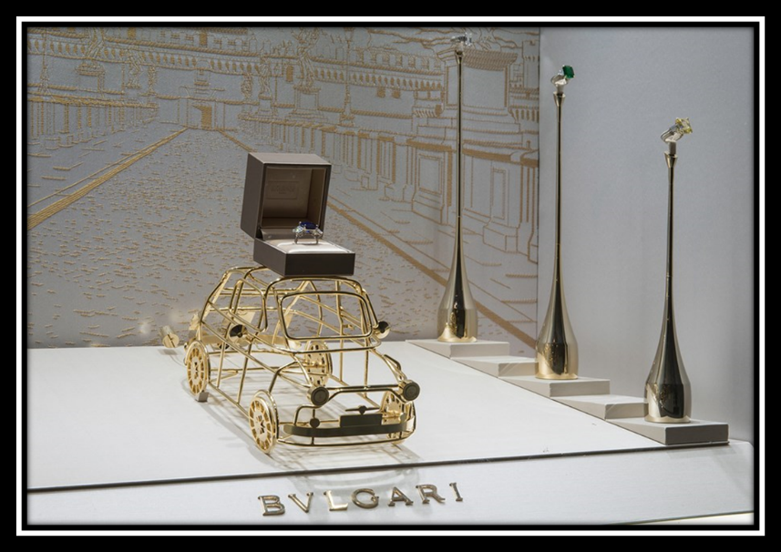
A veritable treasure trove housed in the Fine Jewellery Room on the ground floor of Harrods , whit an modern - luxury design and very friendly atmosphere , the Bulgari Boutique offer for the customers an exclusive look one – of – a – kind high jewellery pieces ,as well as a providing a comprehensive after sales-services .
Here the customers can taste the truly and unique experience to create their own watch and jewellery .

Harrods White pearl almas caviar

Only in Harrods you will find a chilled bowl of caviar , and the delicate ,pearly white eggs of the albino starlet sturgeon are sure to delight .from history almas-caviar meaning diamonds in Russian and was reserved for royalty .

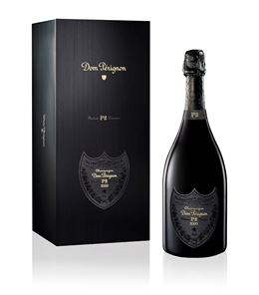

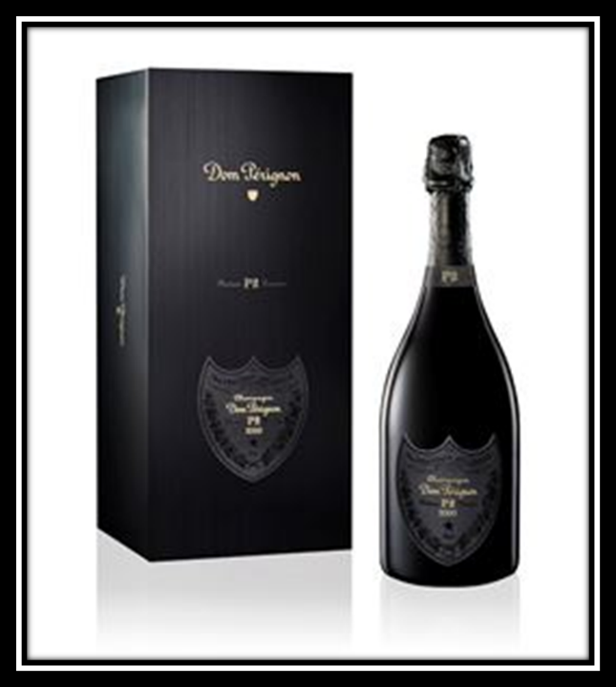Produced by the iconic Champagne house Moët & Chandon, Dom Pérignon is arguably one of the most prestigious brands of fine Champagne in the industry. Created and named after Pierre Pérignon, the 17th century Benedictine monk who worked in the cellars of the Benedictine Abbey of Hautvillers, this luxurious tipple is a culmination of his dedicated work to perfecting a sparkling wine whose reputation knows no equal. To this day Dom Pérignon still enjoys the same respect for its vintage varieties, thanks to its unique experimentation of blending and fine-tuning of both white Chardonnay and red Pinot Noir grapes. Featuring a deluxe collection of labels ranging from three decades, any bottle would make a wonderful addition to a special occasion.
Don Perignon


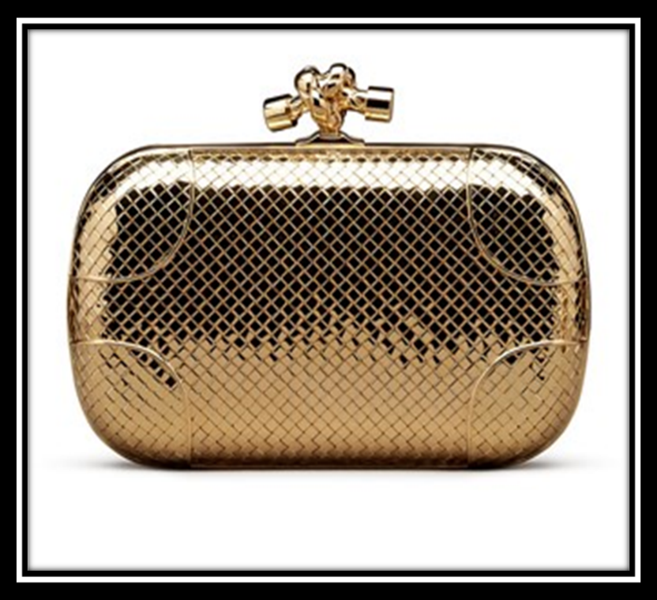
Exclusive only in Harrods BOTTEGA -VENETA is the most lovely style from Midas , is take more then six months to produce is made only from 18 karat yellow gold and diamond set – claps .
Whit Harrods are collaborate all the famous designers from all over the world , producing unique items and personalized for the customers .
Harrods is considerate a glamorous shopping place ,people visiting Harrods may belong to any age group but majority of them belong to the sociality class “A” and they expect the services to be mark up ,they expect that the services and product for Harrods to be very high standards and unique quality .
Harrods is a high end department store which offer a grate range of products and services ,
British
Sensation
Luxury

HARRODS

Services
Innovation

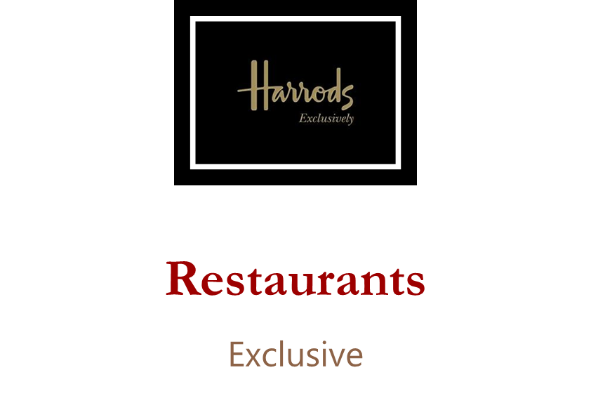
Harrods has an incredible range of hamper and food order services its help bring some of the magic of the Harrods Foods .There you find a coffer bar were is served freshly roast coffee and expertly baked goods by day and expresso Martinis by the night .As well Harrod has an incredible Caviar House Oyster Bar were is served fresh oysters , caviar , crustaceans , smoked salmon ,champagne and the most grate wines .To relax your self after a walk in Harrods you can joint the Room Tea knows as a Georgian Restaurant , offer you all the day a sophisticate menu signed by the expert team of in-house chefs .in the Chuck Restaurants you will find speciality from Italy cuisine whit specific from Mediterranean Sea .Harrods aims to meet all the customers needs , that why all the time they have everything fresh and for all the testes .

Location

Reputation
extravagantly
HARRODS
Power of buyers

Loyalty of the department-store
High quality of Services

Harrods dependent store is one of London attraction for the tourists , when you look to the size of this wonderful decorate building inside and outside .And about all the lights bulbs that light up Harrods in the dark are not less then 12,000 bulbs .
Harrods value is British , luxury ,sensation and innovation . Harrods aim is to attracting customers from all over the world , Harrods believes that expelling expectation , achieving, excellent in everything what they do in their store .
As I mentioned before Harrods as leading luxury retail business , GREEN and GOLD programs stand four elements :work place , marketplace , community , environment.
For Harrods all the organizations are designed to enable human and their objective to reach goals and targets .
CONCLUSION AND UNDERSTANDING OF THE STUDY CASE
Each organization can be understood in different ways , Harrods is different by using emotions to figure out the paradoxical character of organisational life and work for the employers.
Harrods organisation are following those elements :
- Harrods has purpose and goals
- Harrods has value of structure
- Harrods follow the update of the technology
- Harrods improve their own structure , value and cultures
Harrods it is and will be a British value , providing development and opportunity is the key factor in how Harrods maintains its high level , the business look after their employers and help them along their career .As a result employers are loyalty to the company and continues to offer exceptionally levels of commitment and services .
Harrods stand out from his competitors by providing very high quality of services , high standards for customers , unique items , and developments and opportunities for employers .
Harrods is probably the most well know and respected rail store for all over the world and has build a unique reputation supported by the key brand – value .
References :
www.marketing91.com
welford,R2016. Corporate environment management 3: towards substitute development Routledge
www.harrods.com
Lasserre,P, 2017 global strategic management . Macmillan International High Education

