REPORT TITLE:

Marketing Essentials

Giulia Giuseppina Villa
Student ID: 1815169
M.Code: M4X01916
Lecturer: Dale Clark
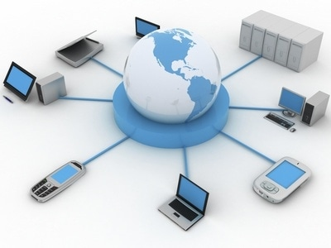
Written Assignment part 2

Marketing Information System

CONTENT:

INTRODUCTION.................................................................................................................pg 2
MIS..........................................................................................................................................pg2
TYPES...................................................................................................................................pg 3
ADVANTAGES AND DISADVANTAGES..............................................................................................................pg 4
STRATEGIES........................................................................................................................pg 5
CONCLUSION......................................................................................................................pg 5
REFERENCES.......................................................................................................................pg 6

Introduction:

For my assignment, on the analytical approach it will be made to explore the marketing information system and how the hotel industry uses this for communicating information gathering and marketing.
I'm going to make a detailed analysis of Marketing essentials, Marketing Information System. I will start my assignment with a definition of what means this system, and how it works, and which are the components and main elements.

Marketing Information System:

A marketing information system, well known with the acronym MIS, is a tool designed to support managing decision making.
It is a set of people techniques and technologies who cooperate for purpose of developing a business strategy using a wide range of data both internally and externally to the company itself, which are subsequently analyzed and distributed.
This system could be a valuable and useful tool in the hospitality industry in order to develop a social media strategy and making a new brand, and attract new guests.
To understand the importance of this system in the Hotels and Hospitality industry can help to standing out in the competitive job market.
Developing a MIS is becoming extremely important as the strength of companies to better understand the specific needs of customers and to define and differentiate the value proposition.
It consist to gathering, analysing, reporting and distribution of the information, from internal and external sources to the marker: The market information system(MIS) gives the Data to the marketeting managers who can easly take decisions related to the marketing operations, such us: media, pricing, promotion, distribution, etc.
Marketing operations usually works with the conditions delivered from both inside and outside the organization, and also considering several sources like Marketing Intelligence and Marketing Resources, through which the relevant factor about the Market can be obtained.
The MIS is a very important tool for Market professionals Researcher because it provide a huge range of functions. An MIS can be utilyzed to analyse the kind of data that marketing and advertising decisions maker required, which is a very excellent system. Morever, The more common useful function of an MIS is the ability to collect informations and then sort it for future accesses.
Finally, this tool can be used to distribute informations to managers who can utilyze it for services or promotions and however, since the use of this system is under the organization of a market researcher, the informations will be distributed to the clients just one time.

This diagram shows the following steps for setting up an MIS:
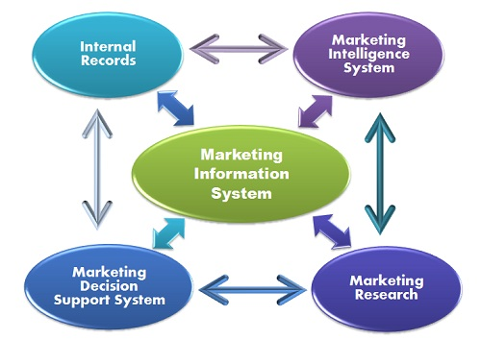

Types:

The main components for MIS are:

- Internal records
The companies can collect informations through costumers database, product database, financial data, and operations data.
- Marketing intelligence
The Marketing intelligence system offers the informations about what is happen in the market, such us marketing enviroments. It includes informations about new market trends, competitor’s strategy, changing in the costumers tastes, competitor’s promotion strategy , etc.
- Marketing research
The marketing research concerns the systematic gathering , analysis, and interpretation of the primary or the secondary informations to solve marketing faults. In order to conduct marketing research, the Data is to be divided between primary data ( first-hand data ), which is to be collected by the researcher by certain methods such us questionnaries, personal interviews or seminars etc, and secondary data (second-hand data) which are publicly available in books , magazines, journals, etc.
- Marketing decision support system
The Marketing support system include many software that can be utilized by the marketers to analyze the informations order to take better decisions. Using computers, the managers can storage a range of data in a tabular form, and then can use statical programs to analyze the data.

Advantages and disadvantages.

Advantages
- The biggest advantages of using this system is that all your company informations are analyzed and keep it well organized, for the time you will need it. In this way, you can find easly and quickly your needed specific informations.
- An MIS can help the marketing managers to understand the good or bad performances of the companies, and it is helpful to prevent a crisis. Furthermore, it can be used to check competitor’s scores and ratings.
- Any MIS is different from his competitor’s one, they are always updated and provide the system informations at all the time: 24/24 hours 7 days per week, all over the world.
Disadvantages
• Maintenance work and setting up an MIS its really difficult.
• Sometimes the systems has security issues. A lot of different type of hacker can try to violate the system, because it contain all the company several informations.

Strategies:

Management information system, or MIS, refers to a computer-based system that provides managers with the tools to organize, evaluate, and efficiently manage departments within an organization. In order to provide past, present and prediction information, a management information system can include software that helps in decision making, data resources such as databases, the hardware resources of a system, decision support systems, people management and project management applications, and any computerized processes that enable the department to run efficiently.
For my assignment, I’ve chosen a family business company placed in Sorrento and the hotel is called Hotel Belair.
The marketing department focuses its strategy on the MIS to collect user demographics such as age, gender, and location, length of internet use, the total amount of users and data usage.
This level of analytics helps any company to deploy its marketing messages to the right people, at the right time.
The best way to make strong brand awareness is to create an online presence. It’s about putting the right content in the right place through hotel social media strategies and content marketing.
The idea is to think of Facebook/Instagram as a hub for social profiles and website content – a place on social media where everything comes together. The hotel should try to integrate as many as social profiles with Facebook/Instagram as possible.
Customer reviews are a crucial point for online marketing strategy because the hotel has to be able to manage them. That’s because the presence of bad reviews can also have a positive effect on your conversion rate. A blend of good reviews and bad reviews shows that you aren’t trying to hide anything, and makes the good reviews seem more sincere.
In order to get the most value of its marketing budget, the company has defined a successful hotel email marketing campaign. With this knowledge, you can create email marketing campaigns that deliver the best results for your business.
This campaign included an exciting offer like a large discount or even a free night’s stay. It has been a re-engagement campaign with the aim get unengaged subscribers to re-engage, leading to more opens and ultimately more conversions, or, to drop some contacts from the list and focus on the people that will actually deliver results.
After understanding the subscribers in more detail and segmenting them accordingly the marketing team delivered more relevant branding campaigns for example about local events or points of interest.
The marketing department has used the Wifi connection system to offer promotions and local services and has even invited users to opt-in to marketing lists or connect through Social Media should they wish. This has allowed also to invite customers to 'Like' its Facebook Page or 'Follow' the hotel on Instagram in exchange for free Wi-Fi.
In addition, another strength was to adopt Upselling and Cross-selling strategy to involve the customers and make the offer more attractive and specific for them.
Upselling is the practise to encorauge costumers to purchase a comparable product then the one in question, while Cross-selling is the practise to invite costumers to buy related or complementary items.

Conclusion:

This assignment helped me to understand how Marketing information system works and which are the main components of this system. It was helpful because I learned the functionality of the MIS in hospitality sector.
Since tourism is a fast growing area, the role of hotels take a big place in the market, so using a manual system can lead to errors and it could be time-consuming. Therefore, to use a computerized system can resoult more efficient. An Marketing information system helps companies to track financial and operational informations at one point, allowing to measure the hotel’s efficiency. Finally ,it is a powerful tool with the long term aim of increasing the value and profits of the business.

References:

(Smartsheet, 2019) Smartsheet. (2019). The Definitive Guide to Marketing Information Management & Systems. [online] Available at: https://www.smartsheet.com/marketing-information [Accessed 17 Mar. 2019].
(Crawford, 1997) Crawford, I. (1997). Marketing research and information systems. Rome: Food and Agriculture Organization of the United Nation
Marshall, K. (1996). Marketing information systems: creating competitive advantage in the information age. Danvers: Boyd & Fraser.
Cheverton, P. (2004). Key Marketing Skills 2. London: Kogan Page.
Withers, J. and Vipperman, C. (1998). Marketing your service. Bellimgham, WA ; North Vancouver, BC: Self-Counsel Press.

