Problem Solving and Decision Making for Amazon

Student name: Diana Czanasz

Student number: 1808345

Module code: BMSK 4004

Tutor name: Yajesh Kumar

Date: 01 September 2019
CONTENTS
- Table of figures 9,12,13,19,20,21
- Introduction 3
- Company Description 4
- Problems and Challenges faced by Amazon 5
- Tools and Techniques used for problem solving 9
- Recommendations and Solutions 14
- Implementation of best Solutions 19
- Communicating the plan for stakeholders 21
- Summary 22
- References 23

INTRODUCTION

The aim of this report is to recognise and evaluate the problems and challenges faced by the “Amazon” company. I have chosen to direct my focus on the problems such as high employee turnover, data protection and customer demands. I will apply different set of adequate techniques and tools, such as: SWOT analysis and Ishikawa diagram that can be used in order, to reduce the problems faced by this organisation. Therefore, following topics will be covered in this report: short description of the organisation, analysis of recognised problems and challenges , tools and techniques with can be used in order to solve these issues, recommendations, best possible solutions to the mentioned problems, implementation of solutions and communication of the ideas to stakeholders. Assignment will be finished with summary and at the very end of this report list of references will be provided.

- Company description


Amazon…
The company was created by Jeffrey P. Bezos on the 5th July the year of 1994 in the Bellevue, Washington. The purpose of amazon business was to sell books in its written and electronic form.
The wish of Bezos was to give the access to his online bookstore to the people from all over the world. Due to potential success of the retail, four years later in the 1998, Amazon added to its sales videos and music, at the same year beginning to cooperate with United Kingdom and Germany. By 1999 online retail store expanded adding even more products, such as: electronics, games, houseware, toys, clothes and many others (Hall, 2019).
Due to enormously fast growth of the company, Amazon opened its warehouses in countries like: France, Germany, Italy, Spain, Poland and United Kingdom in order, to store, but also pick and pack the goods which are shipped to millions of customers all over the world (Transporteca, 2019).
According to Sean Farrell (2019), United Kingdom hosts currently seventeen of Amazons fulfilment centres otherwise known as warehouses and over twenty-seven thousand, of people are employed in those work placements.

- Problems and challenges faced by
Amazon.

  - High employee turnover

- Poor contract arrangement
According to Alan Selby (2017), who went to work undercover for one of the amazons fulfilment centres based in Tilbury Essex, one of the main reason of which people are leaving their jobs, is because they being promised permanent positions but in fact after working hard for almost a year they are still on temporary arrangements receiving minimum wages.
Amazon have bad habit of hiring temporary agency staff instead of providing already employed people with stable contracts. But it is not the only reason of why there is such a high turnover in employability.
Amazon has very strict rules for its associates, known as “3 strike” practise, when if person receives the right amount of strikes will be immediately “released” fired. Employee can receive such strike if attend to work with lateness, call sick three times within the 3 months of work or cannot meet the company expectations such as hourly target.

b). Workplace environment

Amazon apart of being known as successful and wealthy organisation, also known by its poor work environment. Associates that used to, or still do work for biggest world retailer, often call the fulfillment centre a “slave camp”.
Small handed computer devices which are constantly pressuring people along their work also became a reason of complains. Those devices, would indicate their work performance showing whether someone was ahead of target or running behind, displaying it precisely. Moreover, managers were able to send warning massages to those devices telling that employees must increase their speed of work. One former worked added that managers in order, to eliminate time wasting would often forbid any interactions between co-workers, constantly reminding about being silent while on the shift (O’Connor, 2013).
Bad allocation of facilities such as toilets or canteen is causing employees to stress themselves as to reach those facilities they often tend to walk nearly 10 minutes, as all of the toilets are based in ground floor same as canteen.
Therefore, if employee appears to work on the third floor, he or she must walk long distance in order to urine and this would have impact on their productivity potentially resulting in “strike”, where after three such strikes they would lose their job. Some of the employees in order, to avoid such consequences reduce the amount of water that they are drinking (BBC, 2018).
Not enough space in the canteen and shortage of lockers for staff, cause people to have their breaks in their cars at the amazon parking space, with will require to walk long distance losing significant amount of time (BBC, 2018).
All of the factors mentioned above often result in loose of employees and what goes in pair, budget of the company will suffer as finding the right replacement and provide new worker with training costs time and money.

2.2. Data security
Despite the growth in the data security industry, companies such as amazon are still figuring out about best practices for their security.
Here are common ways that amazon can suffer financial damage:
- Data loss affects the productivity. Without the help of PC databases, employees will consume much more time in order, to solve the company problems. Data loss can result in failures of the applications and other system problems, preventing the people to do their jobs in efficient way (Petrocelli, 2005). Theft, of customer information could result in customer attrition and loos of trust (Sotnikov, 2018).
- Legal consequences – failure of complying with data protection security requirements might result in fines or other legal consequences (Sotnikov, 2018).
- System or application downtime – performance failure of the primary function might unable the communication between employees and make it impossible for the customers to place orders or complete payments (Sotnikov, 2018).
According to CISO MAG (2019), amazon suffered fraud attack one year ago between May and October 2018. Unknown cybercriminals stolen money from approximately one-hundred seller accounts. The amount of money which was stolen is unknown. Amazon’s legal team believes that hackers used the fishing techniques which enabled them to gain sensitive information about the sellers.
Concerns and issues about data protection vary widely from industry to industry and company to company. According to Peter Cheslock (2018), businesses that obtains large data source, are often struggle to understand or to provide an answer to “how they can protect and secure their data, their customers before moving to (or while expanding on) AWS”- amazon cloud storage.

2.3 Customer demands
Online retailers belong to one of the most competitive environments in today business. Due to continuously shifting customer preferences towards online and mobile shopping, amazon is being confronted with new challenges (PWC, 2017).
2.3.1 Waiting time
a). Website loading time
Customers are making the choice whether they want to use the specific website in less than a second. According to (Lawson, 2017) conversions can fall 20% for every second delay in web page loading. If website is loading longer than few seconds shopper is likely to leave or switch the platform.
b). Delivery
According to Dennis Green (2018), some of the amazon prime members, are complaining about delivery delays of the purchased items. Customers are claiming that amazon does not accomplish the prime guaranteed two-day shipment. There are few complaints that can be seen on social media platforms such as: Twitter, Facebook and Reddit.
Amazon two-day shipping perk have been misunderstood by many of its users. Customers often think that items will arrive to their doors within two days after purchase has been made. However, they do not realise that amazon prime equals the maximum of two days delivery, but from the moment of this item leave the amazon warehouse. This confusion leads the members of prime to becoming frustrated and unsatisfied. (Ramhold, 2018).
Amazon must remember that unhappy customers often do not only share their poor experience with the family and friends, but also leave comments and feedback on the social media platform. This would have negative impact on the amazon market.

- Tools and Techniques used for
problem solving

a). SWOT Analysis

Figure 1. The SWOT Analysis for Amazon
Strengths:
- Customer oriented – amazon gives opportunity to buy all kind of items needed at attractive price offering quick delivery (Business Strategy Hub, 2019).

- Brand name – the name of company it is known worldwide due to its success and strong market position (Business Strategy Hub, 2019).

- Low leadership costs – as online retail amazon does not have to maintain any physical retail shops. Therefore, company is saving money that would potentially have to be spent for rental of the spaces investing it in other areas of its business. Efficient budget control helps amazon to lower its costs of inventory replenishing (Business Strategy Hub, 2019).

Tbc….

- Highest industry revenue – amazon is leading the market with its $200 billion annual revenue.

- Large merchandise selection- amazon have biggest choice of products including expensive products with attracts the customers from all over the world.

- Grate distribution system – amazon offers range of delivery time periods having the prices set accordingly to customer choice, providing fast and secure deliveries of the goods sold (Business Strategy Hub, 2019).
Weaknesses:
- Product failures - not all the products launched are growing as expected, for example kindle fire device did not grow well (Business Strategy Hub, 2019).

- Avoidance of the taxes - bad company reputation resulted by avoidance of the tax payments in few countries.

- Model easy to imitate or copy – online retails became very popular. It is quite easy for competitors to imitate the amazon’s business model (Business Strategy Hub, 2019).

- Loose of margins – in some of the amazon markets margins went down due to free shipment to its customers.

Opportunities:

- Opening physical stores outside United States – by opening such stores amazon would gain customer trust and loyalty at same time increasing its profit margins (Bhasin, 2019).

- More acquisition – would result in increasing the market capacity and at same time decreasing the level of competition.

- Backward Integration – launching its own brands in different products categories and differentiate the offers by offering higher range of products will be cost effective but it will attract more customers resulting in long run profit (Bhasin, 2019).

Threats:
- Employees treatment and work condition – limited facilities such break area space or toilets, lack of air conditioning, poor working schedule, constant monitoring and incredibly high expectations can result in loose of employees and affect the company reputation (Business Strategy Hub, 2019).

- Hacking and identity theft – there will always be a concern about customer data safety, therefore amazon must ensure that privacy data of its consumers is secured (Management Study Guide, 2019).

- Competition – businesses such as eBay or Alibaba create the competition as they are selling similar range of products offering attractive prices.

- Constantly raising customer expectations

Summarising of SWOT
As amazon constantly grows, SWOT analysis is a grate tool that can be used as a guide to future development. As a suggestion amazon should focus on sharpening the saw developing its strengths, eliminate or minimise the weaknesses, counteract the threats and use its opportunities to become even more powerful (Management Study Guide, 2019).

b). Ishikawa Diagram
Diagram created by Kaoru Ishikawa outlines the roots that potentially causes the specific problem, by using the arrows and lines in its model structure. The structure of this diagram looks like fish skeleton. Therefore, it is also called fishbone diagram (ASQ, 2016).
When analysing customer satisfaction issues the fishbone diagram tool is very handy, because it enables to list the causes in clear and logical way that can be easily interpret and understood.
Figure 2. Customer Satisfaction Cause & Effect Diagram
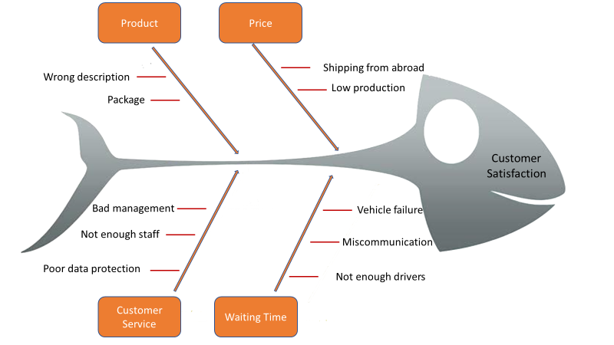

Customer plays crucial role within the retail industry. Therefore, amazon must direct the focus on to the customer needs and ensure that people are satisfied with their products and services in order to raise their loyalty and encourage them to purchase items using their platform rather than the platform of competitors.

c). Security Risk Management Process

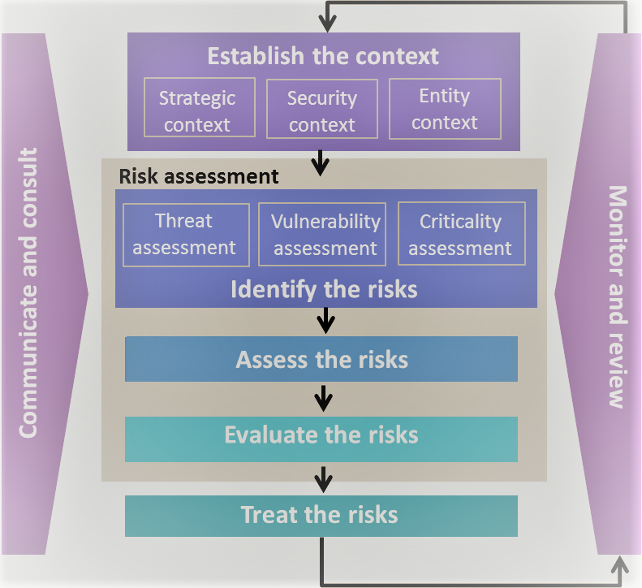
Figure 3. Security risk management process
Process shown above was designed in order, to help in preventing companies from cybercrime and minimising the threat of data loses. The success of security risk assessment depends on effectiveness of the security planning (Australian Government, 2019).

- Recommendations and solutions to the recognised problems.
4.1 High employee turnover
It is truth that each, and every company is focusing their interest onto rising their profit. But people often tend to forget that to achieve the goals and targets, each of the individuals working for the organisation must perform at their best level. Therefore, it is been proven that by creating safe and friendly work environment benefits will be seen by both employee and the company and this will result in better performance and productivity increase (Power, 2018).
To reduce the high employee turnover and encourage people to stick longer with the company does not have to be necessary expensive. There are few methods that are costless or inexpensive so that organisation can save their budget and still achieving.
a). Recruitment process – hire the right people
Interview is the first and important interaction with the person who potentially will be working for the organisation. When in process of choosing the right candidate it is crucial to ask adequate questions, like for example: “How would you react if..?”, “What would you do?”.
Creating work related scenarios and analysing the answers, can give an idea if person would be right for the position available. Showing to candidate the areas of workplace itself and communicating the required sets of tasks clearly without misleading or hiding information will enable candidate to understand what is expected and such candidate will then be ready to accept or resign the offer.
If candidate was successful and shows courage to work within the organisation, contract must be signed. Work contracts are usually starting with the three month probationary period, and that’s the time when employer can extend or fire the associate, depending on the progress and performance presented during that period of time. Good recruitment practices will save time and money to the company. Contract should ideally include information such as: required hours of work, job description, pay rate and procedures. Signing the contract by employee indicates that he or she agrees to the term and conditions offered by employer (Acas, 2019).
Recommendation:
Make sure that Human Resources take extra care while interviewing new people, there must be clear communication about the tasks and job description between recruitment team and future employee. Contract should be clear and easy to understand by employee. There should be no hidden agenda.

b). Provide your employees with the adequate
facilities
Employers must provide their workers with the certain work facilities in order, to comply with the United Kingdom’s safety, health and welfare legislation (Talk Business, 2019).
When opening and structuring work placements such as amazon warehouses it is very important to considerate facilities such as toilets, changing rooms, hand wash areas and restroom or canteen where employees would be able to dine or take rest during their break time.
If work placement is as big as amazon fulfillment centre in Rugeley witch its length equivalent to nine and a half football pitches and 3 floor high (Corser, 2018) where over 1800 people are employed each year (Farrell, 2018), it should have the right amount, of toilets adequate to the number of employees and placed on each floor, so that workers do not waste time walking long distances and waiting in the que.
Staff restroom is also very important, it is a place for employees to rest and load their energy, it should be provided with cold water dispenser or bottles of water, kettle in order to prepare hot drinks and microwave to heat the food if there is no canteen provided. Employee should be able to take break in a peaceful and comfortable environment in addition to keep up with the good performance (Talk Business, 2019).
Recommendation:
Build facilities such as toilets and restrooms adequately to number of workers in order, to comply with health and welfare legislations, and to make employees feel comfortable at the place of work.

c). Work life-balance
The trace of work-life balance concept can be seen in the XVIII century, at the time when United Kingdom and United States decided to enact legislation in order to, shorten the amount of weekly working hours for all employees. In the XIX century both countries enforced mandatory lives in occasion of events such as: illness and childbirth (Mind tools, 2019).
The term “work-life balance” was popularised in the 1980 due to more women joined the workforce. Thereafter, this concept of balance achievement accounted for the needs of both, men and women (Mind Tools, 2019).
According to the research done by Joanna Hughes and Nikos Bozionelos (2007) work-life imbalance appeared to be the main source of job dissatisfaction among the participants. When people are unable to control their time efficiently, they often tend to stress themselves and what goes along, drooping on work productivity. Working long hours can have serious effect on the health, these can include anxiety, headache, weakened immune system, anger issues, insomnia, high blood pressures and even clinic depression (Bozionelos & Hughes, 2007).
At amazon fulfillment centres, associates work four-ten hour shift each week and if an overtime is required, they must attend the work on the fifth, sometimes six day (About Amazon Staff, 2019).
Most of the physical jobs at amazon warehouse require standing at the same spot or walking long distances, picking up and lifting hundreds of items during each shift. It is hard for employees to meet the expected daily target when such routine must be continued for many hours. Therefore, it is very important to create the right work schedule so that the tasks are divided equally and evenly between employees.
Recommendation:
Changing the rota the way that instead of employee attend 4 days in the week working 10 hours a day to 5 days but 8 hours a day instead, would minimise tiredness, preventing accidents at the workplace and at same time the productivity would be higher. Those simple changes will not affect the budget of the company but would result in positive changes within organisation.

d). Motivating factors – solution to employee turnover
There are few factors that motivates people and engages them to stay within the organisations. Some of those factors were mentioned above as work environment and work-life balance other motivational factors are:
Recognition - In order, to make people retain within company, employers should show appreciation by complementing on the good performance of their workers. Every person has a need of being recognised in order, to feel better about themselves. By adapting the habit of recognition, organisations are sustaining positive workplace environment and encouraging their employees to better performance (Ng, 2019).
Compensation – pay rise encourage the employees to serve longer and build their loyalty. Competitive salary will stop employee from searching different employment.
Career opportunity – investment in trainings and development plans will benefit in high employee motivation and higher productivity
The above are known as recognised key factors with lead people to decision making when it comes to retention or exit of the workplace. Therefore, it is crucial for organisations to follow those factors and make sure that workers are continuously motivated, so that employee turnover will retain at lowest level (Ng, 2019).

4.2 Data Protection
Data is a very important cooperate asset that must be protected at all the times due to demands of the 21st century business. Every business is obligated to meet the governments regulations on storing data and electronic communications, violation of those regulations might cause companies to pay the fines or to undertake other legal actions (Petrocelli, 2005).
Solution:
By recruiting highly skilled IT people that would carry the risk assessment and by investing in development of the accurate data security system, amazon would minimise the financial losses involved with decrees in productivity and prevent its customers from fleeing into the hands of competitors by building their trust (Petrocelli, 2005).
4.3 Customer Demands
a). Waiting time
When it comes to delivery issues, amazon should consider the fact that the customers are being confused by the 2-day delivery prime offer. It is been proven that amazon’s sales are increasing every year, this would mean that employees being in charge, of deliveries have more packages to deliver, this workload could also cause delays.
Solution:

Clear information about the shipment time and possibility to truck the parcel will prevent the unnecessary confusion among not only prime members, but of all amazon users. Taking in consideration increase in sales, amazon should hire more drivers to assure the smooth and stress-less process of package deliveries.

- Implementation of the solutions.
5.1 Employee turnover

Figure 4. Motivational Factors of Employee Retention.

By implementation of motivational factors model shown above as Figure 3, amazon will benefit by significant drop in employee turnover. Sustaining the high percentage of retention process will increase the chances that employees will stay within organisation for many years.
This action plan will be undertaken by management and human resources team. Beginning with the focus on existing employees, work schedule will be reviewed and improved the way it suits both, organisation and workers. There will be new possibility of cross training for employees interested in role changes. Introduction of new competition - employee of the month, the title and special price for outstanding performance will keep employees motivated. In order, to reduce the workload company will look, into investing in better and innovative equipment. Pay rise will be offered to those employees who serve the company for over the year and those who shows high performance. Future actions regarding the improvement of facilities such as toilets and restroom will be undertaken after the high season will finish.

5.2 Data Security

Figure 5. Prevention of cybercrime strategy.

Prevention of Cybercrime

Appliance of this strategy will minimise the risk of cybercrime. Investing in better and innovative equipment will allow the smooth run of the newest updated security programs and systems. Good recruitment process will allow to hire competent people who should be able to apply best strategies and perform the IT risk assessment at the minimal budget. Continuous recording of the results will enable better decision making on procedures and budgets policies (Sotnikov, 2018).

Record & Document the Results
Carry the Risk Assessment
Hire Skilled IT People
Invest in Better & Innovative Equipment
Update the Security System
- Communication Plan Project

Goals:
- increase employee retention and overall experience
- increase productivity and meet customer expectations
- provide information fast, accurate and clearly reducing the lag time between communication
- avoid bad decision making

Figure 5. Stakeholders Communication Plan (Moodle, 2019).

Stakeholders Communication Plan
Shareholder | Power/Interest | Key Interest & Issues | Communication method | Frequency | Comments
COS | High | - Budget  - Legislations  - Feedback  - Revenue | - Meetings  - Conference | - Critical situation  - Once a month
Employees | High | - Feedback  - Performance  - Appraisal  - Trainings  - Retention | - Group chats  - Meetings  - Briefings  - Email | Daily basis
Customers | High | - Feedback  - Expectations  - Bounding  - Complains | - Social media  - Emails  - Surveys  - Call service | Daily basis

This communication plan is created in order, to improve communication process, enabling clear, accurate and fast delivery of information. This will allow employees to engage with the operations of the company reducing lag time between communication and increasing productivity. Such plan ensures that employees are informed of changes in a timely manner (Lewis, 2019).
To keep communication run smoothly amazon must follow through on performance reviews, by organising meetings where feedbacks can be received. Those meetings could also build the boundaries between employees across all organisation encouraging them to better performance (Lewis, 2019).

Summary
Ensuring creative and innovative approach to challenges is crucial in success of every company. Amazon as the leading retailer, is facing number of problems. The problems evaluated in this report were: employability turnover, customer demands and issues involved with data security. Tools and techniques outlined in this report enable company to early recognition of the issues and challenges. Wild range of resources utilise amazon with recommendations and solutions to the arising problems. By implementation of proposed solutions amazon can improve the working conditions, customer expectations and minimise the risk of cybercrime.

REFERENCES
- Acas (2019) Employment Contracts. Available at: https://www.acas.org.uk/index.aspx?articleid=1577 (Accessed: 20th July 2019).

- ASQ Service Quality Division (2016) Fishbone (Ishikawa) Diagram. Available at: http://asqservicequality.org/glossary/fishbone-ishikawa-diagram/ (Accessed: 4th August 2019).

- Australian Government (2019) Security planning and risk management. Available at: https://www.protectivesecurity.gov.au/governance/security-planning-risk-management/Pages/default.aspx (Accessed: 22th August 2019).

- BBC (2018) [Online Video] Amazon’s Rugeley Site ‘one of most dangerous in Britain’ Available at: https://www.bbc.co.uk/news/uk-england-stoke-staffordshire-45424412 (Accessed: 20th July 2019).

- Bhasin, H. (2019) SWOT analysis of amazon. Available at: https://www.marketing91.com/swot-analysis-of-amazon/ (Accessed: 29th July 2019).

- Bhasin, H. (2019) Differentiation Strategy. Available at: https://www.marketing91.com/differentiation-strategy/ (Accessed: 29th July 2019).

- Business Strategy Hub (2019) Amazon SWOT 2019. Available at: https://bstrategyhub.com/swot-analysis-of-amazon-amazon-swot/ (Accessed: 29th July 2019).

- Cheslock, P (2018) The top 7 AWS security issues. What you need to know. Available at: https://www.threatstack.com/blog/what-you-need-to-know-about-the-top-7-aws-security-issues (Accessed: 15th August 2019).

- CISO MAG (2019) Amazon suffers ‘fraud attack’ from cybercriminals. Available at: https://www.cisomag.com/tag/amazon/ (Accessed: 15th August 2019).
- Corser, J. (2019) Amazon denies union claims Rugeley warehouse 'one of most dangerous places'. Available at: https://www.expressandstar.com/news/business/2018/06/02/amazon denies-union-claims-rugeley-warehouse-one-of-most-dangerous-places/ (Accessed: 17th July 2019).

- Farrell, S. (2019) Unions lobby investors to press Amazon over UK working conditions. Available at: https://www.theguardian.com/technology/2019/may/20/unions-lobby-investors-to-press-amazon-over-uk-working-conditions (Accessed: 17th July 2019).

- Green, D. (2018) Disgruntled amazon customers are complaining that their packages keep arriving late, and it could be an ominous sign for prime. Available at: https://www.businessinsider.com/amazon-prime-customers-complain-delays-2018-4?r=US&IR=T (Accessed: 15th August 2019). Business Insider (2018).
- Hall, M. (2019) Amazon.com. Available at: https://www.britannica.com/topic/Amazoncom (Accessed: 15th July 2019).
- Hughes, J; Bozionelos, N (2007) Work-life balance as source of job dissatisfaction and withdraw attitude. Available at : https://www.emerald.com/insight/content/doi/10.1108/00483480710716768/full/html (Accessed: 26th July 2019).

- Lawson, M. (2017) 4 Things you need to know about the future of marketing. Available at: https://www.thinkwithgoogle.com/marketing-resources/micro-moments/future-of-marketing-mobile-micro-moments/ (Accessed: 21th August 2019).

- Lewis, M; R. (2019) How to write an internal communication plan. Available at: https://www.wikihow.com/Write-an-Internal-Communications-Plan (Accessed: 24th August 2019).

- Management Study Guide (2019) SWOT analysis of amazon. Available at:https://www.managementstudyguide.com/swot-analysis-of-amazon.htm (Accessed: 29th July 2019).

- Mind Tools (2019) Finding the right work-life balance. Available at: https://www.mindtools.com/pages/article/work-life-balance.htm (Accessed 26th July 2019).

- Moodle (2019) Stakeholders Communication Plan. Available at : ^{[1]}https://moodle.uwtsd.ac.uk/course/view.php?id=4180 (Accessed: 24th August 2019).

- Ng, A. (2019) Top 10 factors that motivate employees. Available at: https://www.aptsg.com/index.php/articles-2/15-for-employers-hr-training-dept/36-top-10-factors-that-motivate-employees (Accessed: 22th August 2019).

- O’Connor, S. (2013) Amazon unpacked: The online Giant is creating thousand, of UK jobs, so why are some employees less than happy? Available at: https://www.ft.com/content/ed6a985c-70bd-11e2-85d0-00144feab49a (Accessed: 17th July 2019).

- Petrocelli, T. (2005) The changing face of data protection. Available at: http://www.informit.com/articles/article.aspx?p=422303&seqNum=3 (Accessed: 21th August 2019).

- Power, R (2018) 10 reasons why it is important create a happy workplace. Available at: ht\tps://www.inc.com/rhett-power/10-reasons-why-it-is-important-create-a-happy-workplace.html (Accessed 20th July 2019).

- PWC (2017) Total Retail. Available at: https://www.shopify.co.uk/retail/5-examples-of-how-to-build-trust-with-online-customers (Accessed: 20th August 2019).

- Ramhold, J (2018) 14 confusing things about shopping on Amazon. Available at: https://www.techspot.com/news/73477-14-confusing-things-about-shopping-amazon.html (Accessed: 10th August 2019).

- Selby, A. (2017) Timed toilets brakes, impossible targets and workers falling asleep on feet: Brutal life working in amazon warehouse. [Online Video] Available at: https://www.mirror.co.uk/news/uk-news/timed-toilet-breaks-impossible-targets-11587888 (Accessed: 15th July 2019).

- Sotnikov, I. (2018) How to perform IT risk assessment. Available at: https://blog.netwrix.com/2018/01/16/how-to-perform-it-risk-assessment/ (Accessed: 22th August 2019).

- Talk Business (2019) What facilities does an employer legally need to provide. Available at: https://www.talk-business.co.uk/2018/09/19/what-facilities-does-an-employer-legally-need-to-provide/ (Accessed: 26th July 2019).

- Transporteca (2019) Amazon Fulfillment Centre Locations. Available at: https://transporteca.co.uk/amazon-fulfillment-center-locations/ (Accessed: 17th July 2019).

