2014439
[Company name]
ACBA 4002- Digitalsurveying
2014439
“Part 1
Surveying can be classified based on different factors, outline these factors, and discuss in details different types of surveying under one of the factors.

Part 2
Briefly describe the application of digital surveying technologies in surveying listed buildings giving examples of appropriate tools to be used and the information to be collected from the survey.”

Contents
Introduction 3
What is Surveying? 3
Primary Surveys 3
Purpose Based Surveys 3
Construction Survey 4
Surveys based on Equipment 4
Surveying Listed Buildings 7
Conducting a Survey of a Listed Building 7
Survey Report 9
References 10

Introduction

In this work we will look at what surveying is, as well as some of the different types and methods of surveying that exist now and in history. We also look at how these techniques can be used to survey listed buildings, and what details should be included in a measure building survey.

What is Surveying?

The Oxford English Dictionary defines surveying as,
‘The profession or work of examining and recording the area and the features of a piece of land so as to construct a map, plan, or detailed description of it’. (Oxford, 2010)
However, the process of examining, recording, mapping, and planning of such features can be classified in different ways. Typically, there are four distinct classifications of surveys. These are namely primary surveys, purpose-based surveys, method-based surveys, and equipment-based surveys.

Primary Surveys

The two types of primary survey are called geodetic surveying and plane surveying. Geodetic surveying deals with areas that are so extensive they take into consideration the true shape and dimensions of the earth. Geodetic surveys are useful in that they try to establish a rigid control for the coordination of all other types of surveys (Fitzgerald, 2012). Within a Geodetic survey, any triangulation between points is considered to be within a spherical shape, the angles are considered to be spherical, and any line between two positions is considered to be on a curved line, accounting for the curvature of the earth.

Therefore, a Plane survey is one that does not consider the curvature of the earth. Triangulation between points is on a constant level plane, and the distance between any two points is considered completely flat or straight as opposed to being curved. The difference between a straight line and an arc that accounts for the earths curved shape between two points equates to approximately 100mm in 11.3 miles (Daily Civil, 2021).

Purpose Based Surveys

Different types of surveys can also be pigeon-holed according to the nature of the field of work that survey is concerned with. Most common types of purpose-based survey include land surveying, and marine surveying, but can also include the study of the cosmos with Astronomical Surveying.

Some type of Land Surveys include.
- Cadastral Surveying- within this discipline, surveying is mainly conducted with the hope of establishing boundaries of land or property and establishing certain rights that maybe associated with such properties. (unknown, 2020)
- City Surveying- These are carried out in and around a town or city to establish areas of land that would be suitable for expansion or improvement, like extra housing or commercial units.
- Construction Survey (which will be discussed at a later point)
- Forestry Survey- These are conducted to help monitor the production of a forest or to highlight if any further conservation work is required at a particular site.
Marine or Hydrographic surveying is concerned with the mapping of the surfaces below the oceans. They are also used to survey all other bodies of water like rivers, streams, harbours, and reservoirs. The findings of such surveys help us with nautical navigation, conservation, flood control, and water supply issues.

Construction Survey

A construction survey or measured building survey is an accurate survey of a building to show all the architectural and structural elements of a building. Often floor plans can be roughly sketched out, and then dimensions, elevation details and sections produced to add further detail for the client. Constructions surveys are required if a property is to be redeveloped or extended, or the purpose or use of the building was going to be changed dramatically. Standard things that will be surveyed include windows, walls, doors, floors, stairs, beams, and ceilings. Also, the height or levels of arches, beam soffit, and the floor levels at the centre of each room will be recorded. These are standard things that will be included in any survey, but the client may specify other features to include within a survey such as cupboards, or radiators, or description of ceilings etc. A surveyor will use a number of different pieces of equipment to conduct a survey, and these will be discussed in the next section.

Surveys based on Equipment

In this section we will look at both modern and historical pieces of equipment that aid surveyors in their work.
-Gunter’s Chain
This was an early measuring device that was created by the English Mathematician Edmund Gunter. The chain was made up of 100 links and measured 66 foot in length. Measurements taken with the chain were easily convertible. 80 lengths of the chain equalled a mile. And every ten links of the chain in a square would equal an acre. This tool was likely the reason for a surveyor’s assistant being called a chainman or chain boy. Using a ranging rod or pole, the surveyor would direct their assistant towards the pole (located at the second point we are measuring to) to ensure the chain was being laid straight for a more accurate distance measurement. (Constructor, 2021)
-Engineers Chain
The engineer’s chain or 100ft chain would later replace Gunter’s chain. The chain was made of 100 links each being a foot in length, and measurements could be taken easily in feet and decimal (Constructor, 2021).

-Laser and Tape Measures.
Surveyors will still carry the traditional tape measure, as this can help take small measurements that may be needed very quickly. Laser tape measures can be handy in taking larger measurements, where a tape may bend and provide less accuracy. Electric laser measures can measure the height and widths of a building quickly and accurately. Typically, they are accurate to within 2 mm over a 200-metre distance. (Newing, 2020)

-Diopter/Theodolite
Measuring angles seemed to be a bit more challenging than point to point distance measurements. The Greeks invented a tool called a diopter which works similarly to the theodolite used today. The diopter was a cogwheel attached to a water level and screw and allowed angles to be read on vertical and horizontal planes. (Arora, 2010)

-Total Station
The total station has become by far the favourite tool of surveyors and engineers, as like the name suggests, it can do almost totally everything. Total stations use electronic transit theodolites along with an electronic distance metre (EDM) to read any slope distance from any spot. Total stations also allow data to be extracted from the machine and mapped into and auto cad file with relative ease. So, it does the measuring and the mapping all for you. However, you can still record survey results in the traditional way. See below is a survey I conducted using a robotic total station on the fourth floor of the new residential building next to Tesco’s in Swansea city centre. I was taking the height readings of the slab. The survey books made by Chartwell are made with excellent strong paper making it resistant to wet weather.
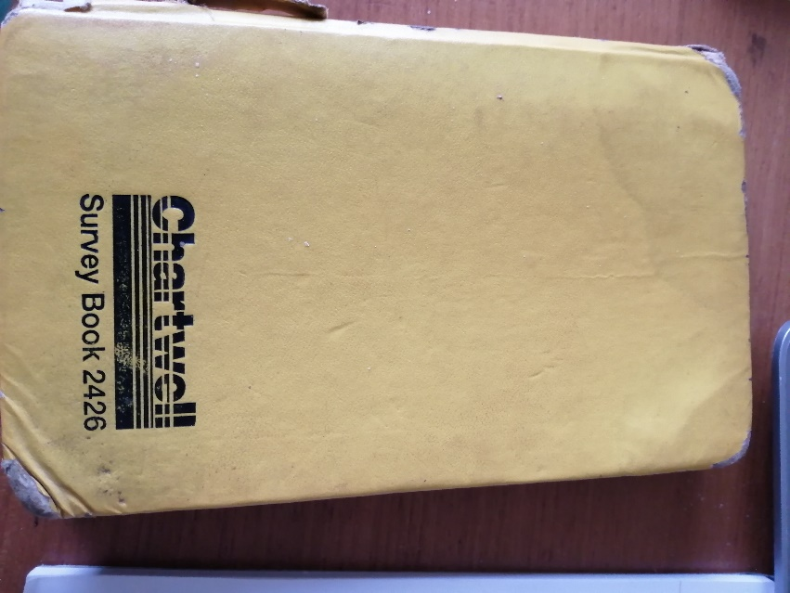
Figure 1 My Chartwell Survey Book
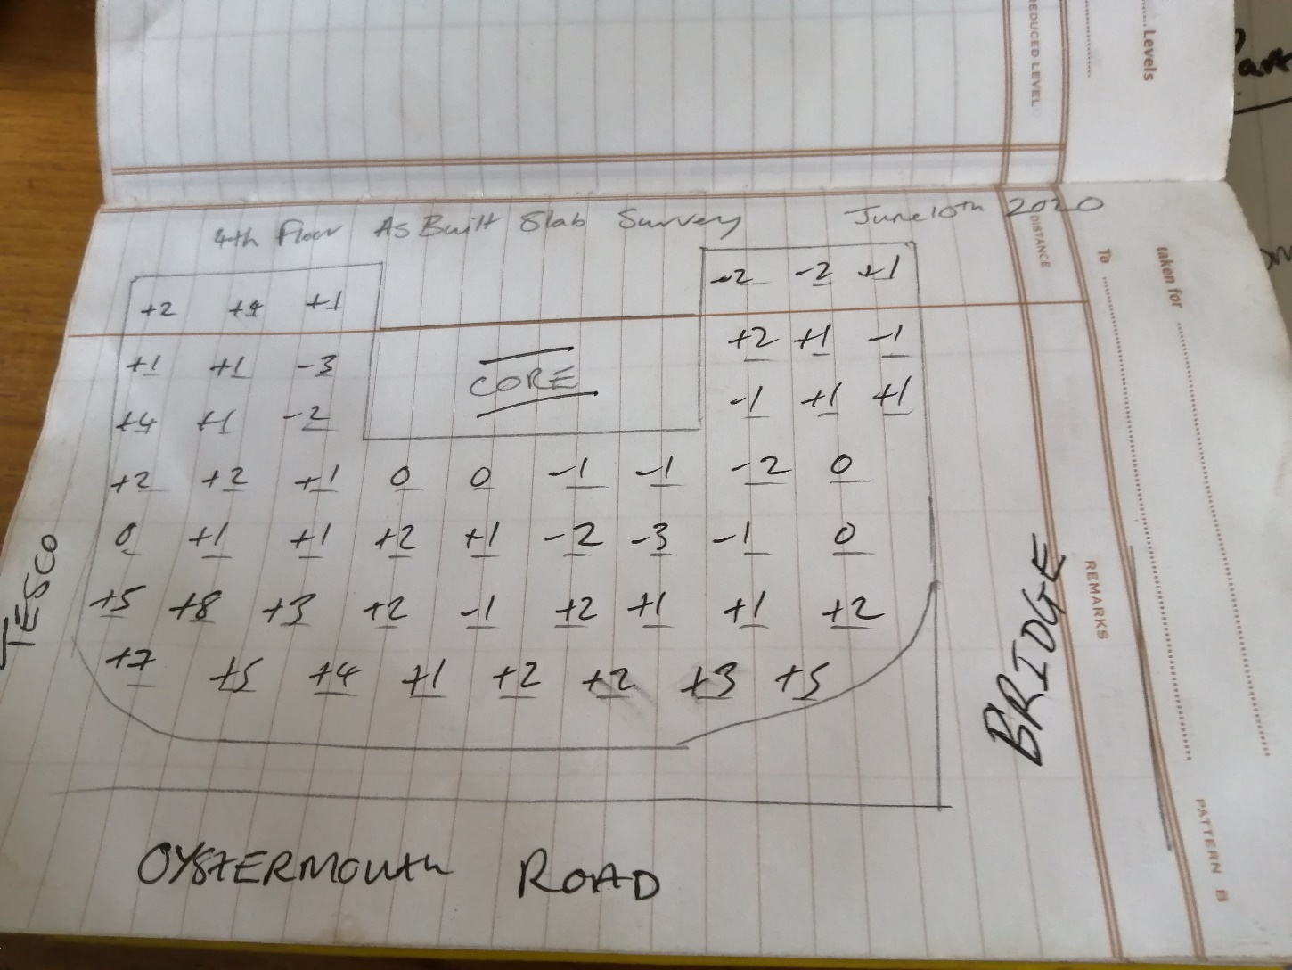
Figure 2 Survey of 4th Floor Slab. Swansea Arena and Residential complex Buckingham group

Surveying Listed Buildings

A listed building is a structure that has been place on a register for the purposes of protecting it. They are usually protected for their historical or architectural importance. These registers are kept by Historic England, Environment Scotland, Cadw in Wales, and the Environment Agency in Northern Ireland. In England and Wales, the Planning Act 1990 is the governing legislation protecting such buildings and provides three types of grading to protected buildings.
- GRADE 1- these buildings are described as buildings of exceptional interest
- GRADE2*- are buildings considered to be important buildings of more than special interest
- GRADE2-are building of special interest and every effort should be made to preserve them (Historic England, 2021)
Buildings graded in such a way cannot be altered in any way, demolished, retrofitted, or extended without permission from local authorities and the respective central governing authority. (GOV.Uk, 2015)

Conducting a Survey of a Listed Building

The first step in conducting a survey of a historic building would be to conduct a desk study. This is the preliminary research a surveyor will conduct before, and physical or on-site work is conducted. Within a desk study you would hope to research and uncover any site specific geological, environmental, and historic areas of importance. A desk study is also useful for determining any potential risks that may arise from any later work on the building. These risks particularly for historic buildings could be the uncovering of archaeological remains or unexploded ordnance. (Designing Buildings , 2020)

Once the desk study has been completed, and initial assessment can be undertaken of the building in question. First, the person conducting the survey should use appropriate personal protective equipment, and ensure the building is safe enough to enter. Steps should be taken if there is requirement to work in confine spaces or working at height. The main elements of the building can then be reviewed. Features such as the walls, ceiling, stairs, roof, and services can be scored in the following way.
Good- this is where the building is weathertight and structurally sound, and little to no major repair will be required by the client
Fair- this is where the building elements are structurally sound, and some minor repairs may be required.
Poor-These are elements that require repairing or maintenance but are not considered to be urgent.
Very Bad-These are serious repairs that maybe hindering the overall strength of the structure. Such repairs should be addressed immediately.
Not Inspected- These maybe areas where the person was unable to access. Like small, cramped areas / ceiling spaces etc.

Observations made by the surveyor should be back with on site photographs. Other visual aides should be used to inform the client. For instance, figure 3 below is a survey I conducted of some steel sheet piles on by current job. Some have been damaged so I have marked an area of the pile with French chalk that needs to be cut, and I have also used my tape measure to show we would need to cut off anymore than 150mm, as this was the limit or tolerance set out by the client. I have also noted on the sheet pile the piles number.
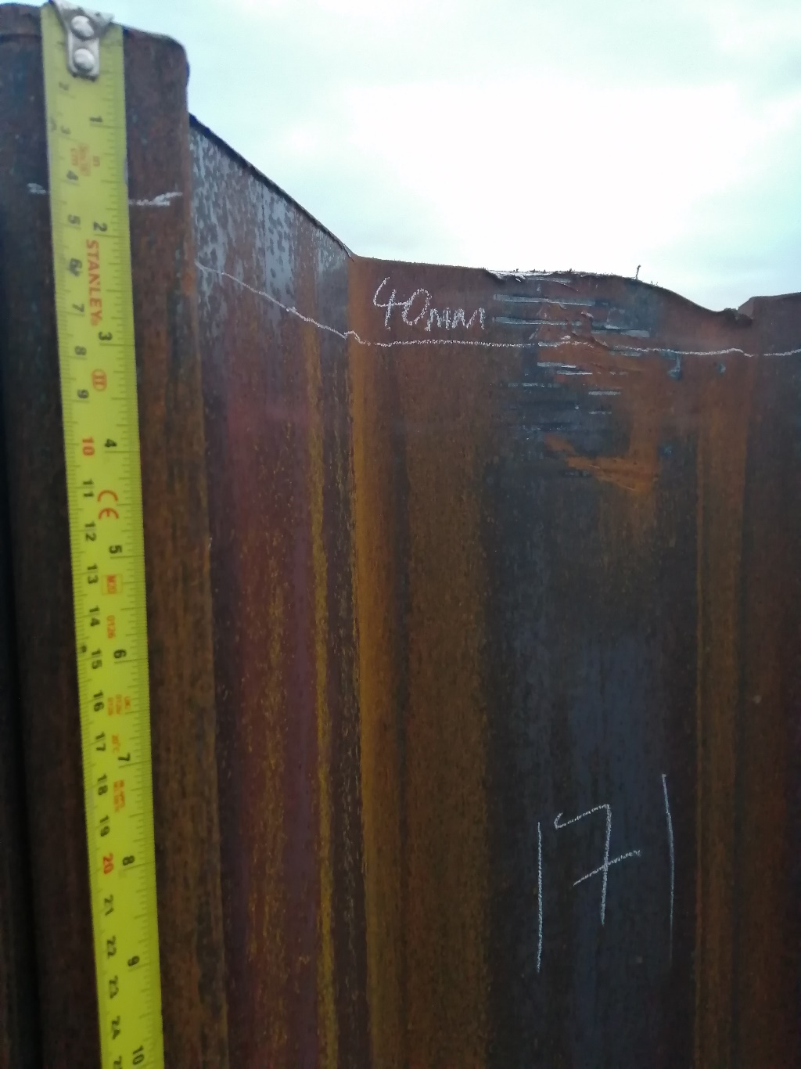
Figure 3 Damaged Sheet Pile. Avonmouth Flood Defence BAM Nuttall Ltd

Once an assessment has been made of all the buildings main elements, an overall score can be given for the overall condition of the property. This score is usually given as good, fair, or poor. Good would be a property that requires no real repair. Fair would be that some maintenance is required, and poor is where urgent repair or further investigation is required. These finding will be delivered in a full survey report.

Survey Report

This report will deliver all the findings of a surveyor from both the desk study and the site visit. The report could contain a summary of findings that can be understood by a person who may not be from a construction background. The main body of the report should be broken down into relevant areas and headings were your findings of any structural risks or damages can be reported. These will be broken down into the main elements of the building i.e., interior, exterior, services, and grounds.

In addition, an appendix should be included of any sketches, drawings or photos should be included that may help the client visualise the reports findings better. These can either be sketches or CAD drawings.

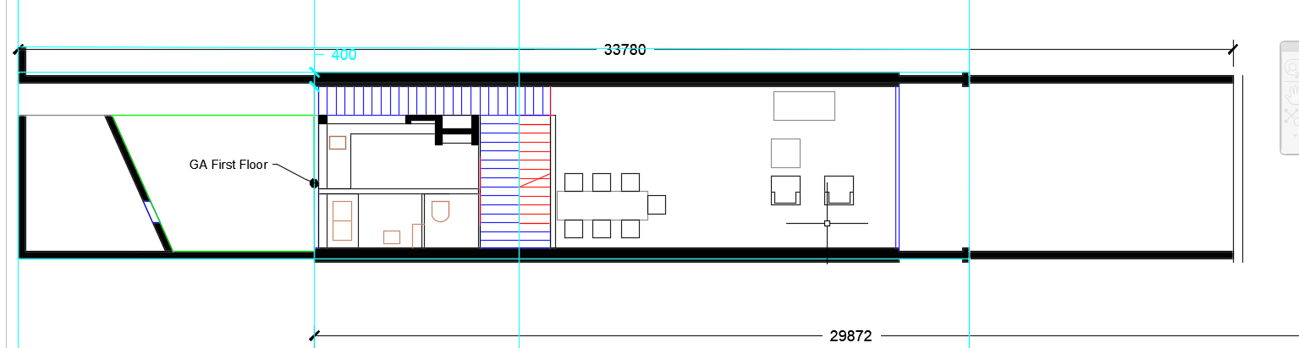
Figure 4 GA First Floor
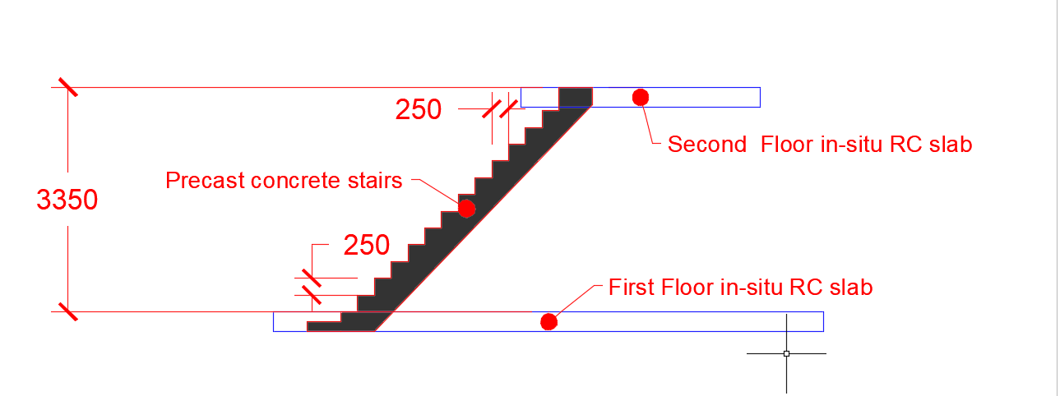
Figure 5CAD Sketch of Stair detail

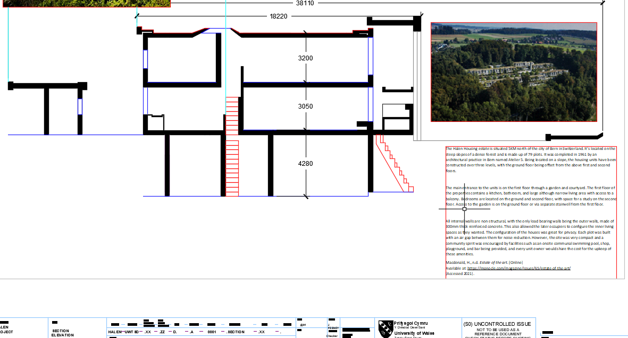
Figure 6 Section of building showing elevation. Drawing is also accompanied with pictures of the site

A conclusion should be then presents summarising the main findings presented in the main body of the report.

References
Arora, N., 2010. Surveying Instruments. [Online]
Available at: www.geospatialworld.net/article/timeline-surveying-instruments
[Accessed 2021].
Constructor, T., 2021. Types of chains used in surveying, Their Parts, Testing and Advantages. [Online]
Available at: https://theconstructor.org/surveying/types-of-chains-surveying/13889/
Daily Civil, 2021. Plane Surveying. [Online]
Available at: https://dailycivil.com/plane-surveying-details/
[Accessed January 2022].
Designing Buildings , 2020. Preliminary Site Investigations. [Online]
Available at: https://www.designingbuildings.co.uk/wiki/Preliminary_site_investigations
[Accessed 2022].
Fitzgerald, L. L., 2012. Geodetic Surveying. Australian Surveyor, 5(7), pp. 391-398.
GOV.Uk, 2015. Arrangements for handling heritage applications Direction 2015. [Online]
Available at: https://www.gov.uk/government/publications/arrangements-for-handling-heritage-applications-direction-2015
[Accessed 2022].
Historic England, 2021. Living in a Grade I, Grade II* or Grade II Listed Building. [Online]
Available at: https://historicengland.org.uk/advice/your-home/owning-historic-property/listed-building/
[Accessed 2022].
Newing, S., 2020. The Ultimate Guide to Measured Building Surveys. [Online]
Available at: https://www.southwestsurveys.co.uk/news/the-ultimate-guide-to-measured-building-surveys/
[Accessed 2022].
Oxford, 2010. Oxford Dictionary of English. 3rd ed. s.l.:Oxford University Press.
unknown, 2020. Cadastral Surveying. [Online]
Available at: https://www.land.vic.gov.au/surveying/cadastral-survey
[Accessed 2022].

