University of Wales Trinity Saint David
School of Engineering
Computer Aided Manufacturing and Design for Additive Manufacturing Technologies
James Gregory
P148409
BEng Mechanical Engineering
22/02/19
Manufacturing Design & Technology
M5X02070



Contents
1 Introduction 5
2 Background Research 6
2.1 Additive Manufacturing 6
2.1.1 What is additive manufacturing? 6
2.1.2 Benefits of additive manufacturing 6
2.2 Heat Exchangers 7
2.2.1 What are heat exchangers? 7
2.2.2 Principle of heat exchange 7
2.2.3 Classification of heat exchangers based on fluid flow arrangements 7
2.2.4 Gasket Plate Heat Exchanger (GPHE) 8
2.3 Thermal Plates 9
2.3.1 What are thermal plates? 9
2.3.2 Traditional manufacturing process of thermal plates 11
3 Methodology 13
3.1 Justification for the redesign 13
3.1.1 Factor one 13
3.1.2 Factor two 13
3.2 FMEA of the original component 15
3.1 Quality Function Deployment (QFD) 17
3.2 Direct Metal Laser Sintering (DMLS) 18
3.2.1 DMLS process 18
3.2.2 DMLS benefits 19
3.3 FMEA of redesigned component 19
4 Discussion 22
4.1 CAD design of the component 22
5 Conclusion 26
6 Evaluation 27
7 References 28
8 Appendices 1
8.1 QFD template 1

Table of figures
Figure 1: Diagram of conduction, convection and radiation (Alfa Laval, 2004) 7
Figure 2: Schematic diagram of three common flow arrangements, from left to right: cocurrent, countercurrent (parallel) and crossflow (Brogan, 2011) 7
Figure 3: Schematic diagram of a gasket plate heat exchanger (GPHE) (ALFA LAVAL, 2018) 9
Figure 4: Schematic diagram of fluid flow in a GPHE (ALFA LAVAL, 2018) 10
Figure 5: Diagram of common plate corrugations: (a) washboard, (b) zigzag, (c) chevron or herringbone, (d) protrusions and depressions, (e) washboard with secondary corrugations and (f) oblique washboard (Mota, et al., 2015) 10
Figure 6: Typical gasket used on a thermal plate (WTSML, n.d.) 11
Figure 7: Schematic diagram of the production of thermal plates (Hydraulico, 2014) 12
Figure 8: Diagram of a timeline showing the 3D printing process (red) compared to traditional manufacturing process (black) (Redwood, 2018) 13
Figure 9: Diagram of a typical thermal plate with a gasket (Danfoss, 2018) 14
Figure 10: FMEA evaluation criterion (Morgan, 2019) 15
Figure 11: Schematic diagram of a DMLS process (Jardini, et al., 2017) 19
Figure 12: CAD model of a thermal plate 22
Figure 13: Technical drawing of a thermal plate 23
Figure 14: CAD model of a plate assembly 23
Figure 15: Technical drawing of a plate assembly 24
Figure 16: CAD model of a plate heat exchanger 24
Figure 17: Technical drawing of a plate heat exchanger 25
Figure 18: Exploded view of an entire heat exchanger model 25
Figure 19: QFD template 1

Table 1: FMEA (part 1) 15
Table 2: FMEA (part 2) 18

Introduction
The aim of this report is to explore the theory of how additive manufacturing, mainly focusing on Direct Metal Laser Sintering (DMLS), could be used to redesign the thermal plates used in a general heating and cooling plate heat exchanger. The report consists of background research into the areas of additive manufacturing, heat exchangers and thermal plates. A discussion about the justification to redesign the component, identifying any tools or techniques used to aid in the redesign process. Using SolidWorks to create CAD models of the component with its new redesigned features, as well as, technical drawings presenting the specifications. A conclusion containing a summary about the results gained from redesign. Finally, an evaluation into how the redesign could have been improved further and how it could fit into the real world.

Background Research

Additive Manufacturing

What is additive manufacturing?
Additive Manufacturing (AM), also known as Rapid Prototyping (RP) or 3D printing, is a technology that is modernising the way systems, sub-systems or components are being produced within the manufacturing industry (Roschli, et al., 2014). The emphasis of using this technology is to create a system or component rapidly and produce a prototype or basic model which can be improved upon with further models and a final product (Gibson, et al., 2015). AM is currently used in the aerospace, automotive, healthcare, and product development industry, where there is an array of products ranging from prosthetics, to rear wings of Formula 1 cars, to fuel nozzles used in a Boeing 787 being produce by AM (GE Additive, 2019).

Benefits of additive manufacturing
AM offers industries with ground-breaking benefits which they may not achieve through traditional manufacturing processes, these include: up to 30% reduction in material waste, lower energy use, reduction in material and labour costs, large-scale production of parts, parts possessing better strength and durability, more freedom with design complexity and the use of environmentally friendly materials (Ghaffara, et al., 2018).

Heat Exchangers

What are heat exchangers?
A heat exchanger is a system or device designed to efficiently exchange heat from one location to another by conveying the heat between fluids at dissimilar temperatures. The fluid could be a liquid, such as water or oil, or moving air (Bosrup, 2002).

Principle of heat exchange
Within a heat exchanger, the heat exchange process can be defined by three processes: conduction, convection and radiation. Conduction is the process whereby energy is transferred between solids or fluids by the movement (kinetic motion) of atoms or molecules. Convection is the process whereby energy transferred from a hot to cold fluid. Radiation is the process whereby energy is transferred by electromagnetic radiation (Alfa Laval, 2004).
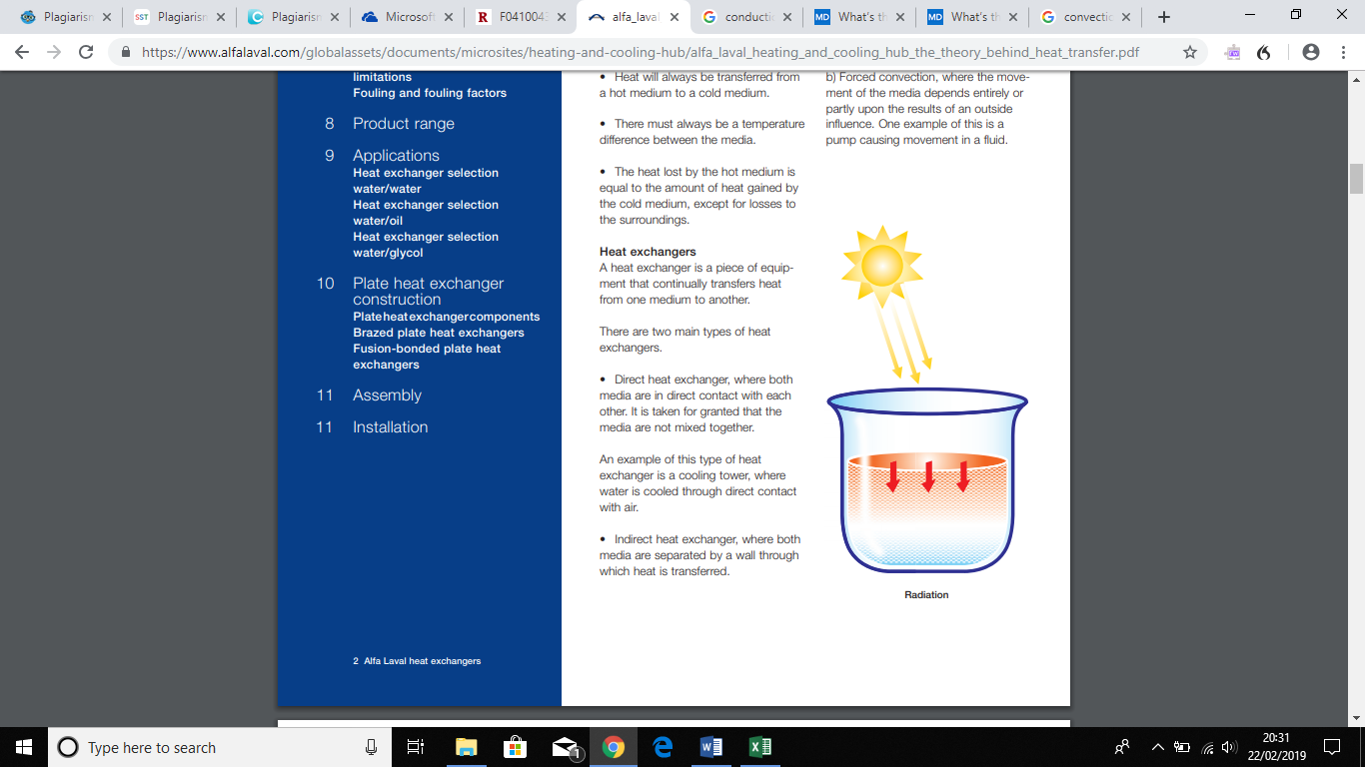
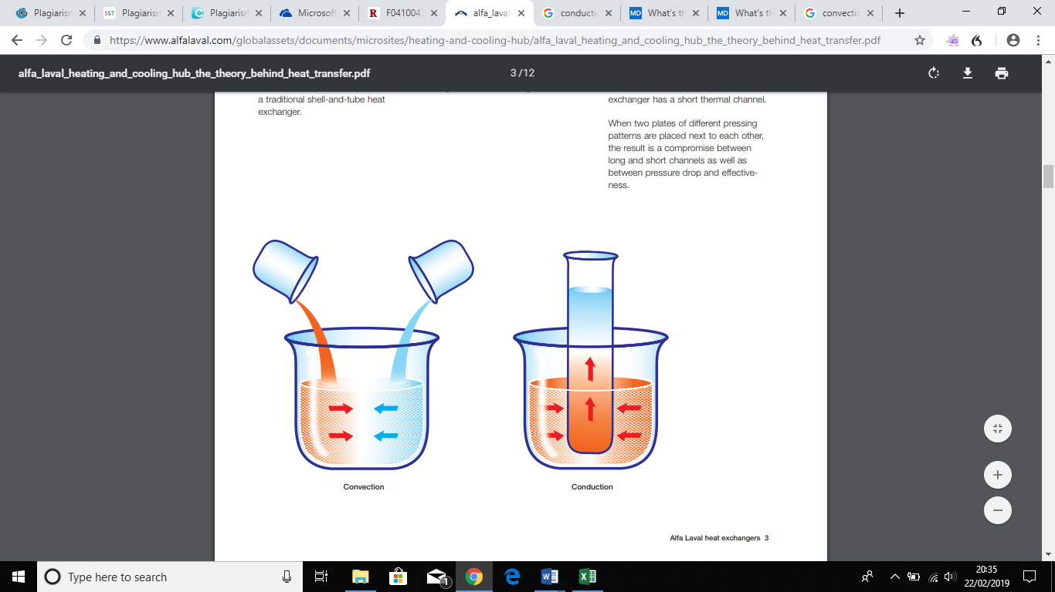

Figure 1: Diagram of conduction, convection and radiation (Alfa Laval, 2004)

Classification of heat exchangers based on fluid flow arrangements
Heat exchangers are classified based on the pathways in which fluid flows through the system. There are three basic types of pathway arrangements: parallel flow, counter flow and cross flow. The choice of flow is dependent upon the design criteria, just to name a few: exchanger effectiveness, temperature levels, available pressure drops and piping and plumbing considerations. Shown in figure one below is three diagrams showing the arrangement of flow. Out of the three, counter flow is the most efficient as it provides better thermal conductivity but allowing a larger change in temperature between both fluids (VIJAY & SNEHALATHA, 2016).
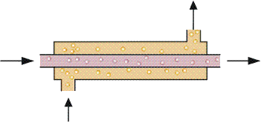
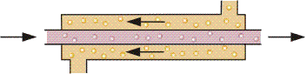
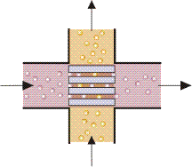
Figure 2: Schematic diagram of three common flow arrangements, from left to right: cocurrent, countercurrent (parallel) and crossflow (Brogan, 2011)

Gasket Plate Heat Exchanger (GPHE)
A GPHE is a countercurrent flow heat exchanger used in many commercial and industrial applications, such as: HVAC, refrigeration systems, engine cooling, dairy and food, chemical processing, oil production and power generation (UK Exchangers Ltd, 2018). The design itself consists of numerous thin metal plates called thermal plates, upon which contain a corrugated pattern and a gasket. The plates are compressed together between a fixed frame plate and a moveable pressure plate by tightening nuts and bolts, lock washers and a bearing box. When compressed, a plate pack is formed, the plate pack forms an arrangement of parallel channels through the port holes in each corner of a plate. Hot and cold fluids used in the system will flow countercurrent (opposite) to each other through the alternate channels thus providing heat transfer (Mota, et al., 2015). Shown in figure two below is an exploded view of a plate heat exchanger.

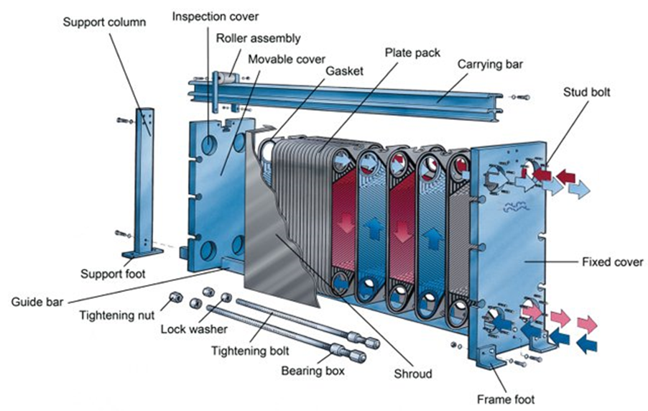
Figure 3: Schematic diagram of a gasket plate heat exchanger (GPHE) (ALFA LAVAL, 2018)

Thermal Plates

What are thermal plates?
Thermal plates (also known as heat transfer plates) are crucial to the performance of a heat exchanger and the most expensive component. A thermal plate is essentially a piece of sheet metal which has been manufactured to provide efficient heat transfer between hot and cold fluids through opposite sides of the inlet and outlet holes at each corner of plate, shown in figure three. On the surface of each plate is a corrugated pattern, these patterns have specifically been manufactured on the plate for three main purposes: to increase the turbulence of the fluid flow and the thermal exchange surface and to provide mechanical rigidity. Shown in figure four are six types of corrugations which are used on GPHE’s, however, most heat exchangers these days use the chevron (herringbone) pattern as it causes very high turbulence flow, thus achieving high heat transfer (Mota, et al., 2015).

An individual plate size can range anywhere from 100mm x 300mm to 1000mm x 2500mm with a thickness between 0.6mm to 1.0mm and the number of plates used can vary from just ten to several hundred, depending on the application they are used for (Golin, n.d.).
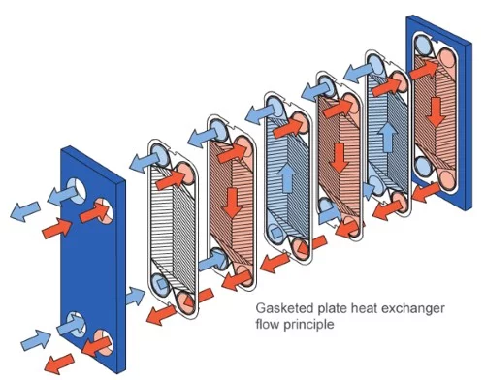

Figure 4: Schematic diagram of fluid flow in a GPHE (ALFA LAVAL, 2018)
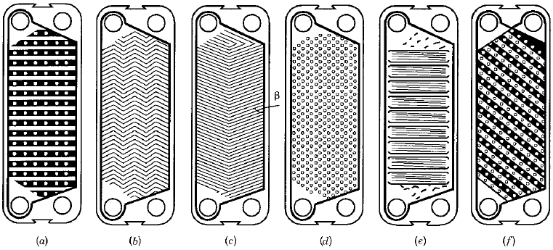
Figure 5: Diagram of common plate corrugations: (a) washboard, (b) zigzag, (c) chevron or herringbone, (d) protrusions and depressions, (e) washboard with secondary corrugations and (f) oblique washboard (Mota, et al., 2015)
A gasket is another feature used on the surface of each thermal plate. A gasket is used mainly for two purposes: to prevent leakage of fluid and to direct the flow of fluid along the plate. It can also act as a detection system to workers in terms of fluid leakage, if there is a leakage from the heat exchanger then one of the first components to be checked would be the gasket as it is the most likely of components to fail. Gaskets are generally made from a single uniform material, such as, nitrile rubber or EPDM and attached to the plate by glue, clip, stud or snap-in (SPETECH, n.d.) Below is a diagram of a standard gasket used on thermal plates.
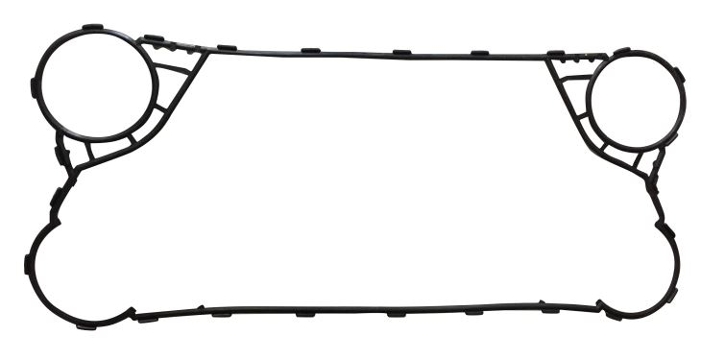
Figure 6: Typical gasket used on a thermal plate (WTSML, n.d.)

    - Traditional manufacturing process of thermal plates
Thermal plates are traditionally manufactured by a technique called sheet metal forming which occurs through a production line. The process begins with a coil line system in which a coil of sheet metal usually stainless steel (304 or 316), aluminium, or titanium is unravelled and fed into the production line. The sheet or strips of metal reach a straightener, which as the name suggests, straightens out the metal removing any residual effects caused by the coiled arrangement. Once straightened, the material moves on to two pressing stages; the first stage is the modular press, where a 200-tonne hydraulic press stamps out the desired shape of the material and the second stage is the embossing press, where a 5,000-tonne hydraulic press embosses the plates with the required corrugation pattern and forms the inlet and outlet holes at the corners of the plate. Finally, the plates are automatically straightened once more and then stacked onto a pallet by an automated stacking system (Hydraulico, 2014).
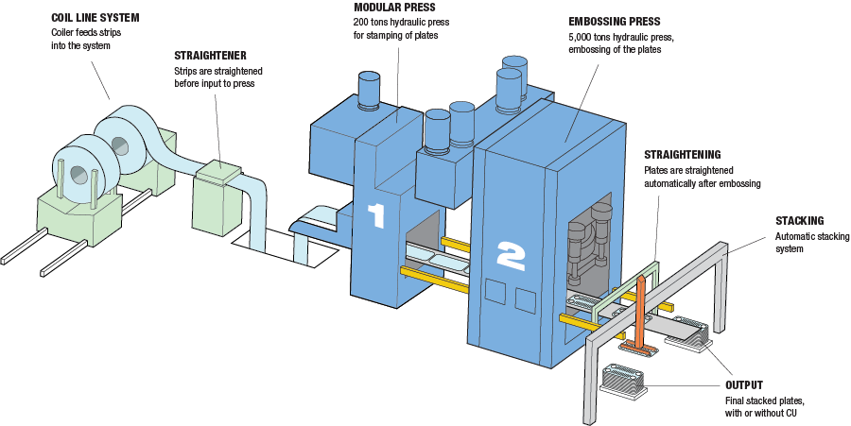

Figure 7: Schematic diagram of the production of thermal plates (Hydraulico, 2014)

- Methodology
  - Justification for the redesign
The justification to redesign the component with the use of 3D printing was down to two factors:
    - Factor one
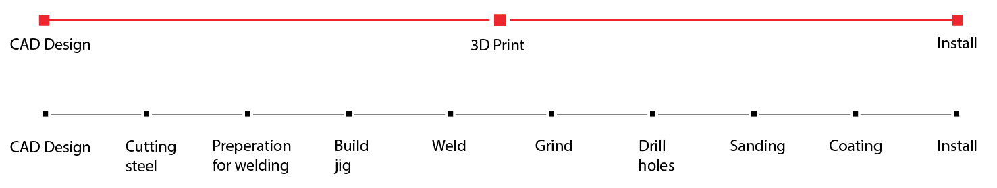
To use additive manufacturing to construct the plates in a single step process. Thermal plates require many manufacturing steps to be produced by traditional processes and the order of these steps can affect the quality and manufacturability of the design. For example, thermal plates are traditionally manufactured by sheet metal forming, however, before they can reach that stage of the process, they start off as a piece of metal melted inside a blast furnace at a sintering plant. It then goes through a process where it is continuously casted and sent to a rolling mill where it will eventually become a piece a sheet metal ready to be worked by metal forming. The process is very long-winded. So, by 3D printing the component in a single step it significantly reduces lead time, costs and greatly reduces the dependence of other manufacturing processes and allows the designer to have greater control over the final product.
Figure 8: Diagram of a timeline showing the 3D printing process (red) compared to traditional manufacturing process (black) (Redwood, 2018)

    - Factor two
To use additive manufacturing to reduce or possibly eliminate the use of gaskets and welds. Although gaskets are useful components, they do bring unnecessary limitations, such as; being prone to damage during assembly, cleaning and disassembly and so extra precaution must be taken by maintenance personnel. They add more to costs because of the need to use extra material and they are a nuisance in terms of appearance and functionality because engineers must alter the design of the pate to fit around the design of the gasket. Welds are also an issue in that the welding can cause residual stresses to the plate due to the heat treatment of the material. These residual stresses are the result of areas on the plate, which have been heated the most and because of this they add to the external load on the plate. This in turn, raises the average stress level in the component, which can severely reduce the weld’s fatigue resistance and cause plate damage (Alfa Laval, 2017).
By implementing 3D printing, gaskets can be printed in the same material as the plate and can be reduced in size and area resulting in less material used and allowing for greater customisation. Finally, due to the plates being built in a single step, there would be no need for welding, resulting in less issues.
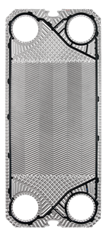
Gaskets can be reduced in size

Possible material change
More corrugations can be added

Figure 9: Diagram of a typical thermal plate with a gasket (Danfoss, 2018)

  - FMEA of the original component
In addition to justification for the redesign, a Finite Mode Effect Analysis (FMEA) was performed on a typical thermal plate. The tool was used to investigate deeper into the manufacturing process and functionality of the component and identify any potential failures which might occur with this design.
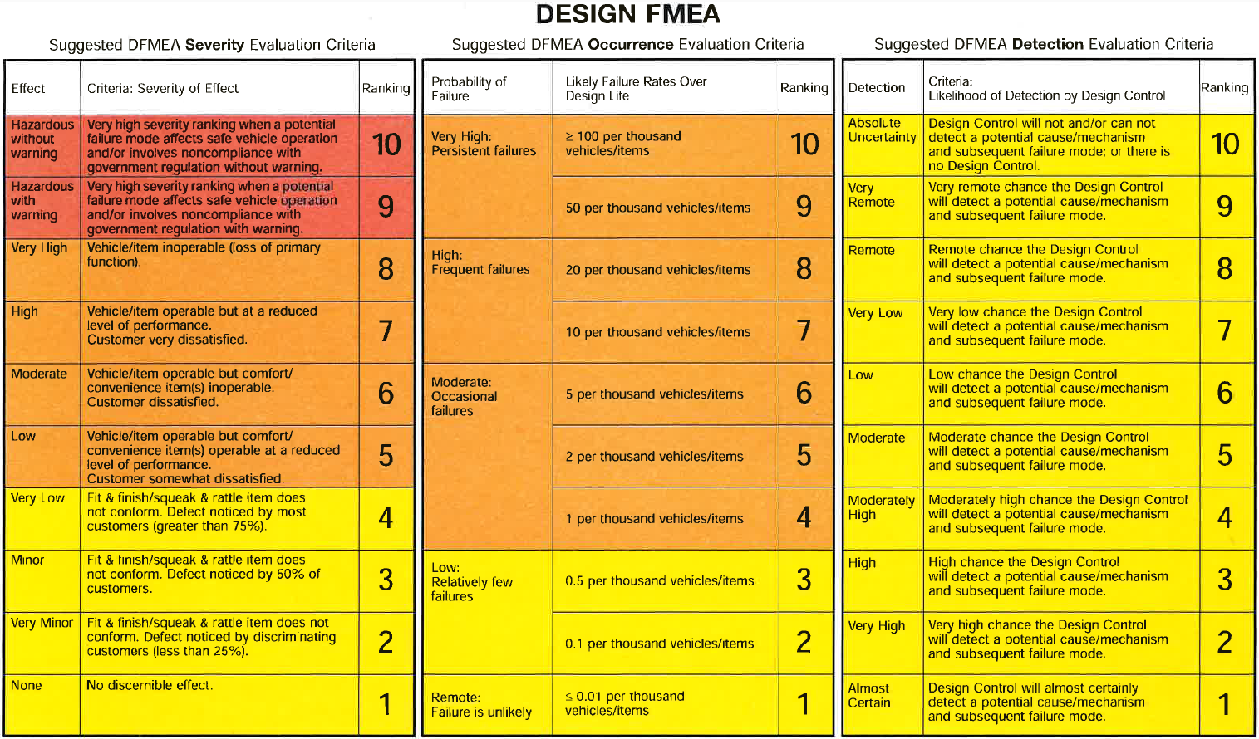
As part of the FMEA process, an evaluation criterion, shown in figure eight, was used to categorise the severity, occurrence and detection of each failure mode. The evaluation would provide an awareness into how severe the failure is, how many times it occurs per thousand items and the likelihood the failure could be detected. These three factors would then be multiplied together to calculate a Risk Priority Number (RPN) which categorises the failures from highest to lowest priority. The higher the RPN, the greater the risk of failure.
Figure 10: FMEA evaluation criterion (Morgan, 2019)

Using FMEA, seven potential failure modes were identified in the current design (shown in the table below), some failures modes are more critical than others in terms of their severity, occurrence and RPN.
Table 1: FMEA (part 1)

From the table above, FMEA has identified areas in the design which are most at risk of failing, demonstrated by their severity rating and RPN. It is in the interest of the redesign to prioritise the potential failures which have the highest RPN, as the value is determined by the severity, occurrence and detection. Thus, by examining the table, four failures have been identified which yield a great risk of failure and they have been ranked from highest to lowest priority in terms of their RPN. Starting from the highest risk of failures: weld defects (252), ruptured gaskets (168), plate misalignment (140) and plate/deformation/fracture (81). These failures would be considered during the redesign phase to ensure that they are reduced or eliminated, by implementing new methods of manufacturing or features on the redesign to prevent them.

Quality Function Deployment (QFD)
A QFD was conducted, shown in the appendices, to investigate the relation between customer requirements and functional requirements and what could be achieved with the redesign of the component. Four stages of the QFD were followed during this process to ensure appropriate results were gained, these were: technical aspects of a thermal plate and how they compare to customer requirements. An analysis into the performance of existing products in comparison to the redesign and how it ranked in terms of customer satisfaction and technical performance. Setting targets in areas where the product needs improving and prioritising these targets in terms of customer demand and improved functionality.
From the QFD, customers were asked what their requirements were in terms of the quality of a thermal plate and how important that requirement was to them. Out of the eleven requirements listed, all of them were of some importance to the customer, measured by a rating of three, four or five in the weight/importance column. From these requirements, a survey was carried out between our redesign and two other competitors on the market to find out how well each product met these customer requirements. Out of the three products, ours was ranked best (5) for being low weight, compact and cheap. Average (3 and 4) for being efficient, reliable, durable, and stable, no leakage and high heat dissipation. Worst (0, 1 and 2) for ease of maintenance and replacement of plates. Out of the eleven requirements important to the customer, our product satisfied seven of them with a rating between four and five, these are: lightweight, efficient, compact, reliable, durable, no fluid leakage and low cost.
Customer requirements can only be met if the functionality requirements of the design can allow it. There are fourteen functional requirements which needed to be considered as part of the redesign to ensure the product met both functional and government standards. Out of all the functional requirements listed, only seven were of importance to the customer, demonstrated by the weight/importance and relative weight value, these were: exit quality of fluid, expected life, number of plates per assembly, material cost, thermal resistance, thermal conductivity and manufacturing cost: these seven requirements will be prioritised first, to satisfy both customer and government standards and functionality.
So, from the results obtained above, targets can be set in the areas where the product needs improving, such as: ease of maintenance, replacement of plates, operation stability and heat dissipation. Prioritising these targets in terms of customer demand and improved functionality.

Direct Metal Laser Sintering (DMLS)
DMLS appeared to be the most appropriate technique to use in the redesign process because of its suitability and benefits it could offer which other power bed fusion techniques could not.

DMLS process
DMLS works by selecting a powdered material, usually titanium, stainless steel or aluminium, the material is spread out in a layer and melted by an Ytterbium fibre laser, which is directed through two lenses and onto a scanning mirror. When the laser hits the powder, the particles of the material are heated to their melting point and join with each other laterally. When the material cools down and solidifies, the powder bed moves down allowing a new layer of powder to be deposited and melted again in the same areas, this process continues until the desired part is finished being built layer by layer (Jardini, et al., 2017).
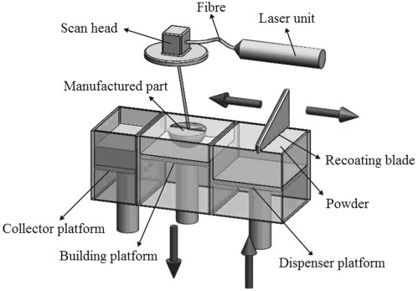

Figure 11: Schematic diagram of a DMLS process (Jardini, et al., 2017)

DMLS benefits
DMLS offers countless benefits which cannot be achieved through traditional manufacturing methods, such as: freedom of design, part weight reduction, strong, light and durable parts, greater structural stability, less waste, no tooling required, and parts can be built in a matter of hours or a few days (Incodema3D, 2017).

FMEA of redesigned component
The second part of the FMEA investigated into the actions taken during the redesign process to determine whether these potential failures have been reduced or eliminated. Shown in figure eleven below are the areas which will be considered in the FMEA, these are: recommended action(s), exploring the possible actions which could be taken to prevent these failures. Responsibility and target completion date, who is responsible for implementing these failures and when will they take into effect. Finally, actions taken, what were the actual actions taken to reduce or eliminate these failures. Using the same evaluation criterion above, new severity, occurrence and detection values will be determined based on how well or worse these actions have had on the risk of failure.

Table 2: FMEA (part 2)

From part 2 of the FMEA shown above, actions were taken to try and reduce the severity, occurrence and RPN of the component. As said previously in part 1, four potential failures would be the main priority as they possess the highest risk of failure shown by their RPN, these are: weld defects, ruptured gaskets, plate misalignment and plate deformation/fracture. Looking at both tables (part 1 & 2) there are some significant changes in the RPN, for example, in part 1, the RPN for weld defects is 252, however, by implementing new actions, for instance, using DMLS to 3D print the plates in a single step process it can eliminate the need to use welds and in so it eliminates the failures it brings, such as: residual stresses on the plate, plate fracture, fluid leakage and plate debris. Due to implementing this action it reduced the RPN from 252 to 96.
The RPN which did not change throughout this process was the defects which occurred during installation. This was because no other action could be implemented at the time which have improved upon what was already being executed and it was not one of main failures being looked at and so it was not a massive concern in terms of reducing this failure.

Discussion

CAD design of the component
Using SolidWorks, CAD models and technical drawings were produced to show how the features of the redesign would look like if it was 3D printed.
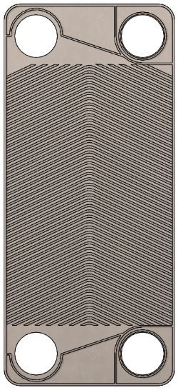
Gaskets have been reduced to inlet and outlet holes
Material: 316 Stainless Steel Sheet (SS)
Increased area of fluid flow

More corrugations added

Outer rim has been created to prevent fluids leaking

Figure 12: CAD model of a thermal plate
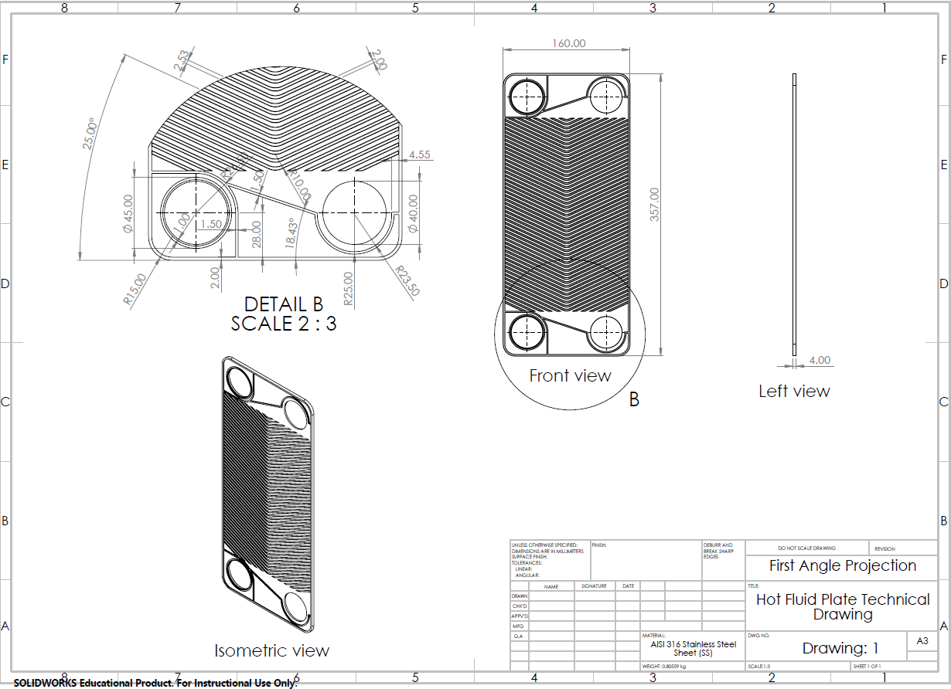
Figure 13: Technical drawing of a thermal plate
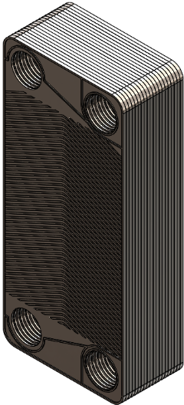
Figure 14: CAD model of a plate assembly
Thickness of each plate: 1mm
More compact

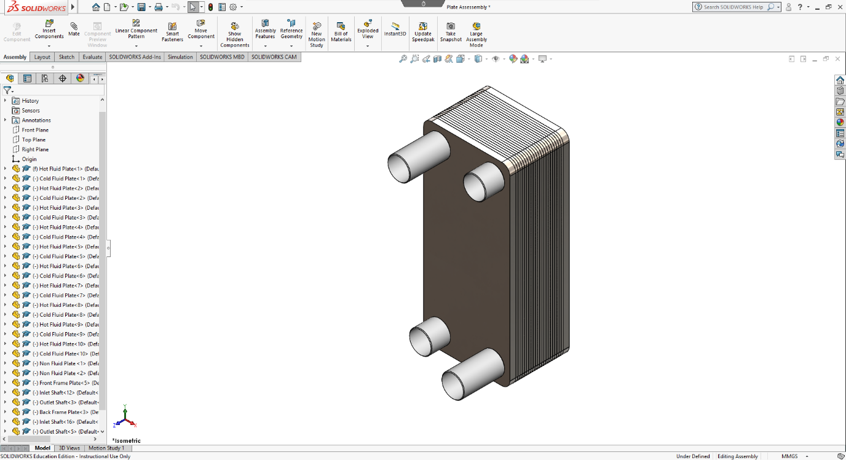
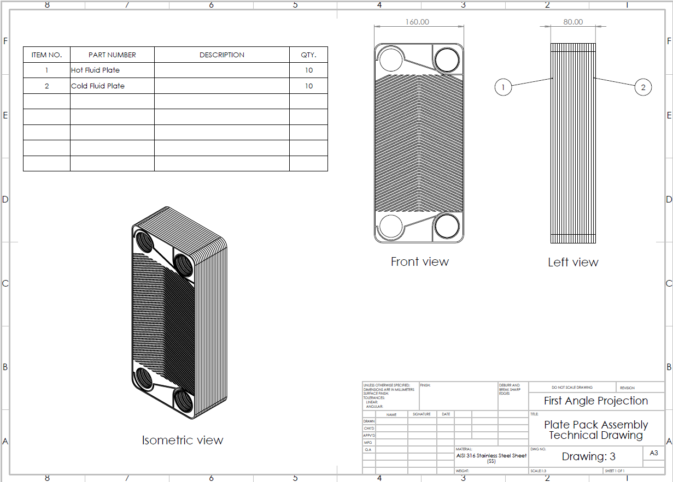
Figure 15: Technical drawing of a plate assembly

Figure 16: CAD model of a plate heat exchanger
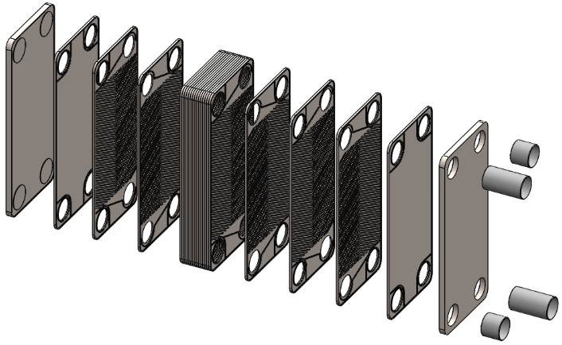
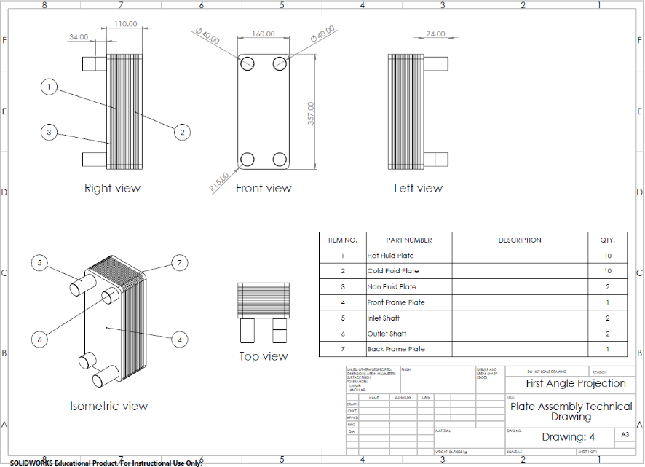
Figure 17: Technical drawing of a plate heat exchanger
Figure 18: Exploded view of an entire heat exchanger model

Conclusion
In conclusion, the aim of this report was to explore the theory of how DMLS could be used to redesign the thermal plates used in a heating and cooling plate heat exchanger. From the research conducted, it was found that by implementing DMLS there could be significant changes to the manufacturing process but minor changes to the functional features of the design. By 3D printing the plates in a single step process it eliminated the entire manufacturing process currently used. This included all traditional processes, starting from blast furnace right through to sheet metal forming. By eliminating these methods, it reduced manufacturing and labour costs, lead time, material waste and the process of welding but allowed the designer to have greater control over the design. In terms of functional features, the gaskets could be 3D printed which excluded the need to use extra material and allowed greater customisation, in regards of where the gasket could be printed.
FMEA proved to be a good success during the redesign as it allowed us to delve deeper into the manufacturing process and functional features of a typical design used in industry and investigate any potential failures. We could then focus on these failures and redesign the component in a way that it would reduce the severity and occurrence of these failures. QFD was also a useful tool as it provided us with direction with what customers wanted out of a thermal plate and what could realistically be achieved. By examining customer requirements, we could find out the areas in which our product was doing well and where it could be improved and assessing against other competitors.

Evaluation
Looking back at the redesign process, I believe that more could have been done in terms of investigating deeper into the functionality of the design, such as looking into Finite Element Analysis (FEA) to investigate how my redesign could have coped with thermal stresses, fatigue and external loads such as: force, pressure and temperature. Also, Computational Fluid Dynamics (CFD), to analyse the behaviour of fluid flow, temperature differentiation, heat flow, mass transfer and chemical reactions. Calculations could have been made to examine how the redesign performed in terms of its thermal conductivity and resistance, heat dissipation, temperature control and the quality of the fluid.
Despite of this, I still think the design can be achieved using 3D printing and it is a topic which could potentially be looked at further in the future. In general, I think 3D printing is the way forward in terms of future manufacturing capabilities, however, I believe there are still a few years to go before it can reach its full potential and we can be more reliant on it. But for now, traditional manufacturing seems to be a safe bet for many industries and customers.

References
Alfa Laval, 2004. The theory behind heat transfer. [Online]
Available at: https://www.alfalaval.com/globalassets/documents/microsites/heating-and-cooling-hub/alfa_laval_heating_and_cooling_hub_the_theory_behind_heat_transfer.pdf
[Accessed 22 02 2019].
Alfa Laval, 2017. How to minimize fatigue problems in plate-and-shell heat exchangers. [Online]
Available at: https://www.alfalaval.com/globalassets/documents/microsites/duroshell/power/alfa-laval--plate-and-shell-white-paper.pdf
[Accessed 17 02 2019].
ALFA LAVAL, 2018. How gasketed plate heat exchangers work. [Online]
Available at: https://www.alfalaval.co.uk/microsites/gasketed-plate-heat-exchangers/tools/how-gphes-work/
[Accessed 15 02 2019].
Bosrup, E., 2002. WHAT IS A HEAT EXCHANGER?. [Online]
Available at: https://www.lytron.com/Tools-and-Technical-Reference/Application-Notes/What-is-a-Heat-Exchanger
[Accessed 18 12 2018].
Brogan, R. J., 2011. HEAT EXCHANGERS. [Online]
Available at: http://www.thermopedia.com/content/832/
[Accessed 18 February 2019].
Danfoss, 2018. SONDEX® Fishbone plates. [Online]
Available at: https://www.danfoss.com/en/products/heat-exchangers/dhs/brazed-heat-exchangers/fishbone-plates/#tab-overview
[Accessed 19 02 2019].
GE Additive, 2019. What is Additive Manufacturing?. [Online]
Available at: https://www.ge.com/additive/additive-manufacturing
[Accessed 16 12 2018].
Ghaffara, S. H., Corkerb, J. & Fan, M. F., 2018. Automation in Construction. Additive manufacturing technology and its implementation in constructionas an eco-innovative solution, September, Volume 93, pp. 5-6.
Gibson, I., Rosen, D. W. & Stucker, B., 2015. Introduction and Basic Principles. In: Additive Manufacturing Technologies: 3D printing, rapid prototyping and direct digital manufacturing. 2nd ed. New York; London: Springer, p. 1.
Golin, E., n.d. PLATE HEAT EXCHANGER WORKING PRINCIPLE. [Online]
Available at: https://www.onda-it.com/eng/news/how-a-plate-heat-exchanger-works/plate-heat-exchanger-working-principle
[Accessed 12 02 2019].
Hydraulico, 2014. Production of heat exchanger plates. [Online]
Available at: https://www.hydraulico.com/solutions/heat-exchanger-plate-production.html
[Accessed 12 02 2019].
Incodema3D, 2017. DMLS Specifications. [Online]
Available at: http://www.incodema3d.com/dmls3d/dmls-specifications
[Accessed 13 02 2019].
Jardini, A. L., Larosa, M. A., A., K. & Kharmandayan, P., 2017. Additive Manufacturing in Medicine. Reference Module in Materials Science and Materials Engineering.
Morgan, R., 2019. Manufacturing Design and Technology. [Online]
Available at: https://moodle.uwtsd.ac.uk/course/view.php?id=2442
[Accessed 14 02 2019].
Mota, F. A. S., Carvalho, E. P. & Ravagnani, M. A. S. S., 2015. Modeling and Design of Plate Heat Exchanger. Heat Transfer Studies and Applications, 29 July.
Redwood, B., 2018. The Advantages of 3D Printing. [Online]
Available at: https://www.3dhubs.com/knowledge-base/advantages-3d-printing
[Accessed 19 02 2019].
Roschli, A. et al., 2014. Designing for Big Area Additive Manufacturing. Additive Manufacturing, Volume 25, p. 275.
SPETECH, n.d. GASKETS FOR PLATE HEAT EXCHANGER. [Online]
Available at: https://www.spetech.com.pl/en/about-us.html
[Accessed 20 02 2019].
UK Exchangers Ltd, 2018. GASKETED PLATE HEAT EXCHANGERS. [Online]
Available at: https://www.uk-exchangers.com/heat-exchange-products/gasketed-plate-heat-exchangers/
[Accessed 18 02 2019].
VIJAY, D. A. & SNEHALATHA, P., 2016. COMPUTER AIDED DESIGN AND ANALYSIS OF A HEAT EXCHANGER. International Journal of Science, Engineering and Technology Research (IJSETR), July, 5(7), p. 2522.
WTSML, n.d. PLATE AND GASKETS. [Online]
Available at: http://www.heatexchangersgasket.com/heat-exchanger-gaskets/heat-exchanger-gasket-product.html
[Accessed 18 02 2019].

Appendices

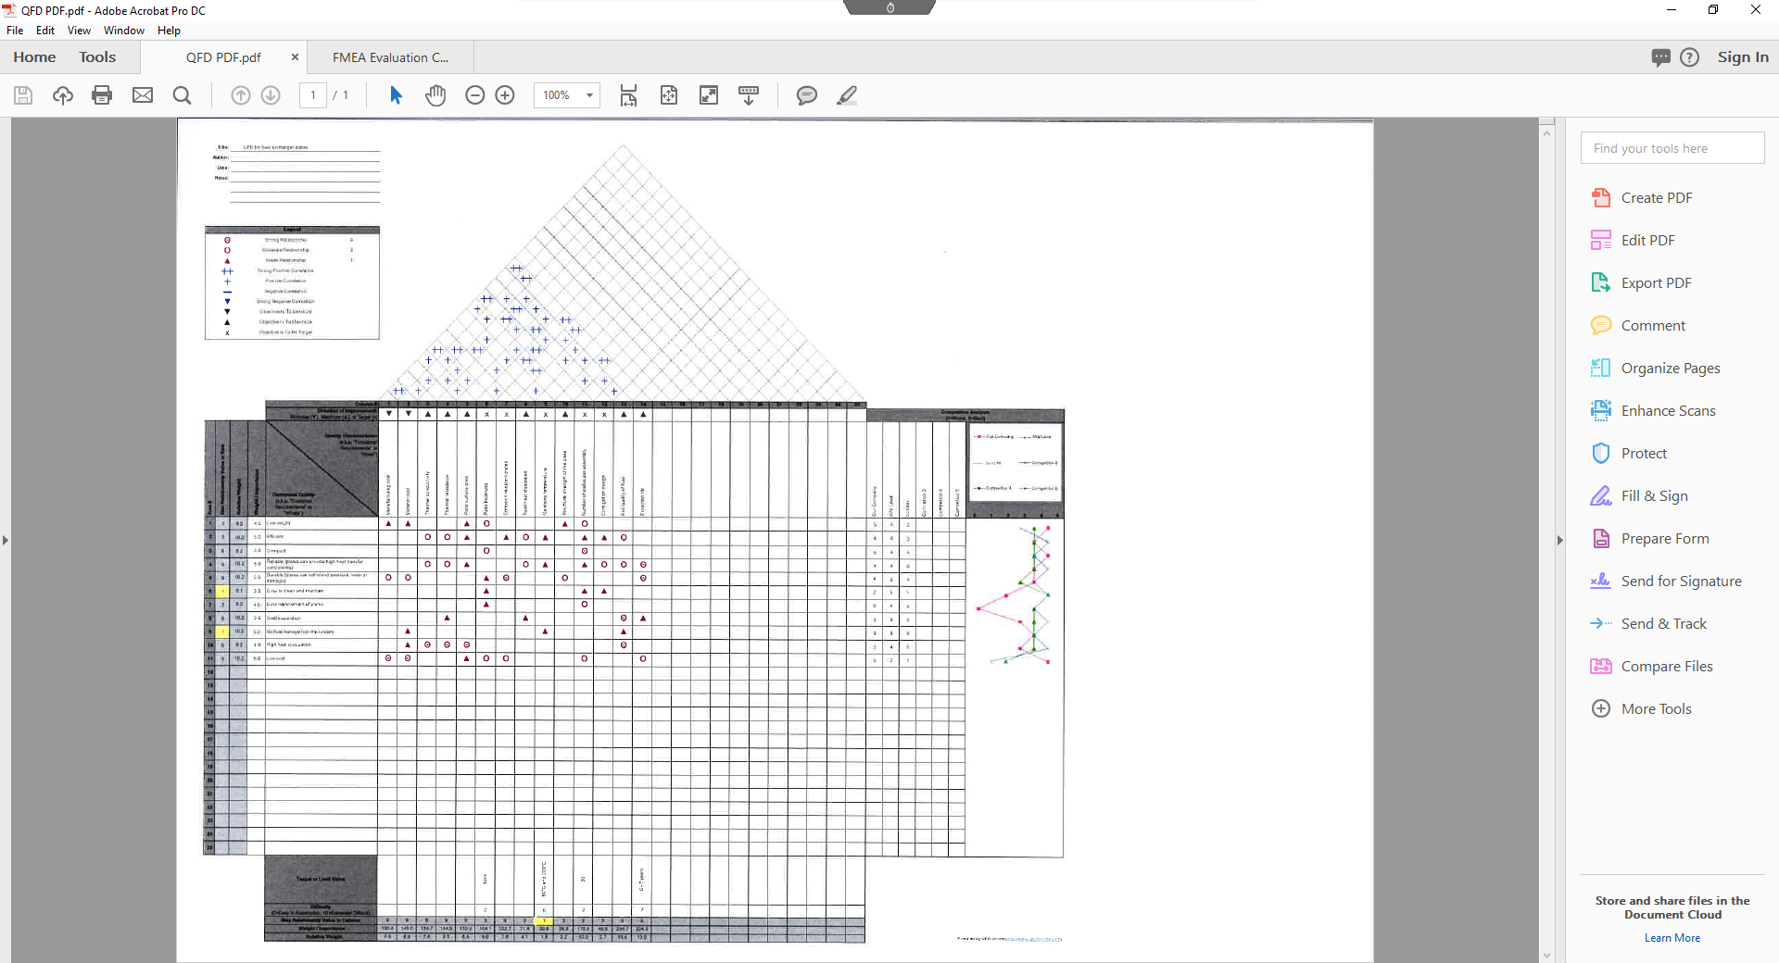
QFD template
Figure 19: QFD template

