The influence of Sustainable Relationship Marketing Policies and Practices and the Impact on the Organisation Performance

Roxana Meader
2222009
28/11/2024
University of Wales Trinity Saint David
BMSW5007_SWAN
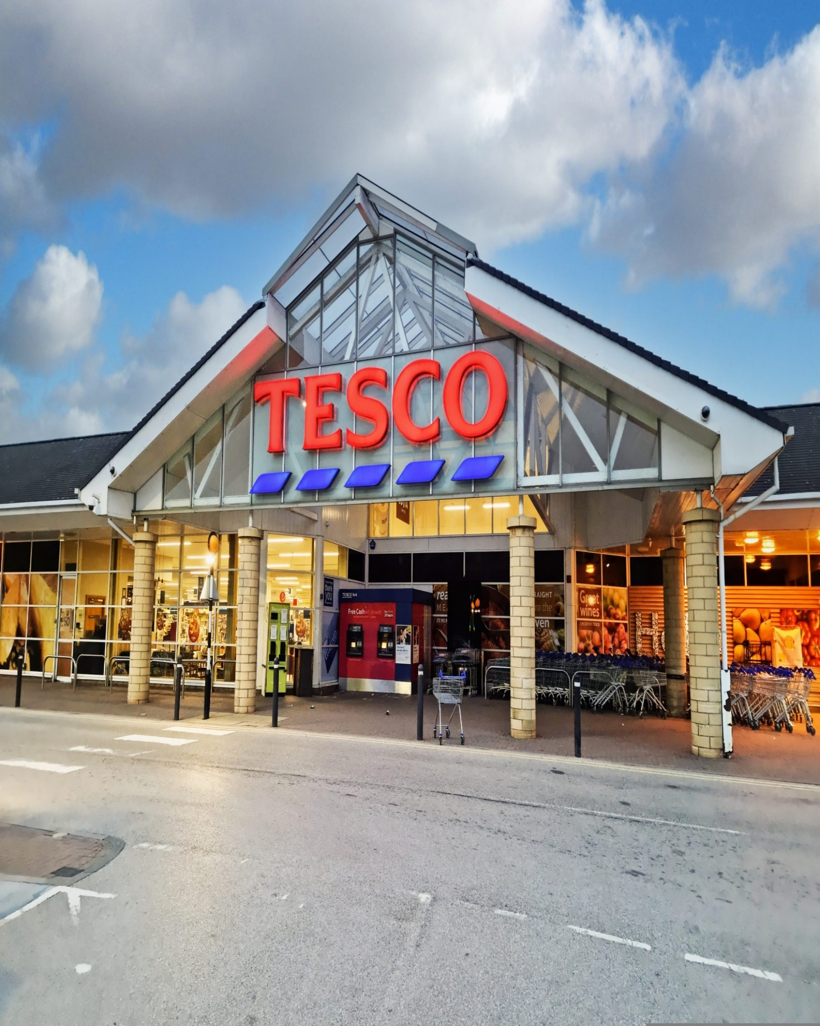

1.0. Executive Summary

This report is compiled to give an overview of Tesco PLC background and its marketing strategies, the main areas of success of its relationship management strategy and further possible recommendations that may ensure its further development.

Tesco has been the leading groceries retailer in the UK for the last 10 years, and it has based its success on focusing on a customer-orientated strategy. The company covers successfully many market segments and provides products that meet their customers’ needs. The customer centricity strategy is applied to every aspect of their business, from price, quality, customer service, logistics and sustainability.

Although the success of the company is still ongoing, there are some areas of their strategy that should be reenforced and focused on. Due to the rapid technological development, especially concerning AI and online marketing, Tesco needs to concentrate and further invest in its digital presence. The organisation needs to maintain the focus on ethical and sustainable practices and follow the data control policies and procedures.

Table of Contents

1.0. Executive Summary 1
2.0. Introduction 3
3.0. Main Findings
3.1. Brief Tesco historical development and growth 4-5

3.2. Task two-The impact of data collection on Market customer 6-7
relationship

3.3. Task three-Critical discussion on Tesco market strategies and 8-11
custom centrality and differentiation.

3.4. Ethics and Sustainability 12-14

4.0. Conclusion 15
5.0. Reference 16

2.0 Introduction

This report has been requested by the Marketing Executive Officer of ‘Marketing Focus’ and is part of the assignment for BMSW5007_SWAN module conducted by the lecturer Gwyneth Jones.
The report has been compiled by Roxana Meader and it is based on research collected from secondary sources such as academic textbooks, websites, journals and reliable online sources that were used to illustrate Tesco’s history, past and present development and the marketing strategies employed in its ascension.
The author has utilized the main research findings in a critical and analytical manner, trying to provide a clear picture of the organisation marketing approach, its benefits and disadvantages, and potential recommendations.

3.0. Main Findings

3.1. Brief History of Tesco PLC.

The birth of Tesco retailer company originates in 1924, when Jack Cohen began selling groceries from a stall in London. He had a vision of selling affordable food for every household; The name came about after Jack Cohen bought a shipment of tea from Thomas Edward Stockwell. He made new labels using their initials and he expanded his business from the first branded Tesco tea product in 1929, to opening a chain of stores that operates on multinational levels and being the third largest retailer in the world in 1919. (Tesco PLC., 2024).

Currently the company offers a variety of products such as fresh foods, bakeries, frozen foods, drinks, baby products, household appliances, pets’ products, entertainment, clothes and shoes, electronics and electrical goods, petrol, health and beauty products.

Tesco carries out its business to cater to customers’ needs and recently extended the shopping experience online. The significant influence on the business market is also emphasized by the banking, consultancy, telecom and insurance services that the company provides and its presence in Europe. (Global Data., 2024).

The mission statement of the organization remains in essence the same: “serving the customers, community and planet a little better every day.” (Tesco PLC, 2024), and it is a commitment of the company to put the customers’ values and needs at the center of its activity by providing better, healthier and more affordable choices and adhering to environmentally sustainable practices.

In 2024 Tesco is still the leading grocery retailer in the UK with a share of 27 percent of the market. (Bedford E., 2024).

According to Marketing Week in the preliminary results for year 2024 Tesco achieved “7.2% growth year-over-year to £61.48bn.” (Niamh Carroll, 2024).

Tesco PLC Annual Report and Financial Statement 2024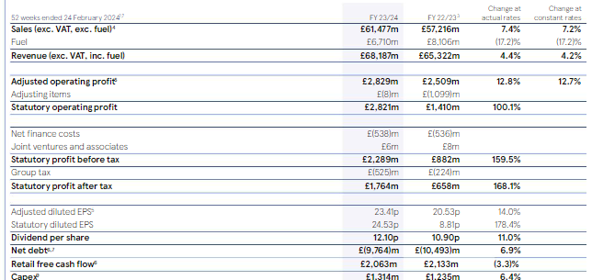
(Tesco PLC, 2024).
The picture above illustrates the annual financial report of the company in the current year, which shows an increase in sales and revenue, comparing to previous years. The picture below, shows Tesso leading in market share for the past 10 years.
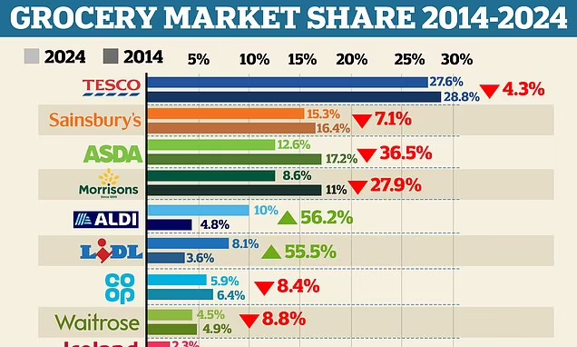This is money.co.uk. (2024).
In 1995 Tesco launched the membership Clubcard and According to Sky news, in 2024 Tesco attains considerable growth in customers after focusing its marketing strategy on value and price, and Tesco Clubcard covers 23 million households. (Sillars J., Sky News, 2024).

3.2. The impact of data collection on Market customer relationship

To create strong customers relations and sustainable retention, an organisation needs to gain insight into client’s needs, values, choices, habits, and backgrounds. Armstrong states that “The marketing world is filled to the brim with information from innumerable sources.” (Armstrong G., Kotler P., 2023).
According to Glazer data and information are crucial in the marketing field. (Glazer R.,1991).
Tesco collects data through the usual customer touch points, such as physical store with self-checkout and POS systems, CCTV and foot traffic analyses, web, computer, smart phone, customer service, surveys and feedback, email, social media, advertising, and through club cards.
As stated by BizTech there are four important types of customer data collected, such as: Identity data, descriptive data, behavioural data, and qualitative data, and they provide information on ethnicity, age, sex but also patters, behaviours, choices, feedback, and ratings. (BizTech, 2021).
The data collected will be analysed, stored, and used by the CRM system, which is the “core business strategy that aims to create and maintain profitable relationships with customers” (Buttle F., Maklan S.,1919). Tesco is using Dunnhumby as a data Hub.
The CRM will enable a better understanding of customers insights, will allocate more resources to add value to customer relationship, will “tailor and promote further products and services to customers in the way that the customers prefer, at the time that they need them, before they ask “and personalise communication with the clients.( Fairhurst P., 2001).
According to Medium.com Tesco Clubcard led to sale increase and elevated the organisation to the rank of leading supermarket retailer in UK. The Clubcard provided information to each customer and purchase but also the insights in how expenditure and choices varied. (Chowdhury B., 2023). The loyalty rewards programs are personalised and can enhance and strengthen the customer’s brand experience, and in essence “marketing is also carried out by buyers” by the continuous feedback they provide back into the market. (Kotler, P., Armstrong, G., et al., 2001, p 10).
In conclusion, data collection constitutes a key factor in the customisation and enhancement of customer relationships, which consequently will produce an increase in the lifetime value of the customers and their retention trough a boost in loyalty. In 2003, Paul Claussen introduced the term of 3R’s of customer loyalty based on three strategies that are rooted in data collection and CRM system.
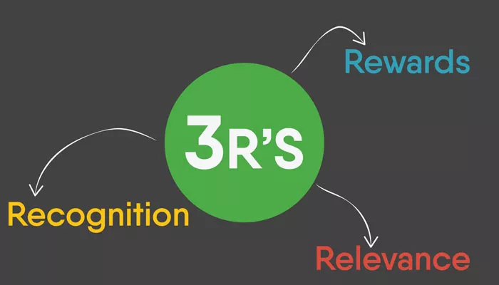
(Claussen P., 2003)

Additionally, data analyses can provide a competitive advantage and aid in the creation of personalised marketing.
According to Goodgrowth.co.uk limitations will arise due to the customers concerns on data privacy. Furthermore, the continuous increase in the volume of data can be a cause of “data blindness and the necessity for analytic tools, data quality and data privacy” should be brought forward. (Good Growth, 2024).

3.3. Critical discussion on Tesco marketing strategies,
custom centrality and differentiation

In present economy is not possible for a “company to target an entire market due to time and cost limitations” (The Economic Times, 2024). Consequentially, the market will divide into different segments that will aim to fulfil customers’ expectations, by providing products tailored to their own needs, behaviours, and backgrounds. Marketing segmentation is the key to successful, long term customer relationships.
From the beginning Tesco focus was customer orientated, and with the use of marketing segmentation strategies, the organisation is developing products designed to meet buyer’s needs. Therefore, Tesco concentrates on a differentiated market strategy, for different segments of the market and a mixture of segmented and micromarketing in small neighbourhood shops, such as Tesco Express.
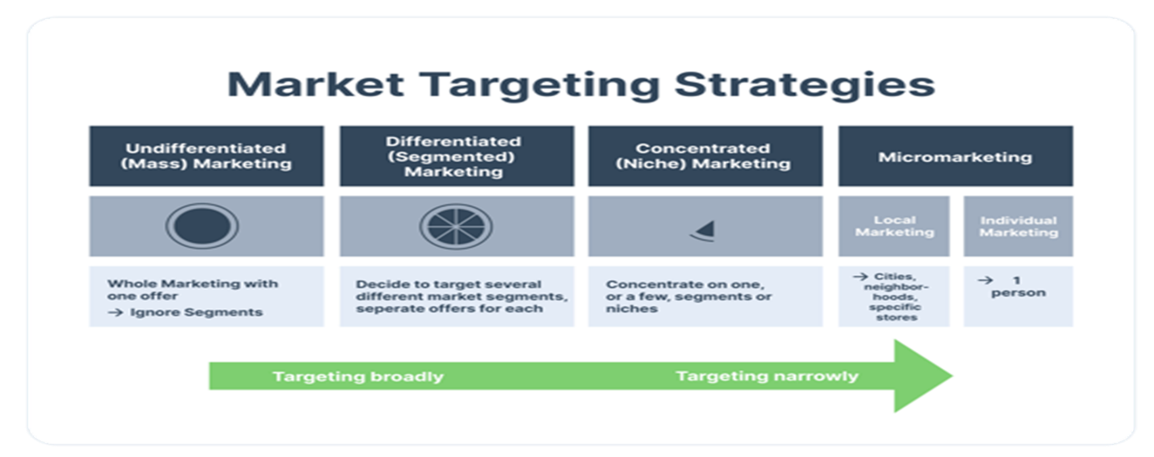From the data collection and analysis that Tesco is undertaking, the main segments of the market separate, based on the following types of marketing segmentation.

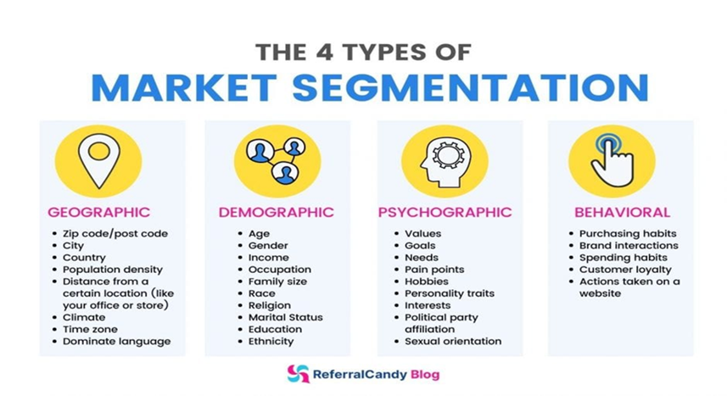
Tesco is using the segmentations strategies through loyalty cards, feedback, and targeted marketing campaigns. This way the organisation can reach a wider audience and can tailor products after customer needs. Tesco uses the geographic aspect to adapt the stores and optimise convenience, meeting the demands of different customers based on logistic and accessibility and operates a total of 2,048 small convenience stores in the United Kingdom, followed by 809 large stores. (Statista, 2024). In terms of accessibility Tesco also introduces the Scan as you shop technology which simplifies customer experience and saves time.
The demographic, behavioural and psychographic segmentation differentiates through the loyalty card which will provide information about age, gender, income, purchasing habits but also values, cultures, interests, and spending habits.
In this way the organisation customises its products and provides a wide range of items such as health-conscious options: vegan, vegetarian, organic, gluten free or any other dietary specific products. It also provides budget orientated products with the own label brands, Tesco Value and Tesco finest, which would satisfy the quality/budget specific audience. Using Behavioural segmentation Tesco provides discounts and rewards to the customers based on shopping patterns.
David Hughes argues that Tesco has been for a long time a leader in “taking the differentiated product approach forward” and identifies six customers segments. (Hughes D, 2014)

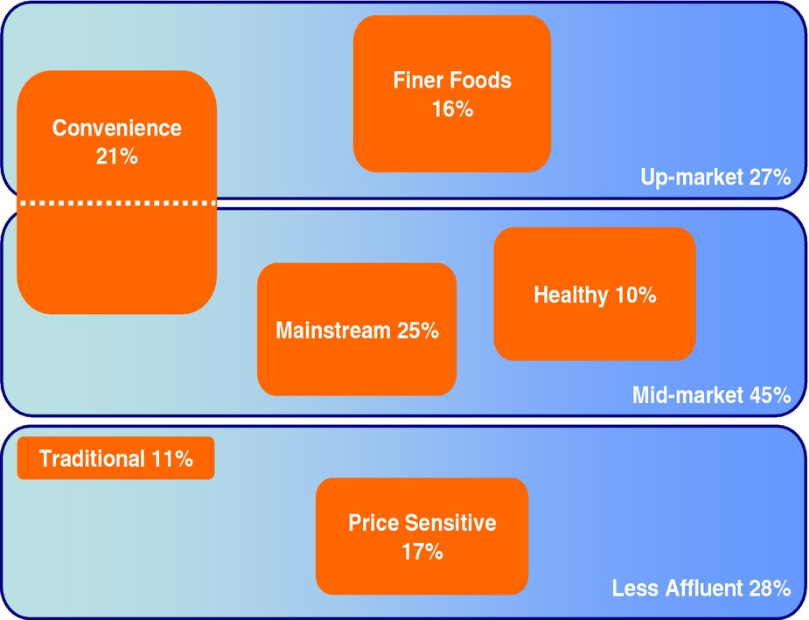

The product customisation come with few difficult aspects in terms of data privacy and price range. Whenever Tesco is providing products to its wide audience, is focusing is strategy on the marketing mix.

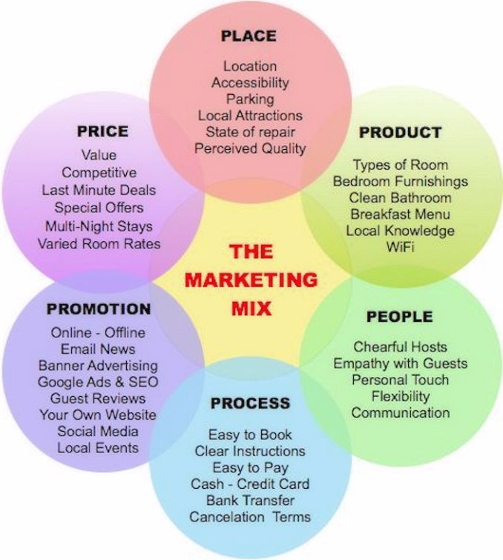
The marketing mix provides an extensive marketing plan which reveals the connection and inter collaboration of its elements with the purpose of generating sales. (Investopedia, 2024).
Reuters attests that Tesco’s marketing strategy is profitable, and customers are more interested in the quality of the products, Tesco finest brand is up with 15.7 % this year, the popularity of the club card is increasing and the strategy of matching prices of Aldi is advantageous. (Reuters, 2024).
In terms of competitive strategy Tesco is using a mixture of cost leadership and differentiation.

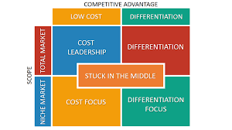
According to Porter’s theory there are two types of “competitive advantage an organisation can posses and those are low cost and differentiation” (Porter M. E., 1985).
Tesco is competing to achieve both advantages by using strategies as price reductions, with the Tesco value brand, but also by matching prices with competitors. The organisation is attempting to differentiate on multiple levels, such as reward strategy with club card, product quality with unique ranges as Tesco finest, price decrease and price match with own brand products, customer convenience and accessibility by introducing Scan as you shop.
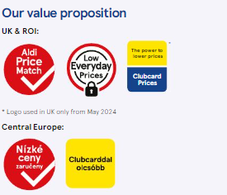

Regardless of Tesco’s steady growth and marketing strategy, controversy can still arise that may damage the organisation image or customer relations. According to BBC News, there is a discrepancy between Tesco’s price match with Aldi’s and the product quality. The article in question can affect Tesco image and customer perception. (BBC News, 2024). Additionally, the club card program will always be at risk to raise privacy and data concerns.

3.4 Ethics and sustainability

Ethics constitutes one of the main pillars of a successful business and according to Bryars and Stanbery “a company enters a social contract with the society as a whole” and must strive to achieve social benefits. (Byars, S. M., & Stanberry, K. 2018).
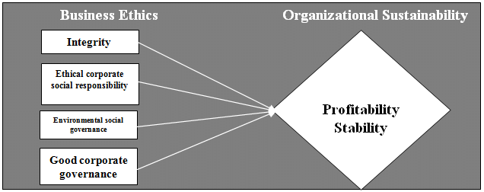
By extension Tesco PLC values are committed to its customers, community and employees and it is functioning responsibly in terms of sustainability.
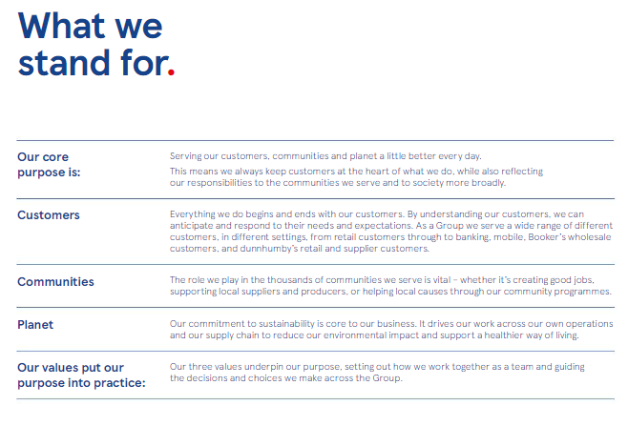
By providing customised products and services Tesco ensures its customer centrality and upholds its commitment to the buyers’ values and needs. The club card offers the insight into the current choices and needs of the audience and allows Tesco to reinforce its sustainability practice by offering products with reduced environmental impact and orientated on health and wellbeing.
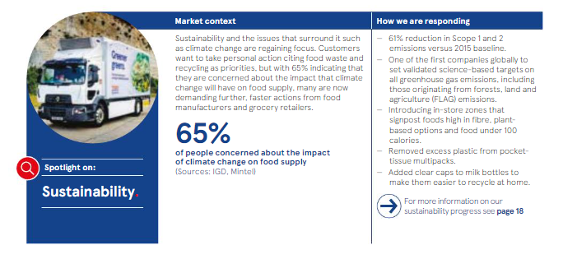

In 1987, the United Nation defined sustainability as “meeting the needs of the present without compromising the ability of future generations to meet their own needs.” (United Nations, 1987)

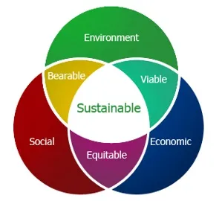
According to the Legal Quotient economic stability regards the “practices and policies that support long-term economic growth without negatively impacting social, environmental, or cultural aspects of a society.” (More H., 2024).

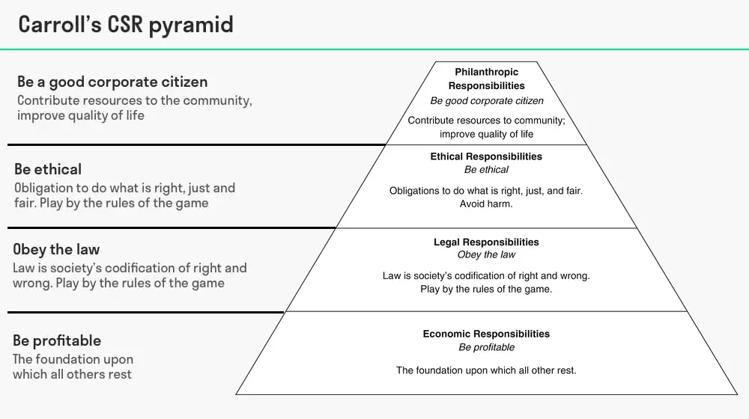
(Carol A.,2016).
In accordance with the CSR pyramid Tesco is “engaging in practices and takes responsibilities”( BA theories, 2022) on all four levels by ensuring economic growth, following the Employment, Health and Safety laws, by using the moral and ethical principles of the society when dealing with stakeholders, customers, employees and by engaging in philanthropical activities like food donations and charity partnerships.

The theoretical views are multiple and differ in message, Friedman believes that a business holds no social responsibility, and the implementation of CSR might impede its efficiency (Friedman M., 1970).
Tesco understands that in a continuous changing world the ethical and sustainability values are the way forwards and is committed to environmental health and its legal and moral obligations towards its stakeholders.

4.0 Conclusion

In conclusion, the leadership place that Tesco occupies in UK market in terms of shares and international sales is a result of successful CRM strategies. The organisation is orientated on extensive customer centric strategies and loyalty programs, engaging customers online and in shops, providing personalised products and recommendation through Club Card and monthly magazine. With the involvement in community and CSR practices such as, reducing the carbon footprint, engaging in different charity works, investing in environmentally conscious products, reducing plastic usage, Tesco built a favourable image focused on customer centrality and sustainability.
Tesco should continue to consolidate its customer centric strategies but keep in mind that privacy and customers data will aways bring forward breaching risks. Tesco’s internet presence is gradually getting stronger, but there is nowhere close to some competitors such as Amazon. Therefore, close attention and investment into digital strategy, should be promoted. The investment should be extended to further involvement into community initiatives, such as supporting local businesses, maintaining eco-friendly and fair-trade approaches and reach carbon neutrality as predicted by 2035.

5.0 Reference

Armstrong G., Kotler P. (2023). Marketing an introduction. 15th ed. London: Pearson Education Limited. p.124.

BA Theories. (2022). Carroll’s CSR Pyramid: Understanding the Four Levels. [Online]. BA Theories. Last Updated: February 26, 2022. Available at: https://www.batheories.com/csr-pyramid/?noamp=mobile [Accessed 27 October 2024].

BBC News. (2024). Aldi price match at Tesco - some goods not like-for-like. [Online]. BBC News. Last Updated: 23 September 2024. Available at: https://www.bbc.co.uk/news/articles/c0m0vrmlzgyo [Accessed 26 October 2024].

Bedford E. (2024). Tesco PLC - statistics & facts. [Online]. Statista. Last Updated: Jun 14, 2024. Available at: https://www.statista.com/topics/3807/tesco-plc/#topicOverview [Accessed 18 October 2024].

Buttle F., Maklan S. (2019). Customer relationship management. 4th ed. New York: Routledge. p.17.

Niamh Carroll. (2024). Tesco CEO claims retailer ‘more competitive than ever’ on value. [Online]. MarketingWeek. Last Updated: 10 Apr 2024. Available at: https://www.marketingweek.com/tesco-ceo-more-competitive-value [Accessed 23 October 2024].
Byars, S. M., & Stanberry, K. (2018). Business Ethics. OpenStax College, Rice University.

Carroll, A.B., 2016. Carroll’s pyramid of CSR: taking another look. International journal of corporate social responsibility, 1(1), pp.1-8.

Chowdhury B. (2023). The Role of Data in Tesco’s Retail Success: A Look at the Clubcard Strategy. [Online]. Medium. Last Updated: Mar 5, 2023. Available at: https://medium.com/@boktiarchowdhury/the-role-of-data-in-tescos-retail-success-a-look-at-the-clubcar [Accessed 25 October 2024].

Davie J. (2024). UK's Tesco forecasts profit rise as consumer sentiment improves. [Online]. Reuters. Last Updated: April 10, 2024. Available at: https://www.reuters.com/world/uk/britains-tesco-expects-profit-rise-202425-year-2024-04-10/ [Accessed 26 October 2024].

Friedman M. (1970). A Friedman doctrine‐- The Social Responsibility of Business Is to Increase Its Profits. [Online]. The New York Times. Last Updated: Sept. 13, 1970. Available at: https://www.nytimes.com/1970/09/13/archives/a-friedman-doctrine-the-social-responsibility-of-busines [Accessed 27 October 2024].

Glazer, R. (1991). Marketing in an Information-Intensive Environment: Strategic Implications of Knowledge as an Asset. Journal of Marketing, 55(4), 1-. https://doi.org/10.2307/1251953

Global Data. (2024). Tesco Plc: Overview. [Online]. Global Data. Last Updated: November 2024. Available at: https://www.globaldata.com/company-profile/tesco-plc/ [Accessed 18 October 2024].

Good Growth. (2024). The Data-Driven Rise of Supermarket Loyalty Cards and the Risk of Data Blindness. [Online]. Good Growth. Last Updated: 2024. Available at: https://goodgrowth.co.uk/articles/the-data-driven-rise-of-supermarket-loyalty-cards-and-the-risk-of- [Accessed 25 October 2024].

Fairhurst, P. (2001). e-CRM. Journal of Database Marketing & Customer Strategy Management, 8(2), 137–142. https://doi.org/10.1057/palgrave.jdm.3240028

Hughes, D. (2014). European Food Marketing: Adding Value in Mature Food Markets through Market Segmentation and Product Differentiation. EuroChoices, 13(2), 20–26. https://doi.org/10.1111/1746-692X.12058

Investopedia. (2024). Marketing Mix: The 4 Ps of Marketing and How to Use Them. [Online]. Investopedia. Last Updated: July 30, 2024. Available at: https://www.investopedia.com/terms/m/marketing-mix.asp [Accessed 26 October 2024].

Kotler, P., Armstrong, G., Saunders, J., & Wong, V. (2001). Principles of Marketing, 2nd edition. Corporate Communications, 6(3), 164–165. https://doi.org/10.1108/ccij.2001.6.3.164.1

More H. (2024). Sustainable Development. [Online]. The Legal Quotient. Last Updated: September 14, 2024. Available at: https://thelegalquotient.com/social-laws/environmental-laws/sustainable-development/4811/ [Accessed 27 October 2024].

Porter, Michael E., "Competitive Advantage". 1985, Ch. 1, pp 11-15. The Free Press. New York.

Sillars J. (2024). Tesco sees sales growth after focus on value and rise in premium shoppers. [Online]. Sky news. Last Updated: 3 October 2024. Available at: https://news.sky.com/story/tesco-credits-value-drive-for-hike-to-annual-profit-expectations -13226956 [Accessed 24 October 2024].

Smith E. (2021). The 4 Types of Consumer Data That Matter to Retailers. [Online]. BizTech. Last Updated: 29 September 2021. Available at: https://biztechmagazine.com/article/2021/09/4-types-consumer-data-matter-retailers-perfcon#:~:text=C [Accessed 24 October 2024].

Statista. (2024). Number of Tesco group stores in the United Kingdom (UK) as of financial year end 2023/24, by type. [Online]. Statista. Last Updated: 2024. Available at: https://www.statista.com/statistics/490955/tesco-group-stores-by-type-united-kingdom-uk/ [Accessed 26 October 2024].

Tesco. (18th October 2024). Our history. [Online]. Tesco plc.com. Last Updated: 18th October 2024. Available at: https://www.tescoplc.com/about/our-history [Accessed 18 October 2024].

The Economic Times. (2024). What is 'Segmentation'. [Online]. The Economic Times. Last Updated: 26 October 2024. Available at: https://economictimes.indiatimes.com/definition/segmentation [Accessed 26 October 2024].

This is money.co.uk. (2024). Grocery market share. [Photograph]. London: This is money.co.uk.

United Nations. (1987). Sustainability. [Online]. United Nations. Last Updated: 1987. Available at: https://www.un.org/en/academic-impact/sustainability#:~:text=Sustainable%20development%20requires%20 [Accessed 27 October 2024].

