5OS01 - Specialist Employment Law
Claire Milligan
Contents
Task 1.1 1
Task 1:2 5
Task 1:3 10
Task 2 15
Bibliography 15

Task 1.1

Evaluate the aims and objectives of employment regulation
(AC 1.1)
Employment law regulates the relationship between employers and employees. It governs what employers can expect from employees, what employers can ask employees to do, and employees’ rights at work. (CIPD, 2022)
Employment laws safeguard organisations because they specify what should be covered in employee contracts, disciplinary rules, holiday entitlement and policies, for example, to ensure the organisation is clear on its expectations, within the law. As well as contracts the Employment Law covers equal pay, holiday entitlement and pay, working hours, grievance procedures, disciplinary procedures, maternity and paternity leave, different types of discrimination, equality and diversity in the workplace, reasonable adjustments for employees with disabilities, the redundancy process and much more. Employment law is there to achieve social justice. (DANIELS, 2022)
They are also there to safeguard the employee, to ensure good hiring practices are followed, good conduct and of course fair pay. Employees are covered by some laws before they are even hired, the Equality Act 2010 for example prohibits discrimination based on any membership from a set of 9 characteristics, these are: - Sex, Marital status and civil partnership, Pregnancy and maternity, Race, Disability, Gender reassignment, Sexual Orientation, Religion and Belief and Age. (DANIELS, 2022)
To sum up, the aim and objective of employment regulations and the laws is to ensure all staff members have a right to a safe working environment and are treated equal. The law protects against the unjust, ensuring such things like slavery and child labour do not exist.

Examine the role played by the tribunal and court systems in enforcing employment law
(AC 1.2)
In the UK, there are 2 main categorised laws, ‘civil law’ and ‘private law’. A claimant could be an employee or worker, a former employee or worker, or an unsuccessful job applicant. The claimant will use the court and the tribunal system to allege that the respondend (the person being sued) has done them some form of detriment and in doing so has broken the contravention of the law. (CIPD, 2021)
There are 2 main types of court, Criminal and Civil. Cases are brought to the Criminal court when an employer is accused of failing to comply with health and safety regulations, or employed someone illegally by breaching immigration regulations, as an example. If a case is taken to the criminal court the burden of proof always lies with the prosecution. A criminal court will not convict unless it is certain ‘beyond reasonable doubt’ that the defendant is guilty. Civil courts operate differently. Here the courts look at proof ‘on the balance of probability’. The burden of proof also changes, depending on who is claiming against who. (CIPD, 2021)
Cases usually start in 1 of 3 courts: -
- The employment tribunal – breach of employment statue, can hear over 80 types of claims, heard by usually 3 people (but not always) Government funded, ACAS supported, claimants don’t pay fees, appeals are taken to the EAT (Employment Appeals Tribunal)
- The county courts – breach of common law
- The High Court – common law, damages more than £50,000 personal injury or £15,000 in all other cases, parties represent themselves or by a lawyer, appeals taken to the Court of Appeal
Which court depends in part on the legal matter of the claim and partly on the level of compensation being sought. (CIPD, 2021)
You can appeal to the Employment Appeal Tribunal (EAT) if you think a legal mistake was made in an employment tribunal case.
For example, you could appeal if it:
- got the law wrong
- did not apply the correct law
- did not follow the correct procedures and this affected the decision
- had no evidence to support its decision
- was unfairly biased towards the other party
EAT is independent and will listen to both sides before deciding. (DANIELS, 2022)

Explain how cases are settled before and during legal proceedings
(AC 1.3)
Cases can be settled before and during legal proceedings.
Early Conciliation
The early conciliation process was introduced in April 2014 and became compulsory in May 2014, unless the claim is for one of 5 specific reasons:
- The claim is against the secret service
- Another person already has an Early Conciliation number
- The claim is against an insolvent employer
- The claim involves multiple claimants
- There is an application is for interim relief
The claim cannot go to the Employment Tribunal without first engaging in the Early Conciliation process. The EC process starts by the claimant contacting the service ACAS. Once this is done the below is put in place: - (DANIELS, 2022)

ACAS Early Conciliation Flowchart
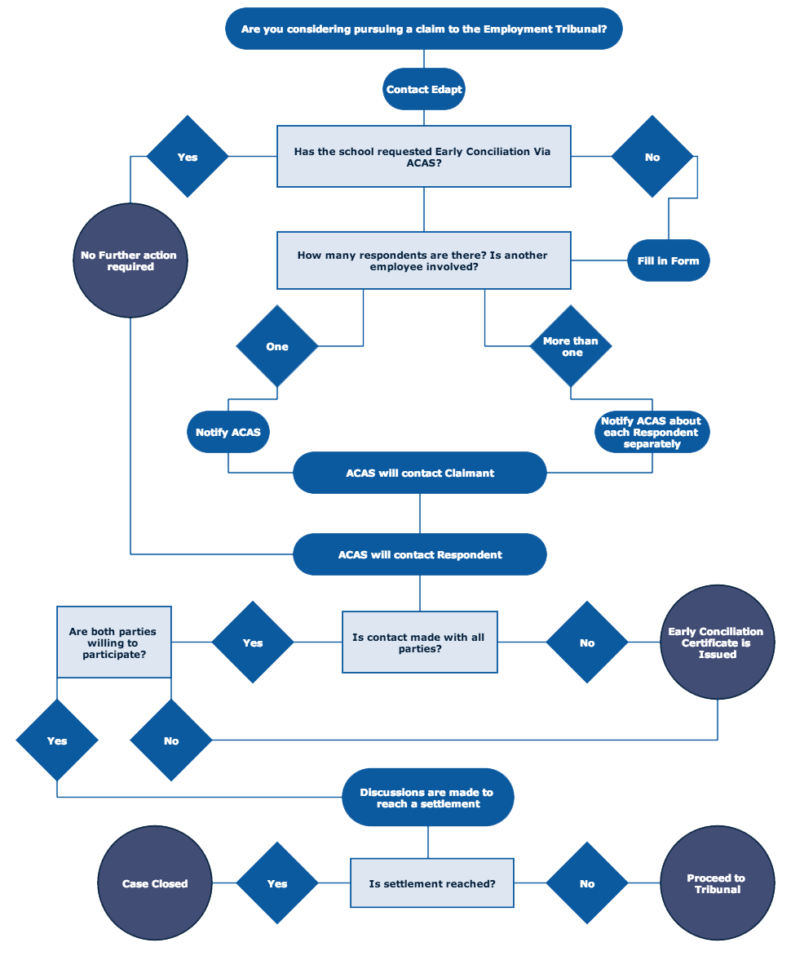(ACAS, 2021)
Employment Tribunal
If a case goes to the Employment Tribunal ACAS have a statutory duty to try and facilitate a settlement, even if this was already attempted through the Early Conciliation process. A payment of a financial sum is normally covered during the conciliation process. If both sides agree a settlement through ACAS the claim is then withdrawn through the Employee Tribunal, once this is done a form known as COT3 is completed, once this form is signed neither side can pursue any matter relating to this case. (DANIELS, 2022)
A settlement can be agreed between each party without the involvement of ACAS, these settlements must be made in writing and agreed by both parties, these are referred to as settlement agreements and have the same status as COT3 forms. (DANIELS, 2022)
The claimant can still withdraw their claim at any stage by informing the Employment Tribunal that there is no intention to pursue. (DANIELS, 2022)

Flowchart

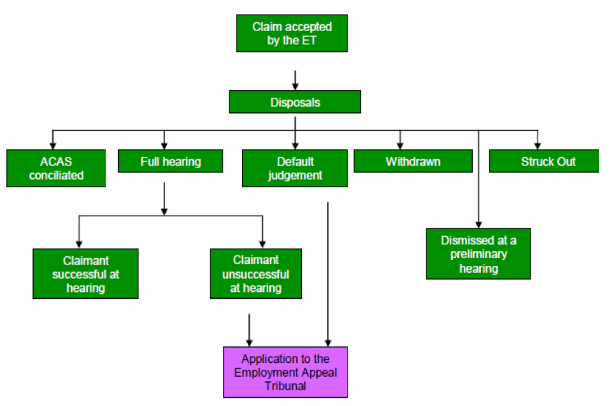
(Guide to Tribunal Statistics Quarterly, 2022)

Before a case is listed the notes will be read by a judge. The Employee Tribunal will send directions to both parties to allow time to prepare for the hearing. Once all the evidence has been heard at the hearing the Employment Tribunal will retire to reach a verdict. Any decision will always be confirmed in writing. (DANIELS, 2022)

Task 1:2

Explain the statutory rights workers have in relation to pay
(AC 4.1)
The Equality Act 2010, which replaced the original Equal Pay Act of 1970, covers the principles of equal pay.
The Equal Pay Act of 1970 (now part of the Equality Act 2010) came about after concerns were raised about the unfair treatment of women in the workplace, mainly around terms of pay and conditions of employment. Women have the right to be paid the same as men. (CIPD, 2021)
As well as gender, the law also requires organisations to not pay any employee less or put them at a disadvantage based on their disability, race, religion, sexual orientation. (CIPD, 2021)
The law also requires employers to give workers a basic rate of pay. These are:
 | 23 and over | 21 to 22 | 18 to 20 | Under 18 | Apprentice
April 2021 (current rate) | £8.91 | £8.36 | £6.56 | £4.62 | £4.30
April 2022 | £9.50 | £9.18 | £6.83 | £4.81 | £4.81
(GOV.UK, 2022)
Statutory Sick Pay, or SSP, was first introduced in 1983 to provide a prescribed amount of pay to employees unable to work due to short-term illness. To be eligible for SSP, an individual must be an ‘employee’ or agency worker, earn on average at least £120 per week, and have been ill or self-isolating for at least seven consecutive days. SSP is paid by employers from the fourth day of sickness absence at a flat rate of £96.35 per week (for April 2021 to April 2022) for a maximum of 28 weeks. The SSP rate is uplifted every April. (CIPD, 2019)
Employees and workers have the right to an itemised pay statement. The contents of the pay statement were revised on 6 April 2019, and now must include:
- Gross salary
- Any elements of variable pay
- Deductions from the gross amount, and their purpose
- Net salary
- Amount of method of any part payments (if any)
If the salary varies according to the amount of time worked the total number of hours worked must be specified. (CIPD, 2019)

Explain the major statutory rights in leave and working time
(AC 4.2)
Annual Leave
From April 6, 2009, a worker has been entitled to 5.6 weeks (28 days) paid leave, which includes the 8 public holidays in the UK. Workers are entitled to be paid a sum equivalent to a week’s pay for each week of leave. (DANIELS, 2022)
Case law example - Bowden and others v Tuffnel Parcels Express Ltd (2001) IRLR 838
Maximum working week
The number of hours worked, including overtime, must not exceed an average of 48 hours per week over a 17-week reference period. A worker can work over this amount in a week however they must work under it in another week to ensure the average is no more than 48 hours over the 17-week period. (DANIELS, 2022)
Case law example – Barber and others v RJB Mining (UK) Ltd (1999) IRLR 308
Night work
Night work is defined as a period that is not less than 7 hours and includes the normal hours of 11pm to 6am, a ‘night worker’ is normally someone who works at least 3 hours during this time. A night worker does not have to work these hours each week but there is a regular feature of their pattern of work. (DANIELS, 2022)
Case law example – R v Attorney General for Northern Ireland (1999) IRLR 315
Rest breaks
All adult workers are entitled to at least 11 consecutive hours rest in every 24-hour period. Young workers (under 18) are entitled to rest periods not less than 12 hours in every 24-hour period. (DANIELS, 2022)
A worker is entitled to at least 24 hours uninterrupted rest in every seven-day period. (DANIELS, 2022)
If a workers day lasts more than 6 hours the worker is entitled to a rest period, the length of the break can be collectively agreed but it must be for at least 20 minutes. Young workers are entitled to 30 minutes break for every 4.5 hours worked. (DANIELS, 2022)
Case law example – Kepak v Grainne O’Hara (2018) ADJ-00008654
Statutory sick pay
There is no legal requirement for an employer to have a sick-pay scheme, however all employers are required to pay SSP when an employee qualifies for such payments. Employees who have been continually sick for four or more calendar days in a row are entitled to earn SSP. Any day which SSP is claimed must be on an ordinary day the employee would work. SSP is claimed for a maximum of 28 weeks in any 12-month period. (DANIELS, 2022)

Explain the main principles of maternity, paternity, and adoption rights in the context of employment rights
(AC 4.3)
Maternity
Maternity protection is there to cover a woman through the periods of antenatal care, care at work during the pregnancy and during her maternity leave. All pregnant women have a right to paid time off for antenatal appointments. Proof of pregnancy and appointments in normally required by the employer. When an employer learns of a pregnancy they must complete a risk assessment, to identify if it remains appropriate to continue to carry out her role, without any fear of harm to herself or her baby, if this is the case she should be moved to an appropriate alternative or suspended on full pay on maternity grounds. (DANIELS, 2022)
There are three periods of maternity leave:

Compulsory maternity leave | No employee may work for her employer for the two weeks following the date of childbirth
Ordinary maternity leave | All pregnant women are entitled to take 26 weeks leave regardless of their length of service
Additional maternity leave | All pregnant women are also entitled to take 26 weeks AML leaves, regardless of length of service, which starts immediately after their OML finishes, giving a total of 52 weeks.
(DANIELS, 2022)

During maternity leave the employee is:
- Entitled to all the benefits of all the terms and conditions of employment
- Bound by any obligations arising under those terms and conditions
During ML statutory and contractual holiday will continue to accrue throughout. Employees can work up to 10 days during their maternity or adoption leave. These days are called 'keeping in touch days'. Keeping in touch days are optional - both the employee and employer need to agree to them. (DANIELS, 2022)
Paternity
Statutory paternity leave was introduced by the Employment Act in 2002. To qualify, the employee must have worked for at least 26 weeks. Employees can choose to take either 1 week or 2 consecutive weeks’ leave. The amount of time is the same even if they have more than one child (for example twins).
Leave cannot start before the birth and must finish within 56 days of the birth (or due date if the baby is early). The start and end dates are different if the employee is adopting. (GOV.UK)
Shared parental leave
An employee and/or their partner may be able to get Shared Parental Leave (SPL) and Statutory Shared Parental Pay (ShPP). They can share up to 50 weeks of leave and up to 37 weeks of pay. They need to share the pay and leave in the first year after the child is born or placed within the family.
SPL can be taken in blocks separated by periods of work or take it all in one go. They can also choose to be off work together or to stagger the leave and pay. (GOV.UK)
Employees can work up to 20 days during their Shared Parental Leave. These are called 'shared parental leave in touch' (or SPLIT) days. These days are in addition to the 10 KIT days already available to employees on maternity or adoption leave. (GOV.UK)
Adoption leave
Adoptive leave gives 24 weeks' leave off work to one parent of the adopting couple or a parent who is adopting alone. The 24 weeks start from the date the child is placed in your care. Your employer does not have to pay you during adoptive leave unless it is stated in your contract. (GOV.UK)

Explain other employment rights relating to flexible working
(AC 4.4)
‘Flexible working relates to an organisation’s working arrangements in terms of the time, location, and pattern of working. With more and more people thinking differently about how, when and where they work, flexible working is increasingly helping people access the labour market and stay in work.’ (CIPD, 2021)
Some flexible practices include:
- Part time working | - Term time working | - Flexitime
- Compressed hours | - Annual hours | - Working remotely on a regular basis
- Mobile working | - Career breaks | - Commissioned outcomes
(DANIELS, 2022)
Every employee has the statutory right to ask to work flexibly after 26 weeks' employment service. An employee can only make a statutory request once in any 12-month period.
A request from an employee under the Employment Rights Act 1996 and regulations made under it must be in writing and must include the following information:
- What effect, if any, they think the requested change would have on you as the employer and how, in their opinion, any such effect might be dealt with

- A statement that this is a statutory request and when they have made a previous application for flexible working

(DANIELS, 2022)
All requests must be considered carefully looking at the benefits of the requested changes in working conditions for the employee and the business and weighing these against any adverse business impact of implementing the changes.
If the request is rejected, it must be for one of the following business reasons as set out in the legislation:
- the burden of additional costs | - an inability to reorganise work amongst existing staff
- an inability to recruit additional staff | - a detrimental impact on quality
- a detrimental impact on performance | - a detrimental effect on ability to meet customer demand
- insufficient work for the periods the employee proposes to work | - a planned structural change to your business

If the request is rejected, the employee should have the right to appeal the decision. (DANIELS, 2022)
Requests can be made for several reasons, some are:
- Childcare
- Family life
- Work life balance
- Religious grounds
Employee may need to take time off unexpectedly, for emergencies for example, this is normally where time off is taken without pay. (DANIELS, 2022)
However, it is important to note that it does not matter why the employee is requesting flexible working, it can be for whatever reason they wish, the reason itself is not relevant. (DANIELS, 2022)

Task 1:3

Evaluate the principles of discrimination law in recruitment, selection, and employment
(AC 2.1)
Discrimination in the workplace can take many forms, it is worth noting when looking at discrimination law, that the remit of legislation is broader than for many other areas of the law. (DANIELS, 2022)
There are 6 types of discrimination, these are:

Direct | This is where an individual is treated less favourable than someone else on the grounds of a protected characteristic, i.e., a male not being allowed to conduct an examination on a female alone, because he is a male.
Associative | This is treating someone less favourably because they associate with someone of a particular protected characteristic, i.e., a parent being treated less favourably because they have a disabled child
Perceptive | This is treating someone less favourably because it is perceived that they are a part of a protected group, even if they are not, i.e., an employer might assume a candidate’s race based on their name alone
Indirect | This is where an employer applies to all a provision, criterion or practice which puts people at a disadvantage, i.e., asking a Christian employee to work on Sundays
Harassment | This refers to behaviour that creates an intimidating or hostile environment, it’s worth noting that anyone can complain of behaviour that may not be directed at them, but they find offensive.
Victimisation | This refers to penalising employees in some way for exercising their rights under the Equality Act 2010
(DANIELS, 2022)
There are 9 protected characteristics, these are:

Age | The Equality Act 2010 says that you must not be discriminated against because:  - you are (or are not) a certain age or in a certain age group  - someone thinks you are (or are not) a specific age or age group, this is known as discrimination by perception  - you are connected to someone of a specific age or age group, this is known as discrimination by association  Age groups can be quite wide (for example, ‘people under 50’ or 'under 18s'). They can also be quite specific (for example, ‘people in their mid-40s’). Terms such as ‘young person’ and ‘youthful’ or ‘elderly’ and ‘pensioner’ can also indicate an age group.
Disability | The Equality Act 2010 says that you must not be discriminated against because:  - you have a disability  - someone thinks you have a disability (this is known as discrimination by perception)  - you are connected to someone with a disability (this is known as discrimination by association)  It is not unlawful discrimination to treat a disabled person more favourably than a non-disabled person.
Gender Reassignment | The Equality Act 2010 says that you must not be discriminated against because you are transsexual, when your gender identity is different from the sex assigned to you when you were born. For example:  - a person who was born female decides to spend the rest of his life as a man  In the Equality Act it is known as gender reassignment. All transsexual people share the common characteristic of gender reassignment.  To be protected from gender reassignment discrimination, you do not need to have undergone any specific treatment or surgery to change from your birth sex to your preferred gender. This is because changing your physiological or other gender attributes is a personal process rather than a medical one.  You can be at any stage in the transition process – from proposing to reassign your gender, to undergoing a process to reassign your gender, or having completed it.
Marriage and Civil partnership | The Equality Act says you must not be discriminated against in employment because you are married or in a civil partnership.  In the Equality Act marriage and civil partnership means someone who is legally married or in a civil partnership. Marriage can either be between a man and a woman, or between partners of the same sex. Civil partnership is between partners of the same sex.  People do not have this characteristic if they are:  - single  - living with someone as a couple neither married nor civil partners  - engaged to be married but not married  - divorced or a person whose civil partnership has been dissolved
Pregnancy and Maternity | It is unlawful pregnancy discrimination to treat an employee unfavourably:  - because she is pregnant,  - for a reason relating to her pregnancy, or  - because of illness related to her pregnancy,  It is unlawful maternity discrimination to treat a pregnant employee unfavourably because she is about to go on maternity leave.
Race | The Equality Act 2010 says you must not be discriminated against because of your race. In the Equality Act, race can mean your colour, or your nationality (including your citizenship). It can also mean your ethnic or national origins, which may not be the same as your current nationality. For example, you may have Chinese national origins and be living in Britain with a British passport.  Race also covers ethnic and racial groups. This means a group of people who all share the same protected characteristic of ethnicity or race.  A racial group can be made up of two or more distinct racial groups, for example black Britons, British Asians, British Sikhs, British Jews, Romany Gypsies and Irish Travellers.  You may be discriminated against because of one or more aspects of your race, for example people born in Britain to Jamaican parents could be discriminated against because they are British citizens, or because of their Jamaican national origins.
Religion or belief | The Equality Act 2010 says you must not be discriminated against because:  - you are (or are not) of a particular religion  - you hold (or do not hold) a particular philosophical belief  - someone thinks you are of a particular religion or hold a particular belief (this is known as discrimination by perception)  - you are connected to someone who has a religion or belief (this is known as discrimination by association)  In the Equality Act religion or belief can mean any religion, for example an organised religion like Christianity, Judaism, Islam or Buddhism, or a smaller religion like Rastafarianism or Paganism, if it has a clear structure and belief system.  The Equality Act also covers non-belief or a lack of religion or belief. For example:  - the Equality Act protects Christians if they are discriminated against because of their Christian beliefs, it also protects people of other religions and those with no religion if they are discriminated against because of their beliefs
Sex | The Equality Act 2010 says you must not be discriminated against because:  - you are (or are not) a particular sex  - someone thinks you are the opposite sex (this is known as discrimination by perception)  - you are connected to someone of a particular sex (this is known as discrimination by association)  In the Equality Act, sex can mean either male or female, or a group of people like men or boys, or women or girls.
Sexual Orientation | The Equality Act 2010 says you must not be discriminated against because:  - you are heterosexual, gay, lesbian or bisexual  - someone thinks you have a particular sexual orientation (this is known as discrimination by perception)  - you are connected to someone who has a particular sexual orientation (this is known as discrimination by association)  In the Equality Act, sexual orientation includes how you choose to express your sexual orientation, such as through your appearance or the places you visit.
(Equality and human rights, 2022)

There are two types of harassment related to sex; both involve unwanted conduct that has the purpose or effect of violating an individual’s dignity or creating an intimidating, hostile, degrading, humiliating or offensive environment for that individual, sexual harassment, and Sex-based harassment. (CIPD, 2021)
The law protects individuals from harassment while applying for a job, in employment and in some circumstances after the working relationship has ended. (CIPD, 2021)
Under s39(1)(a) of the Equality Act, an employer can discriminate in arrangements for advertising jobs, the actual content of the job ad, the job description or person specification. Poor wording in advertisements can be used as evidence of an intention to discriminate and a job applicant who is rejected or who doesn’t apply because they don’t meet the criteria may, for example, bring a claim of age or sex discrimination. (CIPD, 2021)
Section 159 of the Act permits employers to treat one person more favourably than another equally qualified person in connection with recruitment or promotion. This enables employers to consider the under-representation of disadvantaged groups when selecting between two equally qualified job candidates. This part of the Act is entirely voluntary, but the provisions are complex and must be handled carefully. Any positive action steps an employer takes must be proportionate to meet its needs. (CIPD, 2021).

Discuss the requirements of equal pay
(AC 2.2)
‘The Equality Act 2010 gives both women and men the right to equal pay for equal work, with women and men being legally entitled to be paid at the same rate for like work, work rated as equivalent, and work of equal value.’ (CIPD, 2019)
The right to make a claim under equal pay legislation applies to employees and to anyone with a contract to carry out any work personally. (CIPD, 2019)
Pay reporting aims to encourage employers to reward people fairly. All large UK employers are required legally to disclose certain earnings data by gender.
To bring an equal pay claim, an individual must choose a person of the opposite sex as their comparator. The individual must then show that the comparator is engaged in:
- 'Like work', or
- 'Work rated as equivalent' under an analytical job evaluation study, or
- work of 'equal value'.
If an individual believes that they are receiving less pay or benefits for like work, their first course of action should be to raise a grievance in accordance with the employer's grievance procedure. (CIPD, 2019)
The remedy most awarded by a tribunal is a monetary award. This will consist of:
- future pay and benefits at the same level as the complainant's comparator (if he or she is still in the same job) and
- back pay (with interest) representing the difference in pay for a period of up to six years (five years in Scotland) before the date on which proceedings are commenced.
There are three main ways organisations can defend an equal pay claim. They can show:
- the woman and her comparator are not doing equal work
- the chosen comparator is not legally valid (for example, he is not in the same employment)
- the difference in pay is due to a material factor.
The EHRC has recommended that, to prevent equal pay claims, all employers should carry out equal pay audits or reviews to elicit comprehensive information on how their pay and benefit systems operate and the effect such systems have on people of a particular sex. These reviews can also operate as a risk management tool to highlight areas such as race, religion, disability, or age discrimination. (CIPD, 2019)

Word count - 3168

Task 2

Provide an email response covering the following:
(3.1)
- Outline when and how the staff from the closed site can be moved to work at another site.
- Briefly explain the main requirements of individual redundancy consultation
(3.2)
- If the site was not closing and had been taken over by a competitor, summarise the main requirements of a service provision change in relation to TUPE

From: Claire Milligan, HR Officer, ABC limited
To: Joe Bloggs, Managing Director, ABC limited
Date: 3rd Match 2022
Subject: Site closure
Hi Joe,
(3.1) Whilst I am sorry to hear of the closure of one of our sites, I understand that the business is vastly changing, and we need to make compromises to accommodate these changes. As a business there are many things we need to consider, I will outline these below:
* Meeting affected 5 staff separate meeting rest of workforce (implications to them, business safety)
* change process
* Consultation
* agreement for change process
* contract check/change of contract/is location included (make this up?)
* flexibility options/travel/different shift patterns/expense for travel
* redundancy options/how much//how calculated/holiday
(3.2) tupe in detail

Bibliography
TASK 1

CIPD. 2022. Employment Law | CIPD. [online] Available at: <https://www.cipd.co.uk/knowledge/fundamentals/emp-law> [Accessed 22 February 2022].
DANIELS, K., 2022. INTRODUCTION TO EMPLOYMENT LAW. 6th ed. [S.l.]: KOGAN PAGE
CIPD. 2022. UK Court System & Employment Law | Factsheets | CIPD. [online] Available at: <https://www.cipd.co.uk/knowledge/fundamentals/emp-law/about/uk-court-system-factsheet> [Accessed 25 February 2022].
https://www.acas.org.uk/early-conciliation/how-early-conciliation-works
GOV.UK. 2022. Guide to Tribunal Statistics Quarterly. [online] Available at: <https://www.gov.uk/government/statistics/tribunal-statistics-quarterly-april-to-june-2021/guide-to-tribunal-statistics-quarterly> [Accessed 25 February 2022].
CIPD. 2022. Equal Pay Q&As | CIPD. [online] Available at: <https://www.cipd.co.uk/knowledge/fundamentals/emp-law/equal-pay/questions> [Accessed 25 February 2022].
GOV.UK. 2022. National Minimum Wage and National Living Wage rates. [online] Available at: <https://www.gov.uk/national-minimum-wage-rates> [Accessed 2 March 2022].
GOV.UK. 2022. Statutory Paternity Pay and Leave: employer guide. [online] Available at: <https://www.gov.uk/employers-paternity-pay-leave> [Accessed 2 March 2022].
Cipd.co.uk. 2022. [online] Available at: <https://www.cipd.co.uk/Images/sick-pay-reform_tcm18-104511.pdf> [Accessed 2 March 2022].
CIPD. 2022. Information on Flexible Working | CIPD. [online] Available at: <https://www.cipd.co.uk/knowledge/fundamentals/relations/flexible-working> [Accessed 2 March 2022].
CIPD. 2022. Sex Discrimination at Work | Factsheets | CIPD. [online] Available at: <https://www.cipd.co.uk/knowledge/fundamentals/emp-law/sex-discrimination/factsheet> [Accessed 3 March 2022].
Equalityhumanrights.com. 2022. Protected characteristics | Equality and Human Rights Commission. [online] Available at: <https://www.equalityhumanrights.com/en/equality-act/protected-characteristics> [Accessed 8 March 2022].
TASK 2

