
Certificate of Higher Education in Skills for the Workplace (Health and Social Care)
Effective teamworking and communication (BMSW4002)
January 3, 2022
Alil Lyuman (1815745)
LECTURER: Joy Botu

Table of Contents

Introduction 2
Models of Communication 2
Shannon and Weaver Model of Communication 4
Wilbur Schramm & Osgood Model of Communication 5
David Berlo Model of Communication 6
Communication Between Catering Assistants and Patients 7
Successful Communication 7
Conflict in Communication 7
Conclusion 8
Bibliography 8

INTRODUCTION
Successful communication can be challenging, especially in a fast-paced environment such as busy hospital wards. Catering assistants can be stressed under time pressure and most patients are naturally in a vulnerable state in an unfamiliar environment for them. These contribute to disruption in communication.
This report discusses types of communication, evaluates different models of communication, uses communication between catering assistants and the patients as an example to explore possible disruptions to effective communication and suggest strategies to improve communication.
MODELS OF COMMUNICATION
Communication is defined as “a process by which information is exchanged between individuals through a common system of symbols, signs, or behaviour” (Merriam Webster, 2021). It is important to study different models of communication to explore strategies for effective communication. The exchange of information can be done via speech, writing, non-verbal methods or electronic environment. The medium used to relay information is referred as a “channel”.

There are various verbal and non-verbal tools used to establish successful communication between individuals. Verbal language can be incredibly communicative and direct. Verbal skills include open questions, closed questions, summarising, negotiation, educated guesses, paraphrasing, clarifying and reflection (Thompson, 2017). Verbal communication can be spoken or written. Spoken communication is not merely about words. There is tone, intonation and pace of the language that has an effect on the quality and clarity of the communication (Willkomm, 2018). Written communication is as widely used as spoken communication. Examples include an email, a letter, a leaflet, a contract, or a post on social media. Therefore, it is important to obtain the skills to be able to promote a message clearly and concisely using either spoken or written methods.

Non-verbal communication includes eye contact, facial expressions, posture, gestures and touch. Non-verbal communication can reveal much more than what is being conveyed with verbal communication (Willkomm, 2018). Inconsistencies between verbal and non-verbal communication might reduce the quality of communication by creating confusion or it may indicate that in fact, the person themselves does not agree with what they are saying. Non-verbal communication is very accessible, easy to illustrate and can reduce the time spent trying to convey a message. However, they can be imprecise and hard to interpret in some situations. Thus, there is a risk of distortion of information that is being exchanged (Verbal and Non-Verbal Communication, 2021)

In addition, verbal or non-verbal cues can be used to enhance communication between two parties. In healthcare context, cues are defined as “a verbal or non verbal hint which suggests an underlying unpleasant emotion and would need clarification from the health provider” (Del Piccolo et al, 2006). Some of the non-verbal cues can be challenging to identify e.g. breath patterns, flushed cheeks, dilated pupils but addressing to these cues can help establish a rapport with the other person by building trust between individuals.
There are three types of communication models: linear, interactive, transactional (Amudavalli, 2021). Linear models present communication in a one-way system where one person speaks and the other listens. In linear models, there is no reference to feedback at all (Amudavalli, 2021). This means the receiver can not display any feedback (verbal or non-verbal). However, majority of the situations where people communicate include some type of feedback mechanism.
Interactive models remove the drawback of lack of feedback. In these models, communication is shown as a two-way process where the same person can act as the sender and the receiver of the message. Essentially, the interactive model can be thought as two overlapping linear models which can create a feedback system (verbal, non-verbal or both) (Amudavalli, 2021). However, the feedback can only happen once the message has been received.
Transactional models suggest that communication is a continuous process where the message can be sent and received simultaneously. This is an improvement to the interactive model’s lack of simultaneous ongoing feedback (Corey, 2021).

Shannon and Weaver Model of Communication (1948)
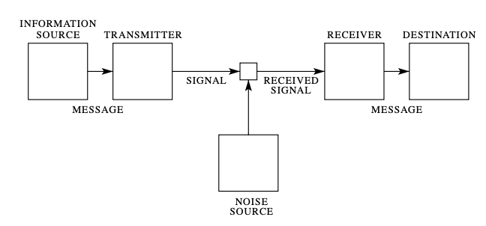
Figure 1: Shannon and Weaver’s Communication Model (Baecker, 2011)
As seen in Figure 1, Shannon and Weaver’s linear communication model which was created in 1948 is considered to be the foundation of communication models. This model consists of information source, transmitter, message, receiver, destination and noise source. Message is the information or statement that is being sent. Information source refers to production of the message. Transmitter refers to production of a signal that is suitable to be transmitted through the channel. Receiver receives the signal and reconstructs the message. Finally, the message reaches the destination, the person the message was sent for. Noise source produces noise which is anything that is irrelevant and prevents successful communication.
Shannon and Weaver’s model presents communication as unidirectional however, in everyday life the communication rarely lacks feedback.
Wilbur Schramm & Osgood Model of Communication (1954)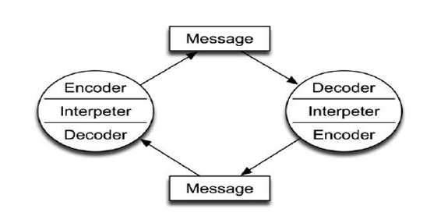
Figure 2: Schramm and Osgood Model of Communication (QS Study, 2021)
Schramm and Osgood’s model of communication, as seen in Figure 2, is a circular and interactive model, unlike the other models mentioned in this report. Each person can act as the sender and the receiver. Here is an example case: Assuming an environment with minimal distractions or “noise”, the catering assistant, the encoder, sends a “message” (Would you like a cup of tea?). The patient, the decoder, receives and interprets the message. The patient responds (Yes, with two sugars please.) i.e. forms a message. The patient now becomes the encoder. The catering assistant receives and interprets the patient’s response thus becomes the decoder. As seen from this example, this dynamic communication model includes feedback as a part of the process which makes it representative of everyday life. However, it does not account for the “noise” e.g. differences in cultural background, socioeconomics or education (Amudavalli, 2021).

David Berlo Model of Communication (1960)
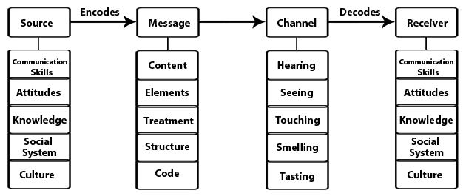
Figure 3: Berlo’s SMCR Model of Communication (Communication Theory, 2021)
David Berlo’s linear communication model, shown in Figure 3, focuses mainly on the source (producer of the message) and the receiver (receiver of the message). There are four components in Berlo’s model and each component includes many sub-components. This model relies on the communication skills of both the source and the receiver (Amudavalli, 2021). For example, if the source can generate a message using high quality communication skills, the receiver should be equally competent in listening to receive the message.
One of the criticisms this model receives is therefore that it is not representative of everyday life. The source and the receiver rarely have the same level of communication skills. Another criticism this model receives is that it leaves no room to represent “noise”, which can be defined as anything that could disrupt effective communication (Communication Theory, 2021). There are only five channels in this model, which are all physical senses. There is no reference to critical thinking, analysing, and understanding which are arguably a few of the most important factors in communication.

COMMUNICATION BETWEEN CATERING ASSISTANS AND PATIENTS
Successful communication
Successful communication between catering assistants and patients ensures that the information given to the patient is clear and the information gathered from them is correct. Multiple communication strategies can be used to negotiate shared decision making while acknowledging the patient’s concerns and preferences.
Variety of strategies can be used to improve communication between catering assistants and patients. Firstly, clear and accessible language should be used to help the receiver (the patient) to interpret the message faster and correctly. Since many patients are tired or not feeling well, using visual aid to simplify the “message” for them can improve communication. To facilitate appropriate interpretation of the message, external factors that may disrupt communication e.g. noise should be minimised. Moreover, building a rapport with the patient will make it easier to understand them and encourage them to listen attentively. Using non-verbal cues can create a more welcoming and trusting environment for the patient to feel more open and valued during the communication process. For patients with special needs, different types of communication should be available. For example, using pictures, realia or demonstrations might help convey the message clearly. Information should be available in different languages for patients who are not fluent in English (NHS England, 2021).
It would be a good idea to offer communication skills training for catering assistants to enhance their communication skills and help them implement the strategies mentioned above. It should also be noted that appropriate non-verbal communication tools should accompany verbal communication to ensure effective exchange of information. For example, appropriate posture, gestures, eye contact and smiling can enhance communication.
Conflict in communication
From my personal experience of working as a catering assistant in an NHS hospital, I observed conflicts in communication between patients and healthcare workers. There are multiple contributing factors that can disrupt effective communication. For example, professional barriers to communication can be due to differences in beliefs or culture, fears, conditions at workplace or lack of communication skills (Thompson, 2017). For instance, the wards in the hospitals can get noisy, especially within a Nightingale ward layout. This creates a barrier for effective communication with the patients. There were many instances where I had to repeat myself or could not hear the patient in a busy and noisy ward. This consequently creates frustration for the patient since they are unable to communicate their needs, concerns or preferences. This increases the risk of misunderstandings.
In addition, some elderly patients have dementia or hearing difficulties. An example from my experience would be that when I asked a patient about their preferences for their tea, their response was unrelated to my question. The patient did not acknowledge my question and kept talking about his personal life or memories. Dementia is a relatively common condition I see in the wards, and it contributes to disruption in communicating with some patients. Some patients do not remember what they ordered for their meal and insist on having something that they did not order. This can then lead to frustration, and it is challenging to communicate with the patients in situations such as this.
Aggressive behaviour is a big disrupter of effective communication. Aggressive patients usually have loud speech and distracted mind. They have difficulties encoding a message and keeping eye contact. Therefore, the catering assistant, who is the decoder, can not interpret the message. In this case, the communication fails to be successful. To resolve this conflict, the catering assistants should leave the patient to calm down and revisit them later for another attempt at communicating. However, when the conflict arises due to the meal provided by the catering assistants, it should be resolved as soon as possible. This means the catering assistant should ask for help from colleagues or management staff. It is important that the catering assistant keeps eye contact with the patient, has an open posture with no distracting gestures to aid de-escalation.
CONCLUSION
Communication is vital for productivity in the workplace. In healthcare environment, effective communication is essential for good outcomes for patient health and safety as well as patient and healthcare staff satisfaction. Thus, improving communication between staff and patients using various strategies should be prioritised in healthcare settings.
Word count: 1830
BIBLIOGRAPHY
Amudavalli, 2021. Theories & Models of Communication. [online] Available at: <https://pdf4pro.com/view/theories-amp-models-of-communication-e-pgpathshala-3eb1a5.html> [Accessed 1 January 2022].

Baecker, D., 2011. Systemic Theories of Communication. [online] Available at: <https://www.researchgate.net/publication/228176300_Systemic_Theories_of_Communication> [Accessed 1 January 2022].

Basu.org.in. 2021. Verbal and Non-Verbal Communication. [online] Available at: <https://www.basu.org.in/wp-content/uploads/2020/08/Verbal-and-non-verbal-communication.pdf> [Accessed 2 January 2022].

Communication Theory. 2021. Berlo's SMCR Model of Communication. [online] Available at: <https://www.communicationtheory.org/berlos-smcr-model-of-communication/> [Accessed 29 December 2021].

Corey, A., 2021. Chapter 1: Introducing Communication. [online] Ecampusontario.pressbooks.pub. Available at: <https://ecampusontario.pressbooks.pub/evolutionhumancommunication/chapter/chapter-1/> [Accessed 29 December 2021].

Merriam Webster. 2021. [online] Available at: <https://www.merriam-webster.com/dictionary/communication> [Accessed 2 January 2022].

NHS England. 2021. Good Communication with Patients Waiting for Care. [online] Available at: <https://www.england.nhs.uk/coronavirus/wp-content/uploads/sites/52/2021/01/C0855-i-good-communication-with-patients-guidance-v2.pdf> [Accessed 2 January 2022].

Qsstudy.com. 2021. Schramm's Model of communication - QS Study. [online] Available at: <https://qsstudy.com/schramms-model-communication/> [Accessed 1 January 2022].

Thompson, S., 2017. Communication Skills.

Willkomm, A., 2018. Five Types of Communication. [online] Goodwin College of Professional Studies. Available at: <https://drexel.edu/goodwin/professional-studies-blog/overview/2018/July/Five-types-of-communication/> [Accessed 2 January 2022].

Wyatt, J., 2005. Communication and navigation around the healthcare system. ABC of health informatics, [online] 331(7528), pp.1325–1327. Available at: <https://www.ncbi.nlm.nih.gov/pmc/articles/PMC1298860/> [Accessed 1 January 2022].

