1920269
Congeita Clarke-Young
BMHP5003_ BIRM
Introduction to Physiology
Rachael Rivers

Anatomy of Human Body
How are Heart Functions.


Anatomy of Human Heart How are parts Functions
(Istock,2022)
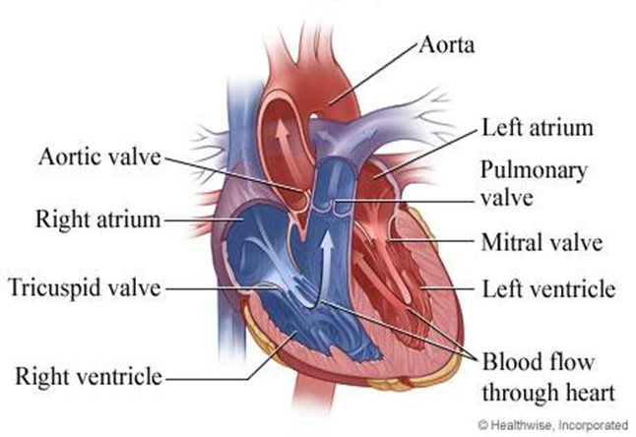
Pulmonary artery
Major vessel that is also called trunk were the lower chambers of the heart that is low within oxygen forwards blood to the Lungs according to The Pulmonary Artery: Where Blue Blood Goes to Get Red Again (2022),”The left and right pulmonary arteries that are separate the pulmonary artery. These arteries carry blood to the lungs that which is low in oxygen and high in carbon dioxide (The Pulmonary Artery: Where Blue Blood Goes to Get Red Again, 2022).

Superior Vena cava
Blood that travels through the chest, arms, head neck According to NCI Dictionary of Cancer Terms (2022), “The blood from the chest, arms, head, and neck flows through the superior vena cava (NCI Dictionary of Cancer Terms, 2022).

(Frankel Cardiovascular Centre,2022).
Pulmonary valve
One of 4 main valve which controls the flow of blood that is forced through the lower right side of the heart chamber also stated by Pulmonary valve repair and replacement - Mayo Clinic (2022), “The pulmonary valve is one of four valves that control blood flow in the heart. It's between the lower right heart chamber (right ventricle) and the artery that delivers blood to the lung’s pulmonary artery (Pulmonary valve repair and replacement - Mayo Clinic, 2022).

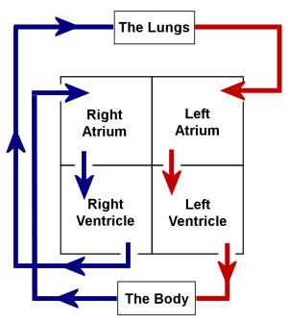
Pulmonary vein
Human body this helps towards carrying Oxygen- rich blood to your lungs then trough to your heart according to Pulmonary Veins: Anatomy and Function (2022), “The only veins in your body that carry oxygen-rich blood are your pulmonary veins. The blood in all of your other veins lacks oxygen (Pulmonary Veins: Anatomy and Function, 2022).
(Walden, 2022).

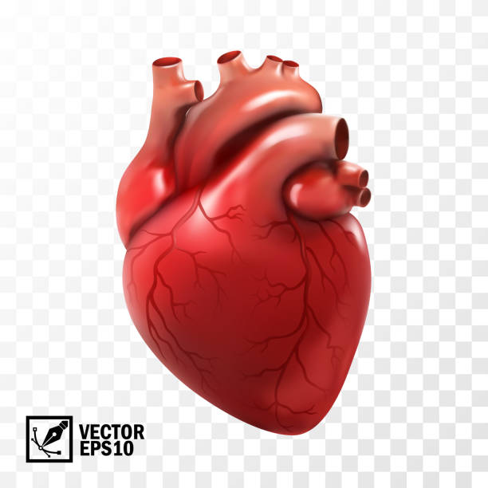
Tricuspid valve
The valve which is situated between the hearts two right chambers that consists of three very thin flaps which are called leaflets which then open to let blood flow from the upper right According to Tricuspid Valve | The Keyhole Heart Clinic (2022), “Between the heart's right atrium and right ventricle is the tricuspid valve. Typically, it consists of three flaps known as the septal, anterior, and posterior leaflets. The tricuspid valve prevents blood from backflowing from the right atrium to the right ventricle (Tricuspid Valve | Keyhole Heart Clinic, 2022).

Mitral valve
Contributes to the flow of blood that runs through your heart then stops the blood from flowing backwards then flows to the rest of the body also stated by Mitral valve: Function, anatomy, and diseases (2022), “ Between the left atrium and left ventricle on the left side of the heart is a flap of tissue known as the mitral valve. It prevents blood from flowing backward and keeps blood flowing forward from the atrium into the ventricle. Mitral valve: Function, anatomy, and diseases, 2022).

(Mitral valve: Function, anatomy, and diseases, 2022).
(Gstatic image, 2022)

Inferior Vena Cava
Blood from the feet, legs, also organs in the abdomen and pelvis are carried by inferior vena cava. Within the body this is largest vein According to Pulmonary artery - Wikipedia, (2022), “An artery in the pulmonary circulation that carries deoxygenated blood to the lungs from the right side of the heart is called a pulmonary artery (Pulmonary artery - Wikipedia, 2022).

Aortic Valve
This is a part of four valves that help control the blood flow within the heart which also separates the lower heart chamber According to Aortic valve (2022), “Along with the mitral, tricuspid, and pulmonary valves, the aortic valve is one of the heart's four valves. The left ventricle and the ascending aorta are separated by the aortic valve (Kenhub, 2022).

References
Cleveland Clinic. (2022). Pulmonary Veins: Anatomy and Function. Available at: <https://my.clevelandclinic.org/health/body/23242-pulmonary-veins> (Accessed 27 September 2022).
Encrypted-tbn0.gstatic.com. (2022). Available at: <https://encrypted-tbn0.gstatic.com/images?q=tbn:ANd9GcS8Sj7XlRsdxsmSnu7fO_8fG0_qzbEyc4uAQA&usqp=CAU> (Accessed 7 October 2022).
Frankel Cardiovascular Centre, (2022). Comprehensive Heart Valve Program Available at: https://www.umcvc.org/conditions-treatments/comprehensive-heart-valve-program (Accessed 7 October 2022).
iStock (2022). Cartoon Hearts Pictures Images and Stock Photos Available at: https://www.google.com/search?q=image+of+cartoon+heart (Accessed 27 September 2022).
Kenhub. (2022). Aortic valve. Available at: <https://www.kenhub.com/en/library/anatomy/aortic-valve> (Accessed 29 September 2022).
Keyhole Heart Clinic. (2022). Tricuspid Valve | The Keyhole Heart Clinic. Available at: <https://www.thekeyholeheartclinic.com/services/valve-disorders/tricuspid-valve/> (Accessed 18 October 2022).
Library, S., (2022). illustration of the human heart anatomy - Stock Image - F023/6064. Science Photo Library. Available at: <https://www.sciencephoto.com/media/982197/view/illustration-of-the-human-heart-anatomy> (Accessed 19 September 2022).
Mayo clinic.org. (2022). Pulmonary valve repair and replacement - Mayo Clinic. Available at: https://www.mayoclinic.org/tests-procedures/pulmonary-valve-repair-pulmonary-valve-replacement> (Accessed 27 September 2022).
Mayo clinic.org. (2022). Tricuspid valve repair and tricuspid valve replacement. Available at: <https://www.mayoclinic.org/tests-procedures/tricuspid-valve-repair-tricuspid-valve-replacement/about/pac-20385087> (Accessed 27 September 2022).
Medicalnewstoday.com. (2022). Mitral valve: Function, anatomy, and diseases. Available at: <https://www.medicalnewstoday.com/articles/mitral-valve> (Accessed 29 September 2022).
National Cancer Institute. (2022). NCI Dictionary of Cancer Terms. Available at: <https://www.cancer.gov/publications/dictionaries/cancer-terms/def/vena-cava> (Accessed 27 September 2022).
Very Well Health. (2022). The Pulmonary Artery: Where Blue Blood Goes to Get Red Again. Available at: <https://www.verywellhealth.com/pulmonary-artery-anatomy-1763912> (Accessed 27 September 2022).
Walden (2022) The Human Heart Available at: <https://www.teachpe.com/anatomy-physiology/the-human-heart> (Accessed 1 October 2022).
Wikipedia.org. (2022). Pulmonary artery Available at: <https://en.wikipedia.org/wiki/Pulmonary_artery> (Accessed 27 September 2022).

