Introduction to public health assignment two.

This assignment will explain and discuss the role of public health within the UK. The assignment will also go on to explain communicable diseases and non-communicable diseases, using the examples of HIV and Asthma. The assignment will also evaluate the current trends of both conditions whilst looking at public health campaigns that are in place to tackle them. Recommendations will be made for improvements in provision and treatment. C. E. Windslow, an American bacteriologist and public health expert, stated that Public Health is “the science and art of preventing disease, prolonging life, and promoting health through the organised efforts and informed choices of society, organisations, public and private communities, and individuals.” (Centers for Disease Control and Prevention, 2021a).

Public health data is recorded and collected through surveillance systems. In the UK, information is collected via primary healthcare, secondary healthcare, tertiary healthcare, birth and death registers, and the Office for National Statistics (The office for National Statistics, 2022). Reported health data is gathered and stored into an organised, systematic compilation which can be accessed through multiple secure sources (National Health Service Digital, 2021). The World Health Organisation (1997) recommends that data should be collected in a standardised way enabling countries from across the globe to record data through surveillance in the same way. The data is then evaluated and analysed. Once the data has been analysed, it is then decided if immediate action should be taken on an outbreak within Wales or whether to sit back and monitor trends of any given disease or health issue within a particular population (Teutsch, and Thacker, 1995). The social determinate of public health involves a range of factors such as demographics, culture, genetics, and economics (Taylor et al. 2004). Public health data is recorded in multiple ways, including birth and death registers, disease registers and the register of notifiable diseases (Centers for Disease Control and Prevention,, 2021b). The Welsh National Health Service (NHS) (NHS, 2022a) holds an online database named The Public Health Wales Observatory whereby scientists, Government and members of the public can obtain information about multiple health conditions such as HIV rates in different areas of Wales

Herd immunity is when a substantial proportion of the population becomes immune to a particular disease. If there are not enough hosts, the virus or bacterial infection of the disease will struggle to survive, which is why viruses mutate to avoid the population becoming immune (Gunn, 2006). One critical factor that must be considered when looking at herd immunity is the replication rate of each disease. There are two ways in which herd immunity can be achieved. The first is through natural resistance through being exposed to a disease whereby a person’s body will develop antibodies; therefore, the antibodies stay in the persons’ system and if they were to become exposed to the disease again, the antibodies would attack, leaving the virus without a host (Gunn, 2006). The NHS (2022b) states that vaccination can also achieve herd immunity. Vaccines mimic the body into thinking it has had a disease or virus, producing a reaction making antibodies within the body. However infections such as HIV there is no vaccination and there is no way to gain herd immunity (Desrosiers, 2021)

According to O`Brien (2013), A communicable disease is an illness due to the transmission of a specific infectious agent from an infected person, animal, or inanimate source to a susceptible host, either directly or indirectly. Human immunodeficiency virus (HIV) is one such communicable disease. Signs and symptoms of HIV include a flu-like illness which may occur 2-6 weeks after infection lasting a brief period (NHS, 2021c). Murrell and Nell (2018) Suggest that between 40 and 90 per cent of people infected will incur other symptoms, including tiredness, joint pain, muscle pain, and swollen glands (NHS, 2022c). HIV can be contracted in several ways, including sexual contact and sharing needles, and it can also be passed onto an unborn child through pregnancy. Aloucer- Bruno et al. (2011) recorded several lifestyle factors that correlate to the transmission of HIV. One such lifestyle choice appears to be partaking in risky behaviours such as not wearing a condom whilst having sex and having many sexual partners whilst having unprotected sex. The statistics show that HIV is more prevalent in gay men than in heterosexual couples and gay women. However, thanks to modern medicine, cases are in a steady decline (BBC, 2020). The United Kingdom Health Security Agency (2020) has released figures that show current trends of the exposure to HIV, looking at sexual preference, age, gender, and region of residence within the United Kingdom that have caught HIV, which can be seen in the graphs below.

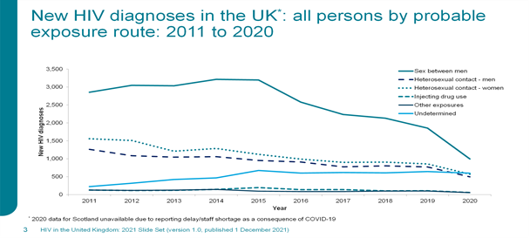
(UK Government, 2015)

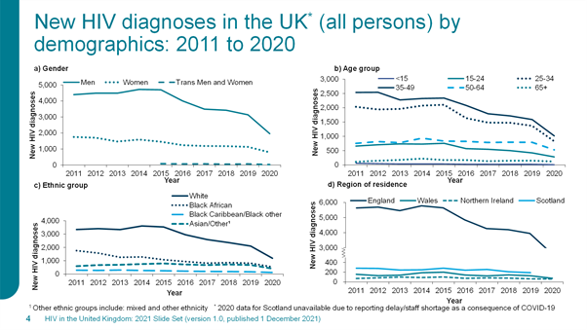
(UK Government, 2015)

Whereham (2020), a Forbes Magazine reporter, interviewed a sexual health worker from a London-based sexual health clinic and during the interview, it was stated that “One reason transmission of HIV has fallen to a record low and plummeted in 2020, is due to the lockdown, which led to less people meeting up to have sex”. Also, in the article, Reckitt Benckiser, who owns the Durex condoms brand said, “ The company have been urging people to limit their intimate contact to reduce the chance of HIV transmission as part of social distancing measures now commonplace across the world.” Besides the factor of the lockdown in 2020, another reason HIV infection rates are falling is due to the introduction of pre-exposure prophylaxis. Recently the Department of Health and Social Care has suggested that the drug would be made more easily accessible and that it should be given to all high-risk groups through sexual health clinics (Ford, 2020). Public Health England (2020a) has also reported that HIV rates have seen a steady decline due to regular testing of HIV within the health profession, the prison population and drug users, and sexual health clinics offer routine testing of their service users. A home testing kit for HIV has been developed, and pregnant women are routinely screened during pregnancy. If a positive result is discovered at any point during the HIV testing process, there is a process whereby all previous partners would be notified and asked if they would like to be tested for HIV. Other than screening for HIV, there have been advancements in medicine with viral suppression drugs and pre-exposure prophylaxis (NHS, 2021c).

During the 1980s, the Department of Health and Social Security (DHSS) launched a health promotion campaign that aimed to raise awareness about AIDS and HIV; this saw advertisements on television as well as leaflets and posters (Anthony, 2011; BFI, 2016). The campaign was shocking and frightening as most people had not heard of HIV. As well as this, during the 1990s, Eastenders aired a storyline showing the reality of living with HIV and the stigma for the character and the character’s family. Eastenders sent out a powerful message whilst educating the public. Research was undertaken by The School of Hygiene and Tropical Medicine (2018) which suggested that as a result of Eastenders running the HIV storyline, there was a dramatic rise in the number of requests for HIV antibody testing.

The Department for Health and Social Care (DHSC, 2021) has written a policy paper containing an action plan that aims to see zero transmission of Aids and HIV and related deaths by 2025. The report sets out three main goals; the first target is to lower the rate of newly diagnosed HIV infected people from 2,860 in 2019 to under 600 in 2025. The second target within the paper is to lower the number of AIDS diagnoses within three months of an HIV diagnosis from 219 to under 110, and the third goal is to reduce deaths from HIV/AIDS in England from 230 in 2019 to under 115 (Public Health England, 2020b). The DHSC has set out transparent goals stating that HIV prevention programmes must be easily accessible to achieve these targets. By doing so, it will help to upscale the uptake of a pre-exposure prophylaxis medication (PrEp). At the same time, testing for HIV should be dramatically increased, and a brisk approach to treatment should be developed, which retains community links with people living with HIV under health and social care. However it is additionally essential to advance the overall quality of life for HIV suffers living with HIV by delivering health and education programmes addressing the stigma HIV sufferers face (HIV Commision, 2021).

According to WebMD (2021), a non-communicable disease is a chronic health condition that is not contagious to others. One such non-communicable condition is Asthma. The National Health Service (NHS, 2021a) states that Asthma is a long term condition affecting the person’s bronchioles, whereby the bronchioles are inflamed. Signs and symptoms of Asthma include a wheezing noise when breathing, a tight chest, and a cough. During an Asthma attack, these symptoms worsen, a person may get so breathless they may not be able to speak, and the persons breathing will become faster than usual (NHS, 2021b). There is no cure for Asthma. However, it is possible for people living with Asthma to manage the condition and live an unrestricted life with the correct medication. The standard Asthma treatment is an inhaler; usually, the person with Asthma will have two inhalers, one to prevent an Asthma attack and the other type of inhaler is a reliever. The reliever is used if symptoms worsen in general or during an Asthma attack. If symptoms become acute, a medical professional such as a general practitioner may prescribe oral steroids (All Wales Medicines Strategy Group, 2021). The person with Asthma may also need to be referred to a respiratory specialist. They will have their peak flow regularly checked, and the person will also be given an Asthma plan specifically for their needs (Asthma UK, 2021). The Centre for Disease Control (CDC, 2020) states that Asthma attacks can be triggered by several factors, including tobacco smoke, dust mites, air pollution, pests, pet, mould, and cleaning products.

Asthma prevalence in the UK by age group from 2006 to 2016

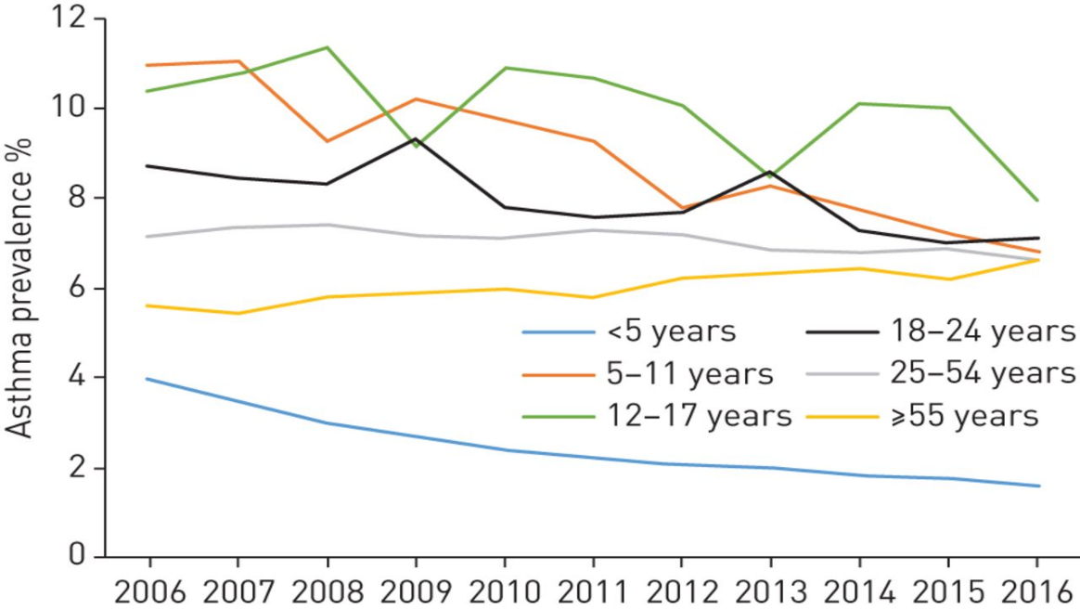
(Bloom et al. 2019)

The graph illustrates the age groups from 5 years to 55 years, showing the percentage of the population with asthma from 2006 to 2016. The blue line clearly shows that out of all the age brackets, the under five year olds had the lowest number of those diagnosed with Asthma within the age groups. The green line on the graph shows that 12 to 17 year olds had the highest number diagnosed with Asthma. However, during this period, there has been a steady decline in all age groups, apart from those within the age bracket 55 and over, where it has slightly increased (Bloom et al. 2019).

Asthma prevalence in males and females between 2006 and 2016. 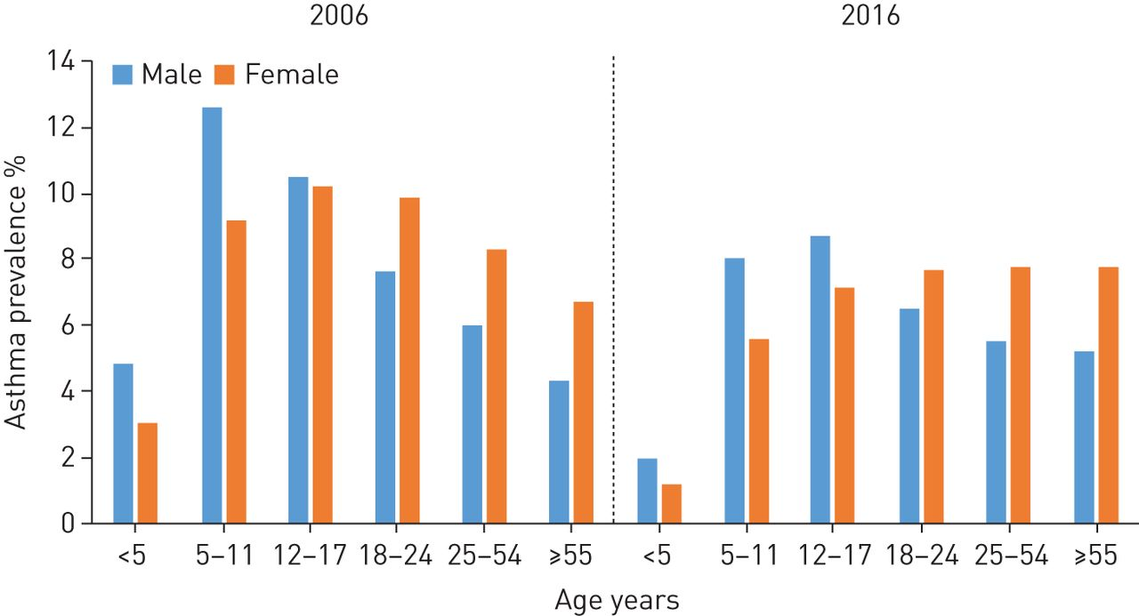
(Bloom et al. 2019)

The above graph compares the percentage of Asthma diagnoses between males and females between 2006 and 2016. Overall the widespread presence of Asthma in 2006 was around 7.2% of the population, and by 2016 there was a steady decline to approximately 6.5%. The graph shows that Asthma occurs more in males than within the female population. This trend seems to carry on until between the ages of 12 to 17 years, where figures are only just below that of males in females (Bloom et al. 2019).

A leading charity, Asthma UK (2022), is calling for change by calling for the Government to axe prescription charges for everyone with Asthma. Beverley Bostock, Nurse Practitioner and Asthma Lead for the Association of Respiratory Nurse Specialists, states “It is unthinkable that people in England are risking their health and potentially their lives because they cannot afford their medication” (Asthma UK, 2022). The cost of living in the UK is soaring, and people are being forced to choose whether to heat their homes or pay for their prescriptions (Asthma UK and British Lung Foundation Partnership, 2019). The Department for Environment Food and Rural Affairs (2019) produced a clean air strategy containing several vital goals: securing clean growth, driving innovation, and reducing emissions from transport, homes, farming, and industry. Kulakiewicz et al. (2021) suggest that early detection and diagnosis are critical to improving asthma’s overall prognosis. It is also vital that the person with Asthma gets the proper support and the correct medication.

In summary, public health surveillance is a vital tool that helps prevent the prevalence of diseases, as well as helping to monitor and control the spread of serious infections. Public health uses data to gain an understanding of what measures are needed to contain the spread of a communicable disease, including the use of medications such as vaccines and health promotion campaigns to educate the public and to gain herd immunity or eliminate a communicable disease, such as HIV. Public health also has a role to play in the fight against non-communicable diseases, such as Asthma. Although Asthma can be treated with medication, there are other environmental issues which need to be taken into consideration to treat the condition, such as emissions from transport, farming, and industry. Recommendations to be made include providing free prescriptions for citizens in England to bring them in line with Wales. Support and care in the community should be made more accessible, and a targeted approach should be put in place to reach those who are less likely to stay within the system due to environmental and social factors.

Reference page

Asthma UK (2021) Stop unfair asthma prescription charges. Available at: https://www.asthma.org.uk/support-us/campaigns/our-policy-work/prescription-charges/. [Accessed 10 January 2022]

Asthma UK and British Lung Foundation Partnership (2019) Choosing between heating or medication | Stop unfair prescription charges with Asthma UK. Available at: https://www.youtube.com/watch?v=KVTwLRVORao&t=38s. [Accessed 10 January 2022]

All Wales Medicine Strategy Group (2021). All Wales Adult and asthma Management and prescribing Guidelines. Available at: https://awmsg.nhs.wales/files/guidelines-and-pils/all-wales-adult-asthma-management-and-prescribing-guidelines-december-2021-pdf/. [Accessed 7 December 2021]

Alcocer-Bruno, C., Ferrer-Cascales, R., Ruiz-Robledillo, N., Sánchez-SanSegundo, M., & Zaragoza-Martí, A. (2020) Personal and Lifestyle Determinants of HIV Transmission Risk in Spanish University Students. International journal of environmental research and public health, 17(22), 8332. https://doi.org/10.3390/ijerph17228332

Anthony, C (2011) Public Information Film - Aids 1986. [online video] Available at: https://www.youtube.com/watch?v=9SqRNUUOk7s.[Accessed 3 January 2022].

Bloom, C, Saglani, S, Feary, J, Jarvis, D and Quint, J (2019)‘Changing prevalence of current asthma and inhaled corticosteroid treatment in the UK: population-based cohort’, European Respiratory Journal 2006–2016 v 53: 1802130; DOI: 10.1183/13993003.02130-2018.

BBC (2020) HIV diagnoses in gay and bisexual men at a 20-year low. Available at: https://www.bbc.co.uk/news/newsbeat-54842623. [Accessed 2 January 2022].

BFI (2016) AIDS: Iceberg (1987) [online video] Available at: https://www.youtube.com/watch?v=yVggWZuFApI. [Accessed 3 January 2022].

Centre for Disease Control (2020b) Common Asthma Triggers. Available at: https://www.cdc.gov/asthma/triggers.html. [Accessed 10 December 2022].

Centre for Disease Control (2021a). Introduction to Public Health; review of concepts. Available at https://www.cdc.gov/training/publichealth101/public-health.html. [Accessed 31 December 2021].

Department for Environment, Food and Rural Affairs (2019) Clean air strategy 2019. Available at: https://assets.publishing.service.gov.uk/government/uploads/system/uploads/attachment_data/file/770715/clean-air-strategy-2019.pdf. [Accesssed 10 January 2022].

DHSC (2021) Towards Zero - An action plan towards ending HIV transmission, AIDS, and HIV-related deaths in England - 2022 to 2025. Available at: https://www.gov.uk/government/publications/towards-zero-the-hiv-action-plan-for-england-2022-to-2025/towards-zero-an-action-plan-towards-ending-hiv-transmission-aids-and-hiv-related-deaths-in-england-2022-to-2025 [Accessed 5 December 2022].

Ford, M. (2020) ‘HIV prevention drug to be rolled out across England,’ The Nursing Times. Available at: https://www.nursingtimes.net/news/policies-and-guidance/hiv-prevention-drug-to-be-rolled-out-across-england-16-03-2020/. [Accessed 3 December 2020].

Gunn, T (2006) Comparing Natural Immunity with Vaccination Pamphlet; London The Informed Parent Publications; 2nd Revised edition. Available at https://www.informedparent.co.uk/comparing-natural-immunity-with-vaccination-2/. [Accessed 1 January 2022]

HIV Comission, (2022) Available at: https://www.hivcommission.org.uk/final-report-and-recommendations/stigma-and-health-inequalities/. [Accessed 5 December 2022].

Murell, M. and Nall, R. (2018) ‘What to know about a fever and HIV,’ Medical News Today. Available at: https://www.medicalnewstoday.com/articles/323845. [Accessed 2 January 2022].

NHS (2021a) Asthma attacks. Available at https://www.nhs.uk/conditions/asthma/asthma-attack/. [Accesssed 5 December 2021].

NHS (2021b) Symptoms Asthma. Available at Asthma - Symptoms - NHS. Availabkle at https://www.nhs.uk/conditions/asthma/. [ Accessed 5 December 2021].

NHS (2021c). Treatment HIV and AIDS. Available at https://www.nhs.uk/conditions/hiv-and-aids/treatment/#:~:text=HIV%20is%20treated%20with%20antiretroviral,quickly%20adapt%20and%20become%20resistant. [Accessed 3 January 20

NHS (2022a) Public Health Wales Observatory. Available at: http://www.wales.nhs.uk/publichealthwalesobservatory. [Accessed 1 January 2022].

NHS (2022b) Why vaccination is safe and important? Available at: www.nhs.uk/conditions/vaccinations/why-vaccination-is-safe-and-important/. [Accessed 1 January 2022].

NHS (2022c) Symptoms HIV and Aids. Available at: www.nhs.uk/conditions/hiv-and-aids/symptoms/. [Accessed 3 December 2021].

NHS Digital, (2021) Personal Demographics Service fair processing. Available at: https://digital.nhs.uk/services/demographics/personal-demographics-service-fair-processing. [Accessed 1 December 2022].

O`Brien, S (2013) Communicable disease epidemics; Oxford Handbook of Public Health Practice 3rd edition. Oxford, Oxford University Press.

Public Health England (2020a). HIV in the UK: towards zero HIV transmissions by 2030. Available at: https://www.gov.uk/government/publications/towards-zero-the-hiv-action-plan-for-england-2022-to-2025/towards-zero-an-action-plan-towards-ending-hiv-transmission-aids-and-hiv-related-deaths-in-england-2022-to-2025. [Accessed 5 December 2022]

Public Health England (2020b) Trends in HIV testing, new diagnoses and people receiving HIV-related care in the United Kingdom: data to the end of December 2019; Health Protection Report Volume 14 Number 20.

Teutsch, S and Thacker, S (1995) planning a public health surveillance system; Epidemiological bulletin PAN American Health organisation, V16 p1.

Taylor, P, Richardson, J, Yeo, A, Marsh I, Trobe K and Pilkington, A (2004).Sociology in Focus. Causeway Press; Edinburgh.

The School of Hygene and Tropical Medicine (2018) Remembering the ‘Don’t Die of Ignorance’ campaign. Available at: https://placingthepublic.lshtm.ac.uk/2018/05/20/remembering-the-dont-die-of-ignorance-campaign/. [Accessed 3 January 2022].

The Office for National Statistics (2022). Health and Social Care; life expectancy and the impact of factors such as occupation, illness and drug misuse. Available at https://www.ons.gov.uk/peoplepopulationandcommunity/healthandsocialcare. [Accessed 21 December 2022]

United Kingdom Health Security Agency (2021) Official Statistics. Available at: https://assets.publishing.service.gov.uk/government/uploads/system/uploads/attachment_data/file/1037215/hiv-2021-report.pdf. [Accessed 31 December 2021].

UK Government (2015) HIV: annual data tables. Available at: https://www.gov.uk/government/statistics/hiv-annual-data-tables. [accessed 2 January 2022]

Whereham, J. (2020) U.K. Lockdown Has ‘Broken HIV Chain’ With Huge Reduction In New STI Cases; Forbes. Available at: https://www.forbes.com/sites/jamiewareham/2020/05/01/uk-lockdown-has-broken-hiv-chain-with-huge-reduction-in-new-sti-cases/?sh=28c273fe51bc. [Accessed 3 January 2022].

World Health Organisation (2014) Protocol for the Evaluation of Epidemiological Surveillance Systems. Available at: http://apps.who.int/iris/bitstream/handle/10665/63639/WHO_EMC_DIS_97.2.pdf;jsessionid=52559DAEB447A39D8342008A0BDA0D9E?sequence=1. [Accessed 1 January 2022].

