Assignment 2:

Operating Systems
CertHE Computing Skills for Workplace

Computer Architecture and Operating Systems. ACCA4022_LON
DR. Redhwan Al-Amri (Lecturer)
University of Wales Trinity Saint David
(London Campus)
Student Name: Cinthya Vera Mendoza
Student Number: 2528123
Group: 01

Table of Contents
Introduction 1
1. Key functions of general Operating Systems 1
1.1 Process and Processor Management 2
1.2 Memory Management 3
1.3 File System Management 3
1.4 Security and Protection 4
2. Use of Windows OS CLI commands. 6
2.1 Process Management 6
2.2 File & Directory Management 8
2.3 Network testing/monitoring 10
2.4 User Management 12
2.5 Task Scheduling 14
3. Use of Linux OS CLI commands. 14
3.1 Process Management 14
3.2 File & Directory Management 16
3.3 17
3.4 User Management 18
3.5 Task Scheduling 19
4. Use of Windows OS scripts. 19
5. Use of Linux OS scripts. 23
Conclusion 26
References 26

Introduction

- This report is about Operating Systems and how they are used in Windows and Linux.
It explains the main functions of an operating system, such as Process and Processor Management, Memory Management, file System Management and Security. It also shows how to use of command- line commands, and simple Batch and Bash scripts. By completing the practical tasks and using the screenshots. I improved my understanding on operating system and learned how these tools can help automate everyday tasks[1].

Key functions of general Operating Systems

An operating system (OS) is one of the most complex programs ever created. It is software that runs on the same processor as applications and is present in every computer system. Its main role is to control processing, manage system resources, and communicate with peripheral devices such as display screens, touchpads, disks, computer networks, and audio devices. All of these functions work together to coordinate the operation of the computer efficiently.
In addition, an operating system allows multiple processes and users to share the processor at the same time while protecting data from unauthorized access. It also ensures that input and output (I/O) devices operate correctly and simultaneously. One of the most important features of an operating system is its ability to provide high-level services to users and applications while working with hardware that operates through low-level instructions[2].
The operating system has three main objectives: Convenience, Efficiency and Ability to evolved[3].

1.1 Process and Processor Management

Process management is one of the main functions of an operating system. The process is a program that is currently running. The operating system monitors and controls each process by allocating processor time and system resources, allowing multiple programs to run efficiently at the same time. In addition, it manages process priorities and coordinates input/output (I/O) operations to improve system performance and prevent conflicts between running programs[3].

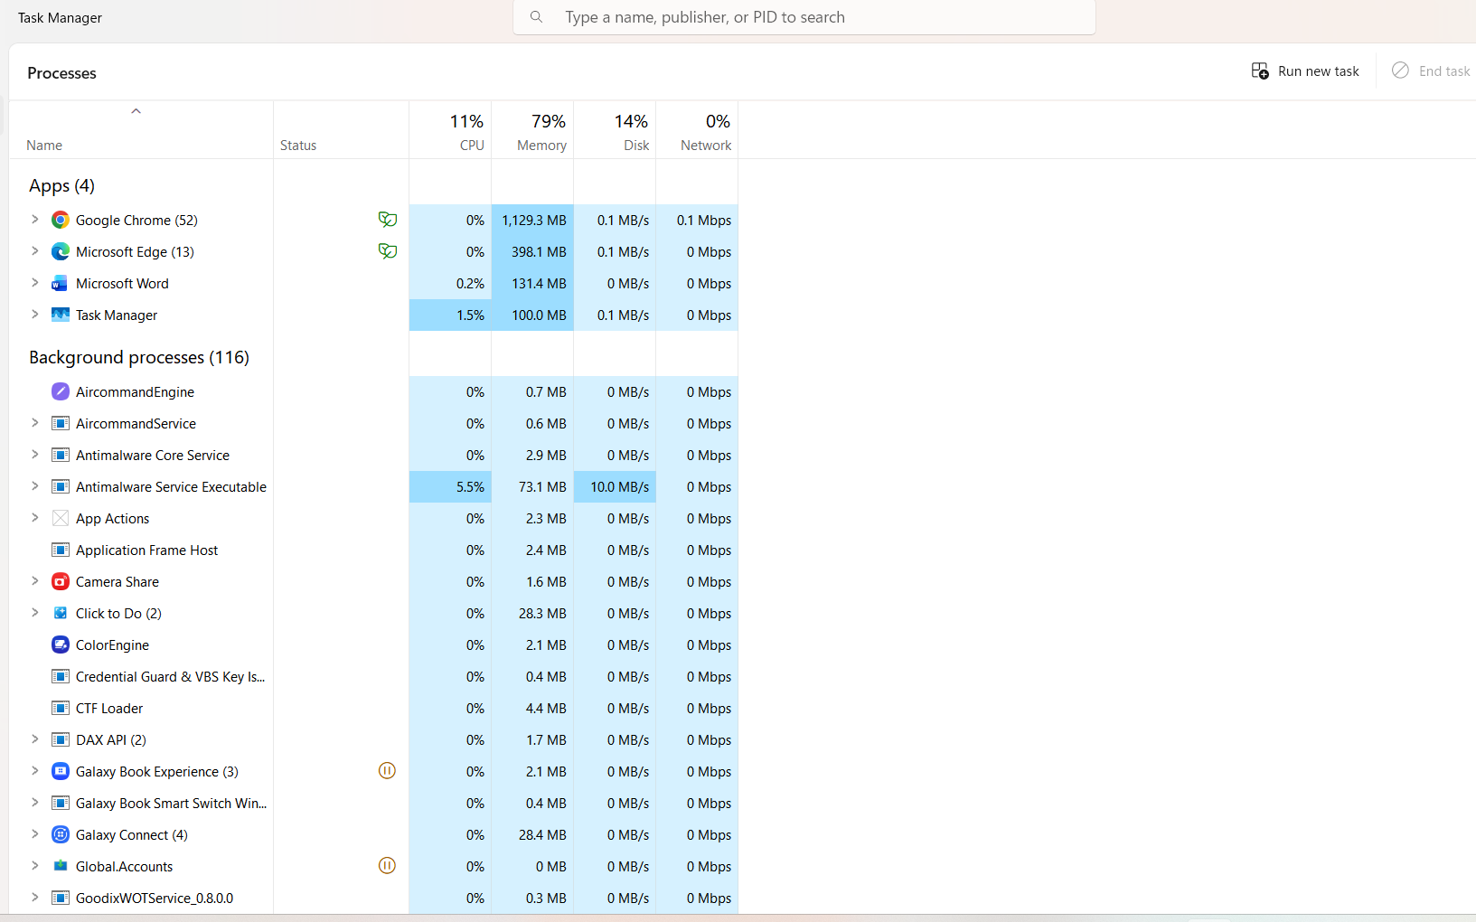
Figure 1 Process Management.

Memory Management

Memory management is one of the main functions of an operating system. It is responsible for allocating and managing memory efficiently so that multiple programs can run without interfering with each other. The operating system isolates processes, protects memory from unauthorized access, protects memory when required.
It has five principal storage management responsibilities: Process isolation, Automatic allocation and management, Support of modular programming, Protection and access control, Long-term storage.
It also supports virtual memory, which allows programs to use more memory that the available physical RAM available by temporarily storing inactive data on secondary storage. This improves system performance and allows multiple applications to run efficiently[3].
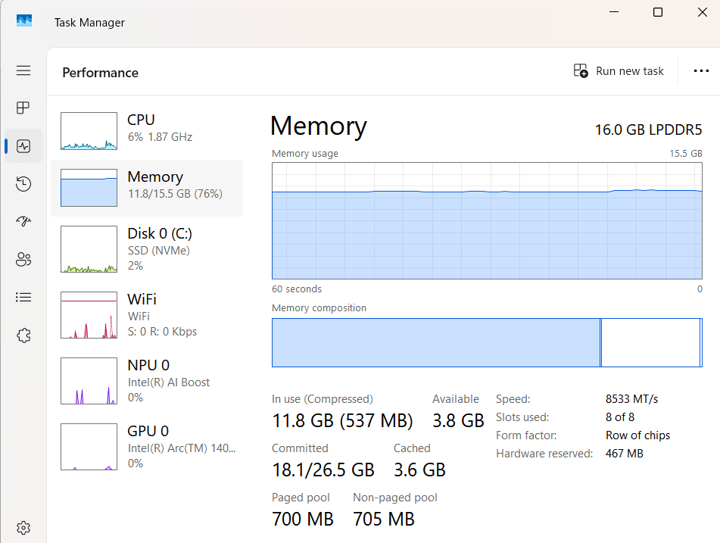
Figure 2 Memory Management.

File System Management

File system management is one of the core functions of an operating system. It is responsible for organizing, storing, retrieving, and managing files and folders on storage devices such as hard drives and SSDs. The operating system allows users to create, copy, move, rename, and delete. It also keeps track of where files are stored, making it easier to access to information quickly and efficiently[4].

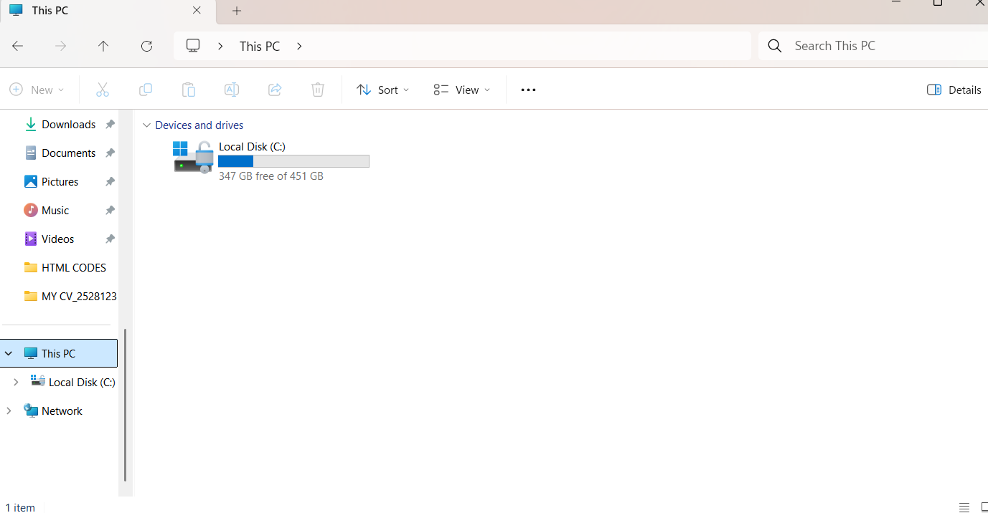
Figure 3 File System Management.

Security and Protection

Operating systems that support a variety of protection and security mechanisms. Also, we are concerned with the problem of controlling access to computer systems and the information stored in them It manages user authentication.
It manages user authentication, controls access permissions, and ensures confidentiality, integrity, and availability of information. These security measures help prevent data loss, unauthorized modifications, and system attacks, allowing users to work safely and securely.

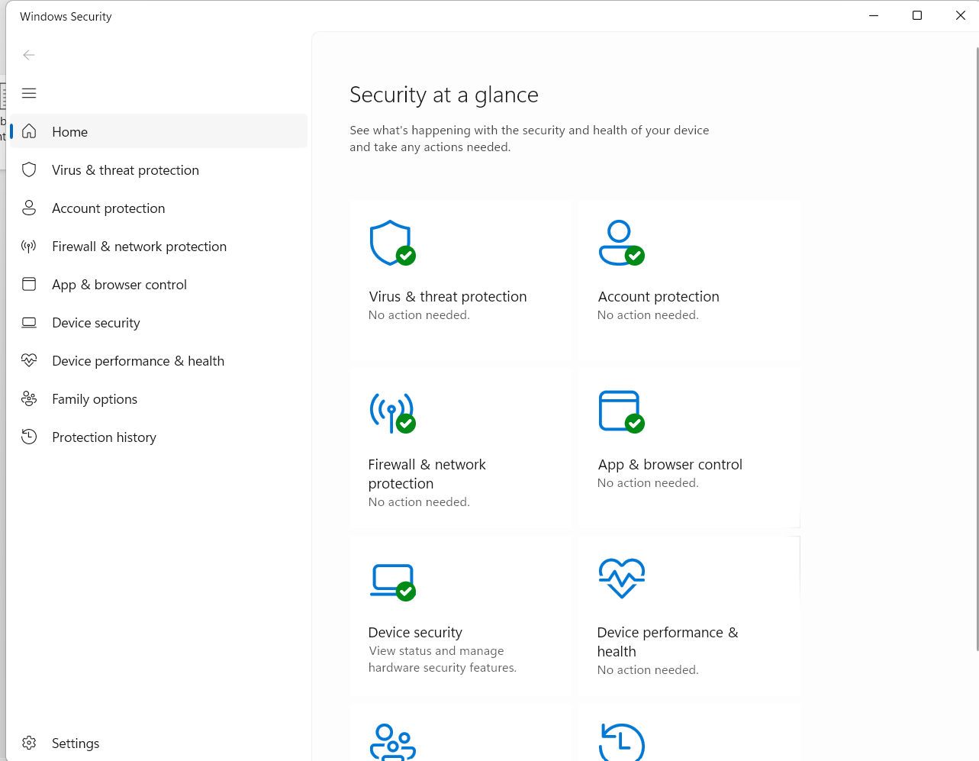
Figure 4 Windows Security.

Use of Windows OS CLI commands.

The Windows Command Line Interface (CLI) allow users and system administrators to manage and monitor the operating system using text-based commands. The commands can be used to manage processes, files and directories, network settings, user accounts, and scheduled tasks.

2.1 Process Management

Command: tasklist
The tasklist command shows the running processes on the computer, including the process name, Process ID (PID), and memory usage. It is useful for monitoring active applications and system processes.
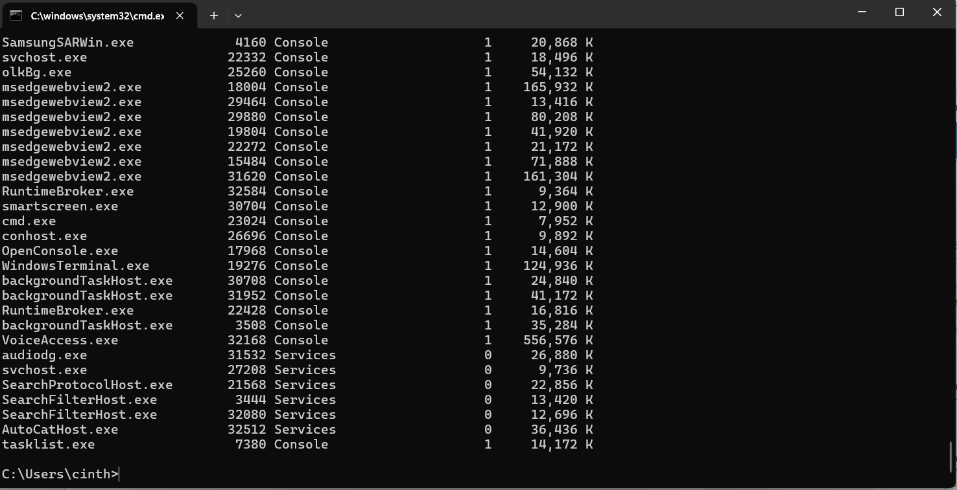
Figure 5 Command tasklist.

Command: tasklist/svc
The tasklist/svc command shows the running processes together with the Windows services linked to them. This command is useful to see which services are active and to better understand how Windows is working in the background.

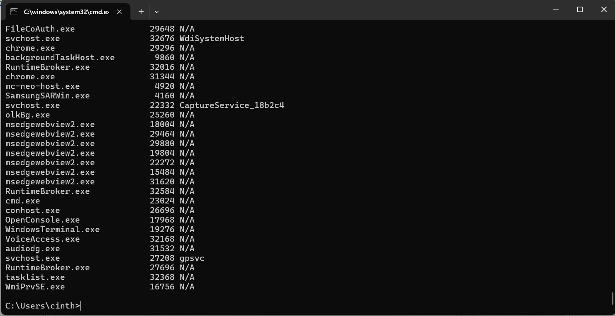
Figure 6 Command tasklist svc.

Command: tasklist/v
The tasklist/v command shows details information about all running processes. It provides additional details such as the process status. Making it useful for monitoring system activity and identifying active applications.

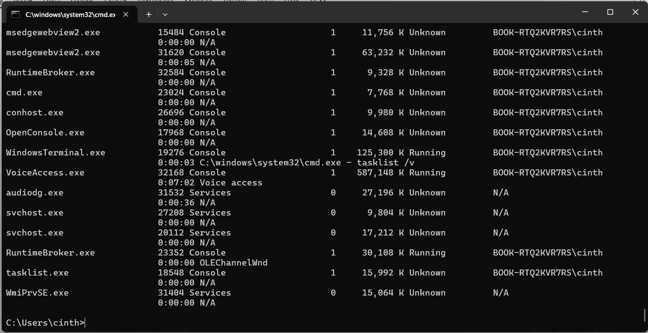
Figure 7 Command tasklist/v.
Command: tasklist/m
The tasklist/m command shows all running process together with the DLL (Dynamic Link Library)
This process is useful for troubleshooting applications, checking which modules are in use, and understanding how Windows processes interact with shared system libraries.

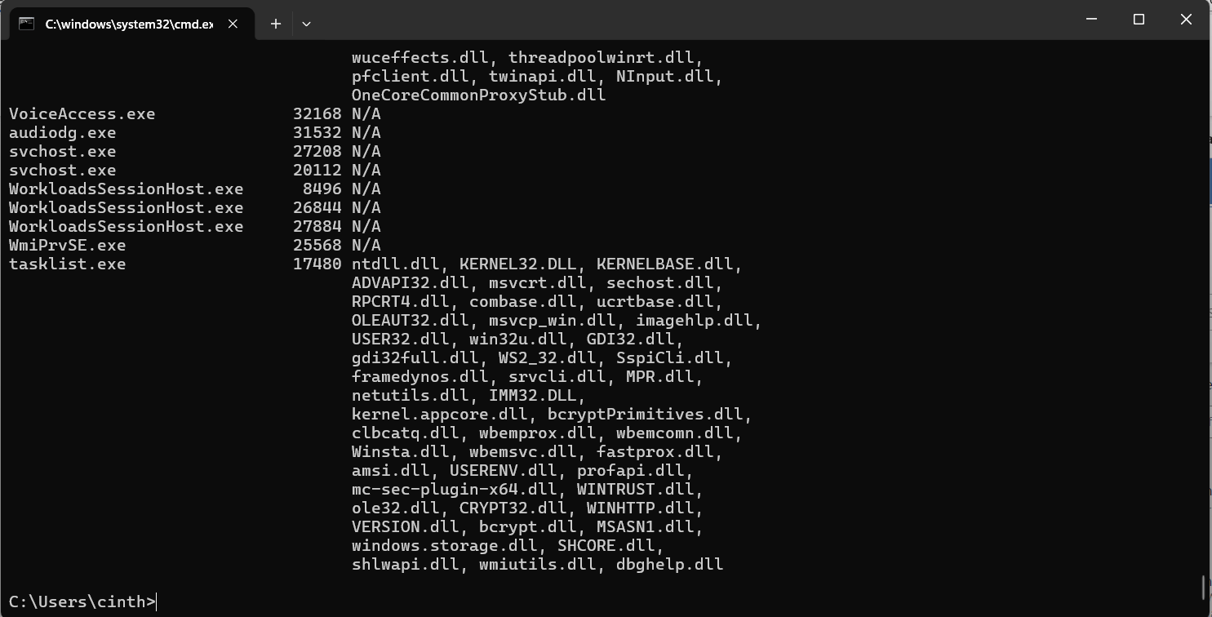
Figure 8 Command tasklist/m.

File & Directory Management

Command: dir
The dir command shows the files and folders stored in the current directory. It is one of the most commonly used Command Prompt commands because it helps users view the contents of a folder, check file names, and verify the location of directories before performing other file management tasks.

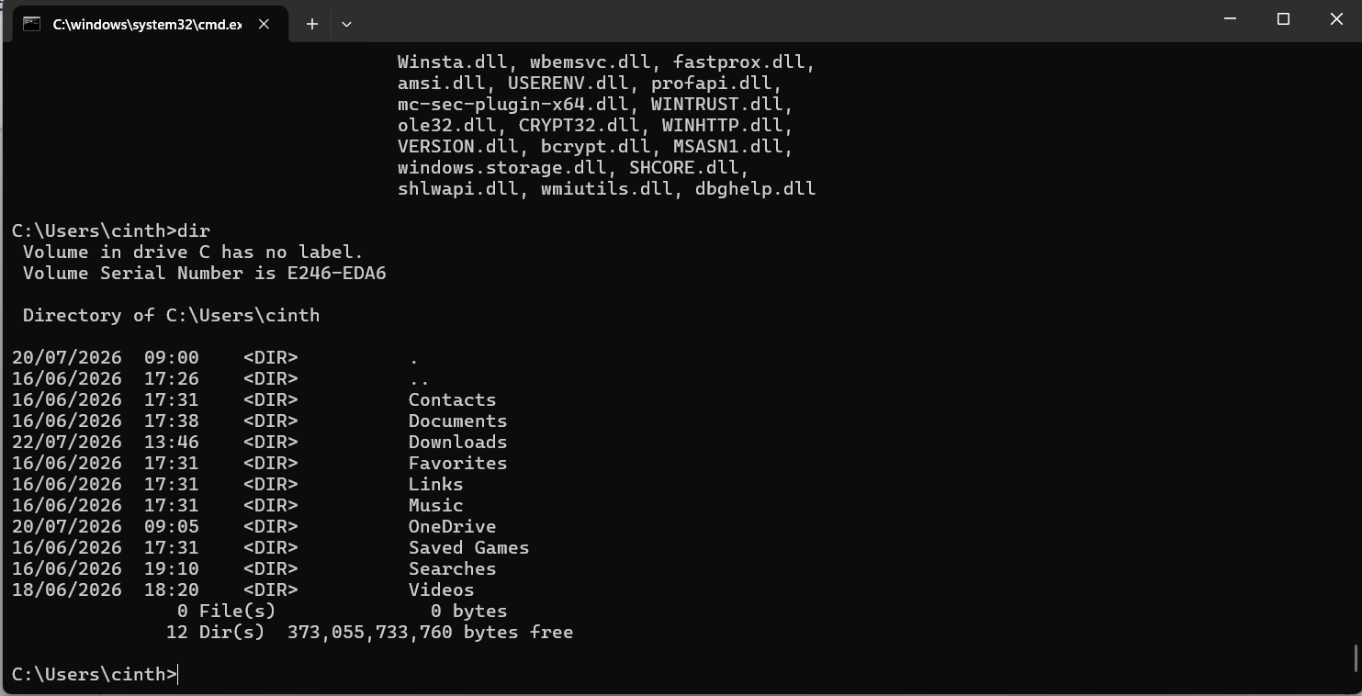
Figure 9 Command dir.

Command: cd Downloads
The cd (change directory) command is used to navigate between folders in the Command Prompt. In this example, the command changes the current location from user’s home directory to the Downloads folder. This makes it easier to access and manage files stored in a different directory.

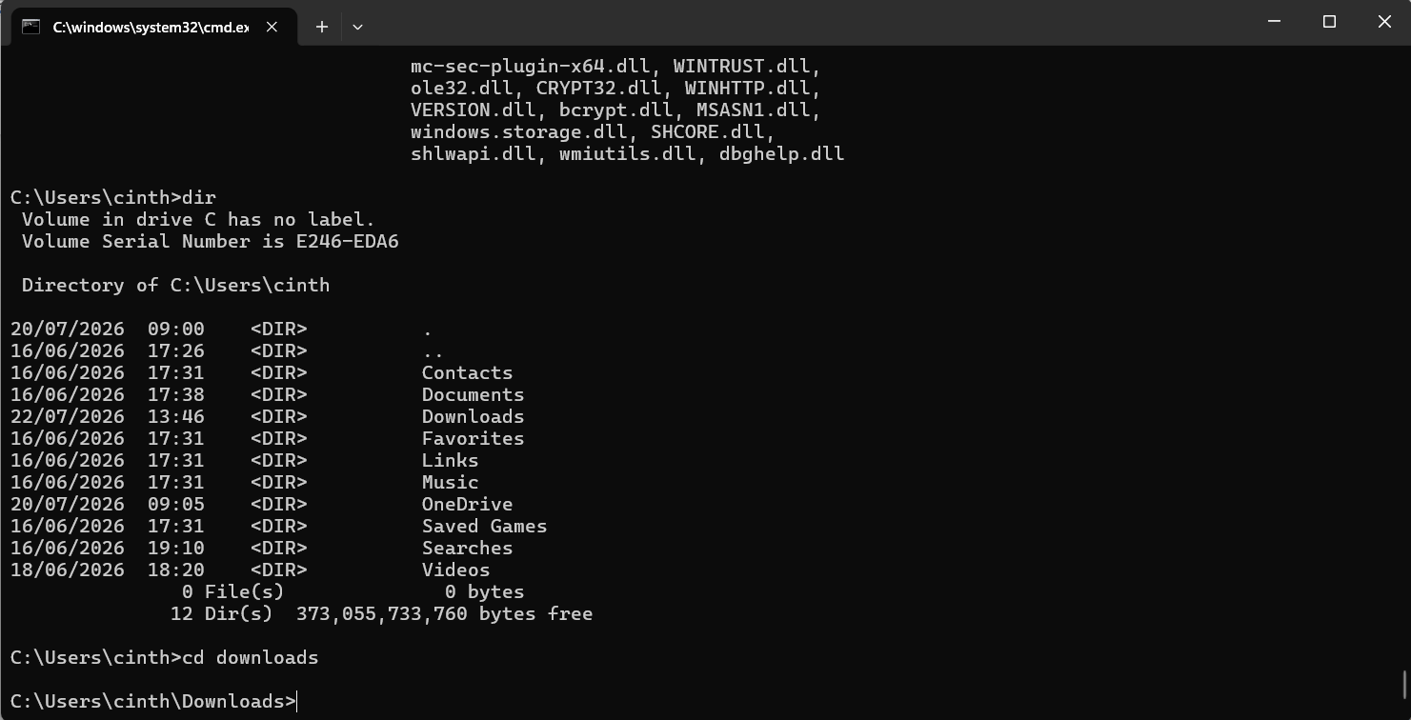
Figure 10 Command cd Downloads.

Command: mkdir TestFolder
The mkdir (Make Directory) command is used to create a new folder from the Command Prompt. In this example, a folder called TestFolder was created inside the Downloads the directory. After running the dir command, the new folder appears in the directory list, confirming that it was created successfully.

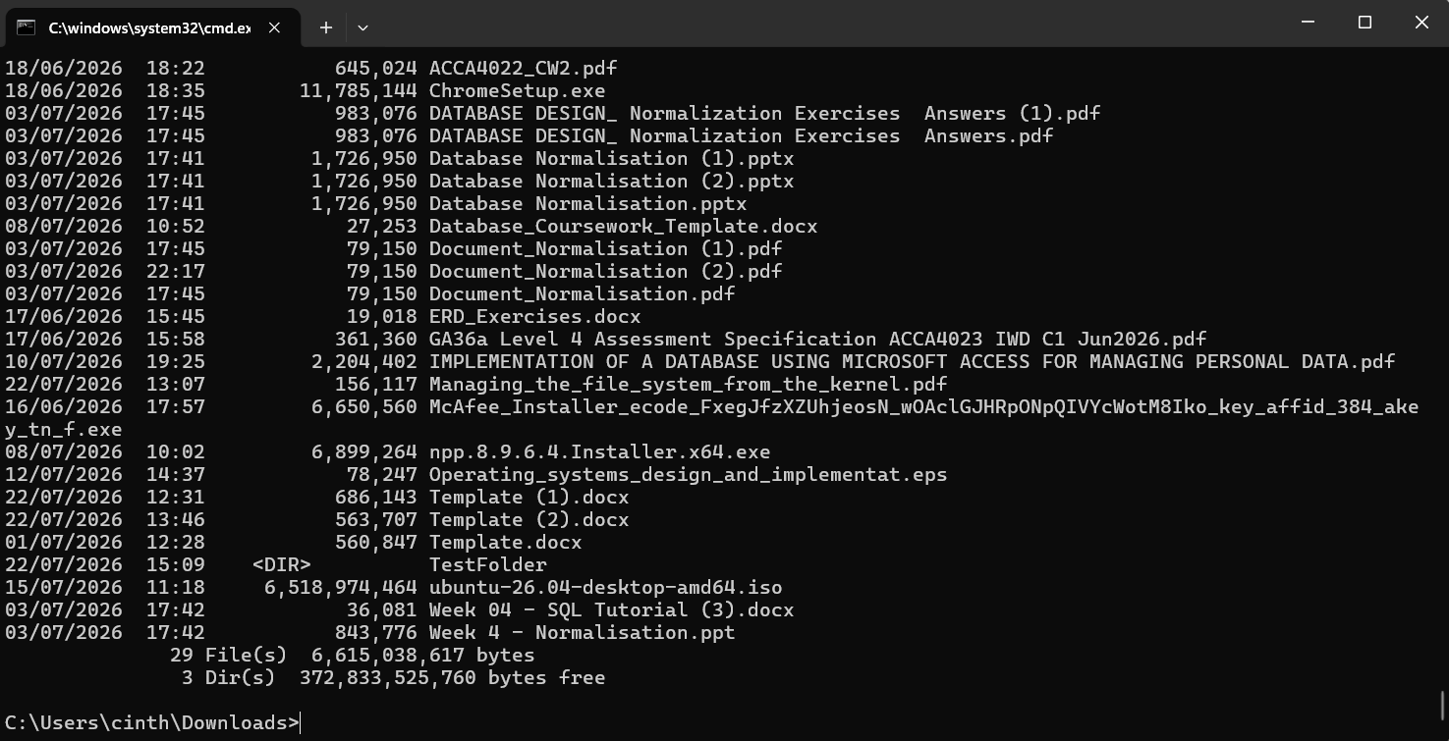
Figure 11 Command mkdir testfolder.

2.3 Network testing/monitoring

Command: ipconfig
The ipconfig command shows the current TCP/IP network configuration of the computer. It provides information such as the IP address, making it useful for checking network setting and troubleshooting connectivity problems.

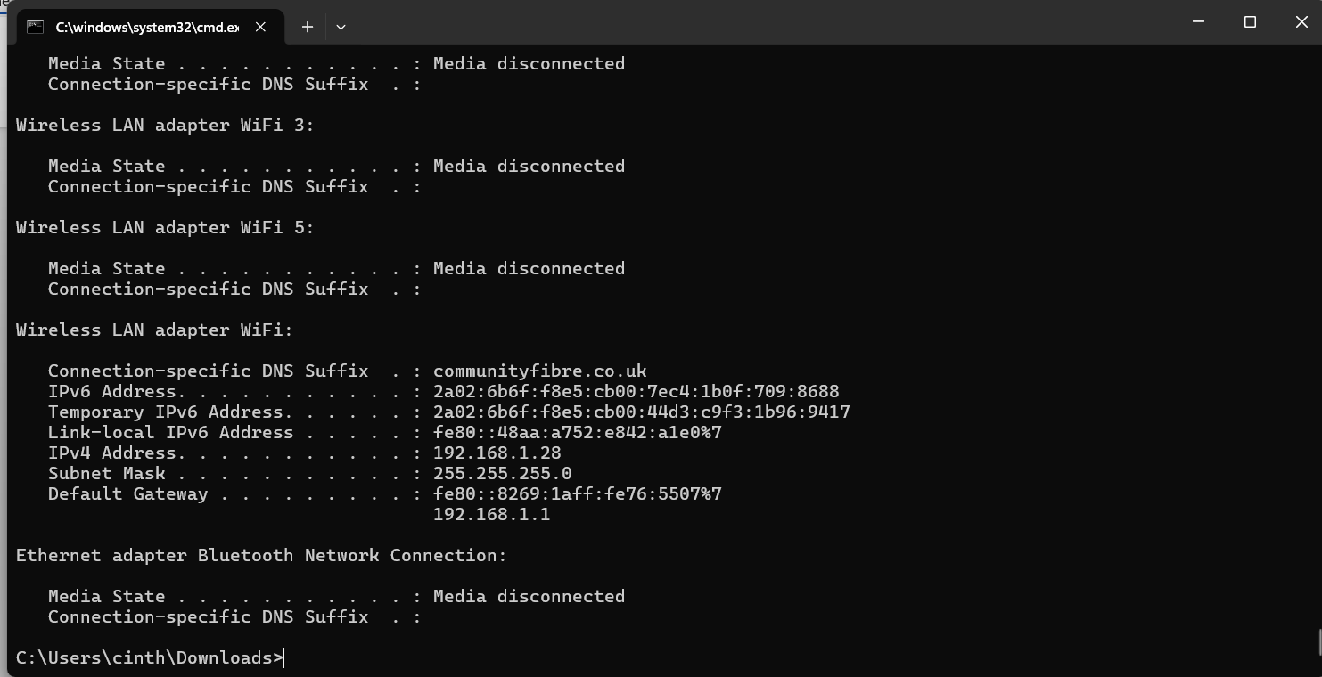
Figure 12 Command ipconfig.

Command: ping google.com
The ping command is used to test the network connectivity between the local computer and another host. In this example, the command sends packets to Google’s server and measures the response time. It is commonly used to verify that the internet connection is working and to identify possible network connectivity issues.
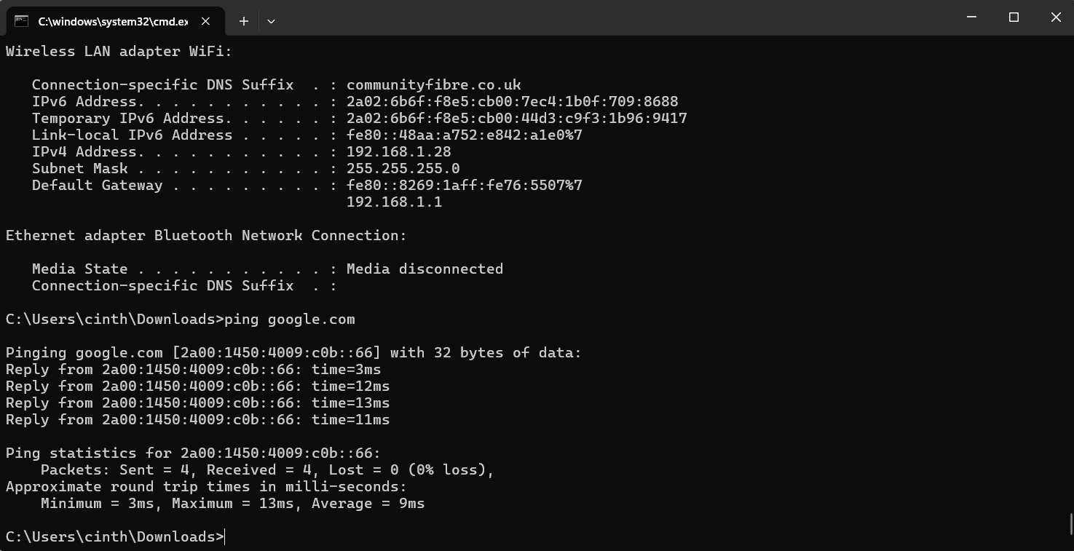
Figure 13 Command ping google.com.

Command: nslookup google.com
The nslookup command is used to find the IP address associated with a domain name. in this example, it looks up the address of google.com using the DNS server. This command is useful for checking whether DNS is working correctly and for troubleshooting name solution problems.

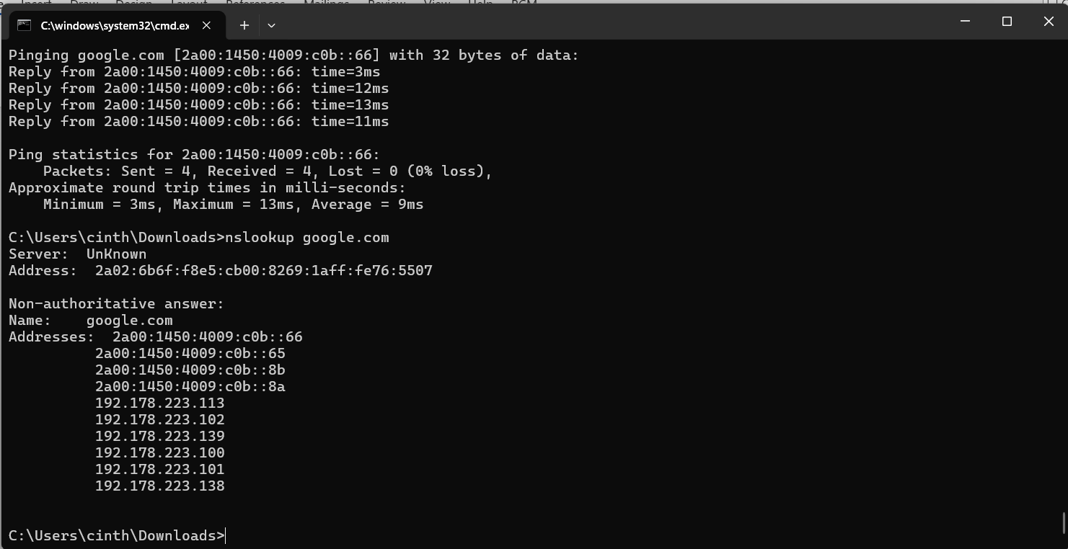
Figure 14 Command nslookup google.com.

User Management

Command: net user
The net user command shows the user accounts that exist on the local computer. It can also be used by administrators to create, modify, or delete user accounts.
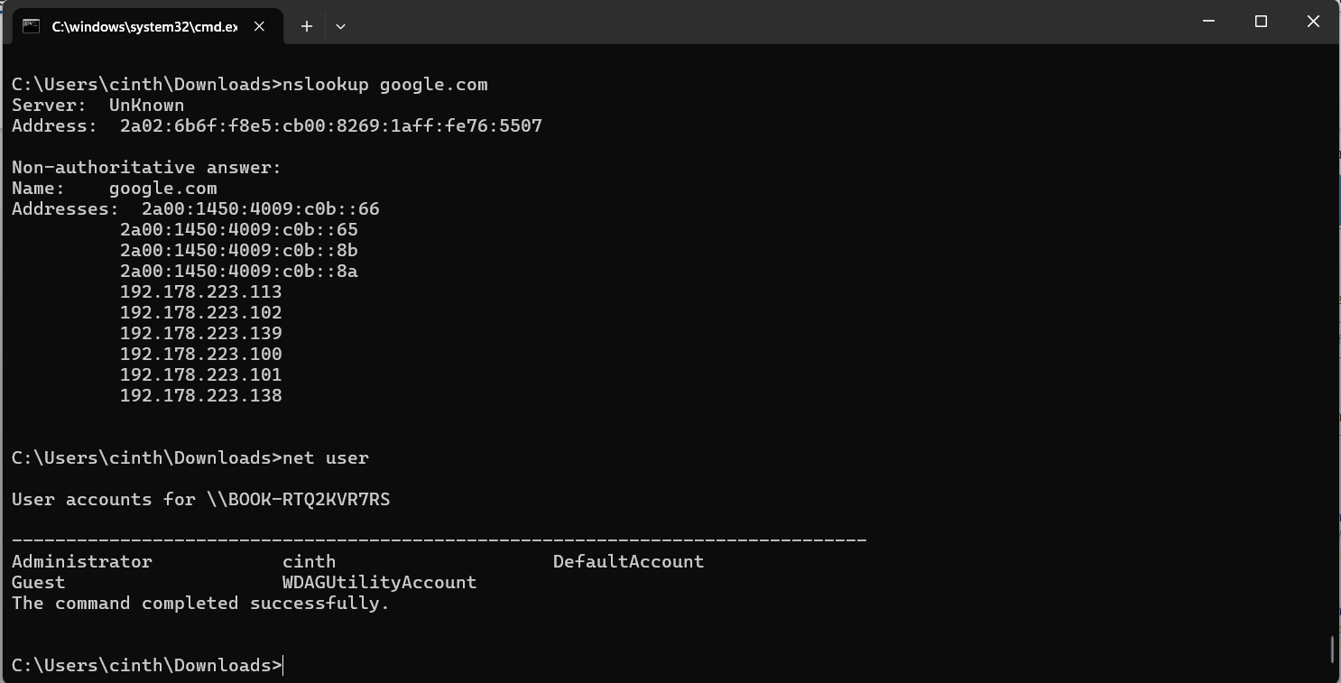
Figure 15 net user

Command: whoami
The whoami command shows the name of the user who is currently logged into the system. It is useful for confirming which user account is running the current Command Prompt session.

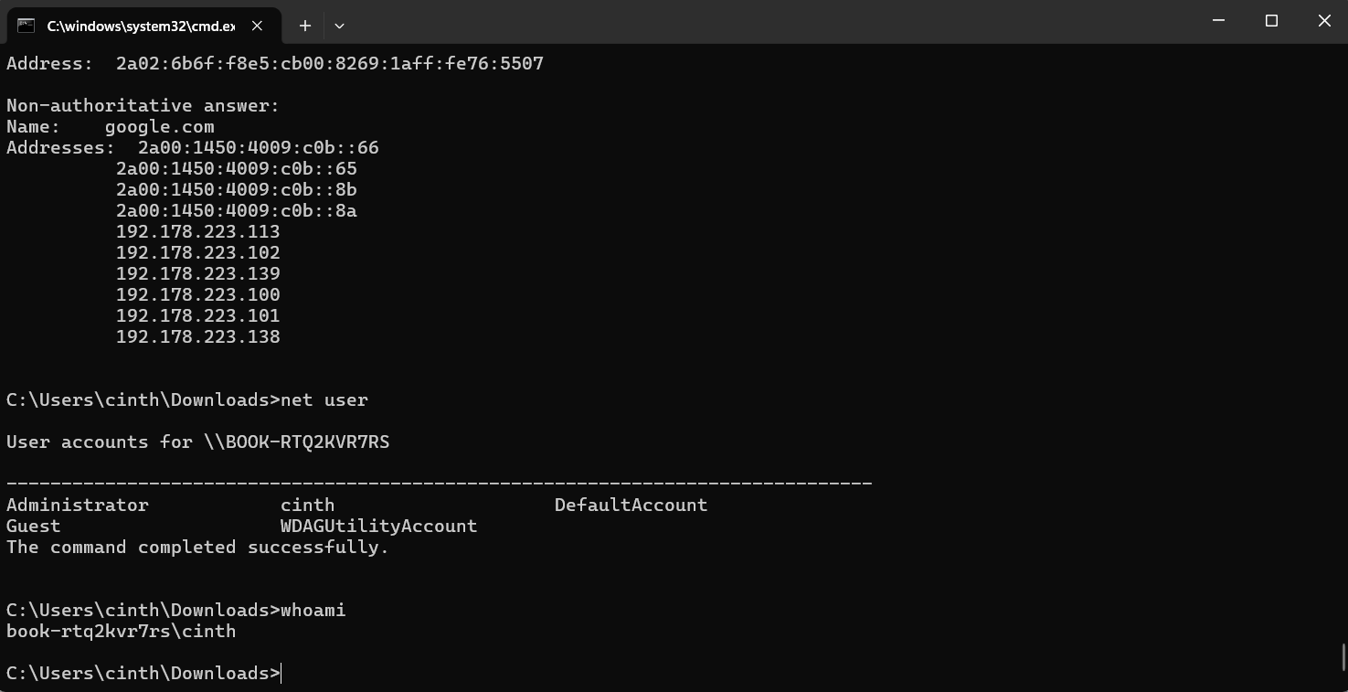
Figure 16 whoami.

Task Scheduling

Command: schtasks / query

The schtasks query command shows the scheduled task configured on the computer. It allows users and administrators to view automatic tasks that run at specific times or in response to certain events, making it useful for managing and monitoring scheduled system activities.

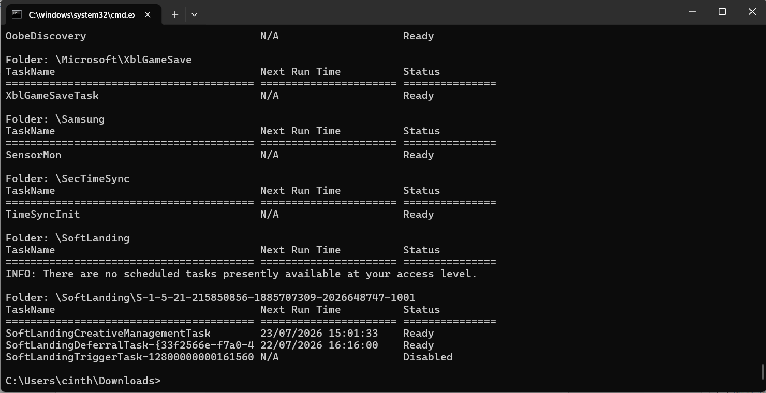
Figure 17 command schtasks/query.

Use of Linux OS CLI commands.

3.1 Process Management
Command: ps -e
This command shows all currently running processes on the Linux system. It is commonly used monitor active processes, identify process IDs (PIDs), and check whether applications or system services are running correctly.
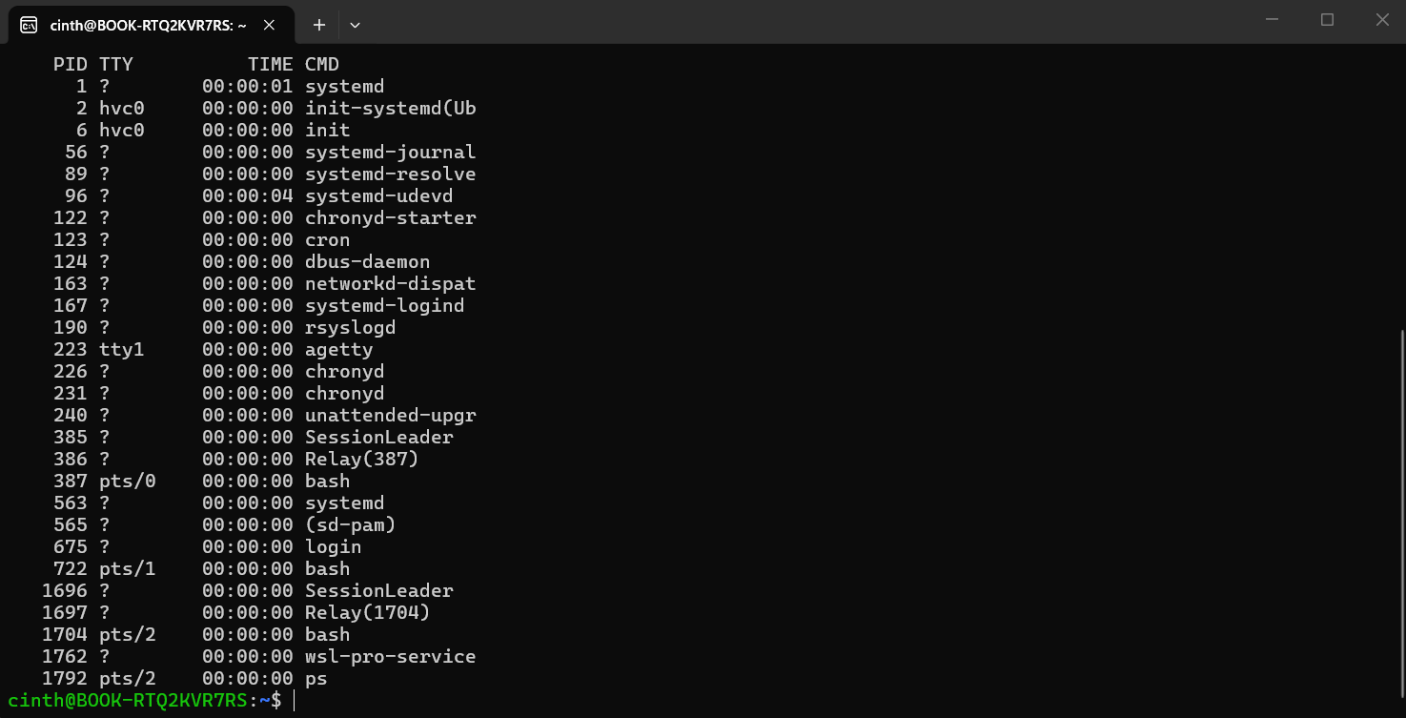
Figure 18 command ps-e.

Command: top
The top command provides a real-time view of the running processes and system performance. It shows CPU usage, memory usage, running tasks, and other system statistics. It is commonly used to monitor system resources and identify processes consuming high CPU or memory.

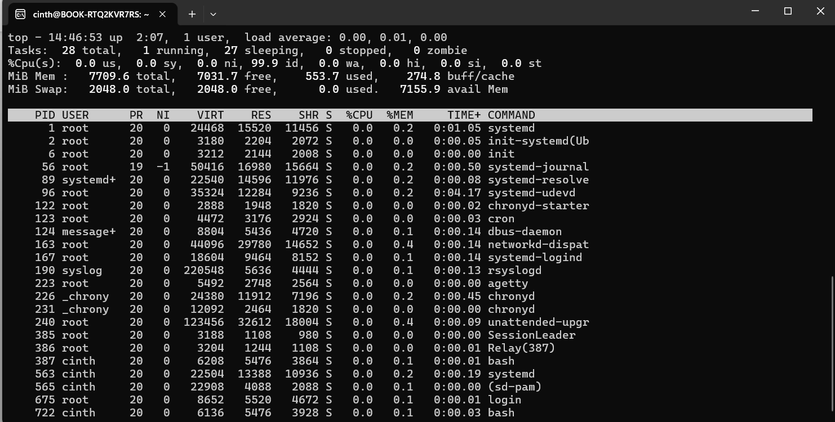
Figure 19 command top.

3.2 File & Directory Management
Command: pwd
The pwd command shows the current working directory. It is commonly used to identify the current location in the Linux file system before navigation or managing files.
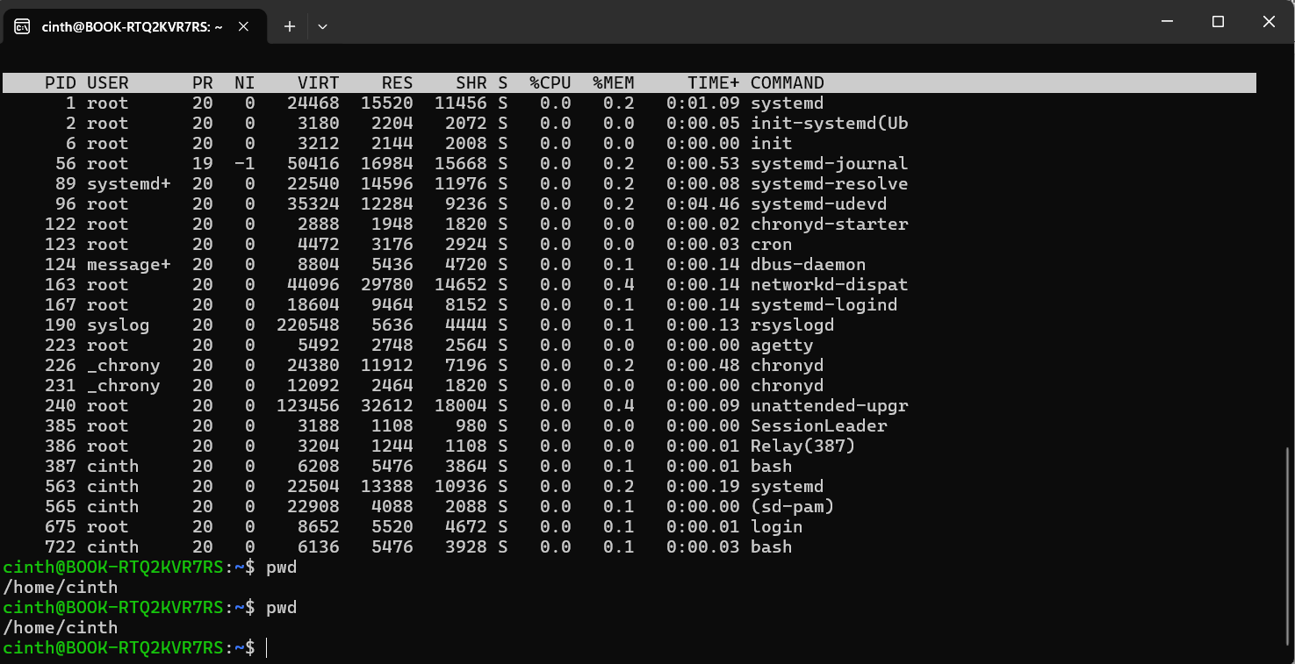
Figure 20 command pwd.

Command: ls -la
The ls -la command lists all files and directories, including hidden files, in a detailed format. It displays permissions, ownership, file size, and modification dates, making it useful for file system management.
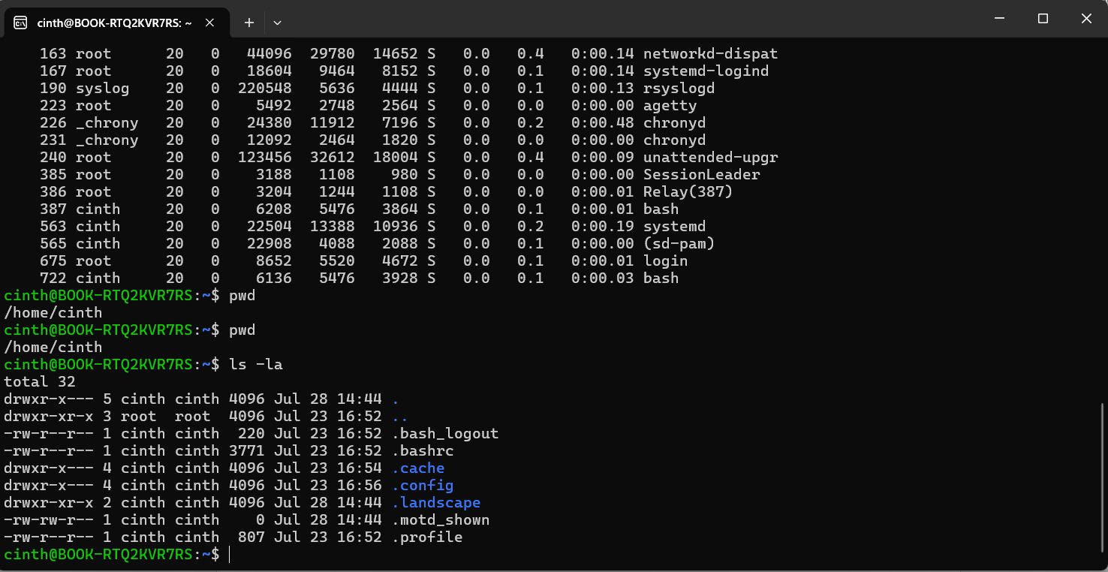
Figure 21 command ls- la.

3.3 Network Testing/ Monitoring
Command: ping google.com
The ping command is used to test network connectivity between the local computer and a remote host. It sends ICMP echo requests to Google’s server and measures the response time.
This command helps to verify that the internet connection is working and can be used to identify potential network issues.
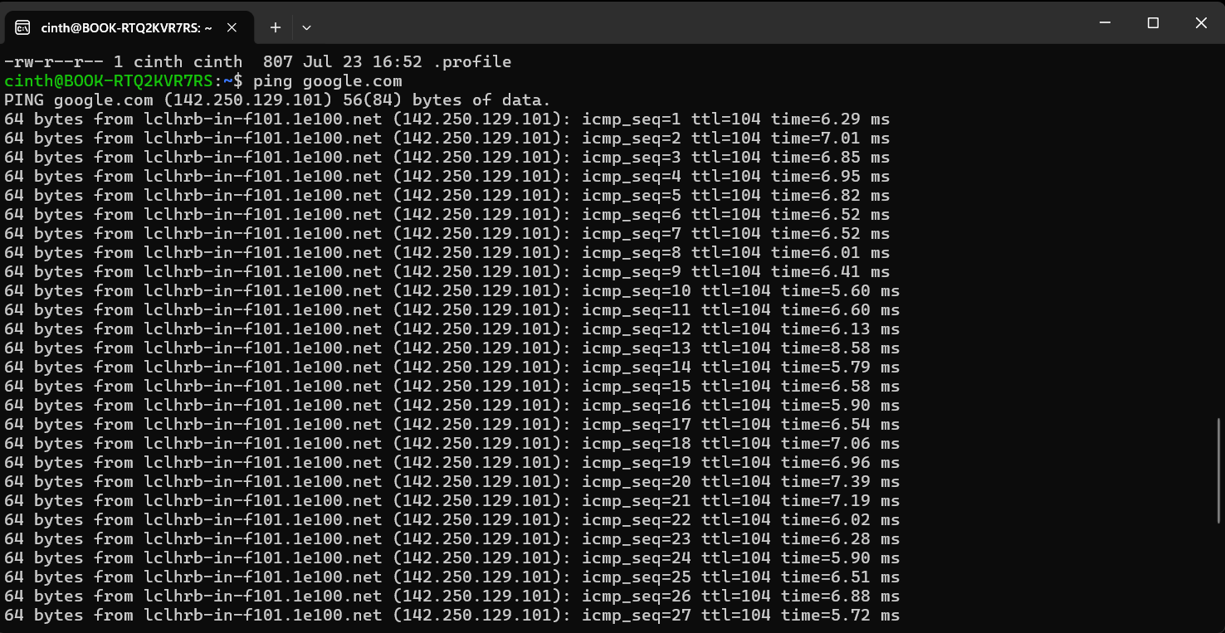
Figure 22 command ping google.com.

Command: ip addr
The ip addr command shows detailed information about the network interfaces configured on the Linux system. It shows IPv4 and IPv6 addresses, interface status, MAC addresses, and other network configuration details.
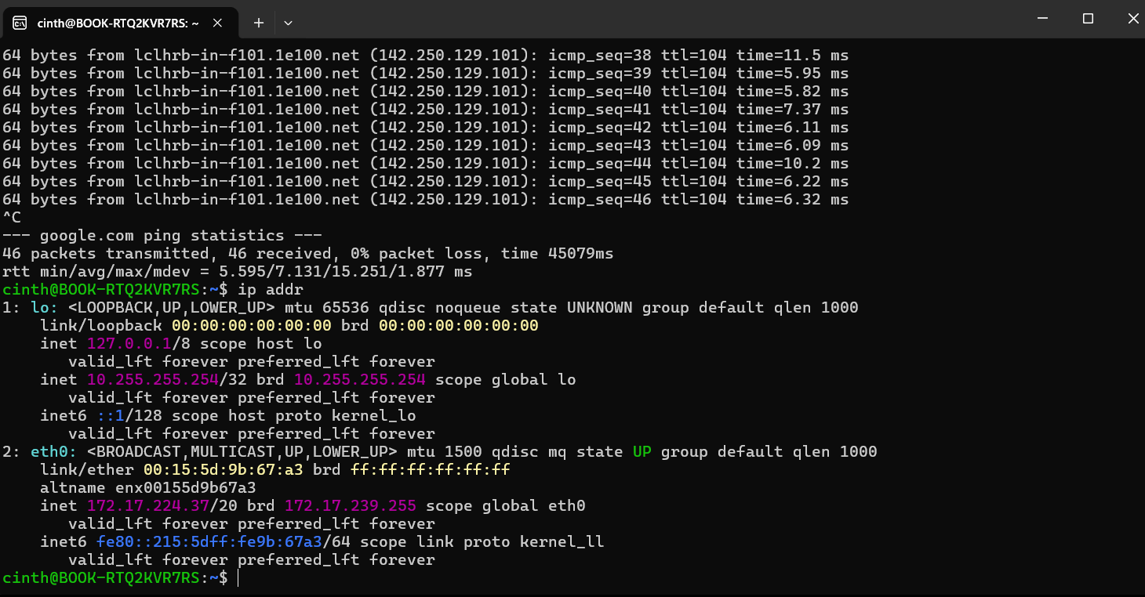
Figure 23 command ip addr.

3.4 User Management
Command: whoami
The whoami command shows the username of currently logged-in user. It is useful for confirming which user account is being used to execute commands and manage system resources.
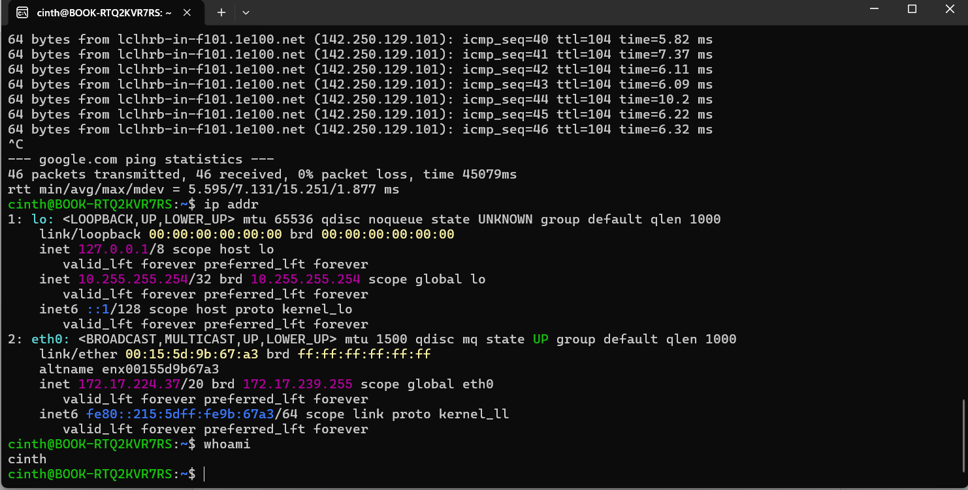
Figure 24 command whoami.

3.5 Task Scheduling
Command: crontab -l
The crontab -l command lists the scheduled cron jobs for the current user. It is used view automated tasks that are configured to run at specific times or intervals. If no scheduled tasks exist, the command reports that no crontab has been created.
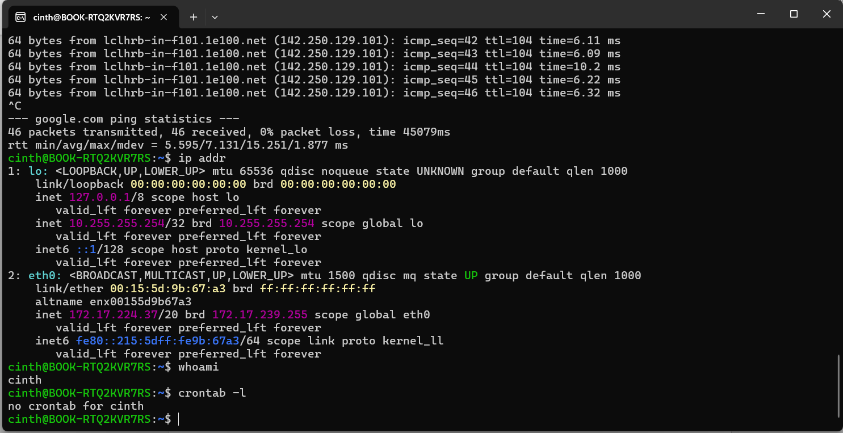
Figure 25 command crontab -l.

Use of Windows OS scripts.
Scrip 1: Numbered Folder Creator
This batch script automatically creates multiple folders using a name and quantity entered by the user. The script uses variables to store the folder name and the number of folders to create. It applies a FOR loop to repeat the folder creation process and an IF statement to validate that the user enters a number greater than zero. This demonstrates how batch scripting can automate repetitive file management tasks, saving time and reducing manual work.
Variables (set /p) -stores the folder name and the number of folders entered by the user.
User input – allows the user to choose the folder name and the quantity.
Conditional statement (IF) – checks that the number entered is greater than zero before continuing.
Loop (FOR) – repeats the mkdir command until all folders are created.
Mkdir command – creates the folder automatically.
Pause- keeps the command prompt window open so the user can read the results.

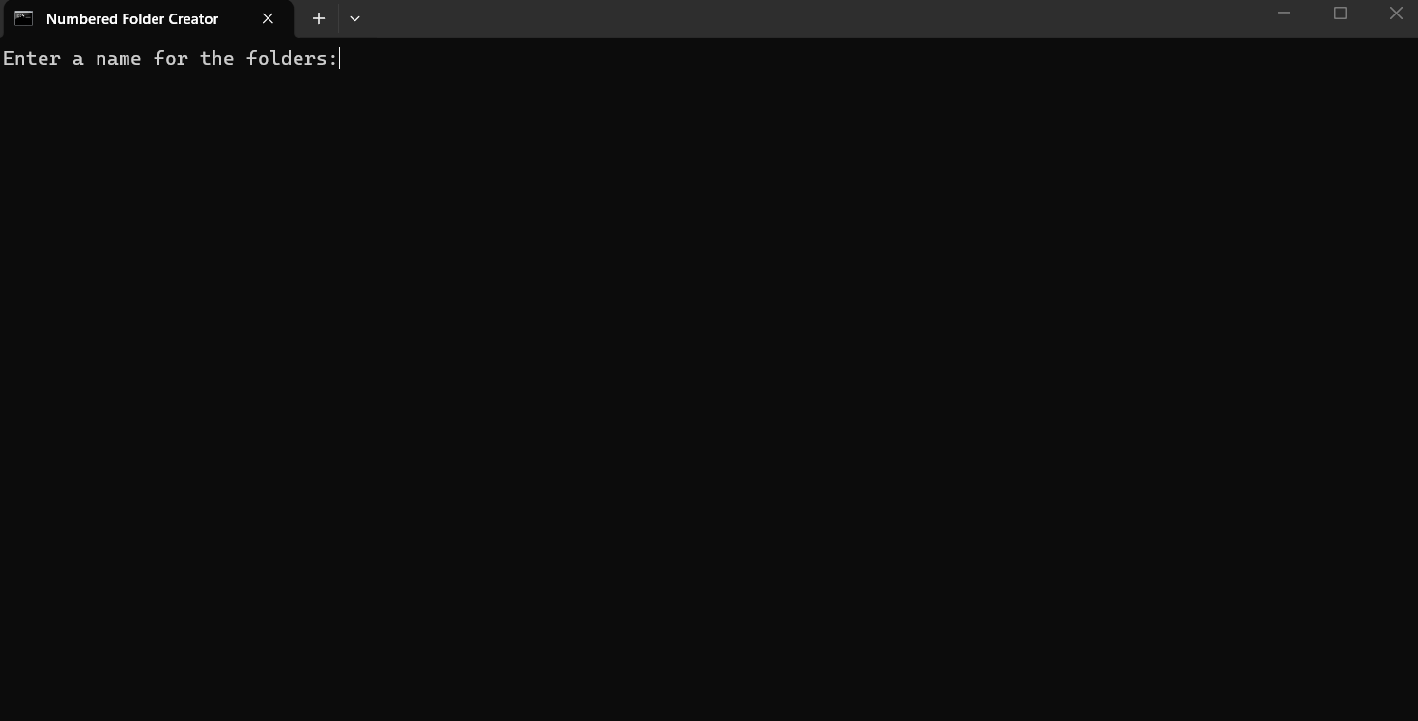
Figure 26.

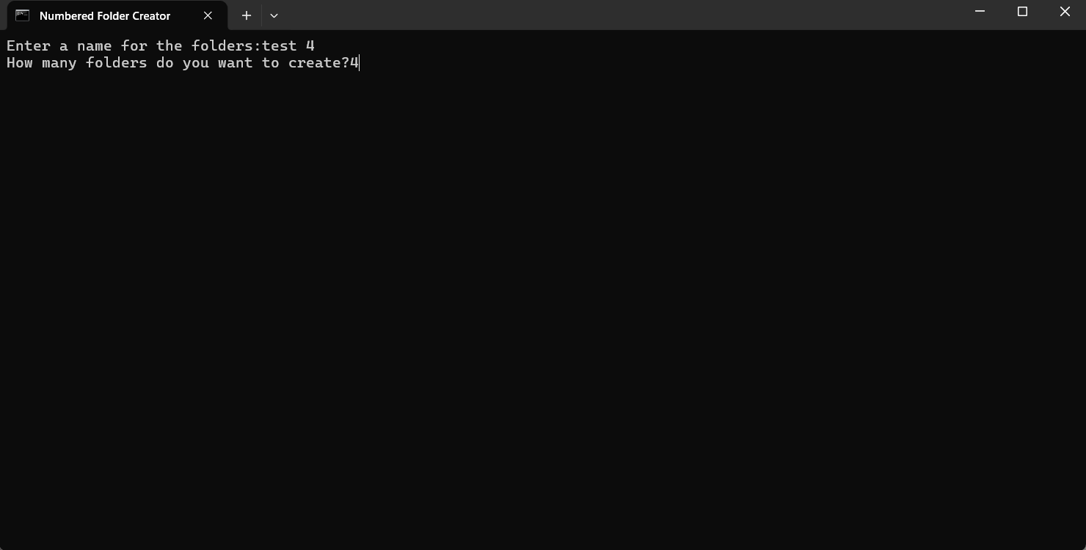
Figure 27.

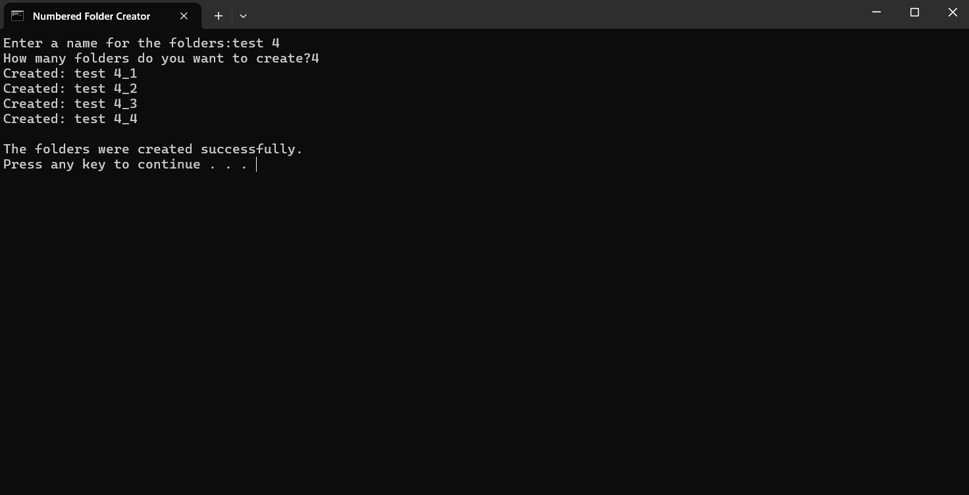
Figure 28.

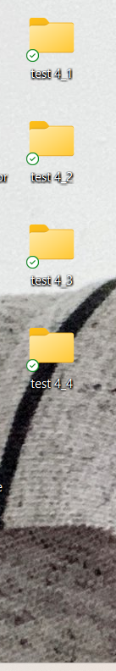
Figure 29.

Scrip 2: Simple Calculator
This batch script asks the user to enter two numbers and calculates their total using the arithmetic operations. It uses an IF statement to check whether the result is greater than or equal to 100 and FOR loop to count from 1 to 5 before displaying the final result.

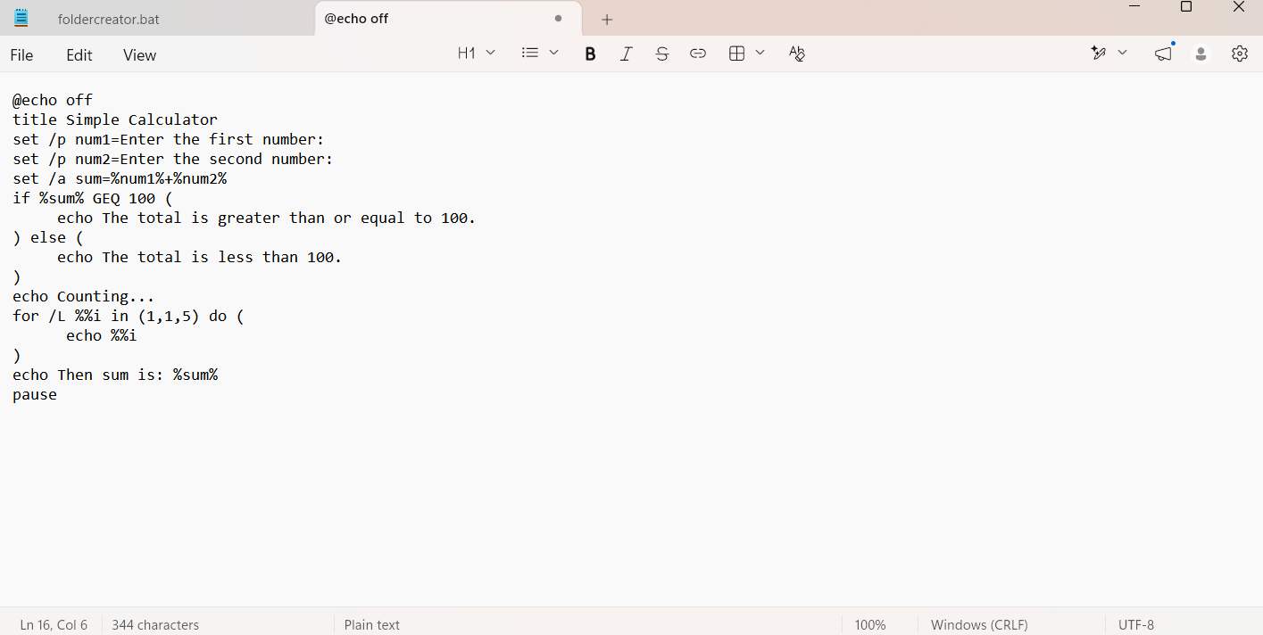
Figure 30.

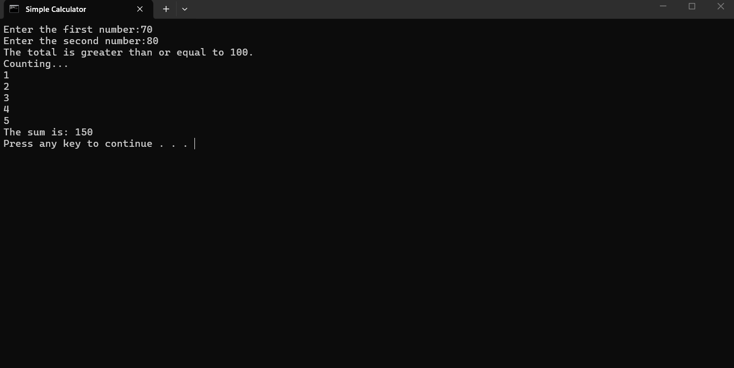
Figure 31.

Use of Linux OS scripts.

Script 1: calculator.sh
This bash script demonstrates basic Linux automation. It uses variables to store two numbers entered by user and performs an arithmetic operation to calculate their sum. An if statement checks whether the results is greater than 100 while a For loop shows the numbers 1 to 5. Finally, the scrips outputs the calculated total, demonstrating the use of users input, variables, arithmetic operations, conditional statements and loops.
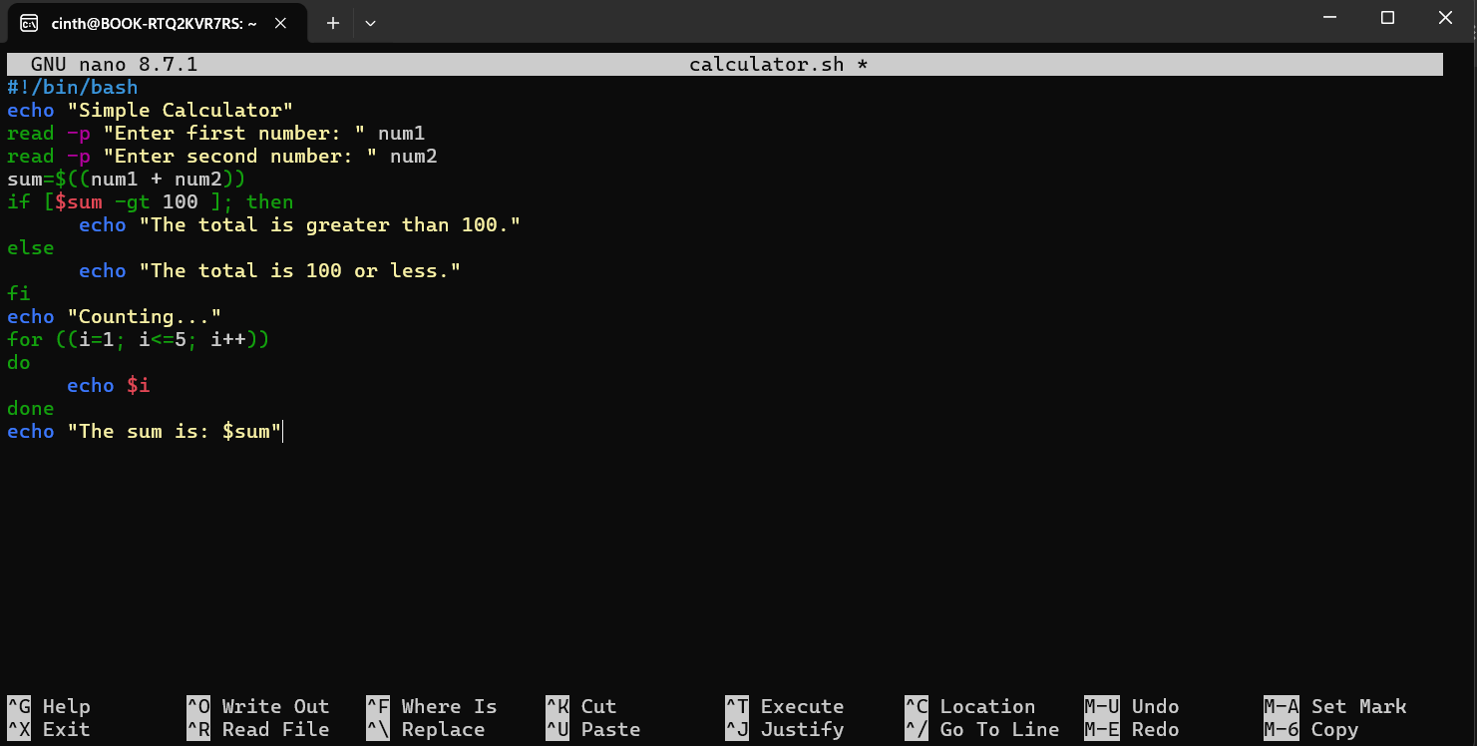
Figure 32.

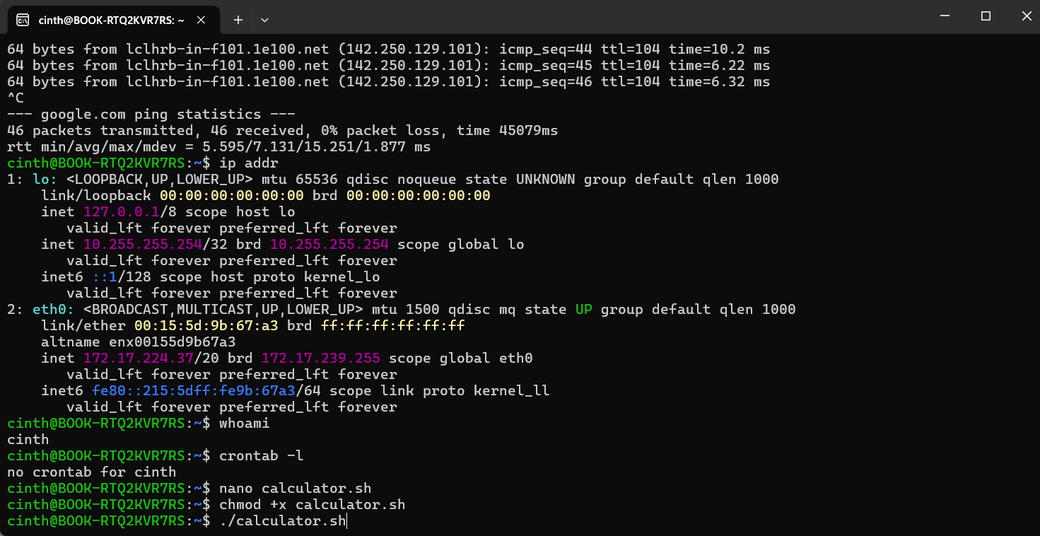
Figure 33.

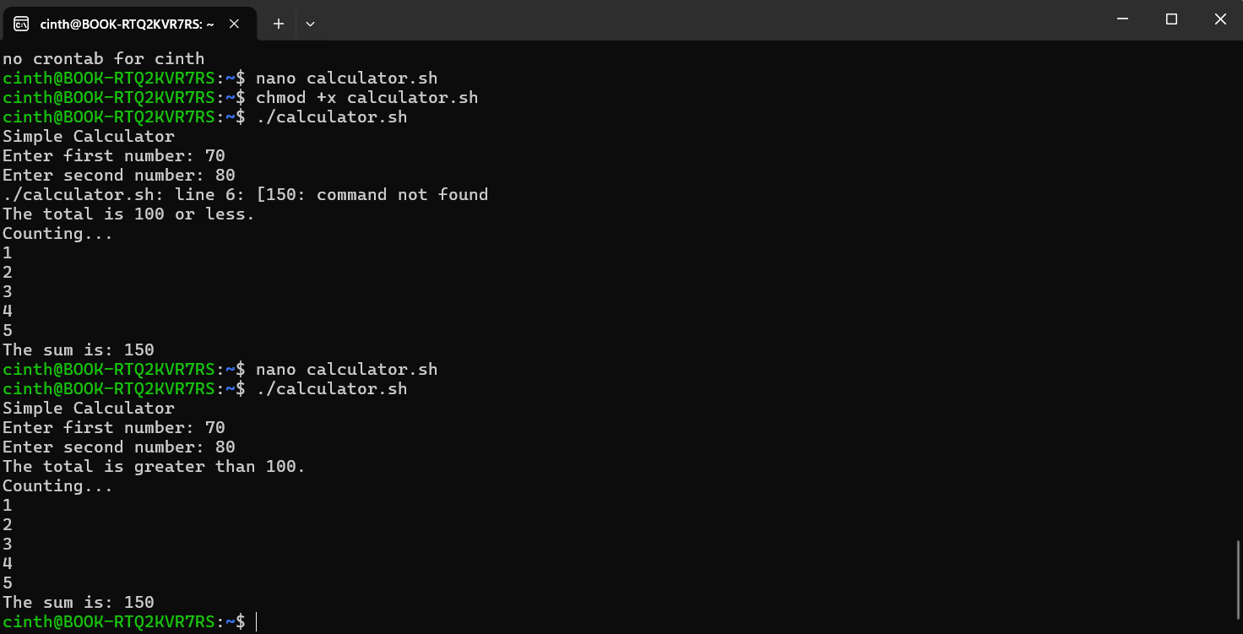
Figure 34.

Script 2: Age checker (nano agechecker.sh)
This Bash script asks the user to enter their age using the read command. It uses an if statement to determine whether the user is an adult (18 or over) or under 18. Also demonstrate a for loop by show the number 123, this example shows the use of user input, variables, conditional statements.

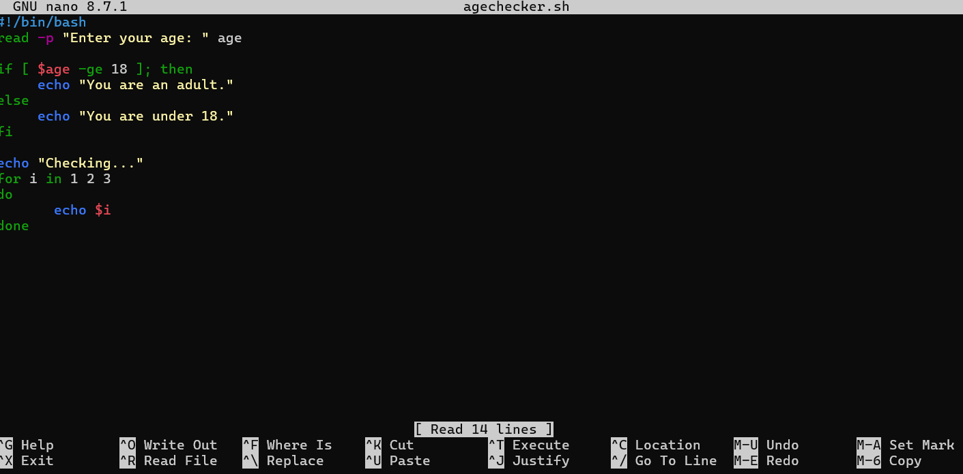
Figure 35.

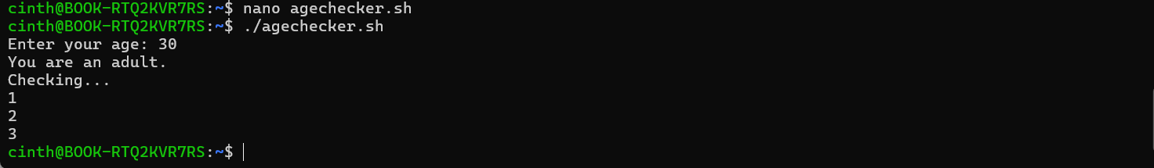
Figure 36.

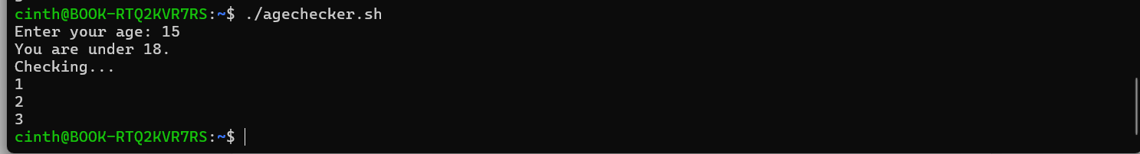
Figure 37.

Conclusion
In conclusion this assignment helped improve my understanding of Operating System and command-line interfaces. By using Windows batch and Linux bash scripts, I learned how variables, user input, loops and conditional statements can automate simple tasks.
Every task helped me understand the differences and similarities between Windows and Linux scripting and grown my confidence using commands[5. 5. 6. 1. 5. 6].

References

[1] "operating system tutorial." [Online]. Available: https://www.geeksforgeeks.org/operating-systems/introduction-of-operating-system-set-1/
[2] D. Comer, Operating system design: The Xinu approach, Chapman and Hall/CRC, 2025.
[3] W. Stallings, Operating systems: internals and design principles, Prentice Hall Press, 2011.
[4] S. R. Chowdhury, C. Adam, F. Wu, J. Rofrano and R. Boutaba, "Managing the file system from the kernel", in 2014 IEEE Network Operations and Management Symposium (NOMS), pp. 1–8.
[5] "lifewire commands," [Online]. Available: https://www.lifewire.com/list-of-command-prompt-commands-4092302https://www.lifewire.com/list-of-command-prompt-commands-4092302
[6] "windows commands." windows. [Online]. Available: https://www.geeksforgeeks.org/operating-systems/introduction-of-operating-system-set-1/

